The Education Security Portal has been updated and the Edwin application has had to undergo some changes as a result. This new version looks and operates slightly differently. Some of the changes, especially in selecting prompts and running reports, as well as how to download data, are important to review to assist you in using Edwin.
This guide helps new and returning users navigate Edwin Analytics and make the most of their experience.

The Home Screen 1
Reports Organized by Content in the Edwin Analytics Folder 2
Selecting Prompts 3
General Report Running Tips 3
View Reports in HTML 4
Print Reports in PDF 4
Export Reports to Excel 5

The Home Screen
When you click on the Edwin Analytics link in the EOE Security portal, the Edwin Home Screen will open in a new tab.
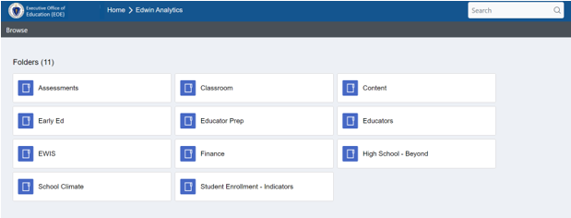
Trouble finding a report? Use the search function in the top right of the home screen.
If you need SIF or reports for another application, you can hit
Home in the folder path at the top of the screen.

Current users may notice there is no longer a “Favorites” folder. It is not possible for us to have a favorite folder or recently run report list at this time in the application. We hope this feature becomes available in the future.
Reports Organized by Content in the Edwin Analytics Folder
- All reports reside in a subject folder, but security on the reports will prevent users from seeing reports they are not permitted to access. A list of report names and information about access levels are available on Edwin’s public website.

- When you click on folder you may see a subfolder. Click on subfolder(s) to see a list of reports. This may include aggregate and student level reports if your security role gives you access to student level data.

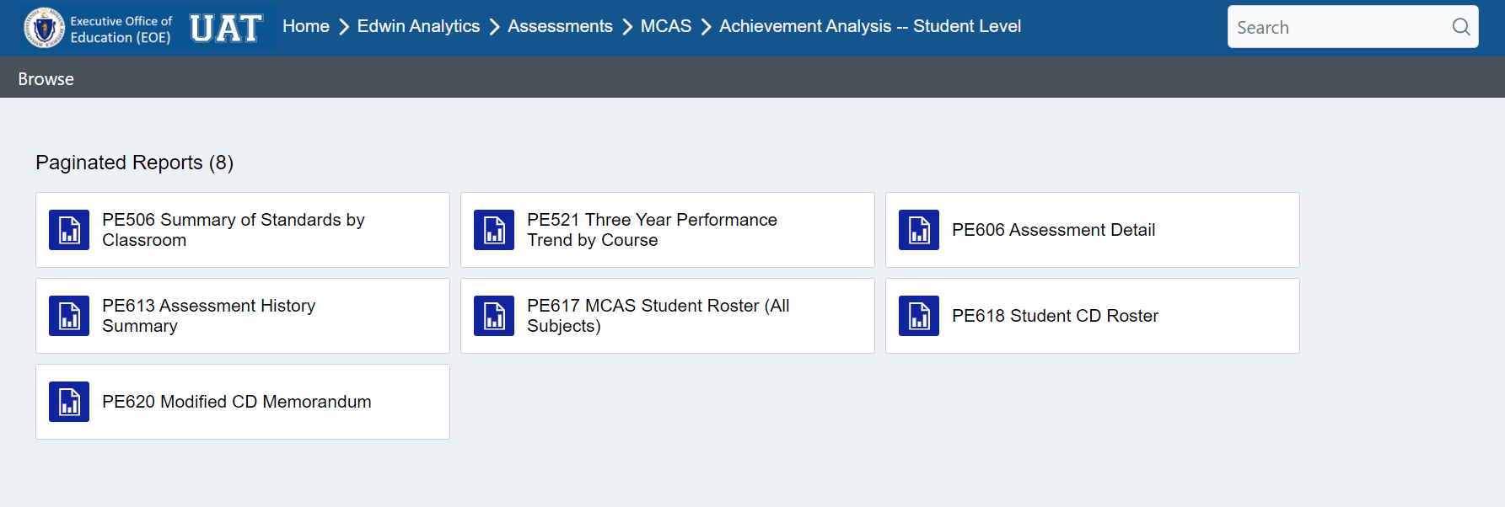
Note: Aggregate reports can be run for the district level or school level in the same report.

- To navigate back to the prior screen, you can use the back button or click on the folder path displayed. For example, in the above screenshot where you are in the Achievement Analysis—Student Level subfolder in the MCAS subfolder of Assessments, you can click on Edwin Analytics to go back to the parent folders or Assessments to see MCAS and ACCESS subfolders, or MCAS to see the other MCAS folders. The ‘browse’ option will return you to the Home folder.

Selecting Prompts
- When opening a report, the prompt section appears at the top of the report and the prompts should be read horizontally to make selections. Some selections will seem to refresh the report but the report itself is not rerun until the “view report” button is selected. On most reports, it will open with some data populated based on the default option.
- When you change any filter selections, hit the “view report” button to the right of the prompts to rerun the report. The button will be green when new filters have been selected. Even if the report screen goes momentarily blank or you see a “fetching data” box appear on the screen, new data will not be displayed until you use the button. Once you have made all the changes to the prompts that you want, hit the green “view report” button to see new info.
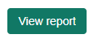
If the “View Report” is Green, hit the button to view new data!!!!
You are not seeing the data reflected by the prompts you picked if the view report button is green!

- Some student level reports do not automatically open with data populating the report section. You can enter SASIDs in the SASIDs box or change “SASID Search” to “No” and other prompts will be made available for running the report on an organization. After making any additional changes to the prompts, hit the “view report” button to see your report.
- When using the “SASID Search” option on applicable reports, you can type in SASID(s) or copy and paste a list of SASIDs from a spreadsheet or other document. Hit the down caret after “Enter SASIDs, if applicable” for a larger box to appear and move the cursor into the larger box to type or paste SASIDs. SASIDs should appear on separate lines or with a comma separating them. It is okay to leave the “Enter SASIDs, if applicable” in the box as long there is a space between it and any SASIDs.
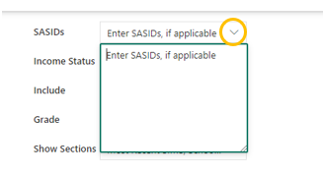
- The prompts have recently been reordered to improve the performance of the reports. It is best to read the prompts horizontally, starting in the top left and read the first row of prompts across and then review the second row of prompts from left to right, the third, etc. For example, the parameter section of PR600 Student Profile report is below. It is best to start with the “Select from” prompt in the top left corner, then decide if you wish to Search by SASID and enter SASIDs, if applicable before making any adjustments to the second row, then moving on to the third, fourth and fifth row of prompts.
1
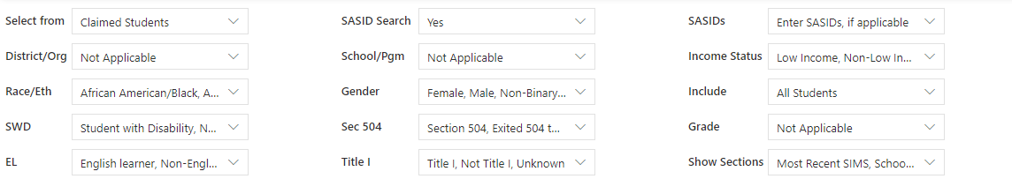
3
2
5
4

- If you get no data after running a report, make sure that your prompts are correct (does the school selected have the grade selected?)
- To run an aggregate report at the district level, select all schools in district. This is typically the default. You can select one school to run the report at the school level.
- Filters are single or multi-select. Multi-select menus default to “select all”. If you type in the district or school prompt box rather than scroll through available options, you should delete the text that is there and then type your choice. Available options should auto populate for you to select.
- You may need to use the scroll bars to view all prompt options or filter menus.

General Report Running Tips
- As you run reports, they will open in the same browser. If you want to have multiple reports open at once, open reports in new tab or window.
- You may need to scroll across or down to view the whole report.
- Some reports have hyperlinks that allow you to click through to a different report (e.g. a student level report). When you click on a hyperlink, the report will load in a new tab.
- Some reports have additional information available if your scroll over an . Additionally, some reports have notes at the beginning or end to help interpret the report. Footnotes may appear on the last page of a report.
- At the top of the report is task bar including the export menu, page navigation buttons, and show/hide parameter options.
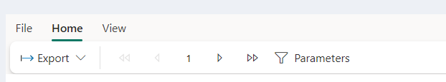
- The report will open in the web layout view. There is an option to change the view to “print layout” and print from Edwin, however most reports will be more printer friendly if you export to PDF and print from PDF. That is the recommended process for printing from Edwin.
- The export button is on the right of the report task bar at the top of the reports. This allows you to export to excel, csv, pdf or other formats. Note: Not all reports are optimized for all export options. The PDF format displays and prints the report exactly as it appears on your screen. Downloading to excel may be helpful to do additional filtering and merging with other data.
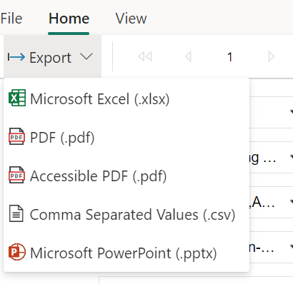
- Some reports have multiple pages. Use the control in the report task bar to navigate across pages.
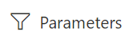
- You can minimize the prompt section by selecting in the task bar at the top of the page. You can show the prompt section by hitting again.

- PR600 Student Profile Report: When running the PR600 Student Profile Report for a large batch of students, it may be easier to navigate among the student records after exporting the data to PDF. Open the PDF in adobe and show the bookmarks (the icon), or open in a web browser and have it show the table of contents or document outline in your view (the icon typically looks like a bulleted list). This will allow you to see a list of student records included. You also can search the PDF for a student name.

View Reports in HTML
Most Edwin Analytics reports are initially displayed in HTML because this is the format of choice for viewing reports on the Internet and the HTML format enables the reports to be interactive by allowing reports to be filtered for specific data prior to viewing.

Print Reports in PDF
Reports can be viewed in PDF, which can make it easier to share copies offline or printed using the PDF format. Printing from PDF assures what you are viewing on the screen is what will print out in hardcopy.
IMPORTANT: As required by state law, data that identifies individual students or individual teachers should not be saved to the local hard drive on your laptop or tablet if it is not encrypted; student- and teacher-level data should only be saved to a secured file server. Contact your district IT department/personnel if you are unsure about the security of your computer’s hard drive
WINDOWS. For those who have Adobe Reader as their default PDF application, point your cursor near the bottom or the top of the report page (depends on your browser) to display the Adobe Reader controls for printing and saving. We do not recommend using your browser menu to print or save Edwin Analytics reports as you may get unexpected results.
IMPORTANT: If you are not using Adobe Reader, follow your computer’s PDF application’s instructions for printing and saving Edwin Analytics reports.
Choose the PDF application’s Print icon to print the report. Choose the PDF application’s Save icon to save the report. In some instances, if you are having trouble saving, you can print to PDF and save that file.

Export Reports to Excel
Some reports can be run directly as an excel report. Most reports can be exported to excel. This may be desired to do additional filtering and additional analysis of your data.
IMPORTANT: While some reports may be exported to Excel successfully, not all reports will correctly format in Excel. After exporting a report to Excel, it is recommended that reports be previewed before printing from Excel. This way, adjustments can be made prior to printing in order to fit the report into the spreadsheet format. It should also be noted that assistance using MS Excel is not supported by the Edwin Analytics team. Questions regarding MS Excel should be directed to your local IT department/personnel.
Trouble seeing the download? The download may appear at the bottom of a new tab or window. MAKE SURE YOUR BROWSER ALLOWS POP-UPS. If in a new window, make sure you can see the bottom of the window. Click the full screen icon in the top right corner.

