Office of Language Acquisition
2023-2024 Professional Learning Calendar
Please note that these dates are for planning purposes but may be subject to change. OLA will notify you of changes to these projected dates.

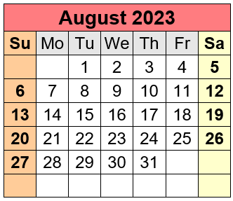 | Until 8/31  Tues, 8/15  Wed, 8/16  Mon, 8/21  Thu, 8/24 | 2022-23 WIDA self-paced workshops available (WIDA portal)  Policy Update Webinar (Zoom, 10:00-11:00)  Initial Identification Webinar (Zoom, 11:30-12:30)  New ELE and World Language Directors’ Induction (Zoom, 9:30-3:30)  OLA Grants Webinar (Zoom, 10:00-11:00)  Creating a Welcoming Environment for Newcomer Students & Families (Zoom, 2:00-3)
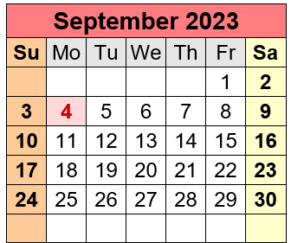 | Thu, 9/28  Ongoing | Welcoming Newcomers, Part 2 (Enrollment) (Zoom, 3:00-4:00)  2023-24 WIDA self-paced workshops available (WIDA portal)
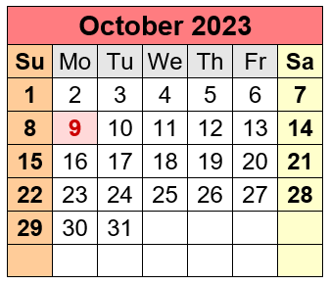 | Wed, 10/11  Thu, 10/12  Mon, 10/30  Tues, 10/31  Ongoing | SLIFE Community of Practice (CoP) Kickoff (Zoom, 11:00-12:00)  Tiered Focused Monitoring (TFM) Review Orientation for 2023-24 Districts (Zoom)  OLA Advisory Meeting #1A (Zoom, 3:30-4:30pm)  OLA Advisory Meeting #1B (Zoom, 9:30-10:30am)  2023-24 WIDA self-paced workshops available (WIDA portal)
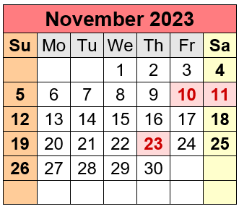 | Wed, 11/1  Wed, 11/8  Wed, 11/15  Wed, 11/29  Ongoing | ALL NETWORK MEETING (Zoom, 9:30-3:00)  WIDA: Scaffolding Learning Through Language (webinar 1, 3:30-5:00)  WIDA: Scaffolding Learning Through Language (webinar 2, 3:30-5:00)  WIDA: Scaffolding Learning Through Language (webinar 3, 3:30-5:00)  WIDA Español: Attending to Equity through Bilingual Instruction (webinar 1, 3:30-4:30)  2023-24 WIDA self-paced workshops available (WIDA portal)
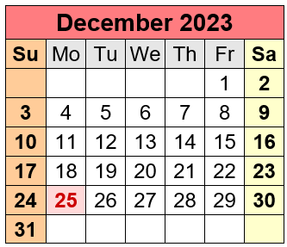 | Tues, 12/5  Wed, 12/6  Thurs, 12/7  Wed, 12/13  Thurs, 12/14  Tues, 12/19  Ongoing | OLA Advisory Meeting #2A (Zoom, 3:30-4:30pm)  OLA Advisory Meeting #2B (Zoom, 9:30-10:30am)  WIDA Español: Attending to Equity through Bilingual Instruction (webinar 2, 3:30-4:30)  WIDA: Planning with the WIDA ELD Standards Framework (webinar 1, 3:30-5:00)  WIDA Español: Attending to Equity through Bilingual Instruction (webinar 3, 3:30-4:30)  WIDA: Planning with the WIDA ELD Standards Framework (webinar 2, 3:30-5:00)  SLIFE Community of Practice (CoP) (Zoom, 9:00-11:00)  2023-24 WIDA self-paced workshops available (WIDA portal)
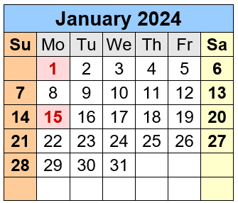 | Thu, 1/11  Thu, 1/18  Thu, 1/25  Wed, 1/24  Ongoing | WIDA: Scaffolding Learning through Language (webinar 1, 3:30-5:00)  WIDA: Scaffolding Learning through Language (webinar 2, 3:30-5:00)  WIDA: Scaffolding Learning through Language (webinar 3, 3:30-5:00)  Tiered Focused Monitoring (TFM) Training for 2024-25 districts (webinar 10:00-11:30)  2023-24 WIDA self-paced workshops available (WIDA portal)
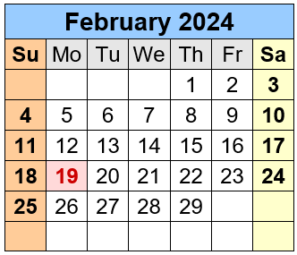 | 2/5 - 5/17  Wed, 2/14  Mon, 2/26  Wed, 2/28  Thurs, 2/29  Ongoing | WIDA: Considerations when Educating Bilingual Learners with Identified Learning Disabilities (15-week eWorkshop)  ALL NETWORK MEETING (Zoom, 9:30-3:00)  WIDA: Bringing Language into Focus (webinar 1, 4:00-5:30)  CIMP Webinar for 2023-24 TFM districts (Zoom, 10:00-12:00)  OLA Advisory Meeting #3A (Zoom, 3:30-4:30pm)  OLA Advisory Meeting #3B (Zoom, 9:30-10:30am)  2023-24 WIDA self-paced workshops available (WIDA portal)
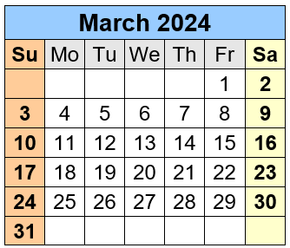 | Mon, 3/11  Tues, 3/19  Thu, 3/28  Ongoing | WIDA: Bringing Language into Focus (webinar 2, 4:00-5:30)  SLIFE Community of Practice (CoP) (Zoom, 9:00-11:00)  WIDA: Scaffolding Learning through Language (webinar 1, 3:30-5:00)  2023-24 WIDA self-paced workshops available (WIDA portal)  WIDA: Considerations when Educating Bilingual Learners with Identified Learning Disabilities (15-week eWorkshop)
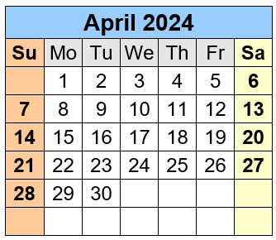 | Wed, 4/3  Wed, 4/10  Thu, 4/4  Thu, 4/11  Fri, 4/12  Wed, 4/24  Ongoing | WIDA: Teacher Leaders Planning with the ELD Standards Framework (webinar, 3:30-4:30)  WIDA: Teacher Leaders Planning with the ELD Standards Framework (in person, 8:30-3:30)  WIDA: Scaffolding Learning through Language (webinar 2, 3:30-5:00)  WIDA: Scaffolding Learning through Language (webinar 3, 3:30-5:00)  OLA Advisory Meeting #4A (Zoom, 3:30-4:30pm)  OLA Advisory Meeting #4B (Zoom, 9:30-10:30am)  ALL NETWORK MEETING (Zoom, 9:30-3:00)  2023-24 WIDA self-paced workshops available (WIDA portal)  WIDA: Considerations when Educating Bilingual Learners with Identified Learning Disabilities (15-week eWorkshop)
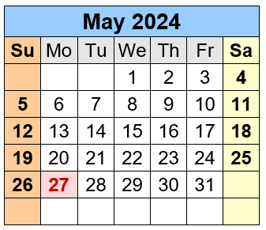 | Tue, 5/21  Ongoing | SLIFE Community of Practice (CoP) (Zoom, 9:00-11:00)  2023-24 WIDA self-paced workshops available (WIDA portal)  WIDA: Considerations when Educating Bilingual Learners with Identified Learning Disabilities (15-week eWorkshop)
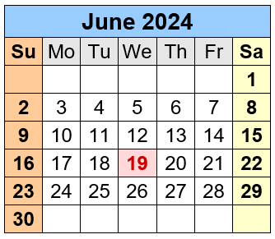 | Thurs, 6/6  Fri, 6/7  Thurs, 6/13  Tue, 6/18  Ongoing | OLA Advisory Meeting #5A (Zoom, 3:30-4:30pm)  OLA Advisory Meeting #5B (Zoom, 9:30-10:30am)  OLA Leadership Network Meeting (in-person, 8:30-3:00)  SLIFE Community of Practice (CoP) (Zoom, 9:00-11:00)  2023-24 WIDA self-paced workshops available (WIDA portal)

NOTE: 2023-24 WIDA self-paced workshops are available through August 31, 2024, to all MA educators via the WIDA portal. These are a great resource for summer professional development.

Contact Us:
EL Education | el@doe.mass.edu | https://www.doe.mass.edu/ele/
World Languages | worldlanguages@mass.gov | https://www.doe.mass.edu/worldlanguages/
Seal of Biliteracy | MAStateSealofBiliteracy@mass.gov | https://www.doe.mass.edu/scholarships/biliteracy/
Our Team:
Allison Balter, Director
Sibel Hughes, Assistant Director
David Valade, Language Acquisition Support Lead
Judith Magloire, Language Acquisition Support Lead
Andy McDonie, Language Acquisition Support Lead - World Languages
Samantha Kodak, Language Acquisition Compliance Specialist
David Parker, Continuous Improvement Manager for Language Acquisition
Dr. Elenita Irizarry-Ramos, Senior Strategist for Multilingual Learning & Dual Language Education
Moira Connolly, Expanded Learning Time Coordinator
Diana Gentile, Management Analyst

