Access to

The SpEd File Exchange Dropbox

It is important to note that not all staff has access to the Department’s Security Portal. See your local Directory Administrator if one of the following occurs:

- You do not have a password to log onto the Department of Elementary and Secondary Education’s Security Portal

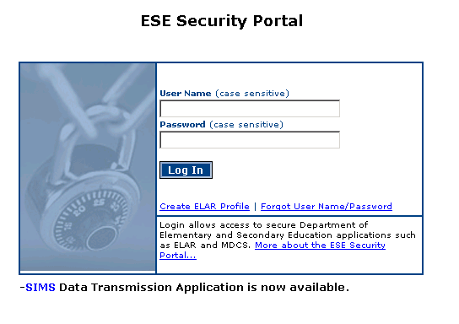
- You have access to the portal but cannot view the “DropBox Central” application

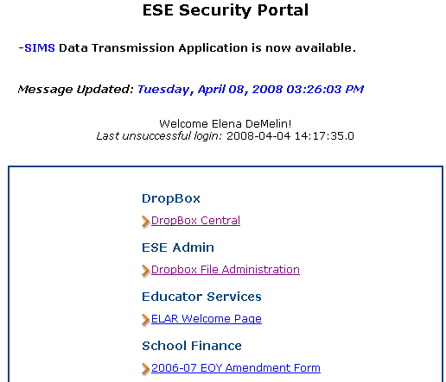
For Directory Administrators:

DropBox Central
How to give yourself access to the Sped File Exchange DropBox

- Go to the security portal at https://gateway.edu.state.ma.us/

- Under Applications select Directory Administration.

- Go to the My Personal Information tab.

- Go to the Security Tab and scroll down to select SPED File Exchange.

- Click SAVE and then go back to the security portal.

- You should see the Sped File Exchange folder listed in the DropBox Central application.

How to access
The SpEd File Exchange Dropbox

All SPED FILE EXCHANGE Users have been provided with the security access to download and upload the Circuit Breaker Update file to the Department of Elementary and Secondary Education’s web site.

If you are the Directory Administrator for your district and would like to assign yourself this security role please see page 2.

SPED FILE EXCHANGE Users:

- Go to the security portal at https://gateway.edu.state.ma.us/

- Login using your personal username and password. Usually the username is your first initial and last name e.g. John Smith’s username is jsmith.

- Under Applications select “DropBox Central”.

DropBox Central

- Select Sped File Exchange from the list.

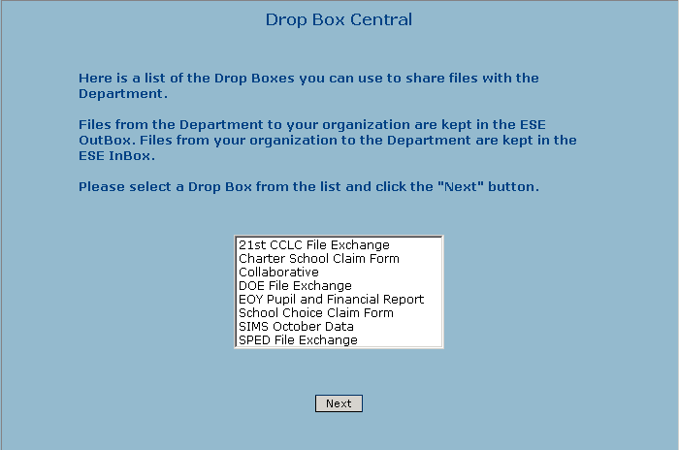

- Select the district that you need to access and click the Next button.

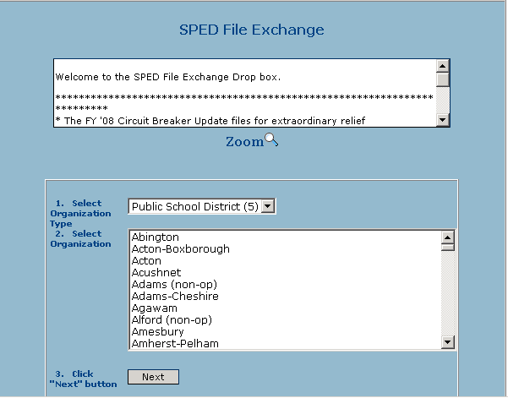

- You are now in the SPED File Exchange DropBox and are ready to download the Circuit Breaker Update file, FYCBXXX.xls (FY represents the current Fiscal Year - insert your district’s 3-digit LEA code in place of the XXX).

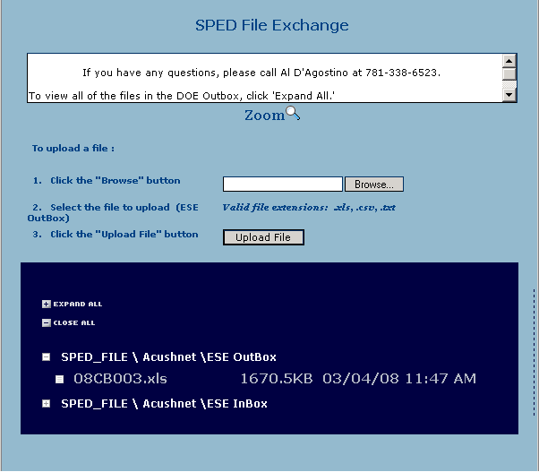

- Scroll down to the ESE Outbox and right click on the file. Select “save target as” which will open a window where it will ask you where to save the file. Be sure to keep the file name the same and save the file to a familiar place on your hard drive.

- Close the security portal and open the file you saved to your hard drive. Make the necessary changes and upload the file back to the security portal at the end of the fiscal year.

- Click on the Browse button to select the file you want to upload to the Department and then click on the Upload button.

- Once you have successfully uploaded the file you will see the following message:

The selected file has been successfully uploaded!

If you have any questions regarding how to download or upload the Circuit Breaker files, please call Al D’Agostino at (781) 338-6523

