dese logo




***Licensure 101: How to Obtain a Massachusetts Educator License***

**Office of Educator Licensure**

**Massachusetts Department of Elementary and Secondary Education**

**75 Pleasant Street,**

**Malden, Massachusetts 02148**

**Call Center: open Mon-Fri 9am–1pm and 2pm–5pm**

**Walk-in Center: open Mon-Fri 8:45-4:45**

**781-338-6600**

[**www.doe.mass.edu/licensure/**](http://www.doe.mass.edu/licensure/)

Table of Contents

How to Use this Orientation 1

Setting Up and Using an Educator Licensure And Renewal (ELAR) Account 2

Massachusetts Educator Personnel ID 2

Applying for a License 2

The License Application Review Process 3

What License Should I Apply For? 4

Category: Academic Teacher 5

Categories: Academic Specialist Teacher and Academic Professional Support Personnel 6

Category: Academic Administrator 8

Submitting Application Documents 9

The Massachusetts Tests for Educator Licensure 10

Using the Licensure Requirements Tool to Determine other Requirements 11

How to Review an Evaluation Correspondence 12

Verifying Licensure in ELAR 14

Obtaining a Hard Copy of a License 14

Additional Information 16

# How to Use this Orientation

Thank you for your interest in pursuing educator licensure in the Commonwealth of Massachusetts which is committed to ensuring excellence within our schools and to supporting and developing our educator workforce. It is because of individuals like you that we are able to achieve these goals.

The purpose of this orientation is to provide individuals interested in earning a Massachusetts “Academic” educator license with some basic information about the licensure process and assist with getting started. In the following pages, we will cover the steps necessary to begin applying for licenses as well as where to find information about fulfilling requirements. Applicants are encouraged to review all information in this orientation as well as the information on the Licensure Office’s website: [www.doe.mass.edu/licensure](http://www.doe.mass.edu/licensure)

Please note that the focus of this orientation will be on Academic licensure. If you are interested in earning a Vocational educator license, some of the information detailed here will not be applicable to you. Please visit <https://www.doe.mass.edu/licensure/voctech/> for information about earning Vocational licensure.

If you have additional questions that are not covered in this orientation and/or the website, you may want to take advantage of one of the following resources:

* **The Licensure Call Center Help Line**: 781-338-6600

Open weekdays 9am-1pm and 2pm-5pm

Call Center Agents service this Licensure Help Line and can assist you with general questions about the licensure process.

* **The Licensure Walk-in Welcome Center Service Counter**

Located on the first floor of our DESE building at 75 Pleasant Street, Malden, MA 02148

Service Counter is open weekdays 8:45am-4:45pm for assistance with general questions about the licensure process.



# Setting Up and Using an Educator Licensure And Renewal (ELAR) Account

ELAR
Educator Licensure And RenewalIf you are looking to earn a Massachusetts Educator License you will need to create an ELAR account. The ELAR system is the online licensing system used by the Office of Educator Licensure to track the Licensure process for all applicants and for educators to monitor their licensure and application status. Through the ELAR system, educators may complete all aspects of the license application process as well as review their current license information. For example, an applicant/educator can apply for new licenses, view their status, upload supporting documents, print an unofficial copy of their license and much more.

## Massachusetts Educator Personnel ID

When an ELAR account is created, the system will automatically generate for the individual a Massachusetts Educator Personal ID, (commonly referred to as a MEPID). The MEPID is necessary to register for licensure testing, is often used by state approved educator preparation programs and allows school administrators a limited view to an individual’s ELAR account/license information.

A step-by-step guide on how to create an ELAR account may be found here: <http://www.doe.mass.edu/licensure/elar/navigating-the-system.docx>

# school busApplying for a License

Interested educators are encouraged to apply for their license at their earliest possible convenience. An educator need not have completed all requirements for a license in order to submit the application. Applying merely begins the process where the Licensure Office will be able to review an applicant’s submitted documentation and provide written feedback about requirements and documenting compliance. Applications are then continuously reviewed on a rolling basis whenever new documentation/information is submitted to the Licensure Office via their ELAR account. There is no fee for each additional review and open applications do not expire in the ELAR system. An applicant’s first license application will cost $100, and each additional application submitted will cost $25. Please see below for additional information regarding getting your application reviewed and what information the Licensure Office will need.

A step-by-step guide on how to apply for a license in the ELAR system may be found here: <http://www.doe.mass.edu/licensure/elar/how-to-apply.docx>.

A paper application option is available for educators to fill out and mail to the Licensure Office. Please note however, that correspondence about said application will occur online via email and the applicant’s ELAR account. A copy of the paper application may be found here: <https://www.doe.mass.edu/licensure/academic-prek12/pk12-application-package.docx>

## The License Application Review Process

An open Educator License application may indicate a status of “Not Ready,” “Ready for Review,” “Pending” or “Idle.”

A **“Not Ready”** status on a license application indicates that an individual has filled out an application, but they have either either not yet submitted payment for the application or they have not submitted the necessary documentation for a first review (Refer to page 8 for more information on this topic). Please note, if you do not see an “application date” present in your ELAR account then your payment was not successful. You can click on “view payment history” to complete any pending transactions as opposed to reapply for the same license.

An application goes into a **“Ready for Review”** status when new documentation is added to an educator’s ELAR profile. “Ready for Review” indicates that the file is in line to be reviewed by a member of the Office of Educator Licensure’s evaluator team. Applicants should note that as long as an application goes into a “Ready for Review” status, they do not need to contact the Licensure Office to inform us that a document has been uploaded. Open applications are processed in the order that they go into a “Ready for Review” status. The turn-around time on a license application will vary depending on the time of year and may range from a few days to a few weeks and if necessary, an authorized school administrator can request to have your application expedited.

Upon review, the evaluator will determine which (if any) requirements have been properly documented and mark them as “verified met” in ELAR. If all requirements have been fulfilled, the license is granted, and the status will read: “**Licensed.”**

If there are outstanding requirements, the status of the application will switch to **“Pending”** and the applicant will be emailed a notification to log in to ELAR and read an updated evaluation letter. This letter will detail which requirements remain and what the applicant’s options are for fulfilling/documenting said requirements. Please note that this “evaluation letter” is available to review 24/7 in the “Correspondence History” within ELAR. If an educator has submitted documentation that has been determined to be unacceptable, the licensure evaluation letter will detail why the documents cannot be accepted and (if applicable) what must be changed in the documentation in order to make them acceptable. The application will then stay in a “Pending” status until new documentation is submitted for review and the review process will begin again.

An application will go into an **“Idle”** status in one of two ways. Either the applicant has pressed the “Change Status to Idle” button in the Activity column of their application list OR more than two calendar years has passed since the applicant has submitted any documents in support of the application. An “Idle” status means that when new documents are uploaded to an educator’s ELAR account, the application will not change over to a “Ready for Review” status because it is assumed that the applicant is no longer pursuing that particular application.

If an educator accidentally puts an application into an “Idle” status, or if they decide to pursue an application that is in an “Idle” status, they should call the Licensure Help Line (781-338-6600) for assistance. The Call Center Representative will be able to take the application out of the “Idle” status and place it back into either “Ready for Review” or “Pending” depending on if there is new information to be reviewed.

## What License Should I Apply For?

The name of each educator license that Massachusetts offers is broken into four components. Taken together, this identifies the exact role in a school that the license is valid for. The four components are:

* 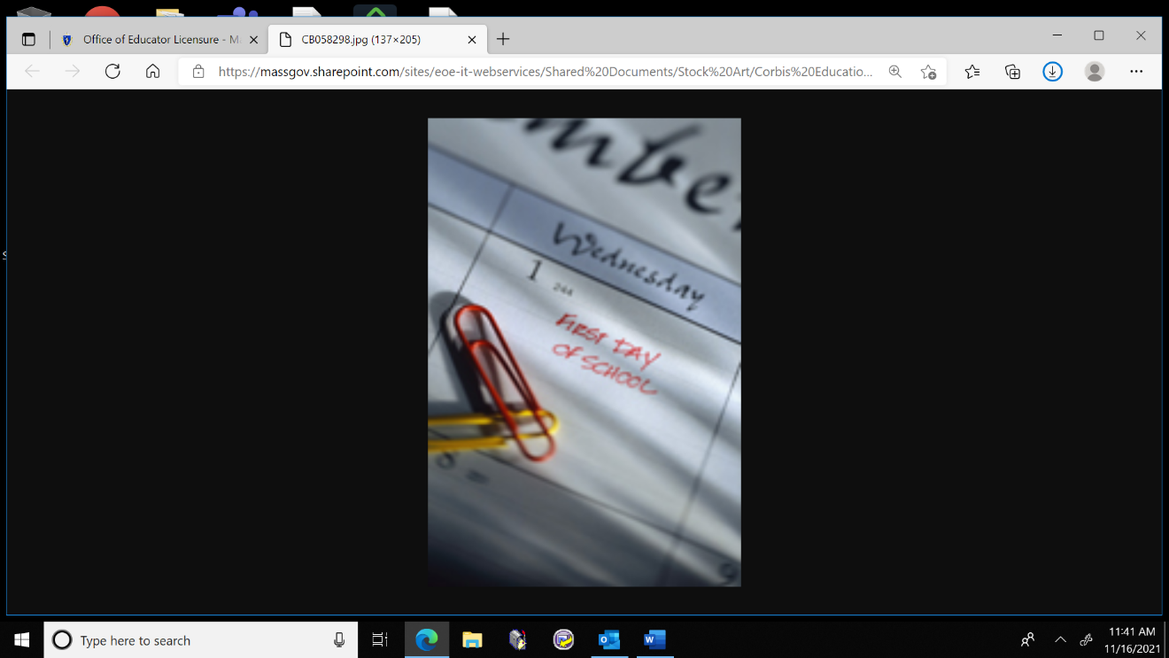**Category:** The Category refers to the grouping of the license by larger function within the school. For example, an Academic Teacher license would be a license used to act as the Teacher of Record. An Academic Administrator license would be used to act in a position in a district or school administration function. The categories of academic licensure are teacher, teacher specialist, professional support, administrator and endorsement.
* **Field:** The Field of a license defines the license discipline or subject matter knowledge area. For example, ‘English’ would be the field of an Academic Teacher license that allows the educator to teach English subject matter knowledge. Principal/Assistant Principal would be the field of an Academic Administrator license that allows the educator to work in the role of a Principal/Assistant Principal.
* **Grade Level:** The Grade Level of a license denotes what range of grades an educator is licensed to teach. For example, an Academic Teacher, Mathematics, 8-12, license allows the educator to teach in a classroom for students from grade 8 to grade 12. Depending on the license, the Department offers a variety of grade levels, including, but not limited to PreK-2, PreK-6, 1-6, 5-8, 8-12, 5-12, etc.
* **Type:** The Type of a license is generally reflective of an educator’s education, training and experience. Depending on a variety of factors, an educator will earn a license at a particular Type and then advance that license to a higher-level Type. For example, the following Types of Academic Teacher are typically issued: Provisional, Initial, Professional or Temporary. Academic Specialist Teacher licenses are issued at either the Initial, Professional or Temporary Type.

Generally, decisions about the **Category**, [**Field** and **Grade Level**](https://www.doe.mass.edu/licensure/academic-prek12/field-grade-levels.html) of a license application are up to the discretion of the applicant. Potential applicants should decide what kind of role they wish to serve in a school district (i.e. Physical Education Teacher, School Principal, School Counselor, etc.) and then find the license Category/Field/Grade Level that is most appropriate for that role. For a list of fields and grade levels available in each Academic PreK-12 license category please visit: <https://www.doe.mass.edu/licensure/academic-prek12/field-grade-levels.html>.

Interested applicants should not feel restricted to a single license field or grade level. Massachusetts educators are allowed to earn as many licenses as they want in as many fields/grade levels as they want, provided that they meet the requirements for each license area.

The **Type** of license that an educator applies for is going to be dependent on a variety of factors, such as the applicant’s education, training, experience, and licensure priorities. In order to assist applicants to choose which license Type to apply for, we have assembled the following overview. Please note that the descriptions are meant as a general synopsis and that you should consult the [Licensure Requirements Tool](https://gateway.edu.state.ma.us/elar/licensurehelp/LicenseRequirementsCriteriaPageControl.ser) (see page 10 for more information about using this tool) for a list of specific requirements

### Category: Academic Teacher

***Licensure Types:***

**Provisional –** The Provisional Teacher license is typically for individuals who have not yet gone through a formal educator preparation program but who are able to demonstrate that they possess the subject matter knowledge relevant to the licensure field, (such as by passing the appropriate MTELs and/or completing a competency review). Out-of-state educators who have not yet obtained the Massachusetts Sheltered English Immersion (SEI) Teacher Endorsement, may also want to apply for the Provisional license. An educator may work under a Provisional license for five years of employment before it is expected that they complete the requirements to advance the license to the Initial stage.

**Initial –** The Initial Teacher license is typically for individuals who have completed a formal Educator Preparation Program (either a “traditional” or “alternative” state approved program). Such a program may have been completed in Massachusetts or in another state/country. An Initial license is valid for five years of employment. By the end of those five years of employment, it is expected that the educator will complete the requirements to advance the license to the Professional stage. However, if needed, the educator may apply for a one-time five-year extension of the Initial license for additional time to complete the Professional license requirements.

**Professional –** The Professional Teacher license is the highest level of licensure and obtaining a first Professional license requires educators to have a minimum amount of 3 years of experience working under a Massachusetts Initial license as well as advanced content knowledge.If you are applying for your first Massachusetts teacher license, you should not be applying for the license at the Professional Type. Please refer to the [Licensure Requirements Tool](https://gateway.edu.state.ma.us/elar/licensurehelp/LicenseRequirementsCriteriaPageControl.ser) for specific information about what is required to advance an Initial license to the Professional Type. Once earned, the Professional license must be renewed every five calendar years.

**Other Licensure Types offered:**

**Temporary –** The Temporary license is an option for educators who are licensed in another state and have three years of experience working in the role of that license in that state. It allows the educator to be employed in the role of the license in a Massachusetts school for one year of employment. By the end of that year, the educator must have earned the Provisional or Initial license in order to continue working in the role. The purpose of the license is to give experienced, licensed educators from another state the opportunity to begin teaching in Massachusetts while they work on passing the required MTELs for their Preliminary and/or Initial license. An Out-Of-State educator is not required to earn a Temporary license, it is merely an option for experienced individuals who require time to pass the required tests.

**Military Spouse License –** The Military Spouse License was created to assist educators who are licensed to teach in another state and who are moving to Massachusetts as a result of their spouse’s military service assignment. It allows the educator to be employed in the role of the license for up to three years of employment without needing to pass the required tests. To earn the license, the applicant must be the spouse of an active military service member who is stationed in Massachusetts or be residing in Massachusetts while the spouse is stationed in a border state. If the educator will be working in the role beyond those three years of employment, they will need to complete the requirements to obtain either the Provisional or Initial license.

### Categories: Academic Specialist Teacher and Academic Professional Support Personnel

***Licensure Types:***

**Initial –** If you are attempting to earn any of the licenses listed in the above categories, you will want to apply for and earn your Initial license first. The requirements for the Initial license will vary depending on what specific license you are pursuing. Please refer to the [Licensure Requirements Tool](https://gateway.edu.state.ma.us/elar/licensurehelp/LicenseRequirementsCriteriaPageControl.ser) for a list of general requirements for the license. An Initial license is valid for five years of employment. By the end of those five years of employment, it is expected that the educator will complete the requirements to advance the license to the Professional stage. However, if needed, the educator may apply for a one-time five-year extension of the Initial license for additional time to complete the Professional license requirements.

**Professional –** The Professional license is typically for educators who have a minimum of 3 years of experience working under a Massachusetts Initial license and advanced content knowledge.If you are applying for your first Massachusetts Specialist Teacher or Professional Support Personnel license, you should probably not be applying for the license at the Professional Type. Please refer to the [Licensure Requirements Tool](https://gateway.edu.state.ma.us/elar/licensurehelp/LicenseRequirementsCriteriaPageControl.ser) for specific information about what is required to advance an Initial license to the Professional Type. Once earned, the Professional license must be renewed every five calendar years.

**Other licenses offered:**

Provisional – For the Academic Specialist teacher and Academic Professional Support Personnel license categories, only the School Nurse, All Levels, license has an option to earn the license at the Provisonal type. This license is typically for individuals who are still in the process of completing the training/experience required for an Initial license. Please refer to the [Licensure Requirements Tool](https://gateway.edu.state.ma.us/elar/licensurehelp/LicenseRequirementsCriteriaPageControl.ser) for specific information about what is required to earn the license. The Provisional School Nurse license is valid for 5 years of employment. By the end of those five years, it is expected that the educator will complete the requirements to advance the license to the Initial stage.

**Temporary –** The Temporary license is an option for educators who are licensed in another state and have three years of experience working in the role of that license in that state. It allows the educator to be employed in the role of the license in a Massachusetts school for one year of employment. By the end of that year, the educator must have earned the Initial license in order to continue working in the role. The purpose of the license is to give experienced, licensed educators from another state the opportunity to begin employment in Massachusetts, while they work on passing the required MTELs for their Preliminary and/or Initial license to be awarded. An Out-Of-State educator is not required to earn a Temporary license, it is merely an option for experienced individuals who require time to pass the required tests.

**Military Spouse License –** The Military Spouse License was created to assist educators who are licensed to teach in another state and who are moving to Massachusetts as a result of their spouse’s military service assignment. It allows the educator to be employed in the role of the license for up to three years of employment without needing to pass the required tests. To earn the license, the applicant must be the spouse of an active military service member who is stationed in Massachusetts or be residing in Massachusetts while the spouse is stationed in a border state. If the educator will be working in the role beyond those three years of employment, they will need to complete the requirements to obtain either the Provisional or Initial license.

### Category: Academic Administrator

***Licensure Types:***

**Provisional –** A Provisional stage license is offered for the Academic Superintendent/Assistant Superintendent, All Levels, license, and the Academic Principal/Assistant Principal licenses. Similar to the Provisional Academic Teacher license, the purpose of the Provisional license is to allow individuals who have a minimum amount of relevant knowledge/experience/training to begin working in the role of the license while they complete any outstanding training/requirements for the Initial license. It is valid for five years of employment and it is expected that individuals complete the requirements to advance to the Initial type before the five years of employed are finished.

**Initial –** The requirements for an Initial Academic Administrator license will vary depending on what licensure field you are applying for, however, all aspiring administrators obtaining their first administrator license must complete one of the following:

1. An approved educator preparation program
2. An apprenticeship/internship in accordance with Department Guidelines
3. A Panel Review

If you are applying for your first Academic Administrator license, you will want to apply for the license at the Initial stage. Please refer to the [Licensure Requirements Tool](https://gateway.edu.state.ma.us/elar/licensurehelp/LicenseRequirementsCriteriaPageControl.ser) for a list of general requirements for the license. Additional information may be found in the [Administrator Licenses Guide and Form](https://www.doe.mass.edu/licensure/academic-prek12/panel-review-administrator-routes.docx). An Initial license is valid for five years of employment. By the end of those five years of employment, it is expected that the educator will complete the requirements to advance the license to the Professional stage.

**Professional –** The Professional license is typically for educator who have a minimum of 3 years of experience working under a Massachusetts Initial license.If you are applying for your first Massachusetts Administrator license, you should probably not be applying for the license at the Professional Type. Please refer to the Licensure Requirements Tool for specific information about what is required to advance an Initial license to the Professional Type. Once earned, the Professional license must be renewed every five calendar years.

**Other licenses offered:**

**Temporary –** The Temporary license is an option for educators who are licensed in another state and have three years of experience working in the role of that license in that state. It allows the educator to be employed in the role of the license in a Massachusetts school for one year of employment. By the end of that year, the educator must have earned the Initial license in order to continue working in the role. The purpose of the license is to give experienced, licensed educators from another state the opportunity to begin employment in Massachusetts, while they work on passing the required MTELs for their Preliminary and/or Initial license to be awarded. An Out-Of-State educator is not required to earn a Temporary license, it is merely an option for experienced individuals who require time to pass the required tests.

**Military Spouse License –** The Military Spouse License was created to assist educators who are licensed to teach in another state and who are moving to Massachusetts as a result of their spouse’s military service assignment. It allows the educator to be employed in the role of the license for up to three years of employment without needing to pass the required tests. To earn the license, the applicant must be the spouse of an active military service member who is stationed in Massachusetts or be residing in Massachusetts while the spouse is stationed in a border state. If the educator will be working in the role beyond those three years of employment, they will need to complete the requirements to obtain either the Provisional or Initial license.

# Submitting Application Documents

Once you have applied and paid for a Massachusetts Educator License, you may begin submitting documentation of the requirements electronically. All documents may be uploaded directly to your ELAR account in a format such as a PDF or jpeg. A step-by-step guide on how to upload documents to your ELAR account may be found here: <http://www.doe.mass.edu/licensure/elar/how-to-upload-documents.docx>

**In order to trigger a first review of a license application, the following must be submitted:**

* An official college/university transcript documenting the awarding of a bachelor’s degree
  + Please note that the Licensure Office will accept a transcript as official provided that the registrar’s signature is clearly visible on the document.
* A passing score on the Communication and Literacy Skills Test
  + Please note that educators do not need to submit their test scores themselves; Pearson will submit the scores directly to ELAR
  + Note that applicants for a Temporary license do NOT need to have passed this test

If you possess any of the following documents, you may want to submit them as well so that their content may be included for a more complete first review:

* An official college/university transcript documenting any additional degrees earned or coursework completed outside of the bachelor’s degree
* A copy of any out-of-state educator license held by the applicant
* Evidence of a name change such as a copy of a marriage/divorce certificate or court documents. (Only required if you are submitting any documents that list your name as anything other than what is listed on your ELAR account)
* A completed [Out-of-State Approved Program Verification Form](https://www.doe.mass.edu/licensure/academic-prek12/form-verify-oos-approve-prep-program.docx) for any educator preparation program completed outside of Massachusetts.

Once the first review has been completed, applicants will be sent an email notification either congratulating them on obtaining a license or asking them to review the updated evaluation letter in their ELAR account. This letter will either provide a general overview on how to advance the license they just obtained or detail the remaining requirements and how to appropriately document compliance.

Please note that submitting the documents above does not guarantee that you will be awarded a license. It merely ensures that your application will be reviewed by the Licensure team in a timely manner and that they can best advise you on your options for earning the license you have applied for. For a list of all requirements for a particular license and information on how to document compliance with all requirements, you should refer to the [Licensure Requirements tool.](https://gateway.edu.state.ma.us/elar/licensurehelp/LicenseRequirementsCriteriaPageControl.ser)

# The Massachusetts Tests for Educator Licensure

The Massachusetts Tests for Educator Licensure (commonly referred to as the MTELs), are the literacy skills and content knowledge exams applicants are expected to successfully complete to obtain licensure. Most licenses offered require that the applicant take and pass at least one MTEL. Applicants should refer to the [Licensure Requirements Tool](https://gateway.edu.state.ma.us/elar/licensurehelp/LicenseRequirementsCriteriaPageControl.ser) for information on which MTELs are required for the license they are applying for. Additional information about the tests, including updates for possible testing alternatives may be found at: <https://www.doe.mass.edu/mtel/>

Individuals who pursue a license of the Temporary Type should note that taking and passing the MTELs is not required to earn the license. This is because the purpose of the Temporary license is to give the experienced out-of-state educator time to pass the necessary MTELs.

The MTELs are proctored by Evaluation Systems Group (ES) of Pearson. Information on how to sign up for the tests, available testing dates/locations and study materials can all be found on the MTEL website: [www.mtel.nesinc.com](http://www.mtel.nesinc.com). Test score results are automatically reported to the Licensure Office and uploaded into the educator’s ELAR account.

Generally, the first MTEL a potential educator should take is the Communication and Literacy Skills test. This test is a requirement for all non-Temporary licenses and is made up of two subtests, a Reading portion and a Writing portion. Educators must take and pass both subtests in order to achieve an overall passing score. Please note that an application (other than Temporary) will not become “Ready for Review” without a passing score on the Communication and Literacy Skills test as well as an official copy of a transcript verifying bachelor’s degree conferral.

Educators coming from other states should note that Massachusetts has begun accepting alternatives to the Communication and Literacy Skills test. If you have taken one of the Department-approved testing alternatives in order to earn your out-of-state license, it may be accepted towards your Massachusetts license. Information about this policy and the list of approved test alternatives may be found here: <https://www.mtel.nesinc.com/PageView.aspx?f=HTML_FRAG/GENRB_Announcement_TestingOptions.html.>

Along with the Communication and Literacy Skills test, applicants should look to take and pass subject matter tests that may be required for the license field they are pursuing, if any. Please refer to the [Licensure Requirements Tool](https://gateway.edu.state.ma.us/elar/licensurehelp/LicenseRequirementsCriteriaPageControl.ser) for a list of what MTELs are required for the license(s) you are seeking.

# Using the Licensure Requirements Tool to Determine other Requirements

The Licensure Requirements Tool is a feature on the Licensure Office’s website that allows individuals to explore the range of licenses offered, the general pathways for earning those licenses and how to document compliance of each of the requirements.

The Licensure Requirements Tool can be found here: [www.doe.mass.edu/licensurehelp](http://www.doe.mass.edu/licensurehelp)

To use the Tool, first select the Category, Field, Grade and Type of the license you are pursuing. (For an explanation of these terms, please see page 7).

For the drop-down box labeled “Tell us about yourself” …

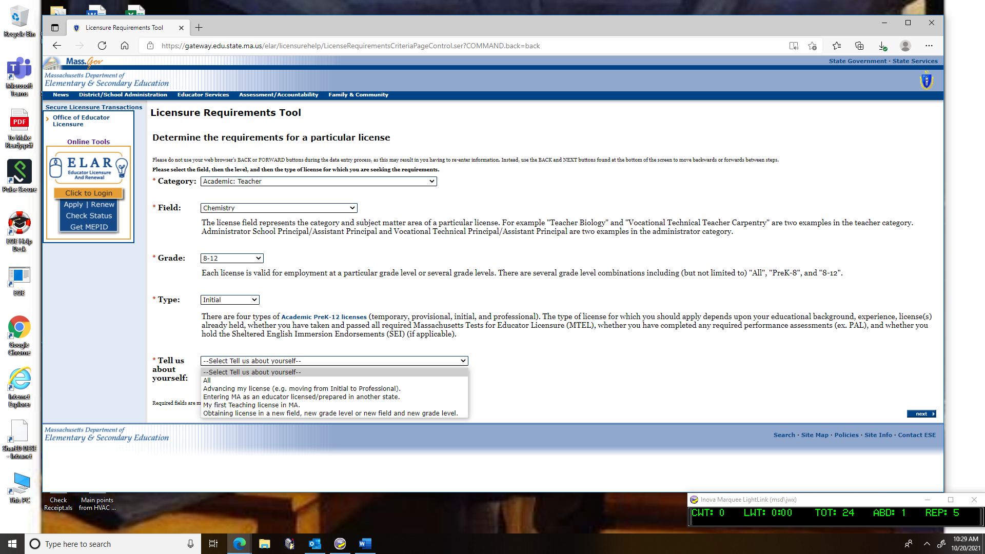

…you have the option of selecting your current licensure circumstances. The Licensure Requirements Tool includes every option and pathway available to licensure so individuals who are not well versed in the intricacies of the Licensure Process, it can be understandably confusing to sort through all of the potential pathways. Selecting the scenario that best fits your circumstance, allows the Licensure Requirements Tool to filter out some of the pathways that would not be applicable.

**All –** By selecting ALL, you will be shown the unfiltered list of all possible and potential pathways towards earning the selected license.

**Advancing My License –** Should be selected when you currently hold a Massachusetts license at one Type and are seeking to advance that license to a higher Type, (such as advancing a Provisional license to an Initial license OR an Initial License to a Professional license).

**Entering MA as an educator license/prepared in another state –** Should be selected if you have completed an Educator Preparation Licensure Program in another state or hold a comparable-level license from another state. This will show you the “Reciprocity” pathways for earning a MA license, detailing what the requirements are for educators who have completed teacher training in another state.

**My first teaching license in MA –** Should be selected if you do not currently hold any Massachusetts educator licenses or if you do not hold a comparable license issued by another state.

**Obtaining license in a New Field, new grade level or new field and new grade level –** For Teacher and Administrator licenses, once an educator has earned their first MA Initial or Professional license, they are no longer expected to earn additional licenses via the “General Requirements” pathway and can utilize the “add license” pathway. If you currently hold either an Initial or Professional license and are looking to earn an additional Initial or Professional license and are looking to earn an additional Initial or Professional license for a new field, new grade level or new field and new grade level, then you should select this circumstance and review the corresponding path.

Once you have selected the “Tell us about yourself” option and pressed the “Next” button, you will be brought to a page that lists the available pathways appropriate to the circumstance selected. Each pathway will include a list of the individual requirements to earn that license via that pathway.

For example, here is the General Requirements pathway for earning an Academic Teacher, Biology, 8-12, Initial license:

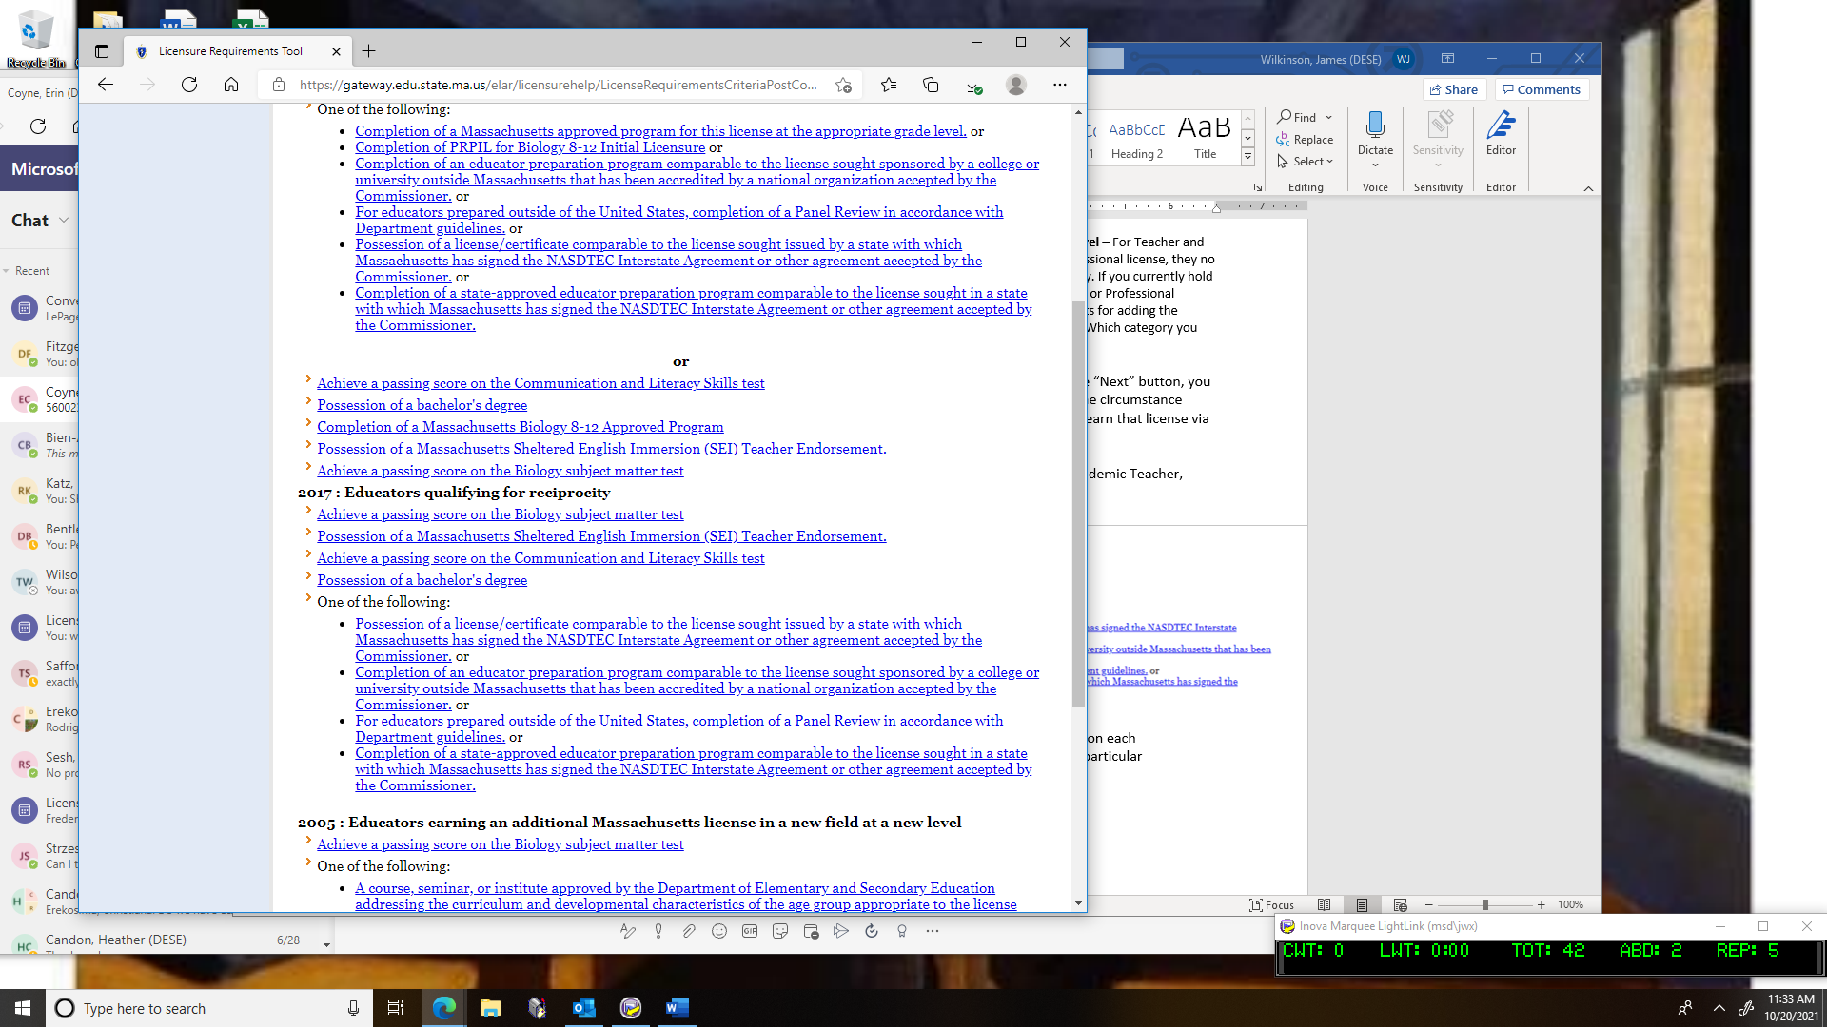

You will notice that each requirement is also a clickable hyperlink. By clicking on each requirement, you will be brought to a page that further explains what that particular requirement entails and the proper procedure for documenting its compliance.

Please note that within the License Requirements Tool, please use the “back and next” buttons that appear on the screen, utilizing the back button in your web browser will result in an error message.

# How to Review an Evaluation Correspondence

If you ever wish to refer back to a Licensure Application Evaluation, a complete record of all official licensure evaluation correspondence can be found in your ELAR account under “Correspondence History.” To access this record, log into your ELAR account and click on the “Check License Status and History” link on the welcome page.

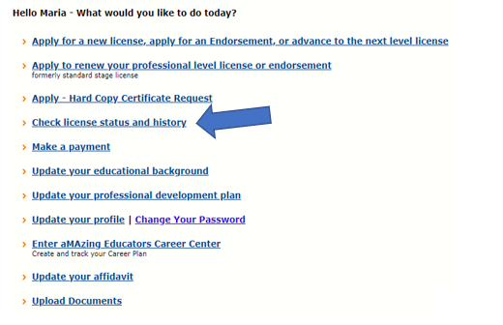

Towards the bottom of the page, you will find a blue button marked Correspondence History.

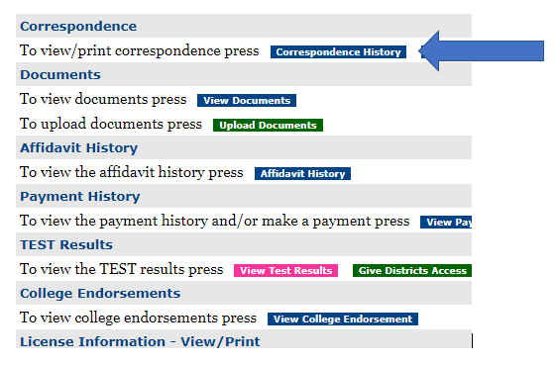

To review a particular evaluation letter, click on the ID number for the most recent Licensure Evaluation.

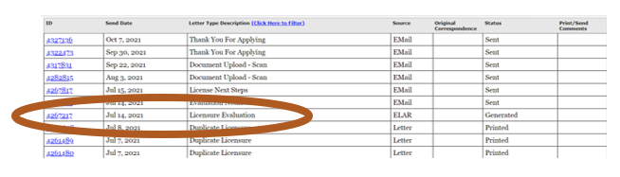

# Verifying Licensure in ELAR

Once you have documented compliance with all application requirements, your license will be issued. The approval will be recorded in your ELAR account, and a license number will be assigned to your file. Please note that no matter how many licenses you are issued throughout your teaching career, all will be found under the same original license number.

## Obtaining a Hard Copy of a License

The Licensure Office no longer automatically issue hard copies of licenses and instead relies on ELAR as the official record of all licenses issued. All Massachusetts school districts have access to ELAR and should be able to confirm your licensure with either your MEPID or license number. You may also confirm your licensure through one of the following ways:

**Option 1: Copy of License found in ELAR**

A free and printable copy of all licenses held may be accessed at any time via your ELAR account. In order to view it, log into your ELAR account and click on the “Check License Status and History” link on the welcome page.

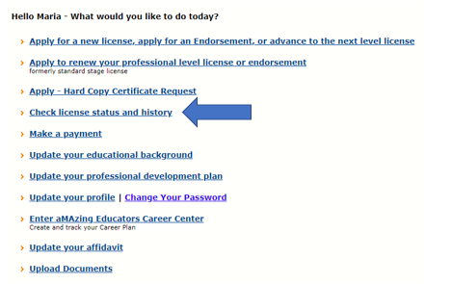

This will bring you to the Inquiry/Activity Summary Page. At the very bottom of the page, you will find a blue button that reads: License Information View/Print.

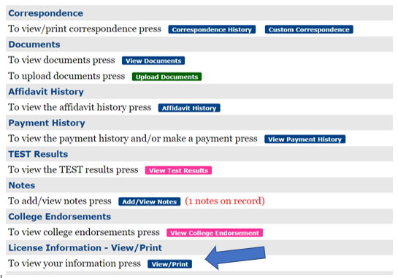

Clicking on this button will open a new window with a copy of all of your current license information. You may print a copy of this page for free. Educators should note that although this page will be listed as “Unofficial License Information” it should be accepted as official by any school district in Massachusetts as the district will have access to ELAR and can confirm licensure with the identification numbers found on this page.

**Option 2: The Public Look-up for Educator Licensure**

A Licensure Public Look-up is available on the Licensure Office’s website and may be found, here: <https://www.doe.mass.edu/licensure/lookup/>

The Public Look-up Tool may be accessed by anyone 24/7 and allows individuals to search for current Massachusetts educator license holders either by name or by license number. Individuals using the tool should be advised that that only current license information will be displayed. The Public Look-up Tool will not give a complete history of the various stages of licensure earned or open license applications that are in process for a given individual.

**Option 3: Request a Hard Copy**

Although the Licensure Office no longer automatically mails out hard copies of licenses when issued, an official hard copy is available upon request for a $25 fee. Educators should note that this official copy is optional. If a Massachusetts school district is requesting a copy of your license, they are most likely referring to the free option described in Option 1 since they can verify the copy with their ELAR access.

A step-by-step guide on how to request an official hard copy of your Educator License may be found here: <https://www.doe.mass.edu/licensure/elar/request-hard-copy-license.docx>

# Additional Information

Thank you for reviewing this orientation on how to begin the Massachusetts Educator Licensure Process. If you have any questions about the contents of this guide, or if you have questions that were not addressed in these pages, the following resources are available:

* **The Licensure Office website:** [www.doe.mass.edu/licensure](http://www.doe.mass.edu/licensure)
* **The MELS video series** explaining the licensure process may be found here: <https://www.youtube.com/c/MassachusettsOfficeofEducatorLicensure>
* **The Licensure Call Center Help Line**: 781-338-6600

Open weekdays 9am-1pm and 2pm-5pm

Call Center Agents service this Licensure Help Line and can assist you with general questions about the licensure process.

* **The Licensure Walk-in Welcome Center Service Counter**

Located on the first floor of our DESE building at 75 Pleasant Street, Malden, MA 02148

Service Counter is open weekdays 8:45am-4:45pm for assistance with general questions about the licensure process.