

**2024 Educator’s Manual for MCAS-Alt**

**Alternate Assessment Based on Alternate Achievement Standards for Students with Disabilities**

Fall 2023

**This publication is available on the**

[**Massachusetts Department of Elementary and Secondary Education**](http://www.doe.mass.edu/mcas/alt/resources.html) **website**



This document was prepared by the   
Massachusetts Department of Elementary and Secondary Education

Jeffrey C. Riley

Commissioner

The Massachusetts Department of Elementary and Secondary Education, an affirmative action employer, is committed to ensuring that all its programs and facilities are accessible to all members of the public.

We do not discriminate on the basis of age, color, disability, gender identity, national origin, race, religion, sex, or sexual orientation.

Inquiries regarding the Department’s compliance with Title IX and other civil rights laws may be directed to the Human Resources Director, 75 Pleasant Street, Malden, MA 02148 (781)-338-6105.

© 2023 Massachusetts Department of Elementary and Secondary Education

Permission is hereby granted to copy for non-commercial educational purposes

any or all parts of this document.

Please credit the “Massachusetts Department of Elementary and Secondary Education”

Massachusetts Department of Elementary and Secondary Education

75 Pleasant Street, Malden, MA 02148-4906

Phone 781-338-3000 TTY: N.E.T. Relay 800-439-2370

[www.doe.mass.edu](http://www.doe.mass.edu)

###### Overview

The *2024 Educator’s Manual for MCAS-Alt* provides guidelines and instructions for educators who are preparing alternate assessments for students with the most significant cognitive disabilities who are designated on their IEP as being unable to participate in the standard MCAS tests. Determination of participation eligibility may be found on page 8 of this manual. The knowledge and skills assessed by the MCAS-Alt are aligned with the same content assessed for other students on the MCAS tests based on the most current versions of the state’s curriculum frameworks. The *2024 Educator’s Manual for MCAS-Alt* should be used in conjunction with *The Alternate Academic Achievement Standards to the Massachusetts Curriculum Frameworks for Students with Disabilities (Resource Guide)* to identify challenging measurable outcomes for students with the most significant cognitive disabilities*.* Both publications are available on the [Department’s website](http://www.doe.mass.edu/mcas/alt/resources.html).

**Contact Information**

For further information on the MCAS-Alt, please contact:

|  |  |
| --- | --- |
| Student Assessment Services  Department of Elementary and Secondary Education  75 Pleasant Street  Malden, MA 02148-4906  Telephone: 781-338-3625  Email: [mcas@doe.mass.edu](mailto:mcas@doe.mass.edu) |  |

MCAS Service Center: 800-737-5103

**TABLE OF CONTENTS**

Overview

PART I Recommended Timeline, New and Notable, and Administrative Responsibilities1

Recommended Timeline and Important Dates1

New and Notable for the 2024 MCAS-Alt2

Rationale and Purpose of the MCAS-Alt3

Administrative Responsibilities and Security Requirements4

PART II Assessment Participation Guidelines5

Participation Requirements5

Guidelines for IEP Team Decision-Making: Which Students Should Take the MCAS-Alt? 5

Decision-Making Tool for MCAS Participation by Students with Disabilities6

PART III Required Assessments in Each Grade7

PART IV Compiling MCAS-Alt Evidence14

Content Checklist14

MCAS-Alt Skills Survey15

Selecting an Entry Point (Skill)16

Submission for Reading, Language, and Mathematics18

Guidelines to Create a Data Chart18

Primary Evidence21

Strand Specific ELA–Reading22

Mathematics23

ELA-Writing23

Science and Technology/Engineering 25

PART V Scoring and Reporting 27

Scoring the MCAS-Alt27

MCAS-Alt Rubric for Scoring Each Strand29

Calculating an Overall Achievement Level in the Content Area35

Including MCAS-Alt Results in Reporting and Accountability37

Policy on Storage and Destruction of Returned MCAS-Alt Materials38

APPENDICES

A. Examples of Completed Forms for the MCAS-Alt40

B. Blank Forms for the MCAS-Alt45

C/D. Why It’s Important to Include Students with Disabilities and Frequently Asked Questions66

# Introduction

## Recommended Timeline and Important Dates for 2023–2024

**Summer 2023**

* Educators may begin collecting evidence on July 1, 2023, for students taking the 2024 MCAS-Alt.

**Fall 2023**

* Identify students who are eligible to participate in MCAS-Alt
* Register [for Forms and Graphs Online, the Department’s web-based secure MCAS-Alt application](https://profile.measuredprogress.org/MCAS-Alt/login.aspx). For technical assistance using Forms and Graphs Online, call (866) 834-8880.
* Complete the MCAS-Alt Skills Survey required for assessment determined by student grade.
* Obtain signed *Consent Form*(s) *to Photograph or Video Student*,as needed, and keep on file at school.
* Consult the Department’s [website](http://www.doe.mass.edu/mcas/alt/resources.html) for information on MCAS-Alt training sessions for teachers and administrators.
  + Identify prospective entry points for each student and develop appropriate measurable outcomes based on current versions of *The Alternate Academic Achievement Standards* to *the Massachusetts Curriculum Frameworks for Students with Disabilities (Resource Guide)* and the results of the MCAS-Alt Skills Survey.
  + Plan instruction in collaboration with general educators, as needed.
* Begin collecting work samples and data on student performance noting accuracy and independence.

Stay apprised of current information by reading the [MCAS-Alt Newsletter](http://www.mcas-alt.org/news/register.htm) (including tips and strategies, training information, logistics, and resources), which is emailed to educators and posted on the DESE site.

**Winter/Spring 2024**

**January/February**

* + **January 2−12**: Principals order MCAS-Alt materials on the Cognia [website](http://www.mcasservicecenter.com/).
  + Consult the Department’s [website](http://www.doe.mass.edu/mcas/alt/resources.html) for registration information for MCAS-Alt review sessions.
  + Open MCAS-Alt materials shipment to schools and review instructions.

**March**

* + Finish collecting, organizing, labeling, and selecting student evidence.
  + Complete required forms, including Student Information Booklet (SIB).
* Label all materials (photographs, videos, etc.).
* Invite parents to view the final assessment(s) and sign the Verification Form *or* document attempts made.
* Review the binder for completeness.
* Remind the building administrator to schedule a pickup of completed binders through MCAS Service Center by **2:30 p.m., Wednesday, March 27**. The administrator verifies assessments are complete, accurate and authentic (PCPA).
* Ensure pickup of all MCAS-Alt materials from school by UPS no later than **Thursday, March 28**. (Do not transport boxes to UPS.)

**June**

– Preliminary results are reported electronically to schools and districts in mid-June.

* File MCAS-Alt Score Appeals, if warranted, by 5:00 p.m. on **Friday, June 21**.

**July**

* Results of MCAS-Alt Score Appeals mailed to principals end of July.

## New for the 2024 MCAS-Alt

The US Department of Education requires that each state define which students having the most significant cognitive disabilities and therefore which students are *eligible to participate* in the alternate assessments**.**

DESEhas adopted the following definition to determine eligibility for participation in the alternate assessment. Students must meet **all** four of the following criteria:

1. have cognitive disabilities evidenced by significant delays in attaining age-level academic achievement standards, even with systematic, extensive individually designed instruction, related services, and modifications
2. have cognitive disabilities that significantly impact their educational performance and ability to apply learning from one setting to another
3. require extensive, direct individualized instruction and substantial support to achieve measurable gains on the challenging State academic content standards for the grade in which the student is enrolled
4. perform significantly below average in general cognitive functioning and adaptive behavior. This is defined as a student functioning two or more standard deviations below the mean on commonly accepted norm-referenced assessments in both cognitive functioning and adaptive behavior *(e.g., two or more adaptive skill areas such as daily living skills, communication, self-care, social skills, and academic skills).*

**Participation in MCAS-Alt**

If the student is determined eligible for the alternate assessment, **all** content areas must be assessed.

A companion form will be completed and submitted to DESE when a student is found eligible to participate in the MCAS-Alt. (Available at [MCAS-Alt](https://www.doe.mass.edu/mcas/alt/essa/))

**MCAS-Alt Spring Submission date:** Assessments must be completed and prepared for submission in time for pick-up from schools no later than **Thursday, March 28, 2024**.All assessments must be submitted on or before this date—no extensions will be granted. Assessments may not be amended, nor materials added, after March 28, 2024.

School administrators must order materials online between **January 2–12, 2024**, and will be sent to each school in late February 2024.

**Educator Materials** for 2024 MCAS-Alt are in a new location. [Completeness Questions](https://profile.measuredprogress.org/MCAS-Alt/login.aspx) and other resources have been added to the login page on the *Online Forms and Graphs* program for the MCAS-Alt. An account is not necessary to utilize the materials site.

**High School** **Science and Technology/Engineering (STE) Chemistry and Technology/Engineering** are no longer assessed for MCAS or MCAS-Alt.

**Fall 2023 *Alternate Academic Achievement Standards to the Massachusetts Curriculum Frameworks for Students with Disabilities* (“Resource Guide”)** has the same format, but the entry points, access skills, and other elements have been updated.

## Notable for the 2024 MCAS-Alt

**MCAS-Alt Skills Survey**

Submission of a completed skills survey is required for each assessed strand. The omission of a completed skills survey will result in a score of *Incomplete*. See pages 19-20 in this manual for details on the skills survey.

###### Data and Evidence Collection

All data points, evidence, and the MCAS-Alt Skills Survey must be completed and compiled during the **current school year** (i.e., between July 1, 2023, and March 28, 2024) for the 2024 MCAS-Alt. Science and Technology/Engineering (STE) may include evidence collected during **two consecutive school years** (i.e., the current and prior school years, between July 1, 2022, and March 28, 2024).

###### ****Sheet Protectors and Staples****

**We continue to request that teachers *not* use sheet protectors or staples with assessment evidence. Instead, we encourage the use of dividers (tabs) between each strand to improve the organization of materials and the efficiency of the scoring process.**

###### ****Forms and Graphs Online****

Use the [Forms and Graphs Online](http://www.doe.mass.edu/mcas/alt/resources.html) application to complete all **required forms, data charts, and work sample description labels** for students’ alternate assessments.

###### MCAS-Alt Score Appeals

A teacher or administrator who believes a discrepancy exists between the assessment evidence and its preliminary score may request an MCAS-Alt Score Appeal **if a** **photocopy of the original binder was retained by the school**. Once a score appeal is received by the Department on or before the deadline for its submission, the strand in question will be reviewed and, if needed, rescored. Score appeals must be submitted by 5:00 p.m., June 21, 2024. Appeals findings are returned to schools by mail in late July. Information on submitting score appeals is available [here](http://www.doe.mass.edu/mcas/alt/results.html).

## Rationale and Purpose of the MCAS-Alt

The MCAS-Alt, when done correctly, provides educators, parents, and the state with information on:

* Academic performance and progress.
* Data for the IEP team to identify challenging academic goals.
* Visibility in the school community.
* Creating consistency among staff.
* Identifying resources for special education classrooms.
* Students' abilities, not disabilities
* Identifying best practices for integrating assessment and instruction.
* How to increase inclusion opportunities.

## MCAS-Alt Administrative and Security Requirements

Principals are responsible for ensuring that all educators administering the MCAS-Alt, including other administrators and staff within the school and district, comply with the requirements and instructions detailed in this manual. Staff members who violate the test security requirements are subject to the sanctions and penalties outlined in this section. The purpose of the MCAS-Alt security requirements is to protect the validity of the statewide results and maintain the integrity of individual assessments and provide every student with the opportunity to show growth.

###### Educators’ Responsibilities for Conducting the MCAS-Alt

Educators who conduct the MCAS-Alt are responsible for ensuring that information is complete and accurate for each student participating in the MCAS-Alt. The educator is also responsible for ensuring that student work samples and other evidence are neither duplicated, altered, nor fabricated in a way that provides information that is false or portrays the student’s performance inaccurately. Evidence for each student, *regardless* of the similarity of classroom instruction or participation in similar classroom activities, must reflect the individual student’s authentic abilities and performance. The student’s teacher is responsible for the timely submission of student assessments with all required forms and information to their principal for review and sign-off on the *Principal’s Certification of Proper MCAS-Alt Administration* (PCPA) before the submission of binders to the Department.

Intentional disregard for MCAS testing and security protocols may constitute misconduct or other good cause for which an educator may face license discipline under Department regulations. If misconduct by a licensed educator is found, the Commissioner, as the Massachusetts educator licensing authority, may further investigate possible license consequences.

Penalties for testing irregularities and/or misconduct may include the following:

* delay in reporting the district, school, and/or student results.
* invalidation or nullification of the district, school, and/or student results.
* removal of school personnel from any future role in MCAS and/or MCAS-Alt administrations.
* possible employment and/or licensure sanctions for licensed educators.

###### Reporting MCAS-Alt Irregularities

Educators or administrators who become aware of any irregularities in preparing or submitting MCAS-Alts must contact the Department at 781-338-3625 to report the issue. The Department may then request that the school or district investigate the matter and submit a written investigative report. The Department may also perform its own independent investigation.

Once the Department has determined whether an irregularity has taken place, the Department will notify the school and district of any consequences that follow from this determination. This may include invalidation of student assessment, licensure sanctions, or other limitations for licensed educators. Consequences imposed by the Department do not limit a local district’s authority to impose its own sanctions up to and including termination.

# Participation Guidelines

## Statewide Assessment Participation Requirements

All students must participate in MCAS testing for their grade level. It is not a question of **whether** students with disabilities participate but **how** they will participate.

*All* students who are educated with Massachusetts public funds, including students with disabilities, English learners, and English learners with disabilities, are required by state and federal laws to participate in statewide assessments. A student participates in the alternate assessment in all grades and subjects for which the standard MCAS tests are required. The student’s grade is determined by information found in the Student Information Management System (SIMS) sent to DESE.

## Decision-Making Guide for Participation in MCAS for Students with Disabilities

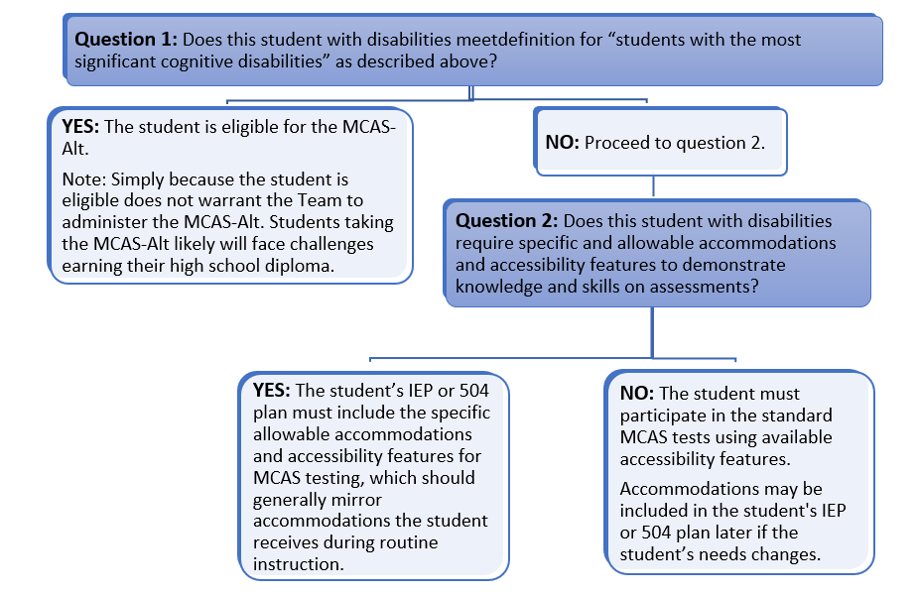

## ****Requirements of the Every Student Succeeds Act (ESSA) Regarding MCAS-Alt Participation****

The ESSA Act has made significant changes regarding student participation rates in the alternate assessment.

* The number of students who may take the alternate assessment is limited to no more than 1.0% of the total number of all students in the State who are assessed in any of the given subjects.
* ESSA further requires that a school district exceeding the 1% cap in any subject area must submit a justification to the DESE, and the DESE must provide appropriate guidance to those districts. Previously, there was no cap on participation rates until 2017.

**Resources are** [available](http://www.doe.mass.edu/mcas/alt/essa/) **in response to the requirements outlined in ESSA, a training PowerPoint for IEP teams, and a sample parent notification letter required for all parents whose child is eligible to participate in the alternate assessment.**

See the New for the MCAS-Alt for DESE’s definition of students with the most significant cognitive disabilities.

**IEP teams should not designate a student for an alternate assessment solely because the student**

* is frequently absent from school
* has not received instruction in the general curriculum
* has a particular disability (e.g., all students with intellectual disabilities should not automatically be designated for the MCAS-Alt)
* is placed in a program or classroom where it is expected that students will take the MCAS-Alt
* has taken an alternate assessment in the past (since this is an annual decision)
* has previously failed the MCAS test
* is an English learner
* is from a low-income family or is a child in foster care
* requires assistive technology or an augmentative communication system that has not been provided

# Required Assessments in Each Grade

## Required MCAS-Alt Assessments in Each Grade

The information in Table 1 below and on the following pages outlines the assessment requirements in each grade for students participating in the 2024 MCAS-Alt. The [Fall 2023 Resource Guides](http://www.doe.mass.edu/mcas/alt/resources.html) are based on the current editions of the Massachusetts Curriculum Frameworks and must be used as the basis for developing measurable outcomes that will be assessed on the 2024 MCAS-Alt.

**Blank forms** and **samples** can be found in the appendices of this document. **Forms and Graphs** a web-based application is needed to digitally create all necessary documentation of the assessment.

**Note:** The [MCAS-Alt Skills Survey](http://www.doe.mass.edu/mcas/alt/skills-survey.docx) must be completed for each strand submitted.

**Grade 3 Table 1. Requirements for Grade 3**

|  |  |
| --- | --- |
| **ELA** | **Required Evidence** |
| Language  (based on standards in the “Vocabulary Acquisition and Use” cluster) | * One data chart measuring the student’s achievement of the measurable outcome on at least eight different dates, based on **one** standard in the “Vocabulary Acquisition and Use” cluster of the ELA−Language strand * Two additional pieces of primary evidence, plus work description forms, showing the student’s achievement of the measurable outcome identified on the data chart |
| Reading:   * Literature   *or*   * Informational Text | * One data chart measuring the student’s achievement of the measurable outcome on at least eight different dates, based on one text type: **either** the Literature **or** Informational ELA−Reading strand * Two additional pieces of primary evidence, plus work description forms, showing the student’s achievement of the measurable outcome identified on the data chart   **Note:** The title of the text must be included; see page 26 for more details. |
| Writing (based on standards in the “Text Type and Purposes” cluster) | * Three **different** final writing samples in any text type * One baseline writing sample in any text type * Work description labels for each writing sample * Three pre-scored writing rubrics, one for each final writing sample |
| **Mathematics** | **Required Evidence** |
| Operations and Algebraic Thinking (OA) | * One data chart measuring the student’s achievement of the measurable outcome, on at least eight different dates, based on one entry point or access skill in the Operations and Algebraic Thinking domain * Two additional pieces of primary evidence, plus work description forms, showing the student’s achievement of the measurable outcome identified on the data chart |
| Measurement and Data (MD) | * One data chart measuring the student’s achievement of the measurable outcome on at least eight different dates, based on one entry point or access skill in the Measurement and Data domain * Two additional pieces of primary evidence, plus work description forms, showing the student’s achievement of the measurable outcome identified on the data chart |

**Grade 4 Table 2. Requirements for Grade 4**

|  |  |
| --- | --- |
| **ELA** | **Required Evidence** |
| Language  (based on standards in the “Vocabulary Acquisition and Use” cluster) | * One data chart measuring the student’s achievement of the measurable outcome on at least eight different dates, based on **one** standard in the “Vocabulary Acquisition and Use” cluster of the ELA−Language strand * Two additional pieces of primary evidence, plus work description forms, showing the student’s achievement of the measurable outcome identified on the data chart |
| Reading:   * Literature,   *or*   * Informational Text | * One data chart measuring the student’s achievement of the measurable outcome on at least eight different dates, based on one text type: **either** the Literature **or** Informational ELA−Reading strand * Two additional pieces of primary evidence, plus work description forms, showing the student’s achievement of the measurable outcome identified on the data chart   **Note:** The **title of the text** must be included; see page 26 for more details. |
| Writing  (based on standards from the “Text Type and Purposes” cluster) | * Three **different** final writing samples in any text type * One baseline writing sample in any text type * Work description labels for each writing sample * Three pre-scored writing rubrics, one for each final writing sample |
| **Mathematics** | **Required Evidence** |
| Operations and Algebraic Thinking  (OA) | * One data chart measuring the student’s achievement of the measurable outcome on at least eight different dates, based on one entry point or access skill in the Operations and Algebraic Thinking domain * Two additional pieces of primary evidence, plus work description forms, showing the student’s achievement of the measurable outcome identified on the data chart |
| Number and Operations−  Fractions  (NF) | * One data chart measuring the student’s achievement of the measurable outcome on at least eight different dates, based on one entry point or access skill in the Number and Operations−Fractions domain * Two additional pieces of primary evidence, plus work description forms, showing the student’s achievement of the measurable outcome identified on the data chart |

**Grade 5 Table 3. Requirements for Grade 5**

|  |  |
| --- | --- |
| **ELA** | **Required Evidence** |
| Language  (based on standards in the “Vocabulary Acquisition and Use” cluster) | * One data chart measuring the student’s achievement of the measurable outcome on at least eight different dates, based on **one** standard in the “Vocabulary Acquisition and Use” cluster of the ELA−Language strand * Two additional pieces of primary evidence, plus work description forms, showing the student’s achievement of the measurable outcome identified on the data chart |
| Reading:   * Literature   or   * Informational Text | * One data chart measuring the student’s achievement of the measurable outcome on at least eight different dates, based on one text type: either the Literature or Informational ELA−Reading strand * Two additional pieces of primary evidence, plus work description forms, showing the student’s achievement of the measurable outcome identified on the data chart   **Note:** The **title of the text** must be included; see page 26 for more details. |
| Writing  (based on standards from the “Text Type and Purposes” cluster) | * Three **different** final writing samples in any text type * One baseline writing sample in any text type * Work description labels for each writing sample * Three pre-scored writing rubrics, one for each final writing sample |
| **Mathematics** | **Required Evidence** |
| Number and Operations in Base Ten (NBT) | * One data chart measuring the student’s achievement of the measurable outcome, on at least eight different dates, based on one entry point or access skill in the Number and Operations in Base Ten domain * Two additional pieces of primary evidence, plus work description forms, showing the student’s achievement of the measurable outcome identified on the data chart |
| Number and Operations−  Fractions (NF) | * One data chart measuring the student’s achievement of the measurable outcome, on at least eight different dates, based on one entry point or access skill in the Number and Operations−Fractions domain * Two additional pieces of primary evidence, plus work description forms, showing the student’s achievement of the measurable outcome identified on the data chart |
| **Science and Technology/**  **Engineering (STE)** | **Required Evidence**  Evidence may be compiled over two consecutive school years in this subject.  (Dated 7/1/22to 3/28/24) |
| STE disciplines:   * Life Science * Earth and Space Sciences * Physical Science * Technology/ Engineering | Choose three STE disciplines. For **each discipline**, select **one core idea**:  For ***each*** Core Idea:   * Choose three pieces of primary evidence (work samples) based on an entry point or access skill and attach each piece to its corresponding STE Summary Sheet. * Each piece of primary evidence must address a different science practice. |

**Grade 6 Table 4. Requirements for Grade 6**

|  |  |
| --- | --- |
| **ELA** | **Required Evidence** |
| Language  (based on standards from the “Vocabulary Acquisition and Use” cluster) | * One data chart measuring the student’s achievement of the measurable outcome on at least eight different dates, based on **one** standard in the “Vocabulary Acquisition and Use” cluster of the ELA−Language strand * Two additional pieces of primary evidence, plus work description forms, showing the student’s achievement of the measurable outcome identified on the data chart |
| Reading: (only one)   * + Literature,   + Informational Text,   + Literacy in Science and Technical Subjects, *or*   + Literacy in History/Social Studies | * One data chart measuring the student’s achievement of the measurable outcome on at least eight different dates, based on one text type: **either** the Literature **or** Informational ELA−Reading strand * Two additional pieces of primary evidence, plus work description forms, showing the student’s achievement of the measurable outcome identified on the data chart   **Note:** The **title of the text** must be included; see page 26 for more details. |
| Writing  (based on standards from the “Text Type and Purposes” cluster) | * Three **different** final writing samples in *any* text type * One baseline writing sample in any text type * Work description labels for each writing sample * Three pre-scored writing rubrics, one for each final writing sample |
| **Mathematics** | **Required Evidence** |
| Statistics and Probability (SP) | * One data chart measuring the student’s achievement of the measurable outcome on at least eight different dates, based on one entry point or access skill in the Statistics and Probability domain * Two additional pieces of primary evidence, plus work description forms, showing the student’s achievement of the measurable outcome identified on the data chart |
| The Number System (NS) | * One data chart measuring the student’s achievement of the measurable outcome on at least eight different dates, based on one entry point or access skill in The Number System domain * Two additional pieces of primary evidence, plus work description forms, showing the student’s achievement of the measurable outcome identified on the data chart |

**Grade 7 Table 5. Requirements for Grade 7**

|  |  |
| --- | --- |
| **ELA** | **Required Evidence** |
| Language  (based on standards from the “Vocabulary Acquisition and Use” cluster) | * One data chart measuring the student’s achievement of the measurable outcome on at least eight different dates, based on **one** standard in the “Vocabulary Acquisition and Use” cluster of the ELA−Language strand * Two additional pieces of primary evidence, plus work description forms, showing the student’s achievement of the measurable outcome identified on the data chart |
| Reading: (only one)   * + Literature,   + Informational Text,   + Literacy in Science and Technical Subjects, *or*   + Literacy in History/Social Studies | * One data chart measuring the student’s achievement of the measurable outcome on at least eight different dates, based on one text type: **either** the Literature, Informational, or Literacy strand * Two additional pieces of primary evidence, plus work description forms, showing the student’s achievement of the measurable outcome identified on the data chart   **Note:** The **title of the text** must be included; see page 26 for more details. |
| Writing  (based on standards from the “Text Type and Purposes” cluster) | * Three **different** final writing samples in any text type * One baseline writing sample in any text type * Work description labels for each writing sample * Three pre-scored writing rubrics, one for each final writing sample |
| **Mathematics** | **Required Evidence** |
| Ratios and Proportional Relationships  (RP) | * One data chart measuring the student’s achievement of the measurable outcome, on at least eight different dates, based on one entry point or access skill in the Ratios and Proportional Relationships domain * Two additional pieces of primary evidence, plus work description forms, showing the student’s achievement of the measurable outcome identified on the data chart |
| Geometry (G) | * One data chart measuring the student’s achievement of the measurable outcome, on at least eight different dates, based on one entry point or access skill in the geometry domain * Two additional pieces of primary evidence, plus work description forms, showing the student’s achievement of the measurable outcome identified on the data chart |

**Grade 8 Table 6. Requirements for Grade 8**

|  |  |
| --- | --- |
| **ELA** | **Required Evidence** |
| Language  (based on standards from the “Vocabulary Acquisition and Use” cluster) | * One data chart measuring the student’s achievement of the measurable outcome on at least eight different dates, based on **one** standard in the “Vocabulary Acquisition and Use” cluster of the ELA−Language strand * Two additional pieces of primary evidence, plus work description forms, showing the student’s achievement of the measurable outcome identified on the data chart |
| Reading: (only one)   * + Literature,   + Informational Text,   + Literacy in Science and Technical Subjects, *or*   + Literacy in History/Social Studies | * One data chart measuring the student’s achievement of the measurable outcome on at least eight different dates, based on one text type: **either** the Literature, Informational, or Literacy ELA−Reading strand * Two additional pieces of primary evidence, plus work description forms, showing the student’s achievement of the measurable outcome identified on the data chart   **Note:** The **title of the text** must be included; see page 26 for more details. |
| Writing  (based on standards from the “Text Type and Purposes” cluster) | * Three **different** final writing samples in any text type * One baseline writing sample in any text type * Work description labels for each writing sample * Three pre-scored writing rubrics, one for each final writing sample |
| **Mathematics** | **Required Evidence** |
| Expressions and Equations (EE) | * One data chart measuring the student’s achievement of the measurable outcome, on at least eight different dates, based on one entry point or access skill in the Expressions and Equations domain * Two additional pieces of primary evidence, plus work description forms, showing the student’s achievement of the measurable outcome identified on the data chart |
| Geometry (G) | * One data chart measuring the student’s achievement of the measurable outcome, on at least eight different dates, based on one entry point or access skill in the geometry domain * Two additional pieces of primary evidence, plus work description forms, showing the student’s achievement of the measurable outcome identified on the data chart |
| **Science and Technology/**  **Engineering** | **Required Evidence**  Evidence may be compiled over two consecutive school years in this subject  (Dated 7/1/22 to 3/28/24) |
| STE disciplines:   * Life Science * Earth and Space Sciences * Physical Science * Technology/ Engineering | Choose three STE disciplines. For **each discipline**, select **one core idea**:  For ***each*** Core Idea:   * Choose three pieces of primary evidence (work samples) based on an entry point or access skill and attach each piece to its corresponding STE Summary Sheet. * Each piece of primary evidence must address a different science practice. |

**Grade 10 Table 7. High School Grade 10 Requirements**

|  |  |
| --- | --- |
| **ELA** | **Required Evidence** |
| Language  (based on standards from the “Vocabulary Acquisition and Use” cluster) | * One data chart measuring the student’s achievement of the measurable outcome on at least eight different dates, based on **one** standard in the “Vocabulary Acquisition and Use” cluster of the ELA−Language strand; plus * Two additional pieces of primary evidence, plus work description forms, showing the student’s achievement of the measurable outcome identified on the data chart |
| Reading: (only one)   * + Literature,   + Informational Text,   + Literacy in Science and Technical Subjects, *or*   + Literacy in History/Social Studies | * One data chart measuring the student’s achievement of the measurable outcome on at least eight different dates, based on one text type: **either** the Literature, Informational, or Literacy ELA−Reading strand * Two additional pieces of primary evidence, plus work description forms, showing the student’s achievement of the measurable outcome identified on the data chart   **Note:** The **title of the text** must be included; see page 26 for more details. |
| Writing  (based on standards from the “Text Type and Purposes” cluster) | * Three **different** final writing samples in any text type * One baseline writing sample in any text type * Work description labels for each writing sample * Three pre-scored writing rubrics, one for each final writing sample |
| **Mathematics** | **Required Evidence** |
| Any **three** of five conceptual categories inHigh SchoolMathematics (see Fall 2022 Resource Guide)   * Number and Quantity * Algebra * Functions * Geometry * Statistics and Probability | Select three different conceptual categories. For each conceptual category, submit:   * One data chart measuring the student’s achievement of the measurable outcome on at least eight different dates, based on onestandard in the selectedMathematicsconceptual category * Two additional pieces of primary evidence, plus work description forms, showing the student’s achievement of the measurable outcome identified on the data chart   Measurable outcomesmay bebased on entry points selected either from high school or from lower grade levels in related domains, according to Figure 5. |
| **Science and Technology/**  **Engineering** | **Required Evidence**  Evidence may be compiled over two consecutive school years in this subject  (Dated 7/1/22 to 3/28/24) | |
| Grade 9 or 10 may  Choose *either*:   * Biology * Introductory Physics | Select **one STE discipline**:  If selecting either ***Biology*** OR***Introductory Physics***, use the STE Resource Guide and select **three core ideas** in the selected discipline**.**  For ***each*** core idea:   * Choose three pieces of primary evidence (work samples) and attach each piece to its corresponding STE Summary Sheet. * Each piece of primary evidence must address a different science practice. | |

# Compiling MCAS-Alt Evidence

### Content Checklist for Required Forms

This checklist will assist in submitting a complete assessment along with the [*Checking for Completeness Questions*](https://profile.measuredprogress.org/MCAS-Alt/login.aspx) document. The required forms listed below (unless noted otherwise), may be found in the [Forms and Graphs](https://profile.measuredprogress.org/MCAS-Alt/login.aspx) Online application. All requirements for each strand are listed in this manual. **Blank Forms are available in the appendices.**

* **Artistic cover** (recommended) designed and produced by the student, inserted in the front window of the three-ring binder.
* **MCAS-Alt Cover Sheet** containing important demographic information about the student, inserted as the first page of the binder.
* **Student’s Introduction** **to the Assessment** produced by the student using his or her primary mode of communication describing “what I want others to know about me as a learner and about my work.”
* **Consent Form to Photograph and/or Video a student**,kept *on file* at the student’s school, if images or recordings of the student are included in the assessment. This consent form gives permission *only* for the student to be recorded digitally in photographs or video for the MCAS-Alt and is **not** a consent form for the student to participate in an alternate assessment. Please do not substitute a “blanket” consent form for this purpose. Consent forms are available in English and Spanish.
* **School calendar** placed in the left inside pocket of the binder.
* **MCAS-Alt Skills Survey** completed for each strand/domain/discipline submitted. Place a completed print version of the survey just after the *Strand Cover Sheet* in each strand.
* **Strand Cover Sheet** placed at the beginning of each strand submitted. Each strand includes a set of evidence that addresses a specific measurable outcome.
* **Data Chart** choice of one bar, line, or field data chart for ELA-Language, Reading, and Math
* **Work Sample Descriptions** attached to each piece of primary evidence for ELA–Language, Reading, and Math.If work description labels are not used, all required information must be written directly on each piece of evidence.
* **ELA–Writing Work Description** labels for 1 Baseline and 3 Finals, 3 State provided Writing rubrics attached to each final writing sample.
* **Science Technology/Engineering Summary Sheet** for each piece of evidence.
* **Verification Form** signed by the parent(s), guardian, or primary care provider signifying that they have reviewed their child’s assessment, or at a minimum, were invited to do so. In the event no signature was obtained, the school must include a record of attempts to invite the parent(s), guardian, or primary care provider to view the assessment. Forms are available in English and Spanish.

## MCAS-Alt Skills Survey

The MCAS-Alt Skills Survey should be completed using the [Forms and Graphs Online](https://profile.measuredprogress.org/MCAS-Alt/login.aspx) application. It is a standardized component of the MCAS-Alt that **must be completed by the teacher for each student BEFORE selecting an entry point or access skill in the subject required for assessment.** The survey will help determine a student’s current level of knowledge, skills, and abilities so that challenging entry points or access skills can be selected in each strand. The survey will also familiarize teachers with the range of entry points in a strand/domain that may be selected for the assessment. Although the skills survey is not required as a follow-up after teaching the skill, it may be helpful to conduct the survey after the skill has been taught to note the student’s progress.

The survey lists the important skills in each strand/domain/conceptual category/discipline from least to more complex. To complete the skills survey, teachers may use the sample tasks provided on the survey, design their own simple tasks, and use classroom observations, class assignments, progress reports, or locally administered assessments to determine the degree to which the student can perform each skill listed in the survey.

**Submission of a completed skills survey is required for each strand being assessed.**

**Note:** The **Science and Technology/Engineering** Skills Survey must be conducted **once** for the entire STE content area, **not** for each discipline, and must include **all** eight science practices.

**Strands that do not include a completed skills survey** will receive a score of *Incomplete.*  Instructions for administering the skills survey and applying the results are available [here](http://www.doe.mass.edu/mcas/alt/skills-survey.docx). A sample skills survey from the ELA−Reading strand is shown in Figure 1.

**Figure 1. 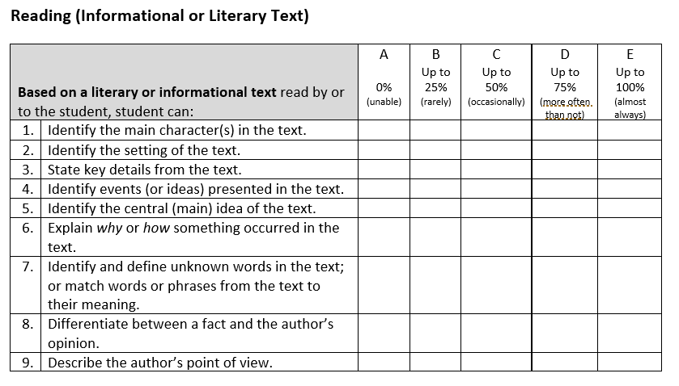Excerpt from the MCAS-Alt Skills Survey in ELA–Reading (for all grades)**

Once the skills survey has been completed for each student in the required strands/domains/conceptual categories, teachers should review the results and select an entry point from the Resource Guide based on a skill (or a related skill) that has been checked in columns A, B, or C (i.e., that the student cannot yet perform independently most of the time).

If columns D and/or E are checked for most of the skills in the strand/domain, then the IEP team should consider whether the standard MCAS test (paper or online) or grade-level/competency portfolio would be more appropriate for the student**.**

If the student is unable to perform any of the skills in the survey due to their disability (i.e., column A above), then the student could be *considered* for access skills, rather than entry points.

###### How to Create a Strand for ELA-Language, Reading and Mathematics

1. **Review the section on Required Assessments in Each Grade (see pages 10-18) to determine the strands and subjects required for assessment in the student’s grade.**
2. **Administer the MCAS-Alt Skills Survey (see Section C below) for each student in the required strands/domains/conceptual categories/disciplines.**
3. **Refer to the**[**Fall 2023 Resource Guide**](http://www.doe.mass.edu/mcas/alt/resources.html) **in the content area being assessed and select a learning standard in the student’s grade for the strand/domain/conceptual category required for assessment in the student’s grade.**
4. Determine the appropriate **level of complexity** for the student based on the results of the MCAS-Alt Skills Survey and s**elect a specific entry point or access skill from the Resource Guide** (see Figure 2) **that is challenging for the student.**
   * *Entry point:* grade-level academic content addressed at a lower level of complexity.

Teachers can select an entry point in the student’s grade or reduce the complexity by selecting an entry point from an earlier grade in the same topic or cluster.

* + *Access skill:* address earliest developmental milestones within the context of an academic activity; for example, grasping or releasing objects during a science activity.

1. Develop a **measurable outcome** based on the entry point or access skill (see page 22)
2. Begin assessing the student on the acquisition of the skill. Collect evidence, including work samples and performance information for a data chart (see **Guidelines to Create a Data Chart** on page 23). Document the percentage of accuracy and independence for each date on which the skill is assessed.

## Selecting an Entry Point (Skill) for MCAS-Alt

The Resource Guide is organized into **strands (ELA), domains/conceptual categories (mathematics), or disciplines (STE)** for each grade or grade span in STE.

**Standards** in each grade are grouped into **clusters or core ideas** of related standards within each strand/domain, conceptual category, or discipline. Following the standards are **entry points** in each grade or grade span thatdescribe outcomes at successively lower levels of complexity, see Excerpt from the Resource Guide below.

**Access skills** are available in the lowest grade or grade span listed for each strand, domain, conceptual category, or discipline except for STE separate section designated.

Review the entry points based on the level determined in the completed MCAS-Alt Skills Survey. It is acceptable to select entry points from an **earlier grade level**. However, educators are encouraged to address the most challenging and appropriate entry point tomeet the needs of the student.

**Figure 2. Excerpt from the Resource Guide in ELA–Language**

Excerpt from ELA-Language Resource Guide showing entry points and
access skills in Language Acquisition and Use in Pre-K - grade 1.

**Teachers may select entry points for assessment either**

* **as written in the Fall 2023 Resource Guide** in the subject being assessed**,** without making any changes.
* **with *minor* modifications**, **for Reading, Language, and Math only,** provided the essential meaning and intent of the entry point is maintained. For example, for the entry point “*Solve word problems involving the addition of fractions using manipulatives*”*,* the words “*using manipulatives*” may be removed, since manipulatives are not the only way to perform the skill. However, “*addition of fractions*” must be included.
  + **When two or more related skills in an entry point are connected by “and,” the teacher may select both skills for assessment; *or* isolate a single skill within the entry point.**
  + **For example, if the entry point says, *“solve single-digit addition and subtraction problems”***
    - **If *both* skills are selected, both skills must be assessed during *each* activity and documented in the brief description for each activity and in the evidence.**
    - **If only *one* of those skills is selected, the measurable outcome must be edited to reflect *only* the selected skill and *only* that skill will be documented in the brief description for each activity and in the evidence.**
  + **Entry points containing “and” may *not* be changed to “or,” since this is considered excessively modifying the entry point and will result in a score of *Incomplete*.**
  + **If more than one skill is listed in an entry point connected by “or” (e.g., “*Identify the meaning of words, phrases, or sentences*”), then *any or all* skills may be assessed on each date.**

Entry points as they appear in the Resource Guide may not be **excessively modified** by the teacher unless approval was previously obtained in writing from the Department prior to the submission date. Overly modified entry points will result in a score of *Incomplete*. If in doubt as to whether a modification of an entry point is acceptable, please contact the Department at [mcas@doe.mass.edu](mailto:mcas@doe.mass.edu).

###### Developing and Assessing a Measurable Outcome for ELA-Language, Reading, and Math

**For entry and access skills:**

* Using the MCAS-Alt Skills Survey as a guide, select either an entry point or access skill from the Resource Guide that is challenging and appropriate for the student (i.e., from columns A, B, or C in Figure 1).
* Select the desired percent of accuracy and independence that would constitute reasonable mastery of the skill. These criteria are selected by the teacher for instructional purposes *only* and need not be attained before the MCAS-Alt is submitted.

**Entry points:**

* Review the examples below to see how the entry points (bolded) have been transformed into measurable outcomes by adding the student’s name and percent accuracy and independence:
* Example 1: Pasquale will**record measurement data for multiple objects using a single unit scale** *with 75 percent accuracy and 90 percent independence.*
* Example 2: Naila will**identify angles of geometric shapes as either obtuse, acute, or right** *with 80 percent accuracy and 100 percent independence.*
* Instructional activities should assess *only* the skill(s) listed in the measurable outcome which is then documented on the data chart and the primary evidence.
* If the teacher changes the measurable outcome because the student has attained the prior measurable outcome, then a new data chart and strand cover sheet must be started.

**Access skills:**

* A measurable outcome based on an **access skill** requires somewhat different criteria to determine accuracy, such as in the following example where the student’s ability to respond within a specific time frame (i.e., latency) is being measured. Latency may not always be necessary depending on the access skill and/or student goals. Educators should ask themselves, what makes this skill right or wrong? Can accuracy be measured across evaluators?
  + Example: Jamal will**respond to material related to key details in a literary text****within 15 seconds of the directive** *with 75 percent accuracy and 100 percent independence*

## Submission for ELA–Reading, ELA-Language, and Mathematics

Each strand requires the submission of a minimum of **a completed skills survey, a Strand Cover Sheet, one data chart, and two pieces of primary evidence** (produced by the student or teacher documented.)

However, teachers are strongly encouraged to include more than the minimum amount of data and/or evidence to reduce the chances of a content area being scored *Incomplete*.

## Guidelines to Create a Data Chart

A data chart is required in the strands **of ELA-Reading, ELALanguage, and Mathematics.** Data charts provide evidence of a student’s progress over time in mastering the skill described in the measurable outcome. (Blank and sample data charts are available in the appendices. Data Chart formats available in the forms and graphs application on the DESE website.)

Each strand must include one of the following formats to collect data on the student’s performance and submit it in the binder.

* **Field data charts** are most effective for collecting response-by-response data on several repeated tasks, trials, or activities conducted during a single session. This allows relevant information for each response to be collected while the activity is ongoing. Field data charts are also effective for tasks that do not yield tangible work samples.
* **Bar graphs** and/or **line graphs** are effective for documenting a student’s performance over a period of time and visually portray the student’s trend and overall performance “at a glance”

**Each data chart must include:**

* **the student’s name, content area, grade-level standard, and measurable outcome being assessed.**
* **accuracy and independence percentages on a minimum of 8 different dates o**n which school is in session.
* a **brief description** beneath each data point that clearly describes ***what*** *skill the student performed* and ***how*** *the student addressed the skill*, taking care to document only the specific skill(s) listed in the measurable outcome, for example:
  + *(Student) determined the meaning of ten synonyms from the context of a story* **(What)** *by completing answers on a worksheet* **(****How)**.
  + *…answered six comprehension questions* **(What)** *orally* **(How)** *after reading Missing* *Links.*
  + *…completed ten 2-digit-by-1-digit multiplication problems* **(What)** *on the computer* **(How)**.
  + *…classified objects into solid, liquid, and gas categories* **(What)** *using an interactive whiteboard* **(How)**.
  + *…retold a birthday party story in chronological order* **(What)** *using a topic board* **(How)**.

Or the following brief descriptions of an activity assessing an **access skill**:

* *(Student) moved* **(What)** *10 plastic coins into a piggy bank* **(How)** *as they were counted* **(link to academic activity)**.
* *…. imitates the action* ***(*What)** *required to divide objects in half* (**link to academic activity)** *using foam balls* **(How)**.
* *…activates a device within 3 seconds* **(What)** *to turn to the next page* ***(How)*** *for The Cat in the Hat* **(link to academic activity)**.

###### Calculating Accuracy and Independence

Collecting data on a student’s performance is an essential part of good instruction and ongoing assessment. Instructional data can help educators make valid and objective decisions about what to teach based on what the student has or has not already learned, and documents vital information on the effectiveness of the instruction provided.

Data can be collected either during routine classroom instruction, during tasks and activities set up specifically for assessing the student, or during naturally occurring activities in the school or community. Even if similar activities are taught in a group setting, the resulting data should be unique to the student. Record data *only* for skill(s) that are based directly on the measurable outcome. More than 1 question/task/trial should be collected for one day.

When *unrelated* or *additional* skills are included on the same data chart, the data will be skewed or inconclusive, and cannot be included in the calculation of the final score, resulting in a score of *Incomplete* (‘*M’- Missing or insufficient information)*.

The percentage of ***accuracy*** for each activity must indicate the percentage of correct responses in relation to the number of total responses (e.g., 8/10 correct = 80%). Teachers must score each activity by marking responses on the work samples that are incorrect so scorers can verify the overall percentage of accuracy.

The percentage of ***independence*** for each activity must indicate the number of independent responses in relation to the number of total responses (e.g., 8/ 10 unprompted, independent responses = 80%). An *independent* response occurs when the student responds to an instructional demand *without the use of prompts or assistance* that would guide them to a response. Teachers should mark **all prompted responses** on the work samples to assist in verifying and calculating the overall percentage of independence.

###### Cues and Prompts versus Accommodations

*Accommodations* provided to the student are *not* considered “prompts” for calculating independence (e.g., use of a text reader, scribe, or calculator) because they **allow the student to respond independently** during the activity. Directives that refocus the student on a task (*e.g., “pick up your pencil”* or *“focus on your work*)*”* should also *not* be considered prompts in the calculation of independence.

*Prompts* that **guide or assist the student to give a correct response** are considered *non-independent* responses in the calculation of independence. **Any prompted response is therefore 0 percent independent**, regardless of the type of prompt used with the student during an activity. The use of a “weighted scale” or “prompt hierarchy” that bases the percentage of independence on the kind of prompt given (e.g., visual versus gestural) may *not* be used for calculating the percentage of independence. Errorless teaching strategies will result in a score of zero until the student is able to perform the skill independently. **Hand-over-hand** assistance is *always* considered a prompted, non-independent response.

**Figure 4** illustrates the method used to calculate accuracy and independence for an instructional activity where a student is answering questions orally. After *each* response, the teacher indicates whether the student’s response was correct or incorrect (accuracy) and whether the response was independent or prompted (independence). This information can be used to determine the final accuracy and independence of this activity. The information could be used as a data point on the graph with a completed brief description.

**Figure 4. How to Calculate Accuracy and Independence for a Series of Responses**

|  |  |  |
| --- | --- | --- |
| ***Question Number*** | ***Accurate or Inaccurate*** | ***Independent or Prompted*** |
| **Question 1** | Correct response (accurate) (+) | Verbal prompt (-) (not independent) |
| **Question 2** | Incorrect response (inaccurate) (-) | Verbal prompt (-) (not independent) |
| **Question 3** | Correct response (accurate) (+) | Gestural prompt (-) (not independent) |
| **Question 4** | Incorrect response (inaccurate) (-) | Verbal prompt (-) (not independent) |
| **Question 5** | Correct response (accurate) (+) | No prompt (+) (independent) |
| **Overall Percent** | (3/5 correct)  60% accurate | (1/5 independent)  20% independent |

**Important Notes for Data Charts**:

* Activities on the first recorded date of the data chart must begin **below 80 percent accuracy *or* 80 percentindependence** to indicate that the student is being taught a skill that he or she has not already mastered.
* Percentages for multiple activities conducted on a single date must be combined and averaged for the data chart.
* Do not include activities on the data chart during which the student performed zero percent accuracy *and* zero percent independence.
* Do not include evidence that does not demonstrate student participation in the activity. (e.g., refusal)

###### Interpreting Data on the Student’s Performance

Instructional approachesshould be individualized and based on the strengths of the student. When designing instruction for data and evidence collection, consider the following:

* Which *accommodations* and *accessibility features* would support the student to perform as *independently* as possible? (e.g., frequent breaks)
* Which instructional *adaptations* or *modifications* are needed? (e.g., access to assistive technology for responses)
* Does the data change depending on *where* and *when* the instruction occurs? (e.g., before lunch/after lunch, in the classroom/outdoors)
* Does the data change based on *who* is delivering the instruction? (e.g., Teacher, Paraeducator, Speech Therapist)
* Does the level of student engagement change with the use of varied materials during instruction?  (e.g., preferred materials, textures, or topics)

If the student’s data chart indicates that the student *is* *not* making effective progress toward meeting the original measurable outcome, or the student has quickly reached mastery of the skill, consider the following:

* The *complexity* of the skill may need to be altered, a new measurable outcome established, and a *new strand cover sheet and data chart* created. Each data chart must reflect data collected on only one measurable outcome.
* The activity *format* or *materials* may need to be altered.
* The *method of instruction* may need to be altered.

## Primary Evidence

In addition to a data chart, at least two additional pieces of **primary evidence** must be included thatdocument the student’s performance of the skill (measurable outcome) selected for assessment. The pieces of primary evidence (work samples) may be included as data points on the chart or may be submitted separately and *not* included on the data chart, at the teacher’s discretion. Primary evidence should provide tangible documentation of the student’s performance of only the skill(s) listed in the measurable outcome.

**Each piece of primary evidence must include the following information, either on a w**ork sample description attached to the evidence application or written directly on each piece of primary evidence**:**

* student’s name
* date of completion of the activity
* percentage of accuracy of the student’s performance of the skill(s) identified in the measurable outcome (i.e., percent of correct versus incorrect responses)
* percentage of independence for the student’s performance of the skill(s) identified in the measurable outcome (i.e., percent of independent non-prompted versus non-independent prompted responses)
* percentages of accuracy and independence must be mathematically possible based on the evidence submitted.
* a brief description of the task or activity in which the student demonstrated performance of the specified skill in the measurable outcome.

The following types of primary evidence may be included in the assessment:

* **Work samples** produced by the student must show:
* the student’s authentic performance.
* verifiable percentages of accuracy and independence based on the total number of tasks.
* a brief description of the activity on an attached work sample description.
* participation by the student must be evident. (blank worksheet not accepted)
* **Photographs\*** thatdocument the skill listed in the measurable outcome that clearly shows an image of the final product of instruction, including:
  + a summary of the percentages of accuracy and independence
  + a clear photograph of an actual work sample that is either:
* three-dimensional
  + - temporary in nature (e.g., a model or presentation)
    - too large, fragile, or perishable
      * a sequence of steps leading to a final product that cannot be included in the binder

(e.g., a pattern of shapes created by a student using manipulatives)

* **Video samples[1]** that clearly show images that:
* document the student performing the skill in the measurable outcome.
* verifiable accuracy and independence during the viewing.
* are no more than three minutesin length.
* if difficult to understand, include a transcription of the audio portion,
* are submitted on a clearly labeled flash drive with a completed Video Description form (See Appendix B)
* is securely attached within the binder (one flash drive per student)
* **Digital evidence** on a flash drivein any of the following formats: Word, PowerPoint, .pdf, .txt, .jpg (JPEG), .mp4, or .mov
* **Teacher-documented work samples** (formerly labeled as teacher-scribed work samples**)** (see the example on page 51 and [online](https://mcas-alt.org/materials/Files/2020/Teacher_Scribed_Work_Samples.pdf)).
* a series of trials conducted during a single session.
* the student’s responses (i.e., levels of accuracy and independence) for *each* item/trial.
* **detailed** information describing the materials, the context of the activity, and expected responses.

## Strand-Specific Requirement for ELAReading

The ELA****Reading strandfocuses onthe comprehension of text, including the understanding of words, phrases, and sentences *in the context of a text*,rather than in isolation. Evidence in this strand must be based **either**onan *informational* or *literary* text, at the teacher’s discretion, but should not include both. For the purposes of assessment, a reading text must consist of at least one grammatically complete sentence.

The title of the text must be in *each* brief description and on pieces of primary evidence, **or** submit a brief excerpt of the text if it is:

* + teacher-created,
  + taken from a digital source (e.g., a website such as *TeacherspayTeachers or EdHelper*),
  + leveled reader (e.g., Reading A-Z)
  + an untitled worksheet, or
  + if the text title does not make it clear whether the text is informational or literary.

Do *not* submit the entire booklet or only the cover.

## Strand-Specific Requirement for Mathematics Grades 3-8, and 10

**Using Entry Points from Earlier Grades in Related Domains**

The teacher may select entry points from lower grade levels in related domains, see above pages 9- 13,

for grade-specific domain requirements. View the [Mathematics](https://www.doe.mass.edu/mcas/alt/rg/math.docx) Resource Guide for more information.

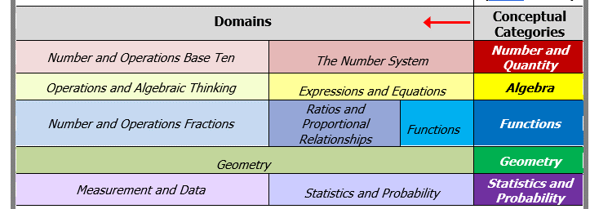

## Strand-Specific Requirements for ELA-Writing

###### ELA−Writing assesses expressive communication by the student.

**Writing samples must reflect the student’s expressive communication. Samples that document only motor skills (e.g., letter formation, tracing, scribbling) will not be scored.**

**Writing samples may *not* include bathroom-related activities, which** will *not* be scored nor included in the minimum required three final writing samples.

In preparing writing samples, students should use their **primary mode(s) of communication** toconvey thoughts, express ideas, and demonstrate knowledge and skills, which may include any of the following formats:

* dictating to a scribe (with verbatim transcription, assume capital letters, spelling, and basic punctuation, but may *not* change or embellish what was dictated.)
* assistive technology, such as an augmentative and alternative communication (AAC) device or other symbol-based communication systems, voice output device (with supporting documentation to show the context of the activity and choices made by the student), or use of word prediction, speech-to-text, or text-to-speech.
* Braille writer, notetaker, ASL, translated into English for submission.
* handwritten
* using a word processor or similar device

**Engage Students by:**

* sharing experiences,
* opinions, preferences,
* ideas, and/or facts
* discussing books, articles, stories, videos
* poetry, imagery,
* sharing knowledge with an audience (e.g., peers)

**The ELA−Writing strand must include the following components:**

* **A completed ELA−Writing Skills Survey**
* **No data charts** are required in the ELA−Writing strand.
* **One** **baseline writing sample with an attached *work sample description*** that is dated *prior* to the final writing samples.
* **Three final** **writing samples with attached *work sample descriptions*** in any **text type**, each based on a different topic, picture, or assignment that demonstrates the student’s *expressive communication skills* and uses the student’s *primary mode of communication* (see below).

**Note:** when changing text types (e.g., narrative to opinion) a new *Strand Cover Sheet* will be generated in the forms/graphs program.

* **Three** **State- Provided ELA−Writing pre-scored rubrics** corresponding to each final writing sample.Rubrics must be completed by the teacher according to the descriptions listed for each rubric area. The date of each writing sample must be matched to the date listed on the pre-scored Writing rubric.

**Any combinationof the following text types may be submitted:**

* + - 1. **Opinion/Argument:** Stating a claim, opinion, preference, or analysis based on a text or topic, citing reasons and evidence from a text. (Educators are encouraged but not required to link expressive language to a reading they have encountered.)
      2. **Informative/Explanatory text:** conveying or explaining facts, information, or ideas on a topic, including descriptions from a text. (Educators are encouraged but not required to link expressive language to a reading they have encountered.)
      3. **Narrative:** Prose that tells a story based on real or imagined events from a text or personal experience. The narrative can be fiction, drama (script), a personal reflection, an event sequence; OR poetry that uses figurative language (e.g., similes, metaphors), imagery, sounds of words (e.g., rhyme), meter, and/or repetition to express emotion or tell a story.

**Writing samples will be based on either of the following:**

* **Entry point**: “*Use the student's primary mode of communication to express or create a writing sample*….” (only one entry point available)

**or**

* **An access skill** selected from the dropdown menu in the online Forms and Graphs.

Students who communicate at a pre-symbolic language level should be assessed based on one of the **access skills** listed in the ELA Resource Guide.

For a student working on access skills, the writing sample must be a tangible (i.e., permanent) product created by the teacher, paraprofessionals, related service provider, or peer(s) that documents the **student’s expressive response including the percent of independence** during the creation of the writing sample. Please review the fall training for Access skills for ELA-Writing.

**Pre-scoring Each Final Writing Sample**

Be aware that the scores submitted on the writing rubrics must reflect the responses generated by the *student*, not the corrections or text provided by the teacher. MCAS-Alt scorers will verify the scores submitted by the teacher and will only change a score if it does not accurately reflect the work of the student.

Edits or corrections made by the teacher should be reflected in the percentage of independence. Base the percentage independence for each final sample *either* on the number of prompts per word, per sentence, or per paragraph, at the teacher’s discretion, depending on the length and complexity of the writing sample (see example in Figure 4 below).

Consider submitting evidence from other content areas as ELA–Writing samples, such as the student’s open responses to comprehension questions in the ELA− Reading or STE strands.

## Strand-Specific Requirements for Science and Technology/Engineering (STE)

The STE MCAS-Alt for students in grades 5 and 8 (all disciplines) and high school (Biology and Introductory Physics) requirements are described below.

The structure and format of the STE assessment encourages instruction using high-quality curriculum *units*, rather than isolated science *skills.* The format described on the following pages is intended to encourage the teaching of a high-quality unit of science based on the core idea. High-quality curriculum units along with topics related to each core idea can be found in the *Table of Contents* in the *Forms and Graphs* online application. The use of a unit also allows for cross-curriculum skills to be addressed.

The 2016 framework emphasizes the application of **science practices** that promote student engagement in scientific inquiry and engineering design skills, in addition to the content in each discipline. Science Practices are numbered for **reference** purposes only, there is no order of how they should be used.

* The eight **science practices** are:

1. Asking (Scientific) Questions and Defining Problems
2. Planning and Carrying Out Investigations (to gather data and perform experiments to answer a scientific question)
3. Using Mathematical and Computational Thinking (to answer scientific questions)
4. Analyzing and Interpreting Data (to recognize patterns and analyze and organize data)
5. Developing and Using Models (to think about and make sense of an experience and make predictions, using 2-D and 3-D representations, constructions, displays, illustrations, and simulations)
6. Constructing Explanations and Designing Solutions (to explain phenomena and use evidence to support explanations)
7. Engaging in Argument from Evidence (to support a claim and critique competing arguments)
8. Obtaining, Evaluating, and Communicating Information (to research, record, evaluate, and present information from scientific texts and digital sources)

* Science practices are grouped in the STE Resource Guide according to the following scheme:
* Practices #1−2 are included under the heading **“Investigations and Questioning.”**
* Practices #3−4 are included under the heading **“Mathematics and Data.”**
* Practices #5−8 are included under the heading **“Evidence, Reasoning, and Modeling.”**
* Each STE entry point and access skill in the Resource Guide combines science content with science practice.
* Entry point or access skills cannot be modified, all changes must be approved by DESE.

**STE Assessment Format and Structure: Grades 5 and 8**

**1. Conduct the STE Skills Survey** to determine the optimal grade span at which to select entry points for the student. **NOTE:** The STE Skills Survey must be conducted **once** for the entire STE content area, **not** for each discipline, and must include all eight science practices.

**2.** **Choose any three (3) of the following disciplines** for each student’s STE assessment:

* Earth and Space
* Life Science
* Physical Science
* Technology/Engineering

**3.** In each discipline, **select one *core idea*** that engages the student. Review the topics related to each core idea, then choose entry points/access skills found in each core idea to relate to a unit of study.

**Tip**: When using the STE units, plan the lessons first and then review entry points to determine the practices that will be covered.

**For *each* core idea:**

**4.** **Select three (3) entry points or access skills that are each from a different science practice** Use the completed Skills Survey to assist in determining the grade span from which to choose the entry point. Submit evidence (e.g., work samples, photographs, or video) aligned with the selected science practice/entry point.

**5.** **Attach one** ***STE Summary Sheet* for each piece of evidence documenting the selected entry points or access skills**. (Three total)Include the following information on each *STE Summary Sheet*.

* student’s name and grade
* core idea (one for each discipline)
* entry point or access skill addressed.
* the science practice number for each entry point or access skill
* date of completion of assignment or activity
* percent of accuracy and independence for each activity
* detailed description of the activity (material, instructional approach, activity)
* self-evaluation either described or attached.

**STE Assessment Format and Structure: High School (either grade 9 or 10)**

**1.** **Choose one** of the following STE disciplines: Biology **OR** Introductory Physics

**2. Conduct one MCAS-Alt STE Skills Survey** to determine the grade span at which to select entry points in each science practice for the student. Only one STE Skills Survey is required for high school *Biology* or *Introductory Physics*.

**3.** **Select three core ideas within the chosen discipline** **from the STE Resource Guide** that engage and challenge the student. See the tips above for high-quality units.

**For *each* core idea:**

**Follow steps 4 and 5 above for each of the three core ideas**.

**Collecting Evidence** for STE MCAS-Alt in grades 5, 8, and high school,must be submitted in the required grade.

* Evidence for STE may be collected over **two school years** (i.e., the current and one prior school year).

###### Evidence of Self-Evaluation

*Self-evaluation*activitiesdocument the student’s choices, decisions, and preferences before, during, and after instruction, including evidence that the student performed any of the following activities:

* reflecting on his or her performance; for example, the teacher can ask the student:
  + *What did you do during this activity? What did you learn?*
  + *What did you do well? What are you good at? Was this too easy?*
  + *How could you do better? Where do you need help?*
  + *What should I work on next? What would I like to learn?*
* planning and goal setting
* using a “K-W-L” chart or questionnaire (What I know, what I want to learn, what I learned)
* choosing an activity, materials to use, or next steps in an activity
* selecting a problem-solving strategy (requesting help, selecting resources)
* self-monitoring own progress or use of a strategy (e.g., by checking off each step as completed)
* deciding when to continue or end participation in an activity (e.g., “more” or “all done”)
* identifying and correcting (or editing) their own responses
* selecting data/graphing their own performance or progress on a chart, table, or graph
* determining their score using a rubric
* selecting work for their assessment

**Note:** Simply placing a **sticker** or **stamp** on the primary evidence or on the work description label (in the sectionmarked *self-evaluation)* does *not* constitute self-evaluation. Similarly, selecting a “motivator” or reward does not constitute self-evaluation. Self-evaluation must reflect the student’s “voice.”

###### Evidence of Generalized Performance

*Generalized performance* reflects the student’s application of knowledge and/or skills in other learning situations, and using different **instructional approaches, variations of materials, student responses, and** **activity formats**. Scores for Generalized Performance are determined by evidence and/or *how* the student addressed the measurable outcome in the brief description of the activity provided on the data chart.

###### Optional Supporting Documentation

Supporting documentation is not required, but it is helpful in showing or describing the *context* of the learning activity. Supporting documentation may include templates, organizers, screenshots from a computer program or AAC device, photographs, or videos that show the setting, instructional approach, or materials.

# Scoring the MCAS-Alt and Reporting Results

## Scoring the MCAS-Alt

###### Scoring Student Assessments

MCAS-Alt is scored by trained and qualified scorers whose performance is closely monitored by the Department to ensure that the score of each assessment is accurate. All strands with missing or incomplete information; with evidence that is determined to be unmatched to the required Massachusetts curriculum framework standards for a student in that grade; will be reviewed by Massachusetts expert scorers.

By verifying the standards being assessed using a universal scoring rubric, and through the rigorous training, qualification, and monitoring of scorers, the evidence of a student’s performance is evaluated and scored using research-based criteria on how students with significant cognitive disabilities learn (*National Alternate Assessment Center*, 2005).

The MCAS-Alt Rubric for Scoring Strands was developed with assistance and feedback from hundreds of teachers and a statewide advisory committee. The criteria for scoring are described on the following pages and are detailed in the *[Guidelines for Scoring the 2023 MCAS-Alt](http://www.doe.mass.edu/mcas/alt/scoreguide.docx)*[.](http://www.doe.mass.edu/mcas/alt/scoreguide.docx)

The scoring of the MCAS-Alt reflects the level at which a student has learned and demonstrated the knowledge and skills outlined in the Massachusetts Curriculum Frameworks. The MCAS-Alt measures progress over time, as well as the highest achievement attained by the student on the assessed standards and incorporates the frequency of prompts provided to the student in determining the overall score.

## MCAS-Alt Rubric for Scoring Strands

The MCAS-Alt Rubric for Scoring Strands is shown on page 37, with an explanation of each rubric area on pages 30−35.

The Rubric for Scoring Strands is used to generate scores in each strand based on each rubric area: Level of Complexity (1–5), Demonstration of Skills and Concepts (M or 1–4), and Independence (M or 1–4). Scores are also generated for Self-Evaluation (M, 1, or 2) and Generalized Performance (1 or 2). A score of “M” means there was insufficient evidence or information to generate a numerical score in a rubric area.

Trained and qualified scorers examine each strand and apply the following criteria to produce a score in each rubric area, based on the evidence found in the assessment:

* **level of complexity** at which the student addresses standards in the Massachusetts curriculum framework in the subject being assessed, through entry points, or through access skills based on alternate academic achievement standards, and the alignment of the assessment activities with the required learning standards
* **completeness** of all assessment materials
* **demonstration of skills and concepts (accuracy)** of the student’s responses to questions, or of his or her performance of specific tasks
* **independence** of the student in responding to questions, demonstrating knowledge and skills, or performing tasks
* **self-evaluation** during or after each task or activity (e.g., reflection, self-correcting, goal setting)
* **generalized performance** ofthe skill or the application of knowledge using different formats and instructional contexts

### C. Using the Scoring Rubric to Guide the Development of the MCAS-Alt

Each student’s assessment must include evidence that the student has learned challenging academic skills and is able to perform those skills as accurately and independently as possible. Evidence taken together should address all areas of the MCAS-Alt Rubric for Scoring Strands, including self-evaluation and generalized performance. A variety of products must be submitted that support and complement one another. A single piece of evidence cannot, by itself, provide evidence of student learning in every rubric category. The Department encourages submission of additional products beyond the minimum required for the “core set of evidence,” if some evidence is not scorable.

The MCAS-Alt Rubric for Scoring Each Strand (see following pages) serves several purposes:

* to inform educators and parents of the criteria that will be used to evaluate student work
* to score the assessment
* to guide teachers in planning and designing standards-based instruction that yields high-quality products for the student’s assessment and engages each student.

|  |
| --- |
| MCAS-Alt Rubric for Scoring Each Strand |

|  |  |  |  |  |  |
| --- | --- | --- | --- | --- | --- |
|  | 1 | 2 | 3 | 4 | 5 |
| **Level**  **of**  **Complexity** | Strand reflects little or no basis in, or is unmatched to, curriculum framework learning standard(s) required for assessment. | Student primarily addresses motor and communication “access skills” during instruction based on curriculum framework standards in this strand. | Student addresses curriculum framework standards that have been modified below grade-level expectations in this strand. | Student addresses a narrow sample of curriculum framework standards (1 or 2) at grade-level expectations in this strand. | Student addresses a broad range of curriculum framework standards (3 or more) at grade-level expectations in this strand. |

|  |  |  |  |  |  |
| --- | --- | --- | --- | --- | --- |
|  | M | 1 | 2 | 3 | 4 |
| **Demonstration of Skills**  **and Concepts**  **(Accuracy)** | The strand contains insufficient information to determine a score. | Student’s performance is primarily inaccurate and demonstrates minimal understanding in this strand  (0–25% accurate). | Student’s performance is limited and inconsistent with regard to accuracy and demonstrates limited understanding in this strand (26–50% accurate). | Student’s performance is mostly accurate and demonstrates some understanding in this strand  (51–75% accurate). | Student’s performance is accurate and is of consistently high quality in this strand  (76–100% accurate). |
| **Independence** | The strand contains insufficient information to determine a score. | Student requires extensive verbal, visual, and physical assistance to demonstrate skills and concepts in this strand (0–25% independent). | Student requires frequent verbal, visual, and physical assistance to demonstrate skills and concepts in this strand (26–50% independent). | Student requires some verbal, visual, and physical assistance to demonstrate skills and concepts in this strand (51–75% independent). | Student requires minimal verbal, visual, and physical assistance to demonstrate skills and concepts in this strand (76–100% independent). |
| **Self-Evaluation** | Evidence of planning, self-correction, task- monitoring, goal-setting, and reflection was not found in this strand. | Student infrequently plans,  self-corrects monitors, sets goals, and reflects in this content area — only one example of self-evaluation was found in this strand. | Student plans, self-corrects monitors, sets goals, and reflects in this content area — multiple examples of self-evaluation were found in this strand. |  |  |
| **Generalized Performance** |  | Student demonstrates knowledge and skills in one context or uses one approach and/or method of response and participation in this strand. | Student demonstrates knowledge and skills in multiple contexts or uses multiple approaches and/or methods of response and participation in this strand. |  |  |

**Expanded Version of the MCAS-Alt Rubric for Scoring Each Strand**

1. **LEVEL OF COMPLEXITY**

To what extent is the evidence aligned with the standards required for assessment in this subject?

|  |  |  |  |  |
| --- | --- | --- | --- | --- |
| 1 | 2 | 3 | 4 | 5 |
| Strand reflects little or no basis in, or is unmatched to, curriculum framework learning standard(s) required for assessment. | Student primarily addresses motor, and communication “access skills” during instruction based on curriculum framework standards in this strand. | Student addresses curriculum framework standards that have been modified below grade-level expectations in this strand. | Student addresses a narrow sample of curriculum framework standards (1 or 2) at grade-level expectations in this strand. | Student addresses a broad range of curriculum framework standards (3 or more) at grade-level expectations in this strand. |

**What each score means in this rubric area:**

1. The evidence in this strand documents instruction that is either **unrelated or unmatched to the Massachusetts curriculum framework standards required for assessment**. Either the standards being assessed were not required of a student enrolled in the grade or the evidence does not document the student’s participation in a standards-based activity. If a score of 1 is given in Level of Complexity, other rubric areas will not receive a score.
2. The evidence indicates that the student is being exposed to the academic curriculum but is **not yet addressing academic content and skills** in this subject. The student is working on early developmental milestones (“access skills”) **during** instructional activities based on curriculum frameworks assessed in that grade, which may include exploring methods, tools, and materials in the content area.
3. The evidence indicates that the student is addressing academic content and skills based on curriculum framework standards in this strand, but **standards have been modified to a lower level of complexity** (i.e., below grade-level expectations) compared with standards addressed by a typical student in this grade. Modified standards are called “entry points” and are described in detail in the Department publication *Resource Guide to the* *Massachusetts Curriculum Frameworks for Students with Disabilities*.
4. The evidence indicates that the student is addressing academic content and skills based on **a small number of curriculum framework** **standards (1** **or** **2) at grade-level expectations, either in a grade level or competency.** A student submitting an alternate assessment based on alternate achievement standards *cannot score* LOC=4.
5. The evidence indicates that the student is addressing academic content based on **a broad range of curriculum framework standards (3 or more) at grade-level expectations, either in a grade level or competency.** A student submitting an alternate assessment based on alternate achievement standards *cannot score* LOC=5.

**NOTE:** A score of 5 in this rubric area is required for a student to be considered for a score of *Partially Meets Expectations* or higher; and in high school, for a student to earn a Competency Determination. The student must submit evidence according to the guidelines described in the [*MCAS Grade-Level and Competency Portfolio Manual*](http://www.doe.mass.edu/mcas/accessibility/).

1. **DEMONSTRATION OF SKILLS AND CONCEPTS**

How accurate was the student’s performance of the skills and concepts being assessed?

|  |  |  |  |  |
| --- | --- | --- | --- | --- |
| M | 1 | 2 | 3 | 4 |
| The strand contains insufficient information to determine a score. | Student’s performance is primarily inaccurate and demonstrates minimal understanding in this strand  **(0–25% accurate)**. | Student’s performance is limited and inconsistent with regard to accuracy and demonstrates limited understanding in this strand  **(26–50% accurate)**. | Student’s performance is mostly accurate and demonstrates some understanding in this strand **(51–75% accurate)**. | Student’s performance is accurate and is of consistently high quality in this strand  **(76–100% accurate)**. |

**Summary:** This rubric area measures the degree to which the student gave the **correct or desired response(s)** during a task or activity. Teachers must provide the student’s percentage of accuracy on (or attached to) *each piece* of primary evidence, and for each data point on the data chart. The percentage of accuracy for points on the data chart is calculated by averaging the percentage(s) of accuracy on all tasks and activities performed by the student in the assessed strand or standard on a single date.

**What each score means in this rubric area: the “final 1/3-time frame.”**

Each strand, **except for ELA−Writing and STE**, will be scored for *Demonstration of Skills and Concepts* by first identifying the “final 1/3-time frame” on the data chart. If fewer than twelve data points are listed on the data chart the final three points will be calculated. An overall average accuracy percentage will be calculated by the scorer based on the percentage of accuracy for all data points during or after the final 1/3-time frame of the data chart. Based on the average percentage of the data points and evidence in the final 1/3-time frame, the overall score for Demonstration of Skills and Concepts (i.e., 1−4) in the strand is determined using the scoring rubric above.

A score of **“**M**”** (missing or insufficient evidence) will be given in both *Demonstration of Skills and Concepts* and in *Independence* when the following primary evidence is not included in the strand:

* **one data chart** (labeled correctly) documenting the student’s performance of the measurable outcome on **at least eight different dates** that show the student’s overall (i.e., average) accuracy and independence for each date; the percentage must begin **below 80 percent** for either accuracy or independence or both. A data point reflecting 0% accuracy and independence will not be included as one of the eight data points. A **brief description** must be provided for each data point describing **what** the student was asked to do and **how** they addressed the measurable outcome.

A score of **“**M**”** will also be given for **primary evidence** that is not labeled properly or when the evidence does not document the measurable outcome

See comments on the *MCAS-Alt Feedback Form* available in mid-June, based on scoring rules.

NOTE: See the ELA–Writing Rubric on page 70 for information on the *Demonstration of Skills and Concepts* for the Writing strand*.*

1. **INDEPENDENCE**

How much support and direct assistance does the student require to demonstrate knowledge and skills?

|  |  |  |  |  |
| --- | --- | --- | --- | --- |
| M | 1 | 2 | 3 | 4 |
| The strand contains insufficient information to determine a score. | Student requires extensive verbal, visual, and physical assistance to demonstrate skills and concepts in this strand  (**0–25% independent**). | Student requires frequent verbal, visual, and physical assistance to demonstrate skills and concepts in this strand  (**26–50%** **independent**). | Student requires some verbal, visual, and physical assistance to demonstrate skills and concepts in this strand  (**51–75%** **independent**). | Student requires minimal verbal, visual, and physical assistance to demonstrate skills and concepts in this strand (**76–100% independent**). |

**Summary:** This rubric area measures the frequency with which cues and prompts (either verbal, visual, gestural, or physical)were used to assist the student in responding to a task, activity, or assignment. The percentage of independence for a single point on a data chart is calculated by averaging the percentage(s) of independent responses on all tasks and activities performed by the student on a single date based on the measurable outcome. ***Any* prompt given to the student during an instructional activity will count as a** **non-independent response** and the percentage of independence will be calculated as 0%.

**Scoring in this rubric area**: **the “final 1/3-time frame”**

Each strand will be reviewed by the scorer for *Independence* who will identify the “final 1/3-time frame” on the data chart (or the final three points, if fewer than twelve points are listed on the chart). An average score will be calculated for independence based on the percentage of independence for all data points during or after the final 1/3-time frame of the data chart. Based on the average of the data points and evidence, the overall score in the strand is then determined using the scoring rubric above.

A score of **“**M**”** (missing or insufficient evidence) will be given in both *Demonstration of Skills and Concepts* and in *Independence* when the following primary evidence is not included in the strand:

* **one data chart** (labeled correctly) documenting the student’s performance of the measurable outcome on **at least eight different dates** that show the student’s overall (i.e., average) accuracy and independence for each date; the percentage must begin **below 80 percent** for either accuracy or independence or both. A data point reflecting 0% accuracy and independence will not be included as one of the eight data points. A **brief description** must be provided for each data point describing **what** the student was asked to do and **how** they addressed the measurable outcome.

A score of **“**M**”** will also be given for **primary evidence** that is not labeled properly or when the evidence does not document the measurable outcome.

See comments on the *MCAS-Alt Feedback Form* available in mid-June, based on scoring rules.

**4) SELF-EVALUATION**

How aware is the student of his or her performance, and how often does he or she make decisions or choices that affect the performance?

|  |  |  |
| --- | --- | --- |
| M | 1 | 2 |
| Evidence of planning, self-correction, task-monitoring, goal-setting, and reflection was **not found** in this strand. | Student infrequently plans, self-corrects monitors, sets goals, and reflects in this content area — only **one example** of self-evaluation was found in this strand. | Student frequently plans, self-corrects monitors, sets goals, and reflects in this content area — **multiple examples** of self-evaluation were found in this strand. |

**Summary:**

Self-evaluation, or “thinking about learning,” measures how well and how frequently the student:

* reflects on his or her performance
* plans and sets goals
* chooses an academic/standard-based activity or next steps in the activity
* selects a problem-solving strategy
* uses a “K-W-L” chart or questionnaire (What I know, what I want to learn, what I learned)
* monitors his or her progress or use of a strategy (e.g., checks off steps as each is completed)
* decides when to continue or end participation in an activity
* self-corrects as necessary
* determines own score using a rubric

Evidence of **self-evaluation** must be clearly labeled with the student’s name and date and may be included on the work description label. If it is included on a piece of primary evidence directly, then it should be briefly described by the teacher (for example, “student corrected his/her incorrect answer,” or “student chose this piece of work”).

**5) GENERALIZED PERFORMANCE**

How frequently does the student demonstrate knowledge and skills in different contexts, and during instruction that uses multiple approaches and formats?

|  |  |
| --- | --- |
| 1 | 2 |
| Student demonstrates knowledge and skills in **one** context or uses **one** approach and/or method of response and participation in this strand. | Student demonstrates knowledge and skills in **multiple** contexts or uses **multiple** approaches and/or methods of response and participation in this strand. |

**Summary:**

Students with significant cognitive disabilities often have difficulty **generalizing** skills in new settings and situations. This area measures the use of effective classroom strategies for ensuring that students can retain and transfer what they have learned (*National Alternate Assessment Center*, 2005).

Generalized Performance reflects the number of **instructional approaches and** **activity formats** through which the student acquires and demonstrates knowledge and skills, including any of the following elements of instruction:

* *media and materials* (using art materials, written text, manipulatives, and computer)
* *activity formats* (classroom projects, small group discussions, paired research, experiments)
* *presentation formats* (oral, written, multimedia)
* *method of response* (handwritten, word-processed, oral, creation of a visual display, on a video)
* *application of skills and/or knowledge* in community settings

**Scoring Information:**

The score for Generalized Performance will not be increased based on changes in the *setting* or *people* who assist the student.

The score in Generalized Performance will always be at least 1 since evidence will always demonstrate at least **one** approach or context.

**Age-appropriate instructional materials:** When the evidence indicates that materials used during instruction were inappropriate to the student’s chronological age, the Generalized Performance score in the strand will be lowered to1.

## Calculating the Overall Achievement Level in the Content Area

To determine the overall achievement level in a content area, each strand is scored separately using the Rubric for Scoring Each Strand (see page 44). A strand score is assigned by applying the score combinations shown in Table 2 below. An **overall** **achievement level** is then determined based on calculating the average of all strand scores in the content area and rounding to the nearest achievement level. Scores in *Self-Evaluation* and *Generalized Performance* are not included in the calculation of the overall achievement level.

**Table 2. Calculating a Strand Score**

A subscore is calculated for each strand based on the score combinations shown below using the Rubric for Scoring Each Strand. Then, each strand score is combined and averaged to yield an overall score in the content area.

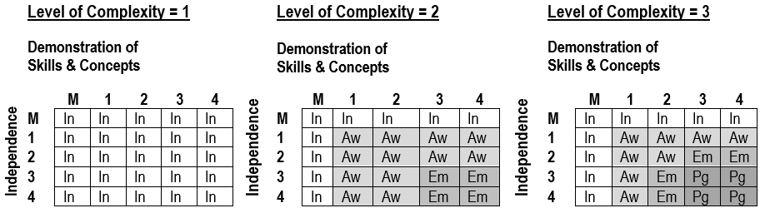

***NOTE:***

“M” means that required information was either missing or insufficient to determine a score.

**Level of Complexity=4 or 5** refers to grade-level and competency portfolios, which are detailed in the *MCAS Grade-Level and Competency Portfolio Manual* available online [here](http://www.doe.mass.edu/mcas/accessibility/).

|  |  |
| --- | --- |
| In | Incomplete |
| Aw | Awareness |
| Em | Emerging |
| Pg | Progressing |

## Including MCAS-Alt Results in Reporting and Accountability

###### Achievement Levels

For each student who takes the MCAS-Alt, one of the following achievement levels will be reported in each content area:

**Grades 3−10 (Alternate Assessments Based on Alternate Achievement Standards)**

* ***Incomplete***—**Sufficient evidence and information** **was not included** to allow an achievement level to be determined in the content area.
* ***Awareness***—Students demonstrate **very little understanding** of standards and core knowledge topics contained in the Massachusetts curriculum framework for the content area. Students require extensive prompting and assistance, and their performance is mostly inaccurate.
* ***Emerging***—Students demonstrate a **simple understanding that is below grade-level expectations** of a limited number of standards and core knowledge topics contained in the Massachusettscurriculum framework for the content area.Students require frequent prompting and assistance, and their performance is limited and inconsistent.
* ***Progressing***—Students demonstrate a **partial understanding that is below grade-level expectations** of selected standards and core knowledge topics contained in the Massachusettscurriculum framework for the content area.Students are steadily learning new knowledge, skills, and concepts. Students require minimal prompting and assistance, and their performance is basically accurate.

**Grades 3−10 (MCAS “Next-Generation” Grade-Level Achievement Standards for ELA, Mathematics, and High School Biology and Introductory Physics):**

* ***Not Meeting Expectations—***Students performing at this level did not meet grade-level expectations in this subject. The school, in consultation with the student's parent/guardian, should determine the coordinated academic assistance and/or additional instruction the student needs to succeed in this subject.
* ***Partially Meets Expectations***—Students performing at this level partially meet grade-level expectations for knowledge, skills, and understanding. These students may need coordinated assistance and/or additional instruction to succeed at the next grade level.
* ***Meeting Expectations***—Students performing at this level meet grade-level expectations for knowledge, skills, and understanding, and are academically prepared to succeed at the next grade level.
* ***Exceeding Expectations***—Students performing at this level exceed grade-level expectations for knowledge, skills, and understanding, and are academically well-prepared to succeed at the next grade level.

###### Alternate Achievement Standards

The state’s alternate academic achievement standards (*Awareness, Emerging, Progressing*) and their descriptors reflect the collaboration, input, and professional judgment of numerous stakeholders who have affirmed that these achievement levels represent the highest possible standards achievable by students taking the MCAS-Alt; and that those standards are appropriate and aligned to ensure that a student who meets those standards is on track to pursue productive post-secondary education, vocational training, and/or competitive integrated employment.

###### School and District Results

*Feedback Forms* containing preliminary school and district performance-level results are posted to DropBox Central on the Department’s [Security Portal](https://gateway.edu.state.ma.us/) in mid-June. Results are available online in the fall and reflect changes made due to discrepancies reported to the Department and the findings of MCAS-Alt score appeals filed in late June. Students’ alternate assessments are returned to schools in the fall after they have been scored.

MCAS-Alt school and district reports include an achievement level for each student attending a school or program in a district, as well as for those students who reside in the district and attend publicly funded out-of-districtplacements, such as educational collaboratives or approved and unapproved private special education schools.

To meet federal requirements for reporting aggregated and disaggregated results of statewide assessments for *all* students, the results of MCAS-Alt are included in school, district, and statewide reports of MCAS results as achievement levels only. The *alternate achievement standards* of *Incomplete, Awareness, Emerging*, and *Progressing* will be included in the *lowest* MCASachievement level for school and district reporting.

###### Parent/Guardian Reports

In the fall, districts receive shipments of MCAS-Alt Parent/Guardian Reports that provide a detailed description of a child’s score in each area of the scoring rubric and an overall achievement level in each subject.

Districts are responsible for sending a parent/guardian report to the home of each student who took the MCAS-Alt. If the student is also reported as an English learner, a copy of the report in the student’s home language must also be sent. Print copies of the translations of the report “shell” in the state’s ten most frequently spoken languages are provided in the shipment of MCAS-Alt Parent/Guardian Reports. The translated report templates are also available [online](http://www.doe.mass.edu/mcas/alt/results.html) in ten languages. Districts may request copies of the Parent/Guardian Report template in alternate formats, including Braille and large print.

###### Including MCAS-Alt Results in School and District Accountability

MCAS-Alt results will be included in the accountability system, together with the results of students who took the standard MCAS tests. Details on the state’s accountability system are available [here](http://www.doe.mass.edu/accountability/). Accountability determinations for schools that administer MCAS tests in grades 3–8 and 10 will be based on a combination of indicators, including:

* average scaled MCAS scores in ELA, mathematics, and science and technology/engineering (this replaces Composite Performance Index points used previously)
* an assigned MCAS-Alt scaled score equivalent (see following page)
* average student growth percentile (SGP) in ELA and mathematics
* progress toward attaining English language proficiency for students reported as English learners
* percentage of chronically absent students

**Table 3** shows the score scale for MCAS tests.

**Table 3. MCAS Tests Scaled Score Ranges**

|  |  |
| --- | --- |
| **Standard MCAS**  **Achievement level** | **Scaled Scores** |
| Not Meeting Expectations (NM) | 440-469 |
| Partially Meeting Expectations (PM) | 470-499 |
| Meeting  Expectations (M) | 500-529 |
| Exceeding Expectations (E) | 530-560 |

**Table 4** shows the average equivalent MCAS scaled score to the results of students who took the MCAS-Alt in each subject as shown in Table 4. The MCAS-Alt equivalent scaled score is only used for the purpose of making accountability determinations.

**Table 4. MCAS Scaled Score Equivalents Assigned to MCAS-Alt Scores**

**in ELA and Mathematics in Grades 3−10 and STE in Grades 5 and 8**

|  |  |
| --- | --- |
| **MCAS-Alt achievement level,**  **based on alternate achievement standards** | **Assigned MCAS Scaled Score Equivalent** |
| Incomplete (INP) | 455 |
| Awareness (AWR) | 470 |
| Emerging (EMG) | 485 |
| Progressing (PRG) | 500 |

## Policy on Storage and Destruction of Returned MCAS-Alt Materials

In September of each year, DESE returns scored MCAS-Alt assessments to schools. Once returned, an MCAS-Alt becomes part of a student’s *temporary record and* must be kept by the school in a secure location. Under the [Massachusetts Student Records Regulations](http://www.doe.mass.edu/lawsregs/603cmr23.html?section=06), a temporary record contains everything that is not in the transcript and that is “clearly of importance to the educational process.” Principals or their designees are required periodically to review temporary student records and to destroy portions that are “misleading, dated, or irrelevant.” Prior to destroying these records, **schools must give parents and eligible students written notice of the intent to destroy records, and of parents’ right to receive copies of these records before they are destroyed** (603 CMR 23.06(2)).

Regardless of the obligation to review and periodically purge temporary records of “misleading, dated, or irrelevant” documents, schools *must* destroy students’ temporary records no later than seven years after the student transfers, graduates, or withdraws from public school (i.e., a student’s temporary records *must* be destroyed *within* seven years after the student exits). However, **schools *may* destroy “misleading, dated, or irrelevant” documents** prior to this time by providing written notice to the student and his/her parentof the approximate date of the destruction of the record and of their right to receive these materials in whole or in part prior to their destruction.

The Department recommends the **following time periods for schools to retain MCAS-Alt assessments** once they have been returned to the school, based on the general view that, over time, the importance of the assessment to the educational process diminishes:

* grades 3−8 ELA and Mathematics binders: two years
* grade 5 Science and Technology/Engineering (STE) binders: three years
* grade 8 Science and Technology/Engineering (STE) binders: two years
* high school ELA, Mathematics, and STE binders: after the student exits public education

After the recommended time, if the student is no longer in the district, or if the parent doesn’t want the assessment after receiving notice of the approximate date of destruction and the parent’s right to receive these materials, the school may destroy the assessment.

Despite these recommendations, schools, and districts should be aware of circumstances in which it may be prudent to retain a student’s MCAS-Alt *longer* than the recommended time periods and treat the destruction of MCAS-Alt for specific students on a case-by-case basis. However, **in all cases, records must be destroyed within the seven-year period described above.**

**Please Note:**

Districts are reminded that the district must furnish a copy of the assessment to the eligible student or parent upon request, per (603 CMR 23.07(2)).

Additionally, when a student is transferring from one Massachusetts district to another, the Department requests that the previous district send the student’s current and/or most recent MCAS-Alt to the new district.

### Bottom of Form

#### Appendix A. Examples of Completed Forms

###### Data Charts: Line Graph, Bar Graph, and Field Data Chart

###### Teacher-Documented Work Sample

###### Sample Completed Strands (available online [here](http://www.doe.mass.edu/mcas/alt/samples.html))

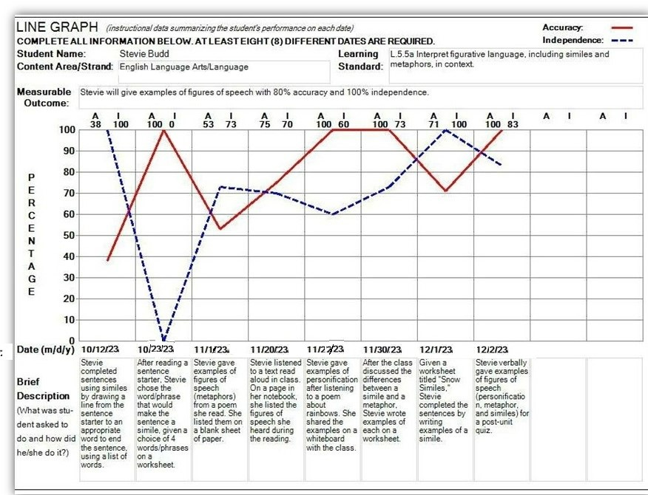

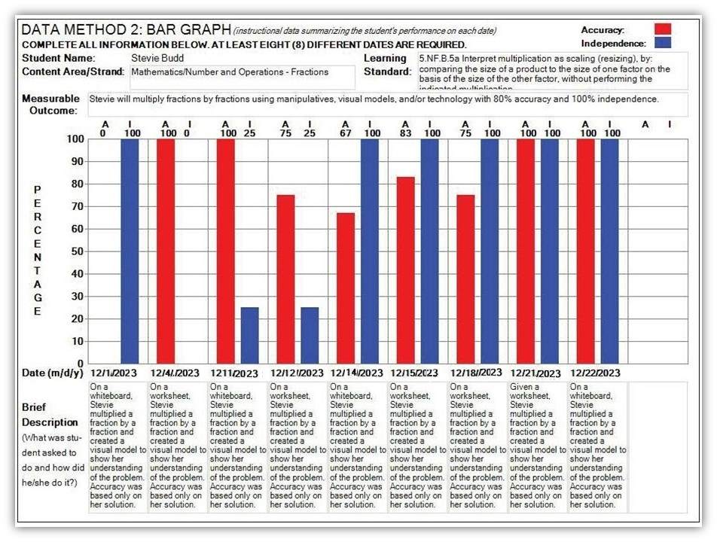

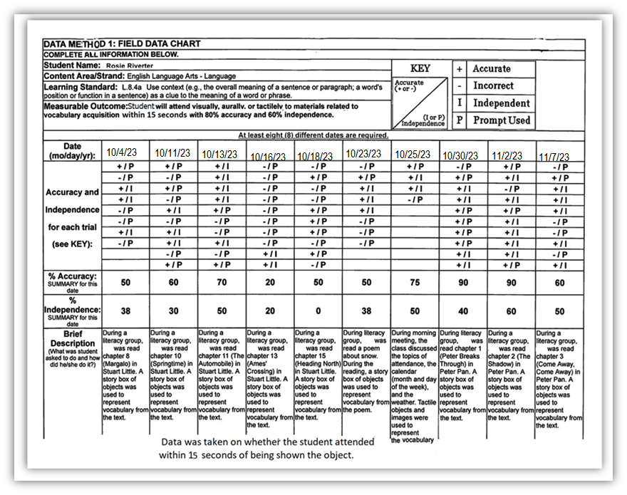

###### Example: Teacher-Documented Work Sample

*(Additional examples are available at* [*Educator Materials*](https://profile.measuredprogress.org/MCAS-Alt/Materials/Default.aspx)*)*

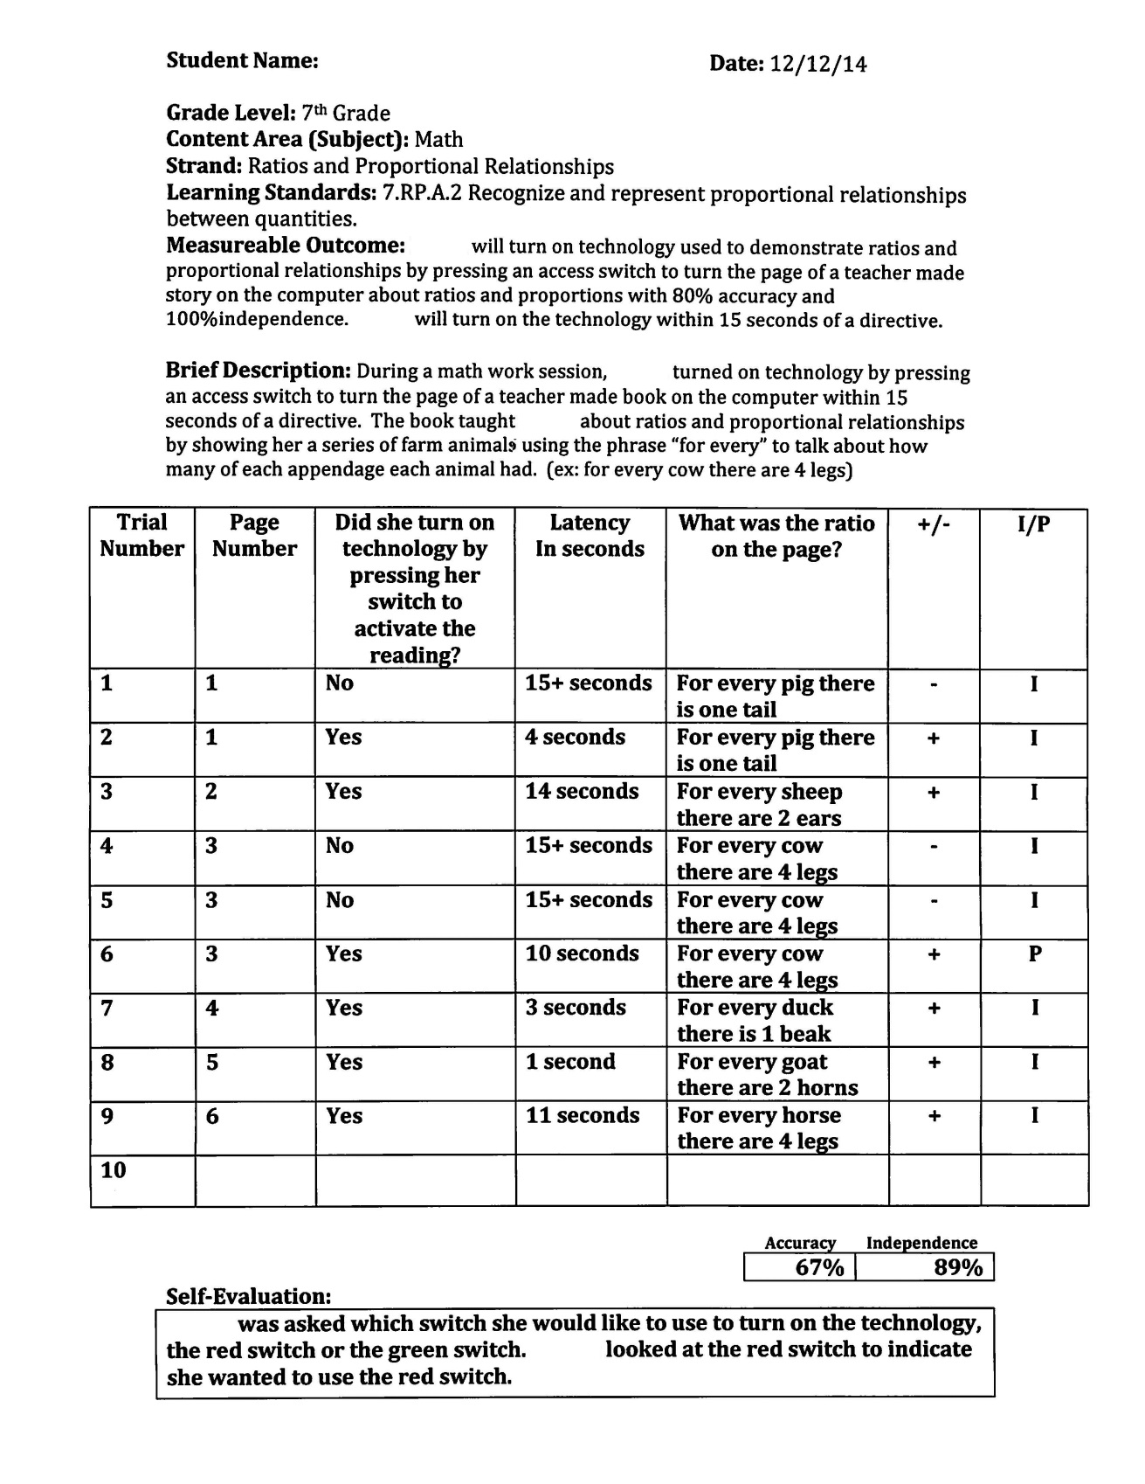

#### Appendix B. Blank Forms for the MCAS-Alt

###### MCAS-Alt Cover Sheet

###### Strand Cover Sheet/STE Strand Cover Sheet

###### Parent/Guardian Verification Form (English and Spanish)

###### Consent to Photograph (English and Spanish)

###### Work Sample Descriptions

###### ELA−Writing Baseline/Final Work Sample Description

###### ELA−Writing Scoring Rubric

###### STE Summary Sheet

###### Blank Data Charts (Line Graph, Bar Graph, and Field Data)

*2024 MCAS-Alt*

**MCAS-Alt COVER SHEET**

(This page must appear as the first page of the binder.)

1) Student’s Name: _____________________________________________________________

|  |  |  |  |  |  |  |  |  |  |  |  |
| --- | --- | --- | --- | --- | --- | --- | --- | --- | --- | --- | --- |
| 2) State-Assigned Student Identifier (SASID): | **1** | **0** |  |  |  |  |  |  |  |  |  |

3) Student’s grade as reported in the Student Information Management System (SIMS): ________

4) School, Educational Collaborative, or Program attended by the student:

____________________________________________________________________________

DISTRICT SCHOOL (See <http://profiles.doe.mass.edu>)

|  |  |  |  |  |  |  |  |  |  |  |  |  |
| --- | --- | --- | --- | --- | --- | --- | --- | --- | --- | --- | --- | --- |
|  |  |  |  | – |  |  |  |  |  |  |  |  |

5) District-School Code:

6) Address of School or Program: __________________________________________________ _________________________________________________________________

7) Student’s sending district, if program is outside the district in which the student lives:

______________________________________________________________________________

8) Contact Information:

Teacher’s Name: __________________________________________________________

School telephone and email: _________________________________________________

9) Content area(s) included in this assessment (check all that apply):

English Language Arts  Mathematics  Science and Technology/Engineering

10) Will this student take a **standard MCAS test** in any content area in spring 2024?

If yes, in which content area(s)?

English Language Arts  Mathematics  Science and Technology/Engineering

*2024 MCAS-Alt*

**STRAND COVER SHEET**

(A completed Strand Cover Sheet must be included at the beginning of each strand being submitted.)

|  |  |
| --- | --- |
| 1) Student’s Name: |  |

|  |  |
| --- | --- |
| 2) Student’s grade as reported in the Student Information Management System (SIMS): |  |

|  |  |
| --- | --- |
| 3) a. Content Area (Subject): |  |
| b. Strand: |  |
| c. Learning Standard: |  |
| (List the standard number for the grade in which the student was reported in SIMS) | |
|  | |

4) Level of complexity: Student addressed the learning standard in this strand…

|  |  |  |  |  |
| --- | --- | --- | --- | --- |
|  | through an “access skill” practiced during academic instruction  (Resource Guide, Page____ ) |  | through an “entry point”  (Resource Guide, Page____ ) | (For a student working at “grade-level,” use the *Work Description for Grade-Level or Competency Portfolios,* instead of this form). |

1. Measurable outcome: Select a challenging skill from the Resource Guide that the student is expected to learn as a result of instruction at the appropriate level of complexity, and the percent of accuracy and independence required for mastery. (for example, “student will summarize key events in a literary text with 80% accuracy and 100% independence”).

|  |
| --- |
| *The student will…* |
|  |
|  |

6) Adaptations, accommodations, and/or modifications routinely used by the student during instruction of this skill, including augmentative or alternative communication (AAC) system, if used:

|  |
| --- |
|  |
|  |

**Primary Evidence Checklist**

|  |  |  |  |  |
| --- | --- | --- | --- | --- |
| (Check boxes if product is included and labeled)  **Required Evidence:** | **Name** | **Date** | **Accuracy** | **Independence** |
| 1. MCAS-Alt Skills Survey for this strand |  |  |  |  |
| 1. Data chart showing measurable outcome listed above |  |  |  |  |
| 1. Evidence #1 based on same measurable outcome |  |  |  |  |
| 1. Evidence #2 based on same measurable outcome |  |  |  |  |

*2024 MCAS-Alt*

**Science and Technology/Engineering (STE)**

**STE STRAND COVER SHEET**

(A completed STE Strand Cover Sheet must be included at the beginning of each STE discipline.)

1. Student’s Name: ______________________________________________________________
2. Student’s grade as reported in the Student Information Management System (SIMS): ________
3. STE Discipline: _______________________________________________________________
4. Core Idea: ___________________________________________________________________

**List each STE Summary Sheet included in the STE MCAS-Alt (three are required):**

|  |  |  |  |
| --- | --- | --- | --- |
| **Practice #**  **(1–8)** | **Date** | **STE Summary Sheet Description** | **Self-Evaluation (Y/N)** |
|  |  |  |  |
|  |  |  |  |
|  |  |  |  |

(Add rows for additional STE Summary Sheets, if included in the strand.)

I completed the **MCAS-Alt Skills Survey** in STE using (check one):

______ Forms and Graphs Online

______ Paper-based format

**I have printed and included one copy of the completed STE Skills Survey.**

*2024 MCAS-Alt*

**Parent, Guardian, or Primary Care Provider**

**VERIFICATION FORM**

Student’s Name: ___________________________________________________________________

School/District: ____________________________________________________________________

Please check below:

_____ I HAVE BEEN GIVEN AN OPPORTUNITY TO REVIEW THE CONTENTS OF MY CHILD’S ALTERNATE ASSESSMENT.

______________________________________________________Date: _____________________

Signature of Parent, Guardian, Primary Care Provider, or Student (if over 18 years of age)

_____ PARENT OR GUARDIAN DID NOT VIEW THE ASSESSMENT BUT WAS INVITED TO DO SO ON THE DATES LISTED IN THE SPACE BELOW.

_______________________________________________________________________________

OPTIONAL: Comments may be provided by the parent, guardian, or primary care provider regarding the child’s MCAS-Alt assessment (continue on reverse side if necessary):

_______________________________________________________________

_______________________________________________________________

_______________________________________________________________

_______________________________________________________________

_______________________________________________________________

Parents may contact the Department of Elementary and Secondary Education directly with comments/questions at [mcas@doe.mass.edu](mailto:mcas@doe.mass.edu).

This form **must be included** in the student’s MCAS-Alt.

*2024 Evaluación MCAS Alterna*

**Padre, Guardián, o Proveedor de Cuidado Principal**

**FORMA DE VERIFICACIÓN**

Nombre del Estudiante:__________________________________________________________

Escuela: ___________________________________________________________________________

Marque abajo:

_____ YO HE TENIDO LA OPORTUNIDAD DE REPASAR EL CONTENIDO DEL PORTAFOLIO DE MI HIJO/A.

__________________________________________________________________________________

**Firma** del Padre, Guardián, or Proveedor de Cuidado Principal, o estudiantes de 18 años, y fecha

_____ EL PADRE O GUARDIÁN NO REVISÓ EL PORTAFOLIO, PERO FUÉ INVITADO A HACERLO EN LAS FECHAS INDICADAS ABAJO.

OPCIONAL: Comentarios del padre, guardián, or proveedor principal sobre el portafolio de MCAS (continuar en el otro lado si es necesario):

________________________________________________________________________________

________________________________________________________________________________

________________________________________________________________________________

________________________________________________________________________________

________________________________________________________________________________

________________________________________________________________________________

Anime a los padres a ponerse en contacto con el Departamento de Educación Elemental y Secundaria directamente con comentarios o preguntas de MCAS a mcas@doe.mass.edu.

Este **formulario debe ser incluido** en el portafolio del estudiante.

*2024 MCAS-Alt*

**CONSENT FORM to Photograph and Video Student**

*(Please keep this on file at school)*

***To Teachers:***

Please share the attached *Consent Form* with the parent(s) or guardian of a student participating in the MCAS-Alt for whom photographs, videotape, or audiotape will be submitted. Informed consent by the parent/guardian is required for this specific use. If consent is not obtained, electronic images and recordings of the student may not be created or submitted.

**Please keep a signed copy of this *Consent Form* in the student’s file.** It is not necessary to include this form in the binder.

Consent is necessary only for the creation of electronic images or recordings of the student.

The signed IEP signifies consent by the parent to have the student participate in the MCAS-Alt.

***2024 MCAS-Alt***

**CONSENT FORM to Photograph and/or Video Student**

*(Please keep this on file at the school)*

State and federal laws require all students in Massachusetts to participate in the Massachusetts Comprehensive Assessment System (MCAS), the state’s student assessment program. As your student’s IEP team meeting, it was determined that your child is eligible to participate in the alternate assessment.

During the school year, your child’s teacher will collect educational information based on daily instruction which documents your child’s achievements. This may include photographs and/or videos of your student. It is not necessary for the student to be videoed or photographed; however, consent is needed to submit photographs or videos.

Revocation of Consent: You may revoke your consent to allow your child to be recorded, photographed, or videotaped for purposes of the MCAS-Alt at any time and for any reason. However, your child will still be required to participate in the MCAS-Alt.

Obtaining More Information about the MCAS-Alt: If you have any questions about the MCAS-Alt or your child’s participation, please contact the Department at 781-338-3625 or by email at mcas@doe.mass.edu.

Within thirty days of receiving this form, sign and return it to your child’s teacher or principal.

**Statement of Consent:**

This Consent Form must be signed by the child’s parent or guardians. Consent signifies agreement to your child being recorded on video, and/or photographed for purposes of the MCAS-Alt.

I have read and understand all of the information in this Consent Form. I knowingly and voluntarily allow my child’s school to release photographs or video of my child *only* to be included in the assessment:

_________________________________________________________________________________

(child’s name)

who is a student attending _____________________________________________________________

(name of school)

I will allow my child to be photographed and/or videoed, for purposes of the MCAS-Alt and for my child’s school to release information about my child that is created and collected pursuant to the terms of this agreement to the Massachusetts Department of Elementary and Secondary Education and Cognia for review by trained professionals. I understand that I may withdraw my consent at any time, with no penalty, by contacting my child’s teacher, Cognia, or the Massachusetts Department of Elementary and Secondary Education.

Signature of Parent/Guardian: _______________________________________________________

Date: **_________________________**

*2024 Evaluación MCAS Alterna*

**FORMA DE PERMISO**

**Lineas Directivas para Obtener Permiso de los Padres o Guardián**

**Para poder tomar Videos, Audiograbación o Fotografías del Estudiante**

***Para los Maestros:***

Favor compartir la *Forma de Permiso* incluida con los padres o guardián de cualquier estudiante que está participando en la Evaluación MCASAlterna durante el año escolar actual. Se requiere permiso para que un estudiante sea fotografiado o grabado para este propósito. Si no se obtiene permiso, no se podrán crear imágenes electrónicas y grabaciones del estudiante.

***Favor notar***

No es necesario obtener permiso para que un estudiante participe en la Evaluación MCAS Alterna, solamente para crear imágenes electrónicas o grabaciones del estudiante, y para ciertos componentes de los archivos confidenciales del estudiante.

*2024 Evaluación MCAS Alterna*

**FORMA DE PERMISO**

**Para Video y Grabación Audio y Fotografía de Estudiantes**

________________________________________________________

**Para Padres o Guardián:**

Como usted sabe, las leyes estatales y federales requieren que todos los estudiantes en Massachusetts participen en la evaluación MCAS (*Sistema de Evaluacion Comprehensiva de Massachusetts)*, por sus siglas en inglés)*,* el programa de exámenes para estudiantes del estado. Massachusetts administra exámenes MCAS en tres areas: Artes de Lenguaje en Inglés, Matemáticas, y Ciencias y Tecnología/Ingeniería. El Equipo del Plan Educativo Individual del estudiante determina si un estudiante con impedimentos debe de tomar el exámen estandarizado MCAS, sea con o sin acomodos, o si el estudiante requiere una evaluación alterna. La Evaluación MCAS Alterna demuestra un medio para examinar el desempeño académico de estudiantes que no pueden participar en exámenes estandarizados MCAS, por causa de su discapacidad, aún con acomodos.

La participación de su hijo/a en la Evaluación MCAS Alterna constituirá cumplimiento del requisito, para que él o ella sea examinado/a través de MCAS en el área en la cual se ha determinado anteriormente, que su hijo/a requiere una evaluación alterna.

**Descripción Corta**: La Evaluación MCAS Alterna requiere que durante el año escolar actual, el maestro de su hijo/a, a lleve a cabo ciertas actividades en el salón de clase con su hijo/a y recogerá información que refleje el desempeño educacional de su hijo/a. El maestro de su hijo/a recopilará esta información en un portafolio, y proveerá la información al Departamento de Educación Elemental y Secundaria para ser repasado por un equipo de repaso y personal específico de Medidas de Progreso (Cognia), el contratista de evaluaciones alternas del estado. El Equipo que repasa el portafolio incluye profesional anotadores entrenados/as, personal del Departamento y sus agentes contratistas. Los portafolios serán revisados y calificados durante la primavera por calificadores entrenados, para asegurar consistencia.

**Componentes de la Evaluación MCAS Alterna:** La Evaluación MCAS Alterna de su hijo/a consistirá de todos o algunos de los siguientes:

1. Ejemplos de Trabajo del Estudiante: Colección de ejemplos del mejor trabajo de su hijo/a demostrando el nivel en la cual su hijo/a está trabajando;
2. Fotografías, grabaciones de video o audio: Documentación de la participación de su hijo/a en actividades del salón de clase y asignaciones a través de grabaciones de videos, audios, o fotografías;
3. Trabajos Escolares: La participación de su hijo/a con el maestro en tareas y actividades en el salón de clase relacionados al Currículo tales como escuchando, comunicándose y usando objetos y materiales en el salón de clase;
4. Horario Semanal Escolar de su hijo/a: Esto demuestra los cursos académicos que toma su hijo/a.
5. Otra Documentación: Una introducción al portafolio creado por el estudiante; una carta firmada por los padres diciendo que ellos han repasado el portafolio de su hijo/a, o por lo menos fueron invitados a hacerlo; y cualquier carta o cartas de apoyo provistas por los compañeros, empleadores, miembros de la comunidad, etc.

**Sometimiento del Portafolio para Repasar y Calificar:** A principios de abril, el maestro de su hijo/a someterá el portafolio del estudiante al Departamento para ser repasado por calificadores entrenados. En conjunto, no más de 20 personas fuera de la escuela de su hijo/a mirarán este material, todos ellos, sea personal del Departamento de Educación Elemental y Secundaria o personal contratista de exámenes del estado bajo acuerdo formal con el Departamento que están entrenados para el propósito de calificar evaluaciones Alternas.

**Confidencialidad de los Archivos de su Hijo/a/Estudiante**: La información creada y recogida cómo parte de la Evaluación MCAS Alterna constituye material de archivo del estudiante y es confidencial bajo la ley estatal y federal. Aquellas personas que constituyen el equipo de repaso de portafolio y quienes estarán repasando y evaluando la información con su consentimiento serán informados respecto a la confidencialidad del material. El nombre de su hijo/a y otra información que lo identifica no se dará a terceras personas fuera de las que el Departamento ha contratado para el propósito de creación y implementación de la Evaluación MCAS Alterna. Los portafolios son regresados a su escuela y deben permanecer archivados como parte del record temporero de su hijo/a.

**Revocación del Permiso:** Usted puede revocar su permiso para permitir que su hijo/a sea fotografiado y estar en video o audio para propósitos de la Evaluación MCAS Alterna en cualquier momento y por cualquier razón. Su decisión en hacerlo no afectará la relación entre usted o su hijo/a con la escuela o con el Departamento de Educación Elemental y Secundaria. Sin embargo, seguira siendo requerido que su hijo/a participe en la Evaluación MCAS Alterna.

**Obteniendo Más Información Acerca de la Evaluación MCAS Alterna:** Si ustede tiene alguna pregunta acerca de la Evaluación MCAS Alterna, o la participación de su hijo/a, favor comunicarse sea con el Departamento de Educación Elemental y Secundaria al tel: 781-338-3625 o por correo electrónico a mcas@doe.mass.edu.

Esta *forma de permiso* debe ser firmada por uno o ambos de los padres o guardianes del niño/a. Permiso significa estar de acuerdo que su hijo/a sea fotografiado o video grabado o audio grabado para propósito de la Evaluación MCAS Alterna.

Dentro de treinta días de recibir la forma, debe de ser firmada y devuelta al maestro del niño/a o Principal. El original debe de ser incluido en el portafolio de la Evaluación MCAS Alterna para someterla al Departamento, con una copia duplicada en el archivo temporal del estudiante.

**Declaración de Permiso:**

Yo hé leído y yo entiendo toda la información en esta Forma de Permiso. Yo conscientemente y voluntariamente autorizo a la escuela de mi hijo/a dar la información acerca de mi hijo/a:

___________________________ en ___________________________________________________.

(Nombre del niño/a) (Nombre de la escuela y dirección)

a ser fotografiado, estar en video o audio grabado para propósitos de la Evaluación MCAS Alterna y para que la escuela de mi hijo/a dé la información acerca de mi hijo/a que es creada y recogida en términos de este acuerdo al Departamento de Educación Elemental y Secundaria de Massachusetts y Cognia para ser repasada por profesionales entrenados. Yo entiendo que puedo retirar mi permiso en cualquier momento, sin ninguna penalidad, comunicándome con el maestro/a de mi hijo/a, Cognia o el Departamento de Educación Elemental y Secundaria de Massachusetts.

Firma del Padre/Madre o Guardián: _____________________________________________ Fecha:_____________________________________________________________________

*2024 MCAS-Alt*

**CONSENT FORM**

**For Incidental Photographing and Video Recording of a Student**

*(Please keep on file at the school.)*

***To Parents or Guardians:***

This year, the Department of Elementary and Secondary Education will work with your son or daughter’s school to conduct the MCAS-Alt. Your child’s teacher will be among those who use alternate assessments with a small number of students with significant cognitive disabilities who cannot take the standard MCAS tests, even with test accommodations.

One or more students in your child’s class will participate in the MCAS-Altduring the 2023–2024 school year. During this process, your child’s teacher may find it necessary to use cameras and/or tape recorders to obtain educational information on these students in order to determine how well they perform certain activities. It may be necessary for your child’s teacher to record the voice or image of the participating student when other students are present in the room. Therefore, there may be limited occasions during which your child may appear incidentally in videotapes and/or photographs or during which his/her voice may be recorded on audiotape. Your child will not be identified by name, nor would any student information or other materials be shared with others outside the school or district for this purpose. We request your consent to allow your child to appear in videotapes and photographs in this limited way. Thank you very much.

Student’s Name: ___________________________________________________________________

Name of School/ District: ________________________________________________________

Teacher’s Name: **___________________________________________________________________**

Signature of Parent or Guardian: _____________________________________________________

Date: **___________________________________________________________________________**

*2024 Evaluación MCAS Alterna*

**FORMA DE PERMISO**

**Para Grabación de Video y Audio y Fotografía Incidental**

**de Estudiantes**

**Para los Padres o Guardián:**

Este año el Departamento de Educación Elemental y Secundaria una vez más llevará a cabo la Evaluación MCAS Alterna en salones de clase del a través del estado. El maestro de su hijo/a estará entre aquellos que usan evaluaciones alternas con un número pequeño de estudiantes con discapacidades significativas que no pueden tomar exámenes MCAS estandarizados, aún con acomodos de exámenes.

Uno o más estudiantes en la clase de su hijo/a participarán en la Evaluación MCAS Alterna durante el año escolar 2023–2024. Durante este proceso, el maestro de su hijo puede encontrar necesario el usar cámaras y grabadoras para obtener información educacional en estos estudiantes, para determinar cómo desempeñan ciertas actividades. Puede ser necesario para el maestro de su hijo/a el grabar la voz o imágen del estudiante, participando y envuelto en actividades de rutina en el salón de clase con otros estudiantes presentes en el salón. Por lo tanto, pueden haber ocasiones limitadas en la cual su hijo/a puede aparecer en grabaciones y/o fotografías, o su voz en grabaciones, aunque solamente incidentalmente. Su hijo/a no será identificado/a por nombre, ni se compartirán los archivos de su hijo/a con otros fuera de la escuela o distrito escolar para este propósito. Nosotros pedimos su permiso en que su hijo/a aparezca en videos y fotografías de esta manera limitada. Muchas gracias.

Nombre del Estudiante: ______________________________________________________________

Nombre de la Escuela/Distrito Escolar: __________________________________________________

Nombre del Maestro: **________________________________________________________________**

Firma del Padre/Madre o Guardián: _____________________________________________________

Fecha : ____________________________________________________________________________

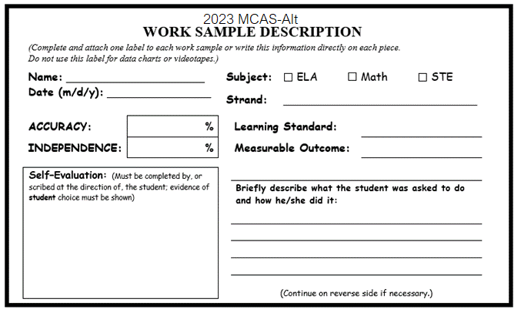



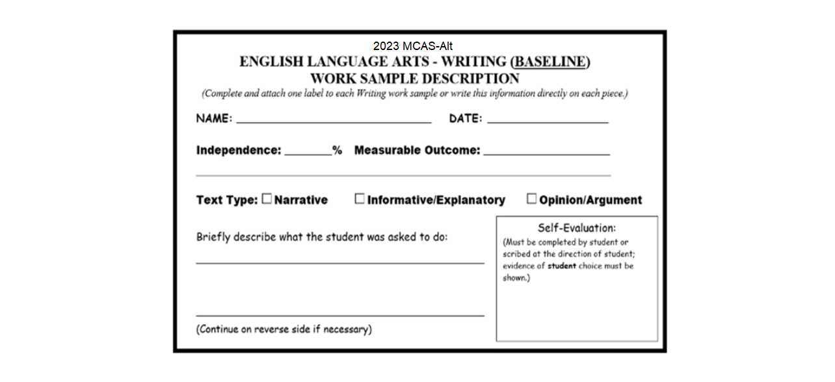

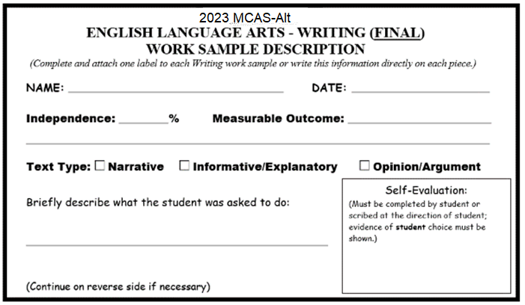

**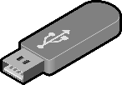***2024 MCAS-Alt*

**Video Description**

Complete, print, and insert one form for each submitted video segment.

**Videos must be submitted on a standard DVD or flash drive or it will not be scored.**

|  |  |
| --- | --- |
| **Name:** |  |

|  |  |  |  |
| --- | --- | --- | --- |
| **Content Area:** |  | **Strand:** |  |

**Description of Each Video Sample in this Strand:**

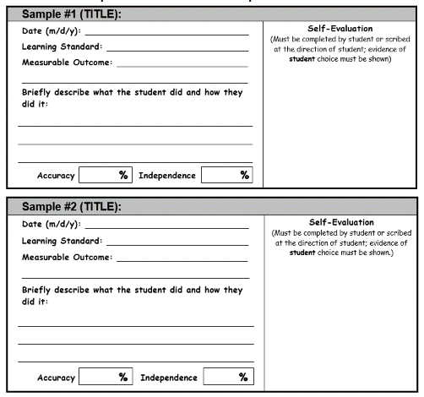

**Science and Technology/Engineering (STE)**

**STE SUMMARY SHEET**

**Directions:** Complete and submit **one summary sheet** **for each selected entry point or access skill** in the core idea (a total of 3 summary sheets are required for each core idea). Document at least **three different science practices** among the three summary sheets. Attach **three pieces of primary evidence**, each to its corresponding STE Summary Sheet.

**Student’s Name: ________________________________________ Date (m/d/y):__________**

**Grade: ________ Discipline (Strand): ____________________________________________**

**Core Idea: _______________________________________Science Practice (#1–8): ______**

|  |  |
| --- | --- |
| **Entry Point**  **Access Skill**  Resource Guide, Page: ______  Grade Span: _______________ | **List the Entry Point or Access Skill here:** |

|  |
| --- |
| **Description of Activity** (including materials, instructional approach, and how the student addressed the entry point or access skill):  **Self-Evaluation:** |
| **SUMMARY for this activity: Accuracy: _______% Independence: _______%** |
| **EVIDENCE must be ATTACHED** to its corresponding STE Summary Sheet. (Total of three)  A clearly labeled photograph with a detailed description may be substituted for evidence that may be difficult or impossible to submit in the binder, including large, fragile, or temporary products, such as a model or a large display. |

**SCORING RUBRIC for ELA–Writing**

**Student’s Name:**

**Date:**

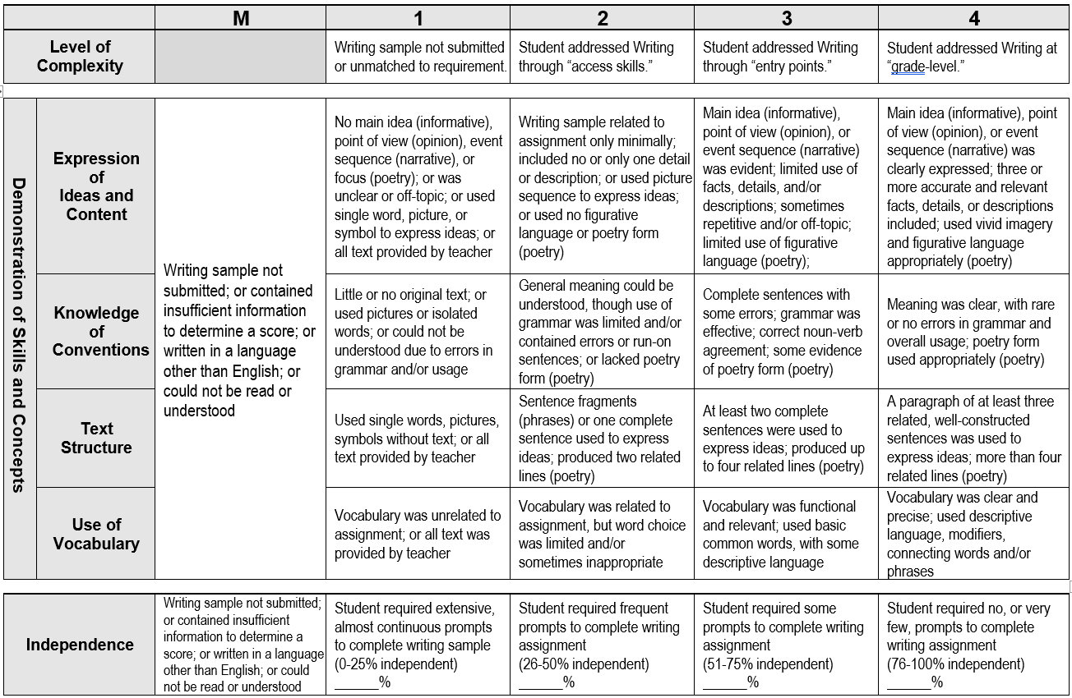

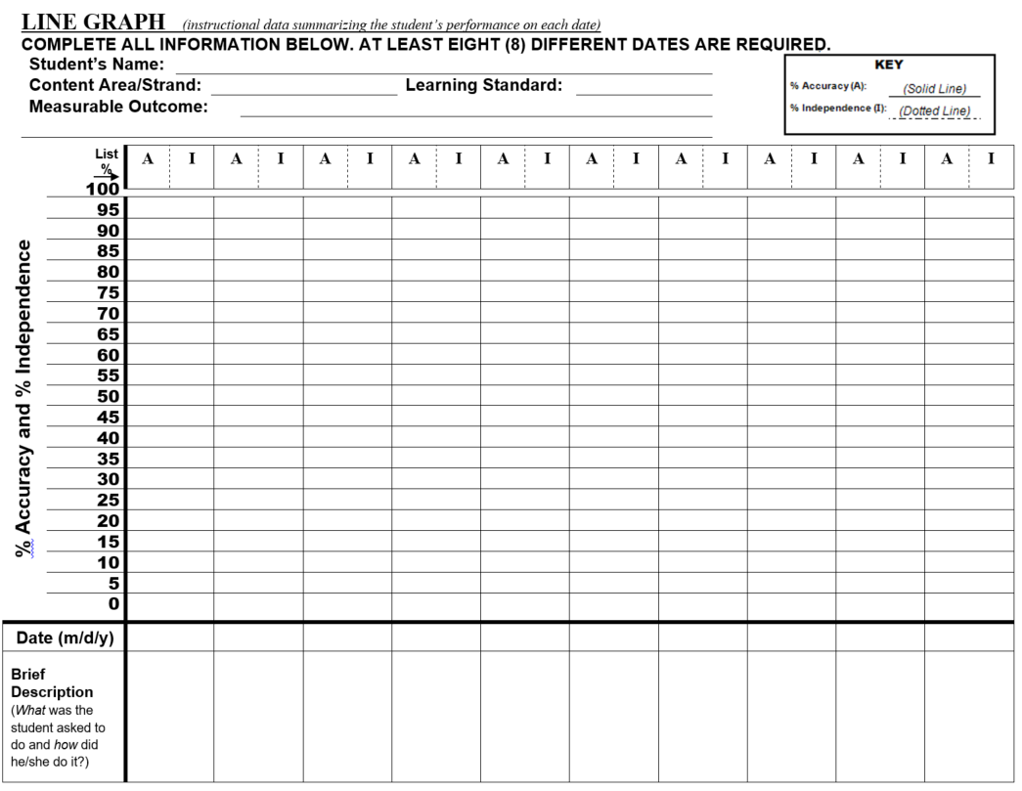

**DATA METHOD: 1**

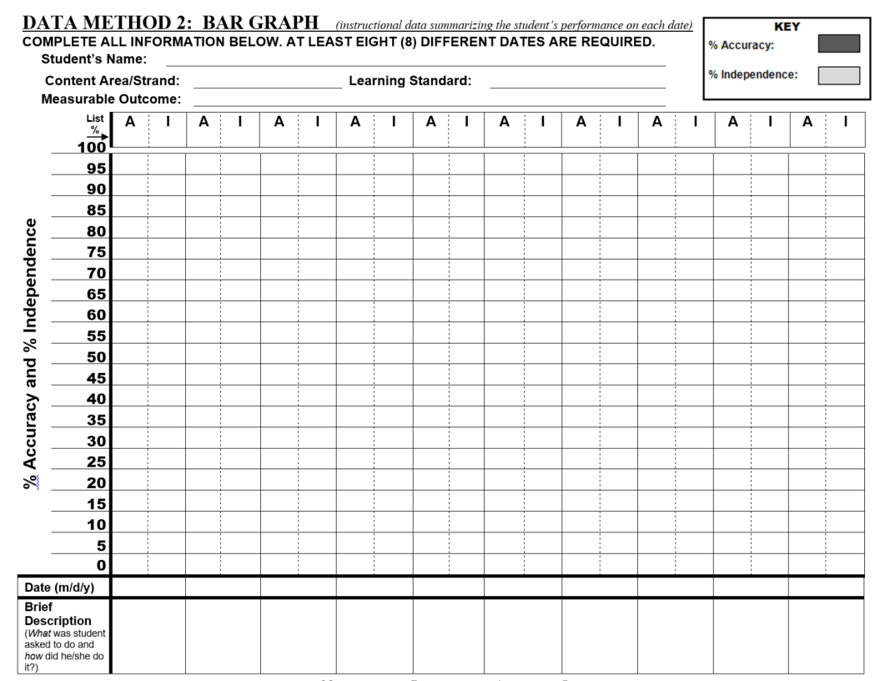

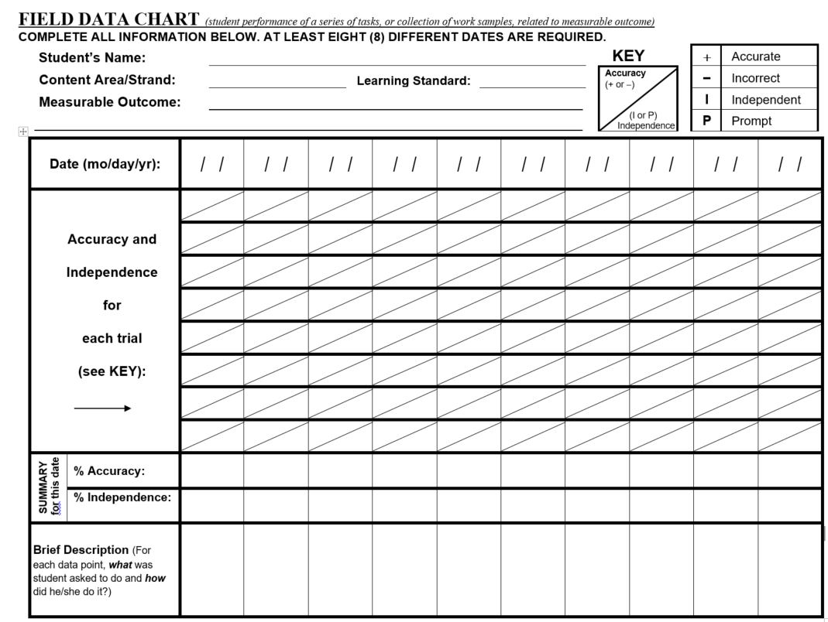

**DATA METHOD: 3**

### Appendix C. Why It’s Important to Include Students with Disabilities in MCAS

Since 1998, students with disabilities have been included in MCAS for the following reasons:

**It’s the law.** State and federal laws require the participation of *all* students in statewide assessments to measure their academic performance. The alternate assessment ensures that students with the most intensive disabilities have an opportunity to “show what they know” and receive instruction at a level that is challenging and attainable based on the Massachusetts Curriculum Frameworks.

**Students who are assessed are those who get taught.** Students with disabilities have become more “visible” in their schools as a result of taking the MCAS and the MCAS-Alt and have a greater chance of being considered when decisions are made to allocate staff and resources to improve their academic achievement.

**As a result of participation in MCAS, learning has improved, and expectations raised.** Evidence indicates that students with disabilities learn more than expected when they are given opportunities to engage in challenging instruction with the necessary support. Indeed, the achievement of students with disabilities on MCAS, and the rate at which these students meet state and local graduation requirements, has steadily increased.

**Participation in MCAS helps to determine whether, and how much, students with disabilities are learning.** In the past, it was not always possible to determine what had been taught and whether special education had been successful with a student; nor was it possible to compare outcomes among students and across programs, schools, and districts.

**Standards-based instruction is for all students.** All students are capable of learning at a level that engages and challenges them. One important reason to include students with significant cognitive disabilities in standards-based instruction is to explore their capabilities. While “daily living skills” are critical for these students to function independently, academic skills are also important. Standards in the Massachusetts Curriculum Frameworks are defined as “valued outcomes for all students.”

**State graduation requirements apply to *all* students, even those taking the MCAS-Alt.**

All students without exception are required to meet the competency determination graduation standard on the ELA, mathematics, and one high school science and technology/engineering assessment to be eligible to earn a high school diploma. Local graduation requirements must also be met. Since students who take alternate assessments are those with significant cognitive disabilities, the number earning a competency determination remains low in relation to the number of students who meet the competency determination requirement on the standard MCAS tests. Students remain eligible for special education services until they meet all graduation requirements or turn 22 years of age.

*For additional information and participation guidelines, please visit the Department’s* [*MCAS Alternate Assessment website*](http://www.doe.mass.edu/mcas/alt)*.*

*For additional information on meeting graduation requirements, please visit the Department’s* [*Graduation Requirements website*](http://www.doe.mass.edu/mcas/graduation.html)*.*

#### Appendix D. Frequently Asked Questions About the MCAS-Alt

(The Massachusetts Department of Elementary and Secondary Education receives many inquiries like the ones below concerning the MCAS Alternate Assessment (MCAS-Alt).)



**Why assess students with the most significant disabilities on the alternate assessment?**

*Rationale:* Students with disabilities are required by law to participate in MCAS to assess their achievement of content knowledge and skills found in the state’s curriculum frameworks. This means students with disabilities must take MCAS tests, either with or without accommodations, or an alternate assessment, based on Alternate Academic Achievement Standards if they are eligible to participate based on the criteria found on page 7-8.

One important reason for requiring alternate assessments is to measure the academic performance of students with the most significant cognitive disabilities. Before 2001, academic learning was not measured or reported for these students. Since taking alternate assessments, students have become more “visible” in their schools and have a greater chance of being considered when decisions are made to allocate staff and resources for their instruction.

Students who participate in the MCAS-Alt are given achievement levels based on progress made during the year. The alternate assessment gives honest, accurate, and detailed feedback that can be used to identify challenging goals and instruction for each student. The evidence submitted in the MCAS-Alt ensures that students with the most significant disabilities have an opportunity to “show what they know” and to receive instruction at a level that is challenging and attainable.



* **The MCAS-Alt requires some effort to conduct. How can teachers manage the process efficiently?**

*Rationale:* DESE has made school administrators aware of the need to coordinate this process in schools and to meet regularly with teachers who conduct alternate assessments to identify resources for teachers who need assistance. The Department encourages all adults who work with a student to be involved in developing his or her assessment.

At statewide teacher training sessions held during the fall, the Department emphasizes the need for teachers to begin collecting student work early in the school year and to complete all required forms and cover sheets well in advance of the submission deadline. Teachers report that after the first year of creating student assessments, they find the process much easier and have developed strategies to organize and manage this task more efficiently.

The key is to integrate the skills during their daily instruction and use the data gathered to plan future instruction, identify educational goals for students, write progress reports, and share information with parents. Thousands of teachers have conducted alternate assessments and are assisting each other in the process. Teachers find that alternate assessments help document their students’ progress and performance so they can focus their time and attention where it is most needed.

We encourage teachers to request assistance from the Department if they need it. Training is available to help teachers who are new to the process.

* **How do we know that alternate assessments truly reflect what students have learned?**

*Rationale:* If teachers follow instructions outlined in the most current version of the *Educator’s Manual for MCAS-Alt*, they can be assured the alternate assessment will receive the score it deserves based on the evidence submitted. Teachers should become familiar with the scoring rubric in the Educator’s Manual to make certain the work samples and data charts address each rubric category. Each year, written feedback is provided directly to the teachers who assessed the students. This feedback is intended to assist teachers to improve the quality of assessments the following year.



* **Why teach and assess the same standards for students with significant cognitive disabilities?**

*Rationale:* One reason to include students with the most significant cognitive disabilities in standards-based instruction is to fully explore and expand their capabilities. Performance expectations for these students have traditionally been quite low and data on their current levels of achievement are needed before determining which knowledge and skills to teach next. *Standards* are defined as “valued outcomes for all students.”

All students are capable of learning at a level that engages and challenges them. Teachers who have incorporated standards into their instruction cite unanticipated gains in students’ achievement and understanding. Teachers have moreover become excited about new teaching possibilities as they use the curriculum resources provided by the Department of Elementary and Secondary Education to improve and enhance their instructional practices.

An additional advantage to this approach is that many social, communication, motor, self-help, and other daily living skills can be incorporated into activities in which standards are taught, as outlined in the Department’s publication entitled *The Alternate Academic Achievement Standards* to *the Massachusetts Curriculum Frameworks for Students with Disabilities (Resource Guide).* The [Resource Guide](http://www.doe.mass.edu/mcas/alt/resources.html) is available online.



* **Why is the graduation rate low for students with significant disabilities?**

*Rationale:* All students without exception are required to meet the Competency Determination standard as part of their graduation requirements by earning a specified minimum score on English Language Arts, Mathematics, and Science and Technology/Engineering MCAS assessments.

Massachusetts provides several pathways for students to meet the graduation requirements:

* by passing the required tests or retests.
* by submitting an MCAS Performance Appeal.
* or by submitting a competency portfolio that demonstrates a level of performance equivalent to a student who has achieved a passing score on the MCAS tests.

Since 2001, thousands of students with disabilities have met the state’s graduation requirement in at least one subject through one of these pathways. As students gain greater access to academic instruction and teachers become more proficient at documenting their students’ achievements, this number may increase further.

The MCAS-Alt is based on *alternate academic achievement standards* and is designed to assess students with the most significant cognitive disabilities who are working well below grade-level expectations. As a result, the number of those students who earn a Competency Determination will likely remain low.

*For additional information on Graduation Requirements, please visit the Department’s* [*Graduation Requirements website*](http://www.doe.mass.edu/mcas/graduation.html)*.*

*For additional information, updates, materials, and participation guidelines, please visit the Department’s* [*MCAS Alternate Assessment website*](http://www.doe.mass.edu/mcas/alt)*.*

1. Written consent must be obtained from the parent, guardian, or student (if 18 years or older) before including photographic or video images of the student in the MCAS-Alt. If a student’s peers are shown in an image or video, consent must also be obtained for those “incidental” images of students. Consent forms for these purposes are provided in [Forms and Graphs Online](https://profile.measuredprogress.org/MCAS-Alt/login.aspx) and must be kept on file at the school.