Principal’s Manual for the 2023–2024 MCAS-Alt
Fall 2023

This document was prepared by the
Massachusetts Department of Elementary and Secondary Education

Jeffrey C. Riley
Commissioner

The Massachusetts Department of Elementary and Secondary Education, an affirmative action employer, is committed to ensuring that all of its programs and facilities are accessible to all members of the public.
We do not discriminate on the basis of age, color, disability, national origin, race, religion, sex,
gender identity, or sexual orientation.
Inquiries regarding the Department’s compliance with Title IX and other civil rights laws may be directed to the
Human Resources Director, 75 Pleasant St., Malden, MA 02148-4906. Phone: 781-338-6105.

© 2023 Massachusetts Department of Elementary and Secondary Education
Permission is hereby granted to copy any or all parts of this document for non-commercial educational purposes. Please credit the “Massachusetts Department of Elementary and Secondary Education.”

This document printed on recycled paper

Massachusetts Department of Elementary and Secondary Education
75 Pleasant Street, Malden, MA 02148-4906
Phone 781-338-3000 TTY: N.E.T. Relay 800-439-2370
www.doe.mass.edu

Purpose of This Manual

The Principal’s Manual for MCAS-Alt is intended to support administrators and supervisors who oversee the MCAS Alternate Assessment (MCAS-Alt) administration in their school or educational program. The MCAS-Alt assesses the academic achievement of a small number of students with the most significant cognitive disabilities who are unable to take the standard MCAS tests, even with test accommodations, but are nevertheless required to participate in statewide assessments.

Students must participate in statewide assessments that correspond with the grade in which they are reported in the Department’s Student Information Management System (SIMS). The decision regarding how a student will participate in MCAS and whether they will require an alternate assessment is made annually by the student’s IEP team, as appropriate, using the criteria provided on page 3 of this document.

Compiling the MCAS-Alt is an important opportunity for educators to identify educational goals for students based on alternate achievement standards and share information about students’ progress in meeting those challenging goals. The MCAS-Alt is an ongoing assessment integrated into daily instruction, with data documented over time.

This manual highlights the critical deadlines, activities, and oversight procedures that must be followed each year, as well as the steps needed to ensure that complete and accurate alternate assessments are submitted each spring. It identifies areas in which resources and attention will be needed to support the instruction and assessment of students with the most significant cognitive disabilities.

The cooperation of administrators is essential in assisting DESE to report effectively on the progress and performance of all students to parents, schools, and the public; and to assist schools in developing challenging programs of instruction for students with the most significant disabilities.

Table of Contents

Important Dates 1
Contact Information 1
Suggested Timeline for Principals 2
MCAS Participation Guidelines 3
Decision-Making Guide for Participation in MCAS for Students with Disabilities 3
One Percent Statewide “Cap” on MCAS-Alt Participation 5
Principal’s Responsibilities for the MCAS-Alt 5
Supporting Teachers Who Conduct the MCAS-Alt 6
MCAS-Alt Ordering Process 7
Completing the Materials Summary 7
Completing Part 1 of the Principal’s Certification of Proper Administration (PCPA) 7
Ordering Additional Materials (if necessary) 7
Shipping MCAS-Alt Materials 8
Scoring the MCAS-Alt 9
Instructions for Viewing and Downloading MCAS-Alt Preliminary Results 9
MCAS-Alt Score Appeals 9
Reporting Results of the MCAS-Alt 10
Achievement Levels 10
School and District Results 10
School and District Accountability 11
Storage and Destruction of Returned MCAS-Alt Binders 12
Frequently Asked Questions about the MCAS-Alt 14
Appendix A: Completing the Student Information Booklet (SIB) 16
Alternate Assessment Participation Tool (IEP Companion Document) 17

Important Dates
Before Submission | Order MCAS-Alt submission materials | January 2–12, 2024
 | Receive submission materials (binders, etc.) | week of February 26, 2024
 | Order additional submission materials, as needed, at www.mcasservicecenter.com | February 26–March 26, 2024
Submission | Schedule UPS pick up at  www.mcasservicecenter.com | March 14 through  2:30 p.m. on March 27, 2024
 | Deadline for UPS pickup | 5:00 p.m. on March 28, 2024
Results Reported | Results posted electronically  in Dropbox Central | week of June 10, 2024
Score Appeals | File an appeal if a scoring discrepancy is noted.  (Note: the school must have retained a photocopy of the assessment.) | 5:00 p.m. on June 21, 2024

Contact Information
MCAS Service Center

Hours: 8:00 a.m.–5:00 p.m., Monday–Friday
Phone: 800-737-5103

MCAS Service Center www.mcasservicecenter.com

Massachusetts Department of Elementary and Secondary Education
Hours: 8:00 a.m.–5:00 p.m., Monday–Friday
Phone: 781-338-3625
Fax: 781-338-3630
Email: mcas@doe.mass.edu
Web: www.doe.mass.edu/mcas/alt/

Suggested Timeline for Principals
2023
September/October
- Teachers who are conducting the MCAS-Alt and administrators overseeing those teachers should register for a virtual fall training session.
- Encourage eligible teachers to apply to be training specialists.
- Ensure that teachers conduct the MCAS-Alt Skills Survey before identifying measurable outcomes for each strand of their students’ alternate assessment.
November/December
- Teachers start inputting data from instructional activities.
- Administrators or designees monitor the progress of educators in compiling their students’ alternate assessments (see Supporting Teachers Who Conduct the MCAS-Alt on page 6 of this manual).
2024
January
- Order MCAS-Alt submission materials between January 2 and 12. Memos containing passwords for use in 2024 will be posted by January 2, 2024, in DropBox Central, the Department’s Security Portal. School principals need a new password for ordering MCAS-Alt materials.
- Teachers register for a state-sponsored review session (in-person or virtual).
February
- After receipt of materials, verify the school received the correct number of binders.
- Complete Part 1 of the online Principal’s Certification of Proper Administration (PCPA).
- Order additional MCAS-Alt submission materials through the MCAS Service Center, if needed.
- Teachers register for a review session (in-person or virtual).
- Continue to monitor teachers’ progress in compiling their students’ alternate assessments.
March
- Verify that teachers have completed their students’ MCAS-Alt assessments.
- Order additional submission materials, if needed, by March 26.
- Schedule your school or program’s UPS pickup through the MCAS Service Center from March 14 to Wednesday, March 27, by 2:30 p.m.
- Deadline for MCAS-Alt pick-up from schools: 5:00 p.m. on Thursday, March 28.
June
- Retrieve preliminary results from the school’s DropBox in the Department’s Security Portal (mid-June).
- Download MCAS-Alt Feedback Forms (FFs) from your school’s DropBox.
- Share FFs with teachers who conducted the MCAS-Alt.
- Review the MCAS-Alt score appeals process (see page 10, MCAS-Alt Score Appeals).
- If needed, submit score appeal(s) by 5:00 p.m. on Friday, June 21.

MCAS Participation Guidelines
All students must participate in MCAS testing for their grade level. The question is not whether students with disabilities participate but how they will participate.
All students who are educated with Massachusetts public funds, including students with disabilities, English learners, and English learners with disabilities, are required by state and federal laws to participate in statewide assessments. A student participates in the alternate assessment in all grades and subjects for which the standard MCAS tests are required. The student’s grade is determined by information found in the Student Information Management System (SIMS) sent to DESE.
All students should be able to review MCAS practice tests before test administration to become familiar with how to access the computer-based tests.

Decision-Making Guide for Participation in MCAS for Students with Disabilities
In accordance with federal regulations, “the identification of a student as having a particular disability as defined in the Individuals with Disabilities Education Act or as an English learner does not determine whether a student is a student with the most significant cognitive disabilities.” 34 C.F.R. § 200.6(d)(1)(i) (emphasis added).
The U.S. Department of Education also requires that each state define students having the most significant cognitive disabilities, and therefore which students are eligible to participate in the alternate assessments. DESE has adopted the following definition/criteria to determine eligibility for participation in the alternate assessment:
Students must meet all four of the following criteria to be eligible to participate in the MCAS-Alt:
- have cognitive disabilities evidenced by significant delays in attaining age-level academic achievement standards, even with systematic, extensive individually designed instruction, related services, and modifications and,
- have cognitive disabilities that significantly impact their educational performance and ability to apply learning from one setting to another and,
- require extensive, direct individualized instruction and substantial support to achieve measurable gains on the challenging state academic content standards for the grade in which the student is enrolled and,
- perform significantly below average in general cognitive functioning and adaptive behavior. “Significantly below average” is defined as a student functioning two or more standard deviations below the mean on commonly accepted norm-referenced assessments in both cognitive functioning and adaptive behavior (e.g., two or more adaptive skill areas such as daily living skills, communication, self-care, social skills, and academic skills).
All four criteria must be met for a student to participate in the alternate assessment. Complete the one-page companion document Alternate Assessment Participation Tool and upload it to the MCAS-Alt File Exchange found in the DropBox in the Security Portal.

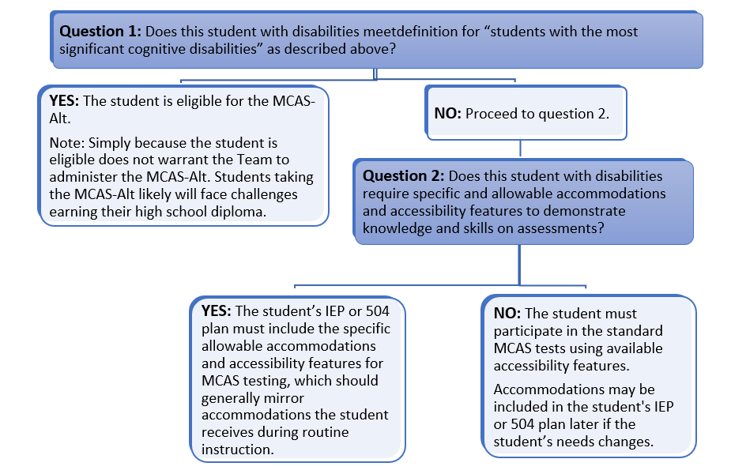
Teams should not base a decision to administer the MCAS-Alt solely on whether the student
- has not been provided instruction in the Curriculum Framework learning standards;
- is absent for an excessive number of days;
- has a specific disability (e.g., not all students with intellectual disabilities should automatically be designated for the MCAS-Alt);
- is placed in a program or classroom where it is expected that all students will take the MCAS-Alt;
- has taken an alternate assessment previously (since this is an annual decision);
- has previously failed the MCAS test;
- is an English learner;
- is economically disadvantaged or is in foster care;
- requires the use of assistive technology or an alternative augmentative communication system.

One Percent Statewide “Cap” on MCAS-Alt Participation
The Every Student Succeeds Act (ESSA) places a statewide cap of 1 percent of the total number of assessed students who may take alternate assessments based on alternate achievement standards. This cap applies only to the basic MCAS-Alt, not grade-level and competency portfolios, which are discussed separately.
The ESSA site provides districts with resources to assist them in meeting the ESSA requirements. An updated presentation intended for the annual training of IEP teams, a companion form for IEP teams to use to determine eligibility for the alternate assessment, as well as an updated sample parent notification letter (with translations), which districts must give or send to parents and guardians of students taking the MCAS-Alt.
DESE has requested that districts review this information, including the criteria for IEP teams to determine which students are eligible to participate in an alternate assessment. Districts will be asked to submit a justification if the number of students who will take the MCAS-Alt exceeds one percent of their assessed students. All other districts will be asked to complete a letter of assurance that all guidelines have been met.
The one-percent requirement represents an important opportunity for districts and IEP teams to revisit decisions to make the least dangerous assumption when designating students for the MCAS-Alt. It is reasonable to assume that at least some students who have been designated for the MCAS-Alt in the past may be better suited to take either computer- or paper-based MCAS tests with accommodations, especially since students who take the MCAS-Alt in high school are not eligible to meet the state’s requirements to earn a diploma. It is the Department’s goal to provide as many students as possible with an opportunity to learn (and be assessed on) grade-level curriculum and to ensure that students with disabilities in high school are not deprived of the opportunity to earn a diploma.
Last year, the Department was granted a waiver of this provision by the U.S. Department of Education with the understanding that it would continue to train districts on these requirements and make efforts to reduce the number of students taking the MCAS-Alt in the future. The Department intends to apply for an extension of this waiver for the 2023–2024 school year if needed.

Principal’s Responsibilities for the MCAS-Alt
Principals are responsible for conducting the following activities:
- ensuring that all students with disabilities participate in MCAS as listed in their IEP
- following the criteria set forth in the definition of students with the most significant cognitive disabilities and recording and uploading results to the state
- identifying qualified school personnel to administer the MCAS-Alt and ensuring that all staff responsible for compiling and submitting the assessment receive training before each administration
- ensuring that all administrators overseeing educators who compile alternate assessments have attended or viewed a state-sponsored training in the fall
- monitoring the alternate assessment process and attesting that student work is neither duplicated, altered, nor fabricated in a way that provides false information or portrays the student’s performance inaccurately
- ensuring that adequate school resources are allocated to guarantee appropriate participation in and timely submission of MCAS-Alt portfolios

Supporting Teachers Who Conduct the MCAS-Alt
Principals can support teachers who are conducting the MCAS-Alt by doing the following:
  - encouraging an early start to the process (i.e., identifying students taking the MCAS-Alt, setting up student folders, and identifying instructional goals and integration of assessment activities that align with curriculum)
  - encouraging collaboration among general education, special education, and related services staff, including paraprofessionals, to collect data and academic evidence for each student’s assessment
  - providing teachers opportunities to attend DESE-sponsored, fall, virtual training, and in-person winter review sessions, including classroom coverage and flexible scheduling to allow them to attend
  - providing time weekly or bi-weekly to input data
  - appointing an MCAS-Alt lead educator to be available to assist colleagues as needed
    - reviewing progress periodically to ensure that assessments are on schedule to be completed
Principals should be aware that teachers compiling the MCAS-Alt are responsible for the following:
- collecting data over a minimum of 8 different dates (as early as July if they educators have ESY)
- embedding the challenging instructional goals into daily instruction based on the results of the MCAS-Alt Skills Survey
- calculating the percentages of accuracy and independence for each student on each activity and recording this information using the Online Forms and Graphs program
- collecting student work or creating a teacher-documented work sample that reflects each instructional goal
- repeating these steps for each “strand” required for the content area being assessed in that grade
- completing all required forms

Schools must submit an assessment for all students. There is no provision for parents to opt‐out of MCAS or MCAS-Alt. Participation in statewide assessments is required of all students enrolled in public schools in the relevant grade levels. The state assessments provide important feedback to families, teachers, administrators, and state policymakers as to where schools are succeeding and where schools and districts need to enhance their efforts.

MCAS-Alt Ordering Process
- Order MCAS-Alt materials between January 2 and 12, according to the number of students in each grade who will participate in the alternate assessment.
- Material will be shipped the week after February vacation. Be sure to open the box and review the Materials Summary (below).
- The shipment will include the following MCAS-Alt materials:

Item | Quantity Provided
Materials Summary | 1 per school
Three-ring binder | 1 per student for whom MCAS-Alt materials were ordered
Student Identification Booklet (SIB) | 1 per student for whom MCAS-Alt materials were ordered
SIB Instruction Sheet | 1 per school
Labeled MCAS-Alt envelope | 1 per student for whom MCAS-Alt materials were ordered; the information on the label must be completed before submitting the binder
UPS Shipping Instructions and pre-printed UPS Shipping Label(s) | 1 label per 10 binders
Pre-printed Student ID Label | 1 per student in grades 4–8 who participated in MCAS-Alt in your school the previous year
MCAS-Alt Score Appeal FAQ | 1 per school

Completing the Materials Summary
- Upon receipt of your shipment, principals or their designee should immediately inventory the materials and complete the Materials Summary to indicate the quantity of materials received. If there are discrepancies between the totals listed on the Materials Summary and the count from the inventory of materials, the discrepancies must be reported to the MCAS Service Center within two business days of receipt of the order.

Completing Part 1 of the Principal’s Certification of Proper Administration (PCPA)
- Principals complete the PCPA (Part 1 only) online and certify that the quantity of materials received is accurate. Check with teachers to see if any additional materials are needed due to late enrollments.

Ordering Additional Materials (if necessary)
- Locate the MP Ship Code on the Materials Summary and go to www.mcasservicecenter.com. Click on “MCAS Alternate Assessment,” then click on “Additional Materials” and place your order. The deadline to order additional materials is Tuesday, March 26, 2024.

Shipping MCAS-Alt Materials
Principals should follow the steps below to prepare and send their shipments:
- Prepare the three-ring binders.
Place all required forms and evidence for each student’s MCAS-Alt in a single three-ring binder. Label all audio/visual and other unattached materials with the student’s name and SASID. Check SASID number with SIMS data to ensure data is reported to the correct school. The completed 2024 MCAS-Alt Cover Sheet must be included in the front of each binder.
- Complete one MCAS-Alt Student Identification Booklet (SIB) for each student (see sample in Appendix A). Do NOT share the SIB with another school or district; it is coded to return assessments from a particular school.
The SIB will be used to document a student’s participation in the MCAS-Alt. Submit one SIB for each student who participates in the MCAS-Alt. Do not submit a standard MCAS answer booklet for a student participating in the MCAS-Alt.
a. For each student scheduled to participate in the MCAS-Alt, complete page 1 with the student’s name or label, if provided, and page 2 with the teacher’s name.
b. Insert each completed SIB in the front inside cover flap of the student’s three-ring binder.
c. Use the student’s label if it has the correct information; if the label is incorrect or if no labels were given, bubble in the information.
- Complete the Materials Summary.
Complete the Material Summary according to the directions. Make a copy of the completed form for your records.
- Pack materials for return.
Put each student’s binder in the large plastic bag (provided). DO NOT SEAL the large plastic envelope. Label each large plastic envelope in designated areas. Return unused binders and SIBs.
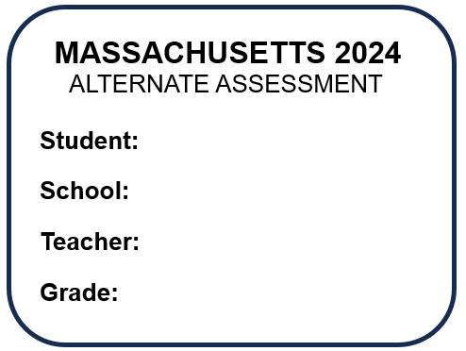
(Further instructions on how to pack unused material available with shipment.)
- Schedule your school’s pick-up of MCAS-Alt materials.
Schedule a UPS pick-up of material through the MCAS service center no later than 2:30 p.m. on Wednesday, March 27. UPS must pick up all MCAS-Alt materials no later than 5:00 p.m. on Thursday, March 28. You are encouraged to schedule a UPS pick-up any time after March 14.
- Retain copies of documents (i.e., packing slips, material summary, the printout of PCPA, UPS tracking numbers, and confirmations).
- Complete Part 2 of the PCPA. Doing so provides assurances that all information is accurate, authentic, and complete for each student.
Remember to report MCAS-Alt irregularities by contacting the Department at 781-338-3625 or by email at mcas@doe.mass.edu. The Department may request a local fact-finding investigation into the alleged irregularity and a written report based on the results of the investigation within an established timeline.

Scoring the MCAS-Alt
After the MCAS-Alt is submitted each spring, it is reviewed and scored at a scoring center sponsored by the Department and by its test contractor. The Department’s Guidelines for Scoring the MCAS-Alt provide detailed information on the scoring process used to review and rate each student’s assessment. Scoring occurs each April and early May under the Department’s direct supervision, using trained and qualified scorers. Scorers are monitored continually for their accuracy and consistency.

Instructions for Viewing and Downloading MCAS-Alt Preliminary Results
To view the MCAS-Alt Feedback Forms (FFs) in mid-June from the previous spring, principals should:
- log in to the Department’s Security Portal
- click on Application List
- choose DropBox Central
- click on MCAS 2024 Data
- choose school name (cannot be in the district view)
- find MCASalt_FeedbackForms2024
- click on MCASalt_FeedbackForms2024 and download the PDFs to distribute to teachers for review
For assistance logging in, see your district or organization Directory Administrator.

MCAS-Alt Score Appeals
Once preliminary results are reported on the Department’s Security Portal in mid-June, a principal or their designee may submit a score appeal if there is evidence that an assessment was scored incorrectly, and a copy of the evidence was kept at school for review.
The deadline for submission of score appeals is 5:00 p.m. on Friday, June 21, 2024.
The following materials must be reviewed by the principal, director, or superintendent when submitting a score appeal:
- the MCAS-Alt Feedback Form (FF) from the scored assessment, available in schools’ DropBox the week of June 10, 2024
- the photocopy of the evidence, kept by the school, to support a claim that the score on the FF does not reflect an accurate score based on the scoring rubric
Please consult the frequently asked questions about MCAS-Alt score appeals.
Results of MCAS-Alt score appeals will be mailed to schools by the end of July. Results are posted in mid-September and reflect changes based on discrepancies reported to the Department and the findings of MCAS-Alt score appeals. Scored student binders are returned to schools in September and must be stored securely. (See Storage and Destruction on page 14.)

Reporting Results of the MCAS-Alt

Achievement Levels
For each student who takes the MCAS-Alt, one of the following achievement levels will be reported in each content area:

Grades 3 through High School (Alternate Achievement Standards for MCAS-Alt)
- Incomplete—Insufficient evidence and information was included to allow an achievement level to be determined in the content area.
- Awareness—Students demonstrate very little understanding of standards and core knowledge topics contained in the Massachusetts curriculum framework for the content area. Students require extensive prompting and assistance, and their performance is mostly inaccurate.
- Emerging—Students demonstrate a simple understanding that is below grade-level expectations of a limited number of standards and core knowledge topics contained in the Massachusetts curriculum framework for the content area. Students require frequent prompting and assistance, and their performance is limited and inconsistent.
- Progressing—Students demonstrate a partial understanding that is below grade-level expectations of selected standards and core knowledge topics contained in the Massachusetts curriculum framework for the content area. Students are steadily learning new knowledge, skills, and concepts. Students require minimal prompting and assistance, and their performance is basically accurate.
Grades 3−10 (Grade-Level Achievement Standards for MCAS):
- Partially Meeting Expectations—Students performing at this level on this test partially meet grade-level expectations for knowledge, skills, and understanding. These students may need coordinated assistance and/or additional instruction to succeed at the next grade level.
- Meeting Expectations—Students performing at this level on this test meet grade-level expectations for knowledge, skills, and understanding, and are academically prepared to succeed at the next grade level.
- Exceeding Expectations—Students performing at this level on this test exceed grade-level expectations for knowledge, skills, and understanding, and are academically well-prepared to succeed at the next grade level.

School and District Results
District-level results include achievement-level results for students attending each school in a district, as well as for those students who reside in the district and attend publicly funded out-of-district placements, such as educational collaboratives or approved and unapproved private special education schools.
To meet federal requirements for reporting, both aggregated and disaggregated results of statewide assessments must be reported for students taking the MCAS and MCAS-Alt. The results of MCAS-Alt are included in school, district, and statewide reports of MCAS results as achievement levels only.
The alternate achievement levels of Incomplete, Awareness, Emerging, and Progressing will be included in the lowest achievement level for school and district reporting.

Parent/Guardian Reports
In early fall, districts receive shipments of MCAS-Alt Parent/Guardian Reports, which provide a detailed description of a child’s score in each area of the MCAS-Alt scoring rubric and an overall achievement level in each subject.
Districts are responsible for sending a parent/guardian report to the home of each student who took the MCAS-Alt. If the student is also reported as an English learner, a copy in the student’s home language must also be sent. Print copies of the translations of the report shell in the state’s most frequently spoken languages are provided in the shipment of MCAS-Alt Parent/Guardian Reports. The translated report shells are also available online.

School and District Accountability
MCAS-Alt results are included in school and district accountability, together with the results of students who took standard MCAS tests (excluding the 2019–2022 school year for which no assessments were administered and no results were reported). Details on the state’s accountability system are available. Accountability determinations for schools that administer “next-generation” MCAS tests in grades 3–8 and 10 will be based on a combination of indicators, including the following:
- average scaled MCAS scores in ELA, mathematics, and science and technology/ engineering (this replaces Composite Performance Index points used previously)
- average student growth percentile (SGP) in ELA and mathematics
- progress toward attaining English language proficiency for students reported as English learners
- percentage of chronically absent students

Table 1 shows the score scale for next-generation MCAS tests. The use of average scaled MCAS scores as an accountability indicator necessitates assigning an average scaled score to the results of students who took the MCAS-Alt in each subject, as well as students who submitted grade-level and competency portfolios, as shown in Table 2.

Table 1
MCAS Tests
Scaled Score Ranges
Standard MCAS  Achievement level | Scaled Scores
Not Meeting Expectations (NM) | 440–469
Partially Meeting Expectations (PM) | 470–499
Meeting  Expectations (M) | 500–529
Exceeding Expectations (E) | 530–560

Table 2
MCAS Scaled Score Equivalents for MCAS-Alt
ELA and mathematics (grades 3–10) and STE (grades 5 and 8 only)
MCAS-Alt Achievement Level,  based on alternate achievement standards | Assigned MCAS Scaled Score Equivalent
Incomplete (INP) | 455
Awareness (AWR) | 470
Emerging (EMG) | 485
Progressing (PRG) | 500

Storage and Destruction of Returned MCAS-Alt Binders
In September of each year, the Department returns scored MCAS-Alt assessment binders to the school from which they were submitted the previous spring.
Once returned, an MCAS-Alt assessment becomes part of a student’s temporary record and must be kept by the school in a secure location. Under the Massachusetts Student Records Regulations, a temporary record contains everything not in the transcript that is “clearly of importance to the educational process.”
Principals or their designees are required to periodically review temporary student records, and to destroy portions that are “misleading, dated, or irrelevant.” Before destroying these records, schools must give parents and eligible students written notice of the intent to destroy records, and of the parent’s right to receive copies of these records before they are destroyed (603 CMR 23.06(2)).
Regardless of the obligation to review and periodically purge temporary records of “misleading, dated, or irrelevant” documents, schools must destroy students’ temporary records no later than seven years after the student transfers, graduates, or withdraws from public school (i.e., a student’s temporary records must be destroyed within seven years after the student exits). However, schools may destroy “misleading, dated, or irrelevant” documents before this time by providing written notice to the student and his/her parent of the approximate date of the destruction of the record and of their right to receive these materials in whole or in part before their destruction.
The Department recommends the following periods for schools to retain MCAS-Alt assessments after the Department has returned them to the schools:
- grades 3−8 ELA and Mathematics assessments: retain two years after the return of assessments to the school.
- grades 5 and 8 Science and Technology/Engineering (STE) assessments:
  - retain three years after grade 5 STE assessments are returned to school.
  - retain two years after grade 8 STE assessments are returned to school.
- high school ELA, Mathematics, and STE assessments: retain two years after the student exits public education.
Despite these recommendations, schools and districts should be aware of circumstances in which it may be prudent to retain MCAS-Alt assessments longer than the above recommended periods and treat the destruction of MCAS-Alt assessments for specific students on a case-by-case basis. However, in all cases, records must be destroyed or given to the parent within the seven years described above.
Please Note:
Districts are reminded that they must furnish a copy of the content in the student’s MCAS-Alt binder to the eligible student or parent upon request, per (603 CMR 23.07(2)). Additionally, when a student is transferring from one Massachusetts district to another, the Department recommends that the previous district send the student’s current and/or most recent MCAS-Alt to the new district.

Frequently Asked Questions
Q. If a student who is designated for the MCAS-Alt moves into my school late in the school year, what should we do?
- If a student moves in from another Massachusetts district and is scheduled to take the MCAS-Alt, the receiving school is responsible for completing and submitting the assessment to the best of their ability. The Department encourages the receiving school to contact the sending school and arrange for the student’s assessment-in-progress to be sent to the receiving school.
If a student has moved to a Massachusetts school from another state, the teacher should attempt to collect evidence in the time remaining before the submission deadline and submit what has been collected.
- Is there a date beyond which a transfer student would be exempt from participating in the MCAS-Alt?
- No, there is no cut-off date beyond which a student is exempt from the assessment, unless the student moves in after the submission deadline of March 29, 2024.
- How does a transfer student’s score affect my school’s results?
A. The transfer student will be counted either as a participant or non-participant in the new school, depending on whether their MCAS-Alt is submitted. The achievement level results will be reported to the new school, but if the student has not attended the school for an entire academic year, the student’s results are included for accountability only at the district level.
- How should the school report a medically absent student?
- The Student Identification Booklet includes a box entitled “Not Tested Status” that must be completed if a student will not participate in the assessment for a medical reason. Documentation must be kept at the school for students who did not participate for medical reasons. An absent student will be reported as a non-participant in the assessment.
- Must the district provide a copy of the completed assessment to the parent, if requested?
- Parents are required to be invited to view their child’s MCAS-Alt before it is submitted each year and to sign a Verification Form. A copy of the contents of their child’s binder must be furnished by the district to the parent/guardian if requested.
- May a parent prohibit their child’s school from submitting the MCAS-Alt for a student who has been designated by their IEP team to take the MCAS-Alt?
- Schools are expected to submit an MCAS-Alt for each student designated for an alternate assessment in their last approved IEP. Parents may not restrict their child’s ability to participate in the MCAS-Alt, nor may parents restrict the school from submitting the student’s alternate assessment.

Common Questions for Schools Implementing the Definition of “Students with the Most Significant Cognitive Disability.”
- Question: Will students be able to take the MCAS- Alt in some areas and the standard MCAS in other areas?
Answer: No. Students who meet the definition of the most significant cognitive disabilities only meet those criteria if they present with global delays. Students with near-grade level skills must participate in the standard MCAS tests with accommodation.
- Question: What if my student is an English Language Learner?
Answer: If the student is an English learner and the student meets the definition of a student with the most significant cognitive disabilities, they may be eligible for participation in the Alternate ACCESS for ELLs. See Participation Guidelines: Which Students Should Take the Alternate ACCESS for ELLs? for further guidance.
- Question: Is the definition of Students with the Most Significant Cognitive Disabilities, a new disability category?
Answer: No. Every Student Succeeds Act, the Federal Law, requires that only students with the most significant cognitive disabilities be designated as eligible by IEP Teams for Alternate Assessments based on Alternate Academic Achievement Standards (AA-AAAS). The Department developed the students with the most significant cognitive disabilities definition to meet federal regulations.
- Question: This definition requires that students should be performing at least 2 standard deviations below the mean in cognitive, academic, and adaptive behavior domains to meet some of the eligibility criteria for an MCAS-Alt. Do I need to reevaluate students now to gather this information for students with the MCAS-Alt listed on their IEPs currently?
Answer: No. Teams do not need to conduct a full reevaluation, but Teams should take steps to obtain evaluation information, if missing, on the required domains of cognitive, academic, and adaptative behavior.
- Question: What happens if an IEP Team determines that a student with a disability is no longer eligible for the MCAS-Alt because the student does not meet the definition of a Student with the Most Significant Cognitive Disabilities?
Answer: The IEP Team must propose a standard MCAS participation with or without accommodations.
- Question: Does the “stay put” provision apply to MCAS participation?
Answer: Yes, IEP Teams should seek to resolve differences when an IEP is rejected in part or in full.
- Question: What if my student is eligible to take the MCAS-Alt, based on the criteria, but the team would like them to participate in the standard MCAS with accommodations?
Answer: The IEP team should then assign the standard MCAS test with or without accommodations.

Appendix A: Completing the Student Information Booklet (SIB)

Page 1
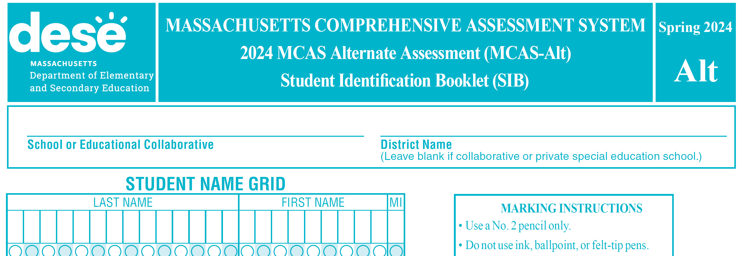
Student’s Name
Page 2

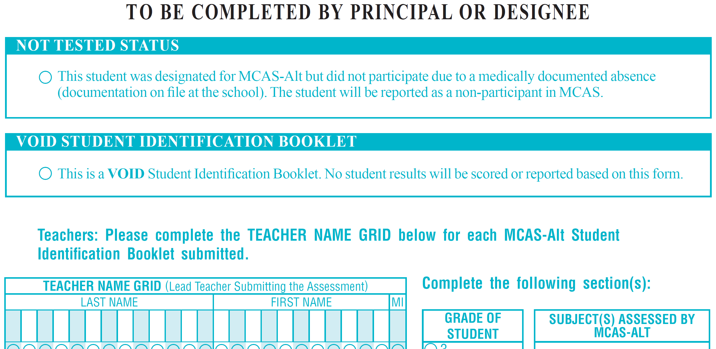
Teacher’s Name

Alternate Assessment Participation Tool (Companion Document)
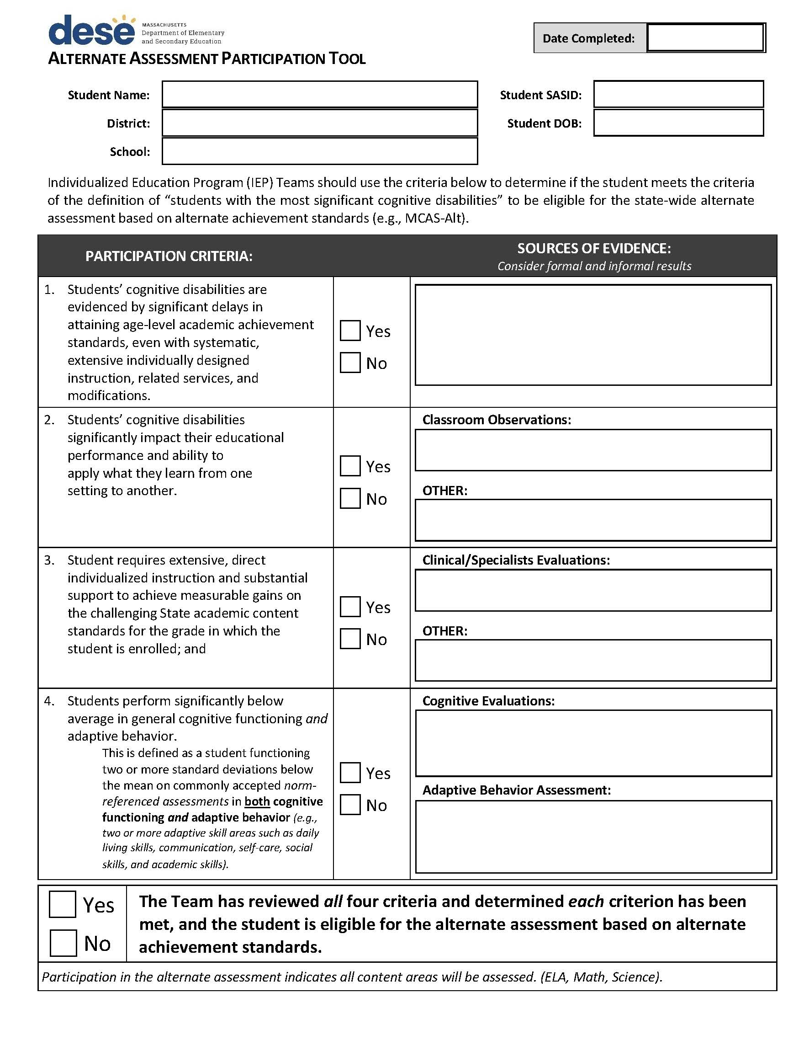
IEP teams will upload this document to the MCAS-Alt File Exchange located in the DropBox in the Security Portal.

