2021 Grade-level portfolio work description
Mathematics - Number and Fractions 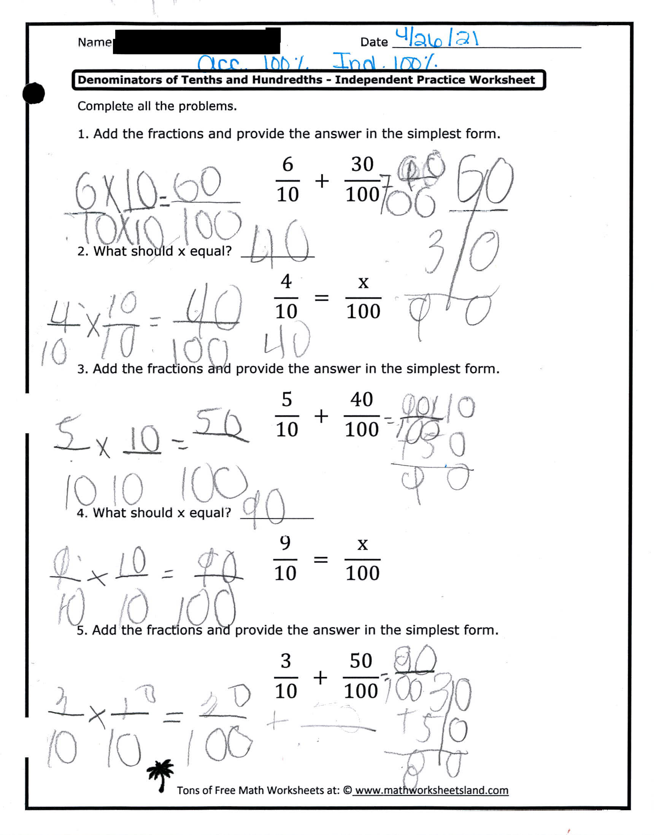2021 Grade-level portfolio work description
Mathematics - Number and Fractions Work sample

Matching fractions worksheet work sample

fractions