

DESE Policy Brief • December 2019

# A First Look at School-Level Expenditures

With the release of the Massachusetts Department of Elementary and Secondary Education’s [2018–19 school report cards](http://reportcards.doe.mass.edu/), parents and administrators now have access to information on school-level spending for all Massachusetts public schools. These data start to shed light on how funds are distributed among schools that differ by enrollment size, grades served, and student need, among many other factors.

Most previous data and research have centered on education funding and spending at the district level. These new data provide insights into spending at individual schools. This brief aims to provide context for these data by assessing factors that affect school spending levels within districts and across Massachusetts.

In addition, this brief highlights issues around equitable resource allocation across schools. Allocating resources *equally* among schools is not necessarily *equitable*, because high-need students (i.e., students who are economically disadvantaged,1 students with disabilities, and English learners) may require more resources to achieve academic success. In this brief, we assess whether schools with higher shares of high-need students spend more per pupil, both across the state and within a given school district.

A text box listing the two authors of this report:
Kristin Blagg and Victoria Lee of the Urban Institute 

We address the following questions:

* How much does Massachusetts spend on its schools?
* What does previous research tell us about district- and school-level spending?
* How does Massachusetts allocate state aid for education to districts?
* How does school-level spending vary within districts and across the state relative to student need?
* How should educators and the public fairly compare school spending levels?

**Key Findings about School-Level Expenditures**

Massachusetts public elementary and secondary schools spent $16.2 billion in the 2017–18 school year across local, state, and federal funding sources.[1] Schools vary substantially in how much they spend per pupil. Most schools spend between $12,000 and $18,000 per pupil, though some schools, especially vocational high schools, spend substantially more.3

**In this brief, we highlight findings from the research literature on school funding:**

* Recent national evidence, based on district spending data, shows that education expenditures matter for student outcomes.
* Studies of school-level spending indicate that, on average, schools with higher shares of high-need students tend to spend as much as, or slightly more than, schools with lower shares of high-need students.

**We assess how Massachusetts schools spend available funds relative to student needs:**

* Massachusetts allocates state education aid based on student needs, community wealth, and local labor costs. Although the formula allocates more state money to districts and students with greater need, districts can use local funds to spend more than what is required.
* Across the state, high schools tend to spend more per pupil than elementary and middle schools.
* To fairly compare schools with different kinds of student needs requires looking at all three high-need subgroups (economically disadvantaged pupils, pupils with disabilities, and English learners) simultaneously.
* Within districts, schools with higher shares of economically disadvantaged pupils, pupils with disabilities, and English learners spend more per pupil.
* Across the state, schools with higher shares of economically disadvantaged students spend less per pupil, unless we account for local labor costs.

**Finally, we provide questions for district and community members to ask as they consider how to use and interpret these numbers.** By asking questions about funding sources, the district’s geographical context, and the choices the district may or may not be able to make in terms of distributing dollars to schools, families and administrators learn more about school spending in their district. Over time, local leaders can develop a fuller understand what drives school-level spending, allowing them to make more informed choices.

*We note that this brief does not address questions such as how much additional spending meets student needs in the variety of circumstances found in districts, nor what may allow similar districts to spend similar amounts and have different impacts on student learning.*

## How much does Massachusetts spend on its schools?

In fiscal year 2018, Massachusetts districts spent $14.4 billion for district schools, and another $1.8 billion on out-of-district programs, for roughly 987,000 pupils.[2] This spending includes all local, state, and federal funding sources.

Massachusetts school districts report school-level expenditures for instructional expenses such as school leadership, teachers, and instructional materials. But administrative and operations costs (e.g., district administration, facilities, and benefits) are reported at the district level. To incorporate district-level services into a measure of school-level expenditures, the Department of Elementary and Secondary Education allocates district-level spending equally per pupil across all the district’s schools. These school-level expenditure data are different than school committee–approved budgets. The school-level expenditure data capture actual spending for the year and include expenditures at the district level, as well as from all funding sources. For our analyses, we look at total actual spending only at traditional public schools and school districts (we exclude charter schools). More information on our approach is available in the methodology appendix.

Across Massachusetts schools, spending ranges from about $7,300 to $38,400 per pupil. This variation could be due to many factors, such as grade span served, the needs of students enrolled in the school, specialized programming within a school, and the community the school is in. Despite this variation, roughly three-quarters of schools in Massachusetts spend between $12,000 and $18,000 per pupil **(figure 1)**.

**Figure 1. Most schools in Massachusetts spent between $12,000 and $18,000 per pupil in 2017–18; the median amount spent per pupil was $14,738**

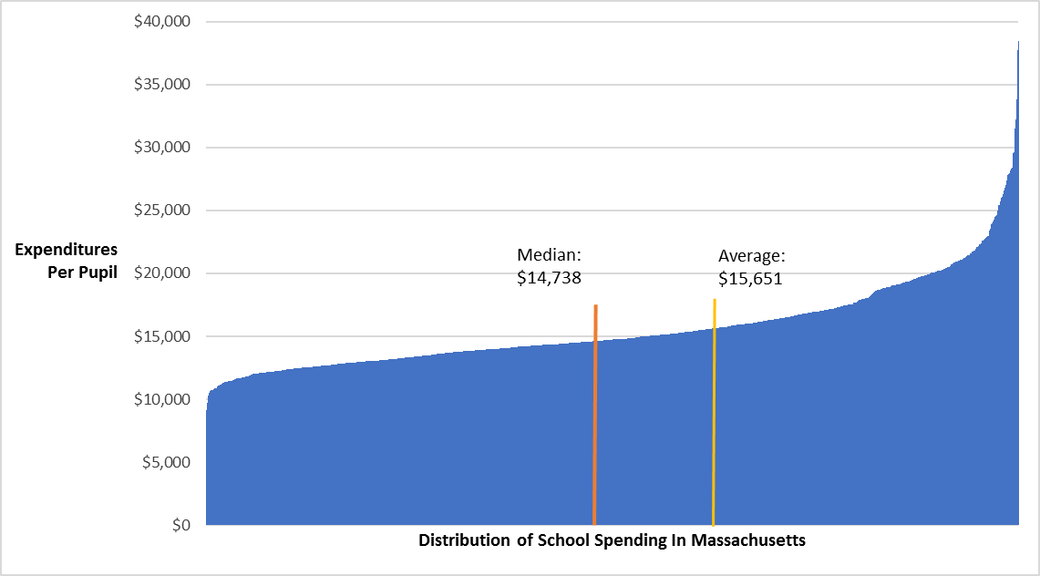

## What does previous research tell us about district- and school-level spending?

### Recent evidence based on district spending data shows that education expenditures matter for student outcomes.

Increased education spending is associated with increased student test score performance (Lafortune, Rothstein, and Schanzenbach 2018), graduation rates (Candelaria and Shores 2017), postsecondary enrollment (Hyman 2017), and earnings among children from economically disadvantaged families (Chetty and Friedman 2011; Jackson, Johnson, and Persico 2014).

Most studies looking at the effects of spending on student outcomes use district-level funding data, but researchers are increasingly looking at school-level spending. Using data from national pilot surveys, researchers have discerned trends in spending at schools within a given district, especially as spending relates to serving students with greater needs.

One of the biggest drivers of differences in expenditures within a district are the grades a school serves. An analysis of 2008–09 school spending showed elementary schools tend to have lower per student personnel expenditures relative to middle or high schools in the same district (Heuer and Stullich 2011).

### Studies of school-level spending indicate that, on average, schools with higher shares of high-need students tend to spend as much as, or slightly more than, schools with lower shares of high-need students.

Research suggests that the distribution of dollars to schools within districts tends to be neutral to slightly more equitable, such that schools with higher shares of economically disadvantaged students tend to have higher per student expenditures relative to schools in the same district with lower shares of economically disadvantaged students (Ajwad 2006; Knight 2017; Roza et al. 2007). Across the United States, poor and minority students tend to receive, on average, 1 to 2 percent more in school resources than their district peers who are not poor or are white (Shores and Ejdemyr 2017).

But districts still vary in the degree to which they direct additional dollars to schools with higher levels of disadvantaged students. In the 2008–09 school year, 37 percent of the highest-poverty schools spent less on personnel than the lowest-poverty schools in their district (Heuer and Stullich 2011). And despite increased spending levels generally, schools with higher shares of disadvantaged students still tend to have less-experienced or less-qualified teachers relative to schools with more-advantaged students in their district (Knight 2017; Malkus 2012; Rubenstein et al. 2007).

## How does Massachusetts allocate state aid for education to districts?

### Massachusetts allocates state aid based on community wealth and student need.

The state aid to education program, Chapter 70, establishes a foundation, or “adequate,” spending level for each district and defines how much of this spending target should be paid for from either state or local sources. Through Chapter 70, the state provides 30 percent of the funds spent on K–12 public education in Massachusetts.[3]

The Chapter 70 formula directs more state funding to districts with less fiscal capacity—as measured by property wealth and personal income—and higher student need. The focus of the state formula is to give students adequate and equitable access to educational success.[4] Thus, the minimum adequate funding level is higher per student in districts that have larger concentrations of students with high needs. For example, in fiscal year 2018 the average foundation budget per pupil for districts in the quartile with the lowest share of economically disadvantaged students was $9,788, compared to $12,126 per pupil for districts in the quartile with the highest share **(figure 4)**. This difference is driven by the higher incremental rates that these districts receive through the formula. In fiscal year 2018, for example, the incremental rate for economically disadvantaged students ranged from $3,817 for districts with the lowest concentrations of poverty (less than 9 percent of district enrollment) to $4,180 for districts with the highest concentrations (47 percent or more of district enrollment).

The calculation of adequate funding levels accounts for student characteristics, including students who are economically disadvantaged, students who are English learners, and the student’s grade level. The Chapter 70 formula also provides a base amount for special education services, which is supplemented by the state’s special education reimbursement (“circuit breaker”) program for high-cost students.

The Chapter 70 formula includes a wage adjustment factor that accounts for differences in the cost of labor across the state. The unadjusted wage adjustment factor varies substantially by town, from 79 percent of the typical statewide labor cost to more than 110 percent of the typical cost, and more generally by region **(figure 2)**.[5]

**Figure 2. Labor market costs vary across Massachusetts by town and by region** Figure 2: This is a city/town map of Massachusetts that color codes each city/town based on their Wage Adjustment Factor as a percent of the state average. The groups shown are:

103% to 113%
98% to 103%
89% to 98%
85% to 89%
79% to 85%

***Despite a formula that allocates more state money to those who have greater needs, some districts spend more than their required level.***

Massachusetts measures local wealth in the Chapter 70 formula using a factor called “combined effort yield” (going forward, we refer to this as “community wealth”), which calculates the share of the foundation budget that could be funded locally based on the district’s personal income and property values. In essence, this factor is the district’s budget, based on student need, relative to its wealth. Similar to local labor costs, community wealth varies widely across the state. Lawrence has the lowest community wealth at 13 percent of foundation budget, while some towns on Cape Cod and the Islands have community wealth higher than 150 percent **(figure 3)**.

**Figure 3. District wealth, relative to student need, varies across Massachusetts by district and by region**

Figure 3: This is a school district map of Massachusetts that color codes each district based on their community wealth as a percent of their foundation budgets. The groups shown are:

115% to 391%
84% to 115%
65% to 84%
50% to 65%
13% to 50%
No calculated community wealth

The Chapter 70 formula accounts for student needs, community wealth, and local labor costs and then sets a district’s required spending level and the share funded by state aid. Although communities cannot spend less than what is required, each community can set its local budget higher than its required local contribution. As a result, districts with more community wealth tend to spend more per pupil than districts with less wealth (Jones, Berger, and Hatch 2018).

Foundation budgets are designed to address student need, such that the average foundation budget per pupil is higher in districts with larger shares of needy students. State funding—determined by both need and community wealth—tends to be higher in districts with higher shares of economically disadvantaged pupils. A Department of Elementary and Secondary Education analysis, which divides districts into weighted quartiles based on their share of economically disadvantaged pupils, demonstrates this trend **(figure 4)**. But because wealthier communities can spend above what is required, actual spending per pupil is not consistently progressive.

**Figure 4. Chapter 70 funding and state aid is allocated progressively across districts, but actual spending varies because districts may spend more than what is required**

Figure 4: This is a bar graph that groups school districts into wealth quartiles based on their economically disadvantaged enrollment as a percentage of their total enrollment (low concentration to high concentration), showing each groups: foundation budget per pupil, state aid per pupil, and actual spending per pupil.

Districts with highest concentrations of economically disadvantaged students have the highest foundation budget and state aid per pupil amounts, while districts with the lowest concentrations of economically disadvantaged students spend more per pupil than districts with the highest concentrations. 

## How does school-level spending vary across the state relative to student need?

### High schools, particularly vocational technical high schools, tend to spend more than elementary and middle schools.

In line with national estimates, the average Massachusetts non-vocational high school spends about $600 more per pupil than the average elementary school **(figure 5)**. The average elementary school spends slightly more than the average middle school: about $350 more per pupil. Vocational technical high schools, which usually have smaller classes and higher equipment and facilities costs, spend nearly $4,500 more per pupil than non-vocational high schools.

**Figure 5. Average per pupil spending is higher in high schools relative to elementary or middle schools**

Figure 5: This is a bar graph that shows average per pupil spending by school type. It shows that average per pupil spending is higher in high schools relative to elementary or middle schools.

Early elementary school: $15,346 per pupil
Elemetnary school: $15,511 per pupil
Middle school: $15,147 per pupil
High school: $16,096 per pupil
Vocational high school: $20,548 per pupil


A school’s grade span can affect per pupil spending, but many Massachusetts districts have only one school in a given grade span, particularly at the middle and high school level. Just 23 of our 321 sample districts have more than one high school, but most districts have more than one elementary school **(figure 6)**.

**Figure 6. Number of districts with two or more schools in a grade span to compare**

|  |  |  |  |  |  |  |
| --- | --- | --- | --- | --- | --- | --- |
|  | Cannot Make Within-District Comparisons | | | Can Make Within-District Comparisons | | |
| Grade Span | Districts | Schools | Students | Districts | Schools | Students |
| Elementary Schools | 115 | 67 | 21,604 | 206 | 999 | 417,460 |
| Middle Schools | 272 | 139 | 87,840 | 49 | 145 | 82,596 |
| High Schools | 298 | 231 | 211,405 | 23 | 83 | 72,600 |

***Note****: Some districts have no elementary schools because they are secondary districts, and other districts have only elementary grades. All 321 districts are included in each grade span count regardless of whether they could have a school in that grade band.*

This figure indicates that, for example, 206 districts can make within-district comparisons of elementary schools, and among these districts, 999 schools educate 417,460 pupils.

Though most Massachusetts districts have few schools, a majority of the state’s pupils are enrolled in large districts with multiple schools in a given grade span. For the districts included in figure 6, 95 percent of elementary students are enrolled in districts with more than one elementary school, 48 percent of middle schoolers are enrolled in districts with more than one middle school, and 26 percent of high schoolers are enrolled in districts with more than one high school.

Because spending varies among elementary, middle, and high schools, we conduct our analyses controlling for the grade span each school serves.

***To compare school spending, we use a methodology that accounts for multiple dimensions of student need.***

Schools with higher shares of economically disadvantaged pupils, pupils with disabilities, and English learners may provide specialized programming and additional supports beyond typical classroom instruction, meriting additional expenditures. To determine whether schools with higher shares of high-need students generally spend more, we evaluate school spending relative to these multiple dimensions of student need.

We find that different types of student needs are correlated within Massachusetts schools. Schools with higher shares of economically disadvantaged students also typically have higher shares of English learners and, to a lesser degree, higher shares of students with disabilities. **Figure 7** demonstrates this trend in the state’s elementary schools, grouping schools into quartiles by the share of pupils who are economically disadvantaged. In the highest quartile (elementary schools with more than 46 percent economically disadvantaged pupils), 27 percent of pupils are English learners, compared with just 4 percent in schools in the lowest quartile (with less than 13 percent economically disadvantaged pupils). Similarly, schools in the highest quartile of economic disadvantage report that, on average, 21 percent of their pupils have disabilities, 4 percentage points higher than for schools in the lowest quartile.

**Figure 7. Elementary schools with high shares of pupils who are economically disadvantaged are more likely to have high shares of English learners and pupil with disabilities**

Figure 7: This figure includes two bar graphs. The first bar graph shows that as the average share of English learners in elementary schools increases, the concentration of economically disadvantaged students in the school increases.

Lowest quartile share of economically disadvantaged students: 4% English learners
Second quartile: 4% English learners
Third quartile: 11% English learners
Highest quartile: 27% English learners


Figure 7: This is the second bar graph in Figure 7. This graph shows that as the average share of students with disabilities in elementary schools increases, the concentration of economically disadvantaged students in the school increases.

Lowest quartile share of economically disadvantaged students: 17% students with disabilities
Second quartile: 19% students with disabilities
Third quartile: 21% students with disabilities
Highest quartile: 21% students with disabilities

***Statistical Methodology***

*Our analyses describe differences in spending when the share of students in a subgroup increases by one standard deviation. A standard deviation describes the amount of variation around the measure’s average and is calculated so that two-thirds of the data fall within one standard deviation of the mean and 95 percent fall within two standard deviations.*

***Figure A. Standard deviations for pupil shares with mean, minimum, and maximum***

|  |  |  |  |  |
| --- | --- | --- | --- | --- |
|  | ***Mean*** | ***Minimum*** | ***Maximum*** | ***Standard Deviation*** *(Percentage Points)* |
| *Economically Disadvantaged Pupil Share* | *30%* | *0%* | *92%* | *21 p.p.* |
| *English Learner Share* | *10%* | *0%* | *83%* | *13 p.p.* |
| *Pupils with Disabilities Share* | *19%* | *0%* | *50%* | *7 p.p.* |

*Using standard deviations allows us to compare the likely increase in spending associated with a similarly sized increase in any of the three high-need subgroups in a school. A standard deviation increase in the share of pupils who are economically disadvantaged is equivalent to a 21 percentage-point increase (box figure A). This number is large because of the wide variation across schools (from 0 percent to 92 percent) in the share of pupils who are economically disadvantaged (box figure B).a Although the data are not normally-distributed, standard deviations allow us to show changes of similar magnitude across the range of possible school-level values for economically disadvantaged. By contrast, a standard deviation increase for English learners is 13 percentage points, and for pupils with disabilities, 7 percentage points.*

***Figure B. Standard Deviations for Shares of Economically Disadvantaged Pupils***

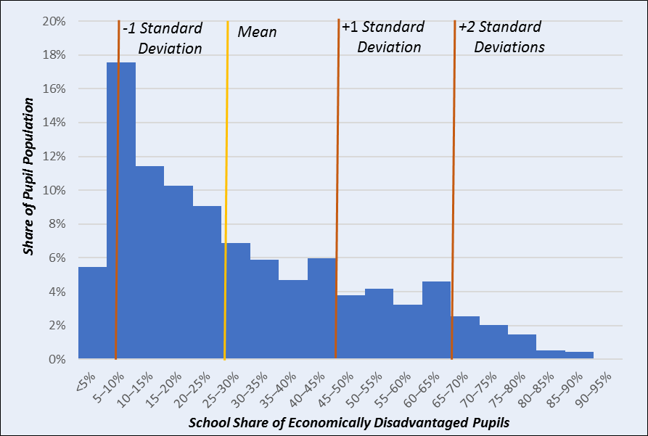

*The comparisons that follow use regression analyses with standard deviations and control for factors that affect school spending, such as grade span and student need subgroups. Using this approach, we can account for the fact that different schools serve different grade spans and different student populations and then evaluate the relationship between each factor and per pupil spending. These analyses do not, however, adjust for all factors that might drive spending. For example, they do not account for the tenure and seniority of teaching staff, which may affect teaching expenditures in each school, or an individual school’s need to provide specialized student services, such as support for homeless students or for students with more severe special needs.*

*a Note that because this analysis does not include students enrolled in charter schools, the share of students enrolled in schools with the highest concentrations of poverty is lower than it would be if they were included.*

***Within districts, schools with higher shares of student need spend more per pupil.***

Our first analysis looks at average differences in school spending within each school district in Massachusetts. To examine school-level expenditures within districts, we control for grade span to account for differences in spending that may be because of the grades of students served, and we control for the share of high-need groups in each school. Because we look at differences within school districts, districts with only one school in a grade span do not contribute to our estimates of spending for subgroups of student need within districts.

We would expect that a school with a high share of economically disadvantaged pupils and a high share of English learners might spend more than a school with a high share of economically disadvantaged pupils and a low share of English learners. To disentangle these relationships, we control for differences in the share of all three types of student need at a school. With this analysis, we can estimate, for example, whether schools within a district that have the same share of economically disadvantaged pupils spend more when they have higher shares of English learners or pupils with disabilities.

Within districts, schools tend to spend more as the share of economically disadvantaged pupils, pupils with disabilities, and English learners increases.

**Figure 8** shows the increase in per pupil school-level spending associated with greater enrollment of different groups of students. These results show that, for example, within the same grade span, a school that has a 1 standard deviation (21 percentage-point) higher share of economically disadvantaged pupils spends, on average, $171 more per pupil relative to a school in the same district with similar shares of pupils with disabilities and English learners. Similarly, a 1 standard deviation (7 percentage-point) increase in the share of pupils with disabilities is associated with schools spending $572 more per pupil, holding all else equal. And a 1 standard deviation (13 percentage-point) increase in the share of English learners is associated with a $109 per pupil increase in spending.

These results provide a broad view of trends in school spending within districts that may not always align with what we would expect. If, for example, the state calculated a foundation budget for each school (which it does not), we would assume a higher level of spending variation within districts between schools with lower and higher concentrations of poverty than what this analysis shows. Not all districts may fit this pattern for a variety of reasons, including limited resources, contractual obligations, and historic spending trends. Further, it is unclear to what extent additional spending meets student need in the variety of circumstances found in districts, nor what may allow similar districts to spend similar amounts and have different impacts on student learning.

**Figure 8. Looking at all three student subgroups together—economically disadvantaged pupils, pupils with disabilities, and English learners—we find that districts spend more on schools that have higher shares of these needs**

Figure 8: This is a bar graph that shows the estimated additional school level per pupil spending within districts per standard deviation increase in the share of each subgroup population.

Economically disadvantaged students: $171 more per pupil
Pupils with disabilities: $572 more per pupil
English learners: $109 more per pupil spending

***Across the state, schools with higher shares of economically disadvantaged students spend less per pupil, unless we account for local labor costs.***

Within districts, schools with higher shares of pupils who are economically disadvantaged, have disabilities, or are English learners tend to spend more. However, although a given district may spend more in schools with higher shares of student need, all schools in the district may have lower levels of spending than schools in other districts.

Previous analysis has shown that districts with higher local incomes and property valuations tend to spend more on average, while other districts are funded locally at a level closer to the minimum required by the Chapter 70 aid program. Statewide school-level spending relative to higher shares of needy students could be affected by the constraints that some district leaders face in terms of funding from state and local sources.

Our next analysis looks at spending differences across the state, rather than looking at within-district differences. The blue bars in **figure 9** show the association between school per pupil spending and our three student need subgroups. They show that schools with higher shares of economically disadvantaged pupils spend *less* per pupil if we only control for grade span spending differences, $505 per pupil less on average when the share of economically disadvantaged students increases by one standard deviation (21 percentage points). However, as shown in Figure 2 above, local labor costs vary across the state, which could affect the resources available for the same dollars. The orange bars show predicted per pupil school spending when controlling for local labor costs. On average, *allowing for local labor costs*, schools spend about $290 more per pupil when the share of economically disadvantaged students increases by one standard deviation.

For English learners, per pupil spending decreases after accounting for local labor costs. When the share of English learners increases by one standard deviation (13 percentage points), the blue bar indicates that spending tends to increase by $942 on average if we only take grade span into account, but after adding a control for local labor costs schools spend only $335 more on average. One possible reason for this finding that a large share of the state’s English learners may be enrolled in districts with high local labor costs, such as in the greater Boston area.

Without labor cost controls, data on spending in schools across the state indicates that districts with higher shares of economically disadvantaged students tend to spend less in their schools overall. Despite higher state aid allocations to districts with higher need, spending in schools depends also on the level to which municipalities choose to fund their school districts above the required minimum. Lower district labor costs are also correlated with higher shares of economically disadvantaged students. As the next section indicates, lower salaries may allow these districts to support relatively higher staffing levels, but this may also mean that these districts are less able to retain experienced teachers who can earn higher salaries in nearby districts.

**Figure 9. Controlling for local labor costs makes a big difference in how we see spending vary across the state relative to student needs**

Figure 9: This is a bar graph that shows the estimated additional school level per pupil spending across districts per standard deviation increase in the share of each subgroup population with grade span controls and with grade span and labor cost controls.

With grade span controls:
Economically disadvantaged students: $505 less per pupil
Pupils with disabilities: $974 more per pupil
English learners: $942 more per pupil

With grade span and labor cost controls:
Economically disadvantaged students: $290 more per pupil
Pupils with disabilities: $972 more per pupil
English learners: $335 more per pupil





***Other factors affecting school-level expenditures include teacher salary differences and federal funding allocations.***

**Teacher Salaries**: Across the state, schools with higher shares of economically disadvantaged pupils tend to have lower average teacher salaries, after controlling for local labor costs (appendix figure 1). One factor that could potentially affect the distribution of average teacher salaries across schools is that Massachusetts school districts generally have collective bargaining agreements, with a salary schedule that increases compensation based on time on the job and highest degree earned. Therefore, a school or district with less experienced teachers would likely have lower average salaries. However, the average can be affected by other factors, such as higher or lower relative district salary scale, or a particular distribution of teachers across the salary range, so this generalization might not hold in all cases.

There is also data that indicates that students with higher needs tend to have more inexperienced teachers. According to data from the MA Department of Elementary and Secondary Education, as of 2017, economically disadvantaged students, students of color, and English learners were disproportionately assigned to an inexperienced teacher (those with fewer than three years’ experience) compared with their peers. Economically disadvantaged students are 29 percent more likely to have an inexperienced teacher than other students, students of color are 43 percent more likely, and English learners 39 percent more likely.b This pattern is consistent with previous national studies that find that schools with more disadvantaged students tend to have less-experienced or less-qualified teachers relative to more-advantaged students in their district (Knight 2017; Malkus 2012; Rubenstein et al. 2007). We find that an increasing number of teachers per 100 students correlates with lower average salaries (appendix figure 2). Lower average salaries at schools with more teachers per pupil may reflect disparities in teacher experience and credentials across schools.

Taken together, these findings tend to indicate that schools with higher shares of economically disadvantaged students may have lower average salaries, less experienced teachers, but also more teachers per 100 pupils than other schools. Offsetting the possible advantage of having more teachers is that as teachers gain experience they may tend to move to other districts with higher pay scales, contributing to a cycle of lower average salaries due to inexperienced teachers.

**Federal Grants**: Although most of the revenue for K–12 education in Massachusetts comes from a combination of state and local sources, a small but substantial share of revenue comes from the federal government. Federal grant funds, about 5 percent of total spending, are almost entirely directed toward districts and schools with high-need students (e.g., the Every Student Succeeds Act Title IA for economically disadvantaged students, the Individuals with Disabilities Education Act for students with disabilities, and the Every Student Succeeds Act Title IIIA for English learners).

Elementary schools tend to receive a higher share of their expenditures from federal sources relative to middle and high schools. Urban districts receive a higher share of their expenditures from federal sources overall; the share of federal dollars spent in high schools in urban districts is nearly as high as the share spent in elementary schools across the state.

b Massachusetts Plan for Equitable Access to Excellent Educators, 2015–2019, accessed at <http://www.doe.mass.edu/educators/equitableaccess/plan.html>.

## How should educators and the public fairly compare school spending levels?

These findings provide a foundation for discussing the distribution of school-level expenditures. Importantly, comparing school-level expenditures in Massachusetts requires careful consideration of a school’s context. Such factors as local labor market costs, community wealth, a school’s demographic composition, and the grade span it serves can all influence school-level per pupil spending. Controlling for these contextual factors, we find that schools with higher levels of student need tend to spend more per pupil.

Despite the average trend of increased school spending for high-need subgroups across the state, not all districts may fit this pattern. Individual districts may be able to improve resource allocation to better support schools with higher shares of student need.

Research shows that increased spending can affect short- and long-run student outcomes, particularly for economically disadvantaged students. As Massachusetts continues to report on school-level expenditures, longitudinal data will allow researchers to see how districts may change their spending and to analyze student performance trends to potentially uncover new links between school-level expenditures and student outcomes.

Our findings suggest that superintendents, policymakers, and families should consider the following questions as they seek to understand school-level spending data:

Expenditures Relative to Student Need: The results show that districts generally spend more on schools with higher shares of student need when we look at spending within districts. How much is this evident, or not evident, in your home district and schools?

Local Resources: Districts can spend above their allocation, but some districts have more community wealth to draw on than others. Even districts with similar levels of community wealth can choose to invest different amounts in their schools. How much does community wealth affect spending in your home district and schools?

Federal Resources: Federal funds typically go to students with the most need. How are federal funds spent in schools in your home district?

Other Factors: Teachers are a key resource, whether considered in budget or staffing terms. How might staffing ratios, local labor costs, or teacher characteristics affect spending in your home district and schools?

## Additional resources from the Massachusetts Department of Elementary and Secondary Education

District and school report cards are available at <http://reportcards.doe.mass.edu/>. Each includes a section called “How much does our school (or district) spend per student?” A school-level spending report with more detail is forthcoming and will be available at this website.

Teacher average salary data are available at <http://www.doe.mass.edu/finance/statistics/>.

District staff have access in Edwin to Student Learning Experiences reports that illustrate how students are assigned to teachers by student groups and by teacher characteristics. This is another way to look at equitable distribution of resources based on student needs.

RADAR (Resource Allocation and District Action Reports) Benchmarking allows users to compare 10 selected districts and compare staffing, spending, and other data, and it is available at <http://www.doe.mass.edu/research/radar/>.

# References

Ajwad, Mohamed Ihsan. “Is intrajurisdictional resource allocation equitable?: An analysis of campus-level spending data for Texas elementary schools.” The Quarterly Review of Economics and Finance 46, no. 4 (2006): 552–64.

Bal, Aydin, Amanda L. Sullivan, and John Harper. “A Situated Analysis of Special Education Disproportionality for Systemic Transformation in an Urban School District.” Remedial and Special Education 34, no. 1 (2013): 3–14.

Candelaria, Chris, and Kenneth Shores. “Court-Ordered Finance Reforms in the Adequacy Era: Heterogeneous Causal Effects and Sensitivity.” Stanford Center for Education Policy Analysis (2017).

Chetty, Raj, and John N. Friedman. “School Quality & Income Inequality: The Long-Term Effects of Early Childhood Education.” The Federal Reserve Bank of Boston (2011).

Cosentino De Cohen, Clemencia, and Beatriz Chu Clewell. “Putting English Language Learners on the Educational Map: The No Child Left Behind Act Implemented” The Urban Institute, Washington, DC (May 2007).

Heuer, Ruth, and Stephanie Stullich. “Comparability of State and Local Expenditures among Schools within Districts: A Report from the Study of School-Level Expenditures.” Office of Planning, Evaluation, and Policy Development, US Department of Education (2011).

Hyman, Joshua. “Does money matter in the long run? Effects of school spending on educational attainment.” American Economic Journal: Economic Policy 9, no. 4 (2017): 256–80.

Jackson, C. Kirabo. Does School Spending Matter? The New Literature on an Old Question. No. w25368. National Bureau of Economic Research, 2018.

Jackson, C. Kirabo, Rucker Johnson, and Claudia Persico. The effect of school finance reforms on the distribution of spending, academic achievement, and adult outcomes. No. w20118. National Bureau of Economic Research, 2014.

Jones, Colin, Noah Berger, and Roger Hatch. “Building an Education System that Works for Everyone: Funding Reforms to Help All Our Children Thrive.” Massachusetts Budget and Policy Center (2018).

Knight, David S. “Are school districts allocating resources equitably? The Every Student Succeeds Act, teacher experience gaps, and equitable resource allocation.” Educational Policy (2017): 0895904817719523.

Lafortune, Julien, Jesse Rothstein, and Diane Whitmore Schanzenbach. “School finance reform and the distribution of student achievement.” American Economic Journal: Applied Economics 10, no. 2 (2018): 1–26.

Malkus, Nathaniel Nelson. “Beneath the District Averages: Intradistrict differences in teacher compensation expenditures.” PhD diss., 2012.

Massachusetts Department of Elementary and Secondary Education. “School Finance: Chapter 70 Program.” September 2018.

Roza, Marguerite, Kacey Guin, Betheny Gross, and Scott Deburgomaster. “Do districts fund schools fairly? In Texas, differences are larger within districts than between.” Education Next 7, no. 4 (2007): 68–74.

Rubenstein, Ross, Amy Ellen Schwartz, Leanna Stiefel, and Hella Bel Hadj Amor. “From districts to schools: The distribution of resources across schools in big city school districts.” Economics of Education Review 26, no. 5 (2007): 532–45.

Shores, Kenneth, and Simon Ejdemyr. “Pulling back the curtain: Intradistrict school spending inequality and its correlates.” Available at SSRN 3009775 (2017).

# Appendix

**Methodology**

For this analysis, we use per pupil school-level spending data from the 2016–17 school year for traditional public schools (we exclude charter schools). A pupil is defined as the full-time equivalent count based on actual days the student spent in the school over the year. Spending per pupil is reported at the school level for such expenses as school leadership and professional development, but administrative costs (e.g., the costs of a central office) are reported at the district level. For this report, we assume these district-level administrative costs are equally distributed, per pupil, at the school level, and we look at overall spending per pupil. We look at total spending, including funds from local, state, and federal sources.

Our analyses exclude alternative schools and schools designated for students with disabilities and schools where more than 50 percent of pupils have special needs. We also exclude the Gosnold school district because it has so few students. For our analyses using grade span, a school is classified as an elementary school if it serves at least one elementary grade (grade level labeled as early elementary school, or EES; elementary school, or ES; or elementary school–middle school, or ESMS). Early elementary schools are excluded from the elementary classification; schools are classified by the Department of Elementary and Secondary Education as early elementary if grades served are below third grade. A school is classified as high school if it serves at least one high school grade (middle school–high school, or MSHS; high school, or HS; or K–12) and is not a vocational school.

**Other Factors**

We examined other possible factors affecting school-level expenditures. The two following figures summarize our initial results in looking at teacher salary levels, teacher staffing levels, and the distribution of federal funding across schools by grade span.

**Appendix Figure 1. Controlling for local labor costs, average teacher salaries are lower in schools with a higher share of economically disadvantaged pupils, holding constant the share of students with disabilities and English learners**

**Appendix Figure 1: This is a bar graph that shows the  estimated change in average teacher salary across the state per standard deviation increase in the share of each subgroup population controlling for local labor costs. It shows that average teacher salaries are lower in schools with a higher share of economically disadvantaged pupils, holding constant the share of students with disabilities and English learners.

Economically disadvantaged pupils: $3,284 less
Pupils with disabilities: $1,220 more
English learners: $2,955**

**Appendix Figure 2: As the number of teachers per 100 pupils increases, the typical teacher salary within the school tends to decline**

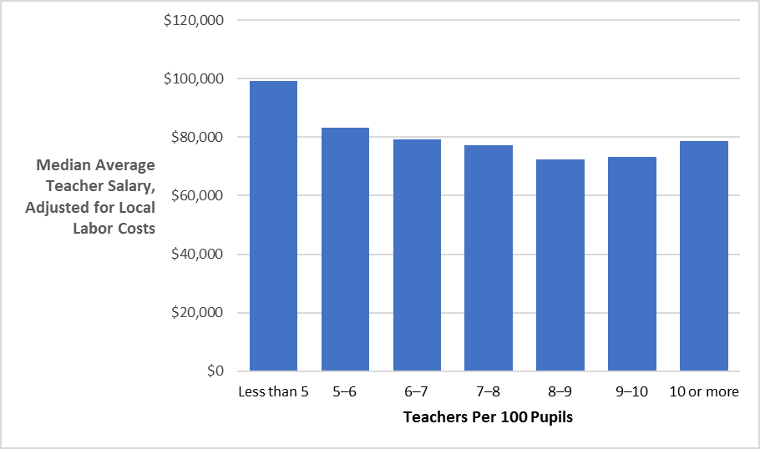

1. 1 Economically disadvantaged students come from families who participate in a social safety net program, such as the Supplemental Nutrition Assistance Program or Temporary Assistance for Needy Families, or are categorically eligible based on a special status, such as being in foster care.

  
2. 2 Massachusetts Department of Elementary and Secondary Education, FY14–FY18 Per Pupil Expenditures, All Funds, accessed at <http://www.doe.mass.edu/finance/statistics/ppx14-18.html>.

   3 We use “pupils” to refer to the full-time equivalent (FTE) student count. This count is based on the actual days that students spent in the school over the year and is the same unit used to report school-level spending.

   Massachusetts Department of Elementary and Secondary Education, FY14–FY18 Per Pupil Expenditures, All Funds, accessed at <http://www.doe.mass.edu/finance/statistics/ppx14-18.html>.
3. In fiscal year 2018, Massachusetts allocated $4.7 billion in Chapter 70 aid to K–12 public school districts, representing 30 percent of the $16.2 billion spent by districts that year from all local, state, and federal funding sources. See <http://www.doe.mass.edu/finance/statistics/ppx14-18.html> and <http://www.doe.mass.edu/finance/chapter70/fy2018/chapter-18.html>.
4. Massachusetts Department of Elementary and Secondary Education, FY19 Chapter 70 Aid and Required Contribution Calculations, accessed at <http://www.doe.mass.edu/finance/chapter70/fy2019/whitepaper.html>.
5. For analyses in this report, we use the 2018–19 unadjusted wage adjustment factor, which includes non-rounded values. The Chapter 70 formula uses an adjusted wage adjustment factor, which cushions low-wage areas from a reduction in spending by setting a floor for wage adjustment factors at 100 percent. This floor has been in place since fiscal year 2004 (Massachusetts Department of Elementary and Secondary Education 2018).