Social and Emotional Learning Indicator System (SELIS): User Guide for Educators
What you need to know to use SELIS survey data
April 2023

VO

This document was prepared by the
Massachusetts Department of Elementary and Secondary Education
Jeffrey Riley
Commissioner

The Massachusetts Department of Elementary and Secondary Education, an affirmative action employer, is committed to ensuring that all of its programs and facilities are accessible to all members of the public.
We do not discriminate on the basis of age, color, disability, national origin, race, religion, sex, gender identity, or sexual orientation.
Inquiries regarding the Department’s compliance with Title IX and other civil rights laws may be directed to the
Human Resources Director, 75 Pleasant St., Malden, MA 02148-4906. Phone: 781-338-6105.

© 2023 Massachusetts Department of Elementary and Secondary Education
Permission is hereby granted to copy any or all parts of this document for non-commercial educational purposes. Please credit the “Massachusetts Department of Elementary and Secondary Education.”

This document printed on recycled paper

Massachusetts Department of Elementary and Secondary Education
75 Pleasant Street, Malden, MA 02148-4906
Phone 781-338-3000 TTY: N.E.T. Relay 800-439-2370
www.doe.mass.edu

Contents
Introduction 1
Background 1
Types of data in your district/school reports 2
SE Competency scaled scores 2
Guidance on interpreting scaled score differences 3
Notes of caution related to SELIS scaled score data use 4
Scale score benchmarks, score levels, and SE abilities profiles 4
Guidance on interpreting SE Abilities Profiles 5
Understanding item-level response data through individual student SWON maps 7
Measurement concepts driving SWON map formation 7
Mapping student’s item responses to identify strengths and areas for growth 8
Interpretation of students’ individual SWON maps (exemplars) 10
Notes of caution related to SWON map use 13
SELIS data and its role in a Multi-tiered System of Supports (MTSS) 13
SELIS in the cycle of inquiry 14
References 16
Appendix A: SELIS survey specification for the three grade-level surveys 17
Appendix B: Relationship Skills competency item hierarchy 18
Appendix C: Item codes and statements by SE competency 19

Introduction
This user guide is provided to help educators understand the basics of what they need to know about the Social and Emotional Learning Indicator System (SELIS) survey, data, and dashboard. This guide provides basic information about what the SELIS survey measures, the types of data available to schools and districts, and how to identify and interpret meaningful differences in SELIS scaled scores and in individual students’ item response maps. It also discusses the use of SELIS data in multi-tiered systems of support (MTSS) and its role in a cycle of inquiry. Educators can explore the SELIS webpage for other useful SELIS resources.

Background
The SELIS is a 45 to 50 item survey for youth in grades 3 through 12, that allows students to self-report their own social and emotional (SE) competency strengths. The SELIS supports an asset-based, tiered approach to developing students’ core SE competencies, which allows educators to support and value students’ identities and recognize competency areas students identify as needing support and development. SELIS is designed to help educators implement evidence-based, culturally responsive SEL strategies that support schoolwide improvement, as well as identify targeted assistance for vulnerable student groups, and to help students who have more intensive academic and behavioral needs.

The SELIS survey measures five competencies of social and emotional learning aligned with the Collaborative of Academic and Social and Emotional Learning’s 5 or CASEL 5: Self-Awareness (SA), Self-Management (SM), Social Awareness (SOC), Relationship Skills (RSK), and Responsible Decision-making (RDM). Table 1 briefly describes each SE competency measured by the SELIS survey.

Table 1: Social and Emotional (SE) Competency Measure
Social and Emotional (SE) Five Core Competencies ¹
Self-Awareness (11 to 12 items) | Self-Management (16 items) | Social Awareness (6 to 7 items) | Relationship Skills (6 to 8 items) | Responsible Decision-making (6 to 7 items)
The abilities to understand one’s emotions, thoughts, and values and how they influence behavior across contexts. | The abilities to manage one’s emotions, thoughts, and behaviors effectively in different situations and to achieve goals and aspirations. | The abilities to understand the perspectives of and empathize with others, including those from diverse backgrounds, cultures, and contexts. | The abilities to establish and maintain healthy and supportive relationships and to effectively navigate settings with diverse individuals and groups. | The abilities to make caring and constructive choices about personal behavior and social interactions across diverse situations.
¹SELIS uses the Collaborative for Academic and Social and Emotional Learning’s (CASEL) conceptual framework and competency definitions
Students respond to item statements (e.g., “Talking to an adult when I have problems at school.”) and are asked to rate how hard or easy it is for them to apply the SE skill. Students respond to each SE skill (item) statement using four scored response options: 3 (very easy), 2 (easy), 1 (hard), and 0 (very hard), respectively. The two intra-personal competencies (self-awareness and self-management) account for over half of the items on each grade-level survey. Because these competencies are multi-faceted and include different but related aspects of each of the two competencies, they account for a higher proportion of the overall number of survey items. For example, self-awareness items measure students’ self-awareness of emotions (SAE: ability to recognize and understand one’s emotions) and their self-awareness of self-concept (SAS: ability to build knowledge about themselves based on their understanding of their own behaviors, emotions, beliefs, and values – their perception of “self”). An example of a SAE item is, “knowing ways to make myself feel better when I’m sad”; an example of a SAS item is, “knowing what I am interested in at school”. Measuring these two aspects of self-awareness is needed to reliably measure a student’s perception of their self-awareness. As with other competency, these item-response data provide rich contextualized information about a student’s perceptions of their SE abilities. A full survey specification is provided in Appendix A.

Types of data in your district/school reports
The SELIS reports include three types of data: aggregate SE competency scaled scores, benchmarked SE abilities profiles, and item response data visualized through individual student maps. Each are used for different purposes, as described below.

SE Competency scaled scores
An SE competency scaled score is a composite measure that summarizes student responses across the items related to each competency. Students’ raw responses are mathematically transformed to create scaled scores (DESE, 2019). This type of data enables districts and schools to:
- Calculate average scores and identify meaningful differences in student perceptions across schools, grades, competencies, student groups, survey administrations, and years.
- Monitor school and district SE ability scores over time.
- Make narrative statements such as, “Female students score 8 points higher on the self-management scale compared to male students,” and “The improvement in the average relationship skills score between the fall and spring administration has halved this year, when compared to last year’s.”

As of 2018, DESE developed six competency scaled scores for educators:
(1) an overall SE scaled score,
(2) a self-awareness (SA) scaled score,
(3) a self-management (SM) scaled score,
(4) a social awareness (SOC) scaled score,
(5) a relationship scaled score (RSK), and
(6) a responsible decision-making scaled score (RDM).
Students’ item responses are benchmarked onto the SE scale by using common items (administered on all three grade-level surveys) to link all student responses to the scale; as a result, all students, and all items within a district are on the same scale irrespective of the grade-level survey form a student took (DESE 2021). The six scaled scores range from 1 to 999 and are anchored on to the fall 2021 item difficulties in order to measure longitudinal trends accurately (DESE 2021). Fall 2021 is the baseline measure for trend data. Individual student scores are then aggregated to provide each school and district their SELIS report. In all cases, a higher average scaled score indicates that students rate their SE abilities more positively.

Please note, scaled scores are provided regardless of the number of students contributing to the score. As a result, it is very important to be aware of the number of students contributing to the aggregate scaled score as there is considerably more measurement error if the number of students is small (<20 students). For more notes of caution related to scaled score use, see this section.

Guidance on interpreting scaled score differences
To help districts and schools interpret scaled score differences between schools, grades, and student groups, the following guidance is provided in the bullets and table (Table 2) below:
- A difference of 5 scaled score points is statistically meaningful, but the practical significance of this difference is hard to discern in terms of students’ ratings of their SE abilities.
- Schools and districts should first focus on the larger differences observed between student groups or over time (e.g., between the fall and spring administration within a school year). If difference of 16 points or larger is observed, this difference warrants further investigation.
- DESE recommends educators focus on patterns of scaled score differences that replicate across administrations (e.g., self-management scores were 14 points higher than self-awareness scores between the fall of 2021 and the spring of 2022 and, similarly, 12 points higher between the fall of 2022 and the spring of 2023). Replication of results across school years supports the interpretation that a meaningful difference exists. Replication is key to validating results and to their interpretation.
- The estimation of aggregate scaled scores for schools with small student populations (less than 20 students) is less reliable (scores will bounce around more). To ameliorate this consequence, small schools can take a 2- or 3-year rolling average of their scores to get a more accurate estimate of student perceptions. This could be done for the fall administrations, and separately for the spring administrations and by breaking out the data by grade, trends in grade-level cohorts can be assessed on a rolling average basis.
- When examining trend data, caution is advised when the number of students in a school or student group is small (less than 20 students); taking a 2- or 3- year average may be warranted. Student group data can be averaged for the fall administration scores across 2- to 3- school years, and separately, averaged for the spring administration scores when student numbers are low.

Table 2: Guidance on interpreting SE scaled score differences
Scaled score point difference | Size of effect (negative or positive)
 | Point difference description¹ | Percentile difference² | Difference in standard deviation units (s.d.)¹
Less than 5 points | Not meaningful | Less than 2 | Less than 0.05
5 points to less than 8 points | Very small | 2 to less than 4 | 0.05 to less than 0.10
8 points to less than 16 points | Small | 4 to less than 8 | 0.10 to less than 0.20
16 points to less than 24 points | Moderate | 8 to less than 12 | 0.20 to less than 0.30
24 points to less than 40 points | Large | 12 to less than 19 | 0.30 to less than 0.50
40 points or greater | Very large | 19 and above | 0.5 and greater
¹This is a rough guide to scaled score point differences; the standard deviations of the average scaled score comparisons can vary when analyzed leading to different results. ²Effect can be interpreted as the percentile difference from the lowest group’s, or school’s outcome standardized mean score (set at the 50th percentile on the normal distribution) and the highest group’s standardized mean score.

Notes of caution related to SELIS scaled score data use
- Educators might assume that all students’ scores will increase between the fall and spring administrations. This may not be the case. At the beginning of the school year, a student may view their SE skill more highly and it is not until the student realizes the expectations for applying these skills, that they realize that their skill level is not as high as previously thought. Some students’ scores will go down between fall and spring with others maintaining their SE competence level, and others will view their SE skills more highly.
- Educators might assume that students’ scores will increase lock-step as they move up each grade level. However, students are responding and interpreting the items (SE skills) in relation to their context, their maturity, and to the expectations of adults. Distractions that make it hard for a student to focus in a high school classroom setting are likely different compared to the distractions found in an elementary school classroom but no less disrupting. The expectations of a high school teacher for a student to ignore these distractions are likely higher compared to an elementary school teacher’s; as a result, high schoolers and elementary students could equally respond that staying focused in class is “hard” or “very hard” for them when distractions are occurring. In general, average scores will increase as you move up the grade levels, but the magnitude of the increase may not be as sizeable as expected or as linear as expected (average scores could go down between grades).

Scale score benchmarks, score levels, and SE abilities profiles
To further make meaning of the SELIS scaled score data, profiles were developed for five benchmark scores on the overall SE scaled score distribution (students’ scores can range from 1 to 999). Benchmark profiles or narratives were first developed for scores of 400, 500, and 600; these benchmarks divide the student score distribution into four levels, namely, emerging skills (<=400), developing skills (401 – 500), developed skills (501 – 600), and highly developed skills (>600). The benchmark profiles for each competency are available here. In addition, to characterize students at the lower and upper ends of the distribution, profiles were also developed for students who had an average score of 300 and an average score of 700, respectively. These profiles provide a detailed narrative of how students with average scores across the full distribution of development typically respond to items and highlights where students at the different levels vary in their responses. These profiles are relevant to responses of all students across all grades but also apply to any average score irrespective of the grouping (e.g., school average, grade average, or student group average). Figure 1 below depicts the percentage of students in the four SE ability levels for all students who participated in the fall 2021 pilot administration.

Figure 1: Fall 2021 distribution of students’ perceived SE ability levels (all grades)

Schools can benchmark the relative strength of their students’ SE abilities and use the distribution to assess the variability in student perceptions of these abilities for each survey administration. They can also use the distribution to assess if interventions targeted to improve students’ SE abilities are effective; if the intervention(s) were having a positive effect, the distribution would shift with more students falling into the “Developed skills” and “Highly Developed skills” levels.

Guidance on interpreting SE Abilities Profiles
Table 3 shows an excerpt from the self-management (SM) abilities profile for a student scoring 600 (top score of “Developed skills” level), a student scoring 500 (top score of the “Developing skills” level) and a student scoring 400 (top score of the “Emerging skills” level). These three profiles can equally be used to describe the average SE ability of a group of students whose average scores were 600, 500, or 400, respectively.

Table 3: Excerpt from Self-management (SM) Abilities Profile
600  Level 3  (Developed) | Students scoring 600 on the scale have somewhat malleable mindsets, exhibit resiliency and good organizational skills; they find it:  - Easy to cope with frustration, to stay calm when stressed, and to be patient even when excited.  - Easy to sustain effort and motivation, and persist when faced with challenges, setbacks, and distractions.  - Easy to plan their work (turn a project in on time), prepare for tests, and to juggle multiple assignments if due at the same time.  - Easy to catch up when they fall behind and to finish their schoolwork without reminders.  - Easy to set, plan and reach their goals.  - Easy to trust and approach an adult when faced with a problem.
500  Level 2  (Developing) | Students scoring 500 on the scale have somewhat fixed mindsets, exhibit some resiliency and organizational skills; they find it:  - Hard to cope with frustration, to stay calm when stressed, and to be patient even when excited.  - Hard to sustain effort and motivation, and persist when faced with challenges, setbacks, and distractions.  - Easy to plan their work (turn a project in on time) and prepare for tests but find it hard to juggle multiple assignments if due at the same time.  - Easy to catch up when they fall behind and to finish their schoolwork without reminders.  - Easy to set and plan goals, but still find it hard to reach their goals.  - Easy to trust and approach an adult when faced with a problem.
400  Level 1  (Emerging) | Students scoring 400 on the scale have fixed mindsets, lack resilience, and have poor organizational skills; they find it:  - Very hard to cope with frustration, to stay calm when stressed, and to be patient even when excited.  - Very hard to sustain effort and motivation, and persist when faced with challenges, setbacks, and distractions.  - Hard to plan their work (turn a project in on time) and prepare for tests, and very hard to juggle multiple assignments if due at the same time.  - Hard to catch up when they fall behind and struggle to finish their schoolwork even with reminders.  - Hard to set and plan goals, making it very hard to reach their goals.  - Very hard to trust and approach an adult when faced with a problem.

It can be seen that a student who scores, on average, 600 finds all of the self-management skills measured easy to apply, whereas a student whose average score is 400 finds these same skills hard or very hard. A student whose average score is 500 finds some of the self-management skills easy to apply, but other skills are hard for the student to acquire and apply. Compared to a student whose average score is 600 (who find all SM skills measured easy), a student scoring 500 finds skills related to self-management of emotions (e.g., staying calm when I feel stressed) and resiliency hard (e.g., working on assignments even when they are hard); these skills are among the hardest SM skills for any student to acquire and it is these types of skills that differentiate students who are still “developing” their skills from those whose skills are “developed”. It is not until a student scores 700 that is located within the “Highly Developed skills” level on the scale that a student will find these SM skills very easy to apply (profile not shown).

Some additional notes on using the benchmarked profiles are below:
- If a school’s or group’s average scaled score lies below 400, the narrative associated with the benchmark score of 400 is likely over-reporting the strength of the students’ SE abilities; educators should read the profile developed for the score of 300 to better understand what the average score means in terms of the students’ responses.
- If an average scaled score falls between two benchmarks (e.g., a score of 450 lies between the benchmark profile of 400 and of 500), the educator should read the two benchmark profiles on either side of the score to make meaning of the average student score.
- If an average student score lies above 600, the narrative associated with the benchmark score of 600 is likely under-reporting the strength of the students’ SE abilities; the school should read the profile developed for the score of 700 to better understand what the average score means in terms of the students’ responses. At the upper end of the scale, there is a ceiling effect, so a profile was not developed for average scores of greater than 700. There is only one relationship skills item (RSK4) that a student scoring 700 finds, “easy” (as opposed to “very easy”). This SE skill (sharing what I am feeling with others) is the hardest skill on the whole survey.

The SE abilities distributions for each grade, administration, and year are available in the SELIS Power BI report received by participating districts and schools. Educators can monitor the percentage of students falling within each level and use the profiles to get a sense of what students’ strengths and areas for growth are at each level.

Understanding item-level response data through individual student SWON maps
A SWON map is a data visualization tool that charts a student’s SELIS survey responses onto four quadrants and to the student’s zone of proximal development (ZPD). These quadrants help identify a student’s SE skills strengths (expected and unexpected) and a student’s areas for SE skills growth (expected and unexpected). These maps are generated by the Rasch-based software called Winsteps (Rasch, 1960; Linacre, 2023) that is used to create the SE scaled scores; they are known as PKMAPs in Winsteps.

Measurement concepts driving SWON map formation
The student’s average SE score in relation to the difficulty of the SE skill being measured is fundamental to understanding how to interpret the SWON map. Some SE skills (items) in each SE competency are, on average, more difficult for a student to apply or acquire than other SE skills (items). For example, the most difficult item in the relationship skills competency is, “Sharing what I am feeling with others” (RSK4); in contrast, the least difficult item is, “Getting along well with my teachers” (RSK6). This means that all students, irrespective of their average score, will find the SE skill measured by RSK4 (sharing feelings) harder to apply or acquire and, hence, are less likely to respond in the “very easy” or “easy” categories unless they have a high level of relationship skills. A student needs an average score of 705 to respond, “very easy” to “sharing what they are feeling with others”. In contrast, a student only needs a score above 535, on average, to respond, “very easy” to the SE skill measured by RSK6 (getting along well with their teachers), respectively. Appendix A illustrates the item difficulty hierarchy for the Relationship Skills competency; other competency item hierarchies can be found in the SELIS Validity Report.

Mapping student’s item responses to identify strengths and areas for growth
This section describes the basic features of the SWON map; an outline of a SWON map is shown in Figure 2.
- Down the center of the map is a portion of the SELIS scale or ruler that locates the student’s average score (marked by XXX on the map) on the SE scale. The two lines either side of the student’s average score (blue lines, figure 2) denote plus or minus one standard error (the wider the lines are apart means that the student was measured with a higher degree of measurement error and caution is advised in interpreting the student’s strengths and areas for growth).
- Items are located on the map’s scale according to their item difficulty with more difficult SE skills (items) located towards the top of the map and easier skills to apply or acquire located to the bottom of the map’s scale. In general, the higher a student’s SE score, the more likely they will respond, “easy” or “very easy” to any SE skill measured; in contrast, students with low SE scores are more likely to respond, “hard” or “very hard” to any SE skill and are predicted to choose the “very hard” response option on the most difficult SE skills to apply (e.g., RSK4).
- On the left-hand side (LHS) of the map are SE skills (items) that a student has a relative strength in, with the SE skill (item) appearing in either quadrant 1 or 2, or within the zone of proximal development (ZPD) on the LHS of the ruler. Please note, SE skills can appear on the LHS of the map even for students with low to very low SE ability scores; a student with a low SE ability may respond that a skill is “hard” for them, but due to their low score was predicted to respond, “very hard” to the SE skill. As a result, this SE skill is a relative strength for this student even though they still report it is, “hard” for them.
- On the right-hand side (RHS) of the map are SE skills (items) that a student “struggles” with relative to their overall SE ability level, with the SE skill appearing in either quadrant 3 or 4, or within the ZPD (RHS). Please note, students with high SE ability scores can “struggle” with a skill if their chosen response option is less favorable than predicted by their SE ability level (for example, a skill may appear on the RHS if a high scoring student was predicted to respond, “very easy” to a SE skill, but actually responded, “easy” to the item). As a result, this SE skill is considered an area for growth even though the student reported it is, “easy” for them.
- Based on their SE skill ability relative to the difficulty of the skill, the model compares the predicted response of a student to an SE skill, to the observed response. As a result, most students regardless of their location on the SE scale (high or low) will have items on both sides of the map with the map identifying and visualizing the student’s relative strengths and areas for growth.
- Rarely will a student have items only on the LHS (strength) or RHS (areas for growth) of the map; these students would be at the extreme ends of the score distribution and would likely score above 900 (LHS) or below 100 (RHS), respectively.
- Each side of the map is further divided into two quadrants to make four quadrants with the ZPD cutting across both sides of the map. A student’s item responses are mapped onto four quadrants (and ZPD) by comparing the student’s predicted response (very hard, hard etc.) to their actual response. The quadrants are delineated by the zone of proximal development with quadrants 2 and 4 residing above the upper limit of the ZPD, and quadrants 1 and 3 residing below the lower limit of the ZPD. The quadrant an item ends up in depends on whether the observed response of the student is as predicted or unexpected given their average SE ability and the difficulty of the SE skill to apply or acquire. Figure 2 explains in more detail the basic dynamics of the four quadrants.
Figure 2: Basic features of a SWON map
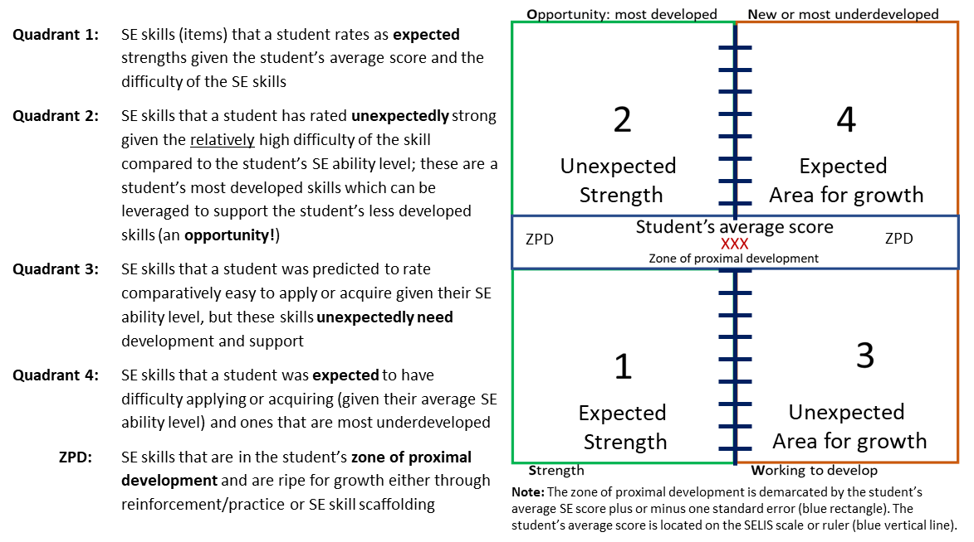

The SWON maps provided to educators are interactive and include detailed information (Figure 3):
- If an educator hovers over the SE skill (item) on the interactive map, the SE skill item statement will show. Figure 3 shows a static version of two interactive maps.
- The items are color coded by competency: self-awareness items are color coded yellow; self-management items, orange; social awareness items, pink; relationship skills items, blue; and responsible decision-making items are color-coded green.
- The items are shown on the map using their SE competency survey number and the student’s observed or actual response to the item. For example, RSK4.1 on the map indicates that it is Relationship skills item number 4 and the student responded, “hard” to the item (the number after the period indicates the student’s item score). As a reminder, items are scored, 3 (very easy), 2 (easy), 1 (hard) or 0 (very hard) and these are reflected on the map.

Interpretation of students’ individual SWON maps (exemplars)
Two SWON maps are presented, both students are in the same classroom and are in grade 3. These students took a 45-item survey, and both responded to all items. The first thing to notice is that the two students’ maps tell two very different stories about the students’ perceptions of their SE skills. Both students have strengths (some of which are unexpected given their SE ability, quadrant 2) and both students have areas for growth (all which are unexpected given their SE ability, quadrant 3). Even though Student One has, on average, highly developed SE skills and many strengths (expected and unexpected), this student struggles with several self-management items (orange coded items). Similarly, although Student Two finds many SE skills easy or very easy to apply, this student reports struggling with several self-awareness skills (yellow coded items). Educators can use these maps to help understand a student’s SE strengths and SE skills that need support and development. Each map’s interpretation will be discussed in turn; it is impossible to discuss every nuance in the two maps, so a summary interpretation of the main points is provided. Appendix B provides all item codes and statements associated with the SELIS survey with 45 of these items appearing on the two SWON maps shown.

Student One Map Interpretation
Not unexpectedly, due to their relatively high average SE score (611), Student One reports being strong in many SE skills (across all five core competencies) and responds to many item statements that the SE skill being measured is “easy” (.2) or “very easy” (.3) for them to apply. At a glance, the student has strong relationship skills (color coded blue) with two relationship skills items (RSK4.3 and RSK2.3) located in quadrant 2 (Opportunity); the student responded, “very easy” to these items. A further four RSK items are located in either the ZPD (strength side of the ruler) or in quadrant 1 (Strength). RSK4 (sharing what I am feeling with others) and RSK2 (talking to an adult when I have problems at school) are the two hardest relationship skills for all students to master; a student with an average score of 611 would not be predicted to respond, “very easy” to these two difficult skills. As a result, these two relationship skills are an unexpected strength of this student. Because of this student’s relatively high score, this student was expected to find the two least difficult relationship skills to apply, “very easy”; as predicted, RSK3 (getting along well with my classmates) and RSK6 (getting along well with my teachers) locate in quadrant (expected strengths) as the student did in fact respond, “very easy” to both of them. The SELIS is an asset-based assessment and is designed to identify a student’s strengths so they can be leveraged to support the student’s SE skills in need of support and development (for Student One, several self-management skills appear in need of support).

Figure 3: SWON maps for two grade 3 students in the same class (each student responded to all 45 items on the survey)

Student One: Student Two:
Scored 611 on the scale Scored 514 on the scale
Student is classified as having highly developed SE skills (Level 4) Student is classified as having developed SE skills (Level 3)

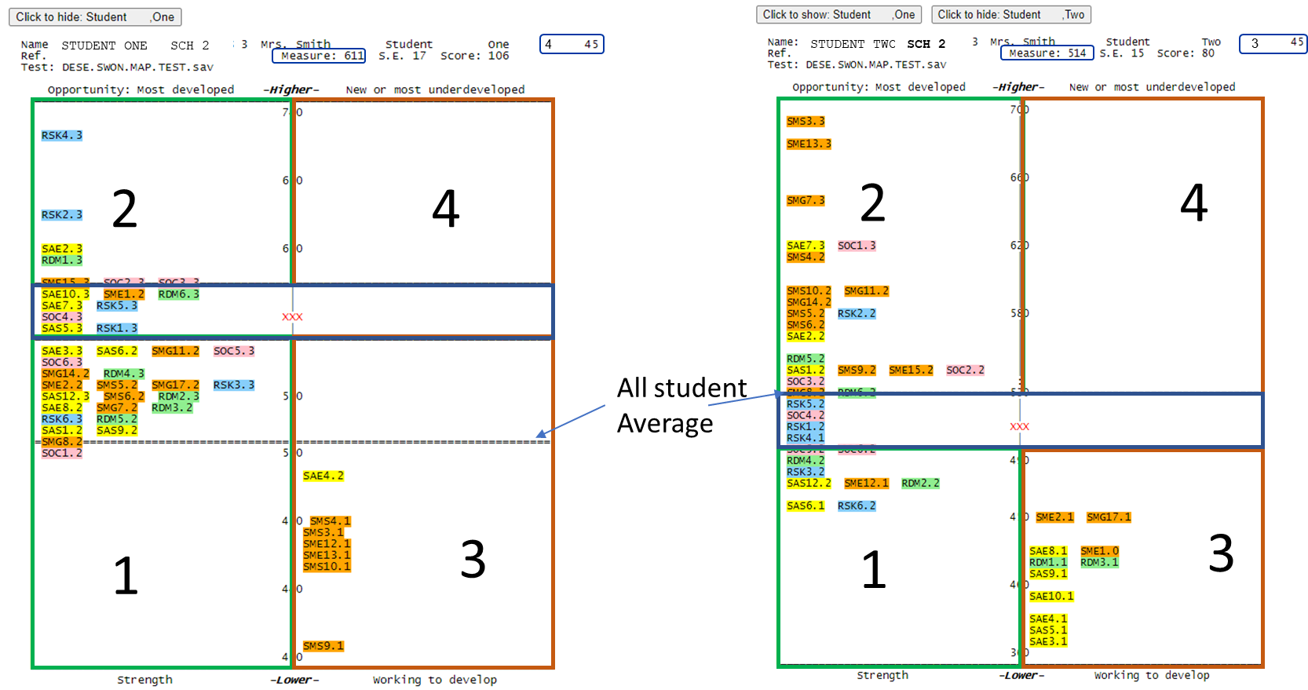

In quadrant 3 (Working to develop), there are several self-management (SM) skills (color coded orange) that the student is struggling with. Given this student’s average SE score, relative to the difficulty of these SM skills, this student was not expected to find these SM skills “hard” to apply or acquire. A review of these skills’ content reveals that the student appears to struggle with self-regulation of their learning and motivation. For example, the student finds it hard to work on assignments even when they are hard (SMS3.1), to stay focused in class even when there are
distractions (SMS4.1), to do their schoolwork even when they do not feel like it (SMS10.1), and to finish their schoolwork without reminders (SMS9.1). All these SM skills measure aspects of self-regulation of their schoolwork and learning. Can this student use the relatively strong self-management skills they do have (located in quadrants 1 and 2) to support the skills they appear to struggle with? The student has comparatively strong planning and organizational skills (SMS5.2, SMS6.2) and goal-setting skills (SMG7.2, SMG8.2, SMG11.2, SMG14.2) which can be leveraged to support their self-regulation skills. Could the student be guided to use their strong relationship skills to build a support system that will help them with their self-discipline and motivation? Interestingly, Student Two has an unexpected strength in the self-regulation skills that Student One struggles with; could pairing these two students in group work help Student One build a relationship with Student Two to better their self-regulation skills and help them understand that with effort, they will overcome any obstacles to their learning?

Student Two Map Interpretation
As mentioned, Student Two has many strengths that cut across all five competencies but their strength in self-management (SM) skills stands out with many SM skills (color coded orange) located in quadrant 2 (Opportunity). The student reported that these SM skills were, “easy” or “very easy” for them to apply. Given this student’s average ability score, they were not predicted to find these skills relatively easy or very easy and these skills are considered an unexpected strength of the student. An analysis of these items’ content indicates that this student has unexpectedly strong ability to manage and regulate their schoolwork and learning (SMS.3, SMS4.2, SMS10.2), relatively strong planning and organization skills (SMG7.3, SMS5.2, SMS6.2, SMS9.2) and goal-setting skills (SMG14.2, SMG11.2). These skills are among the student’s most developed skills and can be opportunistically leveraged to support SE skills that the student is struggling with.

In quadrant 3 (Working to Develop), there are many self-awareness (SA) skills that Student Two appears to unexpectedly struggle with along with some self-management skills. Self-awareness and self-management competencies help us understand a student’s intra-personal skills. Student Two has difficulty recognizing their basic emotions (SAE4.1) and understanding how they might affect their body in stressful contexts (SAE3.1) and also in recognizing coping mechanisms that might help them calm down and manage these situations (SAE8.1, SME2.1, SME1.0). This student also finds it hard to know when their emotions may interfere with their sense of self-concept (SAS9.1), learning (SAE10.1, SAS6.1, SMG17.1), and behavioral choices (SAS5.1). Note that SAS6 (knowing how to get better at things that are hard for me to do at school) is located in quadrant 1 (Strength). Given the difficulty of this skill (the hardest SA skill for all students to apply or acquire) and the student’s SE ability in relation to this skill, the student was predicted to respond, “very hard” to this item, but actually responded, “hard”. This more positive response is considered a relative strength of this student even though they report finding the skill difficult to apply.

Because this student appears to function well and has the skills to self-regulate, their struggle with recognizing and managing their emotions may go unnoticed (the quiet child in the back of the class!) and not get the support they need. Student Two has three self-awareness skills that are unexpected strengths that could be leveraged to support their overall self-awareness ability. This student knows what her strengths are (SAS1.2), knows ways to make themselves feel better when sad (SAE2.2), and knows how their mood affects how they treat others (SAE7.3). The student appears to have a good awareness of her/his moods; can these awareness skills be used to help her/him recognize their emotions and their impacts better?

Notes of caution related to SWON map use
- SWON maps are student-level data, and these data should be secure and only accessed by trained professionals.
- The SWON maps should be used as an asset-based assessment to support students in developing their social and emotional competence. This should be done in a culturally responsive way and used in a manner that values a student’s identity.
- The SWON maps are based on students’ perceptions of their social and emotional skills. It is important for educators to validate students’ perceptions and use the SWON maps appropriately. Ideally, educators/counselors and students will use them as conversation starters in order to set goals for strengthening the student’s SE skills.
  - Goal setting could include discussing together what supports are needed to help the student achieve their goals.
- It behooves educators to use other data that they know about their students to assess whether a student, or a group of students, need additional supports beyond the SE learning that is taking place in the classroom.

SELIS data and its role in a Multi-tiered System of Supports (MTSS)
The different types of SELIS data can fit well into a multi-tiered system of supports (MTSS) framework and be used to inform how well systems in schools and districts are supporting students’ SE and academic well-being and to monitor the impacts of the supports being provided at the system, student group, and individual student level. Figure 4 illustrates the tiered system of support conceptually and summarizes the basic outline of the MTSS framework.

The degree of support provided to students is dependent on their needs with the intensity of support provided driven by data analyses of district-, school- and student-level data. It is important to realize that students or groups of students can at different times move from one level of support to another depending on their needs (depicted by the orange two-way arrows). It is also possible for the different types of SELIS data to be used within all three tiers of the MTSS. Scaled scores (and associated abilities profiles) can be used in aggregate form to get a sense of how a district, school, grade, or group of students are doing in relation to their SE skills. For example, the average scaled score of a student group such as English learners could be used to assess how this traditionally disadvantaged student group compares to their peers in terms of their SE skills. This information on the student group can be used to determine if the student group requires targeted supports (Tier 2) that can be leveraged to best promote and ensure their academic and social and emotional growth. They can also be used at Tier 3 to get an overall sense of which competency the student has a strength in, and which may require more intensive support. The SWON maps similarly could be used to inform tiered supports. For example, it can be used in student advisories when students discuss their responses to the survey (using the map as a conversation starter), and work with their advisors to set goals and supports/strategies needed to help them develop their academic and social and emotional well-being. The SWON map could also be used at Tier 3; for example, they can be used to inform a student’s IEP plan. Educators are directed to the SELIS Research Brief posted on the SELIS webpage to read about how one district used the different types of SELIS data in their MTSS.

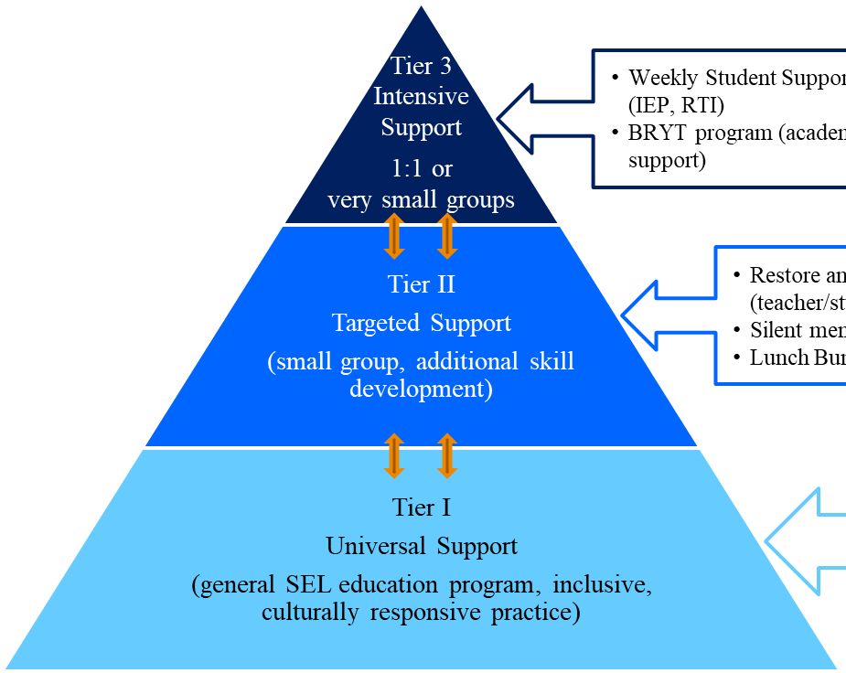
Figure 4: Multi-tiered System of Supports Framework

“MTSS is a framework designed to meet the needs of all students by ensuring that schools optimize data-driven decision-making, progress monitoring, and evidence-based supports and strategies with increasing intensity to sustain student growth. MTSS is not just about tiered interventions, but rather how all the systems in a school or district fit together to ensure a high-quality education for all students.” (DESE, 2019

SELIS in the cycle of inquiry
Ultimately, educators know their students best. Student SELIS data provide an important perspective for educators when evaluating students SE abilities, but it should not be used in isolation. Research has shown that strong social and emotional skills are associated with more positive school climates, higher student attendance, lower chronic absence, lower in-school and out-of-school suspensions, lower drop-out rates, and higher student achievement. When combined with other data each year (e.g., Early Warning Indicator System (EWIS) data, VOCAL school climate data, discipline, attendance, graduation rates, achievement etc.), SELIS data can inform and empower districts and schools with information not previously available to support students’ social and emotional growth and well-being.

References
Crowder, M. K., Gordon, R. A., Brown, R. D., Davidson, L. A., & Domitrovich, C. E. (2019). Linking social and emotional learning standards to the WCSD Social-Emotional Competency Assessment: A Rasch approach. School Psychology, 34 (3), 282 – 295.
Davidson, L. A., Crowder, M. K., Gordon, R. A., Domitrovich, C. E., Brown, R. D., & Hayes, B. I. (2018). A
continuous improvement approach to social and emotional competency measurement. Journal of Applied Developmental Psychology, 55, 93 – 106.
DESE (2019). Multi-tiered System of Supports: Blueprint for Massachusetts. Retrieved from
Multi-Tiered System of Support Blueprint (mass.edu).
DESE (2021). Social and Emotional Learning Indicator System (SELIS): Validity study. Retrieved from https://www.doe.mass.edu/research/selis/validity-report.docx.
Linacre, J.M. (2023). Winsteps: Rasch-Model Computer Program. Downloaded from https://www.winsteps.com.

Rasch, G. (1960). Probabilistic models for some intelligence and attainment tests. Copenhagen: Danish Institute for Educational Research. (Expanded edition, 1980. Chicago: University of Chicago Press).

Appendix A: SELIS survey specification for the three grade-level surveys

SELIS survey specification
Competency | Indicator (Code) | Grades  3 to 5 | Grades  6 to 8 | Grades  9 to 12 | Total²
Self-awareness (SA) | SA of Emotions (SAE) | 6+0 | 6+0 | 6+1 | 7
Self-awareness (SA) | SA of Self-concept (SAS) | 4+1 | 4+1 | 4+1 | 7
Self-awareness | Sub-total | 11 | 11 | 12 | 14
Self-management (SM) | SM of Emotions (SME) | 5+0 | 5+1 | 5+0 | 6
Self-management (SM) | SM of Schoolwork (SMS) | 6+0 | 6+0 | 6+0 | 6
Self-management (SM) | SM of Goal-setting (SMG) | 4+1 | 4+0 | 4+1 | 6
Self-management | Sub-total | 16 | 16 | 16 | 18
Social Awareness (SOC) | Social Awareness (SOC) | 5+1 | 5+2 | 5+2 | 10
Relationship Skills (RSK) | Relationship Skills (RSK) | 6+0 | 6+1 | 6+2 | 9
Responsible  Decision-making (RDM) | Responsible  Decision-making (RDM) | 5+1 | 5+2 | 5+2 | 10
Total number of items |  | 45 | 48 | 50 | 61
¹The number before the plus sign is the number of common items that appear across the three grade-level survey forms; the number after the plus sign is the number of items unique to the grade-level survey form;²Common items are only counted once to derive item totals.

Appendix B: Relationship Skills Competency Item Hierarchy

HARDEST SKILL TO APPLY EASIEST SKILL TO APPLY

Item | Item Prompt (from most difficult to least difficult to apply or acquire)
RSK4 | Sharing what I am feeling with others.
RSK7 | Leading a discussion in class.
RSK2 | Talking to an adult when I have problems at school.
RSK8 | Asking a classmate to do their fair share of a group project.
RSK9 | Standing up for someone even if they are outside of my friend group.
RSK1 | Being welcoming to someone I don't usually eat lunch with.
RSK5 | Respecting a classmate's opinions during a disagreement.
RSK3 | Getting along well with my classmates.
RSK6 | Getting along well with my teachers.

Appendix C: Item codes and statements by SE competency
No.¹ |  | Item code |  | Item Prompt: How hard to easy is the following for you? |  | ES² |  | MS² |  | HS²
1¹ |  | SAS1 |  | Knowing what my strengths are. |  | X |  | X |  | X
2¹ |  | SAE2 |  | Knowing ways to make myself feel better when I'm sad. |  | X |  | X |  | X
3¹ |  | SAE3 |  | Noticing what my body does when I am nervous. |  | X |  | X |  | X
4¹ |  | SAE4 |  | Knowing the emotions I feel. |  | X |  | X |  | X
5¹ |  | SAS5 |  | Knowing when I am wrong in the way I behave. |  | X |  | X |  | X
6¹ |  | SAS6 |  | Knowing how to get better at things that are hard for me to do at school. |  | X |  | X |  | X
7¹ |  | SAE7 |  | Knowing when my mood affects how I treat others. |  | X |  | X |  | X
8¹ |  | SAE8 |  | Knowing ways I calm myself down. |  | X |  | X |  | X
9¹ |  | SAS9 |  | Knowing when I can't control something. |  | X |  | X |  | X
10¹ |  | SAE10 |  | Knowing when my feelings are making it hard for me to focus. |  | X |  | X |  | X
11 |  | SAE11 |  | Understanding the difference between how others expect me to feel and how I really feel. |  |  |  |  |  | X
12 |  | SAS12 |  | Knowing what I am interested in at school. |  | X
13 |  | SAS13 |  | Offering an answer even though I am not sure I am right. |  |  |  | X
14 |  | SAS14 |  | Knowing my opinions matter even when others don't listen to them. |  |  |  |  |  | X
Total Number of Self-Awareness (SA) Items |  |  |  |  |  | 11 |  | 11 |  | 12
15¹ |  | SME1 |  | Staying calm when I feel stressed. |  | X |  | X |  | X
16¹ |  | SME2 |  | Being patient even when I am really excited. |  | X |  | X |  | X
17¹ |  | SMS3 |  | Working on assignments even when they are hard. |  | X |  | X |  | X
18¹ |  | SMS4 |  | Staying focused in class even when there are distractions. |  | X |  | X |  | X
19¹ |  | SMS5 |  | Planning ahead so I can turn a project in on time. |  | X |  | X |  | X
20¹ |  | SMS6 |  | Being prepared for tests. |  | X |  | X |  | X
21¹ |  | SMG7 |  | Thinking through the steps it will take to reach my goals. |  | X |  | X |  | X
22¹ |  | SMG8 |  | Setting goals for myself. |  | X |  | X |  | X
23¹ |  | SMS9 |  | Finishing my schoolwork without reminders. |  | X |  | X |  | X
24¹ |  | SMS10 |  | Doing my schoolwork even when I do not feel like it. |  | X |  | X |  | X
25¹ |  | SMG11 |  | Finishing tasks even if they are hard for me. |  | X |  | X |  | X
26¹ |  | SME12 |  | Getting through something even when I feel frustrated. |  | X |  | X |  | X
27¹ |  | SME13 |  | Working on things even when I don't like them. |  | X |  | X |  | X
28¹ |  | SMG14 |  | Reaching goals that I set for myself. |  | X |  | X |  | X
29 |  | SME15 |  | Trusting at least one adult in school who I can go to if I have a problem. |  | X |  | X |  | X
30 |  | SME16 |  | Being careful about what information I share about myself on social media (e.g., TikTok, Facebook, Instagram, etc.). |  |  |  | X
31 |  | SMG17 |  | Catching up on my work when I get behind. |  | X
32 |  | SMG18 |  | Planning my work when I have multiple assignments due at the same time. |  |  |  |  |  | X
Total Number of Self-management (SM) Items |  |  |  |  |  | 16 |  | 16 |  | 16
Appendix C continued
No.¹ | Item code |  | Item Prompt: How hard to easy is the following for you? |  | ES² |  | MS² |  | HS²
33¹ | SOC1 |  | Knowing what people are feeling by the look on their face. |  | X |  | X |  | X
34¹ | SOC2 |  | Knowing how to get help when I'm having trouble with a classmate. |  | X |  | X |  | X
35¹ | SOC3 |  | Learning from people with different opinions than me. |  | X |  | X |  | X
36¹ | SOC4 |  | Knowing how my actions impact my classmates. |  | X |  | X |  | X
37¹ | SOC5 |  | Knowing when someone needs help. |  | X |  | X |  | X
38 | SOC6 |  | Waiting for other students to finish talking before I speak. |  | X
39 | SOC7 |  | Knowing the difference between bullying someone and joking with someone. |  |  |  | X
40 | SOC8 |  | Knowing when to tell my friends how I really feel |  |  |  | X
41 | SOC9 |  | Knowing when my tone of voice may cause someone to misunderstand what I intended to say. |  |  |  |  |  | X
42 | SOC10 |  | Recognizing when I am making someone uncomfortable. |  |  |  |  |  | X
Total Number of Social Awareness (SOC) Items |  |  |  |  | 6 |  | 7 |  | 7
43¹ | RSK1 |  | Being welcoming to someone I don't usually eat lunch with. |  | X |  | X |  | X
44¹ | RSK2 |  | Talking to an adult when I have problems at school. |  | X |  | X |  | X
45¹ | RSK3 |  | Getting along well with my classmates. |  | X |  | X |  | X
46¹ | RSK4 |  | Sharing what I am feeling with others. |  | X |  | X |  | X
47¹ | RSK5 |  | Respecting a classmate's opinions during a disagreement. |  | X |  | X |  | X
48¹ | RSK6 |  | Getting along well with my teachers. |  | X |  | X |  | X
49 | RSK7 |  | Leading a discussion in class. |  |  |  | X
50 | RSK8 |  | Asking a classmate to do their fair share of a group project. |  |  |  |  |  | X
51 | RSK9 |  | Standing up for someone even if they are outside of my friend group. |  |  |  |  |  | X
Total Number of Relationship Skills (RSK) Items |  |  |  |  | 6 |  | 7 |  | 8
52¹ | RDM1 |  | Helping to make my school a better place. |  | X |  | X |  | X
53¹ | RDM2 |  | Knowing when people's actions are "right" or "wrong" (e.g., helpful or harmful) |  | X |  | X |  | X
54¹ | RDM3 |  | Thinking of different ways to solve a problem (e.g., a disagreement with another student). |  | X |  | X |  | X
551 | RDM4 |  | Saying "no" to a friend who wants to break the rules. |  | X |  | X |  | X
56¹ | RDM5 |  | Thinking about what might happen before making a decision. |  | X |  | X |  | X
57 | RDM6 |  | Taking responsibility for my choices. |  | X
58 | RDM7 |  | Knowing when to accept help when it is offered. |  |  |  | X
59 | RDM8 |  | Understanding the importance of what I am learning to my future success. |  |  |  | X
60 | RDM9 |  | Deciding what courses to take to get me into the college or career I want. |  |  |  |  |  | X
61 | RDM10 |  | Knowing something is wrong to do even when it happens all the time. |  |  |  |  |  | X
Total Number of Responsible Decision-making (RDM) Items |  |  |  |  | 6 |  | 7 |  | 7
Total Number of SELIS Survey Items |  |  |  |  | 45 |  | 48 |  | 50
¹Items taken or adapted from the Social and Emotional Competency Assessment (SECA), (Crowder et al, 2019; Davidson et al, 2018) ²ES: Elementary school grades, 3 to 5; MS: Middle school grades, 6 to 8; HS: High school grades, 9 to 12.

SELIS was originally developed by researchers, practitioners, and CASEL: Davidson, Crowder, Gordon, Domitrovich, & Hayes (2018); Crowder, Gordon, Brown, Davidson, & Domitrovich (2019). DESE improved the responsiveness of the SELIS assessment by developing new items.

