The School Improvement Planning Process

Create—Align—Implement
From Data Analysis to Outcome-Driven Planning to System Alignment
From Action Planning to Progress Monitoring to Potential Redesign

Create—Align—Implement represent the three phases of Planning for Success, a planning process that is designed to strengthen coherence and support school and district success. This planning process centers on the creation of a multi-year School Improvement Plan that is grounded in analysis of a wide array of data; sets specific, measurable school outcomes that are aligned with the District Plan; and identifies the objectives and initiatives to accomplish them. The District Plan, which is the district’s official roadmap for improvement, guides all systems and impacts Educator Evaluation goal setting and budget, technology, and grant and resource allocation for all schools.

This planning process also centers on the creation of an annual action plan that supports success of the School Improvement Plan by identifying benchmarks that schools can use to monitor progress and measure impact while implementation is underway. The activities and resulting plans for each phase are depicted in the graphic below.

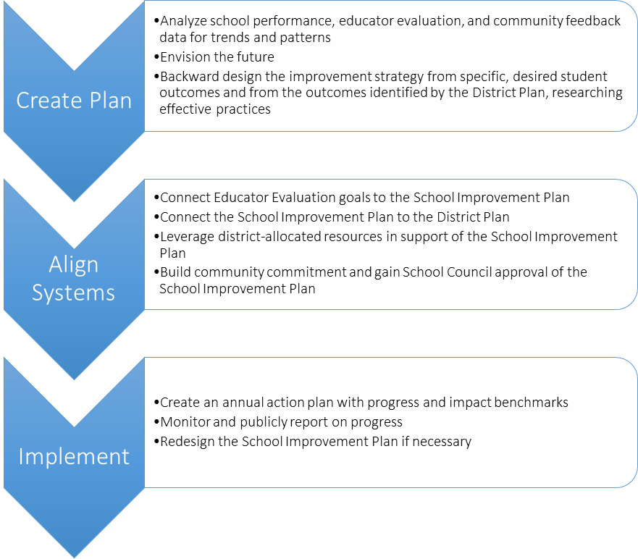
School Action Plan
1 year
School Improvement Plan
3 years

The Massachusetts Planning and Implementation Framework

Multi-Year Plan Components
Element | Definition
Mission | Your purpose: why the organization exists.
Core Values | What you believe in: the principles that guide decision making and action.
Vision | Your aspirations for students: what you value and why, and what future success will look like.
Are the foundation of the…
Theory of Action | The beliefs and assumptions you hold about why certain actions will lead to the vision you seek. Framed as an “if…then” statement.
Which leads to the development of the…
Strategic Objectives | The coherent group of overarching goals and key levers for improvement that will achieve the vision (the “what” and “why”).
Which will be achieved by the…
Strategic Initiatives | The projects and programs that support and will achieve the strategic objectives (the “how”).
The success of the plan as a whole will be measured by the...
Outcomes | The expected results: what they will be, how they will be measured, when they will occur. Outcomes are SMART goals: specific and strategic; measurable; action-oriented; rigorous, realistic, results-focused; timed and tracked.  Final outcomes set targets for improvement achieved at the end of plan implementation. For example: By 2021, decrease chronic absenteeism by 2.8 percentage points to 12%. Interim outcomes set targets for improvement during plan implementation.

Annual Action Plan Components
Element | Definition
Implementation Benchmarks | The planned action steps and their desired impact.  Process benchmarks specify what will happen, who will do it, and when. For example, 20 teachers will complete an ESL course by June.  Early evidence of change benchmarks identify changes you should begin to see if the plan is having its desired impact while being implemented. Early evidence benchmarks are indicators of effective implementation rather than measurements of interim results. Early evidence benchmarks might include changes in practice or attitude from sources such as classroom observation or surveys. For example, an increase in student use of oral language was observed in 80% of these ESL teachers’ classrooms between October and May.
Which you regularly monitor to assess whether the plan is on track to achieve desired change or requires adjustment.

Create—Align—Implement
School Improvement Plan and Action Plan Components
The Massachusetts Planning and Implementation Framework
The Massachusetts Planning and Implementation Framework, displayed on the previous page, was developed by the Department of Elementary and Secondary Education to support plan creation. The framework provides a common planning language, defines all plan components, and supports the shared understanding critical to successful planning and execution.

School Improvement Plan
An effective School Improvement Plan is developed with input from staff, families, students, and community partners; supports the District Plan; and includes the same elements as a District Plan, according to legislation. The outline below identifies a proposed structure for the multi-year School Improvement Plan. These components reflect legislative requirements, educator evaluation expectations, and best practices in planning.

- School Mission, Vision, Core Values
  - The school’s core values
  - The school’s mission
  - The school’s vision
- Data analysis and theory of action for improvement
  - Data analysis of student achievement and gaps between student groups in core subjects
  - The school’s theory of action for improvement
- Strategic Objectives and Initiatives
  - Strategic objectives for improvement (3-5 recommended, to support focus)
  - The strategic initiatives that will achieve these objectives
  - The professional development that will support objectives and initiatives
  - Teacher induction and mentoring activities that support successful implementation
  - District program models and approaches that ensure progress for English learners
- Outcomes
  - Performance benchmarks—interim and final outcomes—and processes for evaluating initiative effectiveness

School Action Plan
The annual action plan supports the implementation of the multi-year School Improvement Plan. The outline below identifies action plan components.

- Implementation Benchmarks
  - Implementation benchmarks for the year, defining specific activities, persons responsible, and timelines for action to be taken to accomplish plan initiatives
- Resources Supporting Implementation
  - The staff and financial resources allocated to support these initiatives

The Massachusetts Planning and Implementation Framework identifies two types of implementation benchmarks: process and early evidence of change. Process benchmarks help monitor progress, specifying what will be done when and by whom. Early evidence of change benchmarks help monitor impact during implementation, specifying changes in practice, attitude, or behavior one should begin to see if the plan is having its desired impact.

Create—Align—Implement

Connecting Existing District Systems to Create Coherence
The graphic below depicts the data sources that inform District and School Improvement Plans; the contents of improvement and action plans and the relationships between these plans; and the connections between these plans and district systems. District and School Improvement Plans are living documents that should guide district systems and respond to changes in the school and district context, including data about plan implementation and impact gathered through action plan monitoring.

Educator Evaluation Data
School Performance Data
Community Feedback
District Plan
Vision, Mission, Core Values
Data Analysis
Strategic Objectives
Strategic Initiatives
Professional Development
Teacher Induction & Mentoring
Outcomes (SMART Goals)

District Action Plan
Implementation Benchmarks
Resources
School Improvement Plan
Vision, Mission, Core Values
Data Analysis
Strategic Objectives
Strategic Initiatives
Professional Development
Teacher Induction & Mentoring
Program Model: English Learners
Outcomes (SMART Goals)

Budget
Grants
Technology
Resource Allocation

Educator Evaluation
System
School Action Plan
Implementation Benchmarks
Resources
District Performance Data
Educator Evaluation Data
Community Feedback

