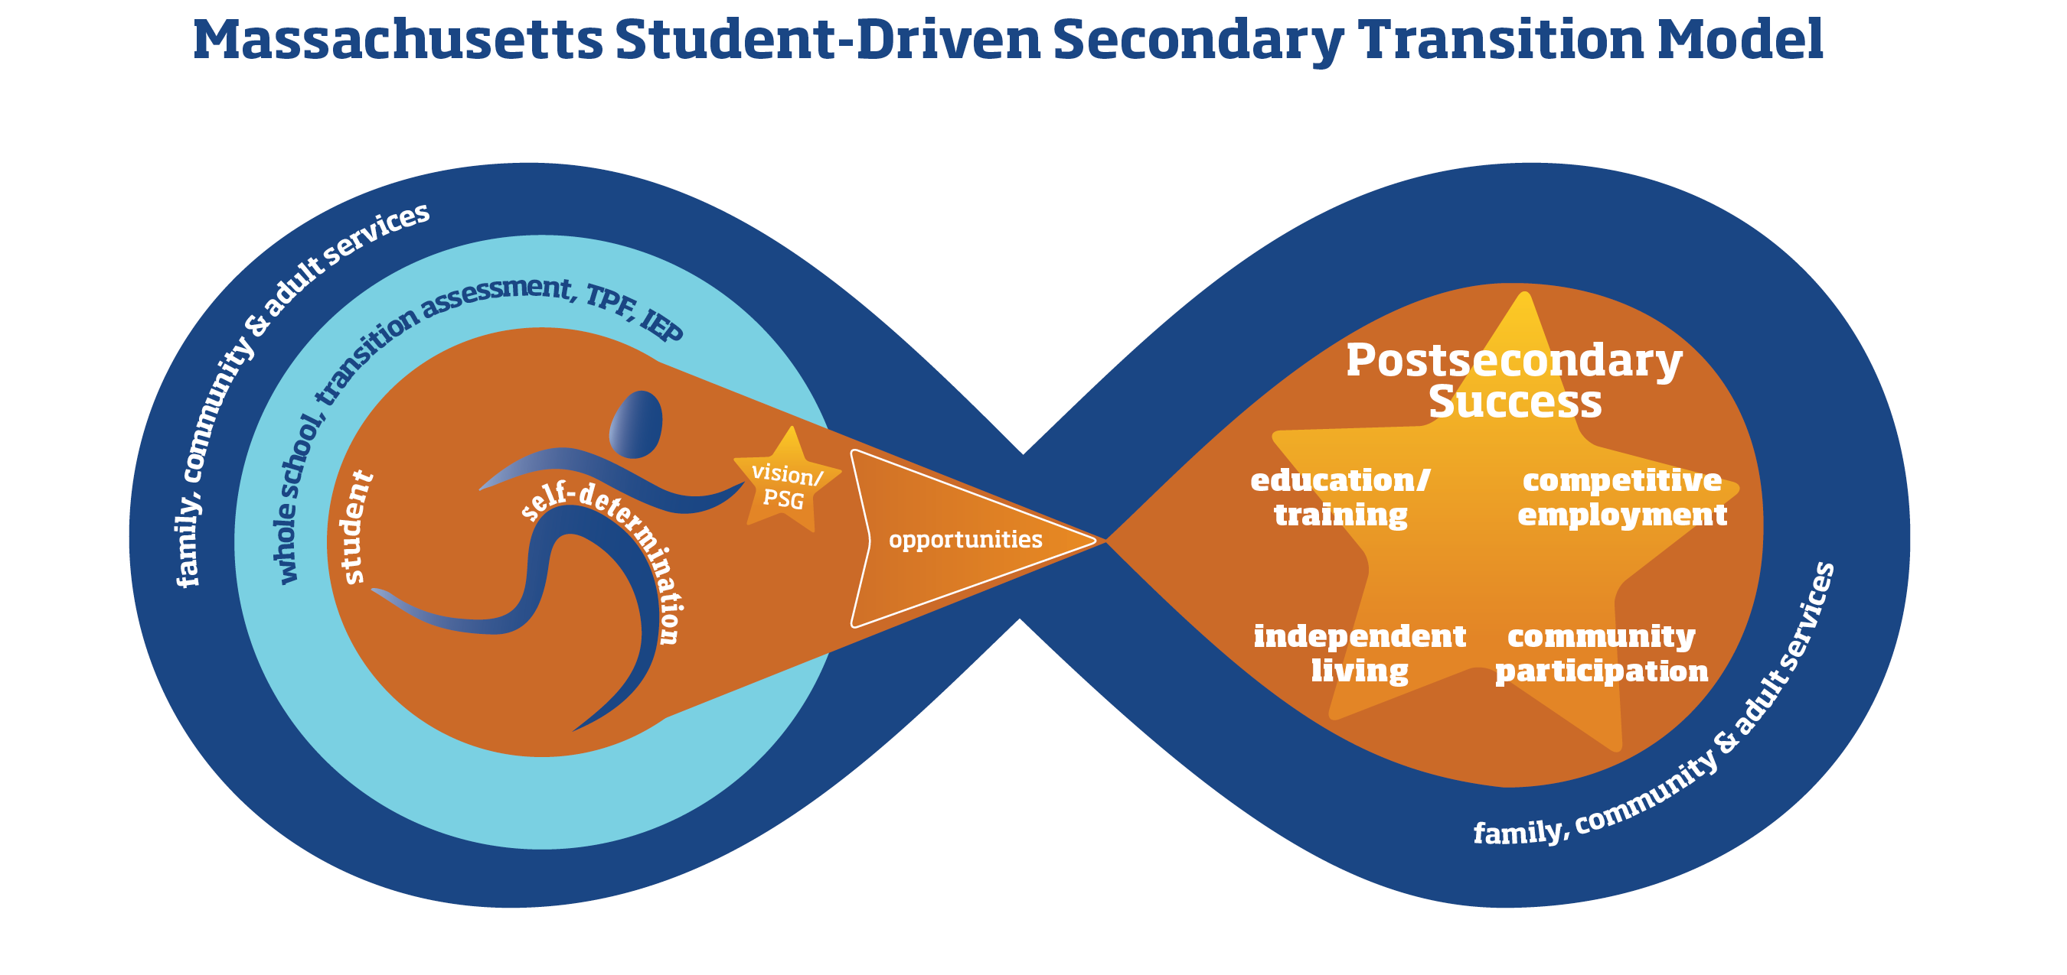

THE MASSACHUSETTS STUDENT-DRIVEN SECONDARY TRANSITION MODEL

Introduction
According to the Individuals with Disabilities Education Act (IDEA), secondary transition services are a "coordinated set of activities… within a results-oriented process, that is focused on improving the academic and functional achievement” of students with disabilities, so as to facilitate their "movement from school to post-school activities." Created by the Department of Elementary and Secondary Education (ESE) in consultation with a broad cross-section of stakeholders, and with graphics expertise donated by the Institute for Community Inclusion at UMass Boston, the Massachusetts Student-Driven Secondary Transition Model visually represents this movement from school to post-school life for students with Individualized Education Programs (IEPs) aged 14-22. The model is informed by two big ideas:

“Student-Driven”
This model emphasizes the central, most important characteristic of a successful secondary transition process: it is student-driven. A large body of research demonstrates that students who achieve postsecondary success tend to be those who are supported by educators, families, and communities to be meaningfully engaged in planning, assessment, IEP development, course of study, and service delivery during their transition years. Successful students understand their own strengths and limitations, know themselves to be “causal agents in their own lives,” have a vision for the future, and are directly involved in actualizing that vision.

An Infinity Symbol
No one – with or without disabilities – becomes successful in a vacuum. We are all interdependent, each person relying on the other for knowledge, companionship, resources, and support. Throughout the course of their lives, in school and beyond, individuals with disabilities are supported by family, community, and (in some cases) state agencies. In this visual model, the dark blue infinity symbol denotes the lifelong interdependence of every person, who from school days (on the left) progresses to adult life (on the right).
We invite all stakeholders – students, families, general and special educators, administrators, guidance counselors, vocational rehabilitation counselors, related service providers, and others – to use this model as a reference to inform the planning and delivery of secondary transition programs and services, on an individual and system-wide basis. We note that the model is aligned with existing state priorities such as college-career readiness, with district standards and indicators, and with initiatives such as the Massachusetts Tiered System of Supports. Already, across the Commonwealth, school districts are developing strategic partnerships that cross traditional boundaries such as those that have existed between general and special education, educators and families, in school and beyond the school walls. This model encourages and supports these efforts, as the best way to promote optimal outcomes for our students.

Exploring the Massachusetts Student-Driven Secondary Transition Model

LEFT SIDE – The Student in the School Context

On the left side of the model is the student with disabilities in the school environment.
Fully self-determined, the student acquires and internalizes self knowledge and key skills, including the ability to evaluate options, make choices and decisions, self regulate, self advocate, set and attain goals, solve interpersonal problems, communicate competently, and effect change according to one’s preferences.
The gold star in the student’s outstretched hand guides the entire secondary transition process. This star is the student’s vision, expressed as postsecondary goals (PSG) which ultimately are realized in adult postsecondary success, as shown on the right side of the model.
A student’s understanding and articulation of his or her personal vision/PSG is a developmental process. Young students may have very little grasp of their own needs, strengths, preferences and interests, and therefore very little notion of what sort of career, postsecondary education, or living arrangements might eventually suit them best. An older student, having enjoyed a greater variety of academic, work, and life opportunities, will more easily express his or her dreams for the future.
Supporting the student in the light blue ring are the whole school, transition assessments, the Transition Planning Form (TPF), and the IEP.
The term “whole school” comprises both academic and nonacademic general education, including curriculum frameworks, guidance counseling, a tiered system of supports, vocational education, work-and-learning initiatives, and the life of the school. The goal of both general and special education is to prepare students for adult life. Special education services – transition assessment, the TPF, the IEP – provide individualized support to promote effective student progress in general education toward the realization of adult success.
- In the whole-school context, the student engages in a course of study aligned with his or her vision/PSG, receiving services and supports which enable him or her to make progress according to the Massachusetts Curriculum Frameworks and his or her IEP goals, and to participate in the life of the school.
- Through age-appropriate transition assessment, the student’s IEP team – of which the student and his or her family are integral members – discerns the student’s vision; comes to understand the student’s strengths, preferences, interests, and disability-related needs; and measures the student’s progress towards the acquisition of skills.
- Annually, the student’s team uses the TPF to guide its discussion of ongoing, age appropriate transition assessments, the student’s vision/PSG and disability-related needs, and an action plan that will detail how the student can prepare both academically and functionally to achieve his or her postsecondary vision/PSG. Although the TPF must be used to guide the transition discussion at the IEP table, the TPF is not a service delivery contract. Thus the TPF is used as a holistic brainstorming document which can record the intentions of many stakeholders in the student’s life: the student, the student’s family, coaches, employers, and others.
- Once the TPF discussion has occurred, the student’s team then develops the IEP. By contrast with the TPF, the IEP is a contract between the district and the parent/family that delineates services and supports the school must provide for the next year, in order to move the student toward the realization of his or her vision/PSG. The IEP records the student’s vision/PSG and any family or student concerns, describes assessment results, sets forth annual skill-based goals, and stipulates supports and services that will be delivered.
Also on the left side of this visual model is half of the dark blue infinity symbol. The student’s education takes place in the context of family, community, and – in many cases – support from adult services. Because of this, schools actively collaborate with other stakeholders in the student’s life in order to support the student’s vision/PSG.
- The student’s family members, who are experts regarding the student, are essential partners during secondary transition planning. For example, they can offer key insights into the student’s interests, preferences, and needs, as well as insights into the student’s growth and development, cultural background, and performance in non-school contexts. Families are often knowledgeable about local resources and can provide linkages to community employment and recreation opportunities. During non-school hours, many families support their transition-aged children to engage in experiences which develop and deepen the students’ knowledge and skills, and support progress toward attainment of their vision/PSG.
- The community in which the student lives can be a rich source of resources and natural supports. Students can explore interests and develop skills through connections with friends, neighbors, coaches, religious congregations, local business owners, civic organizations, clubs, non-profits, etc. Tapping into these resources, schools can provide opportunities inside and beyond the classroom walls to help students clarify their visions/PSGs and make progress toward achieving them.
- For many students, adult services provided by state agencies can be a critical factor in their success. If an IEP team determines that a student would benefit from supports delivered by an agency such as the Department of Developmental Services (DDS), the Massachusetts Rehabilitation Commission (MRC), or the Department of Mental Health (DMH), then a 688 referral is made two years before the student’s anticipated date of exit. State agency representatives can be invited to join the student’s IEP team. For more information on the 688 process, please see the Chapter 688 page on the Department of Elementary and Secondary Education (ESE) website.

CENTER – Transition Learning Opportunities
In the center of the model, the arrowhead pointing to postsecondary success represents the individualized opportunities in the areas of education/training, competitive employment, independent living, and community participation that the student experiences during the transition years.
These opportunities – both on the school campus and in community locations – are facilitated by those on the left side of the visual model: the student him- or herself; the whole school, including special education; family; community; and adult services. All IEP team members share responsibility for planning these essential experiences, through which the student builds the knowledge and skills he or she needs in order to achieve his or her postsecondary vision/PSG.

RIGHT SIDE – Secondary Transition and Successful Adult Outcomes

On the right side of the model is the adult with disabilities, beyond secondary school.
On the right side of the model, the student’s vision/PSG is actualized. No longer in secondary school, the student has achieved his or her postsecondary goals – the gold star – in the domains of education/training, competitive employment, independent living, and community participation.
This is not to say that this young adult’s journey is finished. Personal goal-setting and accomplishment is a continuous process. As the years pass, the individual with disabilities will set new short- and long-term goals, and – as the infinity symbol indicates – will continue to receive support, as needed, from adult services and from his or her family and community. In this way, adults with disabilities are like all people, living interdependent lives, each person drawing strength from the other, each person’s strengths enriching the entire community.

34 CFR § 300.43(a)(1)
Wehmeyer, M. L. (2007). Overview of Self-Determination and Self-Determined Learning. In Promoting Self-Determination in Students with Developmental Disabilities. (1st ed.). (pp. 3 - 16). New York, NY: The Guilford Press, p. 7.

