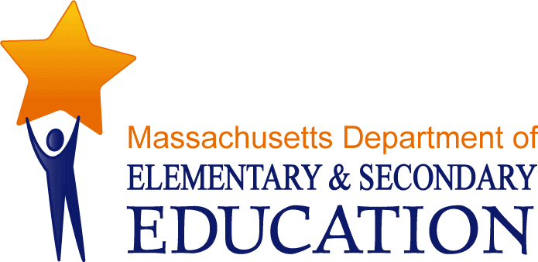
21st Century Community Learning Centers Program

Fiscal Year 2018 Year End Report
December 2019
Massachusetts Department of Elementary and Secondary Education
75 Pleasant Street, Malden, MA 02148-4906
Phone 781-338-3000 TTY: N.E.T. Relay 800-439-2370
www.doe.mass.edu

This document was prepared by the
Massachusetts Department of Elementary and Secondary Education
Jeffrey C. Riley
Commissioner

The Massachusetts Department of Elementary and Secondary Education, an affirmative action employer, is committed to ensuring that all of its programs and facilities are accessible to all members of the public.
We do not discriminate on the basis of age, color, disability, national origin, race, religion, sex, gender identity, or sexual orientation.
Inquiries regarding the Department’s compliance with Title IX and other civil rights laws may be directed to the
Human Resources Director, 75 Pleasant St., Malden, MA 02148-4906. Phone: 781-338-6105.

© 2019 Massachusetts Department of Elementary and Secondary Education
Permission is hereby granted to copy any or all parts of this document for non-commercial educational purposes. Please credit the “Massachusetts Department of Elementary and Secondary Education.”

This document printed on recycled paper

Massachusetts Department of Elementary and Secondary Education
75 Pleasant Street, Malden, MA 02148-4906
Phone 781-338-3000 TTY: N.E.T. Relay 800-439-2370
www.doe.mass.edu

TABLE OF CONTENTS

Introduction 4
Program Information 6
Survey of Academic Youth Outcomes (SAYO) 10
School Year SAYO Results 12
Summer Enhancement Grant 16
Summer SAYO Results 16
SAYO-Youth Results 17
APPENDIX A: Program Goals 19
APPENDIX B: FY18 21st Century Community Learning Centers Grantees and Sites 20

21st Century Community Learning Centers Program

Fiscal Year 2018 Year End Report

Introduction

The following report provides information on the fiscal year 2017-2018 (FY18) 21st Century Community Learning Centers (CCLC) grant program. In particular, it examines program information related to participation, activities, and hours of service. Additionally, it details the results of the Survey of Academic Youth Outcomes (SAYO) evaluation tool, which was developed by the Department of Elementary and Secondary Education (Department) and the National Institute of Out-of-School Time (NIOST) to track information on the effect participation in the 21st CCLC programs has in increasing student achievement, as well as to provide feedback for ongoing program improvement.

FY18 was the sixteenth year that 21st Century Community Learning Centers grants were distributed through the Department and originally funded through Title IVB of the 2001 No Child Left Behind Act (NCLB) and currently through Title IVB of the Every Student Succeeds Act (ESSA) of 2015. These grants are awarded on a competitive basis with continuation funding available for up to two additional years. In addition to funding Out of School Time Programs (OST) in FY18, grants were also awarded for Expanded Learning Time programs (a longer school day/year for all students- ELT).

Overall, the data collected indicates that students who participated in the FY18 21st Century Community Learning Center (CCLC) programs made significant gains in all of the areas measured. Moreover, data indicates that 21st CCLC programs may help reduce the opportunity and achievement gap as well as contribute to decreasing the high school drop rate. It can be seen from the data regarding 21st CCLC participating students that members of the subgroups included in the Department’s accountability system (students with disabilities, for example) and in fact, for some outcomes these students made statistically greater gains than their non-subgroup counterparts.

The results described in this report point to the significant contributions that 21st CCLC programs have made to the academic achievement and youth development of the nearly 22,400 students served across the state during FY18.

Highlights of FY18 21st CCLC Programs and SAYO Results

School Year and Summer (September 2017—August 2018)
- In FY18, the Department awarded approximately $17.5M in grants to 42 grantees through competitive and continuation grants.
- Approximately 22,400 students in grades K-12 participated in 21st CCLC program services at 143 sites across the state.
- 21st CCLC participants included nearly 13,200 students who were designated as economically disadvantaged (ED), 4,300 students with disabilities, and 6,500 students considered English language learners (ELL).
- As rated by school-day teachers, statewide figures for student participants showed positive gains in all eight academic and six intermediary outcomes that the SAYO tool measures, with the greatest average pre to post increases being in reading, written communication, mathematics problem solving, and analysis.
- As rated by 21st CCLC staff, statewide figures for student participants showed positive gains in all five intermediary outcomes measured, with the greatest average pre to post program increases in initiative and relationships with adults.

School Year (September 2017—June 2018)
- Approximately 19,900 students participated in 21st CCLC program services offered by 42 grantees at 143 sites across the state during the school year.
- Approximately 10,100 of students served were in OST and 10,300 were in ELT programs.
- Students who participated in the 21st CCLC OST program attended an average of 156 (and median of 120) hours of programming offered outside of regular school hours during the school year.
- Approximately 11,900 students who were designated as economically disadvantaged, including 4,000 students with disabilities and 5,900 ELL students participated in the 21st CCLC program during the school year.
- Approximately 5,000 SAYO surveys were collected from school-day teachers and 4,200 program staff members.

Summer (July—August 2018)
- Approximately 5,400 students participated in 21st CCLC program services offered by 42 grantees at 103 sites across the state during the summer.
- Students who participated in the 21st CCLC program attended an average of 105 (and a median of 98) hours of programming offered during summer hours.
- Approximately 3,000 students were designated as economically disadvantaged, including 1,200 students with disabilities and 1,300 ELL students participated in summer 21st CCLC programs.
- Approximately 2,900 SAYO surveys were collected from summer program staff.

Massachusetts 21st Century Community Learning
Centers Programs, FY18

Program Information
Participation
As reported by the 42 entities serving students through FY18, an unduplicated total of 22,403 children and youth participated in 21st CCLC school year programs (10,141 in OST and 10,248 in ELT) and 5,372 participated in 21st CCLC summer programs. Figure 1 below shows that nearly two-thirds of all FY18 program participants were children in elementary school (PK-5), while children in middle school (grades 6-8) accounted for 26 percent and high school students (grades 9-12) accounted for 9 percent of those served.

Figure 1: Percentage of Student Participants by Grade Level, FY18

Source: Student Information Management System and grant recipient reports.

Table 1 below compares grade level participation by school year and summer and illustrates that the a slightly higher proportion of elementary versus middle school students were served during the school year versus the summer. More specifically, 65 percent of students served were elementary school students in 64 the school year compared to 68 in the summer, 27 percent were middle school students during the school year compared to 24 percent during the summer, and 8 percent during the summer compared to 9 percent during the summer were high school students.

Table 1: Percentage of Student Participation by Grade Level, FY18

 | School Year |  | Summer
Grade Level | N | % | N | %
Elem. Total | 12,938 | 65% | 3,644 | 68%
Middle Total | 5,344 | 27% | 1,271 | 24%
H.S. Total | 1,654 | 8% | 457 | 9%
Source: Student Information Management System and grant recipient reports.

The racial breakdown of students served is illustrated in Figure 2 on the next page. The majority of students served (69 percent) in FY18 21st CCLC programs were members of a minority group, while 31 percent of students were white. Hispanic students were the largest minority group (45 percent) followed by African American students (14 percent) and Asian students (5 percent). Table 2 also on the next page compares the racial breakdown by school year and summer. As it shows, a higher proportion of minority students as compared to white students were served during the school year (69 percent) than during the summer (62 percent); and in both timeframes, percentages of minority students served were much higher than their statewide proportion (40 percent).
Figure 2: Percentage of Student Participation by Race/Ethnicity, FY18

Source: Student Information Management System and grant recipient reports.

Table 2: Student Participation by Race/Ethnicity during School Year and Summer Programs, FY18

 | School Year 21st CCLC |  | Summer 21st CCLC |  | Statewide
Race/ Ethnicity | N | % | N | % | %
African American | 2,862 | 14% | 734 | 14% | 9%
Asian | 971 | 5% | 383 | 7% | 7%
Hispanic | 9282 | 47% | 1,911 | 36% | 20%
White | 5,953 | 30% | 2,050 | 38% | 60%
Other | 868 | 4% | 294 | 5% | 4%
Source: Student Information Management System and grant recipient reports.

Additionally, during FY18 21st CCLC programs, data was collected by grantees on the number of students served who were classified as economically disadvantaged, as receiving special education services, and as English language learners (ELL). Overall, 59 percent of students served were designated as economically disadvantaged, 19 percent received special education services, and 29 percent were ELL.

Table 3 on the next page examines the percentage of students served in these classifications during the school year and summer. The proportions of economically disadvantaged and ELLs were higher during the school year compared to those served during the summer (approximately 60 compared to 56 percent for economically disadvantaged, and 30 compared to 23 percent for students with disabilities). The proportions of students with disabilities, however, was higher in the summer than during the school year (23 compared to 20 percent). During both the school year and summer, the percentages of these selected populations served were much greater than their statewide proportion, in particular for economically disadvantaged and ELL students.
Table 3: Student Participation by Economically Disadvantaged, SPED, and ELL during
School Year and Summer Programs, FY18
 | School Year 21st CCLC |  | Summer 21st CCLC |  | Statewide
Special Population | N | % | N | % | %
Economically Disadvantaged | 11,893 | 60% | 3,018 | 56% | 32%
Students with Disabilities | 3,988 | 20% | 1,228 | 23% | 18%
English Language Learners | 5,892 | 30% | 1,306 | 24% | 10%
Source: Student Information Management System and grant recipient reports.

Table 4 below examines the 2018 English Language Arts (ELA) state assessment MCAS performance levels of students served in 21st CCLC school year and summer programs. During the school year, 69 percent of students served by 21st CCLC programs were in either the Not Meeting or Partially Meeting Expectations performance levels compared to 49 percent statewide. This percentage was slightly lower in the summer, where 67 percent of all students served in 21st CCLC programs had scored at the Not Meeting or Partially Meeting Expectations performance levels in ELA.

Table 5 below examines the 2018 mathematics state assessment MCAS performance levels of students served in 21st CCLC school year and summer programs. During the school year, 72 percent of students served by 21st CCLC programs were in either the Not Meeting or Partially Meeting Expectations performance levels compared to 52 percent statewide. This percentage was also slightly lower in the summer, where 71 percent of all students served in 21st CCLC programs had scored at the Not Meeting or Partially Meeting Expectations performance levels in mathematics.

Table 4: Student Participation by ELA 2018 MCAS Performance Levels during
School Year and Summer Programs, FY18
 | School Year 21st CCLC |  | Summer 21st CCLC |  | Statewide
Performance Level | N | % | N | % | %
Exceeding Expectations  Meeting Expectations  Partially Meeting Expectations  Not Meeting Expectations | 406  3,154  5,716  2,350 | 3%  27%  49%  20% | 120  885  1,484  582 | 4%  29%  48%  19% | 9%  42%  38%  11%
Source: 2018 MCAS file (grades 3-10) and grant recipient reports.
Note: Grade 10 results are excluded from table above due to different assessment utilized (MCAS) – performance levels and percentages for grade 10 participants (and statewide) were as follows: Advanced 24% (51%), Proficient 57% (40%), Needs Improvement 16% (6%), and Failing 4% (3%).

Table 5: Student Participation by Mathematics 2018 MCAS Performance Levels during School Year and Summer Programs, FY18
 | School Year 21st CCLC |  | Summer 21st CCLC |  | Statewide
Performance Level | N | % | N | % | %
Exceeding Expectations  Meeting Expectations  Partially Meeting Expectations  Not Meeting Expectations | 338  2,947  5,835  2,502 | 3%  25%  50%  22% | 102  800  1,562  617 | 3%  26%  51%  20% | 7%  40%  40%  12%
Source: 2017 MCAS file (grades 3-10) and grant recipient reports.
Note: Grade 10 results are excluded from table above due to different assessment utilized – performance levels and percentages for grade 10 participants (and statewide) were as follows: Advanced 30% (51%), Proficient 26% (27%), Needs Improvement 24% (14%), and Failing 21% (8%).

Hours of Service
Students were served in 21st CCLC programs from September 2017 through August 2018. During the school year (September through June), OST students each participated an average of 156 (and a median of 120) hours. During the summer (July through August), students were served an average of 105 (and a median of 98) hours each. Table 6 below shows the percentage of students served by hour ranges. During the school year, 60 percent of students served participated for at least 100 hours in 21st CCLC programs; and during the summer, 46 percent of students served participated for at least 100 hours.

Table 6: Percentage of Students Served in Program Hour Ranges, FY18

 | School Year  (Mean: 156 hrs/ Median: 120 hrs) |  | Summer  (Mean: 105 hrs / Median: 98 hrs)
Program Hour Ranges | N | % | N | %
1-50 Hours | 1,633 | 16% | 787 | 15%
51-100 Hours | 2,469 | 24% | 2,110 | 39%
101-200 Hours | 2,953 | 29% | 2,041 | 38%
201+ Hours | 3,122 | 31% | 434 | 8%
Source: Grant recipient reports.
Note: This data does not include students who participated in 21st CCLC ELT programs where a minimum of additional hours beyond the state required hours was required for all students.

Academic Subjects/Activities Offered
During FY18, all 21st CCLC program sites provided comprehensive programming by offering a wide variety of academic enrichment activities. Almost all districts offered a homework component during the school year (replaced by learning skills during the summer), and many focused on helping students develop specific mathematics and English language arts skills. See below for a sampling of the academic subjects and activities that were offered at the 21st CCLC sites.

Subjects Activities
English Language Arts (ELA) Project Based Learning
● ELA/Verbal Communication Service Learning
● ELA/Written Communication Arts (Performing, Music/Dance, Graphic, Drawing/Painting)
Mathematics Social Emotional Learning
● Communication Character Education / Bullying Prevention Education
● Problem Solving College/Career Preparation
● Reasoning Culinary Arts
Science Entrepreneurial
Social Science Family Engagement
Health & Wellness
Homework
Media Technology (Includes Film Making, Writing, Print Media)

Expanded Learning Time
In FY18, six districts were awarded to support expanded learning time in 15 schools as part of the required school day for all students during the school year in order to provide creative and engaging academic enrichment opportunities that will help to close proficiency gaps, and support college and workforce readiness and success. Funded schools were required to offer a minimum of 180 additional hours of structured learning time beyond the state required hours for all students as part of their required school year plus 120 (total of 300 hours) for a targeted group of students during the summer. The grantees and schools that received FY18 21st CCLC ELT funding is indicated with an * in Appendix B.

Regional Networks
The purpose of the Regional Networks is to develop and implement capacity building activities that will enhance the ability of 21st CCLC programs in particular, as well as out-of-school time (OST) programs in general, to collaborate and coordinate resources across districts/communities. These capacity building activities foster continuous program improvement and support student achievement that furthers the Department’s efforts to support effective practices across the state during OST, as well as during the school day.

The four Regional Networks (Northeast, Central, Southeast, and West) were managed by experienced Massachusetts 21st CCLC grantees that have demonstrated exemplary practice, and act as coordinators on behalf of their regional networks. Each regional network decided internally who will serve in this capacity. Networks developed capacity building activities and professional development workshops based on the needs of the each of the programs in the individual regions.

Regional network activities included:
Asset Mapping Collaborative Grant Opportunities
Professional Development Curriculum Development
Curriculum Libraries Peer Support
Leadership Development Monthly/Quarterly Regional Meetings

Enhanced Programs for Students with Disabilities

The Enhanced Programs for Students with Disabilities grant program was developed in collaboration and coordination and with financial support from the office of Special Education.

The purpose of this grant program is to enhance the capacity of current 21st CCLC programs to include students on an IEP into an array of activities designed to complement their school-day programs, advance achievement, and provide opportunities for socializing and participating with peers without disabilities.

In FY18, approximately 4,300 students with disabilities were served, which was 19 percent of the total 21st CCLC population.

All FY18 21st CCLC grantees were required to utilize the Survey of Academic Youth Outcomes (SAYO) on a select sample of students, including those served as a result of FC 245. Figure 4A below displays the SAYO-teacher results of students who did and did not receive special education services. Students within this subgroup classification made significantly greater gains than those not in this subgroup on three of the eleven outcomes measured.

Survey of Academic Youth Outcomes (SAYO)
The Department worked with the National Institute on Out-of School-Time (NIOST) over a three-year period to create the Survey of Academic Youth Outcomes (SAYO), an evaluation tool for use by Massachusetts’ 21st CCLC grantees. Results from two rounds of field-testing with over 5,000 students indicated that the SAYO is a valid and reliable instrument for measuring change in youth.
In FY13, the SAYO was piloted in four ELT schools in which SAYO-teacher data was collected on 100 students in each school. The emphasis for the pilot was on implementation, experience and technical performance of the tool. Results of the pilot of the SAYO T showed sufficient reliability and validity that was consistent with findings from use in 21st CCLC OST programs with evidence of change from pre- to post-assessment.

The SAYO Evaluation System uses brief pre-participation and post-participation surveys to collect data from school-day teachers and 21ST CCLC staff. The SAYO Evaluation System is based on a “menu” approach, meaning that programs collect data on selected outcomes that are aligned with their goals and program practices. Each outcome area is measured by asking school-day teachers and program staff to respond to four or five questions related to observable youth behaviors. These items have been extensively tested and found to work as a single scale that effectively captures the outcome being measured. Survey responses from school day teachers (SAYO-T) and program staff (SAYO-S) are completed for a sample of youth in each program.

The SAYO Evaluation System enables 21st CCLC programs to capture information reflecting changes that are (a) associated with participation in a high-quality 21st CCLC programs and (b) likely to occur over a one-year period. Massachusetts requires all 21st CCLC grantees to use the SAYO as a part of their evaluation and reporting efforts. All grantees use SAYO results to indicate the degree to which they have measured positive outcomes among the participants they serve. Grantees select from a list of outcomes and measure what best reflects the focus and goals of their programs.

Academic Outcomes-SAYO Teacher Version (SAYO-T Academic)
The academic section contains two main content areas in which science and social science are expected to be incorporated as well as homework, if assistance with this is offered through the program): ELA and mathematics. Grantees select and report on the main area that best reflect their program goals, and have school-day teachers of students participating in the school year program complete pre-and post-program assessments.

Social and Emotional Learning (SEL) Outcomes-SAYO Teacher Version (SAYO-T SEL)
Grantees are required to consider three SEL outcomes: critical thinking, self-regulation, leadership, perseverance, relations with adults, relations with peers, and engagement. They are asked to select and report on the three areas that best match the goals of their 21st CCLC program Grantees have school-day teachers of students participating in the school year program report pre-and post-ratings in the three chosen outcomes.

Program Staff Version (SAYO-S)
Using the SAYO-S, grantees are required to collect and report on pre- and post-ratings of students by program staff (which may include school-day teachers if they are working in the funded programs). Grantees must collect responses from staff working with students served during the school year as well as during the summer for the same three SEL outcomes selected as part of the SAYO-T described above.

Youth Version (SAYO-Y)
Between October-December 2017 and March-June 2018, grantees were required to administer an online survey with youth in their 21st CCLC program. The SAYO-Y was designed to collect information from youth in three main areas: their program experiences, their sense of competence, and their future planning and expectations.

Assessing Program Practices Tool (APT)
As a complement to the SAYO, the Assessing Program Practices Tool (APT) is an observation instrument developed to assess the extent to which programs are implementing practices congruent with their desired SAYO outcomes. The APT is intended to be a tool that assists grantees with continuous program improvement and with identifying areas for professional development.

School Year SAYO Results
All OST grantees were included in the SAYO-Teacher (Academic and Intermediary Outcomes) and SAYO-Staff samples from the school year. In total, 5,109 SAYO surveys were collected from school-day teachers and 4,150 from program staff members. Tables 7 and 8 below include the number of students surveyed by school-day teachers and/or staff and a comparison of average pre to post percentage changes by outcome.

SAYO-Teacher Results
Table 7 shows that during the school year the most frequently surveyed academic outcome by students' school-day teachers was English language arts (ELA) with approximately 5,000 responses collected compared to only 1,800 for mathematics. Relations with adults was the most commonly measured SEL outcome, with approximately 3,800 teacher responses collected. The average SAYO-T percentage increase from pre to post survey ranged from 7 percent in homework and relations with peers to 11 percent in ELA and critical thinking.

Table 7: School Year SAYO-Teacher Results, FY18

 | ELA | Math | HW | CT | SR | Lead. | Pers. | RA | RP | Eng. | Comm.
Number of Students | 4,999 | 1,841 | 5,109 | 3,561 | 3,334 | 2,320 | 2,294 | 3,841 | 2,727 | 3,471 | 1,201
Average Percentage Change | 11% | 10% | 7% | 11% | 9% | 10% | 10% | 10% | 7% | 9% | 10%
Note: HW= Homework, CT= Critical Thinking, SR = Self-Regulation, Lead.=Leadership, Pers. = Perseverance, RA=Relations with Adults, RP= Relations with Peers, Eng.=Engagement
Source: Grant recipient reports.

SAYO-Staff Results

Table 8 below shows the SAYO survey results reported by the school year program staff. Relations with adults was also the most commonly measured SEL outcome with nearly 4,200 responses followed by engagement with 3,700 responses. The average SAYO-S percentage increase from pre to post survey ranged from 11 percent in relations to peers to 15 percent in critical thinking.

Table 8: School Year SAYO-Staff Results, FY18

 | CT | SR | Lead. | Pers. | RA | RP | Eng. | Comm.
Number of Students | 3,803 | 3,586 | 2,454 | 2,363 | 4,150 | 3.044 | 3,667 | 1,447
Average Percentage Change | 15% | 14% | 14% | 16% | 11% | 13% | 11% | 16%
Note: HW= Homework, CT= Critical Thinking, SR = Self-Regulation, Lead.=Leadership, Pers. = Perseverance, RA=Relations with Adults, RP= Relations with Peers, Eng.=Engagement
Source: Grant recipient reports.

Subgroup Analysis

The following charts on the next six pages examine the SAYO school year survey results by comparing the pre to post average percentage changes for particular outcomes by various subgroups. In general, the results indicate that students served in FY18 21st CCLC programs within specific subgroups made comparable or statistically greater gains than those without that subgroup classification.

Figures 3A & B compare the SAYO results of economically disadvantaged students to those who were classified as non-economically disadvantaged. Economically disadvantaged students made significantly greater gains on eight of the 19 outcomes measured.

Figures 4A & B compare the SAYO results of students who did and did not receive special education services. Students within this subgroup classification made significantly greater gains than those not in this subgroup on 10 of the 19 outcomes measured.

Figures 5A & B compare the SAYO results of students designated as English Language Learners (ELL) to those who were not. ELL students made statistically greater gains on three of the 16 outcomes measured. Most importantly, ELL students made significantly greater improvement than non-ELL students in ELA.

Student Performance Comparisons Based on Economically Disadvantaged Status (Figures 3A&B)

Figure 3A: Average Percentage Improvement on SAYO-Teacher Outcomes –
Economically Disadvantaged, FY18
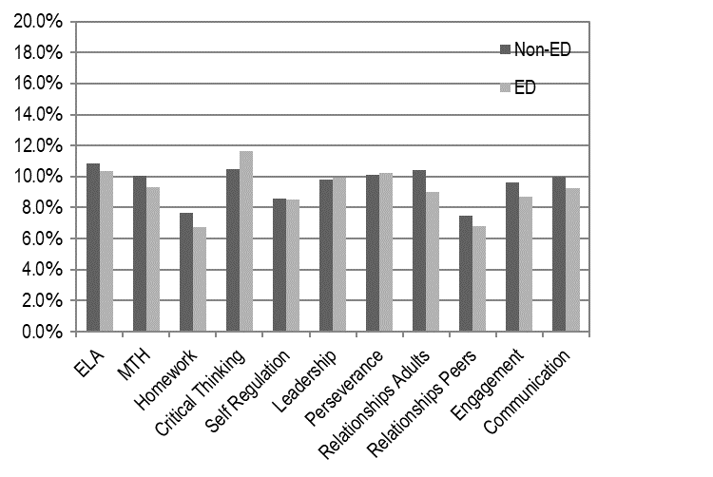
Note: *Statistically significant based on one-way ANOVA (p < .05)
Source: Grant recipient reports.
Figure 3B: Average Percentage Improvement on SAYO-Staff Outcomes—Economically Disadvantaged, FY18

Note: *Statistically significant based on one-way ANOVA (p < .05)
Source: Grant recipient reports.

Student Performance Comparisons Based on Special Education (SPED) Status (Figures 4A&B)

Figure 4A: Average Percentage Improvement on SAYO-Teacher Outcomes—SPED, FY18
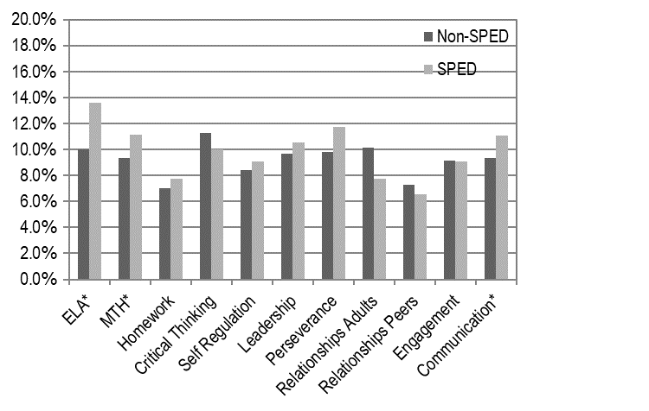
Note: *Statistically significant based on one-way ANOVA (p < .05)
Source: Grant recipient reports.
Figure 4B: Average Percentage Improvement on SAYO-Staff Outcomes—SPED, FY18
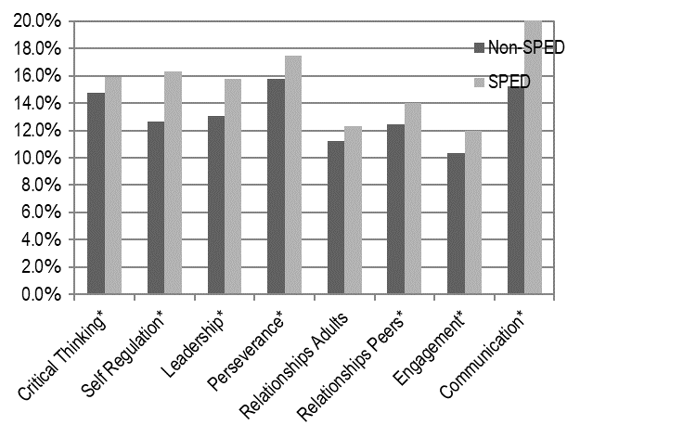
Note: *Statistically significant based on one-way ANOVA (p < .05)
Source: Grant recipient reports.

Student Performance Comparisons Based on English Language Learner (ELL) Status (Figures 5A&B)

Figure 5A: Average Percentage Improvement on SAYO-Teacher Outcomes—ELL, FY18
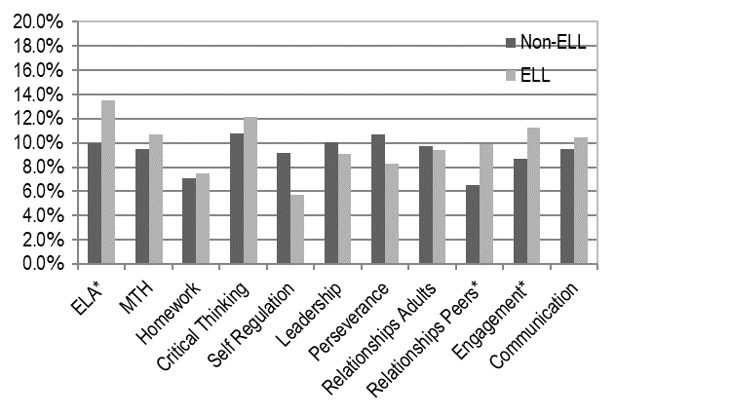
Note: *Statistically significant based on one-way ANOVA (p < .05)
Source: Grant recipient reports.

Figure 5B: Average Percentage Improvement on SAYO-Staff Outcomes—ELL, FY18

Note: *Statistically significant based on one-way ANOVA (p < .05)
Source: Grant recipient reports.

Summer Enhancement Grant
During the summers of 2011 through 2018, the Department’s 21st CCLC Grant Program funded expanded summer learning programs through a Summer Enhancement grant opportunity intended to address summer learning loss by expanding innovative summer learning programs that address both the academic and developmental needs of students.

Grantees were selected through a request for proposal process having to address a number of key participation components. Each program site was required to provide a minimum of 120 hours of programming. Grantees also needed to address the social and emotional needs of students, offer high quality project based learning (PBL) which includes service learning, serve more students (if already at 120 hours of programming) or at least the same number of students as were served during the previous summer, enroll students for the entire length of the program, and require that students attend on average a minimum of 80% of the total hours offered.

Summer SAYO Results
All forty-two (42) grantees ran summer programs at 103 sites. Their associated Survey of Academic Youth Outcomes (SAYO) results are described below. A total of 2,900 surveys were collected from summer program staff. Table 9 includes the number of students surveyed by summer program staff and the average percentage pre to post change in that outcome.

Summer SAYO-Staff Results

Table 9 below shows the results of summer SAYO surveys reported by summer program staff. Unlike during the school year, 21st CCLC summer programs are not required to survey an academic component.
All summer 21st CCLC grantees were required to have summer program staff complete the SAYO-Staff outcomes on a sample of at least 50 students per site. The average percentage increase from pre to post survey ranged from 13 percent in Mathematics to 19 percent in Perseverance.

Table 9: Summer SAYO-Staff Results, FY18

 | ELA | Math | CT | SR | Engag. | Persv. | Lead. | RP | RA | Comm.
Number of Students | 1,740 | 833 | 2,454 | 2,591 | 2,761 | 2,062 | 1,534 | 2,898 | 3,134 | 2,744
Average Percentage Change | 11% | 8% | 18% | 12% | 17% | 15% | 15% | 12% | 17% | 15%
Note: HW= Homework, CT= Critical Thinking, SR = Self-Regulation, Lead.=Leadership, Pers. = Perseverance, RA=Relations with Adults, RP= Relations with Peers, Eng.=Engagement
Source: Grant recipient reports.

SAYO-Youth Results
All grantees with sites serving students in grades 4 or above were required to administer the SAYO-Youth survey during the school year. Sites serving students in grades K-3 were not required to administer the SAYO-Y due to the literacy level of the survey and the ability to respond online. In total, 4,791 SAYO-Youth surveys were collected from students in the fall and 4,924 in the spring. Tables 10-12 below include the number of students surveyed and the outcome means from the fall administration in following areas: program experiences (PE), sense of competence (SC), and future planning and expectations (FPE). Table 12 on the next page includes the results from the spring administration for the retrospective questions.

Supportive Adult was the PE outcome students rated most favorably (mean score of 3.37 out of 4 point scale) followed by Sense of Belonging (3.25). Responsibility / Leadership was the lowest rated PE outcome, with a mean score of 2.48.

Table 10: Fall Program Experiences Outcomes, FY18

 | Enjoyment / Engagement | Challenged | Supportive Adult | Social Environment | Sense of Belonging | Responsibility/ Leadership
Number of Students | 4,791 | 4,791 | 4,704 | 4,703 | 4,644 | 4,528
Average Score | 3.27 | 3.13 | 3.37 | 3.03 | 3.25 | 2.48
Note: All outcomes used a 1-4 point scale (negative to positive).
Source: Grant recipient reports.

Learning was the highest rated SC outcome by students, having a mean score of 3.08. Reading and Writing were the lowest rated SC outcomes with mean scores of 2.68 and 2.67 respectively.

Table 11: Fall Sense of Competence Outcomes, FY18

 | Peers | Learning | Reading | Writing | Math | Science
Number of Students | 4,547 | 4,496 | 3,621 | 4,206 | 928 | 927
Average Score | 2.85 | 3.08 | 2.68 | 2.67 | 2.78 | 2.94
Note: All outcomes used a 1-4 point scale (negative to positive).
Source: Grant recipient reports.

Students were also asked to take a spring version of the SAYO-Y, which included a series of retrospective questions aligned with the SC areas measured in the fall (see Table 13). Students most favorably responded to the question that the program helped them to “make new friends (2.94), “find out what I’m good at doing (2.92), and “get along better with others” (2.91). Students least favorably rated that the program helped them “read more often” (2.42) and “write better” (2.46).

Table 12: Spring Retrospective Questions, FY18

 | Number of Students | Average Score
Has coming to this after-school program helped you to get along better with others? | 4,924 | 2.91
Has coming to this after-school program helped you to read more often? | 4,027 | 2.42
Has coming to this after-school program helped you to write better? | 3,973 | 2.46
Has coming to this after-school program helped you do better in math? | 860 | 2.62
Has coming to this after-school program helped you do better in science? | 848 | 2.53
Coming here has helped me to get my homework done? | 4,823 | 2.88
Coming here has helped me to try harder in school? | 4,822 | 2.80
Coming here has helped me to do better in school? | 4,821 | 2.84
Coming here has helped me feel good about myself? | 4,821 | 2.86
Coming here has helped me find out what I’m good at doing and what I like to do? | 4,820 | 2.92
Coming here has helped me to make new friends? | 4,820 | 2.94
Note: Questions used a 1-4 point scale (negative to positive).
Source: Grant recipient reports.

APPENDIX A: Program Goals

The purpose of the Massachusetts 21st Century Community Learning Centers Program is to support the planning and implementation of additional time for learning for students in grades PK-12. Supported with federal funds, these opportunities will help to close proficiency gaps, increase student engagement, and support college and career readiness and success. Funded activities take place during a longer school day (referred to as Expanded Learning Time or ELT) or during out-of-school time (OST).

Primary Goals for 21st Century Community Learning Centers Programs:

- Provide additional opportunities for engaging teaching and learning of the core subject areas, through both traditional classroom instruction and integrated academic enrichment.
- Provide additional opportunities for creative and innovative enrichment to support students in all developmental areas (academic, social/emotional, civic engagement, wellness, etc.).
- Provide additional opportunities for adults (including school staff, program providers, and partners) to participate in collaborative planning and professional development that supports desired student outcomes.
- Contribute to student performance goals outlined in school improvement plans.
- Build strong school-community partnerships and engage families to support student outcomes in all developmental areas (academic, social/emotional, civic engagement, wellness, etc.).
- Support efforts to strengthen the coordination between the instruction that occurs during the school day and the enrichments and supports that take place during the out-of-school hours.
- Create and maintain a school and community-based infrastructure that establishes procedures to improve outcomes for children and youth through successful program implementation and oversight.
- Establish procedures to evaluate program effectiveness through the collection and analysis of data.
- Promote efficient use of public resources and facilities through effective partnerships between schools, community-based agencies, and other public and private entities.
- Create sustainable models for providing additional quality learning time.

APPENDIX B: FY18 21st Century Community Learning Centers Grantees and Sites

Grantee | Site | ELT/ OST
Athol Area YMCA | Athol Community Elementary School | OST
Barnstable Public Schools | Hyannis West Elementary | OST
Berkshire Hills Regional School District | Muddy Brook Elementary | OST
Berkshire Hills Regional School District | Monument Valley Middle | OST
Boston Day and Evening Academy | Boston Day and Evening Academy | OST
Boston Public Schools | Eliot Innovation K-8 | ELT
Boston Public Schools | Boston International High School / Newcomers Academy | ELT
Boston Public Schools | English High | OST
Boston Public Schools | Gardner Pilot | OST
Boston Public Schools | Thomas Kenny (K-5) | OST
Boston Public Schools | Hennigan Elementary | OST
Brockton Public Schools | Arnone Elementary | OST
Brockton Public Schools | Baker Elementary | OST
Brockton Public Schools | George Elementary | OST
Brockton Public Schools | Raymond K-8 | ELT
Brockton Public Schools | Downey Elementary | OST
Brockton Public Schools | Brookfield Elementary | OST
Chelsea Public Schools | Chelsea High | OST
Collaborative for Educational Services | Maple Elementary (Easthampton) | OST
Collaborative for Educational Services | Pepin Elementary (Easthampton) | OST
Collaborative for Educational Services | Palmer Middle (formerly Converse) | OST
Collaborative for Educational Services | Amherst Regional Middle | OST
Collaborative for Educational Services | Sheffield Elementary (gr. 2-5) | OST
Collaborative for Educational Services | West Springfield High | OST
Collaborative for Educational Services | Easthampton High | OST
Collaborative for Educational Services | Greenfield High | OST
Collaborative for Educational Services | Memorial Elementary (West Springfield) | OST
Collaborative for Educational Services | Coburn Elementary (W. Springfield) | OST
Community Day Care Center (Lawrence) | Emily G. Wetherbee Elementary | OST
Community Day Care Center (Lawrence) | Community Day Arlington | OST
Community Day Care Center (Lawrence) | Alexander B. Bruce | OST
Community Day Care Center (Lawrence) | Frost Elementary | OST
Community Day Care Center (Lawrence) | John K. Tarbox School | OST
Community Day Care Center (Lawrence) | Parthum Elementary | OST
East End House, Inc. (Cambridge) | East End House (primarily serving Kennedy ) | OST
Everett Public Schools | Lafayette | OST
Everett Public Schools | English | OST
Everett Public Schools | Parlin Elementary | OST
Everett Public Schools | Whittier Elementary | OST
Everett Public Schools | George Keverian Elementary (Gr. 2-6) | OST
Everett Public Schools | Webster Elementary | OST
Fall River Public Schools | Doran | OST
Fall River Public Schools | Morton Middle - ELT | ELT
Fall River Public Schools | Mary L. Fonseca Elementary | OST
Fall River Public Schools | Durfee High | OST
Fall River Public Schools | Talbot Innovation (formerly Talbot Middle) | OST
Fall River Public Schools | Greene Elementary | OST
Fall River Public Schools | Letourneau Elementary | ELT
Fitchburg Public Schools | South Street Elementary | OST
Fitchburg Public Schools | Longsjo Middle | OST
Fitchburg Public Schools | Crocker Elementary | OST
Fitchburg Public Schools | Memorial Middle | OST
For Kids Only | William A. Welch Elem (Peabody) | OST
For Kids Only | Center School (Peabody) | OST
For Kids Only | Frank M. Sokowlowski (Chelsea) | OST
Framingham Public Schools | Walsh Middle | OST
Framingham Public Schools | Fuller Middle | OST
Gloucester Public Schools | O'Maley Innovation Middle | OST
Haverhill Public Schools | Tilton | OST
Haverhill Public Schools | Golden Hill | OST
Haverhill Public Schools | Consentino K-4 | OST
Haverhill Public Schools | John Greenleaf Whittier Middle | OST
Haverhill Public Schools | Haverhill High | OST
Haverhill Public Schools | Consentino Middle | OST
Holyoke Public Schools | Donahue (Gr. 5-8) | OST
Holyoke Public Schools | Peck Elementary | OST
Holyoke Public Schools | E.N. White Elementary | OST
Holyoke Public Schools | Holyoke High School | OST
Holyoke Public Schools | Kelly Full Service Community School | ELT
Holyoke Public Schools | Morgan Elementary | OST
Holyoke Public Schools | Lt. Elmer J. McMahon Elementary | OST
Lawrence Public Schools | Parthum Elementary | ELT
Lawrence Public Schools | Arlington Middle | ELT
Lawrence Public Schools | Guilmette Elementary | ELT
Lawrence Public Schools | Emily G. Wetherbee Elementary | ELT
Leominster Public Schools | Sky View Middle | OST
Leominster Public Schools | Samoset Middle | OST
Lowell Public Schools | Greenhalge Elementary | OST
Lowell Public Schools | Shaughnessy Elementary | OST
Lowell Public Schools | Stoklosa Middle | OST
Lowell Public Schools | Christa McAuliffe Elementary | OST
Lowell Public Schools | Abraham Lincoln Elementary School | OST
Lowell Public Schools | Robinson Middle | OST
Lowell Public Schools | Morey Elementary | OST
Lowell Public Schools | Bartlett Community Partnership | OST
Lowell Public Schools | Lowell High | OST
Lowell Public Schools | McAvinnue Elementary | OST
Malden Public Schools | Salemwood K-8 | OST
Malden Public Schools | Forestdale K-5 | OST
Malden Public Schools | Forestdale 6-8 | OST
Malden Public Schools | Beebe 6-8 | OST
Malden Public Schools | Beebe K-5 | OST
Methuen Public Schools | Tenney Lower | OST
Methuen Public Schools | Timony Lower | OST
Methuen Public Schools | Methuen High | OST
New Bedford Public Schools | Gomes Elementary | OST
New Bedford Public Schools | Normandin Middle | OST
New Bedford Public Schools | Hayden-McFadden Elementary | ELT
New Bedford Public Schools | Normandin Middle | ELT
New Bedford Public Schools | Jacobs (formerly Hannigan Elementary) | OST
New Bedford Public Schools | Gomes Elementary | ELT
New Bedford Public Schools | Irwin Jacobs (formerly Hannigan Elementary) | ELT
North Adams Public Schools | Colegrove Park Elementary | OST
North Adams Public Schools | Brayton Elementary (serving K-5) | OST
North Brookfield Youth Center | North Brookfield Elementary | OST
Pittsfield Public Schools | Reid Middle | OST
Pittsfield Public Schools | Herberg Middle | OST
Pittsfield Public Schools | Morningside Community School | OST
Pittsfield Public Schools | Conte Community | OST
Pittsfield Public Schools | Crosby Elementary | OST
Quaboag Regional School District | Warren Elementary | OST
Quaboag Regional School District | Quaboag Innovation Middle | OST
Salem Public Schools | Collins Middle | OST
Salem Public Schools | Bowditch K-8 | ELT
Salem Public Schools | Horace Mann Laboratory School | OST
Salem Public Schools | Bates Elementary | OST
Sociedad Latina | Timilty (Boston) | OST
Sociedad Latina | Mario Umana Academy (grades 6-8, Boston) | OST
South Shore Stars | Randolph Community Middle | OST
South Shore Stars | JFK Elementary (Randolph) | OST
South Shore Stars | Chapman Middle (Weymouth) | OST
South Shore Stars | Randolph High | OST
Springfield Department of Parks, Buildings and Rec. | Mary O. Pottenger Elementary (Springfield) | OST
Springfield Public Schools | Alfred G. Zanetti Montessori | OST
Taunton Public Schools | Taunton Alternative High | OST
Taunton Public Schools | Parker Middle | OST
Triton Regional School District | Salisbury Elementary | OST
Waltham Boys & Girls Club | Whitemore Elementary (Waltham) | OST
Wareham Public Schools | Minot Forest Elementary (serving Gr. 3-4) | OST
Wareham Public Schools | Wareham High | OST
Wareham Public Schools | Wareham Middle | OST
Wareham Public Schools | Decas Elementary | OST
Webster Public Schools | Park Ave. Elementary | OST
Whitman-Hanson Regional School District | Whitman-Hanson Regional High | OST
Winthrop Public Schools | Cummings Elementary | OST
Woburn Boys and Girls Club | Altavesta Elementary | OST
Woburn Boys and Girls Club | Shamrock Elementary | OST
Worcester Public Schools | Sullivan Middle | OST
Worcester Public Schools | Burncoat Middle School | OST
Worcester Public Schools | Claremont Academy | OST
YWCA of Malden | Ferryway (gr. 6-8, Malden) | OST
YWCA of Malden | Ferryway Elementary | OST

