Massachusetts Department of Elementary and Secondary Education

75 Pleasant Street, Malden, MA 02148-4906

Phone 781-338-3000 TTY: N.E.T. Relay 800-439-2370

www

.d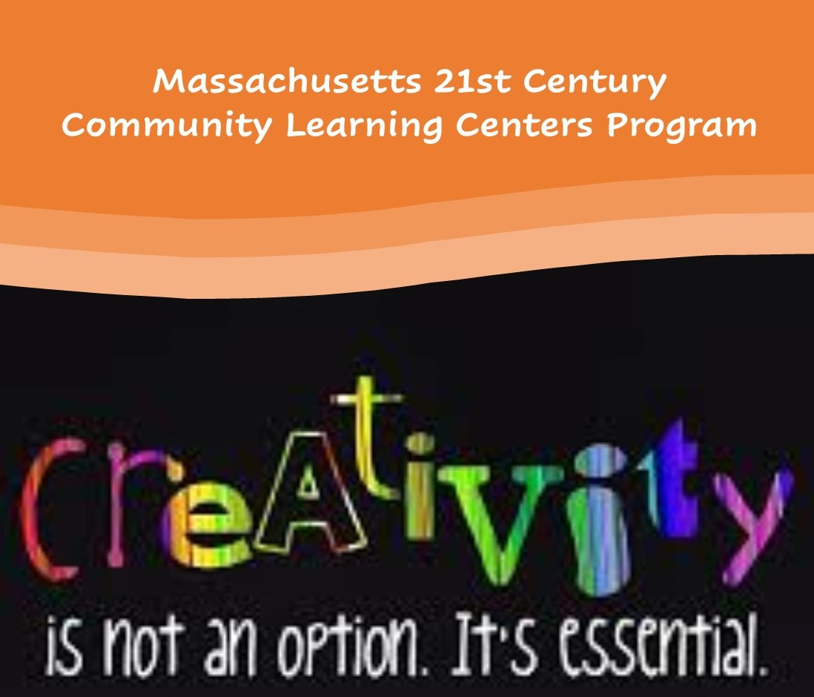oe.mass.edu

21st Century Community Learning Centers Program Fiscal Year 2019 Year End Report

**December 2020**





This document was prepared by the   
Massachusetts Department of Elementary and Secondary Education, with support from the National Institute on Out-of-School Time at Wellesley College

Jeffrey C. Riley

Commissioner

The Massachusetts Department of Elementary and Secondary Education, an affirmative action employer, is committed to ensuring that all of its programs and facilities are accessible to all members of the public.

We do not discriminate on the basis of age, color, disability, national origin, race, religion, sex, gender identity, or sexual orientation.

Inquiries regarding the Department’s compliance with Title IX and other civil rights laws may be directed to the

Human Resources Director, 75 Pleasant St., Malden, MA 02148-4906. Phone: 781-338-6105.

© 2020 Massachusetts Department of Elementary and Secondary Education

Permission is hereby granted to copy any or all parts of this document for non-commercial educational purposes. Please credit the “Massachusetts Department of Elementary and Secondary Education.”

Massachusetts Department of Elementary and Secondary Education

75 Pleasant Street, Malden, MA 02148-4906

Phone 781-338-3000 TTY: N.E.T. Relay 800-439-2370

[www.doe.mass.edu](http://www.doe.mass.edu)



Contents

Introduction 3

General Background Information 3

Program Goals 4

Executive Summary 5

1. Program Information 9

* Student Demographics 9
* Regional Networks 10

Enhanced Programs for Students with Disabilities 10

2. SEL Skills [SAYO – Outcomes] 12

* Communication Skills 12
* Critical Thinking 13
* Engagement in Learning 13
* Leadership 13
* Perseverance 13
* Relationships with Adults 14
* Relations with Peers 14
* Self-Regulation 14
* Comparing Change in Staff- and Teacher- Reported SAYO Outcomes 14

3. Special Populations 15

* Students Receiving Special Education Services 16
* Students who are Learning English 16
* Economic Disadvantage, Race, and Gender 16

4. SEL Skills Promote ELA and Math Academic Progress 17

* English Language Arts (ELA) 19
* Math 23
* Sense of Competence Learning 29
* Retrospective Academic Skills 31
* Retrospective Social-Personal Skills 32

Appendix A: FY19 Grantees and Sites 34

APPENDIX B: Report: Enhanced Programs for Students on an IEP Grant 38

**21st Century Community Learning Centers Program**

**Fiscal Year 2019 Year End Report**

# Introduction

The following report provides information on the fiscal year 2018-2019 (FY19) 21st Century Community Learning Centers (21st CCLC) grant program. In particular, it examines program information related to participation, activities, hours of service, and details the results of the Survey of Academic Youth Outcomes (SAYO) evaluation tool. SAYO was developed by the Massachusetts Department of Elementary and Secondary Education (DESE) and the National Institute of Out-of-School Time (NIOST) to track information on the effect participation in 21st CCLC programs has in increasing student achievement, as well as to provide feedback for ongoing program improvement.

## *Overall, the data collected indicates that* students in Massachusetts 21st CCLC improved Social-Emotional Learning (SEL) Skills and Academic Performance.

***Moreover, data indicates that 21st CCLC programs may help reduce opportunity and achievement gaps as well as contribute to decreasing high school drop rates****. It can be seen from the data regarding 21st CCLC participating students that members of the subgroups included in the Department’s accountability system (students with disabilities, for example) for some outcomes made statistically greater gains than their non-subgroup. counterparts.*

The results described in this report point to the substantial significant contributions that 21st CCLC programs have made to the academic achievement and youth development of the more than 16,000 students served across the state during FY19.

# General Background Information

The Nita M. Lowey 21st CCLC program is authorized under Title IV, Part B of the Elementary and Secondary Education Act, as amended by the No Child Left Behind Act of 2001 and reauthorized by Every Student Succeeds Act (ESSA) of 2015. The program provides federal funding for the establishment of community learning centers that support the implementation of additional learning time through out-of-school time (OST) programming and/or through an expanded day referred to as Expanded Learning Time (ELT). Programming is designed to help close proficiency/opportunity gaps, increase student engagement, support social and emotional learning, and promote college and career readiness and success.

Additional learning time, for the purposes of Massachusetts 21st CCLC grants, is generally defined as follows:

* Out-of-School-Time (OST) — structured programming held outside of the regular school day, week and/or year for a selected group of students.
* Expanded Learning Time (ELT) — adding at minimum 180 hours to the required school day, week and/or year for all students enrolled and 120 hour summer program for a select group of students. The ability to support ELT programming through 21st CCLC funding was added a result of ESEA approved flexibility and the newly authorized ESSA.

Grants are awarded on a competitive basis for up to three years. Grantees meeting all requirements may apply yearly for continuation funds until the three grant cycle is completed.

Grantees in their final year of funding are eligible to apply, though a competitive process, for an Exemplary Programs grant, generally at 85% of their current grant award. The goal of the Exemplary Programs grant is to expand and enhance a statewide network of high quality 21st CCLC programs that serve as resources and mentors. Applicants must be able to demonstrate continuous program improvement and their ability to sustain programming at the same or increased levels.

# Program Goals

To support increased student engagement by increasing motivation to learn through ***culturally responsive***, ***interactive****,* ***relevant****,* and ***engaging*** programming that includes high quality Project Based Learning (PBL) that is aligned to the Department of Elementary and Secondary Education’s (Department) [goals and strategies](http://www.doe.mass.edu/research/StrategicPlan-Summary.pdf). This is accomplished through the

* Implementation of well rounded, ***interactive****,* ***relevant****,* and ***engaging*** teaching and learning that meets the specific academic, social emotional learning, and developmental needs of students;
* Effective use of data to design programming that addresses student needs and interests.
* Use of data to demonstrate continuous program improvement efforts.
* Development of systems of support and programming that leverages the knowledge, strengths, and assets of students, families, educators, and the community.
* Development of engaging summer programming that helps prevent and address the summer learning slide and helps students transition successfully into elementary, middle, and high school.
* Development of effective family engagement strategies that are culturally responsive, collaborative, and demonstrates an understanding of different languages, norms, and
* Development of sustainable models for supporting additional quality learning time.

## Massachusetts 21st Century Community Learning Centers Executive Summary

FY19 Report

## Key Takeaway: Students in Massachusetts 21st Century Community Learning Centers improved Social-Emotional Learning (SEL) Skills and Academic Performance

*Data in this report is from the* [*Survey of Academic and Youth Outcomes*](http://www.doe.mass.edu/21cclc/ta/sayo.html) *(SAYO) evaluation tool, developed by the Massachusetts Department of Elementary and Secondary Education and the National Institute on Out-of-School Time. SAYO is a research-based evaluation system that assesses changes in youth that are associated with participation in high-quality academic enrichment programs that are likely to occur over a one-year period.*

More than **16,000 students at 140 sites** were served by MA 21st CCLC in 2018-19.

Students in 21st CCLC come from diverse racial and ethnic backgrounds and educational experiences. They attend schools that demonstrate financial need.

* 85% at Title I schools; 60% economically disadvantaged
* 20% English Learners
* 20% Students with Disabilities
* 50% Hispanic or Latino
* 30% White
* 10% Black or African American
* 06% Asian
* 04% Multirace-Non Hispanic

On average, students **improved their SEL skills** across all measured domains.

*The SEL skill analyses used data reported by OST program staff and school teachers.*

* **Across all SEL areas, the majority of students (> 50%) increased their SEL skills as reported by program staff and school teachers
* Both staff and teachers reported improved SEL skills in students enrolled in 21st CCLC programs. Staff reported the most change in **Critical Thinking** and teachers reported the most change in **Adult Relationships**
* At the end of the school year, teachers and staff reported similar SEL scores for each student

**Special Populations**

The majority of students in special populations who are served by 21st CCLC showed growth in relationship and leadership skills.

*These Special Population analyses used data reported by OST program staff.*

**65%** of students receiving special education services increased their Relationships with Peers

**74%** of students receiving special education services improved their Relationships with Adults

**

**61%** of students learning English increased their Leadership Skills

All students increased their **Engagement in Learning**, with amount of change varying by race, income, and gender.

**Race differences:** Hispanic students’ scores were the highest at the beginning of the year and were comparable to white peers’ scores at the end of the year. Black students showed the most growth over the year and had the highest scores at the end of the year.

**Income differences:** Economically disadvantaged students’ scores were lower at the beginning and at the end of the year. Their scores showed slightly more growth than their peers who were not economically disadvantaged.

**Gender differences:** Female students’ scores were higher at the beginning and end of the school year. Female and male-identified students showed comparable growth.

**Program Experiences Promote Youth Competence and Skills**

Students who reported more positive program experiences were also more likely to report a higher **Sense of Competence** Academically and with Peers.

Students who reported more positive program experiences were also more likely to report that the program supported the development of their **Academic and Social-Personal Skills**.

*Competence and Skills analyses used data reported by students.*

All five program experiences were positively associated with students’ Sense of Competence and students’ retrospective reports that the program supported their Academic and Social-Personal Skills.

|  |  |
| --- | --- |
| Icon of heart and brain connected  Students who reported a more supportive social environment were also likely to report feeling **more competent learning.**  *A Supportive Social Environment had the strongest association with Sense of Competence as a Learner.* | Icon of two people jumping for joy  Students who reported a more supportive social environment and more opportunities for leadership were also likely to report feeling **more competent in their interactions with peers.**  *A Supportive Social Environment, and Leadership/Responsibility had the strongest associations with Sense of Competence with Peers.* |
| Icon of graduation cap and book  Students who reported feeling more challenged were also more likely to report that **the program supported the** **development of their academic skills.**  *Feeling Challenged had the strongest association with students reporting feeling that the program supported their Academic Skills development.* | Icon of a person inside a gear  Students who reported more enjoyment and engagement, and a more supportive social environment, were also likely to report that **the program supported the** **development of their social-personal skills.**  *Enjoyment and Engagement and a Supportive Social Environment had the strongest association with students reporting feeling that the program supported their Social-Personal Skills development.* |

**SEL Skills Promote Academic Progress**

Students’ change in SEL skills was related to their change in ELA and Math performance relative to grade-level standards.

*Academic Progress analyses used data reported by school teachers.*

|  |  |
| --- | --- |
| Icon of a speech bubble  Students who showed more change in **Communication** skills were also likely to improve their academic performance in ELA.  *Change in Communication Skills was positively associated with change in ELA scores.* | Icon of a gear inside a person's head  Students who showed more change in **Critical Thinking** skills were also likely to improve their academic performance in ELA.  *Change in Critical Thinking was positively associated with change in ELA scores.* |
| Icon of a control panel with sliding levers  Students who showed more change in **Self-Regulation**, were also likely to improve their academic performance in Math.  *Change in Self-Regulation was positively associated with change in Math scores.* | Icon of a person jumping over a cone  Students who showed more change in **Perseverance** were also likely to improve their academic performance in Math.  *Change in Perseverance was positively associated with change in Math scores.* |

*This paper uses images from Flaticon.com that were created by Becris, fjstudio, and Freepik.*



*For more information, contact Karyl Resnick, 21st CCLC Coordinator*

[*karyl.a.resnick@mass.gov*](mailto:karyl.a.resnick@mass.gov) *or 781-338-3515*

# Program Information

## Student Demographics

* 85% Attend Title I Schools
* 60% Economically Disadvantaged
* 26% English Language Learners
* 20% Receive Special Education Services
* 50% Female, 50% Male
* 50% Hispanic
* 30% White
* 10% Black
* 6% Asian
* 4% Multiracial

**School Attendance**: Students enrolled in MA 21st CLCC attended school 95% of the year.

|  |  |  |  |  |
| --- | --- | --- | --- | --- |
| **Table 1.1 OST Attendance FY19** | | | | |
|  | School Year | | Summer | |
|  | Mean: 159 hours | Median:  133 hours | Mean:  113 hours | Median: 108 hours |
|  | N | % | N | % |
| <50 Hours | 1695 | 17% | 616 | 11% |
| 51- 100 Hours | 2067 | 20% | 1934 | 34% |
| 101-200 Hours | 3625 | 35% | 2674 | 47% |
| 201- 300 Hours | 1883 | 18% | 500 | 9% |
| 301 + Hours | 951 | 9% | 17 | 0% |
| Total | 10221 | 100%[1] | 5741 | 100% |

Source: Grant recipient reports.

Note: This data does not include students who participated in 21st CCLC ELT programs where a minimum of additional hours beyond the state required hours was required for all students.

**Academic Subjects/Activities Offered**

During FY19, all 21st CCLC program sites provided comprehensive programming by offering a wide variety of academic enrichment activities. Almost all districts offered a homework/academic support component during the school year (replaced by learning skills during the summer), and many focused on helping students develop specific mathematics and English language arts skills. See below for a sampling of the academic subjects and activities that were offered at the 21st CCLC sites.

|  |  |
| --- | --- |
| **Subjects** | **Activities** |
| English Language Arts (ELA)  ● ELA/Verbal Communication  ● ELA/Written Communication | * Project Based Learning * Arts (Performing, Music/Dance, Graphic,   Drawing/Painting)   * STEM * Social Emotional Learning * Arts Based Literacy * SEL/Character Education / Bullying Prevention Education * College/Career Preparation * Culinary Arts * Entrepreneurial * Family Engagement * Health & Wellness * Homework /Academic Support * Media Technology (Includes Film Making, Writing, Print Media) |
| Mathematics  ● Problem Solving  ● Reasoning  ● Communication  Science  Social Science |

**Expanded Learning Time**

In FY19, six districts were awarded to support expanded learning time in 15 schools as part of the required school day for all students during the school year in order to provide creative and engaging academic enrichment opportunities that will help to close proficiency gaps, and support college and workforce readiness and success. Funded schools were required to offer a minimum of 180 additional hours of structured learning time beyond the [state required](http://www.doe.mass.edu/lawsregs/603cmr27.html) hours for all students as part of their required school year plus 120 (total of 300 hours) for a targeted group of students during the summer. The grantees and schools that received FY19 21st CCLC ELT funding is indicated with an * in Appendix A.

**Regional Networks**

The purpose of the Regional Networks is to develop and implement capacity building activities that enhance the ability of 21st CCLC programs in particular, as well as out-of-school time (OST) programs in general, to collaborate and coordinate resources across districts/communities. These capacity building activities foster continuous program improvement and support student achievement that furthers the Department’s efforts to support effective practices across the state during OST, as well as during the school day.

The Regional Networks (Northeast, Central, Southeast, and West) are managed by experienced Massachusetts 21st CCLC grantees that have demonstrated exemplary practices, and act as coordinators on behalf of their regional networks. Each regional network decides internally who will serve in this capacity. Networks develop capacity building activities and professional development workshops based on the needs of the each of the programs in the individual regions.

**Enhanced Programs for Students with Disabilities**

The Enhanced Programs for Students with Disabilities grant program was developed in collaboration and coordination and with financial support from the office of Special Education Planning and Policy Development (SEPP).

The purpose of this grant program is to enhance the capacity of current 21st CCLC programs to include students on an IEP into an array of activities designed to complement their school-day programs, advance achievement, and provide opportunities for socializing and participating with peers without disabilities.

In FY19, approximately 4,300 students with disabilities were served, which was 19 percent of the total 21st CCLC population. A full list of the grant recipients and corresponding school(s) that received funding in FY19 is available here: [FY19 244 (continuation).](https://www.doe.mass.edu/21cclc/funding/fy19-fc244-addenduma.docx)

# Appendix B displays the MA ESE21CLCC Report: Enhanced Programs for Students on an IEP Grant FY19.

**Survey of Academic Youth Outcomes (SAYO)**

The Department worked with the National Institute on Out-of-School-Time (NIOST) over a three-year period to create the *Survey of Academic Youth Outcomes* (SAYO), an evaluation tool for use by MA 21st CCLC grantees. Results from two rounds of field-testing with over 5,000 students indicated that the SAYO is a valid and reliable instrument for measuring change in youth.

In FY13, the SAYO was piloted in four ELT schools in which SAYO-teacher data was collected on 100 students in each school. The emphasis for the pilot was on implementation, experience and technical performance of the tool. Results of the pilot of the SAYO T showed sufficient reliability and validity that was consistent with findings from use in 21st CCLC OST programs with evidence of change from pre- to post-assessment.

The *SAYO Evaluation System* uses brief pre-participation and post-participation surveys to collect data from school-day teachers and 21ST CCLC staff. The *SAYO Evaluation System* is based on a “menu” approach, meaning that programs collect data on selected outcomes that are aligned with their goals and program practices. Each outcome area is measured by asking school-day teachers and program staff to respond to four or five questions related to observableyouth behaviors. These items have been extensively tested and found to work as a single scale that effectively captures the outcome being measured. Survey responses from school day teachers (SAYO-T) and program staff (SAYO-S) are completed for a sample of youth in each program.

The *SAYO Evaluation System* enables 21st CCLC programs to capture information reflecting changes that are (a) associated with participation in a high-quality 21st CCLC programs and (b) likely to occur over a one-year period. Massachusetts requires all 21st CCLC grantees to use the SAYO as a part of their evaluation and reporting efforts. All grantees use SAYO results to indicate the degree to which they have measured positive outcomes among the participants they serve. Grantees select from a list of academic and social emotional learning outcomes and measure what best reflects the focus and goals of their programs.

***Academic Outcomes-SAYO Teacher Version (SAYO-T Academic)***

The academic section contains two main content areas in which science and social science are expected to be incorporated as well as *homework*, if assistance with this is offered through the program): *ELA and mathematics*. Grantees select and report on the main area that best reflect their program goals and have school-day teachers of students participating in the school year program complete pre-and post-program assessments.

***Social and Emotional Learning (SEL) Outcomes-SAYO Teacher Version (SAYO-T)***

Grantees are required to select three SEL outcomes: *critical thinking, self-regulation, leadership, perseverance, relations with adults, relations with peers, and engagement.* They are asked to select and report on the three areas that best match the goals of their 21st CCLC program Grantees have school-day teachers of students participating in the school year program report pre-and post-ratings in the three chosen outcomes.

***Program Staff Version (SAYO-S)***

Using the SAYO-S, grantees are required to collect and report on pre- and post-ratings of students by program staff (which may include school-day teachers if they are working in the funded programs). Grantees must collect responses from staff working with students served during the school year as well as during the summer for the same three SEL outcomes selected as part of the SAYO-T described above.

***Youth Version (SAYO-Y)***

Between October-December 2018 and March-June 2019, grantees were required to administer an online survey with youth in their 21st CCLC program. The SAYO-Y was designed to collect information from youth in three main areas: *their program experiences, their sense of competence, and their future planning and expectations.*

***Assessing Program Practices Tool (APT)***

As a complement to the SAYO, the Assessing Program Practices Tool (APT) is an observation instrument developed to assess the extent to which programs are implementing practices congruent with their desired SAYO outcomes. The APT is intended to be a tool that assists grantees with continuous program improvement and with identifying areas for professional development.

# **2. SEL Skills [SAYO – Outcomes]**

Today's schools are increasingly multicultural and multilingual with students from diverse social and economic backgrounds. Educators and community agencies serve students with different motivation for engaging in learning, behaving positively, and performing academically. Social and emotional learning (SEL) provides a foundation for safe and positive learning, and enhances students' ability to succeed in school, careers, and life.

Roger Weissberg, Joseph A. Durlak, Celene E. Domitrovich, and Thomas P. Gullotta, adapted from Handbook of Social and Emotional Learning: Research and Practice

In the section below, each SAYO SEL outcome is described. The number of students rated on each SAYO outcome varies because programs self-select which outcomes to measure based in student and school level data.

### *Method and Analysis*

The proportion of students who showed positive change, the mean (average) and standard deviation of the pre, post, and change scores are reported as assessed by teachers and staff during the school year, and by program staff during the summer.

The proportion of positive change reported by teachers and staff is reported from the whole sample assessed on the particular SAYO outcome. If students showed positive change from fall to spring, they were counted as having improved on a particular skill, and these numbers were used to calculate the proportion.

The means and standard deviations, and average change[2] are also reported for the whole sample who were assessed on the particular SAYO outcome. The difference between all pre-post scores are statistically significant p <.001.

## Communication Skills

*Youth are able to effectively express themselves and share their thoughts and ideas with adults and peers. Youth are good listeners to other people’s ideas. Note that youth may use gestures or other devices to support communication.*

### 

### Teachers reported positive change in 54% of 2761 students. Scores increased from Mpre= 3.39 (1.00) in the fall to Mpost = 3.82 (0.94) in the spring, an average change of 0.42.

### Staff reported positive change in 57% of 2820 students. Scores increased from Mpre= 3.42 (0.90) in the fall to Mpost = 3.84 (0.82) in the spring, an average change of 0.41.

### Summer staff reported positive change in 65% of 2192 students. Scores increased from Mpre= 3.20 (0.88) to Mpost = 3.71 (0.88), an average change of 0.51.

## Critical Thinking

*Students are able to engage in disciplined thinking that is clear, rational, open-minded, and informed by evidence. Youth can analyze and evaluate information to form a perspective. They are able to make judgments and think logically.*

### Teachers reported positive change in 62% of 3693 students. Scores increased from Mpre= 3.23(.90) in the fall to Mpost = 3.64 (.87) in the spring, an average change of .42.

### Staff reported positive change in 72% of 3731 students. Scores increased from Mpre=3.11(.87) to Mpost = 3.70 (.82), an average change of .59.

### Summer staff reported positive change in 64% of 2094 students. Scores increased from Mpre=3.20 (.80) to Mpost = 3.67 (.82), an average change of .48.

## Engagement in Learning

*Youth show interest and are actively involved in school or OST program activities.*

### Teachers reported positive change in 58% of 4823 students. Scores increased from Mpre= 3.48 (0.91) in the fall to Mpost = 3.87 (0.89) in the spring, an average change of 0.39.

### Staff reported positive change in 62% of 5004 students. Scores increased from Mpre= 3.50 (0.87) in the fall to Mpost = 3.96 (0.79) in the spring, an average change of 0.46.

### Summer staff reported positive change in 66% of 3088 students. Scores increased from Mpre= 3.39 (0.83) to Mpost = 3.88 (0.82), an average change of 0.49.

## Leadership

*Youth are able to motivate others toward a common goal.*

### Teachers reported positive change in 59% of 2183 students. Scores increased from Mpre= 3.26 (0.92) in the fall to Mpost = 3.56 (0.89) in the spring, an average change of 0.31.

### Staff reported positive change in 69% of 2188 students. Scores increased from Mpre= 3.26 (0.90) in the fall to Mpost = 3.69 (0.83) in the spring, an average change of 0.43.

### Summer staff reported positive change in 67% of 1652 students. Scores increased from Mpre= 3.30 (0.81) to Mpost = 3.73 (0.82), an average change of 0.43.

## Perseverance

*Youth plan for and pursue reasonable goals to completion in the face of challenges.*

### Teachers reported positive change in 55% of 2976 students. Scores increased from Mpre= 3.33 (0.96) in the fall to Mpost = 3.66 (0.95) in the spring, an average change of 0.33.

### Staff reported positive change in 60% of 2976 students. Scores increased from Mpre= 3.39 (0.91) in the fall to Mpost = 3.77 (0.84) in the spring, an average change of 0.38.

### Summer staff reported positive change in 59% of 1634 students. Scores increased from Mpre= 3.33 (0.85) to Mpost = 3.75 (0.85), an average change of 0.42.

## Relationships with Adults

*A supportive relationship with an adult is marked by stability, mutual respect, trust, and honesty.*

### Teachers reported positive change in 68% of 3999 students. Scores increased from Mpre= 3.37 (0.93) in the fall to Mpost = 3.87 (0.77) in the spring, an average change of 0.50.

### Staff reported positive change in 72% of 4056 students. Scores increased from Mpre= 3.30 (0.93) in the fall to Mpost = 3.86 (0.74) in the spring, an average change of 0.56.

### Summer staff reported positive change in 73% of 3019 students. Scores increased from Mpre= 3.29 (0.84) to Mpost = 3.82 (0.73), an average change of 0.53.

## Relations with Peers

*Youth interactions are collaborative, fun, and contribute to a positive social environment. These interactions include those who may differ by gender, age, race/ethnicity, ability, or peer group.*

### Teachers reported positive change in 53% of 3984 students. Scores increased from Mpre= 3.73 (0.87) in the fall to Mpost = 4.08 (0.80) in the spring, an average change of 0.35.

### Staff reported positive change in 63% of 3994 students. Scores increased from Mpre= 3.62 (0.86) in the fall to Mpost = 4.10 (0.76) in the spring, an average change of 0.49.

### Summer staff reported positive change in 66% of 1737 students. Scores increased from Mpre= 3.52 (0.81) to Mpost = 4.05 (0.76), an average change of 0.53.

## Self-Regulation

*Youth are able to shape their thoughts, behaviors, and emotions to express their needs in a way that matches the needs of the context.*

### Teachers reported positive change in 57% of 3870 students. Scores increased from Mpre= 3.48 (.97) in the fall to Mpost = 3.78 (.92) in the spring, an average change of 0.31.

### Staff reported positive change in 62% of 3892 students. Scores increased from Mpre= 3.42 (0.92) in the fall to Mpost = 3.78 (.83) in the spring, an average change of 0.37.

### Summer staff reported positive change in 60% of 2065 students. Scores increased from Mpre= 3.40 (0.85) to Mpost = 3.75 (0.84), an average change of 0.35.

## Comparing Change in Staff- and Teacher- Reported SAYO Outcomes

The graph below (Figure 2.1) shows the amount of change in SAYO skills across all eight outcome areas, presented in alphabetical order. The change score is the difference between the post score (spring) and the pre score (fall). In general, staff reported more change in student SEL skills than teachers, however program staff and teacher scores at the end of the school year were comparable (See Table 2). Particular areas where staff-perceived change is higher than teacher-perceived change are: Critical Thinking, Engagement in Learning, Leadership, and Peer Relationships.

Table with SAYO Staff and Teacher Descriptives

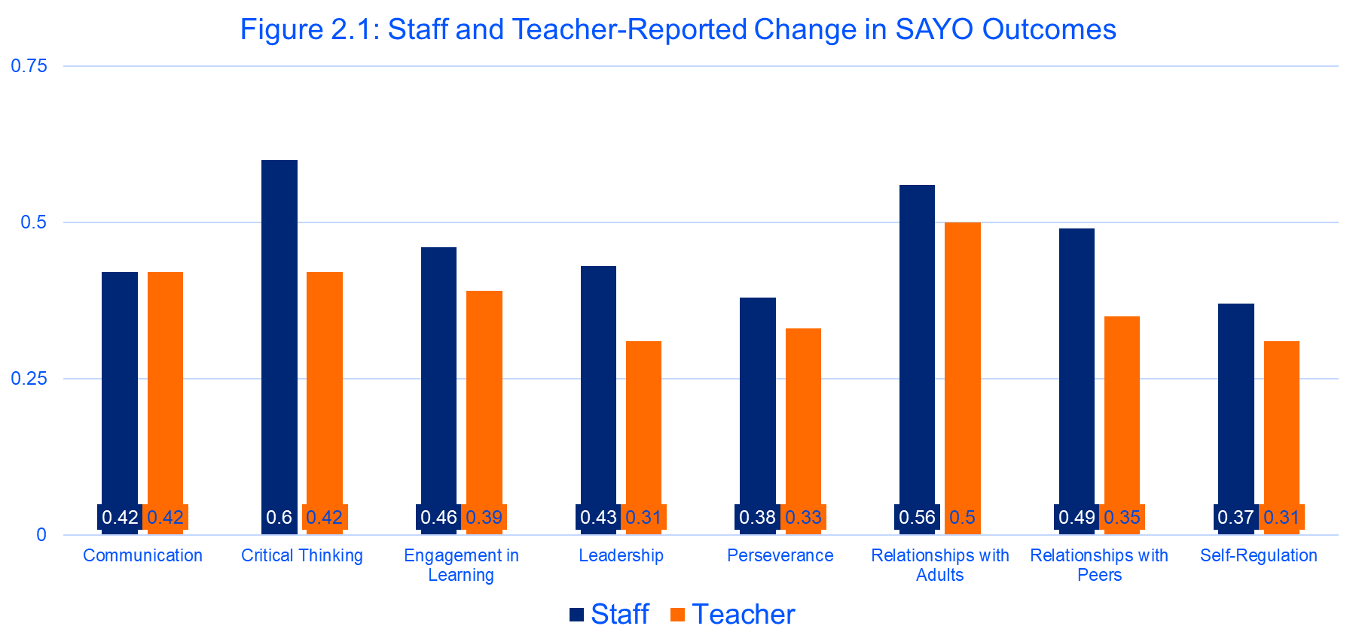

# **3. Special Populations**

This section focuses on Leadership and Relationship Skills with Adults and Peers for special populations: students learning English, and students receiving special education services. This section also assesses Engagement in Learning for students who are economically disadvantaged, Black, Hispanic and White students, and female and male. Note: data is also collected for non-binary students, but in FY19 the N was not of sufficient size to include in the results.

### *Method*

SEL Skills and Special Populations: Three SAYO areas were selected which represent interpersonal SEL skills: Relationships with Adults, Relationships with Peers, and Leadership. (See Section 2 of this report for an overview of each scale and corresponding descriptives from the full sample, and Table 2.0 for a list of alphas). Students in these groups made gains across all SAYO outcome areas, the below results represent a sample of their experience during SY18-19.

Engagement in Learning and Demographic Characteristics: Engagement in Learning is a central focus of MA 21st CCLC. In these analyses, Engagement in Learning is reviewed on three different dimensions of the population: (1) for students who are economically disadvantaged; (2) for Black, Hispanic, and White students; and (3) for female and male students.

Data about students who are economically disadvantaged are compared with students who are not economically disadvantaged to assess if this population, the target group for 21st CCLC, is showing growth in SEL Skills which is comparable to their non-economically disadvantaged peers.

Students who are Black, Hispanic, and White are also compared to assess similarities and differences in SAYO scores in fall and spring. Similarly, students who are male and female are compared for similarities and differences growth in SAYO scores. Black, White, and Hispanic students are the three largest race groups, and male and female are the two largest gender groups in the full sample. Other race, ethnic, and gender groups were too small to make an appropriate comparison.

### Analysis Plans

*Descriptive Analysis of Students Learning English and Students Receiving Special Education Services:* Given the different needs, resources, and challenges of students receiving special education services and students learning English, data are presented as within-group proportions. For example, the proportion of students learning English who improved their Leadership skills is reported from the subsample of only students learning English.

Proportions were calculated based on a student’s SAYO-S change score. If they showed a positive change score, they were counted as having improved on a particular skill. Then, a percentage was calculated to represent the proportion of students learning English who increased their Leadership skills and the proportion of students receiving special education services who increased their Relationships with Adults and Relationships with Peers.

*Group Comparisons of Engagement in Learning:* The economic, gender, and race-related comparisons were analyzed through a Repeated Measures ANOVA which assesses mean differences over time and between groups. Through this analysis, we assess: (1) if there is within group change over time (main effect); (2) if there are between-group differences over time (group effect); and (3) if the groups are changing in different ways over time (interaction). Economic Disadvantage, Gender, and Race were included as factors in the same model, along with covariates, to account for the influence of receiving special education services and/or learning English.

When interpreting these analyses, it is important to note the sample sizes for each group (see Figures 3.1-3.3). Students are relatively evenly split by economic disadvantage or not, and by gender. However, the number of Black students is less than the number of Hispanic and White students.

## Students Receiving Special Education Services

74% of Students receiving special education services increased their **Relationships** **with** **Adults**, and 64% of these students increased their **Relationships with Peers**.

## Students who are Learning English

60% of students learning English increased their **Leadership** skills.

## Economic Disadvantage, Race, and Gender

Students’ change in **Engagement in Learning** varies by Economic Disadvantage, Gender, and Race.

Results of the RM ANOVA suggest that there is a significant effect of time F(1,4290) = 621.46, p< .001. All students’ Engagement in Learning increases over the school year

There is a *group effect for gender* F(1, 4290)=58.97, p< .001. While Engagement in Learning for male and female students increases at about the same rate, female students show higher Engagement in Learning comparative to male students at the start of the program in Fall and at the end of the program in Spring.

There are also *interaction effects for time*economic disadvantage* F(1,4290)= 5.64, p=.02, and *time*race* F(2,4290)=20.65, p<.001. All students’ scores in Engagement in Learning increase over the school year, but students who are economically disadvantaged show slightly more growth than their non-economically disadvantaged peers. Black students show more growth in Engagement in Learning than their Hispanic and White peers, although student’s scores increased among all groups.

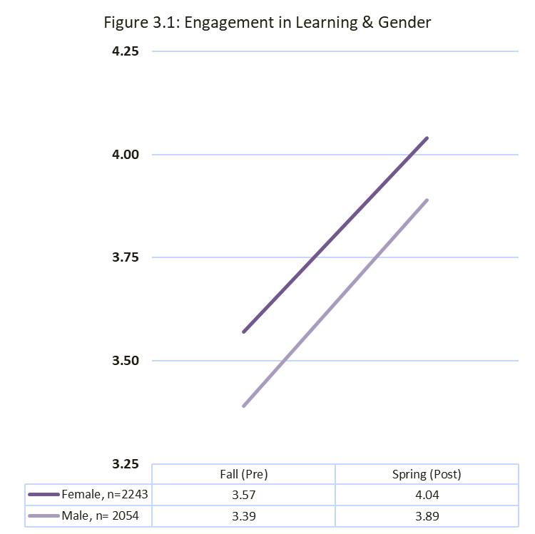 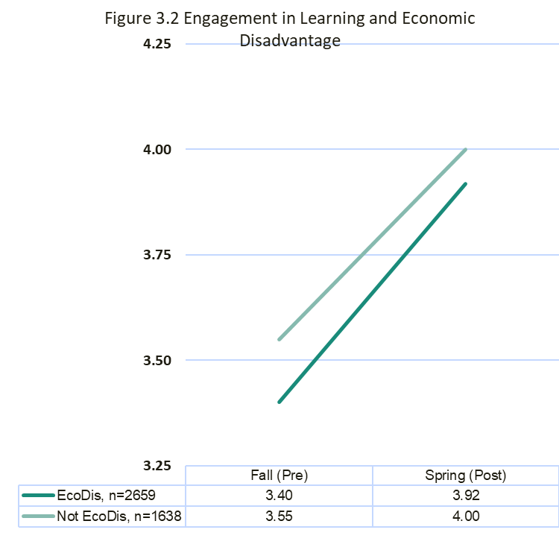

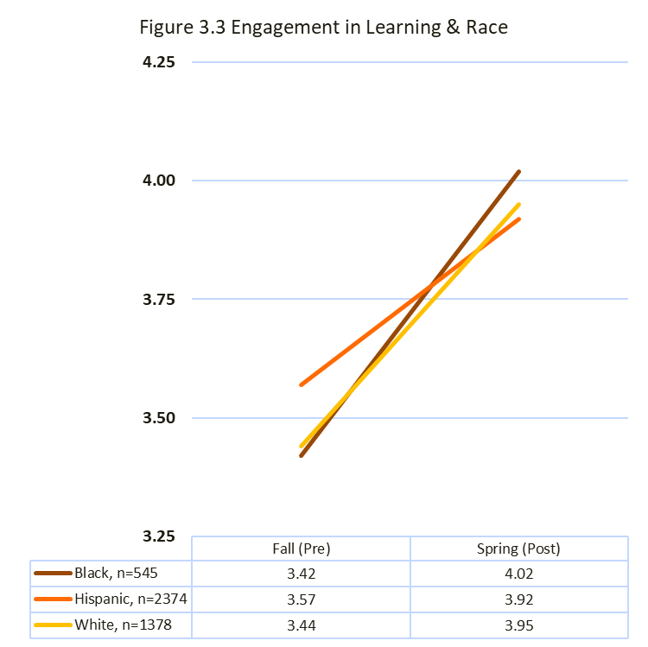

# 

# **4. SEL Skills Promote ELA and Math Academic Progress**

### *Method*

This section includes teacher reports of SEL skills and academic performance in ELA and Math. Descriptive findings related to academic progress for students across all MA 21st CCLC programs are presented. Analyses are also reported on subsamples of students to test associations between change in SEL skills and change in Academic progress.

Covariates: Demographic variables are coded comparatively: female students (compared to male students); Asian, Black, Hispanic, and Multiracial students (compared to White students), students enrolled in special education services (compared to those who are not enrolled), students learning English (compared to those not learning English), and Middle and High school students (compared to Elementary). See Section 1, for demographics of the full sample, and Tables 4.1-4.4 for demographics unique to each model. Baseline scores are the categorization of students in Fall (the beginning of the year) as 1 = Poor, 2 = Needs Improvement, 3= Satisfactory, and 4 = Very Good.

SEL Change (SAYO-T): Four SEL areas are evaluated here: Communication skills, and Critical Thinking were selected because of their potential to connect with English Language Arts performance. Perseverance and Self-Regulation because of their potential to support the practices associated with Math performance. SEL Change is calculated as a difference between Spring (Post) and Fall (Pre) SAYO-Teacher ratings. This change score is entered as the predictor variable in the analyses described below. (See Section 2 of this report for an overview of each scale and corresponding descriptives from the full sample, and Table 2.0 for a list of alphas).

Change in Academic Performance: MA 21st CCLC programs select if they will rate students in ELA or Math performance, depending on the focus of their program. In the full sample of students, ELA performance was reported for 4929 students, and Math performance was reported for 2566 students. Academic performance is rated as 1 = Poor, 2 = Needs Improvement, 3= Satisfactory, and 4 = Very Good. Change in academic performance is calculated as the difference between Spring (Post) and Fall (Pre) SAYO-Teacher ratings. This change score is incorporated into the analyses below as the outcome variable.

Sample: Different students are represented in each model described below. Programs select different SAYO and academic foci, therefore each model will have a unique combination of students. Demographics unique to each model are provided in *Step 3* of Tables 4.1-4.4, along with parameter statics.

### *Analysis* *Plan*

*Descriptive findings about Academic Performance:* These findings are representative of the full sample of 21st CCLC Students. Two sets of descriptive findings are presented for both ELA and Math: (1) student grade-level performance in fall and spring are presented as proportions; and (2) proportions of students whose grade-level performance increased, decreased, or showed no change over the course of the year.

*Associations between SEL and Academic Performance:* In order to test the associations between SEL Skills and Academic Performance, Hierarchical Linear Regressions were conducted. The purpose of these analyses was to evaluate if change in a particular SEL skill influenced change in the academic outcome. These hierarchical regressions were conducted in three steps. In the first step, demographic variables were incorporated into the model, in the second step baseline academic scores were included, and in the third step the SEL change score was included.

Full results for each step of each regression model is presented in Tables 4.1-4.4. In every analysis, the final model (Step 3), was the best predictor of the respective academic outcomes. Therefore, the results for the final and most useful models are presented in text below. Full results for each model are presented in the corresponding tables.

Based on research, theory, and practice we expect that the increased SEL skills will predict increased ELA/Math scores. 

## English Language Arts (ELA)

### *ELA Grade-Level Performance in Fall and in Spring*

The proportion of students performing below grade level in ELA decreased in the spring compared to the fall. The proportion of students performing at or above grade level increased in spring. See Figure 4.1.

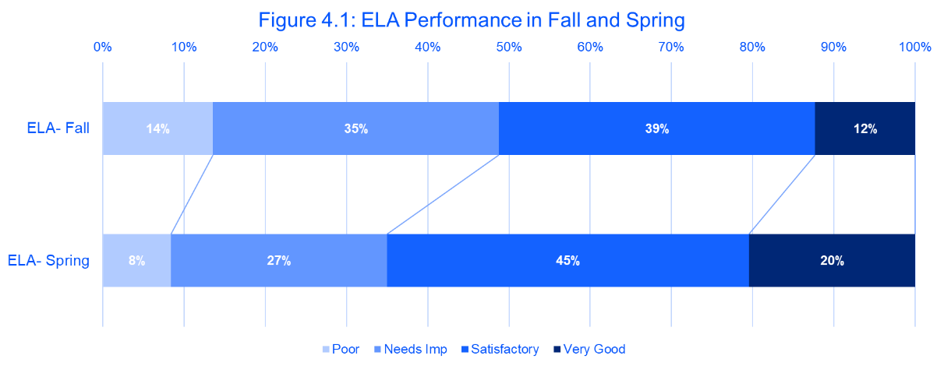

### *ELA Change*

In the sample of 4929 students rated by teachers on ELA, 30% of students increased their scores in ELA, 59% showed no change, and 11% of students’ scores decreased.

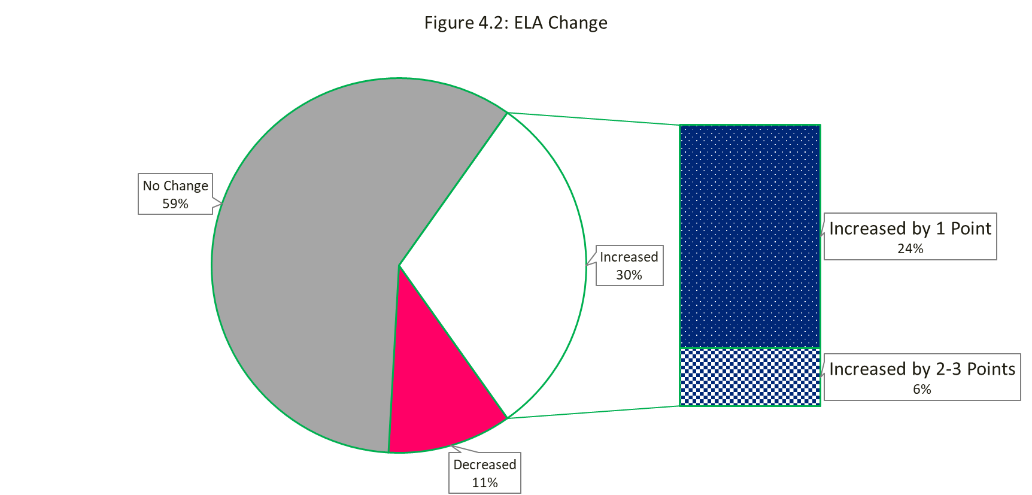

Is change in *Communication* skillsassociated with change in **ELA performance**?

***Communication => ELA***

line graph on change in ELA



The full model including demographic covariates, baseline ELA scores, and change in communication skills, significantly predicted change in ELA scores (R2 = .47, F(12, 2073) =154.23 , p<.001).

Covariate Effects: There were very small demographic effects for female, Black, Asian students who showed slightly more change in ELA scores relative to their comparison group. Students receiving special education services and those learning English showed slightly less change in ELA scores than their comparison groups. Students who started with lower baseline ELA scores showed more change in ELA than students who started with higher baseline ELA scores.

SEL Effects: The amount of change in *Communication* skills is positively associated with the amount of change in **ELA**.(β= .36, p<.001). Students who showed more change in Communication skills were also likely to improve their academic performance in ELA. These results suggest that change in communication skills predicts change in ELA beyond demographic characteristics and baseline ELA scores.

Table on Communication and ELA descriptives and parameters

### 

### Is change in *Critical Thinking* skills associated with change in **ELA performance**?

***Critical Thinking => ELA***

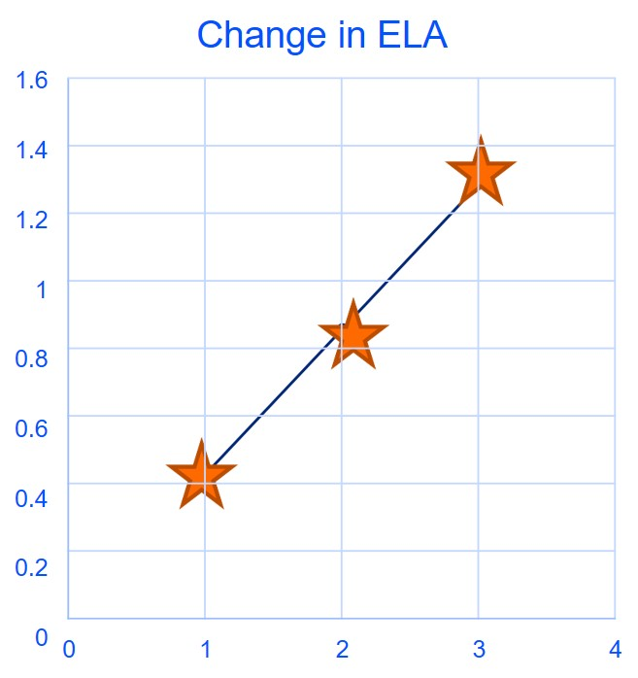

The full model including demographic covariates, baseline ELA scores, and change in Critical Thinking skills, significantly predicted change in ELA scores (R2 = .39, F(12, 2348) =127.04 , p<.001).

Covariate Effects: There were very small demographic effects for students receiving special education services and economically disadvantaged students; both showed slightly less change in ELA scores relative to their comparison group. Students who started with lower ELA scores showed more change in ELA than those who started with higher ELA scores.

SEL Effects: The amount of change in *Critical* *Thinking* skills is positively associated with the amount of change in **ELA** (β= .43, p<.001) Students who showed more change in Critical Thinking were also likely to improve their academic performance in ELA. These results suggest that change in Critical Thinking skills predicts change in ELA beyond demographic characteristics and baseline ELA scores.

Table on Critical Thinking and ELA descriptive statistics and parameters

## Math

### *Math Grade-Level Performance*

The proportion of students performing below grade level in Math decreased in the spring compared to the fall. The proportion of students performing at or above grade level increased in spring. See Figure 4.3.

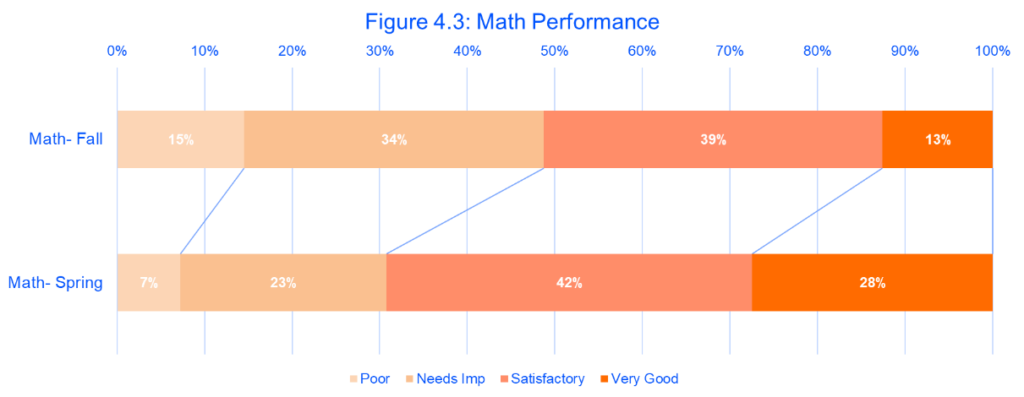

### *Math Change*

In the sample of 2566 students rated by teachers on Math, 40% of students increased their scores in Math, 50% showed no change, and 10% of students’ scores decreased.

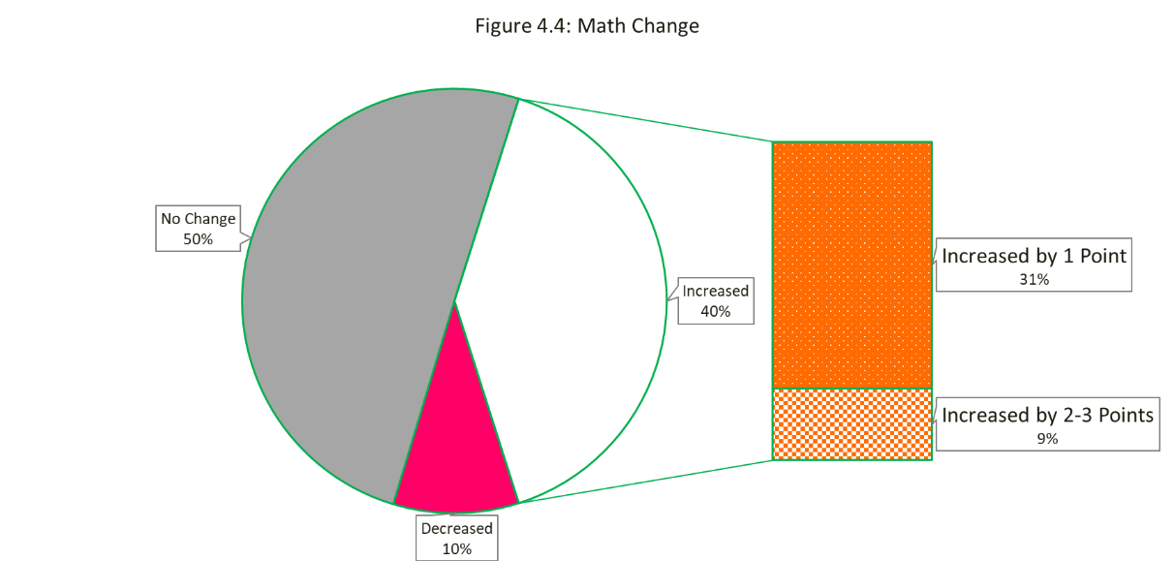

### Is change in *Perseverance* associated with change in **Math** **performance**?

### ***Perseverance => Math***

### Line graph on change in math

The full model including demographic covariates, baseline Math scores, and change in Perseverance skills, significantly predicted change in Math scores (R2 = .48, F(12, 1199) =95.28, p<.001).

Covariate Effects: There were demographic effects for students who were in Middle School, who were learning English, and who were economically disadvantaged; they showed slightly less change in Math relative to their comparison groups. Students receiving special education services showed less change in Math than students not receiving special education services. Students who started with lower Math scores, showed more change in Math than students who started with higher Math scores.

SEL Effects: The amount of change in *Perseverance* is positively associated with the amount of change in **Math** (β= .47, p<.001). Students who showed more change in Perseverance were also likely to improve their academic performance in Math. This analysis suggests that change in Perseverance skills predicts change in Math beyond demographic characteristics and baseline Math scores.

Table on perseverance and math descriptive statistics and parameters

### Is change in *Self*-*Regulation* associated with change in **Math** **performance**?

### ***Self- Regulation => Math***

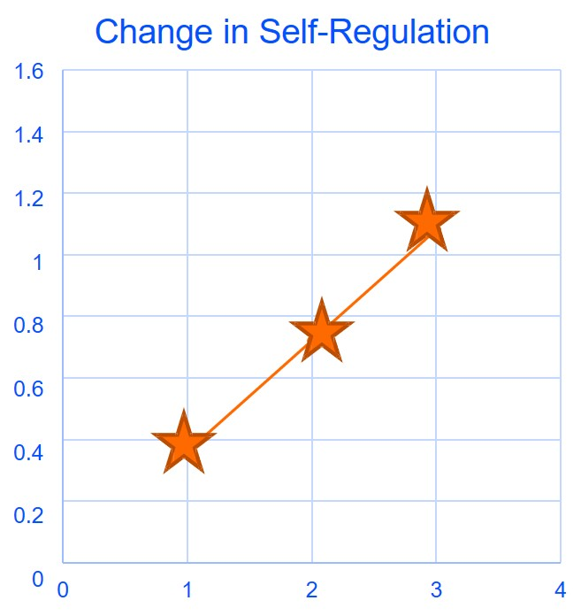

The full model including demographic covariates, baseline Math scores, and change in Self-Regulation skills, significantly predicted change in Math scores (R2 = .43, F(12, 2086) =131.31, p<.001).

Covariate Effects: Hispanic students, students in middle and high school, and students who are economically disadvantaged showed slightly lower change in Math relative to their comparison groups. Students who were receiving special education services showed less change in Math than students not receiving special education services. Students who started with lower Math scores, showed more change in Math than students who started with higher Math scores.

SEL Effects: The amount of change *Self-Regulation* skills is positively associated with the amount of change in **Math** (β= .36, p<.001). Students who showed more change in Self-Regulation skills were also likely to improve their academic performance in Math. This analysis suggests that change in Self-Regulation skills predicts change in Math beyond demographic characteristics and baseline Math scores.

Table on self-regulation and math descriptive statistics and parameters

5. Program Experiences Promote Youth Competence and Skills [SAYO-Y]

### *Program Experiences as building blocks to learning*

### *Supportive Social Environment*

### *Supportive Adult*

### *Feeling Challenged*

### *Enjoyment/Engagement*

### *Leadership/Responsibility*

### Based on research, theory and practice we expect that when youth report positive experiences, they also report higher competence and skills.

### **Program experiences are influential for competence and skill development.**

* Each program experience represents a unique building block
* Different patterns in program experiences when supporting competence and skills
* Each block does a different amount of work in holding up the foundation

### Method

This section includes student reports of **Program Experiences**, **Sense of Competence**, and retrospective reports of the **Academic and Social-Personal skills** that the program helped students to gain.

Covariates: The only demographic information collected was the grade and gender of students. In the full sample, 50% of students were in elementary school, 36% were in middle school, and 15% were in high school. Students identified their gender as 47% girl, 45% boy, and 3% non-binary.

Program Experiences: Program experiences include five areas: (1) Enjoyment/Engagement; (2) Feeling Challenged; (3) having a Supportive Adult; (4) perceiving a Supportive Social Environment; and (5) a sense of Leadership/Responsibility. Students responded to questions for each scale using 1 = No, 2 = Mostly No, 3 = Mostly Yes, and 4 = Yes. The highest average for the full sample was Enjoyment/Engagement. See Table 5.1 for descriptive information about Program Experiences scales in the full sample.

Sense of Competence: Students rated their Sense of Competence Learning and Sense of Competence with Peers on a scale of 1 = Don’t Agree, 2 = Agree a Little, 3 = Mostly Agree, and 4 = Agree a Lot. Sense of Competence Learning had a higher average rating than the other competence scales in the full sample. See Table 5.1 for descriptive information about Sense of Competence scales in the full sample.

Retrospective Skills: Students also responded to questions in which they could retrospectively report if coming to the 21st CCLC program had helped them to build their Academic Skills and/or their Social-Personal Skills. Students responded to questions on each area on a scale of 1 = Don’t Agree, 2 = Agree a Little, 3 = Mostly Agree, and 4 = Agree a Lot. Students reported slightly more of an influence on their Social-Personal Skills than their Academic Skills. See Table 5.1 for descriptive information about Retrospective Skills scales in the full sample.

Table for descriptives results for SAYO-Y full sample

### *Analysis Plan*

In order to evaluate the associations between Program Experiences and the outcomes of Sense of Competence and Retrospective Skills, Hierarchical Linear Regressions were conducted. The purpose of these analyses was to evaluate if youth ratings of Program Experiences related to youth-reported Competence and Skills. These hierarchical regressions were conducted in two steps. In the first step, gender and grade were evaluated, and in the second step all five program experiences scales were incorporated into the model.

Full results for each step of the four regression models are presented in Tables 5.2-5.5. In all analyses, the final model (Step 2) was the best predictor of the outcomes. Therefore, the results for the final and most useful models are presented below.

Are *Program Experiences* associated with **Sense of Competence Learning**?

## Sense of Competence Learning

All program experiences had an influence.

Largest effects:

* Supportive Social Environment
* Challenged

The full model including grade, gender, and the five program experiences scales, significantly predicted Sense of Competence as a Learner (R2 = .36, F(8, 3796) =270.75, p<.001).

Covariate Effects: Middle and High school students reported slightly lower competence than Elementary school students.

Program Experience Effects: Program Experiences were positively associated with Sense of Competence as a Learner. Youth who reported more positive program experiences were more likely to report a greater Sense of Competence as a Learner. All *Program Experience* scales were positively associated with **Sense of Competence as a Learner** and perceiving a *Supportive Social Environment* (β= .23, p<.001) had the largest association with Sense of Competence as a Learner. This analysis suggests that Program Experiences scales, particularly the Supportive Social Environment scale, are associated with Sense of Competence as a Learner, beyond grade and gender.

Table on program experiences and sense of competence descriptives and parameters

Sense of Competence with Peers

Are *Program Experiences* associated with **Sense of Competence with Peers**?

All program experiences had an influence

Largest effects:

* Supportive Social Environment
* Responsibility/Leadership

The full model including grade, gender, and the five program experiences scales, significantly predicted Sense of Competence with Peers (R2 = .43, F(8, 3846) =362.70 , p<.001).

Covariate effects: Students who identified as Girls, in Middle and High school reported slightly lower peer competence.

Program Experience Effects: Program Experiences scales were positively associated with Sense of Competence with Peers. Youth who reported more positive program experiences were more likely to report a greater Sense of Competence with Peers. All *Program Experience* scales were positively associated with **Peer Competence**. Perceiving a *Supportive Social Environment* (β= .40, p<.001) and a sense of *Leadership and Responsibility* (β= .24, p<.001) had the strongest association with Sense of Competence with Peers. Enjoyment/Engagement, Feeling Challenged, and having a Supportive Adult all had lower associations with Sense of Competence with Peers. This analysis suggests that program experiences, particularly a Supportive Social Environment and sense of Leadership/Responsibility predict Sense of Competence with Peers, beyond grade and gender.

Table of program experiences and sense of competence descriptives and parameters

## Retrospective Academic Skills

### Are *Program Experiences* associated with youth-reported program impact on **Academic Skills**?

(Retrospective)

All program experiences had an influence

Largest effects:

* Challenged

The full model including grade, gender, and the five program experiences scales, significantly predicted Retrospective Academic Skills (R2 = .35, F(8, 3886) =256.68 , p<.001).

Covariate Effects: Students in Middle School reported less of an impact on their Academic Skills.

Program Experience Effects: Program Experiences were positively associated with retrospective Academic Skills. Youth who reported more positive program experiences were more likely to report an influence of the 21st CCLC program on retrospective Academic Skills. All *Program Experience* scales were positively associated with **Academic Skills**. *Feeling Challenged* had the strongest association with Academic Skills (β= .23, p<.001). This analysis suggests that program experiences scales predict Academic Skills, beyond grade and gender.

Table of program experiences and retrospective academic skills descriptives and parameters

## Retrospective Social-Personal Skills

### Are *Program Experiences* associated with youth-reported program effects on **Social-Personal Skills**?

(Retrospective)

All program experiences had an influence

Largest effects:

* Supportive Social Environment
* Enjoyment/Engagement

The full model including grade, gender, and the five program experiences scales, significantly predicted retrospective Social-Personal Skills (R2 = .47, F(8, 3884) =427.70 , p<.001).

Covariate Effects: Students who identified as girls, and who were in middle and high school reported a slightly lower influence on their Social-Personal Skills.

Program Experience Effects: Program Experiences were positively associated with Retrospective Social-Personal Skills. Youth who reported more positive program experiences were more likely to report an influence of the 21st CCLC program on their Social-Personal Skills. All *Program Experience* scales positively predicted **Social-Personal Skills**. A sense of *Enjoyment and Engagement* (β= .20, p<.001) in the program, and perceiving a *Supportive Social Environment* (β= .21, p<.001) had the strongest associations with Social-Personal Skills. This analysis suggests that program experiences scales predict Social-Personal Skills, beyond grade and gender.

Table on retrospective social-personal skills descriptives and parameters

# APPENDIX A: FY19 21st Century Community Learning Centers Grantees and Sites

| **Grantee** | **Site** | **ELT/ OST** |
| --- | --- | --- |
| Athol Area YMCA | Athol Community Elementary School | OST |
| Barnstable Public Schools | Hyannis West Elementary | OST |
| Berkshire Hills Regional School District | Muddy Brook Elementary | OST |
| Berkshire Hills Regional School District | Monument Valley Middle | OST |
| Boston Day and Evening Academy | Boston Day and Evening Academy | OST |
| Boston Public Schools | Eliot Innovation K-8 | ELT |
| Boston Public Schools | Boston International High School / Newcomers Academy | ELT |
| Boston Public Schools | English High | OST |
| Boston Public Schools | Gardner Pilot | OST |
| Boston Public Schools | Thomas Kenny (K-5) | OST |
| Boston Public Schools | Hennigan Elementary | OST |
| Brockton Public Schools | Arnone Elementary | OST |
| Brockton Public Schools | Baker Elementary | OST |
| Brockton Public Schools | George Elementary | OST |
| Brockton Public Schools | Raymond K-8 | ELT |
| Brockton Public Schools | Downey Elementary | OST |
| Brockton Public Schools | Brookfield Elementary | OST |
| Chelsea Public Schools | Chelsea High | OST |
| Collaborative for Educational Services | Maple Elementary (Easthampton) | OST |
| Collaborative for Educational Services | Pepin Elementary (Easthampton) | OST |
| Collaborative for Educational Services | Palmer Middle (formerly Converse) | OST |
| Collaborative for Educational Services | Amherst Regional Middle | OST |
| Collaborative for Educational Services | Sheffield Elementary (gr. 2-5) | OST |
| Collaborative for Educational Services | West Springfield High | OST |
| Collaborative for Educational Services | Easthampton High | OST |
| Collaborative for Educational Services | Greenfield High | OST |
| Collaborative for Educational Services | Memorial Elementary (West Springfield) | OST |
| Collaborative for Educational Services | Coburn Elementary (W. Springfield) | OST |
| Community Day Care Center (Lawrence) | Emily G. Wetherbee Elementary | OST |
| Community Day Care Center (Lawrence) | Community Day Arlington | OST |
| Community Day Care Center (Lawrence) | Alexander B. Bruce | OST |
| Community Day Care Center (Lawrence) | Frost Elementary | OST |
| Community Day Care Center (Lawrence) | John K. Tarbox School | OST |
| Community Day Care Center (Lawrence) | Parthum Elementary | OST |
| East End House, Inc. (Cambridge) | East End House (primarily serving Kennedy ) | OST |
| Everett Public Schools | Lafayette | OST |
| Everett Public Schools | English | OST |
| Everett Public Schools | Parlin Elementary | OST |
| Everett Public Schools | Whittier Elementary | OST |
| Everett Public Schools | George Keverian Elementary (Gr. 2-6) | OST |
| Everett Public Schools | Webster Elementary | OST |
| Fall River Public Schools | Doran | OST |
| Fall River Public Schools | Morton Middle - ELT | ELT |
| Fall River Public Schools | Mary L. Fonseca Elementary | OST |
| Fall River Public Schools | Durfee High | OST |
| Fall River Public Schools | Talbot Innovation (formerly Talbot Middle) | OST |
| Fall River Public Schools | Greene Elementary | OST |
| Fall River Public Schools | Letourneau Elementary | ELT |
| Fitchburg Public Schools | South Street Elementary | OST |
| Fitchburg Public Schools | Longsjo Middle | OST |
| Fitchburg Public Schools | Crocker Elementary | OST |
| Fitchburg Public Schools | Memorial Middle | OST |
| For Kids Only | William A. Welch Elem (Peabody) | OST |
| For Kids Only | Center School (Peabody) | OST |
| For Kids Only | Frank M. Sokowlowski (Chelsea) | OST |
| Framingham Public Schools | Walsh Middle | OST |
| Framingham Public Schools | Fuller Middle | OST |
| Gloucester Public Schools | O'Maley Innovation Middle | OST |
| Haverhill Public Schools | Tilton | OST |
| Haverhill Public Schools | Golden Hill | OST |
| Haverhill Public Schools | Consentino K-4 | OST |
| Haverhill Public Schools | John Greenleaf Whittier Middle | OST |
| Haverhill Public Schools | Haverhill High | OST |
| Haverhill Public Schools | Consentino Middle | OST |
| Holyoke Public Schools | Donahue (Gr. 5-8) | OST |
| Holyoke Public Schools | Peck Elementary | OST |
| Holyoke Public Schools | E.N. White Elementary | OST |
| Holyoke Public Schools | Holyoke High School | OST |
| Holyoke Public Schools | Kelly Full Service Community School | ELT |
| Holyoke Public Schools | Morgan Elementary | OST |
| Holyoke Public Schools | Lt. Elmer J. McMahon Elementary | OST |
| Lawrence Public Schools | Parthum Elementary | ELT |
| Lawrence Public Schools | Arlington Middle | ELT |
| Lawrence Public Schools | Guilmette Elementary | ELT |
| Lawrence Public Schools | Emily G. Wetherbee Elementary | ELT |
| Leominster Public Schools | Sky View Middle | OST |
| Leominster Public Schools | Samoset Middle | OST |
| Lowell Public Schools | Greenhalge Elementary | OST |
| Lowell Public Schools | Shaughnessy Elementary | OST |
| Lowell Public Schools | Stoklosa Middle | OST |
| Lowell Public Schools | Christa McAuliffe Elementary | OST |
| Lowell Public Schools | Abraham Lincoln Elementary School | OST |
| Lowell Public Schools | Robinson Middle | OST |
| Lowell Public Schools | Morey Elementary | OST |
| Lowell Public Schools | Bartlett Community Partnership | OST |
| Lowell Public Schools | Lowell High | OST |
| Lowell Public Schools | McAvinnue Elementary | OST |
| Malden Public Schools | Salemwood K-8 | OST |
| Malden Public Schools | Forestdale K-5 | OST |
| Malden Public Schools | Forestdale 6-8 | OST |
| Malden Public Schools | Beebe 6-8 | OST |
| Malden Public Schools | Beebe K-5 | OST |
| Methuen Public Schools | Tenney Lower | OST |
| Methuen Public Schools | Timony Lower | OST |
| Methuen Public Schools | Methuen High | OST |
| New Bedford Public Schools | Gomes Elementary | OST |
| New Bedford Public Schools | Normandin Middle | OST |
| New Bedford Public Schools | Hayden-McFadden Elementary | ELT |
| New Bedford Public Schools | Normandin Middle | ELT |
| New Bedford Public Schools | Jacobs (formerly Hannigan Elementary) | OST |
| New Bedford Public Schools | Gomes Elementary | ELT |
| New Bedford Public Schools | Irwin Jacobs (formerly Hannigan Elementary) | ELT |
| North Adams Public Schools | Colegrove Park Elementary | OST |
| North Adams Public Schools | Brayton Elementary (serving K-5) | OST |
| North Brookfield Youth Center | North Brookfield Elementary | OST |
| Pittsfield Public Schools | Reid Middle | OST |
| Pittsfield Public Schools | Herberg Middle | OST |
| Pittsfield Public Schools | Morningside Community School | OST |
| Pittsfield Public Schools | Conte Community | OST |
| Pittsfield Public Schools | Crosby Elementary | OST |
| Quaboag Regional School District | Warren Elementary | OST |
| Quaboag Regional School District | Quaboag Innovation Middle | OST |
| Salem Public Schools | Collins Middle | OST |
| Salem Public Schools | Bowditch K-8 | ELT |
| Salem Public Schools | Horace Mann Laboratory School | OST |
| Salem Public Schools | Bates Elementary | OST |
| Sociedad Latina | Timilty (Boston) | OST |
| Sociedad Latina | Mario Umana Academy (grades 6-8, Boston) | OST |
| South Shore Stars | Randolph Community Middle | OST |
| South Shore Stars | JFK Elementary (Randolph) | OST |
| South Shore Stars | Chapman Middle (Weymouth) | OST |
| South Shore Stars | Randolph High | OST |
| Springfield Department of Parks, Buildings and Rec. | Mary O. Pottenger Elementary (Springfield) | OST |
| Springfield Public Schools | Alfred G. Zanetti Montessori | OST |
| Taunton Public Schools | Taunton Alternative High | OST |
| Taunton Public Schools | Parker Middle | OST |
| Triton Regional School District | Salisbury Elementary | OST |
| Waltham Boys & Girls Club | Whittmore Elementary (Waltham) | OST |
| Wareham Public Schools | Minot Forest Elementary (serving Gr. 3-4) | OST |
| Wareham Public Schools | Wareham High | OST |
| Wareham Public Schools | Wareham Middle | OST |
| Wareham Public Schools | Decas Elementary | OST |
| Webster Public Schools | Park Ave. Elementary | OST |
| Whitman-Hanson Regional School District | Whitman-Hanson Regional High | OST |
| Winthrop Public Schools | Cummings Elementary | OST |
| Woburn Boys and Girls Club | Altavesta Elementary | OST |
| Woburn Boys and Girls Club | Shamrock Elementary | OST |
| Worcester Public Schools | Sullivan Middle | OST |
| Worcester Public Schools | Burncoat Middle School | OST |
| Worcester Public Schools | Claremont Academy | OST |
| YWCA of Malden | Ferryway (gr. 6-8, Malden) | OST |
| YWCA of Malden | Ferryway Elementary | OST |

# APPENDIX B: FY19 MA ESE21CLCC Report: Enhanced Programs for Students on an IEP Grant

# Introduction

The purpose of the Enhanced Programs for Students on an IEP grant program is to enhance the capacity of 21st Century Community Learning Center (CCLC) out-of-school time (OST) programs to include and support students on an Individual Education Plan (IEP) in gaining the knowledge and skills to prepare themselves effectively for postsecondary opportunities, career training options, economically viable careers, and healthy, productive lives.

This report focuses on students in MA 21st CCLC programs who receive special education services[3]. The analyses in this report document Social Emotional Learning (SEL) and Skill development as reported by teachers during FY19. These analyses respond to two research questions:

1. Are MA 21st CCLC students who are enrolled in special education services developing their SEL skills?
2. Is there a difference in SEL skill development for students who receive the Enhanced Programs for Students Grant and students who do not receive this grant?

# Sample

The sample for this research is the 3310 students in MA 21st CCLC programs who are on an IEP. Of these students approximately 450 (13%) are enrolled in programs that receive the Enhanced Programs for Students on an IEP (EPS) Grant.

Table 1 shows the number of students in each demographic category, and the proportion of students within that category who are served by the EPS Grant[4]. For example, of the 327 Black students who are on an IEP, 6% benefit from the EPS Grant. Similarly, a total of 969 students are learning English, and 13% of these students benefit form the EPS Grant.

|  |  |  |  |  |  |
| --- | --- | --- | --- | --- | --- |
| Table 1: Participation in SNS Grant within demographic group | | | | | |
|  | SP Only | | SP + EPS Grant | | Total |
|  | N | % | N | % |  |
| Asian | 58 | 64% | 33 | 36% | 91 |
| Black | 308 | 94% | 19 | 6% | 327 |
| Hispanic | 1388 | 85% | 247 | 15% | 1635 |
| MultiRacial | 102 | 88% | 14 | 12% | 116 |
| White | 998 | 88% | 137 | 12% | 1135 |
| Not Learning English | 2015 | 86% | 326 | 14% | 2341 |
| Learning English | 845 | 87% | 124 | 13% | 969 |
| Female | 1080 | 87% | 165 | 13% | 1245 |
| Male | 1779 | 86% | 285 | 14% | 2064 |
| Elementary | 1770 | 84% | 337 | 16% | 2107 |
| Middle | 820 | 88% | 109 | 12% | 929 |
| High | 266 | 99% | 4 | 1% | 270 |
| Note: This table should be read horizontally (from left to right).  SP = Receiving Special Education Services  EPS Grant = Served by EPS Grant | | | | | |

Table 2 shows the number of students in each demographic category, and the proportion of students across these categories who benefit from the EPS Grant. For example, of the programs that receive the EPS grant, 37% of the students are female and 63% male and 75% are Elementary Schools.

|  |  |  |  |  |  |
| --- | --- | --- | --- | --- | --- |
| Table 2: Participation in EPS Grant across groups | | | | | |
|  | SP Only | | SP + EPS Grant | | Total |
|  | N | % | N | % |  |
| Asian | 58 | 2% | 33 | 7% | 91 |
| Black | 308 | 11% | 19 | 4% | 327 |
| Hispanic | 1388 | 49% | 247 | 55% | 1635 |
| Multi-Racial | 102 | 4% | 14 | 3% | 116 |
| White | 998 | 35% | 137 | 30% | 1135 |
| Not Learning English | 2015 | 70% | 326 | 72% | 2341 |
| Learning English | 845 | 30% | 124 | 28% | 969 |
| Female | 1080 | 38% | 165 | 37% | 1245 |
| Male | 1779 | 62% | 285 | 63% | 2064 |
| Elementary | 1770 | 62% | 337 | 75% | 2107 |
| Middle | 820 | 29% | 109 | 24% | 929 |
| High | 266 | 9% | 4 | 1% | 270 |
| Note: This table should be read vertically (from top to bottom).  SP = Receiving Special Education Services  EPS Grant = Served by EPS Grant | | | | | |

Method and Analysis

These analyses utilize teacher-reported data from the [Survey of Academic and Youth Outcomes Tool](http://www.doe.mass.edu/21cclc/ta/sayo.html) (SAYO), collected during FY19.

*Group Comparisons:* These comparisons were analyzed through a Repeated Measures ANOVA which assesses mean differences over time and between groups. Through this analysis, we assess: (1) if there is within group change over time (main effect); (2) if there are between-group differences over time (group effect); and (3) if the groups are changing in different ways over time (interaction). Each SAYO outcome was evaluated separately. Covariates were included in these models to account for race, gender, income, grade, and language differences.

Analyses on Critical Thinking, Perseverance, and Leadership were not conducted because of notably unequal sample sizes. There is not enough data available about students served by the EPS Grant in these areas to make a reasonable comparison.

# Results

## Communication

There is a *time*group effect* F(1,517)=56.61, p<.001, for Communication.

Overall, students’ scores in Communication increased over the school year. On average, students served by the EPS Grant had notably lower scores than their peers at the beginning of the school year and by the end of the school year their communication skills had surpassed their peers.

## Engagement in Learning

There is a *time*group effect* F(1, 869)= 63.71, p<.001 for Engagement in Learning.

Overall, students’ scores in Engagement in Learning increased over the school year. On average, students served by the EPS Grant showed more growth over the school year with scores starting lower and ending higher than their peers.

## Relationships – Peers

There is a *time*group effect* F(1, 742)=7.05, p=.008, for Relationships with Peers.

Overall, students’ scores in Relationships with Peers increased over the school year. On average, students served by the EPS Grant started with the same score as their peers, but showed more growth in relationships with peers over the course of the year.

## Relationships – Adults

There is a *time*group effect* F(1, 716)=12.50, p<.001, for Relationships with Adults.

Overall, students’ scores in Relationships with Adults increased over the school year. On average, students served by the EPS Grant started at the same level as their peers, but showed more growth in these skills.

## Self-Regulation

There is a *time*group effect* F(1, 767) = 12.09, p=.001, for Self-Regulation.

Overall, students’ scores in Self-Regulation increased over the school year. On average, students served by the EPS Grant started the school year with lower Self-Regulation scores and by the end of the school year their scores matched those of their peers.

1. Percentages were rounded to whole numbers.
2. Average changes were rounded to two decimal points.
3. This report was created by the National Institute on Out-of-School Time at the Wellesley Centers for Women at Wellesley College. Questions about the analyses in this report can be directed to Lisette DeSouza, Ph.D., lisette.desouza@wellesley.edu
4. When SAYO and 21st CCLC data are collected, whether the student is identified as being served by the enhancement grant is documented as an open-ended text response. If this response included “Y”, “Yes”, or “X” this was considered indication that this student was served by the EPS Grant. If text was entered which did not include these responses (e.g., “No,” or other unrelated text), then these cases were considered to not have been served by the enhancement grant. It is possible that some students were mis-specified during this coding process, however these numbers would be low and not sufficient to change the meaning of the analyses included in this report.