Reactivation Guide for Directory Administrators
Users that did not follow through with the registration process prior to the Education Security Portal migration will need to have their accounts reactivated by the District Directory Administrator.
To reactivate an account, please go to the Directory Administration application, under Organizations search for the district, school or program they are a member of. Once in that organization, go to members and click on the individual’s name.
Once in the member profile, you will see a “Send Activation” button where the reset password option was previously.
*Please note: DA is no longer used for resetting passwords. The “forgot password?” option is now on the login screen and will use Multi-Factor Authorization (MFA) as the method of user verification which will allow the user to reset it themselves.
Verify the email address is correct and click the “Send Activation” button. An email, with instructions, will be sent to the user for reactivation.
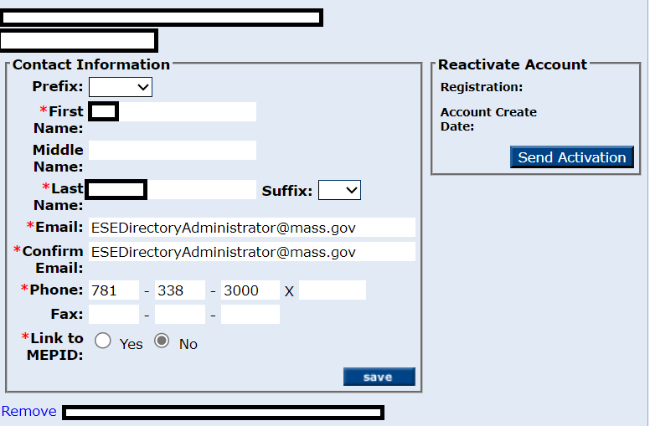
All user questions or issues about the reactivation process should visit the ESP help page for step-by-step documentation or for help desk contact information.

