Classroom Connections
Examining the Intersection of the Standards for Mathematical Content
and the Standards for Mathematical Practice

Title: Focusing on Multiplication Facts

Common Core State Standard Addressed in the Student Work Task:
3.OA.5 Apply properties of operations as strategies to multiply and divide.

Evidence of Standards for Mathematical Practice in the Student Work:
3: Construct viable arguments and critique the reasoning of others.
4: Model with mathematics.
5: Use appropriate tools strategically.
6: Attend to precision.
7: Look for and make use of structure.
8: Look for and express regularity in repeated reasoning.

Task Components:

Part I: Mathematical Background (Page 2)
- Today’s Content

Part II: Math Metacognition (Page 3)

Part III: Unpacking the Rigor of the Mathematical Task (Pages 4 – 5)

Part IV: Looking at Student Work (Page 6)
- Tito’s Strategy Task (Grade 3)
- Protocol for LASW

Part V: Vertical Content Alignment (Page 7)
- Charting Coherence through Mathematical Progressions
- Writing a Grade – Level Problem or Task

Part VI: Wrap – up (Page 8)

Handouts Included:
- Math Metacognition [Directions and sorting cards]: Pages 9 – 10
- Protocol for LASW: Page 11
- Mathematical Task – Tito’s Strategy: Page 12
- Student Work Samples: Page 13 – 16
- Student Work Analysis Grid: Page 17
- Unpacking the Rigor: Page 18

Additional Materials Needed:
- Scissors
- Grid paper
Part I: Mathematical Background
Approximate Time: 5 minutes
Grouping: Whole Group

- Today’s Content:
  - The mathematics during this session focuses on multiplication of whole numbers. In particular, we consider how a student can use what he knows about two multiplication problems in order to determine an unknown, yet related problem. The student work task involves many elements, including drawing a visual model and writing a word problem based on another student’s thinking, as well as extending his thought process to a new problem.

  - What do we need to know about:
    - Decomposition of numbers
    - the relationship between area and the operation of multiplication
    - the distributive property
before we can truly understand and perform multiplication of whole numbers accurately and efficiently?

  - Chart ideas to refer to during the Protocol for LASW.

Part II: Math Metacognition
Approximate Time: 25 minutes
Grouping: Whole Group

- Problem: This problem provides an opportunity to explore some properties of operations and how they relate to multiplication. Teachers will be completing a sorting activity with a set of cards (found on Page 10). Directions are found on Page 9. Teachers can record their answers on a blank piece of paper. If you are pre-cutting the sorting cards, give teachers cards A – Q first and set aside cards R – AA until the last question.
- Sort all cards A – P into two distinct categories. What could these categories be?
- Now sort the cards into at least four distinct categories. What could these categories be?
- Card Q is blank for a reason. Could you figure out a way to use it in one of your categories listed above or use it to make a new category with the existing cards.
- Now, use the cards to show the “train of thought” that might be used during mental math to figure out a particular unknown product. For example, one could start with card E, then use card G, ending with card I. What properties were used in this process?
- Find as many other “trains of thought” that you can. Cards can be used more than once. Be sure to record the properties that were used for each step of the process.
- Finally, using any of the cards A – AA, find four representations (name, description, symbols, and numerical example) of each of the three properties given.

- Solutions:
1: Two categories: Cards with values equivalent to 54 (A, C, F, H, J, K, N, P) and Cards with values equivalent to 84 (B, D, E, G, I, L, M, O).
2: Possible answer: 5 categories [number facts (E, J)]; [commutative property [H, L)]; [decomposition of number (C, D, F, G, K, M)]; [distributive property (B, I, N, P)]; [associative property (A, O)]
3: Answers will vary. Possible (7 * 6) + (7 * 6) = 2 * (7 * 6) and sort cards where doubling would work.
4: E – G – I [decomposition of 7 into sum (5 + 2); distributive property]
5: E – L – M – B [commutative; decomposition of 12 into (6 + 6); distributive property]; E – D – O [decomposition of 12 into (2 * 6); associative]; J – H – F – P [commutative; decomposition of 9 into (4 + 5); distributive]; J – C – A [decomposition of 9 into (3 * 3) and 6 into (3 * 2); associative]; J – K – N [decomposition of 6 into (3 + 3); distributive]
6: Commutative Property (Y, W, R, and L or H); Associative Property (AA, V, T, and A or O); Distributive Property (Z, X, S or U, and B, I, N, or P)

- Problem Intent:
  - Math metacognition allows teachers the opportunity to think about their own mathematical thinking in a more natural way that often makes use of more reasoning and helps to develop a better sense of number.
  - This particular exercise is designed to get teachers thinking about the relationship among the properties of operations and the processes that students may used in mental multiplication and in memorizing multiplication facts.

- Bring discussion back to the topics at hand:
  - How are these properties related? How are they different?
  - How did the process of sorting help you think through these ideas?
  - What implications does this have on our work with multiplication?
  - How can metacognition help promote successful recall and fluency of multiplication facts with your own students?

Part III: Unpacking the Rigor of the Mathematical Task
Approximate Time: 30 Minutes
Grouping: Whole Group

- Comparing Different Versions of the Mathematical Task: Let’s compare the rigor of two related problems to the Tito’s Strategy task. The level of rigor is based on which of the Standards for Mathematical Practice we could expect to see when examining the student solutions. Pass out the “Unpacking the Rigor” handout (see Page 18). See completed chart on the next page for more details of what this would look like.

- In addition to the Mathematical Practices, consider discussing the following with your group as you compare the variations above:
  - Cognitive demand
  - Task accessibility to a variety of learners
  - Real-life applications and math connections
  - Assessment of student learning

- If time allows, you can use a Venn Diagram to compare and contrast the elements of each version of the task.

Unpacking the Rigor
Comparing Different Versions of the Tito’s Strategy Mathematical Task

Task | Level of Rigor
A traditional problem involving multiplication facts would look something like this:  What is 8 x 7? | MP5: When students are using a multiplication chart, arrays, manipulatives, etc. to study and memorize multiplication facts, they may exhibit strategic use of appropriate tools.
Adding a thought question to the problem above, we now have a more rigorous task:  What is 8 x 7?  How do you know your answer is correct? | MP3: When students are asked to explain their numerical reasoning and to prove their answer is correct, they are exhibiting use of this practice.  MP4: When students draw a picture or array to explain their reasoning, they are exhibiting use of models.  MP5: When students are using a multiplication chart, arrays, manipulatives, etc. to study and memorize multiplication facts, they may exhibit strategic use of appropriate tools.
Now, another layer is added to the task – providing someone else’s mental process for recalling this particular fact and asking students to explain how it works using various representations. In addition, students are also asked to demonstrate how the process can work with a different problem. Both of these elements takes the original task to a much higher level of cognitive demand.  Tito’s Strategy  While his class was working on multiplication facts, Tito shared his way of remembering 8 x 7. Since he knew that 8 x 2 = 16 and 8 x 5 = 40, he could add the 16 and the 40 in his head to remember that 8 x 7 = 56.  - Model Tito’s thinking using Base 10 blocks or linking cubes. Draw your model on grid paper.  - Why does his method work?  - Write a word (story) problem that could represent your model.  - Write a number sentence that could represent your model.  Use Tito’s strategy to solve another multiplication problem. | MP3: When students are analyzing another student’s thinking and proving in several ways how a particular method works, they are constructing viable arguments and critiquing the reasoning of others.  MP4: When students draw a picture or array to explain their reasoning, they are exhibiting use of models.  MP5: When students are purposefully using a multiplication chart, arrays, manipulatives, etc. to study and memorize multiplication facts in such a way as to look for patterns or make use of known facts, they are exhibiting strategic use of appropriate tools.  MP6: When students are analyzing number sentences and drawing accurate models, they are attending to precision as they express the correct answers.  MP7: When students are able to use common sense and observe that a pattern seen in one situation (i.e., 7 things = 2 things + 5 things) can be applied in another situation (i.e.,7 groups of 8 is the same as 2 groups of 8 plus 5 groups of 8) they are exhibiting use of this practice.  MP8: When students are able to generalize a given numerical situation or method (i.e., Tito’s strategy) and extend it onto another problem, context, or situation, they are expressing regularity in this repeated reasoning.

Part IV: Looking at Student Work (LASW)
Approximate Time: 50 minutes
Grouping: Refer to protocol

- Mathematical Task Introduction: The problem and student work used for this session are from Grade 3. Complete the Protocol for LASW (see Page 11) with the group.

- Tito’s Strategy Task:
While his class was working on multiplication facts, Tito shared his way of remembering 8 x 7. Since he knew that 8 x 2 = 16 and 8 x 5 = 40, he could add the 16 and the 40 in his head to remember that 8 x 7 = 56.
- Model Tito’s thinking using Base 10 blocks or linking cubes. Draw your model on grid paper.
- Why does his method work?
- Write a word (story) problem that could represent your model.
- Write a number sentence that could represent your model.
- Use Tito’s strategy to solve another multiplication problem.

- Solution:
a: Models will vary, but a typical model is a rectangle with 8 rows and 7 columns as compared to the same size rectangle with a line drawn to show it’s composed of two smaller rectangles (8 rows/ 2 columns and 8 rows/5 columns), yet area is conserved.
b: Tito is making use of the distributive property with his strategy. He decomposes one factor (7) into the sum (2 + 5) and then finds the sum of the products of 8 and the two addends (2,5).
c: I planted a garden last summer. The garden is 8’ long. A section that is 2’ wide will be used for flowers, and a section that is 5’ wide is used for vegetables. What is the total area of my garden?
d: (8 x 5) + (8 x 2) = 56 or (8 x 2) + (8 x 5) = 56
e: Answers will vary.

- Task Intent and Instructional Purpose:
  - Recall of multiplication facts is a skill that is often emphasized in Grade 3. Students would benefit from learning how they can use numerical properties to make sense out of unknown facts by working with known facts, rather than being taught a lot of “tricks” to help in memorization. The intent of this task is for students to model a student’s mental thought process for a challenging fact, 8 x 7, to show that it can be thought of as the sum of two other products, both of which are easily accessible (a “2” fact and a “5” fact.)
  - The two key components of this task 1) its use of multiple representations (modeling with blocks or grid paper, story problems, and number sentences in parts a - c) and 2)its extension to another problem (part d) provides the teacher a better opportunity to fully assess the student’s understanding of multiplication than would be possible with a more basic task.

- Questions for Evidence-based, Whole Group Discussion:
  - Does the student work exhibit proficiency of the Standards for Mathematical Content?
  - Consider the Standards for Mathematical Practice that are embedded in the task design. Which of these Practices do you see exhibited in the student work?
  - What is the evidence in the student work that the student is moving towards the intentions of the task design? (i.e., understanding and demonstrating mastery of the content as well as engaging in math practices)
  - How far removed from the intent of the task is the student’s thinking? Which pieces of understanding are present? Which are not? Is there evidence that they are close? Is there a misconception present?

Part V: Vertical Content Alignment
Approximate Time: 35 Minutes
Grouping: Partners or Small Groups

- Charting Coherence through Mathematical Progressions in the Standards for Mathematical Content
  - The content standard for this task is 3.OA.5. It is important that the group analyzes this standard with respect to standards in K – 2 and beyond Grade 3 in order to identify where along the continuum of learning it falls.
  - Beginning, Middle, End: Using the Standards for Mathematical Content, trace the progression of the concepts involved in this task from K – 8. See separate handout for an example of this progression.

- Writing a Problem or a Task: As a way to synthesize learning from today’s discussion, ask teachers to come up with a math problem or task that would embody the ideas discussed today. The problem should be appropriate to use at a particular grade level. Writing these problems will help both you as the facilitator and the other group members develop a stronger sense of how these mathematical ideas show up in classrooms from grades K – 8.
  - Consider having teachers work in pairs to write these problems. Be sure to have a wide variety of grade levels represented in the problems. This practice is an especially powerful means to identify vertical connections in content. Use the standards identified in Part A: Charting Coherence. Each pair of teachers should select a standard from this progression to be used as a basis for their written task.
  - Have teachers write their problem to share with the whole group. Be sure to ask them to include the appropriate learning standard(s) and Standard(s) for Mathematical Practice to which the problem is written. In this way, teachers are asked to articulate the types of content and practices with which students would be involved as a way to truly see how the work done here can have an impact on classroom practice, regardless of grade level.
  - What do you notice about the problems presented?

Part VI: Feedback & Wrap-up
Approximate Time: 5 Minutes
Grouping: Individual

- Closing: Close your time together by facilitating a discussion around how the LASW process will impact what teachers do within their own classrooms. Some questions to help guide discussion include:
  - What do we take away after LASW?
  - What did we learn? About student thinking? About our own knowledge?
    - Refer back to chart made at the beginning of the discussion during Part I: Mathematical Background.
  - How does it impact your practice at your grade level?

- Exit Cards: Pass out exit cards for the group and ask them to provide some feedback to you as the facilitator. Select one or two questions from the list below to help them summarize their thinking about the mathematics from today’s session. Collect exit cards so that a summary can be shared the next time you meet.

Exit Card Questions

- How does the mathematics that we explored connect to your own teaching?

- How do the mathematical practices that we explored connect to your own teaching?

- What idea or topic did you find most interesting from today’s discussion? Why?

- How was this discussion for you as a learner?

- What ideas were highlighted for you in today’s discussion that you had not previously considered?

- What are you taking away from today’s work?

Math Metacognition
Sorting Directions

- Sort all cards A – P into two distinct categories. What could these categories be?

- Now sort the cards into at least four distinct categories. What could these categories be?

- Card Q is blank for a reason. Could you figure out a way to use it in one of your categories listed above or use it to make a new category with the existing cards.

- Now, use the cards to show the “train of thought” that might be used during mental math to figure out a particular unknown product. For example, one could start with card E, then use card G, ending with card I. What properties were used in this process?

- Find as many other “trains of thought” that you can. Cards can be used more than once. Be sure to record the properties that were used for each step of the process.

- Finally, using any of the cards A – AA, find four representations (name, description, symbols, and numerical example) of each of the three properties given.

Math Metacognition
Sorting Cards

A  (3 * 3) * (3 * 2) = (3 * 3 * 3) * 2 | B  7 (6 + 6) = (7 * 6) + (7 * 6) | C  9 * 6 = (3 * 3) * (3 * 2)
D  12 * 7 = (2 * 6) * 7 | E  84 = 12 * 7 | F  6 * 9 = 6 (4 + 5)
G  12 * 7 = 12 (5 + 2) | H  9 * 6 = 6 * 9 | I  12 (5 + 2) = (12 * 5) + (12 * 2)
J  54 = 9 * 6 | K  9 * 6 = 9 (3 + 3) | L  12 * 7 = 7 * 12
M  7 * 12 = 7 (6 + 6) | N  9 (3 + 3) = (9 * 3) + (9 * 3) | O  (2 * 6) * 7 = 2 (6 * 7)
P  6 (4 + 5) = 6 * 4 + 6 *5 | Q | R  a * b = b * a
S  a (b + c) = (a * b) + (a * c) | T  (a * b) * c = a * (b * c) | U  (a * b) + (a * c) = a (b + c)
V  Grouping factors in any way will result in the same product. | W  Multiplying numbers in any order will result in the same product. | X  Finding the product of a number and a sum is the same as finding the sum of the products of the number and each individual addend.
Y  Commutative Property (Ordering) | Z  Distributive Property (Sharing) | AA  Associative Property (Grouping)
Protocol for
Looking at Student Work

- Read the task and discuss what it is assessing.

- Solve the problem individually

- Share your thinking with a partner

- Discuss the mathematics of the task as a whole
group

- Look at how students solved the same task

- Identify evidence of the Standards of
Mathematical Practice exhibited in the student
work

- Discuss evidence of the Standards of
Mathematical Practice exhibited in the student
work as a whole group

Based on the Mathematics Learning Community (MLC) Protocol for LASW,
© 2011 Commonwealth of Massachusetts [Department of Elementary and Secondary Education

Mathematical Task

Tito’s Strategy

While his class was working on multiplication facts, Tito shared his way of remembering 8x 7. Since he knew that 8 x 2 = 16 and 8 x 5 = 40, he could add the 16 and the 40 in his head to remember that 8 x 7 = 56.

- Model Tito’s thinking using Base 10 blocks or linking cubes. Draw your model on grid paper.

- Why does his method work?

- Write a word (story) problem that could represent your model.

- Write a number sentence that could represent your model.

- Use Tito’s strategy to solve another multiplication problem.
Student Work Analysis
Problem: Tito’s Strategy Grade Level: 3

Student A
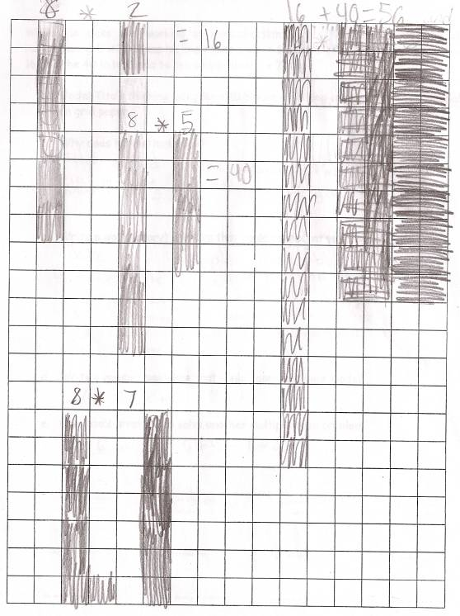
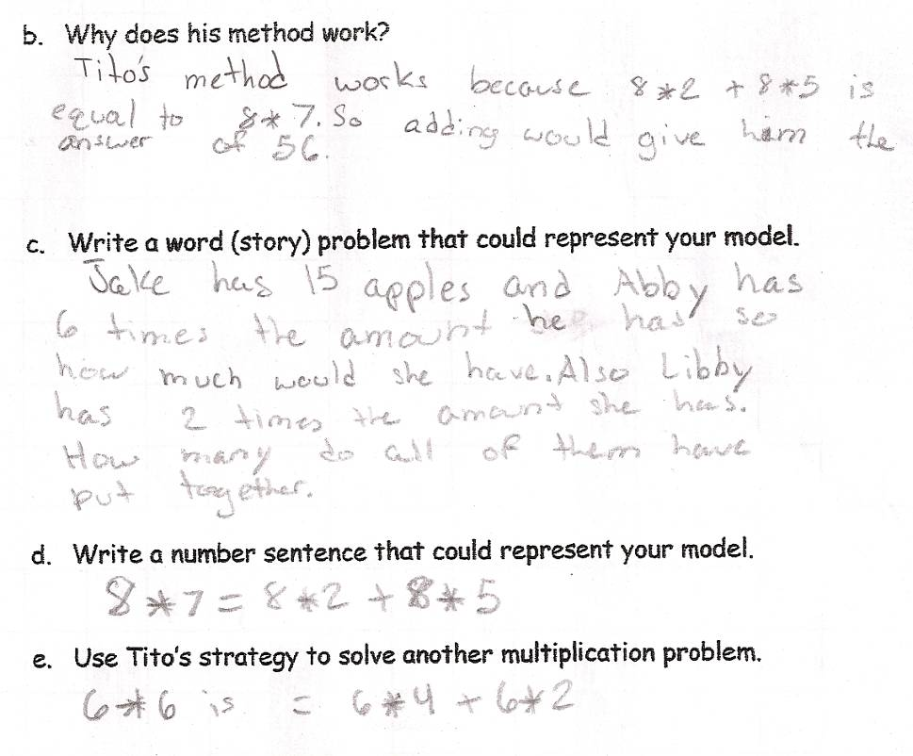
Student Work Analysis
Problem: Tito’s Strategy Grade Level: 3

Student B
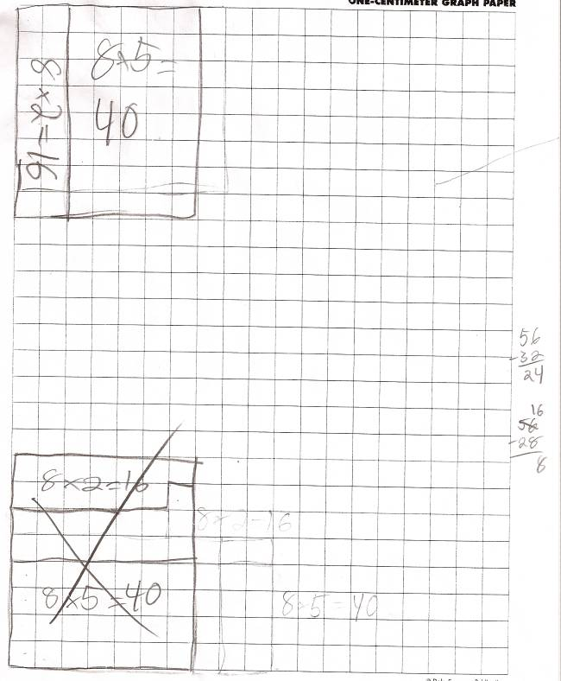
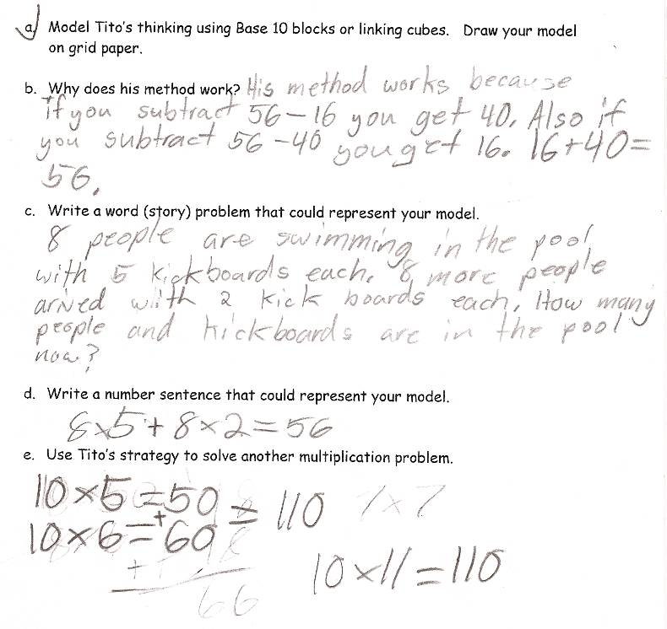
Student Work Analysis
Problem: Tito’s Strategy Grade Level: 3

Student C
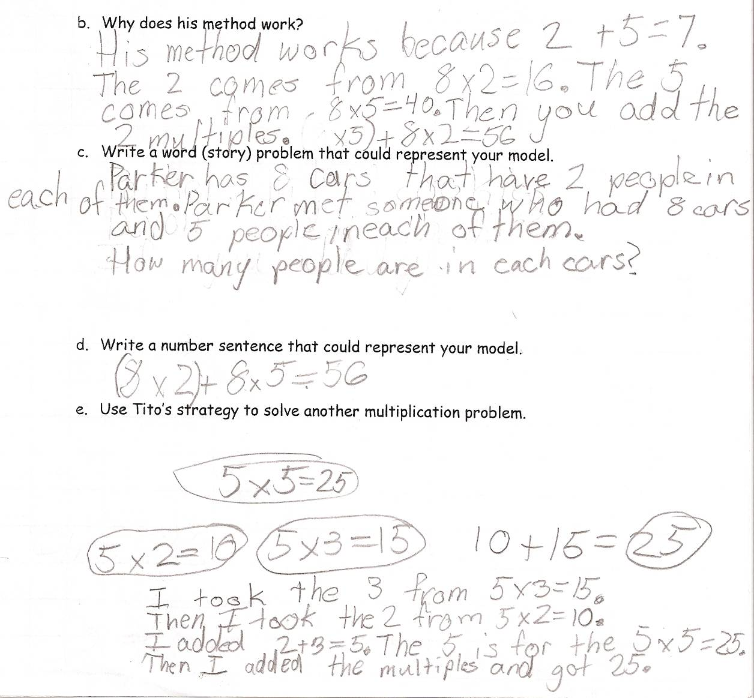
Student Work Analysis
Problem: Tito’s Strategy Grade Level: 3

Student D
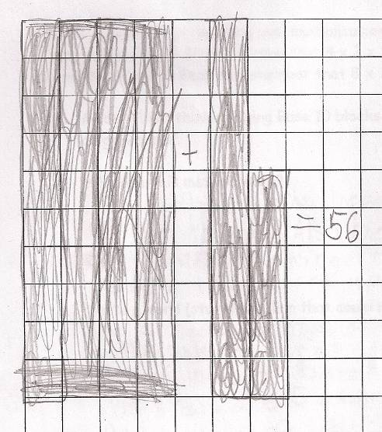
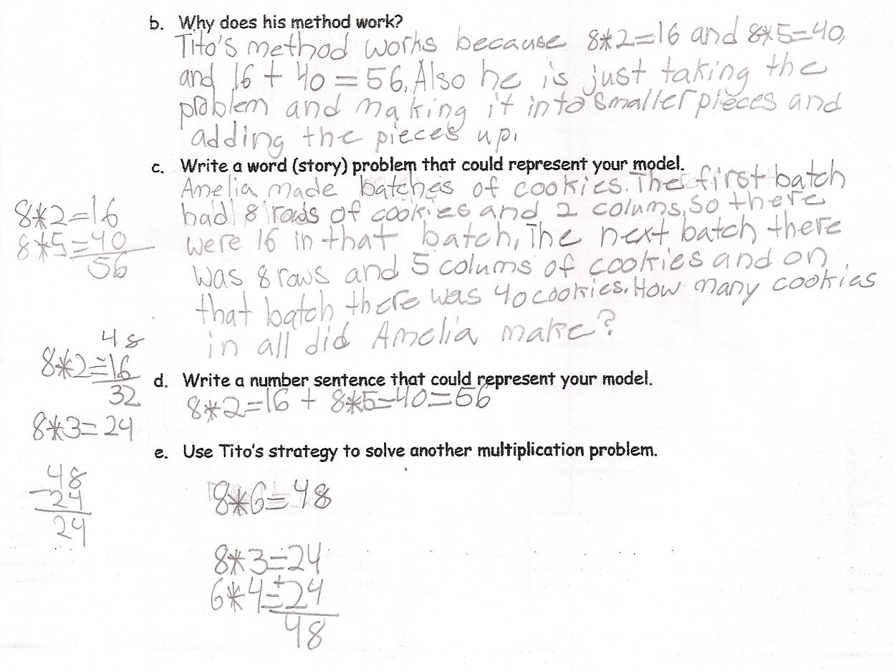
Student Work Analysis for: Tito’s Strategy

Student | MP 4: Model  MP 5: Tools | MP 3: Critique Reason.  MP 6: Precision | MP 7: Structure  MP 8: Repeated Reason. | What comes next in instruction for this student?
A
B

C

D

Unpacking the Rigor
Comparing Different Versions of the Tito’s Strategy Mathematical Task
Task | Level of Rigor
What is 8 x 7?

What is 8 x 7?
How do you know your answer is correct?

Tito’s Strategy

While his class was working on multiplication facts, Tito shared his way of remembering 8 x 7. Since he knew that 8 x 2 = 16 and 8 x 5 = 40, he could add the 16 and the 40 in his head to remember that 8 x 7 = 56.
- Model Tito’s thinking using Base 10 blocks or linking cubes. Draw your model on grid paper.
- Why does his method work?
- Write a word (story) problem that could represent your model.
- Write a number sentence that could represent your model.
- Use Tito’s strategy to solve another multiplication problem.

