Classroom Connections
Examining the Intersection of the Standards for Mathematical Content
and the Standards for Mathematical Practice

Title: Using Functions to Model Real – Life Situations

Common Core State Standards Addressed in the Student Work Task:
F – LE.1 Distinguish between situations that can be modeled with linear functions and with exponential functions.
a. Prove that linear functions grow by equal differences over equal intervals, and that exponential functions grow by equal factors over equal intervals.
b. Recognize situations in which one quantity changes at a constant rate per unit interval relative to another.
c. Recognize situations in which a quantity grows or decays by a constant percent rate per unit interval relative to another.

Evidence of Standards for Mathematical Practice in the Student Work:
1: Make sense of problems and persevere in solving them.
2: Reason abstractly and quantitatively.
3: Construct viable arguments and critique the reasoning of others.
4: Model with mathematics
6: Attend to precision.
7: Look for and make use of structure.

Task Components:

Part I: Mathematical Background (Page 2)
- Today’s Content

Part II: Math Metacognition (Page 3 – 4)

Part III: Unpacking the Rigor of the Mathematical Task (Pages 5 – 6)

Part IV: Looking at Student Work (Page 7 – 8)
- Caffeine in Coffee Task (High School Algebra I)
- Protocol for LASW

Part V: Vertical Content Alignment (Page 9)
- Charting Coherence through Mathematical Progressions
- Writing a Grade – Level Problem or Task

Part VI: Wrap – up (Page 10)

Handouts Included:
- Math Metacognition: Page 11
- Protocol for LASW: Page 12
- Mathematical Task – Caffeine in Coffee: Page 13
- Student Work Samples: Page 14 – 17
- Student Work Analysis Grid: Page 18
- Unpacking the Rigor: Page 19

Materials Needed:
- Graphing Calculators (If not available use scientific calculators and provide graph paper)
Part I: Mathematical Background
Approximate Time: 10 minutes
Grouping Structure: Whole Group
- Today’s Content:
  - The mathematics during this session focuses on the comparison of linear and exponential functions. The metacognition in this session revolves around using multiple representations to highlight the differences in the two types of functions. The student work task involves analyzing a real-world situation in which students determine how long it takes for the amount of caffeine in a cup of coffee to leave the body once the coffee has been consumed. Students must come to terms with competing arguments (one thinking linearly; the other, exponentially) and figure out which model best matches the situation.

  - What do we need to know about:
    - Patterns
    - Arithmetic and geometric progressions
    - Rate of change
    - Growth factor and growth rate
    - Exponents
    - Percentages
    - Linear functions
    - Exponential functions
    - Multiple representations of algebra (i.e., tables, graphs, equations, descriptions)
before we can truly understand and model functions accurately and efficiently?

  - Chart ideas to refer to during the Protocol for LASW.

Part II: Math Metacognition
Approximate Time: 30 minutes
Grouping: Whole Group

- Problem: These problems allow teachers the chance to work with functions and models using multiple representations to compare/contrast linear and exponential growth/decay. Having teachers consider various real-life situations helps to “ground” these functions in a meaningful way.

- Come up with an example of linear growth or decay and an example of exponential growth or decay at each of the three settings listed below:
- The dentist’s office
- At the mall
- In a science lab

- Select ONE of your scenarios from above and describe the two examples in as many ways as possible. Be sure to consider multiple representations (i.e., words, numbers, symbols, graphs, pictures/visuals).

- Solutions:
  - Problem 1: Answers will vary, but some examples are given: A)linear: # of free toothbrushes given out per day (see example on next page), exponential: amount of bacteria growing on teeth over time; C) linear: mouse running rate, exponential: mold growth over time

  - Problem 2: Answers will vary, but you can have teachers describe their scenarios to a neighbor or can report out in whole group. Have at least one person describe a linear situation and an exponential situation to the group as a whole. While they are doing this, you can organize their thoughts into a functions “family portrait” to highlight the similarities and differences of the two types of functions.
Here’s an example of how you could set this up:
Description | Real-Life Scenario
Picture Model | Number Model
Graph Model | Equation Model

Part II: Math Metacognition, cont.

  - Here’s an example of what this might look like:
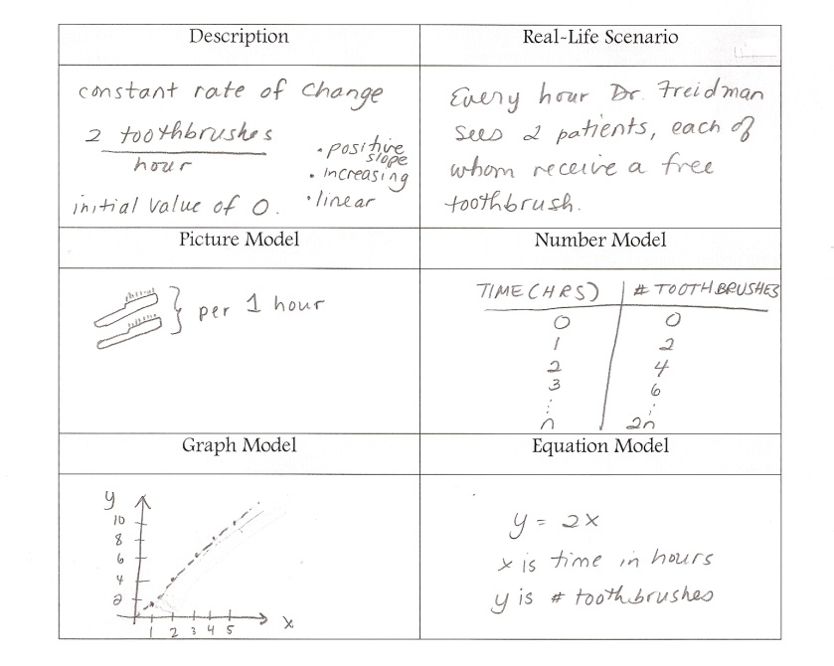
  - Consider using some colored highlighters to identify the elements common to both functions (i.e., color code that both have a y-intercept that shows up in their symbolic form).

- Problem Intent:
  - Math metacognition allows teachers the opportunity to think about their own mathematical thinking in a more natural way that promotes the development of reasoning and sense-making.
  - This particular exercise is designed to get teachers thinking about the different ways in which functions can be considered. It is important for students to see all of these representations connecting together because it gives them a more complete picture of the function and how it can be applied to real-life. These two functions will show up again in the student work task. Having the opportunity to contrast them now sets teachers up to analyze the differences between the two.

- Have teachers share and compare their answers. Then, bring discussion back to the topics at hand:
  - Which setting did you find easier to consider? Which function? Why?
  - What implications does this have on our work with functions? With modeling real-world data or situations?
  - How can metacognition help promote successful problem solving with your own students?

Part III: Unpacking the Rigor of the Mathematical Task
Approximate Time: 30 minutes
Grouping: Whole Group

- Comparing Different Versions of the Mathematical Task: Let’s compare the rigor of two related problems to the Caffeine in Coffee task. The level of rigor is based on which of the Standards for Mathematical Practice we could expect to see when examining the student solutions. Pass out the “Unpacking the Rigor” handout (see Page 19). See completed chart on the next page for more details of what this would look like.

- In addition to the Mathematical Practices, consider discussing the following with your group as you compare the variations above:
  - Cognitive demand
  - Task accessibility to a variety of learners
  - Real-life applications and math connections
  - Assessment of student learning

- If time allows, you can use a Venn Diagram to compare and contrast the elements of each version of the task.

Unpacking the Rigor
Comparing Different Versions of the Caffeine in Coffee Mathematical Task

Task | Level of Rigor
Identify the slope and y-intercept of the graph below:  A traditional problem involving functions would look something like this: | MP4: When students are able to identify important quantities in a mathematical representation (i.e., a graph), they are making use of this practice.
Describe the patterns of change in the table of values below:  X Y₁ Y₂  -1 120 125  0 100 100  1 80 80  2 60 64  3 40 51.2  Here, two functions (one linear, one exponential) are represented numerically. Students are asked to describe the patterns of change in the data, hopefully noting the same y-intercept with differing rates of change. | MP2: When students are asked to reason about numerical quantities with no guidance as to how to approach the process, quantitative reasoning must take place.  MP7: When students look closely to discern patterns of change within tables of values, they are making use of this practice.
Here, additional elements are brought to the task. Two students share their thinking on what “a continuous rate of 20%” could mean in terms of a real-life situation (drinking a cup of coffee). Each student gives a plausible answer for when the amount of caffeine will leave the body, and it is up to the reader to explain both arguments. This task requires reasoning about functions (both linear and exponential) without being told which tools to use. This task now has much higher level of cognitive demand, when compared to the previous two related problems.  A cup of coffee contains 100 mg of caffeine which leaves the body at a continuous rate of 20% per hour. Two students, Joe and Missy, were asked to answer this question: After a person drinks a cup of coffee, in how many hours will there be less than 5 mg of caffeine in his system?  Joe responded, “In 5 hours.” Missy disagreed, saying that it would be more like 14 hours.  Explain how each student might have arrived at his/her answer and tell which answer, if either, is correct. | MP1: When students are extracting important information from a word problem in order to determine the correct solution, they are making sense of problems and solving them.  MP2: When students are asked to reason about a numerical situation with no guidance as to how to approach the process, quantitative reasoning must take place.  MP3: When students are asked to explain two different solutions reached by two different people and then asked to judge which solution is correct, they are exhibiting use of this practice.  MP4: When students apply functions to real-life data or situations, they are modeling with mathematics.  MP6: When students are analyzing a numerical situation that relies on accuracy and correct calculation (i.e., 20% off each hour or 20% off previous hour’s amount) in order to reach a correct solution; they are exhibiting use of this practice.  MP7: When students look closely to discern patterns of change in tables of values or in graphs, they are making use of this practice.
Part IV: Looking at Student Work (LASW)
Approximate Time: 50 minutes
Grouping: Refer to protocol

- Mathematical Task Introduction: The problem and student work used for this session are from High School Algebra I. Note that calculators were allowed. Complete the Protocol for LASW (see Page 12) with the group.

- Caffeine in Coffee Task:

Solve this problem in the space provided below. Show and explain all of your work.
A cup of coffee contains 100 mg of caffeine which leaves the body at a continuous rate of 20% per hour. Two students, Joe and Missy, were asked to answer this question:

After a person drinks a cup of coffee, in how many hours will
there be less than 5 mg of caffeine in his system?

Joe responded, “In 5 hours.” Missy disagreed, saying that it would be more like 14 hours.

Explain how each student might have arrived at his/her answer and tell which answer, if either is correct.

NOTE: calculators allowed

- Solution:
  - Joe could have arrived at his answer of 5 hours by thinking that the rate of 20% per hour was a linear rate (20% of the total caffeine is removed from the body per hour). His thinking would take 100% - 20% - 20% - 20% - 20% - 20% = 0% and therefore it would take 5 hours for the amount of caffeine to be less than 5 mg. His equation is: y = 100 - 20x, where x = # hours and y = amount of caffeine (mg) left in the body.
  - Missy could have arrived at her answer of 14 hours by thinking that the rate of 20% per hour was an exponential decay (20% of the previous total is removed each hour – which is a constant multiplier of 0.20, rather than a constant amount subtracted (as in Joe’s thinking). Her equation is: y = 100(1 - .20)^{x} or y = 100 (.8)^{x}, where x = # of hours and y = amount of caffeine (mg) left in the body.

- Task Intent and Instructional Purpose:
  - Nowhere in this task does it ask students to use either a linear or an exponential function to model the situation. Instead, it leaves that piece of mathematics up to the students to apply. In fact, many students used numerical reasoning and operations to come to a correct answer.

Part IV: Looking at Student Work (LASW), cont.

  - The key to this task is the fact that students have to apply BOTH of these ideas of how rates are changing to this situation, since one type of thinking (Joe’s) relates to a linear model and the other (Missy’s) relates to an exponential decay model. In this way, you as the teacher can more fully assess the student’s ability to problem solve and reason in a real-life context.
  - It is interesting to note that many students thought the question was very ambiguous by pointing out that the phrase “at a continuous rate of 20%” could be interpreted in multiple ways. Because of this, they were unable to come to a correct conclusion.

- Questions for Evidence-based, Whole Group Discussion:
  - Does the student work exhibit proficiency of the Standards for Mathematical Content?
  - Consider the Standards for Mathematical Practice that are embedded in the task design. Which of these Practices do you see exhibited in the student work?
  - What is the evidence in the student work that the student is moving towards the intentions of the task design? (i.e., understanding and demonstrating mastery of the content as well as engaging in math practices)
  - How far removed from the intent of the task is the student’s thinking? Which pieces of understanding are present? Which are not? Is there evidence that they are close? Is there a misconception present?

Part V: Vertical Content Alignment
Approximate Time: 25 Minutes
Grouping: Partners or Small Groups

- Charting Coherence through Mathematical Progressions in the Standards for Mathematical Content

  - The content standard for this task is F – LE.1. It is important that the group analyzes this standard with respect to standards in K – High School Algebra I in order to identify where along the continuum of learning it falls.

  - Beginning, Middle, End: Using the Standards for Mathematical Content, trace the progression of the concepts involved in this task from K – High School Algebra I. See separate handout for an example of this progression.

- Writing a Problem or a Task: As a way to synthesize learning from today’s discussion, ask teachers to come up with a math problem or task that would embody the ideas discussed today. The problem should be appropriate to use at a particular grade level. Writing these problems will help both you as the facilitator and the other group members develop a stronger sense of how these mathematical ideas show up in classrooms from grades K – 12.
  - Consider having teachers work in pairs to write these problems. Be sure to have a wide variety of grade levels represented in the problems. This practice is an especially powerful means to identify vertical connections in content. Use the standards identified in Part A: Charting Coherence. Each pair of teachers should select a standard from this progression to be used as a basis for their written task.
  - Have teachers write their problem to share with the whole group. Be sure to ask them to include the appropriate learning standard(s) and Standard(s) for Mathematical Practice to which the problem is written. In this way, teachers are asked to articulate the types of content and practices with which students would be involved as a way to truly see how the work done here can have an impact on classroom practice, regardless of grade level.
  - What do you notice about the problems presented?

Part VI: Feedback & Wrap-up
Approximate Time: 5 Minutes
Grouping: Individual

- Closing: Close your time together by facilitating a discussion around how the LASW process will impact what teachers do within their own classrooms. Some questions to help guide discussion include:
  - What do we take away after LASW?
  - What did we learn? About student thinking? About our own knowledge?
    - Refer back to chart made at the beginning of the discussion during Part I: Mathematical Background.
  - How does it impact your practice at your grade level?

- Exit Cards: Pass out exit cards for the group and ask them to provide some feedback to you as the facilitator. Select one or two questions from the list below to help them summarize their thinking about the mathematics from today’s session. Collect exit cards so that a summary can be shared the next time you meet.

Exit Card Questions

- How does the mathematics that we explored connect to your own teaching?

- How do the mathematical practices that we explored connect to your own teaching?

- What idea or topic did you find most interesting from today’s discussion? Why?

- How was this discussion for you as a learner?

- What ideas were highlighted for you in today’s discussion that you had not previously considered?

- What are you taking away from today’s work?

Math Metacognition

- Come up with an example of linear growth or decay and an example of exponential growth or decay at each of the three settings listed below:
  - The dentist’s office
  - At the mall
  - In a science lab

- Select ONE of your scenarios from above and describe the two examples in as many ways as possible. Be sure to consider multiple representations (i.e., words, numbers, symbols, graphs, pictures/visuals).

Protocol for
Looking at Student Work

- Read the task and discuss what it is assessing.

- Solve the problem individually

- Share your thinking with a partner

- Discuss the mathematics of the task as a whole
group

- Look at how students solved the same task

- Identify evidence of the Standards of
Mathematical Practice exhibited in the student
work

- Discuss evidence of the Standards of
Mathematical Practice exhibited in the student
work as a whole group

Based on the Mathematics Learning Community (MLC) Protocol for LASW,
© 2011 Commonwealth of Massachusetts [Department of Elementary and Secondary Education

Mathematical Task
Caffeine in Coffee

Solve this problem in the space provided below. Show and explain all of your work.

A cup of coffee contains 100 mg of caffeine which leaves the body at a continuous rate of 20% per hour. Two students, Joe and Missy, were asked to answer this question:

After a person drinks a cup of coffee, in how many hours will
there be less than 5 mg of caffeine in his system?

Joe responded, “In 5 hours.” Missy disagreed, saying that it would be more like 14 hours.

Explain how each student might have arrived at his/her answer and tell which answer, if either, is correct.

Student Work Analysis
Problem: Caffeine in Coffee Grade Level: HS Algebra I

Student A

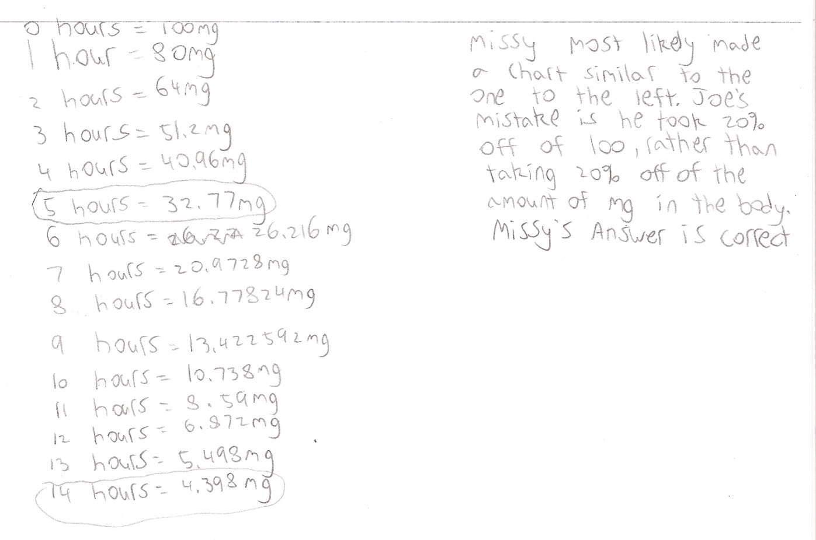

Student Work Analysis
Problem: Caffeine in Coffee Grade Level: HS Algebra I

Student B

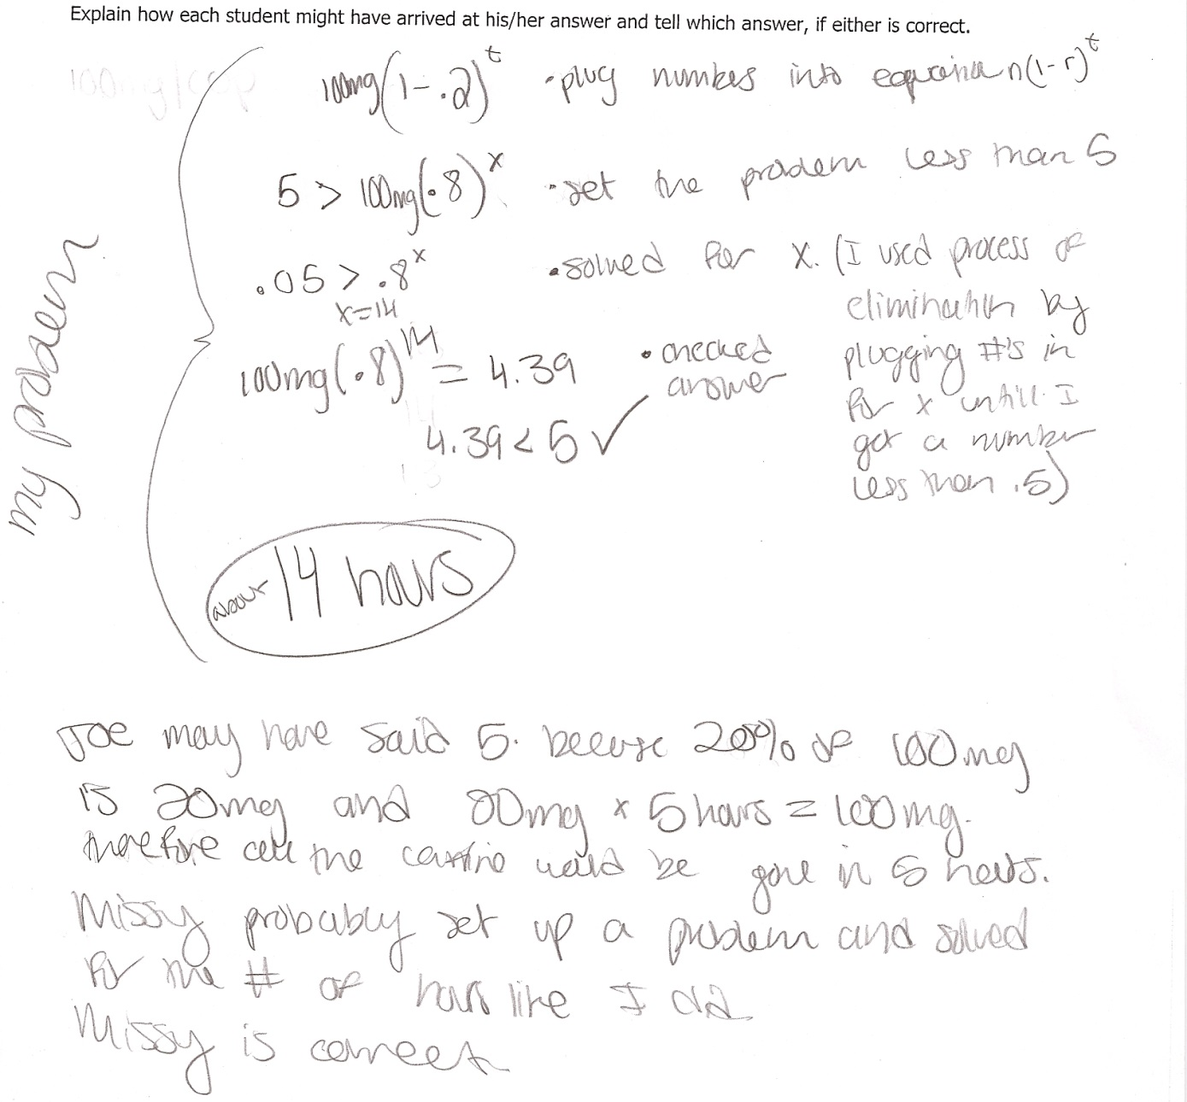

Student Work Analysis
Problem: Caffeine in Coffee Grade Level: HS Algebra I

Student C

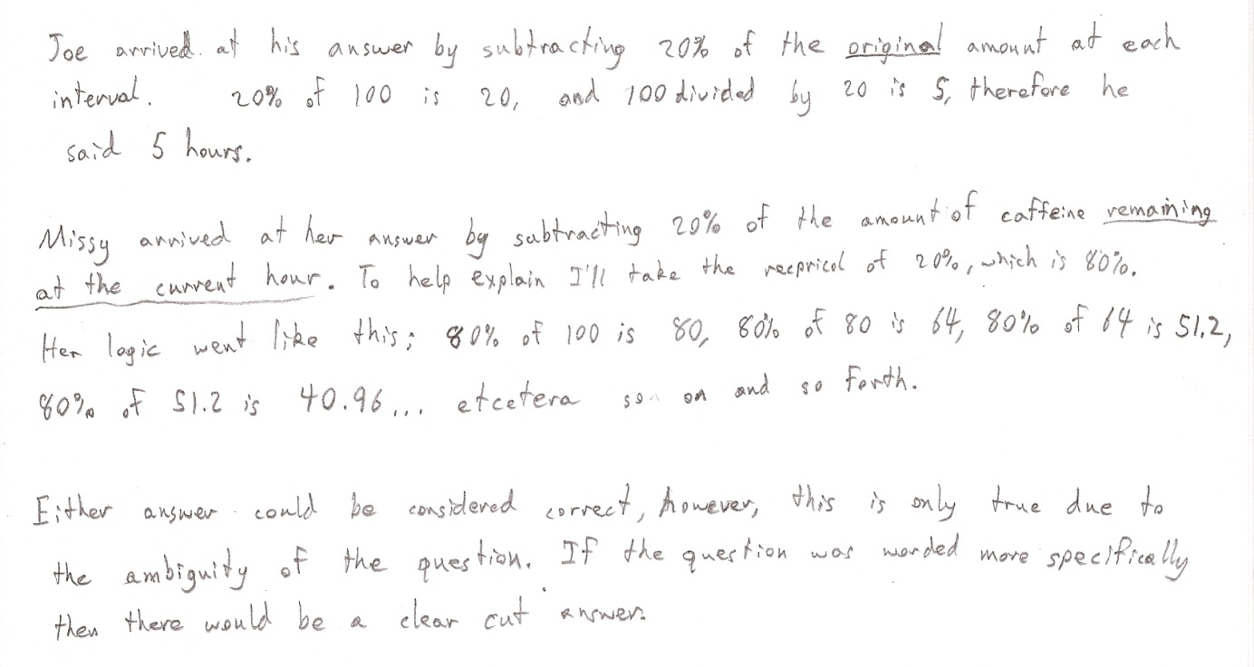

Student Work Analysis
Problem: Caffeine in Coffee Grade Level: HS Algebra I

Student D
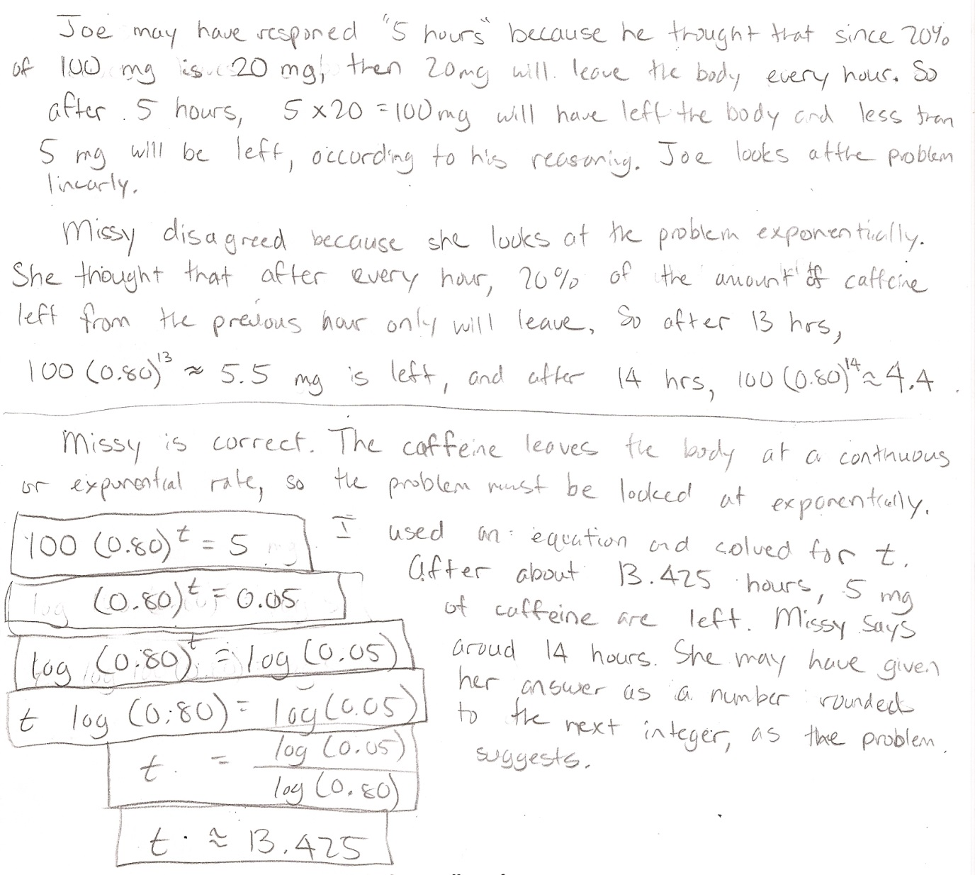
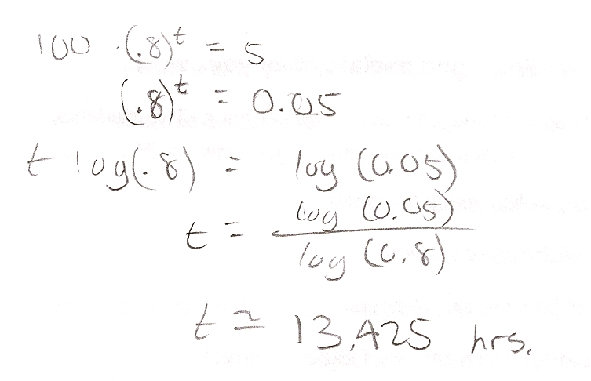
Student Work Analysis for: Caffeine in Coffee

Student | MP 1: Problem Solve  MP 6: Precision | MP 2: Reason abstract.  MP 3: Critique Reason. | MP 4: Model w/ math  MP 5: Use tools | What comes next in instruction for this student?
A
B

C

D

Unpacking the Rigor
Comparing Different Versions of the Caffeine in Coffee Mathematical Task

Task | Level of Rigor
Identify the slope and y-intercept of the graph below:

Describe the patterns of change in the table of values below:

X | Y₁ | Y₂
-1 | 120 | 125
0 | 100 | 100
1 | 80 | 80
2 | 60 | 64
3 | 40 | 51.2

Solve this problem in the space provided below. Show and explain all of your work.

A cup of coffee contains 100 mg of caffeine which leaves the body at a continuous rate of 20% per hour. Two students, Joe and Missy, were asked to answer this question:

After a person drinks a cup of coffee, in how many hours will
there be less than 5 mg of caffeine in his system?

Joe responded, “In 5 hours.” Missy disagreed, saying that it would be more like 14 hours.

Explain how each student might have arrived at his/her answer and tell which answer, if either, is correct.

