Classroom Connections
Examining the Intersection of the Standards for Mathematical Content
and the Standards for Mathematical Practice

Title: Working through Measurement Conversions

Common Core State Standard Addressed in the Student Work Task:
7.G.6. Solve real-world and mathematical problems involving area, volume, and surface area of two- and
three -dimensional objects composed of triangles, quadrilaterals, polygons, cubes, and right prisms.

Evidence of Standards for Mathematical Practice in the Student Work:
1: Make sense of problems and persevere in solving them.
2: Reason abstractly and quantitatively.
4: Model with mathematics.
5: Use appropriate tools strategically.
6: Attend to precision.

Task Components:

Part I: Mathematical Background (Page 2)
- Today’s Content

Part II: Math Metacognition (Page 3)

Part III: Unpacking the Rigor of the Mathematical Task (Pages 4)

Part IV: Looking at Student Work (Page 5)
- Garden Dimensions Task (Grade 7)
- Protocol for LASW

Part V: Vertical Content Alignment (Page 6)
- Charting Coherence through Mathematical Progressions
- Writing a Grade – Level Problem or Task

Part VI: Wrap – up (Page 7)

Handouts Included:
- Math Metacognition: Page 8
- Protocol for LASW: Page 9
- Mathematical Task – Garden Dimensions: Page 10
- Student Work Samples: Pages 11 – 14
- Student Work Analysis Grid: Page 15
- Unpacking the Rigor: Page 16

Materials Needed:
- Rulers
- Calculators

Part I: Mathematical Background
Approximate Time: 10 minutes
Grouping Structure: Whole Group

- Today’s Content:
  - The mathematics during this session focuses on measurement. Of all mathematical topics, measurement is probably the most applicable to everyday life, yet often receives little attention in class. Working with different sized units presents even more of a challenge. The student work task in this session requires students to analyze a given volume of soil and determine the widest possible garden to hold the soil. The height and length of the garden and the volume of the soil are given in different units.
  - What do we need to know about:
    - Dimensions (length, width, height)
    - Area of two-dimensional figures
    - Standard units of measurement
    - Measurement conversions
    - Volume of prisms
before we can truly understand and solve real-life measurement problems accurately and efficiently?

  - Chart ideas to refer to during the Protocol for LASW.

Part II: Math Metacognition
Approximate Time: 30 minutes
Grouping: Whole Group

- Problem: This problem set involves measurement conversions within the standard units system. Measurement metacognition is really important to develop as it is so applicable to everyday life, making estimation in measurement situations a daily occurrence. The need for accurate measurements or even “ballpark” estimates is so great, yet the ability to do so is lacking for many students and adults alike.
Problem Set
- Which area is larger?
Rectangle A: 8” x 3’
Rectangle B: $\frac{2}{3}$ yd x 9”
How do you know?
- Which volume is larger?
Rectangular Prism A: L: 1yd, W: 2’, H: 6”
Rectangular Prism B: L: 3’, 10”, H: ½ yd
How do you know?
- Describe something in real-life that has a volume of: 1 in³, I ft³, and 1 yd³.
- About how many cubic inches are in 1 ft³? In 1 yd³?
- What would you estimate the volume of a standard-sized bathtub to be?

NOTE: If teachers struggle with #4, ask them to consider:
Cubic inches in a cubic foot: Would you say it’s closer to 1000in³ or 2000 in³?
Cubic inches in a cubic yard: Would you say it’s closer to 20,000in³ or 50,000 in³?

- Solutions:
  - 1) Rectangle A has an area of 288 in² while Rectangle B’s area is only 216 in². They should know since 2/3 yard is 2’, which is a smaller dimension than 3’ and since 8” and 9” are very close to one another, it would reason that Rectangle A has a larger area. 2) Rectangular Prism B has a larger volume (3.75 ft³ vs. 3 ft³ for A). Answers will vary for how they know. 3) A cubic inch is about the size of a wooden block, a cubic foot is about the size of a cubby hole in a bookshelf, and a cubic yard is about ½ the amount of space in the back of a pickup truck. 4) 1,728 in³ in a ft³ and 46,656 in³ in a yd³. 5) Standard bathtub measurements (on outside) are 60” long x 30” wide x 17.5” deep, which is 31,500 in³. Converting the measurements to feet would give you about 18 ft³.

- Problem Intent:
  - Math metacognition allows teachers the opportunity to think about their own mathematical thinking in a more natural way that promotes the development of reasoning and sense-making.
  - This particular exercise is designed to get teachers thinking about measurement, volume in particular, especially when the dimensions are given in different standard units. This same situation occurs in the Garden Dimensions student work task, and the overall rate of success on this problem set was extremely poor, leading us to the conclusion that much more measurement problem solving needs to be done.

- Have teachers share and compare their answers. Then, bring discussion back to the topics at hand:
  - Which task did you find easiest to complete? Why?
  - What implications does this have on our work with volume and measurement?
  - How can metacognition help promote successful problem solving with your own students?
Part III: Unpacking the Rigor of the Mathematical Task
Approximate Time: 30 minutes
Grouping: Whole Group

- Comparing Different Versions of the Mathematical Task: Let’s compare the rigor of two related problems to the Garden Dimensions task. The level of rigor is based on which of the Standards for Mathematical Practice we could expect to see when examining the student solutions. Pass out the “Unpacking the Rigor” handout (see Page 17).

- In addition to the Mathematical Practices, consider discussing the following with your group as you compare the variations above:
  - Cognitive demand
  - Task accessibility to a variety of learners
  - Real-life applications and math connections
  - Assessment of student learning

- If time allows, you can use a Venn Diagram to compare and contrast the elements of each version of the task.

Part IV: Looking at Student Work (LASW)
Approximate Time: 50 minutes
Grouping: Refer to protocol

- Mathematical Task Introduction: The problem and student work used for this session are from Grade 7. Complete the Protocol for LASW (see Page 10) with the group.

- Garden Dimensions Task:

Solve this problem in the space provided below. Show and explain all of your work.
The Hansens are making a garden in their back yard and have ordered a truck load of soil to pour into the rectangular frame for the garden. The truck contains 8 cubic yards of soil. The soil in the garden is to be 8 inches deep and the garden is 21 feet long. How wide, to the nearest foot, can the garden be if the Hansens are to use as much as possible of the soil delivered by the truck?

- Solution:
  - The width, to the nearest foot, would be 15 ft.

- Task Intent and Instructional Purpose:
  - The demand for accuracy and precision is very high in a problem such as this. The fact that dimensions are given in different units and that students are solving for one of the lengths, rather than determining the resulting volume, makes this a challenging problem. As a result, making estimates and considering reasonableness of answers is really important. Do students seem to consider the reasonableness of their answer? Do their calculations make sense?
  - How would you teach students to solve problems such as this? How can you help students gain proficiency working with measurement conversions?

- Questions for Evidence-based, Whole Group Discussion:
  - Does the student work exhibit proficiency of the Standards for Mathematical Content?
  - Consider the Standards for Mathematical Practice that are embedded in the task design. Which of these Practices do you see exhibited in the student work?
  - What is the evidence in the student work that the student is moving towards the intentions of the task design? (i.e., understanding and demonstrating mastery of the content as well as engaging in math practices)
  - How far removed from the intent of the task is the student’s thinking? Which pieces of understanding are present? Which are not? Is there evidence that they are close? Is there a misconception present?

Part V: Vertical Content Alignment
Approximate Time: 25 Minutes
Grouping: Partners or Small Groups

- Charting Coherence through Mathematical Progressions in the Standards for Mathematical Content

  - The content standard for this task is 7.G.6. It is important that the group analyzes this standard with respect to standards in K – 6, as well as Grade 8 in order to identify where along the continuum of learning it falls.

  - Beginning, Middle, End: Using the Standards for Mathematical Content, trace the progression of the concepts involved in this task from K – 8. See separate handout for an example of this progression.

- Writing a Problem or a Task: As a way to synthesize learning from today’s discussion, ask teachers to come up with a math problem or task that would embody the ideas discussed today. The problem should be appropriate to use at a particular grade level. Writing these problems will help both you as the facilitator and the other group members develop a stronger sense of how these mathematical ideas show up in classrooms from grades K – 8.
  - Consider having teachers work in pairs to write these problems. Be sure to have a wide variety of grade levels represented in the problems. This practice is an especially powerful means to identify vertical connections in content. Use the standards identified in Part A: Charting Coherence. Each pair of teachers should select a standard from this progression to be used as a basis for their written task.
  - Have teachers write their problem to share with the whole group. Be sure to ask them to include the appropriate learning standard(s) and Standard(s) for Mathematical Practice to which the problem is written. In this way, teachers are asked to articulate the types of content and practices with which students would be involved as a way to truly see how the work done here can have an impact on classroom practice, regardless of grade level.
  - What do you notice about the problems presented?

Part VI: Feedback & Wrap-up
Approximate Time: 5 Minutes
Grouping: Individual

- Closing: Close your time together by facilitating a discussion around how the LASW process will impact what teachers do within their own classrooms. Some questions to help guide discussion include:
  - What do we take away after LASW?
  - What did we learn? About student thinking? About our own knowledge?
    - Refer back to chart made at the beginning of the discussion during Part I: Mathematical Background.
  - How does it impact your practice at your grade level?

- Exit Cards: Pass out exit cards for the group and ask them to provide some feedback to you as the facilitator. Select one or two questions from the list below to help them summarize their thinking about the mathematics from today’s session. Collect exit cards so that a summary can be shared the next time you meet.

Exit Card Questions

- How does the mathematics that we explored connect to your own teaching?

- How do the mathematical practices that we explored connect to your own teaching?

- What idea or topic did you find most interesting from today’s discussion? Why?

- How was this discussion for you as a learner?

- What ideas were highlighted for you in today’s discussion that you had not previously considered?

- What are you taking away from today’s work?

Math Metacognition
Problem Set

- Which area is larger?

Rectangle A: 8” x 3’
Rectangle B: $\frac{2}{3}$ yd x 9”
How do you know?

- Which volume is larger?
Rectangular Prism A: L: 1yd, W: 2’, H: 6”

Rectangular Prism B: L: 3’, 10”, H: ½ yd
How do you know?

- Describe something in real-life that has a volume of: 1 in³, I ft³, and 1 yd³.

- About how many cubic inches are in 1 ft³? In 1 yd³?

- What would you estimate the volume of a standard-sized bathtub to be?
Protocol for
Looking at Student Work

- Read the task and discuss what it is assessing.

- Solve the problem individually

- Share your thinking with a partner

- Discuss the mathematics of the task as a whole
group

- Look at how students solved the same task

- Identify evidence of the Standards of
Mathematical Practice exhibited in the student
work

- Discuss evidence of the Standards of
Mathematical Practice exhibited in the student
work as a whole group

Based on the Mathematics Learning Community (MLC) Protocol for LASW,
© 2011 Commonwealth of Massachusetts [Department of Elementary and Secondary Education

Mathematical Task
Garden Dimensions

Solve this problem in the space provided below. Show and explain all of your work.

The Hansens are making a garden in their back yard and have ordered a truck load of soil to pour into the rectangular frame for the garden. The truck contains 8 cubic yards of soil. The soil in the garden is to be 8 inches deep and the garden is 21 feet long. How wide, to the nearest foot, can the garden be if the Hansens are to use as much as possible of the soil delivered by the truck?
Student Work Analysis
Problem: Garden Dimensions Grade Level: 7

Student A
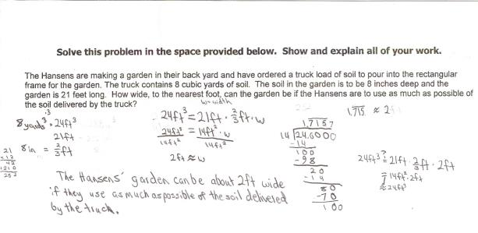

Student Work Analysis
Problem: Garden Dimensions Grade Level: 7

Student B
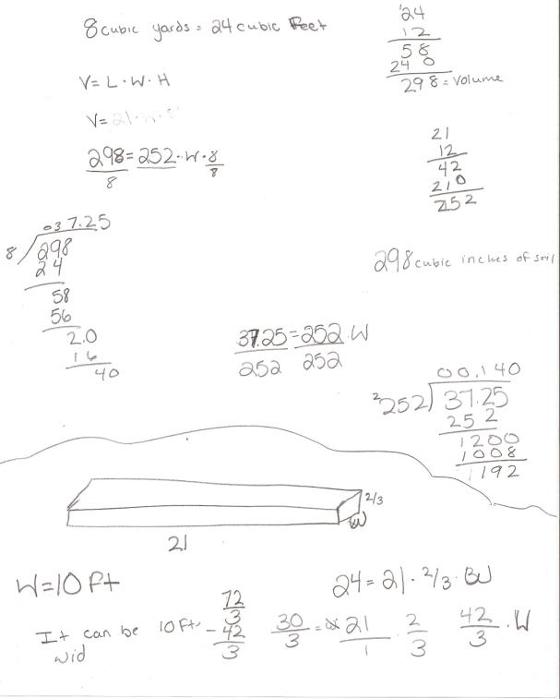
Student Work Analysis
Problem: Garden Dimensions Grade Level: 7

Student C
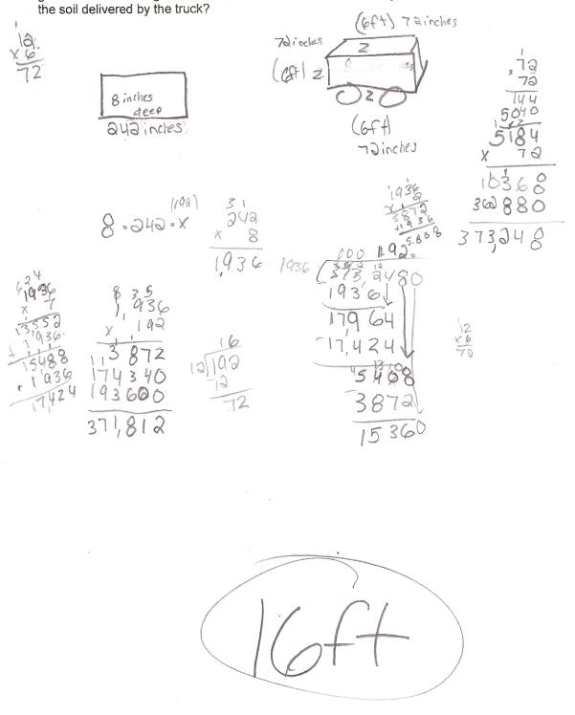

Student Work Analysis
Problem: Garden Dimensions Grade Level: 7

Student D
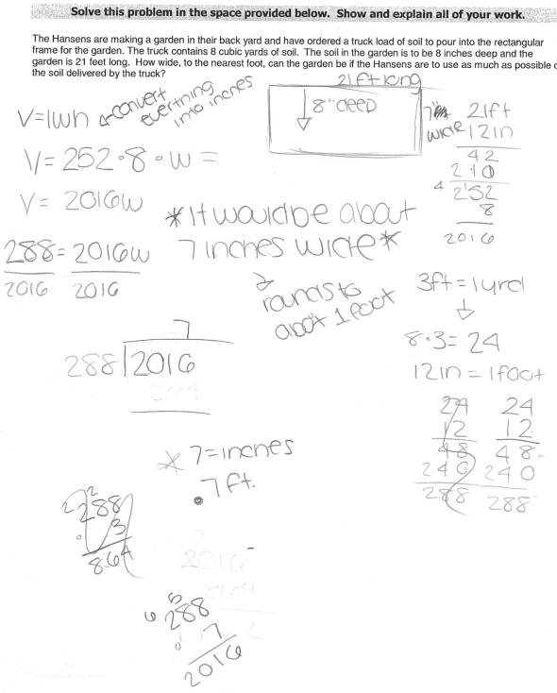

Student Work Analysis for: Garden Dimensions

Student | MP 1: Problem Solve  MP 6: Precision | MP 2: Reason abstractly and quantitatively | MP4: Model with math  MP 5:Use tools | What comes next in instruction for this student?
A
B

C

D

Unpacking the Rigor
Comparing Different Versions of the Garden Dimensions Mathematical Task
Task | Level of Rigor
Convert 8 inches to feet.
Convert 8 inches to yards.

Find the volume of a rectangular prism with dimensions:
L: 8 inches
W: 3 yards
H: 21 feet

Solve this problem in the space provided below. Show and explain all of your work.
The Hansens are making a garden in their back yard and have ordered a truck load of soil to pour into the rectangular frame for the garden. The truck contains 8 cubic yards of soil. The soil in the garden is to be 8 inches deep and the garden is 21 feet long. How wide, to the nearest foot, can the garden be if the Hansens are to use as much as possible of the soil delivered by the truck?

