Mathematics Learning Community

Number Sense
Session 2

Title: From Counting and Cardinality to Number in Base Ten

Common Core State Standards Addressed in the LASW Problem:
1.NBT.2 | Understand that the two digits of a two-digit number represent amounts of tens and ones.
Standards for Mathematical Practice Addressed in the MLC Session:
2: Reason abstractly and quantitatively. 3: Construct viable arguments and critique the reasoning of others. 6: Attend to precision.

Both of the Math Metacognition tasks require MLC members to count using different units of time. While analyzing the lengths of time given to them by their colleagues, they debate the level of precision needed based on the units used. Precision is also required in the LASW student work task as MLC members examine how students count and work with single-digit numbers and consider how they translate that knowledge when reasoning through situations involving place value and two-digit numbers.

Standards-Based Teaching and Learning Characteristics in Mathematics Addressed in the MLC Session:
- 5.1 Depth of content knowledge is evident throughout the presentation of the lesson.
- 5.2 Through the use of probing questions and student responses, decisions are made about what direction to
take, what to emphasize, and what to extend in order to build students’ mathematical understanding.
- 5.3 Students’ prior knowledge is incorporated as new mathematical concepts are introduced.
- 5.4 Student misconceptions are anticipated /identified and addressed.
- 5.5 Classroom strategies incorporate multiple forms of representation.

Session Agenda:

Part I: Mathematical Background

Part II: Math Metacognition

Part III: Looking at Student Work
- Making Large Numbers Problem (Grade 1)

Part IV: Our Learning

Part V: Feedback and Wrap-up

Materials Needed for this Session:
- Nametags | - Highlighters | - Copies of handouts | - Chart Paper and markers
- Index cards | - Refreshments

Possible Ways to Personalize this Session:
- If time is short at the end of the session, have group members take their Exit Card “to go” and drop it off later in your mailbox.
Part I: Mathematical Background
Approximate Time: 20 minutes
Grouping: Whole Group

- Welcome members of your group to the Math Learning Community.

- Remind group of established norms.

- Today’s Content:
  - The mathematics during this session focuses on making connections between counting and cardinality, as developed in preschool and kindergarten and how they translate into understanding about place value and the base ten number system.

  - For an in-depth exploration of the progression of these ideas across the grade levels, be sure to read the Progressions Documents for the Common Core Math Standards, which can be downloaded from this website: http://ime.math.arizona.edu/progressions/

  - What do we need to know to be able to count? How do we then express that counted quantity as a number? What do we need to know in order to be able to identify and represent numbers?

  - Chart ideas to refer to during the Protocol for LASW.

- Relating Content to the Three C’s Theme
  - Counting, composition and context are the three ideas that connect the mathematics throughout the MLC. Today’s session focuses on seeing counting and context in action through the Math Metacognition problem and composition in action through the LASW problem.

  - Do students really understand counting and what conventions, if any, are they using to count?

  - What are the students counting and how are they counting?

  - How are they able to express quantities? How are they able to compare numbers?

Part II: Math Metacognition
Approximate Time: 25 minutes
Grouping: Whole Group

- Problem Set: These problems act as a starting point for us to think about counting and the cardinality of numbers. What is the importance of our own mathematical understanding with something that seems as simple and superficial as counting?
  - For the first problem, have group members figure out how long it is until their birthday. Then, give that answer to another MLC member and see if s/he can determine when the birthday is.
  - For the second problem, ask MLC members to determine the correct preschool program for Jenny’s son.

- Intent of Math Metacognition for all MLC Sessions:
  - We are looking for various logical and reasonable ways that we, quite naturally, use when solving problems – which are for the most part very different from solving the same problems using historically-taught algorithms.
  - More often than not, we surface in our thinking very natural processes (such as breaking apart numbers, rounding up and subtracting out, etc.) to problem solve that bring more sense and accuracy to our mathematics. Metacognition in math helps to promote not only these natural problem solving processes but metacognition about the strategies.
  - When we think about the sense-making of mathematics, number sense is in its truest meaning the ability to do the following:
    - Make connections between algorithms or conventions
    - Move flexibly and fluently around numbers
    - Understand that the value or quantity of the numbers is the constant. For example, if the number 17 doesn’t work for me, I can change that to 20 – 3 or 15 + 2.

- Intent of Problem 1:
  - Discussion should focus on the type of unit used to answer the question (months/weeks/days or a combination) and whether or not the person can articulate what s/he is counting and how s/he is counting enough so that another person can follow that line of thinking.
  - The problem is worded ambiguously (“how long”) because the intent is to see how people count. Do they:
    - Count by groups of 30 days (1 month), and then adding/subtracting for months with 31 or 29 days
    - Count months by moving from the middle of one month the middle of the next
    - Count individual days
    - Count individual days and then translate into months, weeks, days based on 30 days per month, 7 days per week

Part II: Math Metacognition, cont.

  - How might this problem look if the problem context were more explicit? (i.e., used a different phrase for “how long”)?

- Intent of Problem 2:
  - Discussion should focus on how people determined how old Jenny’s son will be in early September and then how that age is reported.
  - This problem brings up the idea that time is not represented using a base ten number system – instead, a year could be considered to be base 12 (i.e., 12 months in a year).
  - In the problem (which represents typical information for preschool registration), the age of a child is written as 2.9 years. Is this meant to notate 2 years, 9 months? If not, what other meaning could 2.9 years have?
  - Yet, in the next level of preschool, is 3.5 years is meant to notate 3 ½ years or 3 years, 6 months or 3 years, 5 months? There is a discrepancy that exists between the two meanings of these numbers and how people are expected to count the number of months involved.
  - If you wanted to further explore this idea with your group, you could also ask them to consider what program would a child enter in September if he had turned 3 on March 28th? He would be 3 years, 5 months on August 28th, but not 3 years, 6 months until September 28th.

Part III: Looking at Student Work (LASW)
Approximate Time: 50 minutes
Grouping: Refer to protocol

- Problem Introduction: The problem and student work used for this session are from Grade 1. Complete the MLC Protocol with the group.

- Making Large Numbers Problem:

Sue and Jack were playing a game with number cards. Each student has four cards and needs to make the greatest two-digit number possible using any two of the four cards. Here are Sue’s four cards:
7 2 4 9
Sue said that the number 9 would need to go in the tens place to make the largest number. Is she correct? Can you say why or why not?
What is the largest two-digit number that you can make with these four cards?

- Solution: Yes, she is correct because you would need the largest digit in the tens place to create the number with the greatest quantity. Then, repeat the same process for the ones place with the remaining digits. Therefore, 97 is the largest two-digit number that can be made with these cards.

- Problem Intent: This problem allows for multiple correct explanations, depending upon how the student articulates the selection of the correct digit.
  - Students should recognize the fact that a two-digit number is composed of both tens and ones.
  - Ten ones compose one ten and that digit in the tens place represents that many tens. So, a 9 in the tens place is no longer representing the quantity “9” but instead representing 9 tens or 90 ones.
  - It is important to note whether or not the student is able to compare the digits to one another, determining that the size of the 9 is the greatest, relative to the other 3 possible digits.
  - In order for students to be able to make a two-digit number, they must understand the ideas expressed in K.CC.6 (comparing numbers by using matching or counting strategies) and use these strategies from single digits which then help them to be able to compare and bundle or unbundle tens when moving into two-digit numbers. (i.e., 90 tens are greater than 70 tens).
  - In addition, they should also understand the ideas expressed in K.CC.4c (each successive number name refers to quantity that is one larger), so students can then translate this idea when working with two-digit numbers to compare numbers in the tens place (i.e., 9 in the tens place is 2 more tens than 7 in the tens place).

Part III: Looking at Student Work (LASW), cont.

- Strategies you might see:
  - Order the digits from least to greatest. Use 9, the greatest, in the tens place since it is larger than 2, 4, or 7. Use 7 in the ones place since it is larger than 2 or 4.
  - Recognize that the largest two digit number possible is 99. Since you have to use two cards, create the next closest value which is 97.
  - Select 9 as the largest single digit since it is close to 10 (which is the lowest two-digit number). Place the 9 in the tens place to create the largest possible bundle of tens. Then place the 7 in the ones place to create the largest bundle of ones.

- Misconceptions & Questions That May Arise:
  - Awareness of digits representing quantity in that place (i.e., 9 for 90 or 9 tens), rather adding or combining digits (i.e., 97, or 9 + 7 = 16). Adding tens and ones based on a digit’s place value is different than single-digit arithmetic. (i.e., 90 + 7 =97 vs. 9 + 7 = 16).

  - Students may think that the tens place is the sole “determiner” of value. Students may correctly select the 9 as the largest digit for the tens place and then give little or no regard for the value in the ones place (i.e., writing 92 or 94 as the solution). This is often even more evident in situations involving three-digit numbers (or greater).

Part IV: Our Learning
Approximate Time: 20 Minutes
Grouping: Whole Group

- Discussion: After evidence of student understanding has been discussed as a whole group, you want to facilitate discussion around how the LASW process will impact what teachers do within their own classrooms. Some questions to help guide discussion include:
  - What do we take away after LASW?
  - What did we learn? About student thinking? About our own knowledge?
    - Refer back to chart made at the beginning of the session
  - How does today’s session relate to important mathematical content and pedagogy?
  - How does it impact your practice at your grade level? (Note: In order to help teachers connect this session to the mathematics within their own grade level, refer to the information below).

Making Connections Across the Grade Levels

K – 2: The birthday problem involves the concept of time until an event occurs and makes use of a calendar as a problem solving tool, a skill which is developed in early elementary school (K.MD.1, MA.2.MD.7a). The LASW problem brings up fundamental ideas about place value and comparison of quantities in base ten, both of which serve as a basis for addition and subtraction (K.CC.1 – 7, K.NBT.1, 1.NBT.1 – 3, 2.NBT.1, 2.NBT.3 – 7, 2.NBT.9). Student Work in this session is from students in Grade 1.

3 – 5: The birthday problem has an answer that can be represented in multiple different correct ways, depending upon the unit of time (month, day, week, etc.). This problem has implications for students in upper elementary school as they work to understand that identifying units is critical during problem solving and representation of solutions (3.MD.1, 4.MD.1, 4.MD.2, 5.MD.1). The LASW problem brings up fundamental ideas about place value and comparison of quantities in base ten, both of which serve as a basis for the operations of multiplication and division, and the extension of the number system to include decimals. (3.NBT.1 – 3, 4.NBT.1 – 6, 5.NBT1 – 7).

6 – 8: The birthday problem is written intentionally to be slightly ambiguous (“how long”) – which can be a good strategy to use with students within this grade band. By presenting students with such a problem, you often get to identify where students are coming from – their natural thinking about a problem situation. You can then also have a discussion about problem intent and potential misconceptions. The LASW problem brings up fundamental ideas about place value and comparison of quantities in base ten, both of which serve as a basis for division and work with decimals. (6.NS.2, 6.NS.3).

- Writing a Problem or a Task: As a way to synthesize learning from today’s session, ask MLC members to come up with a math problem or task that would embody the ideas discussed today. The problem should be appropriate to use at their grade level. Writing these problems will help both you as the facilitator and the other group members to develop a stronger sense of how these mathematical ideas show up in classrooms from kindergarten through grade 8. (Note: See Part IV in Session 1 for more details).

Part V: Feedback & Wrap-up
Approximate Time: 5 Minutes
Grouping: Individual

- Closing: Close the session with a message such as: “Hope you leave here with more questions – about student thinking, about your teaching, and ways that we as a group can help support one another.” Have MLC members keep in mind the following: Dialogue, Reflection, and Inquiry are the keys to successful learning.

- Exit Cards: Pass out exit cards for group members and ask them to provide some feedback to you as the facilitator. Select one or two questions from the list below to help them summarize their thinking about the mathematics from today’s session. Collect exit cards so that a summary can be shared at the next session.

Feedback / Exit Card Questions

- How does the mathematics that we explored connect to your own teaching?

- How do I see what we’ve done today relate to key mathematical ideas or pedagogical content knowledge?

- What idea or discussion topic did you find most interesting from today’s session. Why?

- How was this session for you as a learner?

- What ideas were highlighted for you in today’s session that you had not previously considered?

- What are you taking away from today’s session?

Related Student Discourse Video Clip – LASW Problem

Content-Focused Coaching, Disc 1: Kindergarten
Problem: There are 11 pieces of fruit in a fruit bowl. What are the possible combinations with two types of fruit?

Classroom Discussions: Using Math Talk to Help Students Learn, K Disc
Problem: Decomposing the Number Seven

Session Reference

Classroom Discussions: Using Math Talk to Help Students Learn, 2nd Edition, by. S. Chapin, C. O’Connor, and N. Canavan Anderson, Math Solutions, 2009

Content-Focused Coaching: Transforming Mathematics Lessons, by L. West and F. Staub, Heinemann/University of Pittsburgh, 2003.

Math Metacognition

1. | Determine how long it is until your birthday.  Then, give that answer to another person and see if s/he can determine when your birthday is.
2. | Jenny is enrolling her son at Little Kids Preschool in the fall. The guidelines listed on the school’s website state the following:  Little Critters: 2-2.9 year olds, 8:30-12:00, 3 or 5 days  Puddle Jumpers: 2.9-3.5 year olds, 8:30-12:30, 3 or 5 days  Leap Froggers: 3-4 year olds, 8:30-12:30, 5 days  PreKindergarten: 4-5 year olds, 8:30-12:30, 5 days  Her son will turn 3 years old on November 28th. Which program can he enter in September? How do you know?

LASW Problem

Making Large Numbers

Sue and Jack were playing a game with number cards. Each student has four cards and needs to make the greatest two-digit number possible using any two of the four cards. Here are Sue’s four cards:

7 2 4 9

Sue said that the number 9 would need to go in the tens place to make the largest number.

Is she correct? Can you say why or why not?

What is the largest two-digit number that you can make with these four cards?
Student Work Analysis
Problem: Making Large Numbers Grade Level: 1

Student A

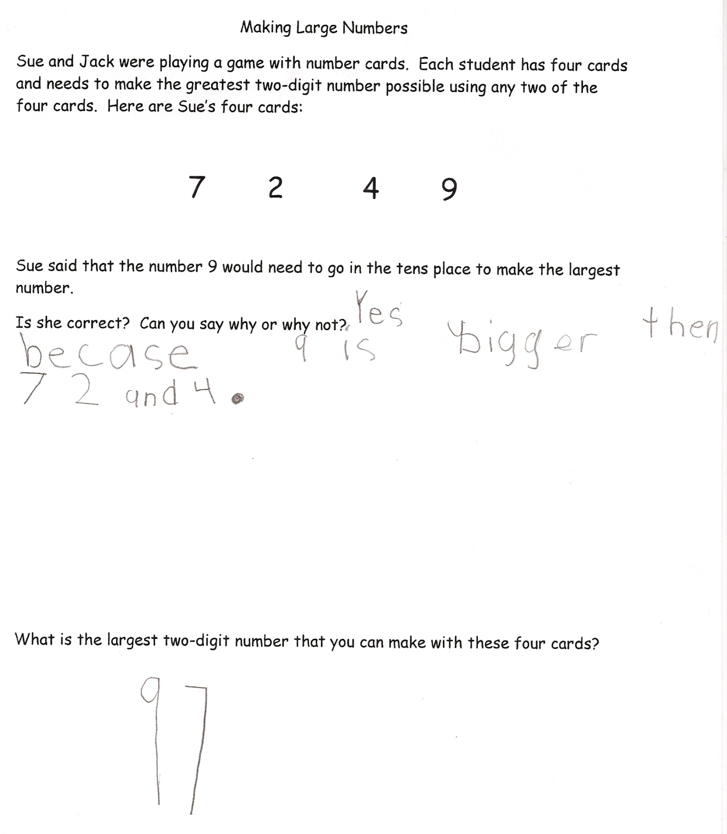

Student Work Analysis
Problem: Making Large Numbers Grade Level: 1

Student B

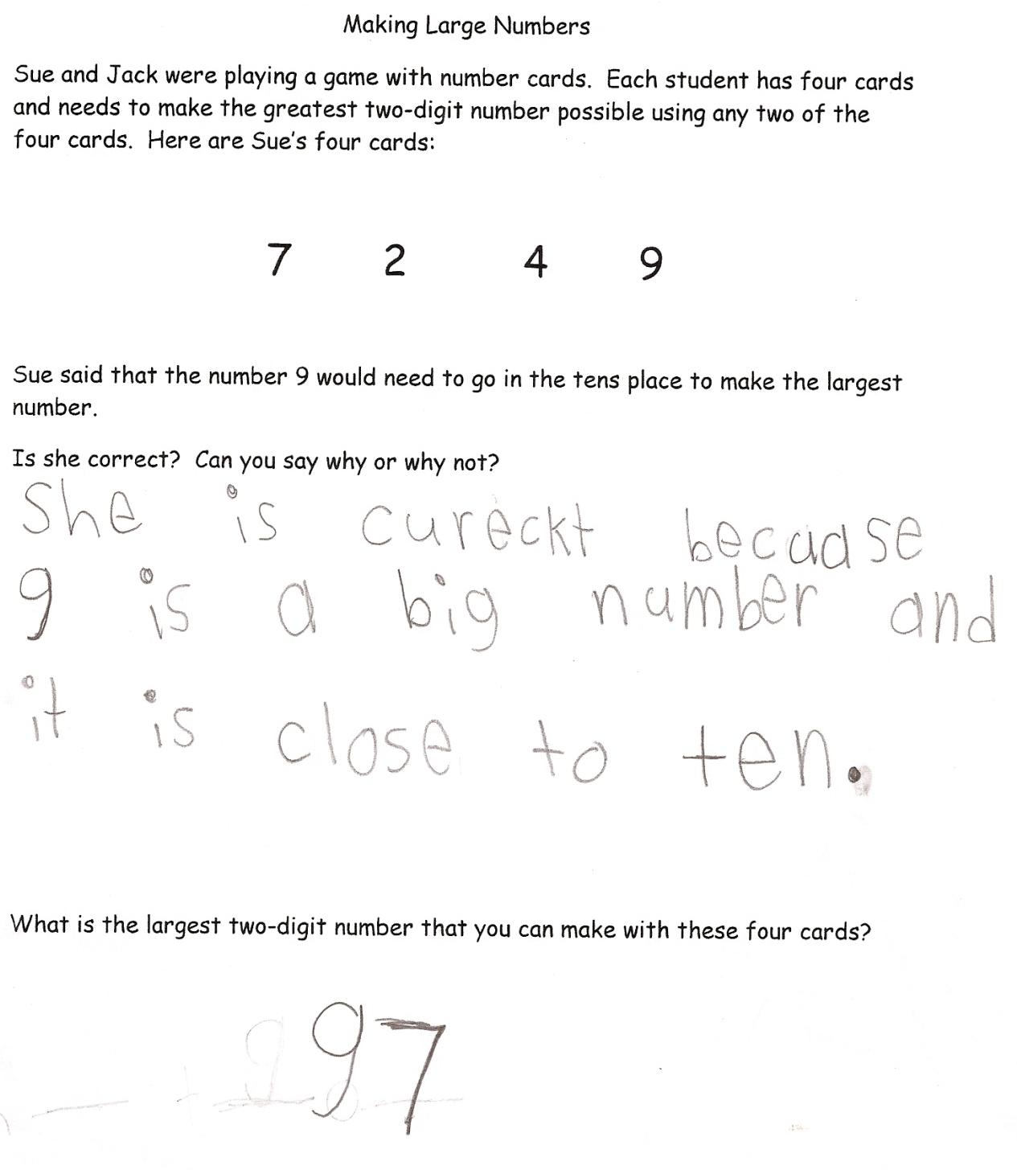
Student Work Analysis
Problem: Making Large Numbers Grade Level: 1

Student C

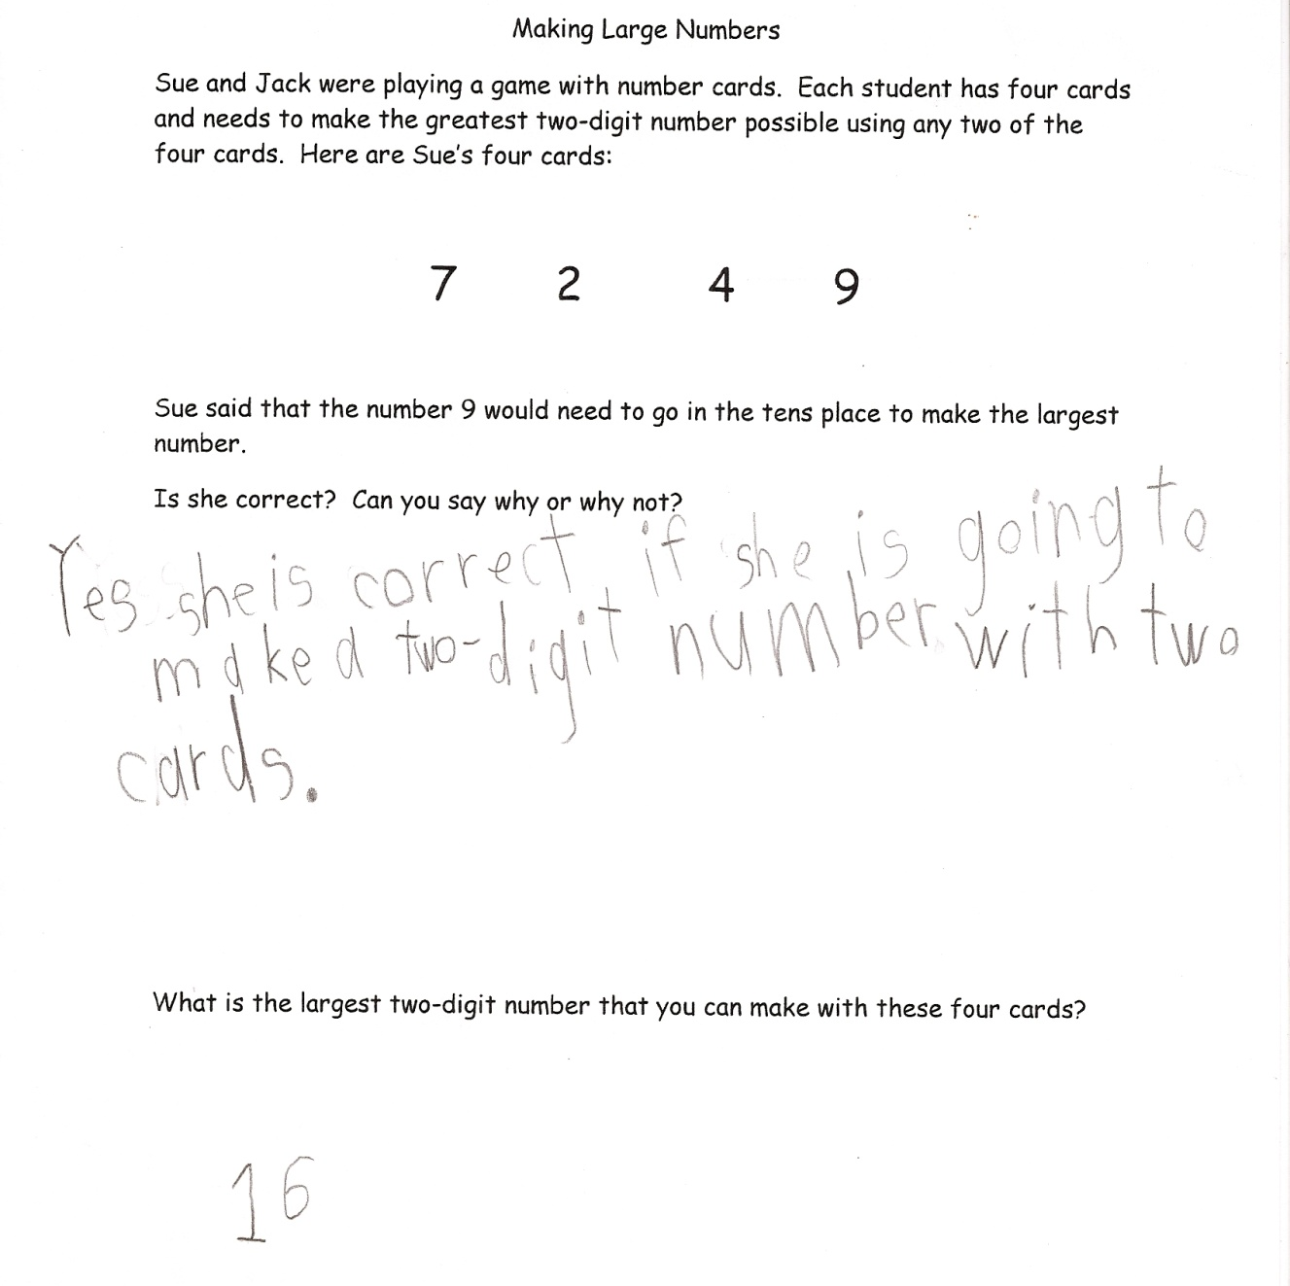

Student Work Analysis
Problem: Making Large Numbers Grade Level: 1

Student D

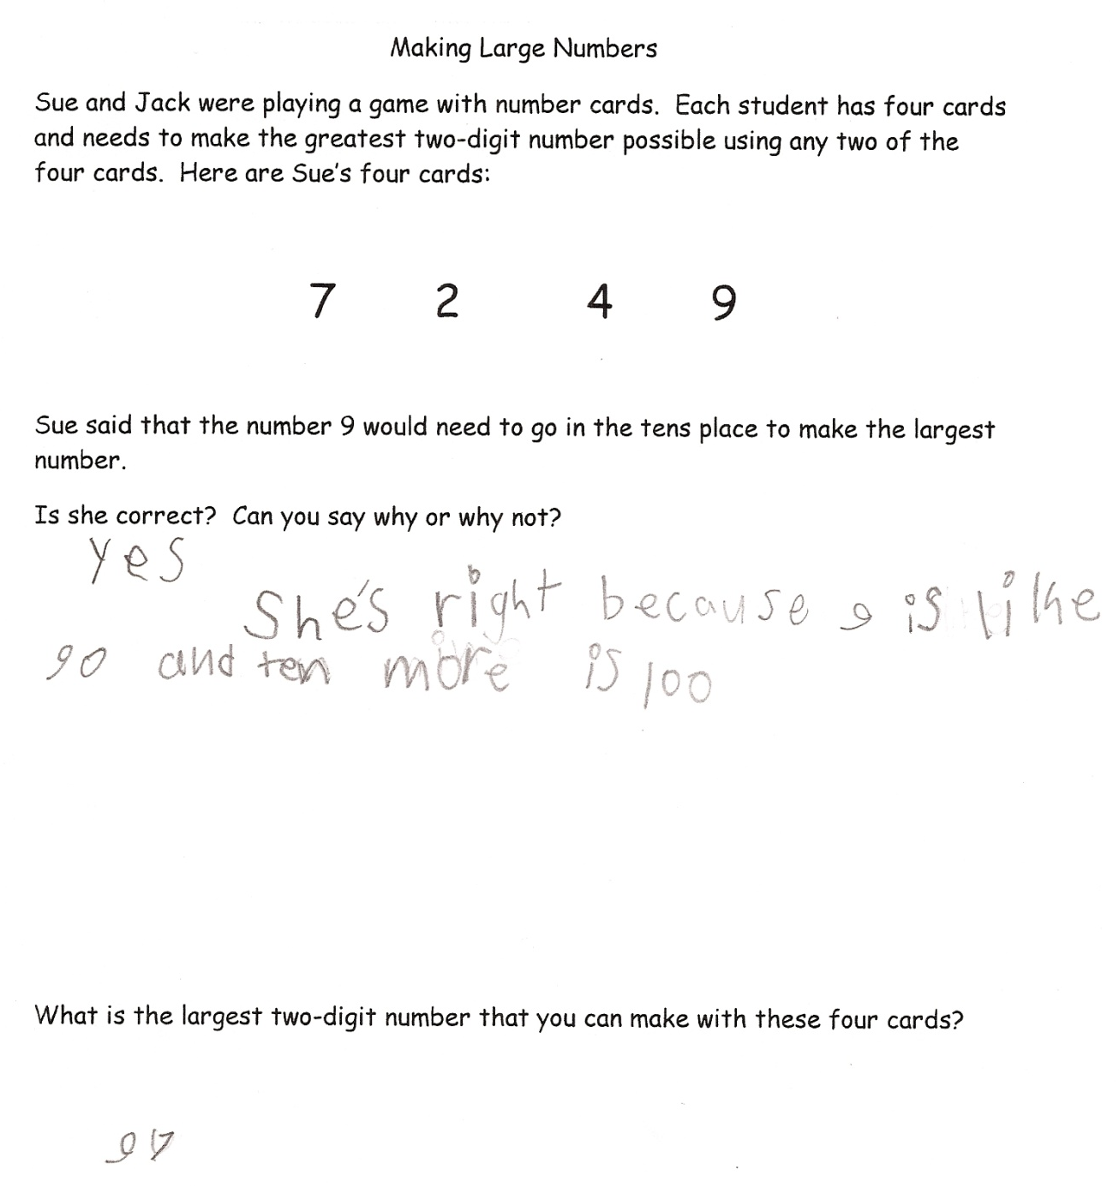
Student Work Analysis for: Making Large Numbers

Student | How does the student connect cardinality and place value? | In what ways does the student compare quantities in the problem? | What do you value mathematically in the student’s work? | What would be your next steps to further develop this students’ understanding of NBT?
A
B

C

D

