Mathematics Learning Community

Number Sense
Session 3

Title: Working with Addition

Common Core State Standards Addressed in the LASW Problem:
2.OA.1 | Use addition and subtraction within 100 to solve one- and two-step word problems involving situations of adding to, taking from, putting together, taking apart, and comparing, with unknowns in all positions, e.g., by using drawings and equations with a symbol for the unknown number to represent the problem.
2.NBT.5 | Fluently add and subtract within 100 using strategies based on place value, properties of operations, and/or the relationship between addition and subtraction.

Standards for Mathematical Practice Addressed in the MLC Session:
2: Reason abstractly and quantitatively. 4: Model with Mathematics.

When asked to compute mentally, one often relies on more intuitive ways to perform calculations than would otherwise occur with paper-and-pencil procedures. More often than not, the mental math strategies that emerge make use of place value and help to strengthen a person’s number sense and quantitative reasoning. The structure of the LASW problem requires students to interpret a situation represented as an equation and then model it with an appropriate story problem. In this way, much more can be assessed about the student’s understanding of addition.

Standards-Based Teaching and Learning Characteristics in Mathematics Addressed in the MLC Session:
- 5.1 Depth of content knowledge is evident throughout the presentation of the lesson.
- 5.2 Through the use of probing questions and student responses, decisions are made about what direction to take, what to emphasize, and what to extend in order to build students’ mathematical understanding.
- 5.3 Students’ prior knowledge is incorporated as new mathematical concepts are introduced.
- 5.4 Student misconceptions are anticipated /identified and addressed.
- 5.5 Classroom strategies incorporate multiple forms of representation.

Session Agenda:
Part I: Mathematical Background

Part II: Math Metacognition

Part III: Looking at Student Work
- 18 + ? = 72 Problem (Grade 2)

Part IV: Our Learning

Part V: Feedback and Wrap-up

Materials Needed for this Session:
- Nametags | - Chart paper and markers | - Copies of handouts
- Index cards | - Refreshments | - Highlighters

Possible Ways to Personalize this Session:
- If time allows, explore the notion of multiple representations.
- If your group is interested in learning more about different word problem types, refer to Part V for an extension activity using the “Common Addition and Subtraction Situations” found on Page 8.
- Consider having a discussion about the properties of operations and equality during either Part I or the “Making Connections across the Grade Levels” piece of Part IV.
- If time is short, pose a question about these properties for your Exit Card.
Part I: Mathematical Background
Approximate Time: 20 minutes
Grouping: Whole Group

- Welcome members of your group to the Math Learning Community.

- Remind group of established norms.

- Today’s Content:
  - The mathematics during this session focuses on addition.
  - What is addition?
  - What do we need to know in order to add?
  - Chart ideas to refer to during the Protocol for LASW.

D. Relating Content to the Three C’s Theme:
- Placing mathematics into an appropriate context helps students build meaning as they develop their mathematical understanding. In addition, context can also provide a much needed visual, especially useful for English Language Learners and visual learners.
- Problem context may affect problem solving strategy. In the real world, we never solve problems involving ‘naked’ numbers.
- Context also helps us to count. Context will help us to come up with an organized, efficient meaningful way to count. Adding like denominators is similar to adding like terms in algebra.

Part II: Math Metacognition
Approximate Time: 15 minutes
Grouping: Whole Group

- Initialize group thinking with this prompt: Think about a time when you took something apart and put it back together. What did you do? Why did you put it back together the way you did? What happened? Why did you take this thing apart in the first place?

- Present the group with the following problems, one at a time, on chart paper or on the board. Have them solve the problems MENTALLY – no paper or pencil. After time is given for participants to think about each problem individually, elicit strategies from the group and chart them to refer to during future sessions.

78 + 43 = ?
192 = 67 + ?

- Refer to strategy names (See Page 4). Often we think that there are countless ways to solve problems, but giving a name to a particular strategy helps to identify that there may be many different ways to approach a problem, but that often the same strategy is being employed.

- Solutions: 121, 125

- Problem Intent: (Note: The problem intent for all Math Metacognition problems is the same). See Session 2 for more information.

- Bring discussion back to initial prompt about putting things together and taking them apart.
  - How does this relate to working with these math problems?
  - What thought processes were you using when solving these problems?
  - How can metacognition help promote successful problem solving with your own students?

Addition Strategies

Starting with one number and adding on the other number in parts

(43 = 40 + 3)
78 + 40 = 118
118 + 3 = 121

(43 = 10 + 10 + 10 + 10 + 3)
78 + 10 = 88
88 + 10 = 98
98 + 10 = 108
108 + 10 = 118
118 + 3 = 121

Compensating to make tens

78 + 2 = 80
80 + 43 = 123
123 – 2 = 121

Adding by place (starting with the largest place value)

70 + 40 = 110
8 + 3 = 11
110 + 11 = 121

Making an equivalent problem

78 + 2 = 80
43 - 2 = 41
80 + 41 = 121

Part III: Looking at Student Work (LASW)
Approximate Time: 50 minutes
Grouping: Refer to protocol

- Problem Introduction: The problem and student work used for this session are from Grade 2. Complete the MLC Protocol with the group.

- Problem:
Write a story problem for this number sentence: 18 + _____ = 72

- Solution: 54 is the missing addend. A possible story problem is: I have 18 shells. Sam has 72 shells. How many more shells do I need to have the same number of shells as Sam?

- Problem Intent: Even though this type of addition problem is a join situation where the change is unknown, historically we have seen that students see the two numbers and join the two quantities. Any strategy they use to find the correct answer to the problem is what we want to look at. That mathematical idea is embedded in this task - having the students create a situation that would lead to the representation of that change. (Note: For additional information on word problem types, refer to the “Common Addition and Subtraction Situations” chart on page 8. This information is presented in Table 1 of the CCSS.)

- Examine how students are solving the problem:
  - By counting
  - Using an addition strategy
  - Using a subtraction strategy (Note: Subtraction will be formally discussed in Sessions 4 and 5).

- Misconceptions & Questions That May Arise:
  - M: Many students see the addition sign and two quantities and will automatically combine them. In this particular problem, do students know enough to realize that they are not meant to join the 18 and the 72?
  - Q: Addition is more than just counting one quantity, counting the other quantity and counting the two together. Are students just counting or do they understand addition? What do you see as evidence of understanding?
  - Q: How are they seeing that unknown quantity, that change between 18 and 72?
  - Q: Do they understand how to work with the unknown quantity in the number sentence? (Note: More discussion about this idea will take place in Session 4).
  - Q: Do students realize the relationship between subtraction and addition? (i.e., a story problem situation might separate 18 from 72, with the resulting difference being 54).
  - Q: Do they write a story problem about the two addends rather than the given addend and the sum? If so, what does this mean, in terms of their mathematical understanding?

Part IV: Our Learning
Approximate Time: 20 Minutes
Grouping: Whole Group

- Discussion: After evidence of student understanding has been discussed as a whole group, you want to facilitate discussion around how the LASW process will impact what teachers do within their classrooms. Some questions to help guide discussion include:
- What do we take away after LASW?
- What did we learn? About student thinking? About our own knowledge?
  - Refer back to chart made at the beginning of the session
- How does today’s session relate to important mathematical content and pedagogy?
- How does it impact your practice at your grade level? (Note: In order to help teachers connect this session to the mathematics within their own grade level, refer to the information below).

Making Connections Across the Grade Levels

K – 2: The LASW problem is adapted from a Grade 2 curriculum and specifically addresses 2.OA.1 and 2.NBT.5. In order to be able to add flexibly and fluently, students must first begin by understanding counting and learning how to work with various quantities (K.CC.4, K.CC.5) along with the foundation of solving addition problems(K.OA.1, K.OA.2, 1.OA.1, 1.OA.5, 1.OA.6).

3 – 5: Various math concepts and skills tied to addition are developed during this grade band, including but not limited to: adding larger quantities (3.NBT.2); solving problems using all four operations (3.OA.8, 4.OA.3); explaining number patterns using properties (3.OA.9); and adding fluently using the standard algorithm (4.NBT.4).

6 – 8: Connect the LASW problem to solving algebraic equations (i.e., 18 + x = 72). What properties are used to solve equations? (6.EE.1, 6.EE.2a-c, 6.EE.3, 6.EE.4, 6.EE.5, 6.EE.6, 7.EE.1, 7.EE.2, 7.EE.3, 7.EE.4a, 8.EE.7a-b, 8.EE.8a-c) NOTE: Refer to the properties of operations and properties of equality (Tables 3 and 4 of the CCSS) that can be found on Page 9).
How are these ideas connected to computation done in early elementary school?

- Writing a Problem or a Task: As a way to synthesize learning from today’s session, ask MLC members to come up with a math problem or task that would embody the ideas discussed today. The problem should be appropriate to use at their grade level. Writing these problems will help both you as the facilitator and the other group members to develop a stronger sense of how these mathematical ideas show up in classrooms from grades K – 8. (Note: See Part IV in Session 1 for more details).

Part V: Feedback & Wrap-up
Approximate Time: 5 Minutes
Grouping: Individual

- Closing: Close the session with a message such as: “Hope you leave here with more questions – about student thinking, about your teaching, and ways that we as a group can help support one another.” Have MLC members keep in mind the following: Dialogue, Reflection, and Inquiry are the keys to successful learning.

- Exit Cards: Pass out exit cards for group members and ask them to provide some feedback to you as the facilitator. Select one or two questions from the list below to help them summarize their thinking about the mathematics from today’s session. Collect exit cards so that a summary can be shared at the next session.

Feedback / Exit Card Questions

- How does the mathematics that we explored connect to your own teaching?

- How do I see what we’ve done today relate to key mathematical ideas or pedagogical content knowledge?

- What idea or discussion topic did you find most interesting from today’s session. Why?

- How was this session for you as a learner?

- What ideas were highlighted for you in today’s session that you had not previously considered?

- What are you taking away from today’s session?

- Extension: Use the “Common Addition and Subtraction Situations” found on page 8 to extend the thinking of this session. Have MLC members work through the problems presented in one of the following ways:
  - Write a number sentence that models each problem. Act out each problem using manipulatives. How do these problems surface ideas about multiple representations of both addition and subtraction?
  - Individually cut out the word problems and try to match each one up to its problem type. Why would knowledge of these problem types be important to know and understand?

Related Student Discourse Video Clip – LASW Problem

Children’s Mathematics: CGI, Disc 2: Grade 2
Problem: 47 trees in total. 31 are oak, the rest are hickory. How many are hickory?

Session Reference

Children’s Mathematics: Cognitively Guided Instruction
by T. Carpenter, et. al., Heinemann/NCTM, 1999

Common Addition and Subtraction Situations (Table 1 of CCSS)

 | Result Unknown | Change Unknown | Start Unknown
Add to | Two bunnies sat on the grass. Three more bunnies hopped there. How many bunnies are on the grass now?  2 + 3 = ? | Two bunnies were sitting on the grass. Some more bunnies hopped there. Then there were five bunnies. How many bunnies hopped over to the first two?  2 + ? = 5 | Some bunnies were sitting on the grass. Three more bunnies hopped there. Then there were five bunnies. How many bunnies were on the grass before?  ? + 3 = 5
Take from | Five apples were on the table. I ate two apples. How many apples are on the table now?  5 – 2 = ? | Five apples were on the table. I ate some apples. Then there were three apples. How many apples did I eat?  5 – ? = 3 | Some apples were on the table. I ate two apples. Then there were three apples. How many apples were on the table before?  ? – 2 = 3
 | Total Unknown | Addend Unknown | Both Addends Unknown
Put Together/ Take Apart | Three red apples and two green apples are on the table. How many apples are on the table?  3 + 2 = ? | Five apples are on the table. Three are red and the rest are green. How many apples are green?  3 + ? = 5, 5 – 3 = ? | Grandma has five flowers. How many can she put in her red vase and how many in her blue vase?  5 = 0 + 5, 5 = 5 + 0  5 = 1 + 4, 5 = 4 + 1  5 = 2 + 3, 5 = 3 + 2
 | Difference Unknown | Bigger Unknown | Smaller Unknown
Compare | (“How many more?” version):  Lucy has two apples. Julie has five apples. How many more apples does Julie have than Lucy?  (“How many fewer?” version):  Lucy has two apples. Julie has five apples. How many fewer apples does Lucy have than Julie?  2 + ? = 5, 5 – 2 = ? | (Version with “more”):  Julie has three more apples than Lucy. Lucy has two apples. How many apples does Julie have?  (Version with “fewer”):  Lucy has 3 fewer apples than Julie. Lucy has two apples. How many apples does Julie have?  2 + 3 = ?, 3 + 2 = ? | (Version with “more”):  Julie has three more apples than Lucy. Julie has five apples. How many apples does Lucy have?  (Version with “fewer”):  Lucy has 3 fewer apples than Julie. Julie has five apples. How many apples does Lucy have?  5 – 3 = ?, ? + 3 = 5
Properties of Operations (Table 3 of CCSS)
Here a, b and c stand for arbitrary numbers in a given number system. The properties of operations apply to the rational number system, the real number system, and the complex number system.
Associative property of addition  Commutative property of addition  Additive identity property of 0  Existence of additive inverses  Associative property of multiplication  Commutative property of multiplication  Multiplicative identity property of 1  Existence of multiplicative inverses  Distributive property of multiplication  over addition | (a + b) + c = a + (b + c)  a + b = b + a  a + 0 = 0 + a = a  For every a there exists –a so that a + (–a) = (–a) + a = 0.  (a × b) × c = a × (b × c)  a × b = b × a  a × 1 = 1 × a = a  For every a ≠ 0 there exists 1/a so that a × 1/a = 1/a × a = 1.  a × (b + c) = a × b + a × c

Properties of equality (Table 4 of CCSS)
Here a, b and c stand for arbitrary numbers in the rational, real, or complex number systems.
Reflexive property of equality  Symmetric property of equality  Transitive property of equality  Addition property of equality  Subtraction property of equality  Multiplication property of equality  Division property of equality  Substitution property of equality | a = a  If a = b, then b = a.  If a = b and b = c, then a = c.  If a = b, then a + c = b + c.  If a = b, then a – c = b – c.  If a = b, then a × c = b × c.  If a = b and c ≠ 0, then a ÷ c = b ÷ c.  If a = b, then b may be substituted for a  in any expression containing a.

Math Metacognition

78 + 43 = ?

192 = 67 + ?

LASW Problem

Write a story problem for this number sentence:
18 + _____ = 72

Student Work Analysis

Problem: 18 + ? = 72 Grade Level: 2

Student A
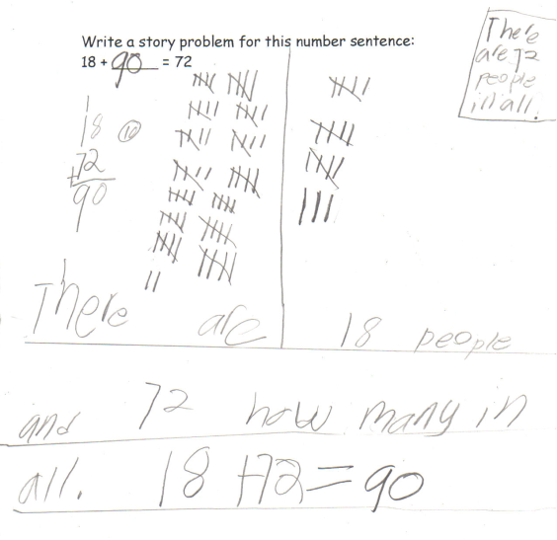

Student Work Analysis

Problem: 18 + ? = 72 Grade Level: 2

Student B
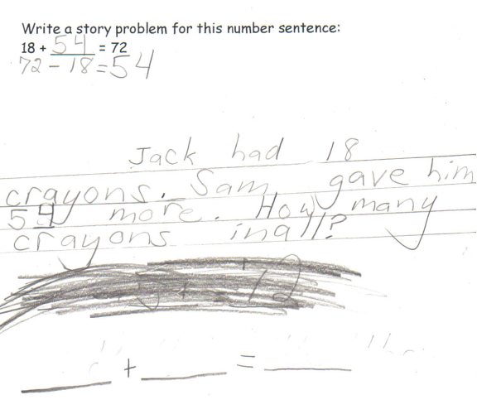

Student Work Analysis

Problem: 18 + ? = 72 Grade Level: 2

Student C
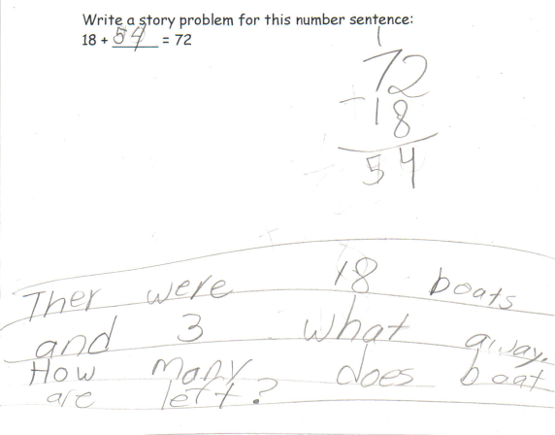
Student Work Analysis

Problem: 18 + ? = 72 Grade Level: 2

Student D
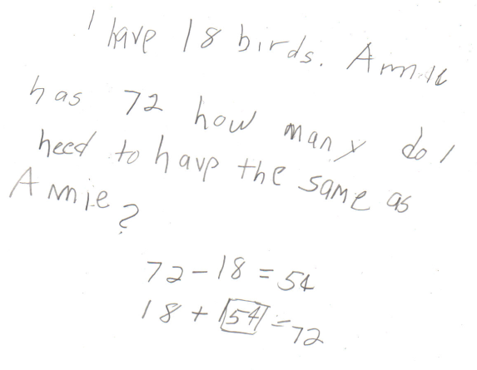

Student Work Analysis Grid for: 18 + ? = 72

Student | What method(s) are used to determine the solution? | Does the story problem match the given number sentence? If not, what implications are there for this? | What do you value mathematically in the student’s work? | What evidence is there of the student’s understanding of addition?
A
B

C

D

Adapted from Box 2-4 of Mathematics Learning in Early Childhood, National Research Council (2009, pp. 32, 33).
These take apart situations can be used to show all the decompositions of a given number. The associated equations, which have the total on the left of the equal sign, help children understand that the = sign does not always mean makes or results in but always does mean is the same number as.
Either addend can be unknown, so there are three variations of these problem situations. Both Addends Unknown is a productive extension of this basic situation especially for small numbers less than or equal to 10.
For the Bigger Unknown or Smaller Unknown situations, one version directs the correct operation (the version using more for the bigger unknown and using less for the smaller unknown). The other versions are more difficult.

