Mathematics Learning Community

Number Sense
Session 7

Title: The Distributive Property

Common Core State Standards Addressed in the LASW Problem:
7.EE.3 | Solve multi-step real-world and mathematical problems posed with positive and negative rational numbers in any form (whole numbers, fractions, and decimals), using tools strategically. Apply properties of operations to calculate with numbers in any form; convert between forms as appropriate; and assess the reasonableness of answers using mental computation and estimation strategies.

Standards for Mathematical Practice Addressed in the MLC Session:
4: Model with Mathematics. 7: Look for and make use of structure.

Multiplication makes up the mathematical content of this session with a special focus on the numerical properties (associative, commutative, and especially distributive) that, when combined with place value, allow for the more intuitive ways to reason about quantities. During Math Metacognition, teachers are asked to analyze the mental math strategies used by the group in order to identify a structure or pattern in the computation – and see how one of the properties listed above is used. In the LASW problem, students have to take a numerical expression and model it with a story problem. Through this modeling, students’ understanding of the distributive property comes to light.

Standards-Based Teaching and Learning Characteristics in Mathematics Addressed in the MLC Session:
- 5.1 Depth of content knowledge is evident throughout the presentation of the lesson.
- 5.2 Through the use of probing questions and student responses, decisions are made about what direction to take, what to emphasize, and what to extend in order to build students’ mathematical understanding.
- 5.3 Students’ prior knowledge is incorporated as new mathematical concepts are introduced.
- 5.4 Student misconceptions are anticipated /identified and addressed.
- 5.5 Classroom strategies incorporate multiple forms of representation.

Session Agenda
Part I: Mathematical Background

Part II: Math Metacognition

Part III: Looking at Student Work
- (20 + 4)(30 + 5) Problem (Grade 7)

Part IV: Our Learning

Part V: Feedback and Wrap-up

Materials Needed for this Session:
- Nametags | - Chart paper and markers | - Copies of handouts
- Index cards | - Refreshments

Possible Ways to Personalize this Session
- Surfacing group member’s ideas about the distributive property may take a bit longer in this session. The ideas that you will want to be listening for will surface as you begin the conversation during Part II. If needed, adjust the times to make this longer and push to stay on task with the remainder of the session.
- Five student work samples are provided for Part III. However, members of your group may be interested in providing some samples of their own student work. See Page 5 in Part III for more details.
- The conversation regarding multiple grade level connections and teacher learning may take place in the context of other parts of this session. If so, you may choose to omit Part IV.
- Two Guiding Questions are provided in the Student Work Analysis Grid – the other two can be selected by you or by the group.

Part I: Mathematical Background
Approximate Time: 10 minutes; (Note: Move through this quickly since this session is a continuation of Session 6).
Grouping: Whole Group

- Welcome members of your group to the Math Learning Community.

- Remind group of established norms.

- Today’s Content:
  - The mathematics during this session focuses on multiplication, in particular on the distributive property.

Distributive Property: For any numbers a, b, and c:
a * (b + c) = a * b + a * c

  - What do we need to know in order to be able to multiply fluently?
  - Build upon ideas discussed in Session 6. You may want to pull out any notes charted during this session.
  - Understanding of content is crucial so you will need the time to dig deep here. It is important for MLC members to understand the development of this concept and the relationship that it has to algebra. Also, it is important to begin to have more of an in-depth conversation regarding pedagogy and ways that classroom practice can shift so that students make connections to the ideas about multiplication and algebraic thinking.
  - We want to think of how can we begin to look at the continuum of learning through student work that needs to happen so that this concept is built overtime for long and sustainable learning. More specifically, we want to consider how we can assure that students have made the connections between what they know about numbers and operations and early algebra. What needs to happen at every grade level to ensure that these connections are made?

- Relating Content to the Three C’s Theme:
  - How do the ways in which students learn to multiply relate to the ways in which they count?
  - Now, move from counting to thinking of composition and context. How do the strategies that students use to multiply fluently relate to the ways in which they compose and decompose numbers? What about context for multiplication? As adults how often do we use multiplication strategies in our daily lives?
  - What about estimation and multiplication? What do we need to know when we estimate using multiplication?

Part II: Math Metacognition
Approximate Time: 25 minutes
Grouping: Whole Group

- Present the following two problems to the group. As they work, ask them to think about the ideas that they rely on to make their mental calculations

39 x 22

325 x 12

- Solution: 39 x 22 = 858, 325 x 12 = 3900. It is important to ask the group members what ideas about number composition helped them make their mental calculations. You will also want to call attention to the strategies that use the distributive property. You may ask the question: “How does composition of number ‘foundationalize’ more formal ideas about the distributive property?”

- Problem Intent: Note: The problem intent for all Math Metacognition problems is the same. See Session 2 for more information. In addition, another intent of this particular problem is not only to surface strategies but also to begin to discuss the distributive property and the important role it plays in mathematics.

- Discuss all strategies: Here you may want to discuss binomial multiplication if it comes up, or you may want to ask someone to hold the idea until after Part III.

- Discuss the following with the group: What understanding(s) did we make use of in order to solve this problem?

Part III: Looking at Student Work (LASW)
Approximate Time: 50 minutes
Grouping: Refer to protocol

- Complete the MLC Protocol with the group.

- Problem: The problem used for this session is appropriate for Grade 7.

(20 + 4)(30 + 5)
Write a word problem that represents this expression.
Solve the problem and show your work.

- Solution: 840. This is the same as double-digit multiplication 24 x 35. (See Page 6 for Sample Word Problems).

- Problem Intent: This problem is presented in this format to see whether students are beginning to develop an understanding of the distributive property and its relationship to double-digit multiplication. Another intent of this problem is to build in time for the MLC to discuss grade-level implications for pedagogy and the teaching of these ideas.

- Discuss the word problems that group members have written, along with strategies for solving the computation problem. (See Page 6 for Problem Solving Strategies).

- Discuss the following mathematical ideas:
  - This problem has implications for one of the foundational skills of algebra (binomial multiplication (Note: Some people refer to this as FOIL)). Double-digit multiplication and the distributive property modeled as area both represent the same mathematical idea. (For more information, see “Distributive Property – Connecting Number & Algebra” on Page 7).
  - Algebra tiles can be used to show the connection between the distributive property, binomial multiplication, double-digit multiplication, partial products, and the area or array model of multiplication. Try some examples together as a group.
  - The expanded notation of 24 x 35 is (20 + 4) (30 + 5). By representing the problem in this way, we can see how students interpret the numbers in this form in their word problem. Are we seeing evidence in their work of their understanding of the distributive property? If so, we can begin to push the level of cognitive demand of the students so that their foundation of algebra is established?
  - Many students continue to move in and out of their understanding of the concepts and skills involved with multiplication, which is evident when their representations (number expressions, story problems) do not match.
  - This problem also brings up the need for careful labeling and using correct units within problems. Many students’ products do not represent the correct units based on their story contexts.

Part III: Looking at Student Work (LASW), continued

- Misconceptions/Questions that May Arise:
  - M: Sum and product are not the same mathematical idea and are not interchangeable. It is important to consider the unit of the quantities within the story problem.
  - M: “What would the product be?” is not an appropriate way to interpret a product within a problem context.
  - Q: Why would the problem be represented as (20+4)(30+5) vs. 24*35. What happens when the problem context doesn’t reflect this?
  - Q: Do 7th and 8th grade students, if already learning algebra, make connections between algebraic properties and related number properties that they learned in elementary school?

Options for Customization

- Sample Guiding Questions:
  - Two Guiding Questions have been provided in the Student Work Analysis Grid for this problem. As a way to customize the LASW process, you, as the facilitator, may want to consider selecting the remaining two questions from the list below. Your group may also be interested in selecting the questions to guide discussion.

Specific Questions:
- What evidence of understanding of multiplication is present in the work?
- How do students negotiate the (20 + 4) and the (30 + 5) in their math solutions? In their story problems?

Generic Questions:
- Did the students label their work?*
- What question could you ask the student to further probe his/her thinking?*
- Where did his/her strategy unravel?*
- What do these pieces of work have in common? What similarities do you see? What differences?
- Were there similarities amongst successful work? Unsuccessful work?*
- What shows mathematical merit in the student’s work?*
- Do students justify their reasoning using numbers and/or words? Do they make any other arguments?*
- What aspects about the student’s approach are most interesting or surprising?*
- What misconceptions are common to all or most solutions?
- Did the student answer the correct question? If not, what question was the student answering?
- What is missing from this student’s response? What piece(s) of information could make this response better?
*Adapted from “Guidelines for Learning from Student Work”

- Using A Group Member’s Student Work:
  - Prior to offering this session to your MLC, you would need to collect student work samples for the task: (20 + 4) (30 + 5).
  - When asking group members to collect student work samples, have them collect at least 10 - 20 samples. Remind them that you are asking them to use this, or any other MLC problem, as a formative assessment, rather than as a part of a math lesson. Ask the students to avoid putting their names on the work. Have the group member then submit the samples to you, and you can select 4 samples to discuss during the MLC session. Prior to photocopying samples, mark them as A, B, C, and D.

Sample Word Problems

I have 20 friends and 4 family members attending a business meeting. Each person is getting $30 for attending and $5 for filling out a survey. How much money will I need to pay out?

I have a pool in my backyard that is surrounded by a garden on two sides. How much space does my pool/garden area take up?
 | 30’ | 5’
20’ | POOL | G  A  R  D  E  N
4’ | G A R D E | N

I have a field that is 24 feet long and 35 feet wide. How large is my field?

I have 24 baskets and 35 flowers in each basket. How many flowers do I have?

Sample Problem Solving Strategies

 | 30 | 5
20 | 6  0  0 | 1  0  0
4 | 120 | 20
Area model
Traditional algorithm
24
x 35
120
+ 720
840

Partial products (distributive property)
20 x 30 = 600
20 x 5 = 100
4 x 30 = 120
4 x 5 = 20
600 + 100 + 120 + 20 = 840

Distributive Property – Connecting Numbers & Symbolic Algebra

Example: (X + 3)(X + 2)
X 3
X | X² | 3X
2 | 2X | 2*3

After combining like terms we end up with the expression:
X² + 5x + 6
(Note: when using Algebra tiles, like terms will have the same shape!)

Now, substitute X=10
(10 + 3) (10 + 2)

Firsts | 10 x 10
Outers | 10 x 2
Inners | 3 x 10
Lasts | 3 x 2

10 3
10 | 10² | 3*10
2 | 2*10 | 2*3

Solution: 100 + 30 + 20 + 6 = 156

13 X 12 = 156

Expanded Notation: 13
x 12
6 (2x3)
20 (2x10)
30 (10 x 3)
100 (10 x 10)

Part IV: Our Learning
Approximate Time: 20 Minutes
Grouping: Whole Group

- Discussion: After evidence of student understanding has been discussed as a whole group, you want to facilitate discussion around how the LASW process will impact what teachers do within their classrooms. Some questions to help guide discussion include:
  - What do we take away after LASW?
  - What did we learn? About student thinking? About our own knowledge?
    - Refer back to chart made at the beginning of the session
  - How does today’s session relate to important mathematical content and pedagogy?
  - How does it impact my practice at my grade level? (Note: In order to help teachers connect this session to the mathematics within their own grade level refer to the information below).

Making Connections Across the Grade Levels

K – 2: Work with multiplication naturally follows from addition – as students look for more efficient ways to add, they realize they can add in groups, skip count, and the like. The concept of multiplication develops from these early strategies (K.CC.1, 1.OA.5, 1.NBT.4, 1.NBT.5, 1.NBT.6, 2.OA.3, 2.OA.4, 2.NBT.2).

3 – 5: Multiplication as both a concept and a skill are developed during upper elementary school. In addition, properties of operations are formally introduced and applied (3.OA.1, 3.OA.3, 3.OA.4, 3.OA.5, 3.OA.7, 3.OA.8, 3.NBT.3, 4.OA.1, 4.OA.2, 4.OA.3, 4.OA.4, 4.NBT.5, MA.4.NBT.5a, 5.NBT.5) Use of parentheses in numerical expressions is also a skill that is taught at this time (5.OA.1).

6 – 8: The LASW problem is appropriate for this grade band to explore and specifically addresses learning standard 7.EE.3. See also the notes on binomial multiplication on Page 7. How are these ideas connected to computation done in early elementary school? Students should eventually be able to connect double-digit multiplication to binomial multiplication – both use the distributive property twice. (6.NS.3, 6.NS.4, 7.NS.2a and c, 7.NS.3) In addition, work with numerical expressions (simplifying, generating equivalent expressions, etc.) is mastered (6.EE.1, 6.EE.2 a – c, 6.EE.3, 6.EE.4, 7.EE.1, 7.EE.2, 8.EE.1).

- Writing a Problem or a Task: As a way to synthesize learning from today’s session, ask MLC members to come up with a math problem or task that would embody the ideas discussed today. The problem should be appropriate to use at their grade level. Writing these problems will help both you as the facilitator and the other group members to develop a stronger sense of how these mathematical ideas show up in classrooms from grades K – 8. (Note: See Part IV in Session 1 for more details).
Part V: Feedback & Wrap-up
Approximate Time: 5 Minutes
Grouping: Individual

- Closing: Close the session with a message such as: “Hope you leave here with more questions – about student thinking, about your teaching, and ways that we as a group can help support one another.” Have group members keep in mind the following: Dialogue, Reflection, and Inquiry are the keys to successful learning.

- Exit Cards: Pass out exit cards for group members and ask them to provide some feedback to you as the facilitator. Select one or two questions from the list below to help them summarize their thinking about the mathematics from today’s session. Collect exit cards so that a summary can be shared at the next session.
Feedback / Exit Card Questions

- How does the mathematics that we explored connect to your own teaching?

- How do I see what we’ve done today relate to key mathematical ideas or pedagogical content knowledge?

- What idea or discussion topic did you find most interesting from today’s session. Why?

- How was this session for you as a learner?

- What ideas were highlighted for you in today’s session that you had not previously considered?

- What are you taking away from today’s session?

Related Student Discourse Video Clips – LASW Problem

Developing Mathematical Ideas: BST, Session 5 Video: Multiplication
Students: Thomas B., Thomas H., Jemea

Developing Mathematical Ideas: MMO, Session 3 Video: Mult./Division
Problem: How many legs on three elephants?

Relearning to Teach Arithmetic, Session 4, Tape 1
Students: Thomas B., Thomas H

Session References

- Developing Mathematical Ideas: “Number and Operations, Part 1: Building a System of Tens,” by D. Schifter, V. Bastable, and S. Russell, Dale Seymour Publications, 1999.

- Developing Mathematical Ideas: “Number and Operations, Part 2: Making Meaning for Operations,” by D. Schifter, V. Bastable, and S. Russell, Dale Seymour Publications, 1999.

- Relearning to Teach Arithmetic: Addition and Subtraction Guide, Dale Seymour Publications, 1999.

- *“Guidelines for Learning from Student Work” Horace, November, 1996, p. 2, www.lasw.org/guidelines.html

Math Metacognition

39 x 22

325 x 12

LASW Problem

(20 + 4)(30 + 5)

Write a word problem that represents this expression. Solve the problem and show your work.

Student Work Analysis
Problem: (20 + 4) (30 + 5) Grade Level: 7

Student A
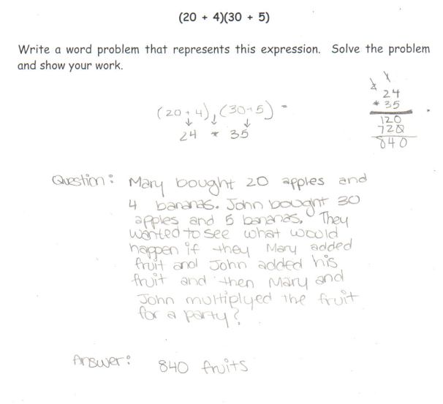

Student Work Analysis
Problem: (20 + 4) (30 + 5) Grade Level: 7

Student B
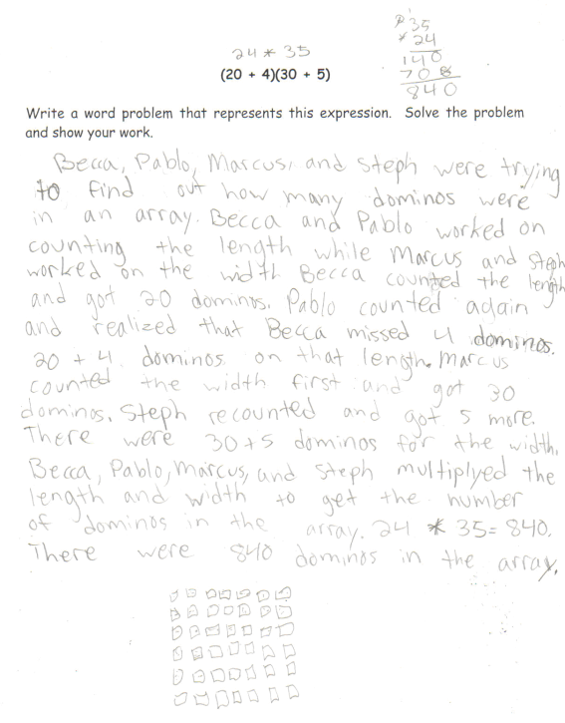

Student Work Analysis
Problem: (20 + 4) (30 + 5) Grade Level: 7

Student C
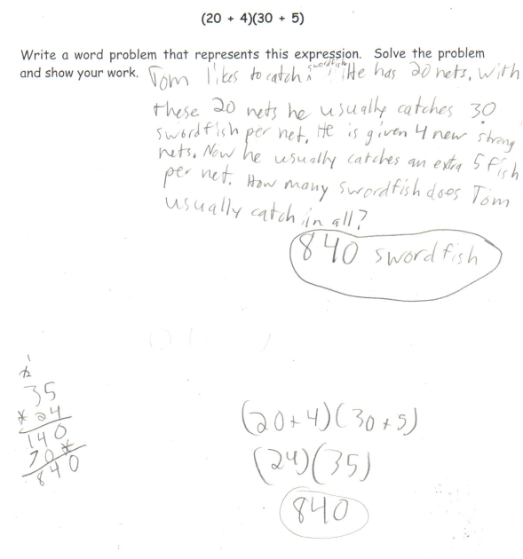

Student Work Analysis
Problem: (20 + 4) (30 + 5) Grade Level: 7

Student D
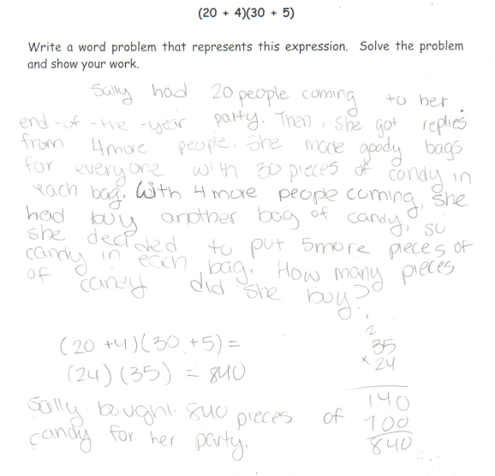
Student Work Analysis for: (20 + 4)(30 + 5)

Student | What method(s) are used to find the solution to the problem? | What is the evidence of the student’s incomplete thinking?
A
B

C

D

