Mathematics Learning Community

Number Sense
Session 9

Title: Partitive and Quotative Division

Common Core State Standards Addressed in the LASW Problem:
5.NBT.6 | Find whole-number quotients of whole numbers with up to four-digit dividends and two-digit divisors, using strategies based on place value, the properties of operations, and/or the relationship between multiplication and division. Illustrate and explain the calculation by using equations, rectangular arrays, and/or area models.

Standards for Mathematical Practice Addressed in the MLC Session:
2: Reason abstractly and quantitatively. 4: Model with Mathematics.

MLC members use linking cubes during Math Metacognition to reason about different types of actions involved in division situations. They connect the two models of these distinct actions (grouping and sharing) to division contexts. During the LASW problem, students provide both a numerical expression and a story problem to model a written statement involving division. As the MLC members analyze these different representations, the students’ understandings and misunderstandings of division are revealed.

Standards-Based Teaching and Learning Characteristics in Mathematics Addressed in the MLC Session:
- 5.1 Depth of content knowledge is evident throughout the presentation of the lesson.
- 5.2 Through the use of probing questions and student responses, decisions are made about what direction to take, what to emphasize, and what to extend in order to build students’ mathematical understanding.
- 5.3 Students’ prior knowledge is incorporated as new mathematical concepts are introduced.
- 5.4 Student misconceptions are anticipated /identified and addressed.
- 5.5 Classroom strategies incorporate multiple forms of representation.

Session Agenda:
Part I: Mathematical Background

Part II: Math Metacognition

Part III: Looking at Student Work
- Twenty Divided by Five (Grade 5)

Part IV: Our Learning

Part V: Feedback and Wrap-up

Materials Needed for this Session:
- Nametags | - Chart paper and markers | - Copies of handouts | - Colored cubes or counters (approx. 20 per person)
- Index cards | - Refreshments | - Highlighters

Possible Ways to Personalize this Session:
- Four student work samples are provided for the LASW problem in this session. However, members of your group may be interested in providing some samples of their own student work. See Page 5 in Part III for more details.
- Two Guiding Questions are provided in the Student Work Analysis Grid – the other two can be selected by you or by the group.
- If your group is interested in learning even more about different division word problem types, refer to Part II for an extension activity using the “Common Multiplication and Division Situations” found on Page 8 of Session 6.

Part I: Mathematical Background
Approximate Time: 20 minutes
Grouping: Whole Group

- Welcome members of your group to the Math Learning Community. Remind group of established norms.

- Today’s Content:
  - The mathematics during this session focuses on division and the two different types of division that exist.
  - There are two types of division problems – partitive and quotative.
    - Partitive (a.k.a. doling out, equal groups or sharing and distributing): partitive problems provide the total number of things and the number of groups. In a partitive division problem, the quotient represents the number of things in each group.
    - Quotative (a.k.a. grouping, measurement division, or repeated subtraction): Quotative problems provide the total number of objects to be divided and the number of objects in each group. In a quotative division problem, the quotient represents the number of groups. The traditional long division algorithm uses this idea.
  - It is not important for students to know the names of these two types of division. What is important is for students (and teachers) to recognize that for any given division number sentence, there are two types of actions that exist simultaneously and describe that same number sentence.
  - For example, 12 ÷ 3 = 4 can be thought of as both:
    - 12 grouped by 3’s – I have 4 groups.
    - 12 shared amongst 3 people – each gets 4 items.
  - Being able to think flexibly in this way will help in solving division problems.
  - What do we need to know in order to be able to divide fluently? How do the two types of division play a role in students’ understanding of the operation of division?
  - Chart ideas to refer to during the Protocol for LASW.

- Relating Content to the Three C’s Theme:
  - Counting connects to the partitive action of division, namely through the 1 – 1 correspondence when doling out items or objects one at a time.
  - Both of these division types are important to consider, especially when division is set within a context, as most real-world computation is.
  - Does the context of the problem match the division statement? Does the representation match the context? How do you work with students to get them to solidify these ideas? It is important for teachers to be able to identify and understand these ideas that students find so complex.

Part II: Math Metacognition
Approximate Time: 25 minutes
Grouping: Individual work
Sharing problems: whole group

- Group members should work on the following task:

15 ÷ 5 = 3

- Model the action in the problem above in two different ways.
- Write a word problem that represents each of the actions modeled.

- Pass out twenty or so colored cubes or counters so that group members can model the action.

- Have group members record their work on a half-sheet of chart paper with markers and post them around the room for discussion. If time allows, have them model their thinking with manipulatives for the group.

- Solution: Multiple responses to this problem are possible. Some example solutions include:

- “I set out 15 cubes. I wanted to share them amongst the five of us, so I doled out one at a time to each of the five people until all the cubes were used. And there were 3 cubes for each.” [Partitive: (counting by ones strategy)]

- Sally has 15 eggs and 5 baskets. How many eggs can she put in each basket? [(Doling out: You dole out 1 egg at a time per basket until all eggs are gone).]

- I set out 15 cubes. I knew I needed 5 in each group, so I counted groups by 5 and got 3 groups.” [Quotative (grouping)]

- Sally has 15 eggs and wants to put 5 eggs in each basket. How many baskets does she need? [(Grouping: counting by groups of 5 and then counting how many groups are made).]

- Problem Intent: (Note: The problem intent for all Math Metacognition problems is the same). See Session 2 for more information.

- A description, along with varied examples, of the different types of Division Situations can be found on page 8 of Session 6. For an extension of this topic, consider having your MLC complete (or revisit) the task described in Part III, F. in Session 6. Since these situations are fairly new to so many, a second look at this information may be helpful as teachers try to increase their own content knowledge around division and its relationship to multiplication.

- Points for Group Discussion:
  - As group members model their actions using manipulatives, be sure to include both types of actions:
    - Doling out the 15 cubes one at a time to 5 piles.
    - Grouping the 15 by piles of 5
  - Discuss with group members who thought of which action first. Would this always be the case with any division problem or is it problem specific? Initially, this problem occurs without a problem context. How do you think problem context influences which action you think of first?
  - What type of division do you see occur most often in classrooms? What limitations does this place on students when problem solving with division?
  - Do students rely on understandings from other operations when entering division problems (i.e., “I knew 3 + 3 + 3 + 3 + 3 = 15” or “I had 15 in my pile, and I did 15 – 3 – 3 – 3 – 3 – 3 = 0” Can they connect what they already know about addition, subtraction, and multiplication to understand what division really is?

Part III: Looking at Student Work (LASW)
Approximate Time: 50 minutes
Grouping: Refer to protocol

- Complete the MLC protocol with the group.

- Problem: The problem used for this session was given to students in Grade 5 to solve.

Twenty divided by 5 is 4.
- Represent this statement as a division problem.

- Write a word problem that models this division problem. Be sure to include labels for each of the three numbers.

- Draw a picture that models your word problem. Be sure to include labels in your picture.

- Solution: Multiple responses are possible. Some example word problems include:
I have 20 candies that I’d like to split equally amongst 5 friends. How many candies will each friend get?

Answer: 4 candies per friend
Farmer Brown had 20 chickens on his farm. He also had 5 pens for his chickens. How many chickens should evenly go into each pen?

Answer: 4 chickens
I need to cut a rectangular piece of fabric that will be 20 square inches. If the length of the rectangle is 5”, how wide should the rectangle be?

Answer: 4”

- Problem Intent: This problem brings up several interesting points for the group to ponder:
  - This problem involves three different representations (numerical, verbal, and pictorial). You want to discuss with your group how the examples in the student work bring up the places where their understanding of division becomes fragile. Consider the number problem, the written word problem, and the pictorial model that students create for this task: is there coherence amongst those three in the students’ work? Where is there a disconnect amongst the numbers, words, and pictures?
  - Most students represented this problem w/ partitive action-based word problems. Why do you think this is so?
  - At what point do we help students solidify their understanding of the traditional division algorithm so that all representations (numerical, verbal, and pictorial) match?

Part III: Looking at Student Work (LASW), continued

- Misconceptions/Questions that May Arise:
  - M: Many students represented (using numbers) 20÷4= 5 rather than 20÷5 =4. However, most of these students’ picture models correctly matched the word problem they had written.
  - Q: Do the three representations (numerical, verbal, and pictorial) match? If not, what does this mean?
  - Q: What is the evidence of student understanding of division when interpreting how a division problem would be represented as a word problem or as a picture model? In particular, do students recognize which of the numbers is the divisor? The dividend? The quotient?
  - Q: What is the prior knowledge that students use to enter a division problem? How do their strategies relate to our strategies discussed during the Math Metacognition?
  - Q: What would happen if you only asked students to complete #1 on the Twenty Divided by Five problem? How would this impact your assessment of their understanding of division? What implications does this have for teachers’ classroom practice?

Options for Customization

- Guiding Questions: Two Guiding Questions have been provided in the Student Work Analysis Grid for this problem. As a way to customize the LASW process, you (or your group) will need to decide on the remaining two questions. You can use the two questions listed below that are specific to this problem or refer to the list of generic questions found on Page 5 in Session 7.
  - Do the verbal and pictorial representations match the numerical? If so, how do you know? If not, what does this imply?
  - What evidence is there of the student’s understanding of division?

- Using A Group Member’s Student Work:
  - Prior to offering this session to your MLC, you would need to collect student work samples for the task: Twenty Divided by Five.
  - See Page 5 in Session 7 for more details on collecting student work samples. For this task, select 4 samples to discuss during the MLC session. Prior to photocopying samples, mark them as A, B, C, and D.

Part IV: Our Learning
Approximate Time: 20 Minutes
Grouping: Whole Group

- Discussion: After evidence of student understanding has been discussed as a whole group, you want to facilitate discussion around how the LASW process will impact what teachers do within their classrooms. Some questions to help guide discussion include:
- What do we take away after LASW?
- What did we learn? About student thinking? About our own knowledge?
  - Refer back to chart made at the beginning of the session
- How does today’s session relate to important mathematical content and pedagogy?
- How does it impact your practice at your grade level? (Note: In order to help teachers connect this session to the mathematics within their own grade level, refer to the information below).

Making Connections Across the Grade Levels

K – 2: Work with division naturally follows from students’ work with counting and with subtraction, along with their real-life experience fair sharing. The concept of division develops from these early experiences. In addition, students in this grade band also begin to have experiences writing their own story problems and modeling the action of an operation using manipulatives and then representing that action with pictures. (K.CC.6, K.OA.1, K.OA.2, 1.OA.3, 1.NBT.6, 2.OA.1, 2.OA.2, 2.NBT.5, 2.NBT.7)

3 – 5: Division as both a concept and a skill are developed during upper elementary school. In addition, translation amongst numbers, pictures, words, and physical models is further developed. The LASW problem is appropriate for this grade band to solve and specifically addresses learning standard 5.NBT.6 (3.OA.2, 3.OA.3, 3.OA.4, 3.OA.5, 3.OA.6, 3.OA.7, 3.OA.8, 4.OA.2, 4.OA.3, 4.NBT.6, 5.OA.2, 5.NBT.7, 5.NF.3, 5.NF.7 a – c).

6 – 8: Prior to moving to the symbolic representation, students must become fluent as they translate information presented in one representation to the others: numerical, pictorial, and verbal. Fluency with these representations will make the shift to the symbolic much easier for students entering Algebra I. In addition, division of fractions is conceptually difficult for students to grasp, especially if they can only interpret division as partitive. (6.NS.1, 6.NS.2, 6.NS.3, 6.EE.2 a – b, 7.NS.2b and c, 7.NS.3, 7.EE.2, 7.EE.3)

- Writing a Problem or a Task: As a way to synthesize learning from today’s session, ask MLC members to come up with a math problem or task that would embody the ideas discussed today. The problem should be appropriate to use at their grade level. Writing these problems will help both you as the facilitator and the other group members to develop a stronger sense of how these mathematical ideas show up in classrooms from grades K – 8. (Note: See Part IV in Session 1 for more details).

Part V: Feedback & Wrap-up
Approximate Time: 5 Minutes
Grouping: Individual

- Closing: Close the session with a message such as: “Hope you leave here with more questions – about student thinking, about your teaching, and ways that we as a group can help support one another.” Have group members keep in mind the following: Dialogue, Reflection, and Inquiry are the keys to successful learning.

- Exit Cards: Pass out exit cards for group members and ask them to provide some feedback to you as the facilitator. Select one or two questions from the list below to help them summarize their thinking about the mathematics from today’s session. Collect exit cards so that a summary can be shared during the next session.

Feedback / Exit Card Questions

- How does the mathematics that we explored connect to your own teaching?

- How do I see what we’ve done today relate to key mathematical ideas or pedagogical content knowledge?

- What idea or discussion topic did you find most interesting from today’s session. Why?

- How was this session for you as a learner?

- What ideas were highlighted for you in today’s session that you had not previously considered?

- What are you taking away from today’s session?

Math Metacognition

15 ÷5 = 3

Model the action in the problem above in two different ways.

Write a word problem that represents each of the actions modeled.
LASW Problem

Twenty divided by 5 is 4.

1. Represent this statement as a division problem:

- Write a word problem that models this division problem. Be sure to include labels for each of the three numbers.

- Draw a picture that models your word problem. Be sure to include labels in your picture.

Student Work Analysis
Problem: Twenty Divided by Five Grade Level: 5

Student A
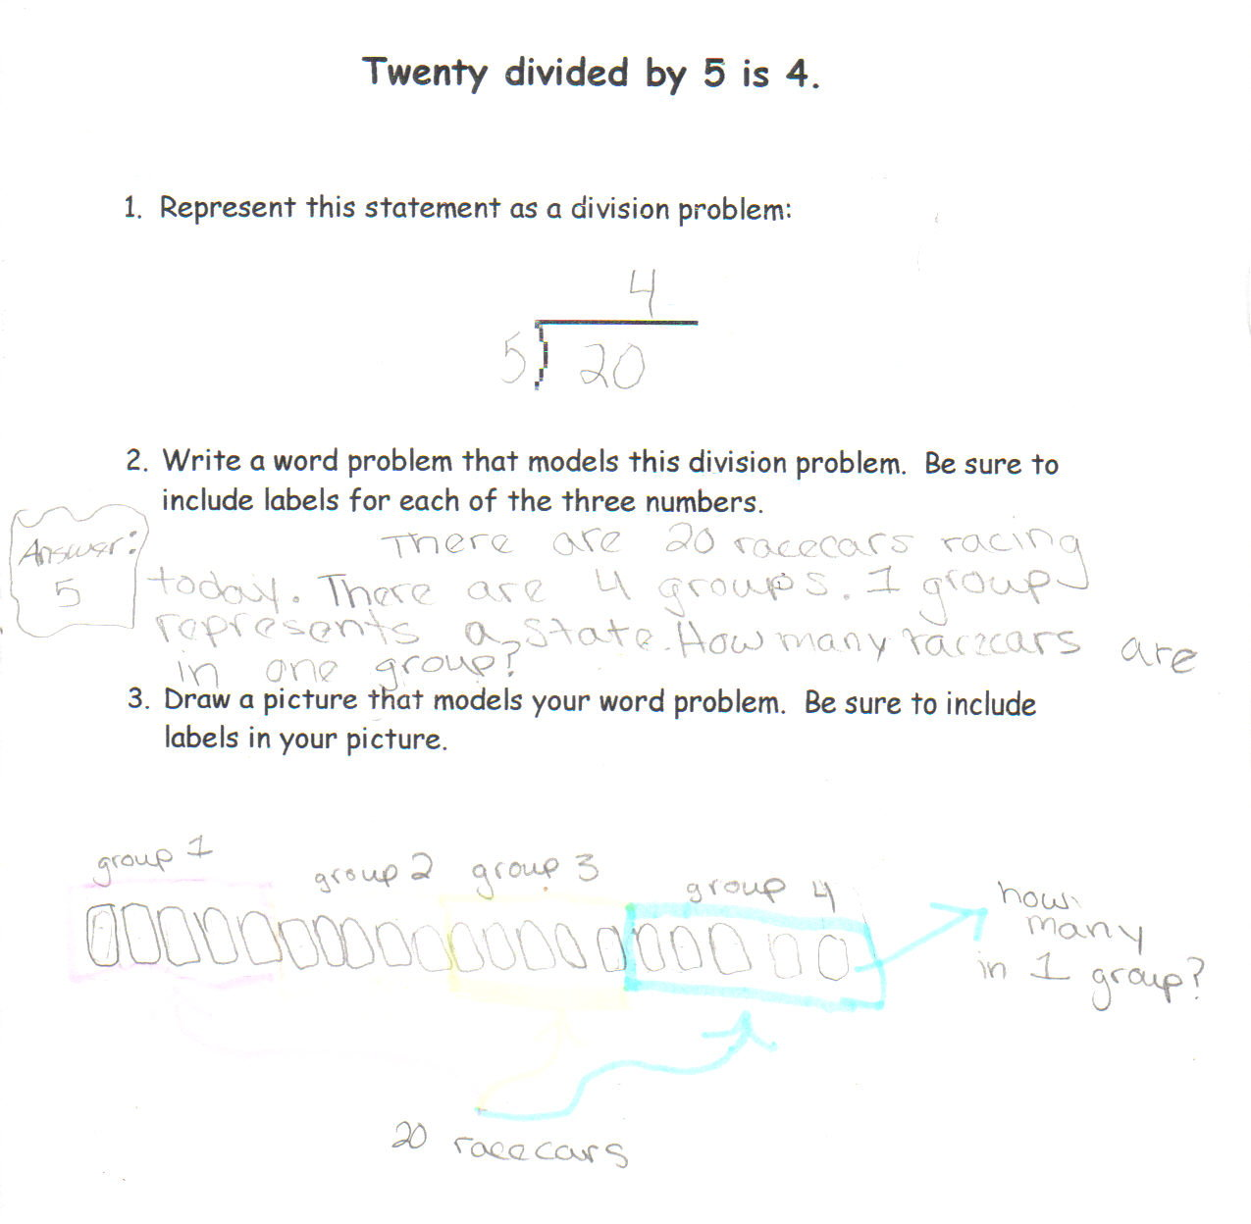

Student Work Analysis
Problem: Twenty Divided by Five Grade Level: 5

Student B
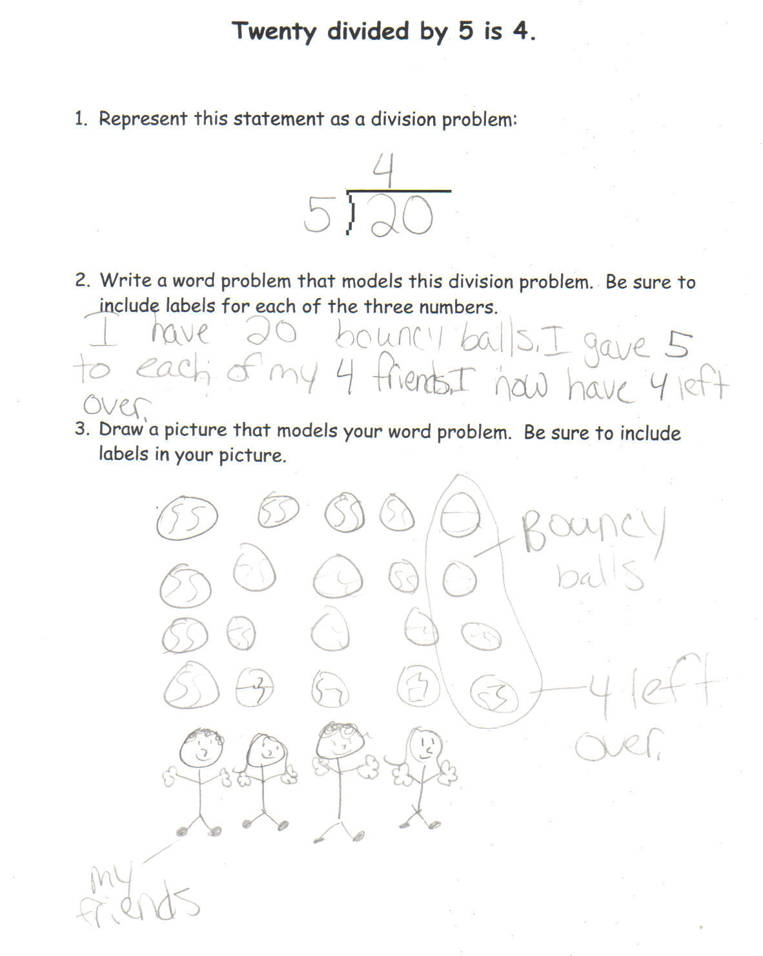

Student Work Analysis
Problem: Twenty Divided by Five Grade Level: 5

Student C
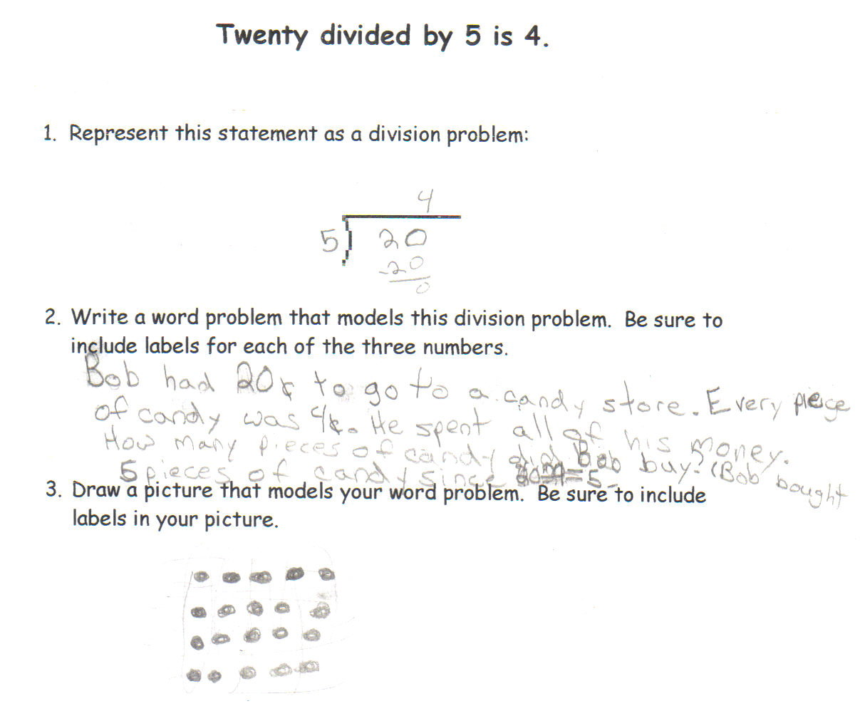

Student Work Analysis
Problem: Twenty Divided by Five Grade Level: 5

Student D
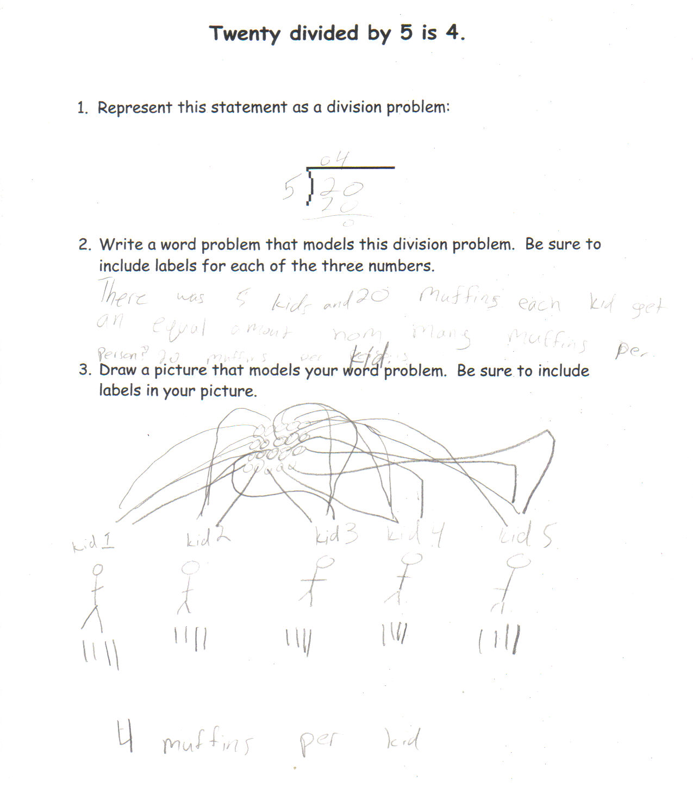

Student Work Analysis for: Twenty Divided by Five

Student | What type of division is represented in the student’s work? | Do the students recognize which quantities are the divisor, the dividend and the quotient in all three representations?
A
B

C

D

