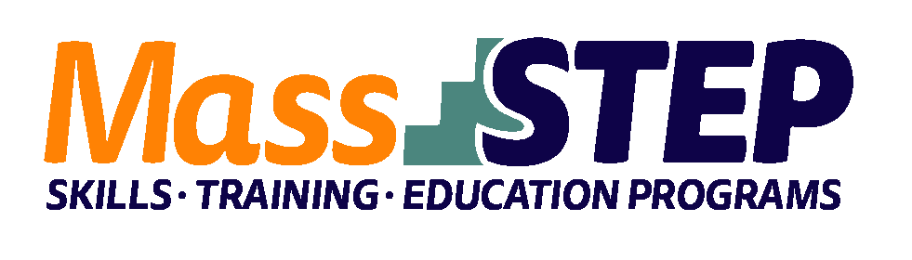
Adult Education Provider: | Bristol Community College (BCC)
Type of Organization: | Community College
Workforce Training Provider: | Bristol Community College
Employer Partners: | Advinia Care/Southpointe Nursing
Level: | Reading and Math GLE 7-12.9
Credential: | Massachusetts Nursing Assistant Training Certification
Occupational Group: | Healthcare
Occupation: | Certified Nursing Assistant
Program Description: | Students are enrolled in health contextualized reading/writing and math classes, career readiness skills, and nursing assisting training. The CNA training includes a digital immersive, story-based curriculum and an in-person skills component, as well as clinical hours in a skilled nursing facility. With successful completion of the nursing assisting training students will receive a Nurse Assistant Training Certificate and CPR Certification. Students will also sit for the MA State NAT Competency Exam. The program includes weekly check-ins and monthly advising appointments and certification preparation workshops. Students also receive a free uniform and stethoscope.

Weekly Schedule
 | Monday | Tuesday | Wednesday | Thursday
9:00 AM – 12:00 PM | Certified  Nursing Assistant Training | Math  Adult Education Classes | Certified  Nursing Assistant Training  *In-person Skills component | ELA  Adult Education Classes
12:00 PM
12:30 PM – 2:30 PM |  | Career  Readiness Skills

Contact: Christa Silva, MassSTEP Community Outreach Counselor, christa.silva@bristolcc.edu, 774-357-2430

Website:
http://www.bristolcc.edu/learnatbristol/prepareforcollege/adulteducation/adulteducationcareerpathways/

