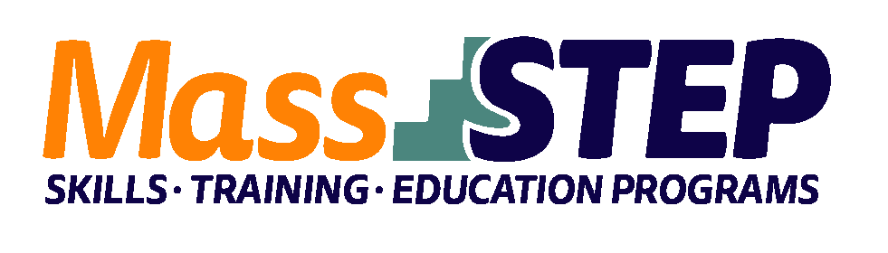
Adult Education Provider: | Bristol Community College (BCC)
Type of Organization: | Community College
Workforce Training Provider: | Bristol Community College
Employer Partners: | City of Fall River Water Division and Veolia North America
Level: | Reading and Math GLE 7-12.9
Credential: | Massachusetts Municipal Wastewater Treatment Plant Operator Grade 3 Certification
Occupational Group: | Production
Occupation: | Water and Wastewater Treatment Plant and System Operators
Program Description: | Students interested in a career in the field of water quality are co-enrolled in Bristol’s adult education classes (HiSET/GED) and two college level Clean Water Quality courses as part of Bristol’s Clean Water Technology Professional Certificate Program. Coursework prepares students for the Massachusetts Wastewater Operator I Certification Exam. Successful completion of the exam qualifies students to become a licensed Massachusetts Wastewater I Technician.

Weekly Schedule
 | Monday | Tuesday | Wednesday | Thursday
9:00 AM – 11:00 AM | Group and individual tutoring | EGR 143 –  Conceptual Math for Environmental Technicians | EGR 241 –  Clean Water Technology I | EGR 241 –  Clean Water Technology I
11:00 AM – 12:00 PM | Individual advising appointments
12:00 PM
12:30 PM – 2:30 PM |  | Adult Education – Math | Career Readiness | Adult Education  - ELA

Contact: Christa Silva, MassSTEP Community Outreach Counselor, christa.silva@bristolcc.edu, 774-357-2430

Website:
http://www.bristolcc.edu/learnatbristol/prepareforcollege/adulteducation/adulteducationcareerpathways/

