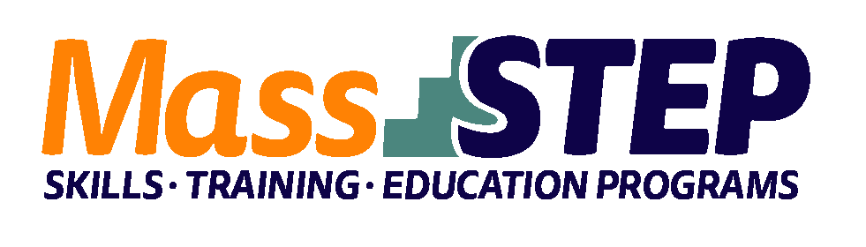

Adult Education Provider: | Valley Opportunity Council
Type of Organization: | Community-Based Organization
Workforce Training Provider: | United Tractor Trailer School (UTTS)
Employer Partners: | City of Holyoke Department of Public Works
Level: | SPL 3+
Credentials: | CDL Class A
Occupational Cluster: | Transportation and Materials Moving Occupations
Occupation: | Heavy and Tractor Trailer Truck Drivers
Program Description: | The program is offered 3 times per year Students receive CDL Class A Training at UTTS and contextualized ESOL classes. Evening and weekend cohorts are available. Students must obtain the Department of Transportation Physical and Class A Permit prior to enrollment.

Weekly Evening Schedule
Week 1 | Monday | Tuesday | Wednesday
9:30 AM – 1:00 PM | ESOL and Workforce Preparation | ESOL and Workforce Preparation | ESOL and Workforce Preparation

Weeks 2 – 3 | Monday | Tuesday | Wednesday | Thursday | Friday
5:30 PM – 9:30 PM | CDL Training | CDL Training | CDL Training | CDL Training | CDL Training

Weeks 4 – 9 | Monday | Tuesday | Wednesday | Thursday | Friday
9:30 AM – 1:30 PM | ESOL and Workforce Preparation | ESOL and Workforce Preparation | ESOL and Workforce Preparation
5:30 PM – 9:30 PM | CDL Training | CDL Training | CDL Training | CDL Training | CDL Training

Week 10 | Monday | Tuesday | Wednesday
9:30 AM – 1:00 PM | ESOL and Workforce Preparation | ESOL and Workforce Preparation | ESOL and Workforce Preparation

Weekly Schedule Weekends
Weeks 1 | Monday | Tuesday | Wednesday | Saturday | Sunday
9:30 AM – 1:30 PM | ESOL and Workforce Preparation | ESOL and Workforce Preparation | ESOL and Workforce Preparation | CDL Training  8:00 AM – 4:30 PM | CDL Training  8:00 AM – 4:30 PM

Weeks 2 – 6 | Monday | Tuesday | Wednesday | Saturday | Sunday
9:30 AM – 1:30 PM | ESOL and Workforce Preparation | ESOL and Workforce Preparation |  | CDL Training  8:00 AM – 4:30 PM | CDL Training  8:00 AM – 4:30 PM

Weeks 7 – 10 | Monday | Tuesday | Wednesday | Saturday | Sunday
9:30 AM – 1:30 PM | ESOL and Workforce Preparation | ESOL and Workforce Preparation | ESOL and Workforce Preparation | CDL Training  8:00 AM – 4:30 PM | CDL Training  8:00 AM – 4:30 PM
5:30 PM – 9:30 PM | CDL Training | CDL Training | CDL Training

Week 11 | Monday | Tuesday | Wednesday
9:30 AM – 1:00 PM | ESOL and Workforce Preparation | ESOL and Workforce Preparation | ESOL and Workforce Preparation

Contact: Hayley Nelson, hnelson@valleyopp.com, (413) 612-0206

Website: www.valleyopp.com

