Quick Guides for Interpreting the
MAPT-CCR for Reading Score Reports

In the following pages are the Quick Guides that have been developed to assist in the interpretation of the MAPT-CCR for Reading score reports. Three Quick Guides have been developed, and are included here in this order:

- Individual Student Score Report by Content Standard
- Individual Student Score Report by Domain
- Class Score Report by Content Standard and Topic

These Quick Guides are also available on the ACLS Test Help blog.

Quick Reference Guide to the MAPT-CCR for Reading:
Student Score Report by Content Standard

1
2
3
5
4
2. Below the header is an illustration of the student’s score range as it connects to the MAPT-CCR scale.
1. The header of the report contains basic identifying information as well as the student’s MAPT-CCR score and score range, which represents the range of scores we would expect if we tested the student over and over without additional learning.

4. Every item is aligned to a benchmark in the CCRSAE Standards.
3. The item difficulty level is a value on the MAPT-CCR scale associated with a 50% chance of answering the
item correctly.
5. Each of the 35 items a student takes will be in one of these columns: Questions Answered Correctly or Questions Answered Incorrectly. MAPT-CCR items are confidential and cannot be included on score reports. Therefore, we report the benchmark measured by each item rather the item itself.

The items in this report are organized by Content Standard.

To interpret this report
- Note the student’s MAPT-CCR score (in this example, 355)
- Note the score range associated with the MAPT-CCR score (in this example, 323-388)
Using this information
- Look for items answered incorrectly with item difficulty values lower than the students’ score range (in this example, the last item on the incorrect side). These were expected to have been easy for the student based on their difficulty level, but were not answered correctly.
- Look also for items answered incorrectly with item difficulty values higher than the student’s score range. These were relatively hard for the student given the student’s performance and are benchmarks to work on.
- Look for items answered correctly with item difficulty values lower than the student’s score range. These were answered correctly and were relatively easy for the student.
- Look for items answered correctly with item difficulty values higher than the student’s score range. These were relatively hard for the student given the student’s performance, but were answered correctly.
Questions to consider
- How does this information align with what content/skills were taught to students in the class?
- What benchmarks represent material covered that was mastered?

Quick Reference Guide to the MAPT-CCR for Reading:
Student Score Report by Domain

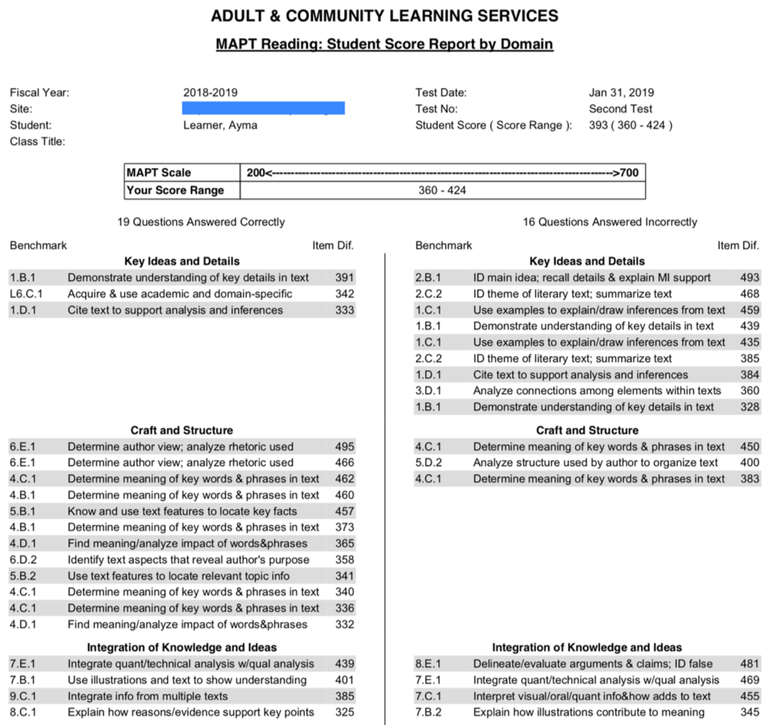
2
3
1
5
4
2. Below the header is an illustration of the student’s score range as it connects to the MAPT-CCR scale.
1.The header of the report contains basic identifying information as well as the student’s MAPT-CCR score and score range, which represents the range of scores we would expect if we tested the student over and over again without additional learning.
3. The item difficulty level is a value on the MAPT-CCR scale associated with a 50% chance of answering the
item correctly.

5. Each of the 35 items a student takes will be in one of these columns: Questions Answered Correctly or Questions Answered Incorrectly. MAPT-CCR items are confidential and cannot be included on score reports. Therefore, we report the benchmark measured by each item rather the item itself.
4. Every item is aligned to a benchmark in the CCRSAE Standards.

The items in this report are organized by Domain.

To interpret this report
- Note the student’s MAPT-CCR score (in this example, 393)
- Note the score range associated with the MAPT-CCR score (in this example, 360-424)
Using this information
- Look for items answered incorrectly with item difficulty values lower than the students’ score range (for example, the last item on the incorrect side). These were expected to have been easy for the student based on their difficulty level, but were not answered correctly.
- Look also for items answered incorrectly with item difficulty values higher than the student’s score range. These were relatively hard for the student given the student’s performance and are benchmarks to work on.
- Look for items answered correctly with item difficulty values lower than the student’s score range. These were answered correctly and were relatively easy for the student.
- Look for items answered correctly with item difficulty values higher than the student’s score range. These were relatively hard for the student given the student’s performance, but were answered correctly.
Questions to consider
- How does this information align with what content/skills were taught to students in the class?
- What benchmarks represent material covered that was mastered?

Quick Reference Guide to the MAPT-CCR for Reading:
Class Score Report by Content Standard and Topic

1.The header of the report contains identifying information about the class. Note that in a given class, the number of students may not equal the number of tests recorded because individual students may have taken the test multiple times within the same fiscal year.
2. Each item on the MAPT-CCR is mapped to the MAPT-CCR scale, and so falls into one of five score ranges.

1
2
3
Topic
Standard

3. The “# Student Responses” and “% Correct” columns present information about how many student responses were provided, and the percent of these that were correct. Within each cell, these may or may not represent the same item seen by more than one student, or different items seen by different students.

The items in this report are organized by Content Standard and Topic.

To interpret this report
- Note the Difficulty Range of Items (along the top of the table)
- Identify a standard and topic combination you want to look at.
- Note the number of student responses and the percent of these that were answered correctly for the cell you are interested in.
Using this information
- If the number of student responses is less than 5, be aware that this is a relatively small number of items and any conclusions to be drawn are likely to be unreliable.
- Where the number of student responses is greater than 5, look at the percent correct.
  - If the percent correct is high, that represents higher numbers of correct answers to those items in that difficulty range and greater mastery of skills among members of the class as a group.
  - If the percent correct is low, that represents lower numbers of correct answers to those items in that difficulty range and a lower degree of mastery of skills among members of the class as a group.

