Assessment Credentials
The UMass Center of Educational Assessment (UMass CEA) teamed up with LiteracyPro Systems to make assessment credential information available to program directors.

To see credentials for staff certified to administer and score NRS assessment trainings, go to the Staff Area in LACES. Click MORE and select ALL STAFF CREDENTIALS. Then filter by test or staff.
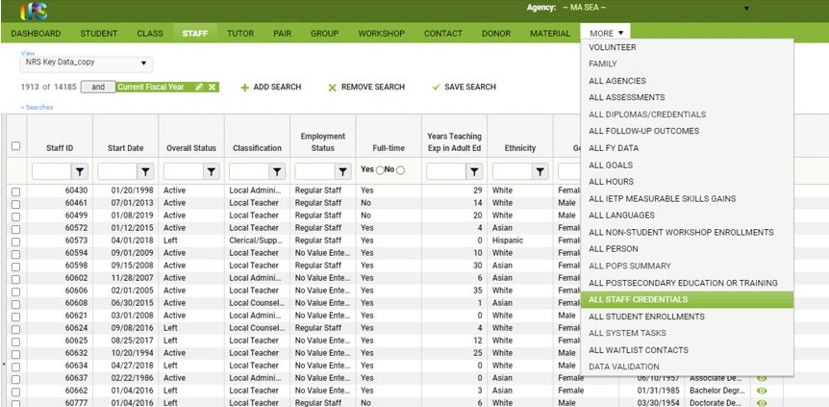

The TABE CLAS E and BEST Plus 2.0 require recertification. To identify which staff are certified to administer these tests enter the start date of the current fiscal year under Recertification Due Date and filter for Greater than or equal.

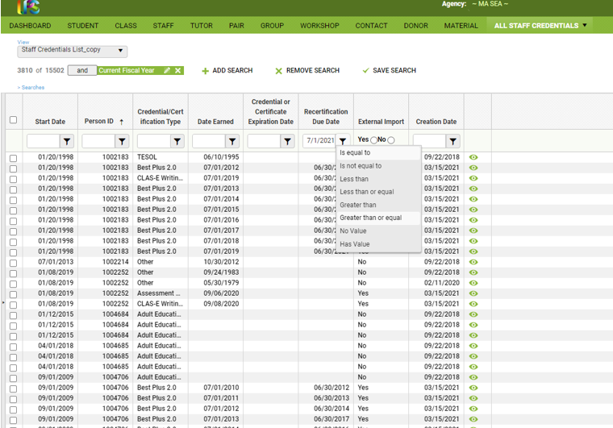

You can also view this information in the staff record by expanding the credential panel in the staff data tab.

If you have a question or note a discrepancy about what is listed in the program’s LACES record (or the record of a staff member at the program), please use this form to submit a help request to the UMass Amherst Center for Educational Assessment (CEA). UMass CEA will follow up with program directors with a resolution or a request for additional information within three business days.

