LACES Update – Enrollment Reports
The LACES enrollment report shows the number of participant enrollments by month, the average monthly enrollment, and how your program’s actual enrollment compares to its target. You can use this report to quickly review your program’s enrollment and to complete the ABE and ESOL Enrollment searches for the desk review.
From the student area in LACES, remove any searches, including the default “Current Fiscal Year.” Then click on “Reports” to expand the Report Manager.
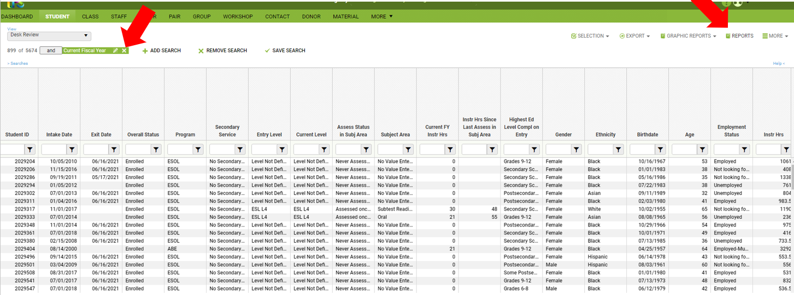
Select the “Fund Code Enrollment Report.” Choose which fiscal and date range. Click Print PDF or Print Excel.
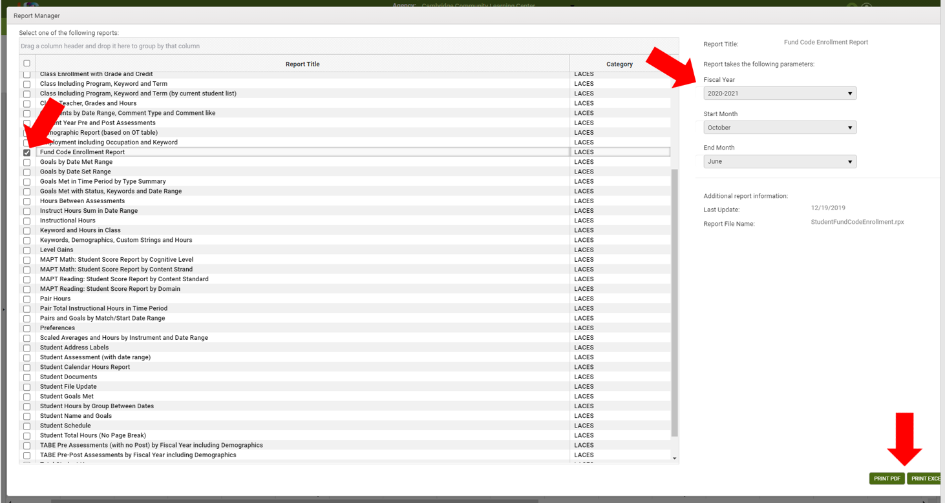
In FY21 many programs started later than usual due to pandemic related challenges such as remote testing and orientation, ACLS did not hold programs to enrollment targets in September. The report below provides enrollment averages only for October through June. Including September would have lowered the averages.
When completing the desk review, you should select only the months that you are reporting. For example, if you are reviewing data to be submitted in January, run the report starting with September and ending in December. If you select September through June, there will be six months of zero enrollments and an artificially low average monthly enrollment.
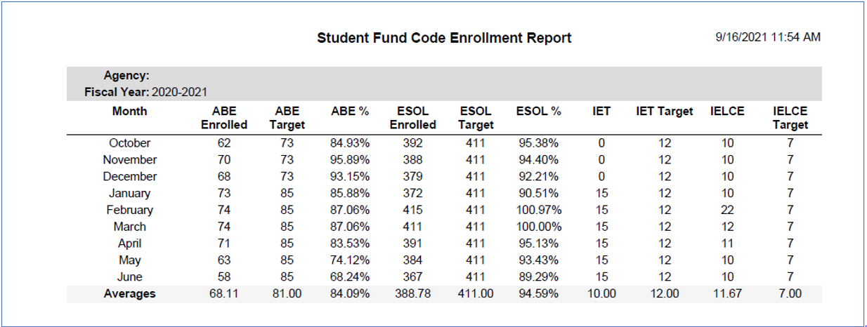
The enrollment report targets increase by the number of MassSTEP enrollments as shown in the example below from FY21. Table 1 shows an ABE average monthly enrollment target of 59. Their IET began in January and enrolled 15 participants. The report automatically added 15 to the ABE target, bringing it to 74. The target drops to 71 for two months and then to 69 in the last month of the training.
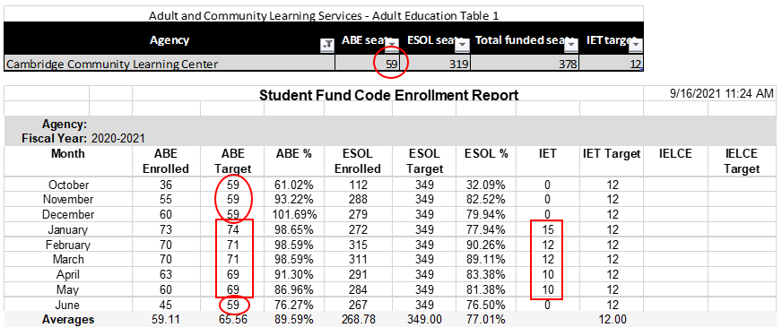
The targets also include match enrollments. In addition to the 319 ESOL enrollments on Table 1, this program has two match ESOL classes of 15 students. ACLS increased the target by 30 to reflect the match commitment.
