- Use the TEXTJOIN function to create a comma delimited list.
  - Click on a convenient empty cell. In this example it’s R2.
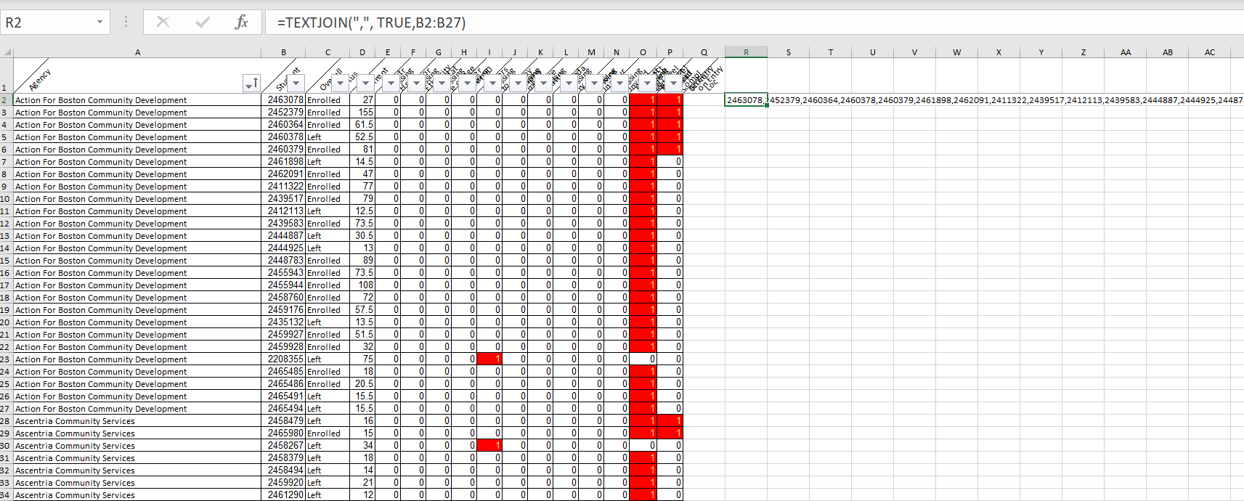
  - Type in =TEXTJOIN(“,”, TRUE,B2:B27)
    - Note the space between the second comma and TRUE
    - All the IDs are in the cells from B2 to B27. You can type in the range as shown or select.
  - Hit Enter and you will see the ID numbers listed with commas between.
- Display only these students in LACES
  - From the STUDENT area in LACES
    - Close any searches
    - Click “+ADD SEARCH”
    - In the dialogue box start typing STUDENT
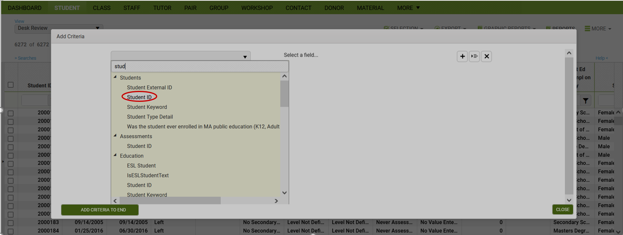
    - Click “Student ID”
    - From the “Select a Field” dropdown, select “In the list”
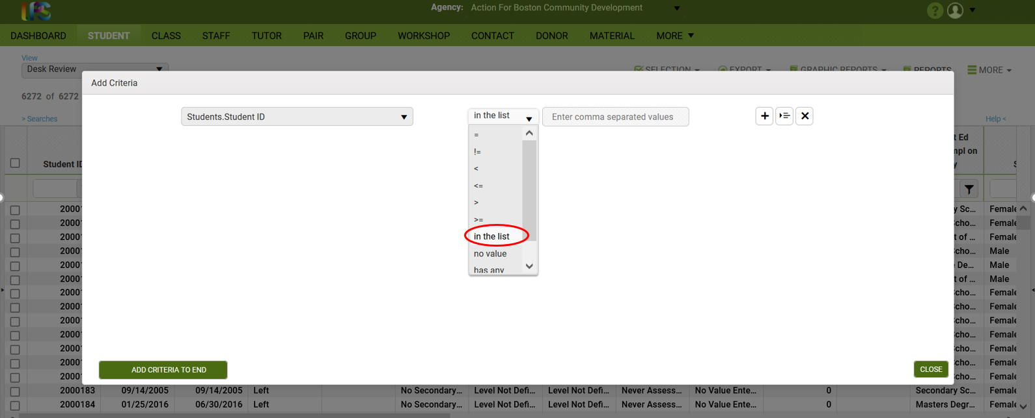

  - Return to the Excel file and select the cell that you used the TEXTJOIN function to create your list
    - Copy just that one cell, R2 in the example
    - Then paste into the search field and click “APPLY.”
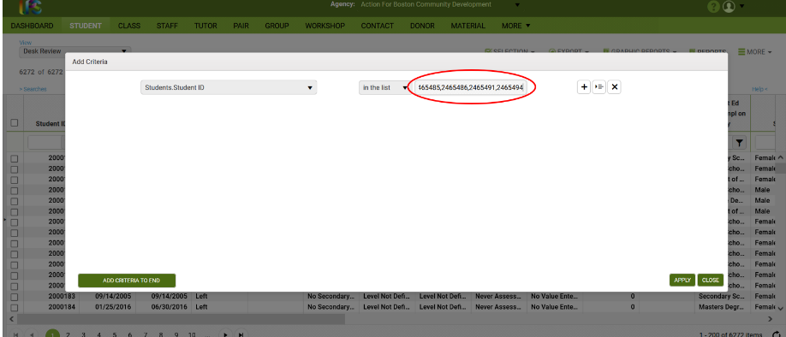
This will return the set of records with the selected IDs, in this case 26.
