Massachusetts Department of

Elementary and Secondary Education

75 Pleasant Street, Malden, Massachusetts 02148-4906 Telephone: (781) 338-3000 TTY: N.E.T. Relay 1-800-439-2370

Jeffrey C. Riley
Commissioner

February 1, 2023

Dear Directors and Coordinators,

Are you learning about ACLS and LACES updates only after someone else tells you? Have you missed student referrals because the contact information and description in the ACLS program directory is old or inaccurate? You can remedy this in just a few minutes by following these four steps.

1. Your contact information in agency settings in LACES—not your staff records—is used to populate the ACLS program directory and the email list for communications from ACLS. Only program staff with full access can edit or update incorrect or incomplete contact information. ACLS cannot edit this or any program information in LACES.

To access agency settings, hover your pointer over Person Profile at the top right of the screen. 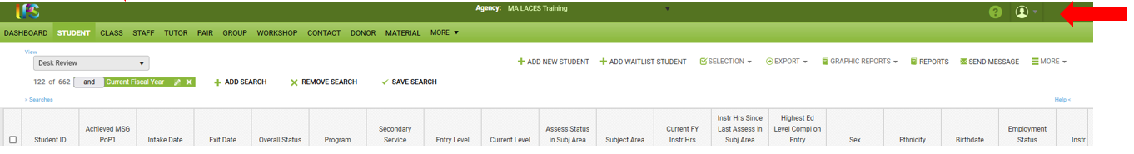

2. Select 'Agency Settings' from the drop-down menu. Note: Agency Settings is only available to full access users.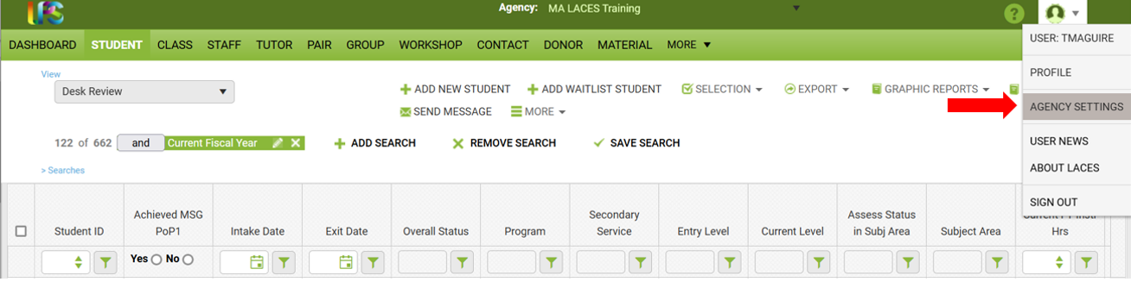

3. From the Agency Data tab, enter or update your primary contact information, including the workforce area. Then click save.
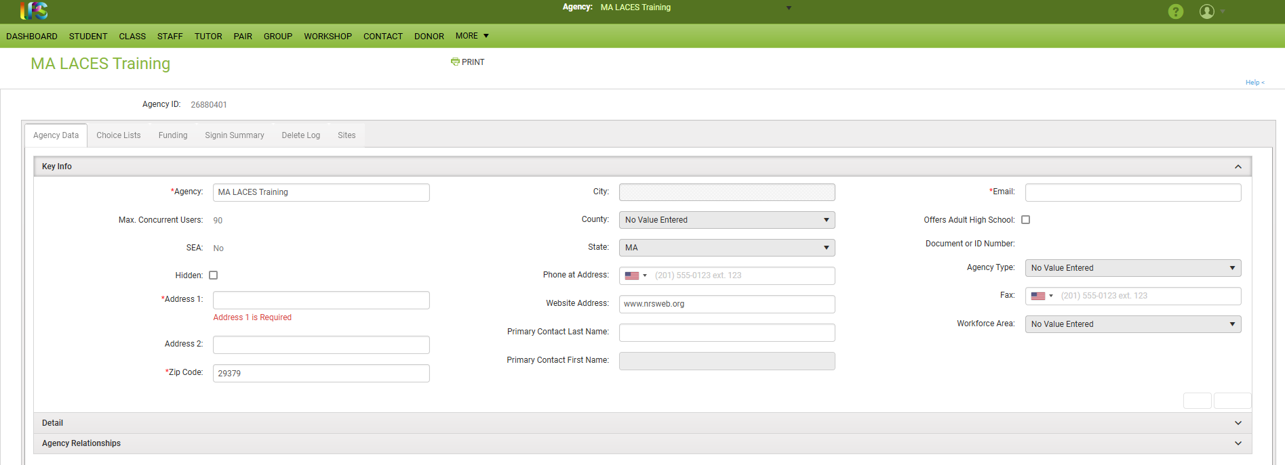

4. Select the Site tab. There will be at least two sites. One is the same as the agency. To edit the site information, click on the eye at the end of the row. The site edit record card will pop up. This will allow a second contact to be listed in the directory.

Do not edit the Remote Agency site. Programs are asked to select this site on the assessment card when adding a remotely administered NRS test.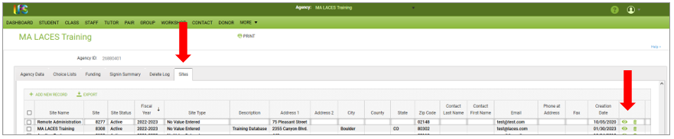

You may add sites. However, all active sites will show as options when you create classes.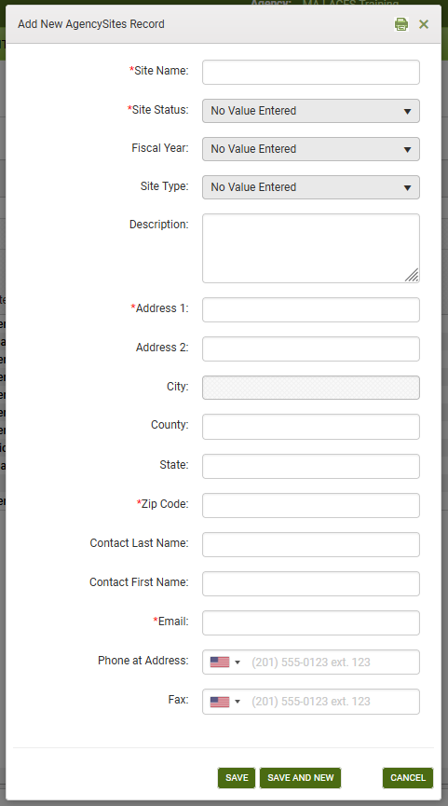

Subscribe to the ACLS Monthly Mailing Newsletter separately.
For additional information on creating and using sites, go to https://sites.google.com/a/literacypro.com/laces-massachusetts-customizations/sites.

