Instructions: To avoid delays in the processing of your grant, use this checklist to check off each step as you complete it.
Please Note: New vendors / Applicants to DESE must complete paperwork to be created in EdGrants prior to adding users.

Prior to entering the EdGrants the applicant MUST:
___ Please Review the EdGrants: User Security Controls
___ Send email to EdGrants@doe.mass.edu to request form. Form must be completed and emailed by your Superintendent/Business Manager/Executive Director via email (wet signature is not required) to Create User Account

Step 1: Register Grant on Funding Opportunity Page in EdGrants/Create Project in EdGrants by Fund Code (See User Guide for Detailed information)
___ Register Funding Opportunity (i.e., grant fund code).
___ Enter Project. Filter for your project using drop-down arrow next to Funding Opportunity Name.
___ Click on Add Project icon at top left of screen.
___ Enter Applicant Project Name (e.g., FY19 340 ABE Grant). Once Applicant Project Name is entered, check for typos, and click Save & Back.
___ Filter on Applicant Project Name to find the project you just created.
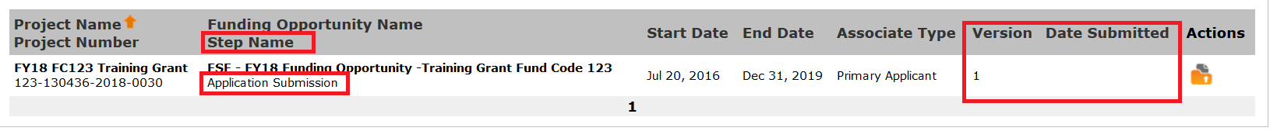
___ After your project is created, apply for grant by clicking on Submissions.

Step 2: Application Submission (See User Guide for Detailed information)
___ Applicant Information
___ Applicant Contacts
___ Budget Entry
___ Project Expenditures (For IDCR option, check approved rate.)
___ Attachment List (Ensure cover page amount matches budget amount in Table 1 and EdGrants. Ensure all required forms are uploaded correctly.)
___ Information and Affirmation
___ Submission Summary
___ Before you click Submit, verify that total award in Table 1 matches budget expenditure page in EdGrants; cover page/revised cover page is completed correctly; all required documents are submitted; you have an approved IDCR if you are applying for indirect.

Next Step: Once submitted, your grant will go through the following internal process for ACLS Office and Grants Management Office (GM) review and approval.
- Program Specialist (i.e., PS or EdGrants Internal Reviewer) conducts grant review and initial approval.
If no issues are found:  - PS moves grant on to ACLS Project Unit Approver. | If issues are found:  - grant is amended back to applicant for correction. Applicant addresses issues and returns to PS.  - If issues have been corrected, PS moves grant on to ACLS Project Unit Approver.
- ACLS Project Unit Approver completes second review, gives final approval, and moves grant on to Grants Management Office.
- Grants Management Office does final review of budget. They generate Interagency State Agreement (ISA) to be completed and returned to GM by applicant; flags issues such as cover page not signed, calculation of IDCR incorrect or not approved, amends back to ACLS if needed, sets up payment placeholders in EdGrants, enters approved start date, sets up transaction, waits for approval from Comptrollers office, and releases initial payment (i.e., Applicant’s Record Card) at 10% of total grant.

