2017
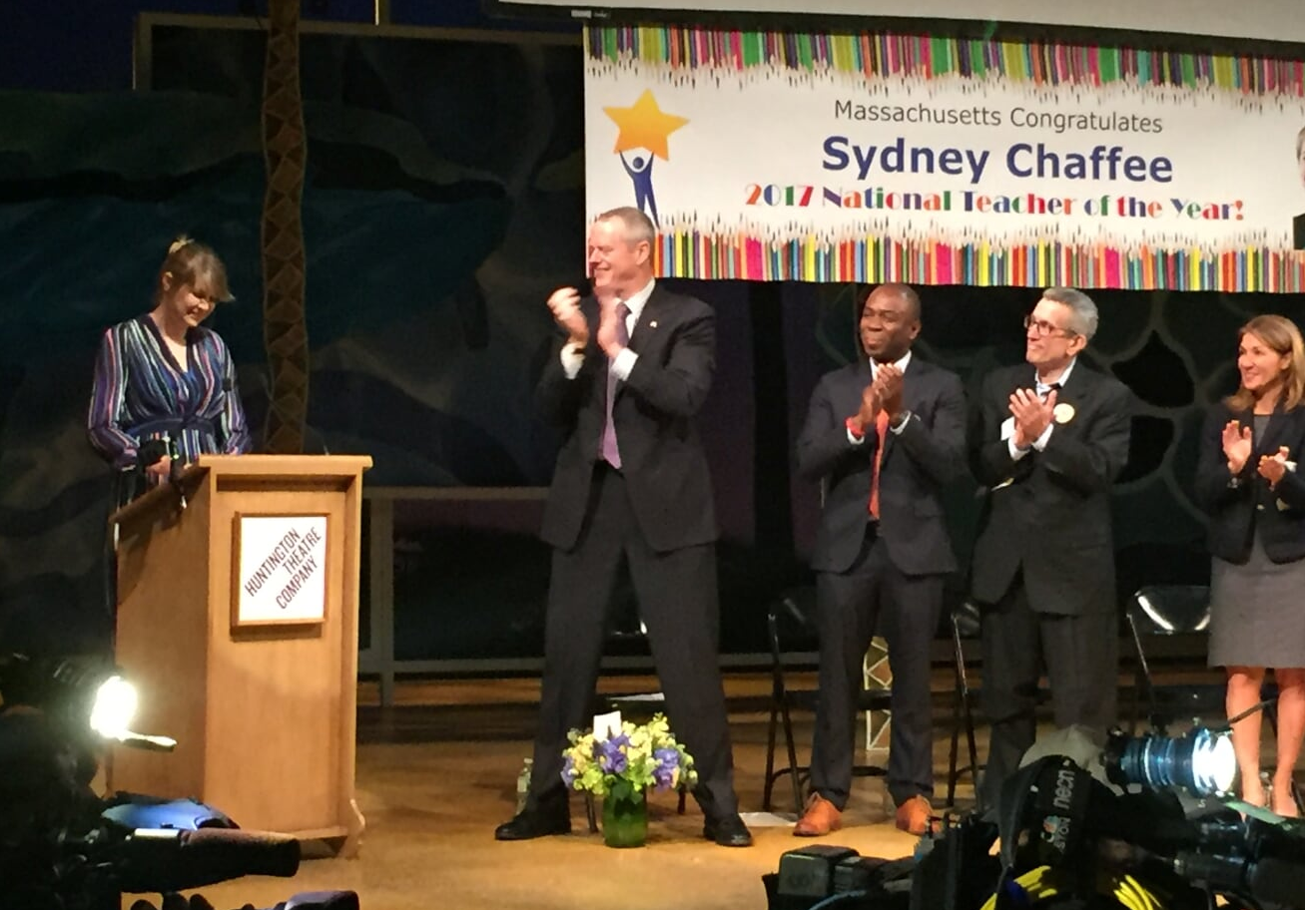

Annual Report

This document was prepared by the
Massachusetts Department of Elementary and Secondary Education
Jeff Wulfson
Acting Commissioner

Board of Elementary and Secondary Education Members

Mr. Paul Sagan, Chair, Cambridge
Mr. James Morton, Vice Chair, Springfield
Ms. Katherine Craven, Brookline
Dr. Edward Doherty, Hyde Park
Ms. Amanda Fernández, Belmont
Ms. Margaret McKenna, Boston
Mr. Michael Moriarty, Holyoke
Mr. James Peyser, Secretary of Education, Milton
Ms. Mary Ann Stewart, Lexington
Ms. Hannah Trimarchi, Chair, Student Advisory Council, Marblehead
Dr. Martin West, Newton

Jeff Wulfson, Acting Commissioner
Secretary to the Board

The Massachusetts Department of Elementary and Secondary Education, an affirmative action employer, is committed to ensuring that all of its programs and facilities are accessible to all members of the public.
We do not discriminate on the basis of age, color, disability, national origin, race, religion, sex, gender identity, or sexual orientation.

Inquiries regarding the Department’s compliance with Title IX and other civil rights laws may be directed to the
Human Resources Director, 75 Pleasant St., Malden, MA 02148-4906. Phone: 781-338-6105.

© 2018 Massachusetts Department of Elementary and Secondary Education
Permission is hereby granted to copy any or all parts of this document for non-commercial educational purposes. Please credit the “Massachusetts Department of Elementary and Secondary Education.”

This document printed on recycled paper

Massachusetts Department of Elementary and Secondary Education
75 Pleasant Street, Malden, MA 02148-4906
Phone 781-338-3000 TTY: N.E.T. Relay 800-439-2370
www.doe.mass.edu

TABLE OF CONTENTS

In Memory of Commissioner Chester | 4
Letter from the Acting Commissioner | 5
Letter from the Board Chair | 6
Major Accomplishments During the 2016-2017 School Year | 7
Strengthen standards, curriculum, instruction, and assessment | 8
Promote educator development | 8
Support social-emotional learning, health, and safety | 8
Turn around the lowest performing districts and schools | 9
Enhance resource allocation and data use | 9
FOCUS: Next-Generation MCAS | 10
Board Members 2016-2017 | 12
Appendices
Education-Related Laws | i
Student Data | vi
Educator Data | vii
Summary Data | ix
Agency Information | xi

In Memory of
Commissioner CHESTER

To people who did not know him well, Massachusetts Elementary and Secondary Education Commissioner Mitchell D. Chester could be a formal and reserved education official, one with a tremendous intellect and the ability to quickly synthesize and analyze mammoth amounts of information.

People who had a chance to see him interact with children, however, saw another side of him, one that was glad to join in a game on field day, read a favorite Dr. Seuss book, or learn from children what was happening in their classroom and school.

He listened wherever he went, to students, educators, parents, researchers, policymakers, community members, and colleagues, and when he didn't understand a point, he'd ask them to try again, saying, "Say that again in a different way." By listening, Mitchell Chester could find ways to make practical their suggestions and address their needs.

He took what he learned from people and from his own studies and used it to continuously improve the Commonwealth's public elementary and secondary schools until they were the best in the country. When he passed away from an illness on June 26, 2017, Dr. Chester, 65, was the longest serving of the country's current chief state school officers and a sought-after voice on school and district turnaround, assessment, and the state’s role in strengthening teaching, learning, and opportunities for all students.

In a message following Commissioner Chester's death, Education Secretary James Peyser said Commissioner Chester "was often called upon to make difficult and at times controversial decisions. In all cases, he did so with humility, compassion and thoughtfulness. But in making those tough decisions, he also acted with courage and decisiveness. He was not afraid to do what he thought was right, and in the vast majority of cases, history will show that he was right."

Letter from
the acting commissioner

Jeff Wulfson  Acting Commissioner of Elementary and Secondary Education | January 2018  Dear Board Members,  In April 2017, Massachusetts celebrated one of its own teachers, Sydney Chaffee, being chosen National Teacher of the Year. It was a momentous occasion not only because of its worthy recipient, a humble and eloquent humanities teacher at Codman Academy Charter Public School in Dorchester, but because it was the first time in the 65-year history of the award that a teacher from Massachusetts was selected. During the public celebration that followed at the Huntington Theatre Company, Ms. Chaffee shared the stage with representatives from Codman Academy and from the state, including Governor Baker and Commissioner Chester, who attended despite his private battle with cancer.  Sydney and Mitchell shared many of the same values. Like Mitchell, Sydney believes it is up to adults to continually learn and adjust their approach in order to better serve students. Like Sydney, Mitchell believed that the fundamental work of educators transcends categories like charter schools and traditional schools. Both felt an urgency to reach under-served students, and both took joy in students' success.  This report summarizes some of the ways ESE tried to serve all students in 2016-17 and some of the success those students enjoyed:  - The Board adopted the 2017 Massachusetts Curriculum Framework for English Language Arts and Literacy and the 2017 Massachusetts Curriculum Framework for Mathematics. Thanks to the expertise of Massachusetts educators, these revised frameworks maintain our commitment to ambitious standards and high expectations for all students.  - The Department administered the next-generation English language arts and mathematics assessments to students in grades 3-8. The next-generation assessments were developed on an aggressive timeline and maintained such a high level of quality that Rhode Island has also decided to use them.  - The four-year graduation rate improved for the 10th consecutive year.  - In addition to honoring our first National Teacher of the Year, we updated our plan to ensure all students have equitable access to excellent teachers.  I am grateful to all the teachers and families who do so much for our students, and I am grateful for all that you do in service to this Board. Your support in my role as Acting Commissioner since Mitchell Chester’s untimely passing has enabled us to make this a year of continued success and growth for the students of the Commonwealth.  Jeff Wulfson  Acting Commissioner of Elementary and Secondary Education
Letter from
the board chair

Paul Sagan  Chair of the Board of Elementary and Secondary Education | January 2018  Dear Board Members,  It has been my pleasure to serve as Chair of the Massachusetts Board of Elementary and Secondary Education since March 2015.  The passing of Commissioner Mitchell Chester in June 2017 marked the 2016-2017 school year. I am grateful for the time I was able to work with Mitchell and to learn from him. I know that Massachusetts students, and many others nationwide, will continue to benefit from work he led and inspired.  Much of what we accomplished in 2016-17 was the result of the recommendation Mitchell made in fall 2015 to revise the state's mathematics and English language arts frameworks, and to create a new assessment system unique to Massachusetts. In March 2017, the Board adopted revised frameworks that were the work of Massachusetts educators, and later in the spring of 2017, the next-generation MCAS tests were given to students in grades 3-8 for the first time.  If Mitchell were still with us, I know he would be applauding the success of our students and educators – and he would also be reminding us of the work ahead. With the completion of the revisions to the mathematics and English language arts frameworks, there is an urgent need for us to continue to oversee the work to review the history and social science framework to ensure each student is prepared to be an engaged citizen. Our work in the state's most challenged schools and districts remains essential for the students learning there, and achievement gaps statewide continue to demand our attention and best thinking.  It is a privilege to serve with each of you, and I look forward to continuing our vital work to improve outcomes for the Commonwealth's nearly one million public school students.  Paul Sagan  Chair, Board of Elementary and Secondary Education

major accomplishments
During the 2016-2017 School Year

This report of the Massachusetts Board of Elementary and Secondary Education covers the activities and initiatives of both the Board and the Department of Elementary and Secondary Education (Department or ESE) for FY17. Each year, the Board is required to submit a report to inform the public and the Legislature about decisions that have been made and work that is taking place to support and continuously improve public education across the Commonwealth.

The Board engaged in discussions and made key decisions, such as adopting revised English language arts and math frameworks. The Board also informed the launch of the next-generation MCAS and worked collaboratively with the Board of Higher Education to make early college programs more widely available.

Highlights of the 2016-2017 school year include:
- Revised and strengthened the ELA and mathematics standards and frameworks
- Delivered a high quality next-generation MCAS
- Launched the review of the history and social science framework
- Continued to implement the workgroup recommendations for civic engagement and learning
- Worked with educators to support students’ social/emotional learning
- Revised the educator evaluation regulations based on feedback from the field
- Expanded digital learning opportunities to enhance and augment teaching and learning
- Promoted greater achievement for all students with a focus on improving third-grade reading and middle grade mathematics achievement
- Continued to strengthen teaching and learning for students in Level 4 and 5 schools

The following are some of the Department's major accomplishments in FY2017, organized under the Board’s five priority areas: standards, curriculum, instruction, and assessment; educator development; social-emotional learning, health, and safety; district and school turnaround; and resource allocation and data use.

major accomplishments
During the 2016-2017 School Year

Strengthen standards, curriculum, instruction, and assessment | - In March 2017, after completing a review process that was launched in November 2015, the Board voted to adopt the 2017 Massachusetts English Language Arts and Literacy Framework and the 2017 Massachusetts Mathematics Curriculum Framework. The revised frameworks benefited from Massachusetts educators' experience and insights and maintain our commitment to ambitious standards and high expectations for all students.  - In spring 2017, ESE and school districts successfully administered the first next-generation MCAS tests for grades 3-8 in English language arts and mathematics.  - The Board launched the review of the history and social science curriculum framework, including the integration of civic engagement.
Promote educator development | - After reviewing extensive public comment, the Board voted in February 2017 to amend the educator evaluation regulations. The changes eliminate the separate student impact rating of high, moderate, and low, and preserve a focus on student learning by adding a student learning indicator to the standards of effective practice.  - In June 2017, the Board voted to streamline and update the educator licensure and preparation regulations, clarifying provisions, and reducing regulatory burden.  - In April 2017, the Department and state and local officials celebrated the selection of Sydney Chaffee, a teacher from Codman Academy Charter Public School in Dorchester, as National Teacher of the Year, a first for a Massachusetts teacher.
Support social-emotional learning, health, and safety | - The Department refocused one of its strategic priorities on “supporting social-emotional learning, health, and safety.” Areas of focus include school culture and climate; social and emotional learning; health, wellness, and safety; and family and community engagement.  - Under its Rethinking Discipline Initiative, the Department is facilitating a professional learning network and participating schools and districts are implementing action plans to reduce the overuse of long-term suspensions and expulsions and the disproportionate use of suspensions and expulsions for students with disabilities and students of color.  - Through the Leading Educational Access Project (LEAP), the Department is working with districts to address the disproportionate identification and placement of student subgroups for special education and helping districts develop sustainable systems and practices to support all students, especially the most vulnerable, such as low-income students, English learners, students of color, and students with disabilities.  - As part of the Department's work to promote evidence-based inclusive practice, it posted and distributed the Educator Effectiveness Guidebook for Inclusive Practice after a thorough review and field feedback process. The Department also launched two free online Foundations for Inclusive Practice courses for educators and administrators that can be used to help fulfill requirements to renew a professional license.

major accomplishments
During the 2016-2017 School Year

Turn around the lowest performing districts and schools | - Lawrence Receivership: Lawrence Public Schools continues to see an increase in the percentage of students achieving at Proficient and Advanced levels. The percentage of students scoring Proficient and Advanced in ELA has increased by 10 points since 2012. The percentage of students scoring Proficient and Advanced in mathematics has increased by 21 points since 2012.  - Holyoke Receivership: The district implemented several key initiatives, particularly at the high school level. All ninth grade students now attend a ninth grade academy at Holyoke High School and are eligible to participate in exploratory opportunities at Dean Technical High School. Upon completing ninth grade, students can decide to stay at Holyoke High or apply for admission to Dean.  - Southbridge Receivership: Improvements in Southbridge Public Schools during FY17 included the creation of dozens of new curriculum units, the addition of thousands of books to the elementary schools and middle school, the creation of an alternative school called Southbridge Academy, increased home visits, a new Department of Social and Emotional Learning, increased staffing for students who are English language learners, and infrastructure improvements such as increased wireless access and the addition of Chromebooks for students.  - Springfield Empowerment Zone Partnership (SEZP): In February 2017, Zone management transitioned to co-executive directors, who report to the SEZP Board and, along with a small team, support the Empowerment Zone schools.
Enhance resource allocation and data use | - In 2017, the Department released two policy briefs that each summarize the national research on a particular issue and analyze Massachusetts data to see how the issue plays out in our context. The first focused on gaps in access to effective teachers for low income students; the other on class size as a resource allocation issue. The Department also launched a new website for the How Do We Know? Initiative in order to help districts better understand how to use, build, and share evidence to improve student outcomes. Finally, the Department piloted a statewide school climate survey for students in grades 5, 8, and 10 to share their views on engagement, safety, and environment.  - Eight districts participated in a pilot of the Department's Resource Allocation and District Action Reports (RADAR), a mechanism that lets districts compare their use of resources with that of other districts.

FOCUS:
Next-Generation MCAS

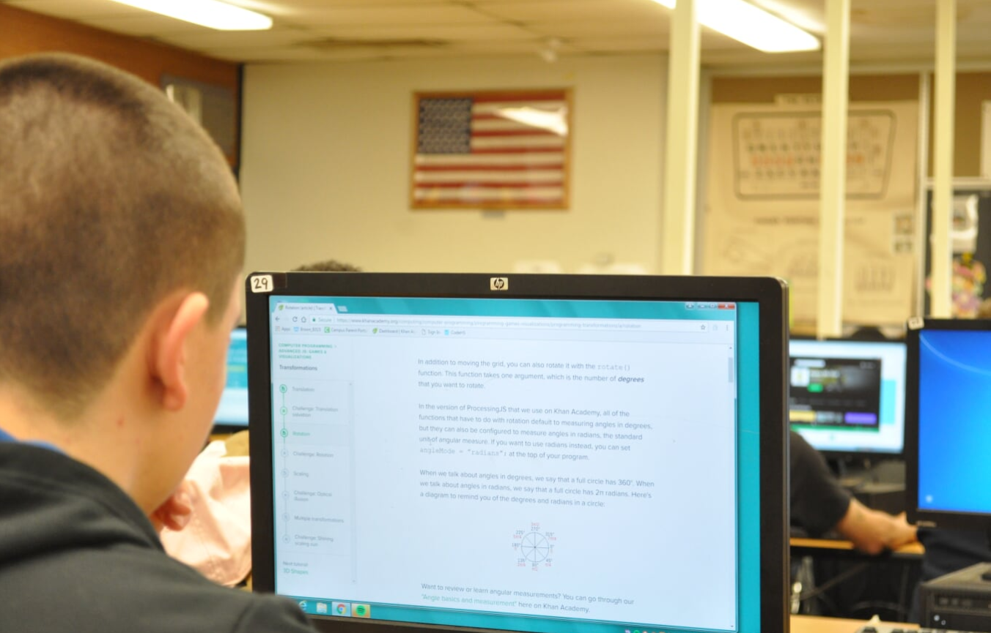 | 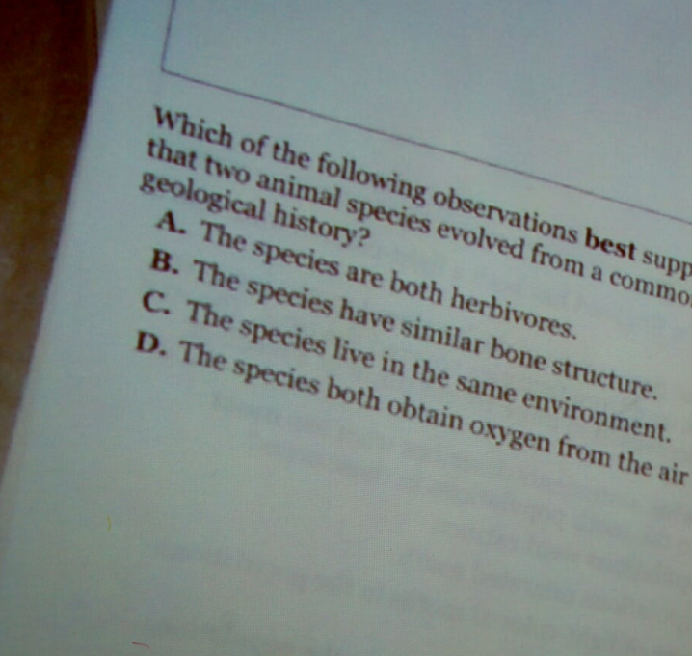

Participation and Achievement
The twentieth administration of the Massachusetts Comprehensive Assessment System (MCAS) tests took place in spring 2017.

A total of 550,083 Massachusetts public school students in grades 3–10 participated in MCAS tests in English language arts (ELA), mathematics, and science and technology/engineering (STE). Participation rates remained very high, ranging from 98 to 100 percent across the grades and subjects tested.

Next-Generation MCAS Tests
Between April 3 and May 26, 2017, students in grades 3–8 participated in the new next-generation MCAS tests in English language arts and mathematics. Student achievement in next-generation achievement categories was relatively consistent across the grade levels, with between 47 and 51 percent of students scoring Meeting Expectations and above in ELA, and between 46 and 50 percent scoring Meeting Expectations and above in Mathematics.

High School MCAS: ELA and Mathematics Tests Administered in Grade 10; Science and Technology/Engineering Tests Administered in Grades 9 and 10
At the high school level, 71,049 students participated in the grade 10 MCAS tests. Compared to results in 2016, the percentage of students scoring Proficient or higher remained at 91 percent in 2017 in ELA and increased by one percentage point to 79 percent in Mathematics. In 2017, MCAS STE tests were administered to 51,940 students in grade 9 and to 19,040 students in grade 10. Grade 10 STE results for 2017 include results from grade 10 students who took one of the four STE subject tests in 2017 and from grade 9 students who took one of the four STE subject tests in 2016. Compared to 2016, the percentage of students scoring Proficient or higher increased from 73 to 74 percent in 2017.
Among students in the Class of 2019 (10th graders in spring 2017) participating in MCAS tests in 2017 to earn a Competency Determination, 88 percent scored Needs Improvement or higher on their first attempt on the ELA, mathematics, and STE high school tests. On the individual subject area tests, in ELA, 95 percent of students scored Needs Improvement or higher; in mathematics, 90 percent of students did so; and in STE, 93 percent of students did so.

Board Members
2016-2017

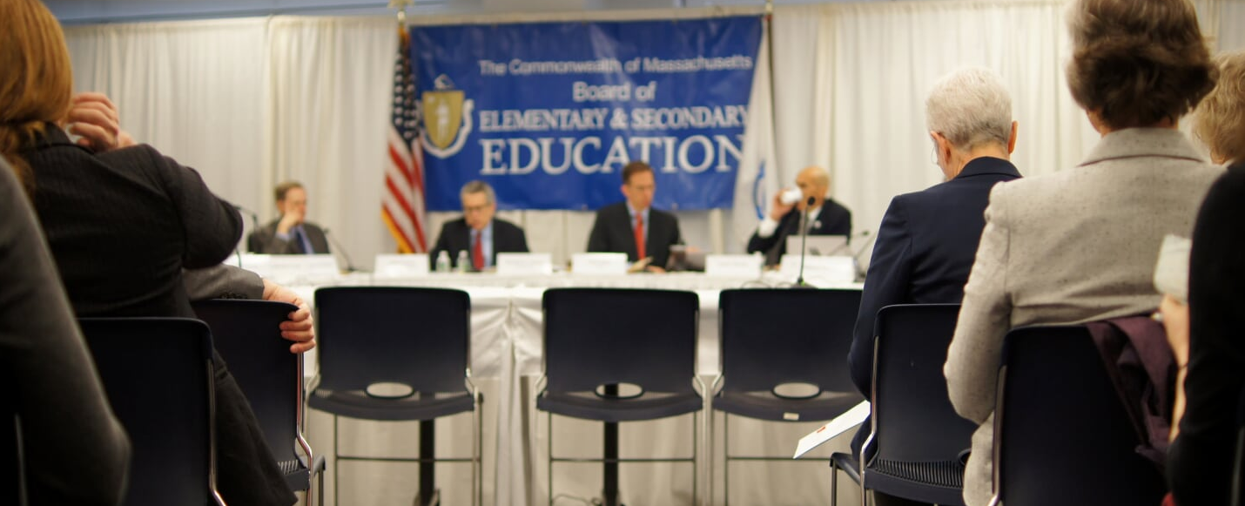

Paul Sagan, Chair  2015 - present | Sagan is an Executive in Residence at General Catalyst Partners in Cambridge, MA. From 1998 until 2013, Paul Sagan was a member of the executive team of Akamai Technologies, Inc., a leading Internet services company based in Cambridge, where his responsibilities including serving as CEO, president and chief operating officer. Prior to joining Akamai, Sagan served in various executive positions at Time Warner Cable and Time Inc., where he helped to found several Internet businesses. Sagan was also a senior advisor to the World Economic Forum, and he has served on the boards of numerous advisory panels and educational organizations including for the Massachusetts Institute of Technology, Northwestern University, the Alliance for Business Leadership, Massachusetts Business Leaders for Charter Public Schools, and the National Security Telecommunications Advisory Committee. In addition, Sagan is a director of three public companies with headquarters in Massachusetts: Akamai, EMC Corp. and iRobot Corp. He is also a director of VMware, Inc. He received his Bachelor of Science from Northwestern University and was a Fellow at the Shorenstein Center at the Harvard University Kennedy School of Government. Sagan is a resident of Cambridge.
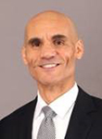  James O'S. Morton,  Vice Chair  2012 - present | James O'S. Morton is the 13th President and CEO of the YMCA of Greater Boston. James joined the Greater Boston Y in 2015 after serving at YMCAs in Hartford, CT and Springfield, MA YMCAs. Prior to joining the YMCA of Greater Boston, James served as President and CEO of the YMCA of Greater Hartford where the Y experienced double digit growth in contributions; developed innovative programming; improved the membership engagement experience; and built many collaborative relationships. He led a successful $15 million capital campaign and launched a new strategic plan to guide the work of the organization.  He also has a deep personal and professional connection to work force development and education having served as a leader to two work force development agencies and as an educator in the Springfield, MA public school system.  James earned a Bachelor of Arts in sociology from the University of Wisconsin and a Juris Doctorate from Northeastern University School of Law. He is a current member of the Massachusetts Bar Association, serves on the Commonwealth of Massachusetts Board of Elementary and Secondary Education, and is a trustee of Springfield College. In addition, he has served on numerous YMCA of the USA committees and task forces around brand management, executive leadership and multiculturalism.  James has a compelling personal history that exemplifies the positive impact that the Y makes. With an African-American father and mother of Irish descent, James laughingly often introduces himself as "Black Irish," and his background and personality provide him with a unique ability to forge meaningful connections with everyone that he meets. James is a world class runner and continues to run competitively. In 2008, James was the national Master's champion and #2 in the world in the 800 meter, in his age bracket.
Katherine Craven  2014 - present | Katherine Craven currently serves as the Chief Administrative Officer of Babson College, one of the nation's leading business colleges. Craven began her career as a budget director and policy advisor to the Massachusetts House of Representatives Committee on Ways and Means. Craven was named Executive Director and Chief Executive Officer of the newly created Massachusetts School Building Authority in 2004, where she won plaudits for her effective management and leadership. While leading the School Building Authority, Craven was also named First Deputy Treasurer of the Commonwealth. Craven left the School Building Authority and the Treasurer's Office in 2011 when she was appointed Executive Director of the UMass Building Authority and Assistant Vice President for Capital Finance for the University of Massachusetts. Craven received a Bachelor of Arts in History from Harvard University. She is a resident of Brookline, where she lives with her husband and four children. Her appointment fills the vacancy left by Board member Beverly Holmes, who stepped down from the Board. Craven fills the business seat on the Board.
Ed Doherty  2014 - present | Ed Doherty's involvement in public schools began more than sixty-five years ago when he entered the first grade at the Patrick F. Lyndon School in West Roxbury. He graduated from Boston Latin School in 1963, and then went on to Boston College. In 1967, Ed began his career in education as an English teacher at Boston Technical High School. While teaching he earned his Master's Degree in Education at Boston State College, and later a Master of Arts in English at UMass Boston.  Ed's family is also heavily involved in public education. His wife Bea is a former ESL teacher in Boston; both their daughters attended the Boston Public Schools (his daughter Allison is now a Special Education teacher at West Roxbury High School); and now Ed and Bea have grandchildren attending the Boston Public Schools at the Franklin D. Roosevelt Elementary School in Hyde Park.  When Ed and Bea's children attended the Boston Schools, they both became very active in the Parent Councils, and in the 70's and 80's Ed served on the Executive Board of the City-Wide Education Coalition. The CWEC was a group of educators, parents, and community leaders dedicated to building and preserving a quality, integrated public school system in Boston.  In 1975 Ed left the classroom to work full time for the Boston Teachers Union. In 1983 he was elected President of the BTU, a position which he held for twenty years. While serving as BTU President he attended Harvard University on a part-time basis and earned his Doctorate Degree in Education. In 2003, Ed left the BTU to become the Special Assistant to the President of the American Federation of Teachers Massachusetts, the position that he currently holds.  Over the years Ed has served on a number of Boards including, the Executive Council of the American Federation of Teachers, the AFT Massachusetts Executive Board, the Executive Council of the Massachusetts AFL-CIO, and MassPartners for Public Education.
Roland Fryer  2015 - 2017 | Roland G. Fryer, Jr. is the Henry Lee Professor of Economics at Harvard University and faculty director of the Education Innovation Laboratory (EdLabs). Fryer's research combines economic theory, empirical evidence, and randomized experiments to help design more effective government policies. His work on education, inequality, and race has been widely cited in media outlets and Congressional testimony.  Professor Fryer was awarded a MacArthur "Genius" Fellowship and the John Bates Clark Medal -- given by the American Economic Association to the best American economist under age 40. Among other honors, he is a fellow of the American Academy of Arts and Sciences and a recipient of the Calvó-Armengol Prize and the Presidential Early Career Award for Scientists and Engineers. At age 30, he became the youngest African-American to receive tenure at Harvard.  His current research focuses on education reform, social interactions, and police use of force. Before coming to Harvard, Fryer worked at McDonald's (drive-thru, not corporate).
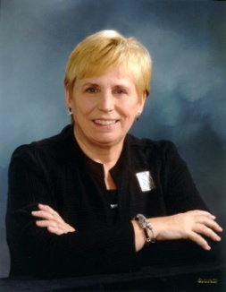  Margaret McKenna  2014 - present; Chair, 2014 - 2015 | Margaret McKenna is an educator and lawyer who has spent her career advocating for social justice. She was appointed the University’s 10th president in 2015. McKenna began her career as a civil rights attorney for the U.S. Department of Justice. Later in her career, she served as the deputy counsel in the White House, as undersecretary of the U.S. Department of Education, and led the education transition team for President Clinton. McKenna’s experience in higher education includes serving as vice president of Radcliffe College and as president of Lesley University for 22 years. She also served as a fellow at the Institute of Politics at Harvard University. During her tenure at Lesley, the college grew from 2,000 to more than 10,000 students, from a college to a university, and from a small regional college to a nationally recognized leader in teacher education. While leading the Walmart Foundation from 2007 – 2011, McKenna created a strategy that emphasized hunger relief, education, and the economic empowerment of women. During her term, the foundation provided more than $900 million in grants annually. McKenna is an author, speaker, and expert on issues of educational access, women’s economic empowerment, hunger, and social change leadership. She has served on five corporate boards and dozens of non-profit boards and is the recipient of 10 Honorary Degrees. She also serves as the vice chair of the Beth Israel Deaconess Medical Center Board.
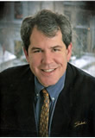  Michael Moriarty  2015 - present | Michael Moriarty is a lifelong resident of Holyoke, where he served for 13 years on the school committee. He was instrumental in the formation of the Holyoke Early Literacy Initiative, a community wide collaborative focused on increasing the number of students that are proficient in reading by the end of third grade. He has also been a vocal advocate for arts education.  In 2013, Attorney Moriarty was named the executive director of a community development corporation based in Holyoke. Olde Holyoke Development Corporation is a mission driven non-profit that believes every resident of Holyoke should live in a dignified home and a safe, attractive neighborhood. Prior to joining the company, he was a practicing attorney focused on real estate and civil matters. In the 1980's, he was a teacher at William R. Peck Junior High School. He has also taught at Holyoke Community College and retains an active educator's license.  He is a graduate of the Catholic University of America (BA '85) and Western New England University School of Law (JD '93). He is married to Attorney Susan Turcotte Moriarty. They are the parents of two children, who like Mike, are proud products of the Holyoke Public Schools.
Penny Noyce  2012 - 2017 | Penny Noyce is a founding trustee of the Noyce Foundation, which since 1991 has supported US public education with a focus on mathematics and science. With a B.A. from Harvard and an M.D. from Stanford, Penny practiced as an internist in Boston and Wellesley for several years. From 1993-2002 Penny was co-PI of the $16 million NSF- and state-funded PALMS initiative to improve mathematics and science education K-12 in Massachusetts. Penny has served on several non-profit and foundation boards including the Libra Foundation, TERC, the Rennie Center of Education Research and Policy, the Concord Consortium, the Gulf of Maine Research Institute, and more. The mother of five children, Penny is a founder of Tumblehome Learning, author of several works of middle grade fiction, and editor of a book on formative assessment in education.
James Peyser Secretary of Education | Jim Peyser was appointed Secretary of Education by Governor Charlie Baker in January 2015. He is the former Managing Director at NewSchools Venture Fund, a non-profit grant-making firm that seeks to transform public education in high-need urban communities by supporting innovative education entrepreneurs. From 1999 through 2006, Secretary Peyser served as Chairman of the Massachusetts Board of Education. Prior to joining NewSchools, Secretary Peyser was Education Advisor to Governors Bill Weld, Jane Swift and Mitt Romney, where he helped shape state policy regarding standards and assessments, school accountability, and charter schools. In 1995, he served as Under Secretary of Education and Special Assistant to Governor Weld for Charter Schools. He spent seven years as Executive Director of Pioneer Institute for Public Policy Research, where he helped to launch the Massachusetts Charter School Resource Center, which supported the development of the state’s first charter schools. Prior to joining Pioneer, Jim held various positions at Teradyne, Inc. in Boston, an electronic test equipment manufacturer.  Jim holds a Master of Arts in Law and Diplomacy from The Fletcher School (Tufts University) and a Bachelor of Arts from Colgate University
Mary Ann Stewart  2014 - present | Mary Ann Stewart was appointed Parent Representative to the Massachusetts Board of Elementary and Secondary Education by (then) Governor Patrick in August 2014. From 2010-2012, she served as President of the Massachusetts PTA and continues to serve on the state PTA Board as a Member-at-Large. She also serves as a member of the National Advisory Council for Media Literacy Now.  Mary Ann is a parent of three and resides in Lexington. She has been active in the schools and in town government, serving as an elected representative to Town Meeting since 2006 and on the School Committee from 2009-2014 where she led as Chair from 2011-2012.  Mary Ann has served in numerous leadership roles at the local, state, and national levels. She is a champion of children, youth, and families, and her experience in organizational development and passion for advocacy and creativity has leveraged engagement in professional and volunteer settings alike. Mary Ann received her Bachelor of Science from the University of Massachusetts for Music Education.
Nathan Moore  June 2016 - June 2017 | Nathan Moore is the 2016-2017 Chair of the State Student Advisory Council (SSAC), elected by his fellow students in June 2016. Nathan served during his junior year at Scituate High School.
Mitchell D. Chester  Commissioner of Elementary and Secondary Education  2008-2017 | Mitchell Chester began serving as Commissioner of the Massachusetts public schools in May 2008 after being unanimously selected by the Board of Elementary and Secondary Education in January.  Dr. Chester began his career as an elementary school teacher in Connecticut, and later served as a middle school assistant principal and district curriculum coordinator. From there he moved to the Connecticut State Department of Education where he oversaw curriculum and instructional programs. In 1997, he was named the Executive Director for Accountability and Assessment for Philadelphia, where he headed the offices of Assessment, Research, and Evaluation, Student and School Progress, and Pupil Information Services. In 2001 he moved to Ohio, where he served as the Senior Associate Superintendent for Policy and Accountability for the Ohio Department of Education, overseeing standards, assessments, accountability, policy development, and strategic planning.  Dr. Chester has presented nationally on accountability, assessment, and teacher induction and retention. He has served as a consultant to states and school districts regarding curriculum and instruction, teacher evaluation, student achievement, and assessment and accountability. Dr. Chester holds a doctorate in Administration, Planning, and Social Policy from Harvard University, as well as advanced degrees from the University of Connecticut and the University of Hartford.

appendices

Appendix 1: Education-Related Laws | i
Appendix 2: Student Data | vi
Appendix 3: Educator Data | vii
Appendix 4: Summary Data | ix
Appendix 5: Agency Information | xi

appendix 1:
Education-Related Laws

Legislation
The following laws relating to the Department of Elementary and Secondary Education (ESE) were enacted during the 2015-2016 189th Legislative Session. The laws are listed in chronological order of approval.
- An Act relative to relative to state personnel
Chapter 19 of the Acts of 2015
Approved: 05/04/15
Effective: 05/04/15
Early Retirement Incentive
- An Act relative to the essex north shore agricultural and technical school district
Chapter 41 of the Acts of 2015
Approved: 06/30/15
Effective: 06/30/15
Extends the deadline for chapter 95 of the Acts of 2014 to take effect. Beginning July 1, 2016, employees of the district will be eligible to participate in all group insurance programs and benefits administered by the group insurance commission.
- An Act establishing a state workforce development board
Chapter 142 of the Acts of 2015
Approved: 12/02/15
Effective: 12/02/15
Establishes a Workforce Development Board to promote innovative and performance driven models for workforce development. The Secretary of Education serves on the Board.
- An Act relative to substance use, treatment, education and prevention
Chapter 52 of the Acts of 2016
Approved: 03/14/16
Effective: 03/14/16
Requires public schools to prepare a substance abuse prevention and education plan, notify parents and students, and file the plan with ESE. ESE, in collaboration with the Department of Public Health (DPH), will provide guidelines on its website to assist schools with developing and implementing the plan and ESE (with DPH) must recommend two grade levels at which students will be screened in schools for substance abuse. Subject to appropriation, districts will use a substance use screening tool that is approved by ESE (with DPH) by the 2017-2018 school year and districts shall report aggregate data within 90 days of screening to DPH. ESE shall notify each school district in writing of the requirement to screen students for substance use disorders pursuant to this section. ESE (with DPH) shall create a notice and opt-out form relative to substance use disorder screenings. MASC, MASS, and MCPSA to report to ESE and the Joint Committee on Mental Health and Substance Abuse on compliance with Chapter 71 Section 96 (substance abuse prevention policy requirement for public schools) by 07/01/16.
ESE’s Guidance on School Policies Regarding Substance Use Prevention is posted at: http://www.doe.mass.edu/sfs/safety/substance-use-prevention.docx.
- An Act to improve public records
Chapter 121 of the Acts of 2016
Approved: 06/13/16
Effective: 01/01/17
Promotes greater electronic access by urging departments to put more documents online and distribute documents that already exist electronically in an electronic format. Requires timely agency response to public records requests.
- An Act modernizing municipal finance and government
Chapter 218 of the Acts of 2016
Approved: 08/09/16
Effective: 07/01/16 through 01/01/18
Primarily makes clarifications to existing municipal statutes around fiscal actions. The law also stipulates prioritization of grant applications representing regional compacts, as well as requiring the Commonwealth’s Operational Services Division to develop a process by which districts can access lower cost textbooks and other educational materials through bulk purchasing.
- An Act relative to job creation and workforce development
Chapter 219 of the Acts of 2016
Approved: 08/10/16
Effective: 08/10/16
The FY17 Economic Development Bill includes a $45.9 million competitive grant program for career and technical schools to purchase and install new equipment, $2.4 million in competitive grant funding for early college programs that allow high school students to earn free college credits towards an associate degree or certificate at partnering institutions of higher education, provides structure for a program to support training to address workforce shortages in the advanced automotive and diesel technician industry, and establishes a special commission to conduct a comprehensive study relative to the practical, economic, fiscal and health related impacts of the commonwealth remaining on eastern daylight time.
- An Act relative to school improvement plans
Chapter 225 of the Acts of 2016
Approved: 09/01/16
Effective: 12/01/16
Clarifies the protocol for school improvement plan submission and approval.
- An Act establishing Massachusetts farm-to-school month and commending farm-to-school programs
Chapter 267 of the Acts of 2016
Approved: 09/21/16
Effective: 09/21/16
Designates October as Massachusetts farm-to-school month and authorizes ESE to collaboratively form a joint taskforce with the department of agricultural resources and the department of public health to strategize regarding opportunities to expand farm-to-school programs statewide.
- An Act requiring automated external defibrillators in schools
Chapter 443 of the Acts of 2016
Approved: 01/13/17
Effective: 07/01/18
Requires school districts, private schools, charter schools, approved private day or residential schools, and collaborative schools to maintain an AED at each of its instructional facilities. ESE is directed through this bill to administer hardship waiver requests submitted by districts in cases where districts are unable to comply with the requirement. In addition, ESE is required to promulgate regulations around the maintenance of the units and to provide districts and aforementioned schools with information about resources available to procure the AEDs.

BUDGET LAWS
FY15
- An Act making appropriations for the fiscal year 2015 to provide for supplementing certain existing appropriations and for certain other activities and projects
Chapter 119 of the Acts of 2015
Approved: 11/02/15 (in part)
Effective: 11/02/15
The fall FY15 supplemental budget appropriated $4.5 million including $3.8 million for mental health counselors in schools and an additional $630,000 in foundation reserve funding. Outside Section 4 provides for consolidated Human Resources for the Department of Higher Education, the Department of Early Education and Care and the Department of Elementary and Secondary Education. Outside Section 34 establishes a task force on child sexual abuse prevention on which the Commissioner of Elementary and Secondary Education sits.
FY16
- An Act making certain appropriations for fiscal year 2016 – General Appropriation Act (GAA)
Chapter 46 of the Acts of 2015
Approved: 07/17/15 (in part)
Effective: 07/01/15
The General Appropriation Act contains total state spending of $38.34 billion, of which ESE receives $5.1 billion, approximately 13.3 percent of the state budget for FY16, over 95 percent of which is local education aid, grant funding, or reimbursement for cities, towns, and regional school districts. The budget plan places particular emphasis on increasing local education aid for districts. The FY16 total appropriation for K-12 education represents an increase of $144.1 million above FY15. The FY16 state budget allocates $27.4 million for ESE to administer its responsibilities, approximately 0.5% of the total state budget for K-12 education.
Some budget line items of particular note:
- Line 7061-0008 appropriates $4.51 billion for Chapter 70 state aid, representing an increase of $111.2M (2.5%) over FY15.
- Line 7061-0012 funds $271.6 million for the Special Education Circuit Breaker program, which is an increase of $18.2 million over the FY15 budget of $253.4 million.
- Line 7035-0006 funding for Regional School Transportation Costs is at $59 million, which is a $2.5 million increase over the FY15 budget of $56.5 million.
New grant programs:
- Line 7061-9812 Child Sexual Abuse Prevention……………………………….$150,000
Some outside sections that are of significance to ESE and elementary and secondary schools:
- Section 3. Requires that health care costs for retired teachers not be considered part of net school spending for any district in which such costs were not considered part of net school spending in fiscal year 1994, and in which such district did not already accept the provisions of chapter 165 of the acts of 2014.
- Section 7. Creates a STEM advisory council on which the Commissioner of Elementary and Secondary Education will serve as an ex-officio member.
- Section 31. Creates an Economic Trust Fund to, in part, establish financial literacy programs as well as college and career readiness programs. The commissioner of elementary and secondary education serves on the board of trustees.
- Section 63. Authorizes the Massachusetts Computing Attainment Network (MassCAN) to collaborate with the department of elementary and secondary education to develop new voluntary computer science standards for K-12.
- An Act making appropriations for the fiscal year 2016 to provide for supplementing certain existing appropriations and for certain other activities and projects
Chapter 70 of the Acts of 2016
Approved: 4/1/2016
Effective: 4/1/2016
The spring FY16 supplemental budget appropriates $1.8 million for the student assessment account.
- An Act making appropriations for the fiscal year 2016 to provide for supplementing certain existing appropriations and for certain other activities and projects
Chapter 283 of the Acts of 2016
This FY16 supplemental budget funds the state student assessment line item 7061-9400 for an additional $8.75 million.
FY17
- An Act making certain appropriations for fiscal year 2017 – General Appropriation Act (GAA)
Chapter 133 of the Acts of 2016
Approved: 07/08/16 (in part)
Effective: 07/01/16
The GAA contains total state spending of $38.9 billion, which reflects spending growth of 1.3 percent ($489 million). This overall spending authorization reflects a downward adjustment in the state revenue growth assumption from 4.3 percent to 3 percent, $838 million in available revenue. The FY17 GAA bill provides total spending authority of $5.208 billion for ESE, which represents 13.4 percent of the total state budget and 1.8 percent growth ($91.3 million) over FY16 spending. Over 95 percent is local education aid, grant funding, or reimbursement for cities, towns, and regional school districts. The FY17 state budget allocates $23.6 million for ESE to administer its responsibilities, approximately 0.45% of the total state budget for K-12 education. In signing the budget, the Governor emphasized a commitment to fund local education aid accounts.
Note: On 12/06/16, the Governor exercised his 9c budget reduction authority. The ESE list totals $6.3M and is targeted to legislative earmarks that the Governor had previously vetoed earlier in FY17 and that were subsequently overridden by the Legislature.
Some budget line items of particular note:
- Line 7061-0008 appropriates $4.63 billion for Chapter 70 state aid, representing an increase of $116,131,419 over FY16.
- Line 7061-0012 funds $277.28 million for the Special Education Circuit Breaker program, which is an increase of $5.56 million over the FY16 budget of $271.6 million.
- Line 7035-0006 funding for Regional School Transportation Costs is at $61 million, which is a $2 million increase over the FY16 budget of $59 million.
Some outside sections that are of significance to ESE and to elementary and secondary schools:
- Section 49. Removes the 5 percent sponsor-district enrollment requirement for virtual schools in Massachusetts.
- Section 165. Requires ESE to conduct a study on the calculation of low-income students within public school districts as it relates to determining the number of low-income students in the distribution of funding pursuant to chapters 70 and 76 of the General Laws and to report findings by December 19, 2016.
- Section 188. Establishes a commission to review how regional school districts are funded with a report due to the legislature by December 31, 2017. The Commissioner appoints a member of the Commission.
- Section 190. Sets up a special commission to study and make recommendations to improve efficiencies relative to transportation for homeless students with a report due to the legislature by July 1, 2017. The Commissioner serves on the Commission.
- Section 193. Establishes a special commission on behavioral health promotion and upstream prevention to investigate evidence-based practices, programs, and systems to prevent behavioral health disorders and promote behavioral health. The Commissioner serves on the Commission, which is required to file a report with the legislature within 2 years of its inception.

appendix 2:
Student Data

2016 Graduation Rate
The 2016 four-year cohort graduation rate for Massachusetts public high schools increased by 0.2 percentage points to 87.5 percent from 87.3 percent for the 2015 cohort. This represents the tenth consecutive year of
increase in the four-year rate (see below).
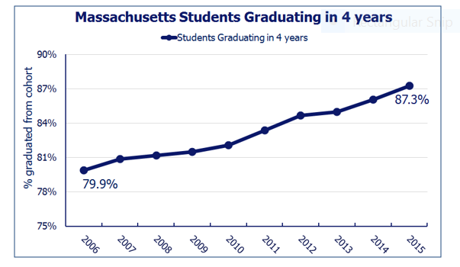

All student subgroups showed increased four-year rates as compared to the 2014 cohort. The largest increase among major racial and ethnic groups was shown by the African-American and Hispanic subgroups, which increased by 1.4 and 0.5 percentage points respectively. There are, however, significant gaps in the graduation rates among subgroups. Among the major race and ethnicity subgroup rates, there is a 20.0 percentage point difference between the highest and lowest, belonging to Asian and Hispanic students. This difference is 0.2 percentage points lower than in 2015.

Other significant findings include:
- The dropout rate for the 2016 cohort was 4.9 percent, the lowest since ESE began calculating cohort dropout rates in 2006 and was 0.2 percentage points lower than the 2015 cohort dropout rate.
- 5.7 percent of the 2016 cohort is still enrolled in high school.
- Hispanic male students graduated at a rate that was 2.9 percentage points higher than the 2015 cohort
- The graduation rate for students with disabilities in the 2016 was 71.8%. This is the first time the students with disabilities subgroup has been above 70% since ESE began calculating cohort graduation rates.

appendix 3:
Educator Data

Teachers in Massachusetts, 2016-2017
Total number of teachers | 72,090
Percent of teachers licensed in teaching assignment | 97.4%
Percent of classes in core academic areas taught by teachers identified as highly qualified | 96.3%
Student to teacher ratio | 13.2 to 1
Average teacher salary* | $74,442
*This number reflects 2016 data.
Source: Massachusetts State Profile – Teachers, http://profiles.doe.mass.edu/. http://profiles.doe.mass.edu/state_report/teachersalaries.aspx

Licensure data
Educator licenses, renewals, and waivers
License | Description | 2016 | 2017
Educator licenses issued* |  | 21,839 | 21,797
Preliminary | First license for people who have not completed an approved educator preparation program; valid for five years | 4,624 | 4,245
Initial | First license for people who have completed an educator preparation program; valid for five years | 10,413 | 10,671
Professional | Second license for people who have been employed for at least three years under an initial license; must be renewed every five years | 5,996 | 6,080
Temporary | Temporary license for experienced teachers from another state; valid for one year | 398 | 421
Vocational | Licenses issued for educators in vocational schools (may be Preliminary, Initial, Professional, or Temporary) | 408 | 380
Endorsement | A supplementary credential issued to an educator licensed under 603 CMR 7.00, or a credential issued to an individual otherwise required by law or regulation to obtain such credential, indicating satisfactory knowledge and skills to perform services in the area(s) specified. | 19,096 | 12,355
Initial Extension | The Initial license is valid for five years of employment and may be renewed at the discretion of the Commissioner for an additional five years | 830 | 967
Renewals and waivers issued**
Renewals | Renewals of professional licenses for experienced educators*** | 11,174 | 11,309
Waivers | Waivers of licensure requirements for districts that have made a good-faith effort to hire a licensed or certified educator for a particular position but have been unable to find one | 938 | 1,089
Notes: The descriptions of the licenses are in general terms and are not meant to fully detail all the pathways to each license.
*Data are for calendar years.
**Data are for fiscal years.
***The licensure renewal cycle requires educators that hold a professional license to renew every five years. 2019 (June) will be the fifth major renewal cycle since the implementation of license renewal.
Source: Educator Licensure Office.

Closing the Equity Gap

Massachusetts has much to be proud of in K-12 public education. Our schools are recognized as best in class among the states, and our students perform at academic levels commensurate with the highest performing education systems in the world. Yet despite our overall success, substantial gaps in student outcomes persist in our state, and too often, those gaps are correlated with students’ racial/ethnic identification, family economic background, disability status, and English language proficiency.
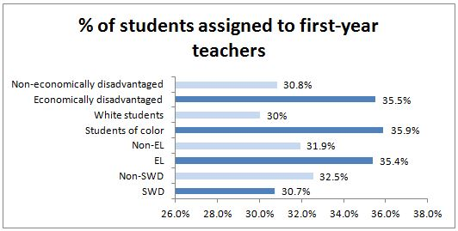
When analyzing statewide data at the student level, students who are economically disadvantaged, students of color, or ELs are more likely to be assigned to first-year teachers. The adjacent graph shows the proportion of students in a subgroup assigned to at least one first-year teacher. While ESE does not assume that less experienced educators are uniformly less effective, the substantial gaps in student access to experienced teachers call for further analysis and action.

appendix 4:
Summary Data

Districts and schools, 2016-2017
Districts |  | 404
Schools |  | 1,851
 | Elementary | 1,140
 | Middle/junior high | 314
 | High school | 397
Commonwealth Virtual Schools |  | 2
Educational Collaboratives |  | 26
Charter Schools
 | Commonwealth | 69
 | Horace Mann | 9

Enrollment by Race/Ethnicity, 2016-2017
 | % of State
African American | 8.9
Asian | 6.7
Hispanic | 19.4
Native American | 0.2
White | 61.3
Native Hawaiian, Pacific Islander | 0.1

Enrollment by GENDER, 2016-2017
 | State
Male | 488,985
Female | 464,716
Total | 953,748

Chapter 70 aid, FY17
 | State total
Foundation enrollment* | 940,103
Foundation budget* | $10,128,238,383
Required minimum local contribution | $5,926,185,567
Chapter 70 aid | $4,628,013,619
Required net school spending | $10,554,199,186
Actual net school spending | $13,073,856,642
*For further explanation of this terminology, see School Finance: Chapter 70 program.
http://finance1.doe.mass.edu/chapter70/
Source: FY17 Chapter 70 Aid and Net School Spending Requirements, Net School Spending Trends
http://www.doe.mass.edu/finance/chapter70/

Per pupil expenditures, FY16
Pupils
 | Enrolled at the district | 905,677
 | Tuitioned out of district | 73,251
 | Total pupils | 978,928
Expenditures per pupil in the district |  | $15,024
 | Administration | $550
 | Instructional leadership | $1,017
 | Classroom and specialist teachers | $5,832
 | Other teaching services | $1,241
 | Professional development | $207
 | Instructional materials, equipment, and technology | $468
 | Guidance, counseling, and testing | $460
 | Pupil services | $1,501
 | Operations and maintenance | $1,129
 | Insurance, retirement, and other | $2,619
Total expenditures |  | $15,217,355,731
Total expenditures per pupil |  | $15,545

Source: http://www.doe.mass.edu/finance/statistics/

appendix 5:
Agency Information

State education funding, FY17 Budget Summary
7010-0005 | Department of Elementary and Secondary Education | $12,473,413
7010-0012 | Programs to Eliminate Racial Imbalance - METCO | $20,642,582
7010-0020 | Bay State Reading Institute | $133,333
7010-0033 | Literacy Programs | $1,620,000
7027-0019 | Connecting Activities | $2,998,750
7027-1004 | English Language Acquisition | $1,743,981
7028-0031 | School-Age Children in Institutional Schools and Houses of Correction | $8,126,495
7035-0002 | Adult Basic Education | $28,824,073
7035-0006 | Transportation of Pupils - Regional School Districts | $61,021,000
7035-0007 | Non-Resident Vocational Students Transportation | $250,000
7035-0008 | Reimbursement for Transportation of Homeless Students | $8,350,000
7035-0035 | Advanced Placement Math and Science Programs | $2,700,000
7053-1909 | School Lunch Program | $5,426,986
7053-1925 | School Breakfast Program | $4,421,322
7061-0008 | Chapter 70 Payments to Cities and Towns | $4,628,013,618
7061-0012 | Circuit Breaker - Reimbursement for Special Education Residential Schools | $277,281,180
7061-0029 | Educational Quality and Accountability | $890,322
7061-0033 | Public School Military Mitigation | $1,300,000
7061-9010 | Charter School Reimbursement | $80,500,000
7061-9200 | Education Technology Program | $770,481
7061-9400 | Student and School Assessment | $34,471,782
7061-9406 | College and Career Readiness | $233,334
7061-9408 | Targeted Intervention in Underperforming Schools | $7,391,120
7061-9412 | Extended Learning Time Grants | $14,174,528
7061-9611 | After-School and Out-of-School Grants | $2,240,001
7061-9612 | Safe and Supportive Schools Grant | $400,000
7061-9619 | Franklin Institute of Boston | $1
7061-9626 | Youth-Build Grants | $2,000,000
7061-9634 | Mentoring Matching Grants | $500,000
7061-9810 | Regional Bonus Aid | $110,000
7061-9812 | Child Sexual Abuse Prevention | $150,000
 | TOTAL | $5,202,153,096

Retained Revenues
7061-9601 | Teacher Certification Retained Revenue | $1,746,349

Source: http://www.mass.gov/bb/gaa/fy2017/app_17/dpt_17/hdoe.htm

The four subject-specific high school science and technology/engineering tests given in grades 9 and 10 — Biology, Chemistry, Introductory Physics, and Technology/Engineering — are counted here as one operational test.
⁸ Working Paper 12155, 2006.; Rice, J.K. The impact of teacher experience: Examining the evidence and policy implications. Calder Brief 11. Washington, DC: National Center for the Analysis of Longitudinal Data in Education Research (CALDER), Urban Institute, August 2010.

