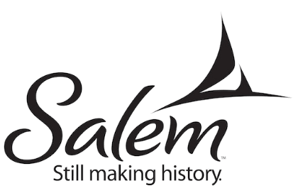
Providing Equity and Access Through Standards-Based Curriculum

On its face, curriculum development represents a distinctly technical aspect of the teaching and learning process. However, the critical function of a high-quality curriculum goes deeper - and that is to ensure equity by providing all students access to high expectations, while at the same time, providing the scaffolds and supports they need to master grade-level standards.

At Salem Public Schools, educators worked in teams to identify what students at each grade level needed to know and be able to do. Guided by the state frameworks and other national curriculum documents, they wrote comprehensive curriculum maps. In some cases, curriculum writing was entrusted to valued partners. The resulting maps are living documents that are shared through an online curriculum mapping system, Atlas Rubicon. Each year, these maps are revisited and updated based on educator feedback. See a sample curriculum map here.

At first, some teachers were wary. They worried that having to follow curriculum maps and pacing guides would curtail their ability to make instructional decisions based on the needs of their students, or that they would have to teach in lockstep (“If it is Tuesday, you should be on Lesson 10”). As time has passed, they have recognized that professional judgment, instructional choice, and personal creativity continue to play a significant role in delivering curriculum. As teachers meet to plan an upcoming set of lessons, they use Atlas maps as an essential tool to set the context for the overarching ideas of the unit and the specifics about expected student outcomes. They have appreciated that curriculum maps are enhanced by the inclusion of state-of-the-art materials and resources.

To see grade 8 teachers using a curriculum map to preview unit vocabulary, go to Gr. 8 Tiered Vocabulary Discussion (3:24)

One of the factors leading to the successful implementation of curriculum maps has been the involvement of a cadre of experienced, dedicated content coaches. They assist grade level teams in unpacking the standards, planning aligned assessments, leading curriculum map development work, and implementing resources that are both current and culturally responsive. They support teachers in planning inquiry-based, student-centered lessons that incorporate accessibility scaffolds. (To view the "Look-fors for Accessibility Scaffolds, click here.)

To see a vertical team previewing a unit with a science coach, go to: Gr. 3-5 Science Planning (7:21)

Middle School ELA Teachers Planning from Curriculum Maps  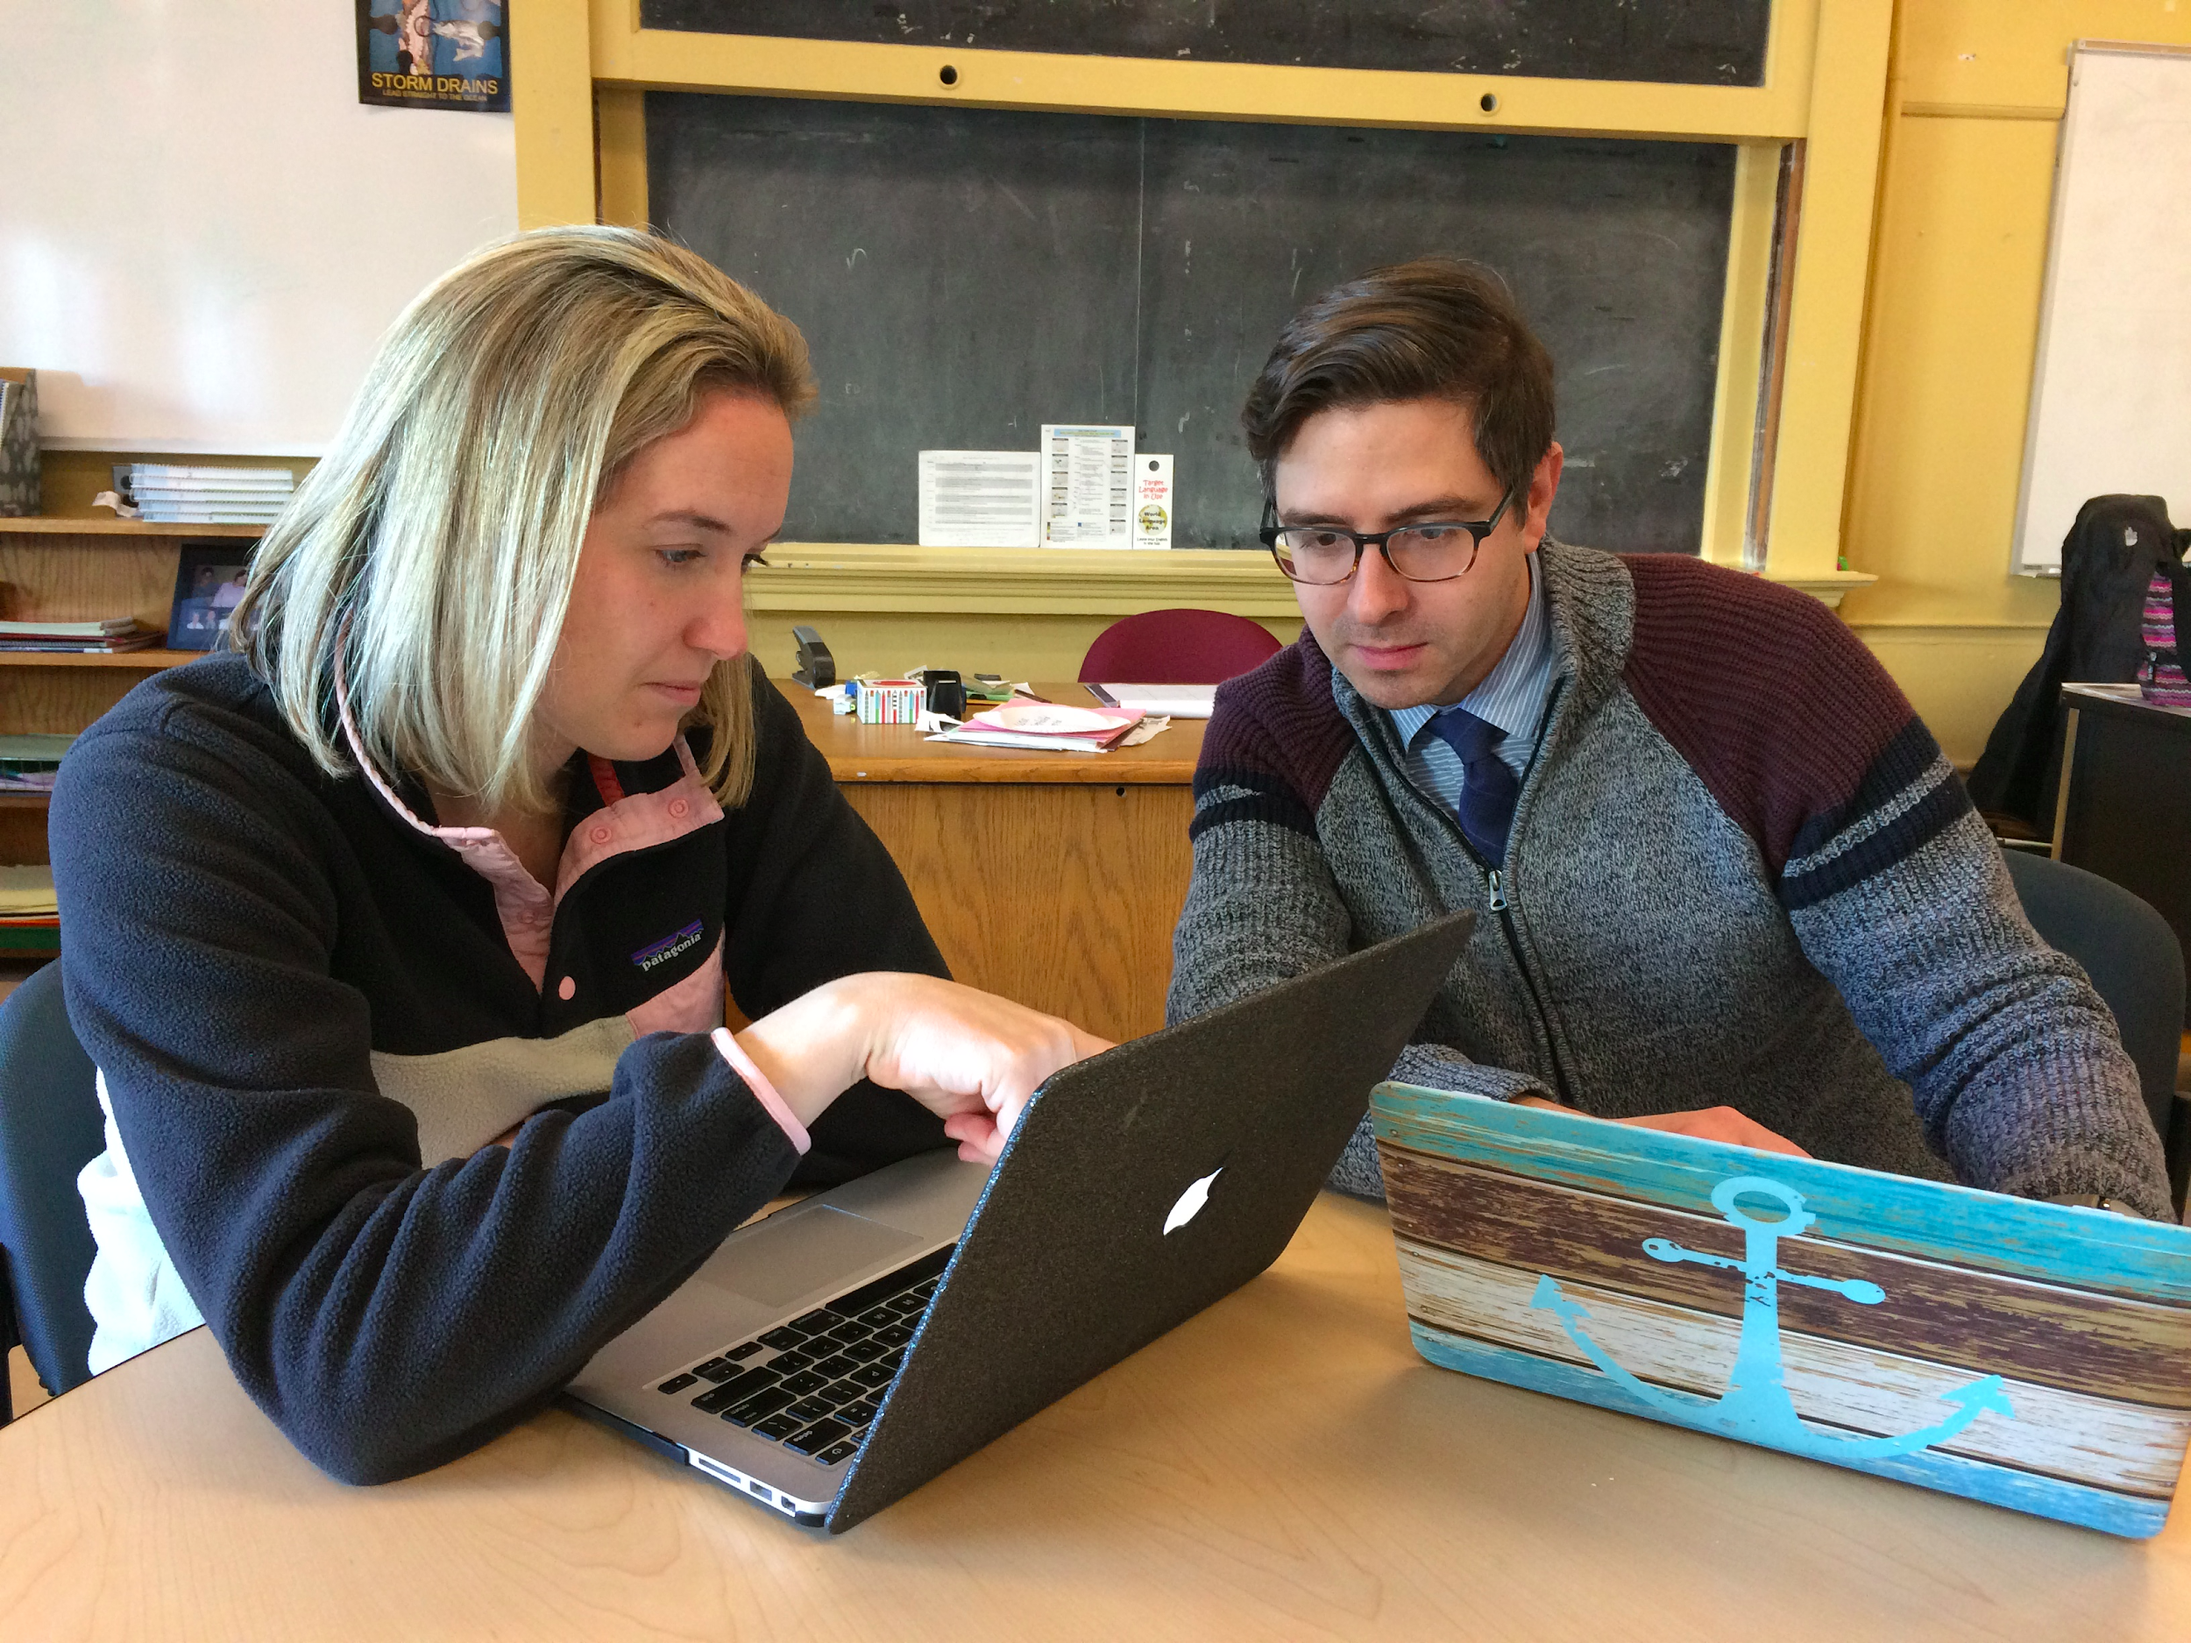 | Grade 4 Math Units  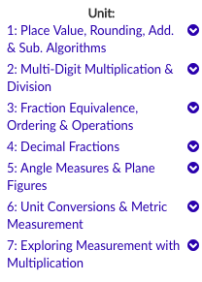 | New science books!

Salem strives to stay ahead of the curve by aligning to new frameworks while still in draft form. This helps teachers to adjust their instruction well before state assessment expectations shift.

In November 2018, elements of SPS curriculum maps were made public so that parents, community members, and others could gain insight into what students at each grade level were learning. High school maps are scheduled to be added soon. (Note: The public version does not include assessments, lesson plans, or specific resources.) To see the public version of Salem’s curriculum maps, go to Salem Public Schools Curriculum.

