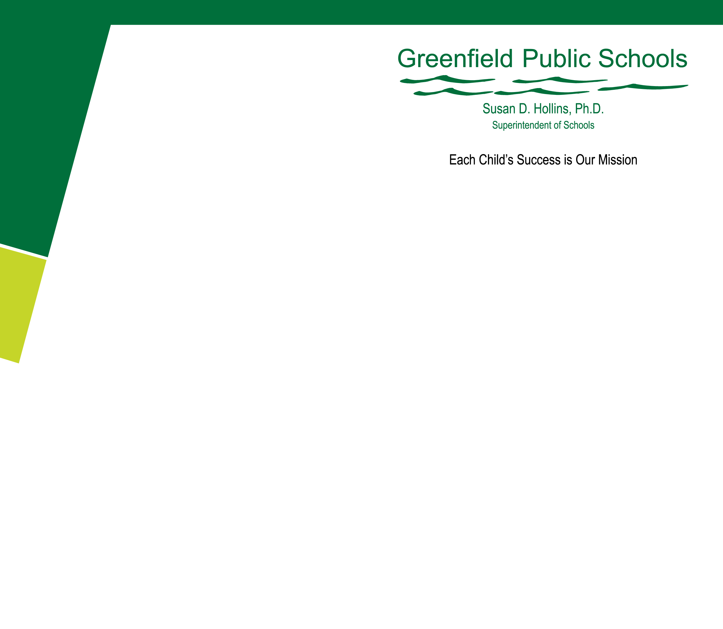

Commissioner Mitchell Chester

Department of Elementary and Secondary Education

75 Pleasant Street

Malden, MA 02148-4906

May 7, 2012

RE: Waiver Request

Dear Commissioner Chester:

I am pleased to report that Greenfield’s virtual innovation school had a successful second year. We have grown slightly and are increasingly sophisticated in virtual public schooling.

Our school is in compliance with current state guidelines and we are meeting Greenfield’s own specific virtual school goals. We have experienced, certified district administrative personnel (Superintendent, Special Education, Business, and Principal) overseeing and consulting together on operations and complex issues, such as attendance, special education, and state testing. A committee of the school committee provides oversight and needed policies. Our attorney has worked with us on unique, technical guidelines. As needed, Jeff Wulfson who is always helpful and DESE program directors have consulted with us. In sum, we will soon complete the first two and most difficult years of a complex new schooling model in Massachusetts. Most important, Greenfield’s school provides a new option for students.

During the 2011-2012 school year, our enrollment has been 450-475 students, grades K-9

(plus a few older Greenfield students). Among our accomplishments:

* Revising our application/enrollment process to better address information and guidance to potential students and families, resulting in higher retention,
* Increasing our capacity from 298 students to approximately 450-475 students,
* Implementing monthly, community-based programs for students and families,
* Implementing rigorous, virtual school professional development for our teachers, particularly as regards monitoring student achievement,
* Working successfully with school districts for our students involved with special education (a complex issue); all districts currently are providing IEP services and assisting with state MCAS requirements for their virtual school students,
* Conducting an internal audit of the first year, making any needed adjustments with districts as regards the state’s required tuition billing process (now abandoned),
* Creating attendance policies and guidelines that conform to state requirements,
* Working with our curriculum provider, K12, to make adjustments so our virtual school is in compliance with our school system policies and our specific innovation plan,
* Implementing the MCAS statewide with 97-98% participation,
* Improving our logistical operations, which includes 100% student access to computer equipment, telecommunication services, and technical support,
* Being vigilant notifying Superintendents as to their students joining and leaving the virtual school.

We now have four years of experience and time investment—two planning and two implementation—and we believe our efforts are making a significant contribution to Massachusetts.

We have worked closely with our curriculum provider, K12 Inc. All our requests for revisions have been met, including contract and procedures. With new school models, a plethora of reports emerge pro and con; our experience, although arduous, has been positive for working with our chosen virtual curriculum provider. This year we have an experienced virtual school administrator on our team helping us fine tune procedural issues. We emplaced new strategies to assure students joining the virtual school better understand that our particular school is rigorous, competency based, and requires daily participation. We have learned that there will

be more movement in and out of the virtual school for the very reasons that students seek this option; for example, students with health concerns may become healthier or more ill. We actually have one student who took her computer and program into the hospital with her to continue her education during treatments.

We again request a waiver of the current Board of Elementary and Secondary Education’s regulations 603 CMR 48.05(2)(b,c,d)—enrollment limits. The reasons for this request are fourfold: 1) we believe we have demonstrated our careful, successful management of the state’s first virtual school, 2) we have made a significant, all-district investment bringing this particular innovation virtual school to fruition under an approved school committee innovation plan and wish to continue, 3) it is unlikely that more than 1% of a school district’s student population would choose a virtual public school and the current rule for enrollment percentage requirement is unrealistic; we request continuing with a 2% requirement if this rule is not abandoned, and 4) we request a modest increase to 750-800 students so we can serve new students in higher grades. We anticipate our current grade K-9 students continuing.

To be honest, many of the older students requesting admission for reasons of health, pregnancy, bullying/safety, or unique career interests have no viable options. We need approx. 300 students to support the high school staff needed. In 2011-2012, we had 276 students in grades 9-12 apply, hoping the state would reconsider its position. Our keen interests continue to be students whose reasons for applying are mental and physical health, pregnancy and child care, unique career interests, and bullying/personal safety. We hope to persuade you that this small number seeking a viable alternative should be allowed. It is difficult to hear stories from students, parents, and even school districts and have to explain the current guidelines.

Thank you for your consideration. Our school system looks forward to continuing Greenfield’s quality, cost-effective virtual school that is providing a needed alternative to a small but important group of Massachusetts students.

Sincerely,

Susan D. Hollins, Ph.D.

Superintendent