Martin Luther King, Jr. Charter School of Excellence – Report on Probationary Conditions
January 2013
Massachusetts Department of Elementary and Secondary Education
75 Pleasant Street, Malden, MA 02148-4906
Phone 781-338-3000 TTY: N.E.T. Relay 800-439-2370
www.doe.mass.edu

This document was prepared by the
Massachusetts Department of Elementary and Secondary Education
Mitchell D. Chester, Ed.D.
Commissioner

The Massachusetts Department of Elementary and Secondary Education, an affirmative action employer, is committed to ensuring that all of its programs and facilities are accessible to all members of the public.
We do not discriminate on the basis of age, color, disability, national origin, race, religion, sex, gender identity, or sexual orientation.
Inquiries regarding the Department’s compliance with Title IX and other civil rights laws may be directed to the
Human Resources Director, 75 Pleasant St., Malden, MA 02148-4906. Phone: 781-338-6105.

© 2012 Massachusetts Department of Elementary and Secondary Education
Permission is hereby granted to copy any or all parts of this document for non-commercial educational purposes. Please credit the “Massachusetts Department of Elementary and Secondary Education.”

This document printed on recycled paper

Massachusetts Department of Elementary and Secondary Education
75 Pleasant Street, Malden, MA 02148-4906
Phone 781-338-3000 TTY: N.E.T. Relay 800-439-2370
www.doe.mass.edu

Martin Luther King, Jr. Charter School of Excellence

Type of Charter | Commonwealth | Location | Springfield
Regional/Non-Regional | Non-Regional | Districts in Region | NA
Year Opened | 2006 | Year Renewed | 2011
Maximum Enrollment | 360 | Current Enrollment | 366
Waitlist | 142 | Grade Span | K-5

Mission statement: “Martin Luther King, Jr. Charter School of Excellence prepares kindergarten through 5th grade students of Springfield for academic success and engaged citizenship through insistence on rigorous, challenging work. The school incorporates Dr. King’s commitment to the highest standards in scholarship, civic participation and the ideal of the beloved community.”

Report on Conditions

In January 2011, the Board renewed the charter of MLK with probationary conditions that required the school make major improvements in academic performance, school leadership, and school programs. The following is a report on the progress the school has made in terms of the conditions imposed.

Condition 1: By December 2012, Martin Luther King, Jr. Charter School of Excellence shall demonstrate that it is an academic success by:
- meeting academic growth standards as established by the Department, or by making Adequate Yearly Progress (AYP) in the aggregate and for all statistically significant subgroups in English language arts and mathematics by 2012; and
- providing evidence to the Department that the school has met or is making substantial progress towards meeting all benchmarks in its 2011-2016 accountability plan.

Status: Met
In 2012, MLK achieved strong median student growth percentiles (SGP) for mathematics and adequate growth for English language arts (ELA). Please see the table below:

MLK Median Student Growth Percentile
Year | 2009 | 2010 | 2011 | 2012
English Language Arts | 48.0 | 44.0 | 32.0 | 50.5
Mathematics | 27.0 | 32.0 | 55.0 | 73.0

As shown in the graphs below, however, MLK has not demonstrated gains in absolute ELA scores since the imposition of conditions. The school’s CPI in ELA has fallen in the last two successive administrations of the MCAS. Conversely, MLK has seen substantial gains in overall mathematics CPI since 2010. Since 2010, aggregate mathematics performance has increased by 14.4 points. Additionally, in 2011, MLK did not make AYP in ELA for the aggregate or for subgroups. In 2011, MLK made AYP for the aggregate in mathematics, but not for all subgroups.

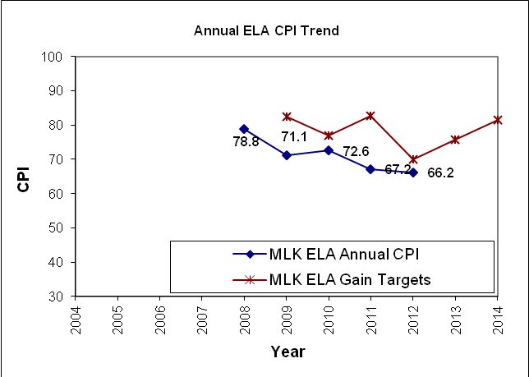

In 2012, MLK met a majority of measures contained in its accountability plan.

Condition 2: No later than December 2011, Martin Luther King, Jr. Charter School of Excellence shall provide evidence of a fully documented curriculum that is aligned to the Massachusetts curriculum frameworks.

Status: Met after deadline
During the year six site visit, in the 2011-12 school year, site visitors determined that the school had partially met this measure. At the time of the visit, MLK had fully documented curriculum maps for each subject area: English language arts, mathematics, social studies, and science. The curriculum maps were aligned to the Common Core or Massachusetts curriculum frameworks as required. Unit plans, however, were not yet fully documented. A unit plan template was in place and had been used to create unit plans for all units taught so far in the school year. School administrators reported that once the unit plans were complete and in place, the school would have a fully documented curriculum. By the end of the 2011-12 school year, MLK teachers finished creating unit plans. During the summer of 2012, the school’s instructional leader reported that the units were realigned to curriculum maps and the entire curriculum was reviewed for alignment to the Common Core and state standards.

Condition 3: No later than June 30, 2011, Martin Luther King, Jr. Charter School of Excellence shall provide to the Charter School Office an evaluation of its leadership structure, an organizational chart with accompanying job descriptions, and a plan to fully staff the administrative structure.

Status: Met
As required by the conditions, MLK evaluated its leadership structure, developed a new organizational chart to fit the school’s needs, and has fully staffed its administration. In May 2011, MLK submitted to the Charter School Office an evaluation of its leadership structure, a revised organizational structure, and job descriptions for the administrative team. The school also submitted a plan to fully staff the administrative structure. With the hire of a new instructional leader in June 2011, the school’s administrative structure was fully staffed.

