Seven Hills Charter Public School – Report on Probationary Conditions
January 2013
Massachusetts Department of Elementary and Secondary Education
75 Pleasant Street, Malden, MA 02148-4906
Phone 781-338-3000 TTY: N.E.T. Relay 800-439-2370
www.doe.mass.edu

This document was prepared by the
Massachusetts Department of Elementary and Secondary Education
Mitchell D. Chester, Ed.D.
Commissioner

The Massachusetts Department of Elementary and Secondary Education, an affirmative action employer, is committed to ensuring that all of its programs and facilities are accessible to all members of the public.
We do not discriminate on the basis of age, color, disability, national origin, race, religion, sex, gender identity, or sexual orientation.
Inquiries regarding the Department’s compliance with Title IX and other civil rights laws may be directed to the
Human Resources Director, 75 Pleasant St., Malden, MA 02148-4906. Phone: 781-338-6105.

© 2012 Massachusetts Department of Elementary and Secondary Education
Permission is hereby granted to copy any or all parts of this document for non-commercial educational purposes. Please credit the “Massachusetts Department of Elementary and Secondary Education.”

This document printed on recycled paper

Massachusetts Department of Elementary and Secondary Education
75 Pleasant Street, Malden, MA 02148-4906
Phone 781-338-3000 TTY: N.E.T. Relay 800-439-2370
www.doe.mass.edu

Seven Hills Charter Public School

Type of Charter | Commonwealth | Location | Worcester
Regional/Non-Regional | Non-Regional | Districts in Region | NA
Year Opened | 1996 | Year Renewed | 2001, 2006, 2011
Maximum Enrollment | 666 | Current Enrollment | 665
Waitlist | 283 | Grade Span | K-8

Mission statement: “The mission of Seven Hills Charter Public School is to prepare a diverse cross section of Worcester children for success as students, workers, and citizens by providing them with a high quality education at prevailing public school costs.”

Report on Conditions

In February 2011, the Board renewed the charter of SHCPS with probationary conditions that required the school to make major improvements in academic performance, school leadership, and board oversight. Below is a report on the progress made in meeting the conditions.

Condition 1: No later than March 31, 2011, Seven Hills Charter Public School shall submit to, and receive approval from, the Charter School Office the following:

a comprehensive school self-evaluation that determines the strategies to be used to address academic underperformance of the school. The self-evaluation and subsequent corrective actions should include, but not be limited to:

      - a comprehensive evaluation of the school’s current academic program, and a plan to implement proven curricular and instructional programs;
      - a comprehensive evaluation of school leadership and a plan to staff an effective administrative structure; and
      - a comprehensive evaluation and plan for any necessary development of the board of trustees to ensure that the members have the skills and experience required to implement changes in leadership and programs and to oversee the school on an ongoing basis.

The evaluation must include an action plan with a timetable for the implementation of corrective actions, must set deadlines for the completion of key tasks, and must set clear and specific implementation benchmarks to allow the Charter School Office to monitor implementation.

Status: Met
SHCPS submitted a self-evaluation and action plan on March 9, 2011. The Charter School Office finalized and approved the action plan on March 29, 2011. The action plan outlines the process by which the school evaluated its program, how the school selected external partners to help with corrective actions, the school’s strengths, the school’s weaknesses, the corrective actions to be taken, dates of action implementation, and how the school will evaluate the success of the action. The document provides an evaluation of and corrective action plan for the school’s academic program, leadership structure, and board of trustees. School administrators have provided the SHCPS’s board of trustees and Charter School Office with periodic updates on plan implementation. Updates provided to the Charter School Office, as well as site visits conducted to the school, confirm that SHCPS is meeting its implementation benchmarks as outlined in the school’s action plan.
Condition 2: No later than May 31, 2011, Seven Hills Charter Public School shall have completed the process to receive approval from the Charter School Office for an Accountability Plan, including objectives and measures regarding academic success, organizational viability, and faithfulness to charter in alignment with the implementation benchmarks of the self-evaluation.

Status: Met
SHCPS submitted a draft Accountability Plan to the Charter School Office prior to the required deadline. The plan was finalized and used to evaluate the school’s performance beginning in the 2011-12 school year, as intended by the condition.

Condition 3: By December of 2012, Seven Hills Charter Public School shall demonstrate that it is an academic success by:
  - meeting academic growth targets in English language arts and mathematics, as established by the Department of Elementary and Secondary Education, or
  - achieving Adequate Yearly Progress in the aggregate and for all statistically significant subgroups in English language arts and mathematics by 2012, and
  - by meeting the goals and objectives established in the school’s Accountability Plan.

Status: Met
As shown in the table below, in 2012, SHCPS achieved a median student growth percentile (SGP) above the state median of 50 in English language arts (ELA). The school’s mathematics SGP was slightly below the state median in 2012.

SHCPS Median Student Growth Percentile
Year | 2009 | 2010 | 2011 | 2012
English Language Arts | 34.5 | 40.0 | 37.0 | 60.0
Mathematics | 42.0 | 41.0 | 53.0 | 49.0

As shown in the graphs below, overall MCAS performance as measured by CPI has improved in both ELA and mathematics since 2010. Mathematics scores have shown steady improvement since 2009. ELA scores showed slight improvement in 2011, followed by a large improvement in 2012. SHCPS, however, did not make AYP for English language arts or mathematics in 2011 in the aggregate or for subgroups.

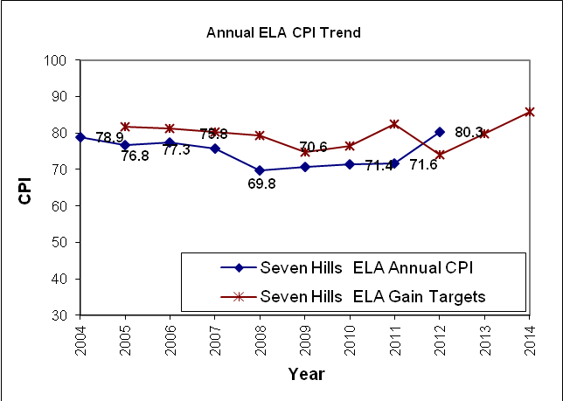

In 2012, the school met all of its measures contained in its accountability plan.

