Massachusetts Department of

Elementary and Secondary Education

75 Pleasant Street, Malden, Massachusetts 02148-4906 Telephone: (781) 338-3000

TTY: N.E.T. Relay 1-800-439-2370

Mitchell D. Chester, Ed.D.
Commissioner

MEMORANDUM

To: | Members of the Board of Elementary and Secondary Education
From: | Mitchell D. Chester, Ed.D., Commissioner
Date: | October 18, 2013
Subject: | Charter Schools – Update Regarding Spirit of Knowledge Charter School (Probation)

This memorandum provides an update regarding the Spirit of Knowledge Charter School (SOKCS) and its probation. The Board of Elementary and Secondary Education (Board) placed SOKCS on probation in May 2013 and imposed nine conditions on the school’s charter. In May, the fiscal health of the school was noted as a concern. Currently, a lower than expected student enrollment has required the school to make budget cuts and lay off staff. Moreover, the school’s academic performance continues to be very poor, as shown by the results of the most recent MCAS administration. At this point, I have deep concern about the viability of this school.

We will discuss this update as well as further possible action at our October meeting.

Mission Statement

“The Spirit of Knowledge Charter School’s 7th through 12th grade Worcester students will create value in their lives and the lives of others through high-standards academic learning, especially in math, science and technology, gaining admission to college, and developing a positive character.”

Type of Charter | Commonwealth | Location | Worcester
Regional/Non-Regional | Non-Regional | Districts in Region | NA
Year Opened | 2010 | Current Enrollment | 158
Maximum Enrollment | 275 | Students on Waitlist | unknown
Chartered Grade Span | 7-12 | Current Grade Span | 7-12

School History

On May 10, 2013, I recommended that the Board place SOKCS on probation. In my memorandum recommending probation, I outlined concerns regarding the ability of SOKCS to manage the school effectively. By the end of its third year of operation, SOKCS was struggling in nearly all aspects of school operation. The school did not have promising academic results, was not faithful to the terms of its charter, had instability in governance and leadership, did not implement a clear educational program, had a board of trustees that provided minimal oversight, lacked fiscal health, and had low enrollment. At that meeting, the Board placed the school on probation and imposed nine conditions on the school’s charter.

Current School Status

Enrollment data and financial status

In March 2013, SOKCS reported 214 students as pre-enrolled for grades 7-12. Actual enrollment on the first day of school was 170 students. As of this week, enrollment has declined to 158 students.
The budget for FY14 included in the school’s annual report was based upon an enrollment of 185 students. The school has subsequently provided updated cash flow projections to the Department that depend upon a line of credit or further staffing cuts for the school to continue in operation. As noted in my earlier memo, the financial audits for the past two years have noted significant deficiencies in internal controls. In the current fiscal year, the reduction in expected revenues and the lack of any significant cash reserves has left the school with little or no margin for unexpected circumstances. The Department continues to monitor the situation very closely.
MCAS performance

In 2013, SOKCS administered the MCAS tests for the third time to its students. The school’s MCAS scores for 2013 declined in all three areas: English language arts (ELA), mathematics, and science. The school’s 2013 median student growth percentiles (SGP) display low growth: 39.0 for ELA and 23.0 for mathematics.

SOKCS Median SGP
Year | 2011 | 2012 | 2013
ELA (all grades) | 34.5 | 47.0 | 39.0
Mathematics (all grades) | 21.0 | 37.0 | 23.0

Proficiency rates for mathematics and science remain low for SOKCS, and rates declined for ELA in 2013.

SOKCS Aggregate Proficiency Rates (Advanced and Proficient)
Year | 2011 | 2012 | 2013
ELA (all grades) | 66% | 69% | 55%
Mathematics (all grades) | 26% | 33% | 20%
Science (all grades) | N/A | 24% | 19%

SOKCS has not yet been assigned an Accountability and Assistance Level under the Commonwealth’s school accountability system, because the school does not yet have four years of testing data. In 2013, however, the school received an Annual Progress and Performance Index (PPI) of four (4) points. The Department considers a school on target for narrowing proficiency gaps if the school receives a PPI of at least 75 points. The tables below illustrate Composite Performance Index (CPI) scores in ELA, mathematics, and science for SOKCS as compared to the school’s targets for narrowing proficiency gaps. CPI performance declined in all subjects in 2013.

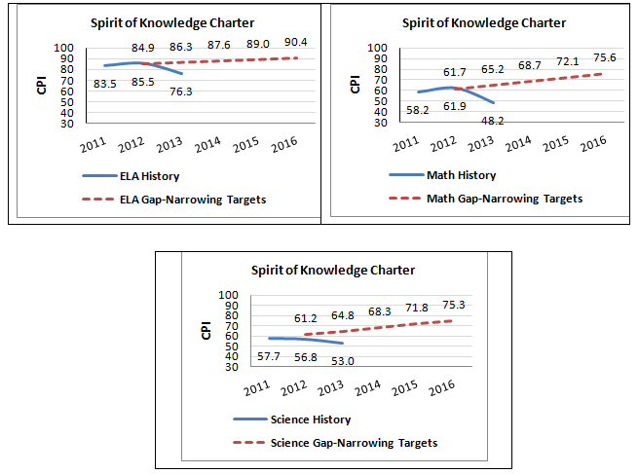

Report on Conditions

Below is a summary of the school’s progress toward meeting the nine conditions imposed in connection with placing the school on probation. While we have not yet reached the deadline for many conditions, SOKCS has met one condition and partially met two.

Condition 1: Beginning in May 2013 and until further notice, the school must submit to the Department of Elementary and Secondary Education (Department), at charterschools@doe.mass.edu or 75 Pleasant St., Malden, MA, 02148, board meeting agendas, materials, and minutes prior to each board meeting at the same time that these items are sent to the school’s board members. The Department reserves the right to require the submission of additional information, such as quarterly or monthly financial statements, if board materials do not already include this information, and the school must provide such additional information within two business days.
Status: In process
The school has submitted meeting agendas, materials, and minutes prior to each meeting. This condition is ongoing.

Condition 2: By July 1, 2013, the school must submit a facilities plan. This plan must align with the growth plan specified in the school’s charter and must include timelines for leasing, construction, and improvements to ensure that the school’s facility is programmatically accessible for the remainder of the charter term.
Status: Met
The school submitted a plan by July 1, 2013. During the summer, school administrators negotiated with the school’s landlord and received the use of additional, programmatically accessible space in the current facility.

Condition 3: By August 1, 2013, the school must submit an annual report for FY13 in accordance with the requirements outlined in the Annual Report Guidelines, including an updated recruitment and retention plan.
Status: Partially met
The school submitted an annual report by August 1, 2013. The school had to revise its annual report and resubmit it due to incomplete financial statements. The revised annual report has not yet been received.

Condition 4: By October 1, 2013, the school’s board of trustees will engage in training conducted by an external consultant, acceptable to and approved in advance by the Department, on the roles and responsibilities of a board of trustees for a charter school.
Status: Partially met
The school’s board of trustees engaged a consultant who provided training on June 22, 2013. The school did not ask for approval of the consultant in advance of the training.

Condition 5: By November 1, 2013, the school must submit its annual financial audit for FY13 in accordance with the requirements outlined in the Massachusetts Charter School Audit Guide (http://finance1.doe.mass.edu/charter/charter_audit.html). Such audit must indicate that the school has resolved all concerns indicated in the findings of prior audits and management letters.
Status: Not yet due

Condition 6: By December 31, 2013, the school’s board of trustees must have completed a comprehensive self-evaluation of its own capacity and must have recruited additional board members with needed expertise. Such new members must have been approved by the Department and be sufficient to meet the minimum number of members (seven) specified in the school’s bylaws.
Status: In process
On June 3, 2013 the school’s board of trustees submitted an amendment request to change its bylaws to reduce the minimum number of required elected members from seven to five. On October 10, 2013, I granted approval of five new members of the school’s board of trustees, bringing total membership to eight.

Condition 7: By December 31, 2013, the school’s board of trustees must develop and implement a formal system of evaluation for the executive director.
Status: Not yet due

Condition 8: By December 31, 2013, the school must provide documented evidence, corroborated through site visits, of consistent implementation of the key elements of its educational program in alignment with its charter. Alternatively, the school’s board of trustees must request and receive approval for an amendment to its charter that accurately reflects the school’s educational program.
Status: Not yet due

Condition 9: By December 31, 2014, the school must demonstrate that it is an academic success by providing affirmative evidence of significant improvement in academic performance in English language arts, mathematics, and science.
Status: Not yet due
While this particular condition is not yet due, the 2013 results, as discussed above, have caused me to have grave concerns about the school’s academic program.

Conclusion

The school’s current under-enrollment, unstable fiscal situation, and poor academic results indicate that SOKCS faces substantial challenges in implementing a viable and effective academic program. At the October meeting, we can answer any questions that you may have regarding this update, provide any new information that is available, and discuss possible next steps including, but not limited to, the potential revocation of the school’s charter.

If you have any questions regarding these matters or require additional information, please contact Cliff Chuang, Associate Commissioner (781-338-3222); Jeff Wulfson, Deputy Commissioner (781-338-6500); or me.

SGP measures how much a student's performance has improved from one year to the next relative to his or her academic peers (other students statewide with a similar history of MCAS test scores). The median SGP is the midpoint of student growth percentiles in the school.

