ESE

The longitudinal demographic comparison data presented in the following four graphs is intended to provide context for the charter school’s recruitment and retention efforts. The set of displayed comparison schools includes the charter school of interest, and all of the public schools in the charter school’s region that serve at least one grade level of students which overlaps with the grade levels served by the charter school. All data displayed in these graphs is derived from ESE District and School Profiles (http://profiles.doe.mass.edu/).

The first four graphs provide comparison enrollment percentages for four different subgroups of students: English language learners, first language not English, low income, and students with disabilities. Each line on the graph represents the percentage of total school enrollment from 2010 to 2013 for a given school or set of schools. Data listed is displayed longitudinally across multiple years in line graph form, with:
- a solid bold black line representing subgroup enrollment in the charter school of interest;
- a dotted green line for the statewide average;
- a blue line for the district in which the charter school is located;
- a dotted orange line for the median enrollment percentage of the comparison schools; and
- gray lines for enrollment percentage in each individual comparison school.
The next two graphs summarize attrition rates in the aggregate and for the high needs subgroup. Please note that district percentages are not included since attrition at the district-level cannot be reasonably compared to attrition at the school-level.
Important Notes: Though comparisons of subgroup enrollment in a charter school to that of other public schools in a geographic area can provide some information to assess comparability of student populations, the subgroup composition of a charter school is not required to be a mirror image of its sending districts and region. Students choose to enroll or are assigned to the schools in a geographic region due to a variety of reasons and factors, including: the random lottery admissions requirement for charter schools, district assignment and programmatic placement decisions, parent choice, uneven distribution of families within a geographic region due to housing or wealth distribution patterns, and natural population variation, among many others. Charter schools are mandated to receive Department approval for a recruitment and retention plan to be reported on and updated annually. When deciding on charter renewal, the Commissioner and the Board of Elementary and Secondary Education must consider the extent to which the school has followed its recruitment and retention plan, using deliberate, targeted strategies to recruit and retain students in subgroups where enrollment has not been comparable, and whether the school has enhanced its plan as necessary. It is also important to note that it may take time for a charter school’s recruitment and retention efforts to be reflected in the aggregate demographic percentages given sibling preference for admission and a limited number of entry grades.
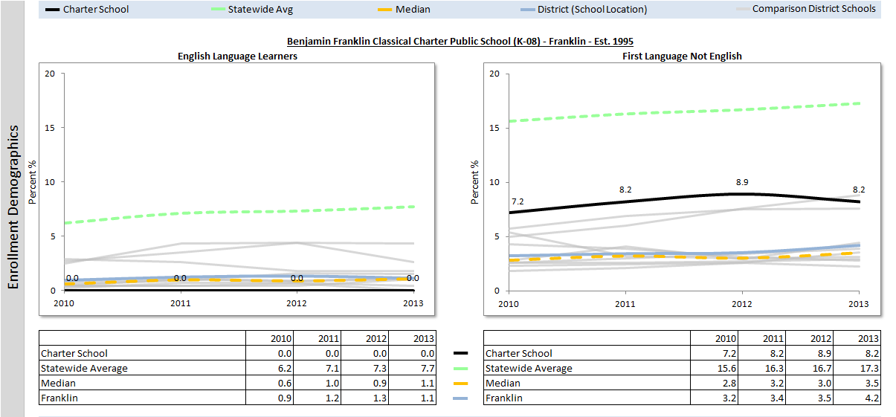
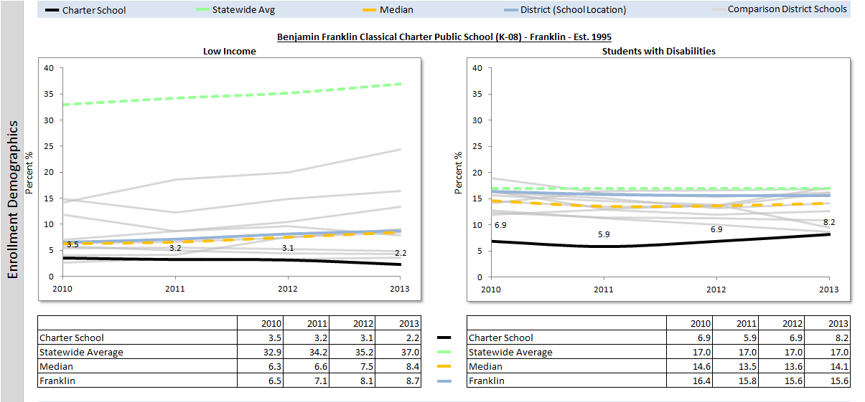
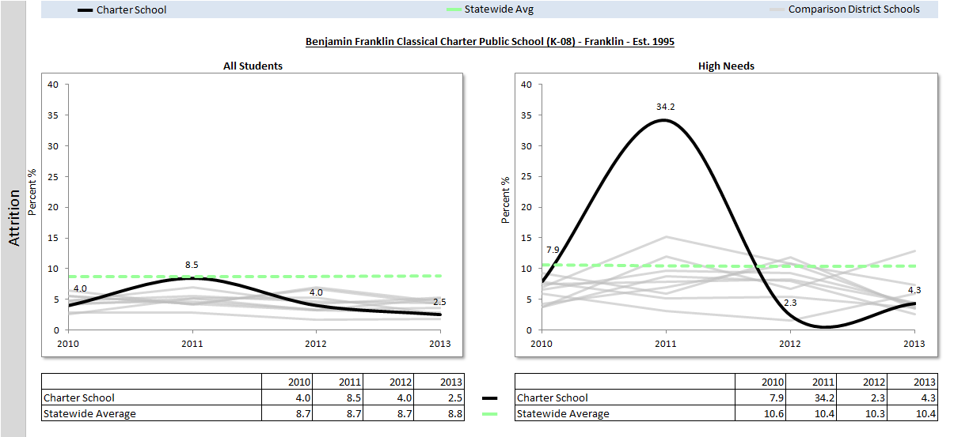
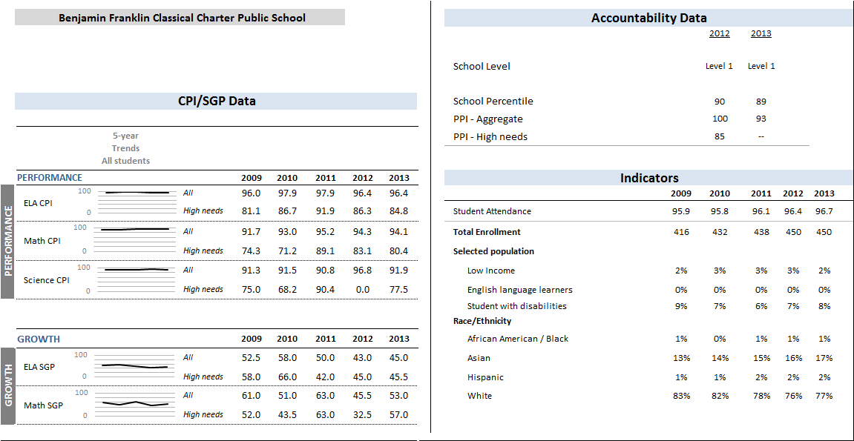
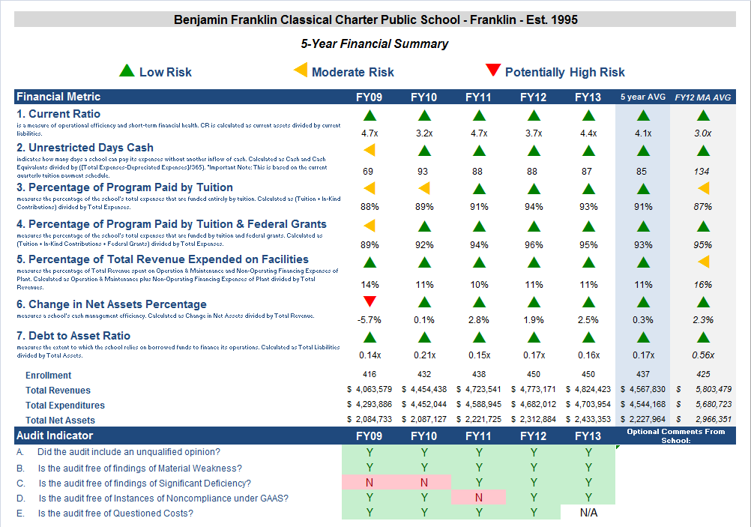

Financial Metric Definitions |  | Low Risk | Moderate Risk | Potentially High Risk
1. Current Ratio | Current Ratio is a measure of operational efficiency and short-term financial health. CR is calculated as current assets divided by current liabilities. | >= 1.5 | Between 1.0 (inclusive) and 1.5 | < 1.0
2. Unrestricted Days Cash | The unrestricted days cash on hand ratio indicates how many days a school can pay its expenses without another inflow of cash. Calculated as Cash and Cash Equivalents divided by (Total Expenses/365). | >= 90 days | Between 60 (inclusive) and 90 days | < 60 days
3. Percentage of Program Paid by Tuition | This measures the percentage of the schools total expenses that are funded entirely by tuition. Calculated as (Tuition + In-Kind Contributions) divided by Total Expenses (expressed as a percentage). Note: In-Kind Contribution are added to the numerator in this ratio to balance out In-Kind Expenditures which will be captured in the Total Expenses in the denominator. | >= 90% | Between 75% (inclusive) and 90% | < 75%
4. Percentage of Program Paid by Tuition & Federal Grant | This measures the percentage of the schools total expenses that are funded entirely by tuition. Calculated as (Tuition + In-Kind Contributions + Federal Grants) divided by Total Expenses (expressed as a percentage). Note: In-Kind Contribution are added to the numerator in this ratio to balance out In-Kind Expenditures which will be captured in the Total Expenses in the denominator. | >= 90% | Between 75% (inclusive) and 90% | < 75%
5. Percentage of Total Revenue Expended on Facilities | This measures the percentage of Total Revenue that is spent on Operation & Maintenance and Non-Operating Financing Expenses of Plant. Calculated as Operation & Maintenance plus Non-Operating Financing Expenses of Plant divided by Total Revenues (expressed as a percentage). | <= 15% | Between 15% and 30% (inclusive) | > 30%
6. Change in Net Assets Percentage | This measures a school's cash management efficiency. Calculated as Change in Net Assets divided by Total Revenue (Expressed as a percentage). | Positive % | Between -2% (inclusive) and 0% | < -2%
7. Debt to Asset Ratio | Measures the extent to which the school relies on borrowed funds to finance its operations. Calculated as Total Liabilities divided by Total Assets. | <= .9 | Between .9 and 1 (inclusive) | > 1
FY12 MA AVG Column | All financial indicated in this column are a results of each ratio calculated using statewide totals. For Enrollment, Total Net Assets and Total Expenditures rows, these numbers are averages using statewide totals of charter schools’ data.

1 The names of each of these schools and additional subgroup detail can be found in the Charter Analysis and Review Tool (CHART), expected to available early in 2014 and upon request. For a charter school that draws more than 20% of its students from a district outside the districts specified in its charter, comparison schools from these districts are also included. This only occurs with two schools located in Cambridge which draw more than 20% of their students from Boston.
The midpoint value of all the comparison schools for the percent of students enrolled.
³ The percentage of attrition, or rate at which enrolled students leave the school between the end of one school year and the beginning of the next.
4 A student is high needs if he or she is designated as either low income, or ELL, or former ELL, or a student with disabilities. A former ELL student is a student not currently an ELL, but had been at some point in the two previous academic years.

