*****Massachusetts Department of***

***Elementary and Secondary Education***

### 75 Pleasant Street, Malden, Massachusetts 02148-4906 Telephone: (781) 338-3000

## TTY: N.E.T. Relay 1-800-439-2370

|  |  |
| --- | --- |
| Mitchell D. Chester, Ed.D.  *Commissioner* |  |

# MEMORANDUM

|  |  |
| --- | --- |
| **To:** | Members of the Board of Elementary and Secondary Education |
| **From:** | Mitchell D. Chester, Ed.D., Commissioner |
| **Date:** | October 10, 2014 |
| **Subject:** | Charter Schools – Recommendation to Place Boston Green Academy Horace Mann Charter School on Probation |

Pursuant to the Charter School Regulations at 603 CMR 1.12(2), I recommend that the Board of Elementary and Secondary Education (Board) place Boston Green Academy Horace Mann Charter School (BGA) on probation in order to allow for the implementation of a remedial plan. My recommendation is based upon my continuing concern about the performance and viability of this school.

The FY13 financial audit, which was submitted to the Department of Elementary and Secondary Education (Department) ten months after its due date, raises serious concerns about the school’s financial controls and status. Beyond a lack of financial oversight, the school’s board of trustees has failed to follow regulatory requirements, state guidance, and its own bylaws. In addition, BGA has not shown promising academic results. Given the evidence that is further outlined below, it is clear to me that the school’s board of trustees has failed to oversee BGA effectively.

The Board has previously placed charter schools on probation during the first five-year charter term. This action signals clear concern about the school and the hope that BGA can fulfill the probationary conditions and offer a successful educational program to the students it serves. Based upon the success—or lack thereof—of BGA in meeting the conditions imposed and in alleviating the causes of its probation, I will recommend further action as appropriate.

|  |  |  |  |
| --- | --- | --- | --- |
| ***Boston Green Academy Horace Mann Charter School*** | | | |
| **Type of Charter**  (Commonwealth or Horace Mann) | Horace Mann | **Location** | Boston |
| **Regional or Non-Regional?** | Non-Regional | **Districts in Region**  (if applicable) | N/A |
| **Year Opened** | 2011 | **Year(s) Renewed**  (if applicable) | N/A |
| **Maximum Enrollment** | 595 | **Current Enrollment** | 369 |
| **Chartered Grade Span** | 6-12 | **Current Grade Span** | 6, 9-12 |
| **Students on Waitlist** | 750 | **Current Age of School** | 4 years |
| **Mission:**  Boston Green Academy’s mission is to graduate all of our students prepared for success in college  and the workforce. We are especially committed to recruiting, enrolling, and supporting off-track 6th and  9th grade students before they enter the “drop-out pipeline”. As a public school that is deeply vested in  cultivating a highly skilled and actively engaged global citizenry, we will prepare all of our students to  be leaders in local and global environmental stewardship and activism, to live their lives responsibly  and sustainably, and to take advantage of employment opportunities in the burgeoning ‘green’ economy. | | | |

In its application submitted in 2010 to become a Horace Mann III charter school, BGA promised to serve students from a closed Boston high school. In its subsequent memorandum of understanding (MOU) with Boston Public Schools (BPS), BGA agreed to open in 2011 with students in grades 9-12, to absorb the student population from Odyssey High School (Odyssey), and to occupy Odyssey’s facility. Originally proposed as a 6-12 school, the MOU altered the founding group’s original growth plan and delayed offering middle school grades. This year, the school moved to a new location in Brighton and is serving grades 6 and 9-12.

Due to persistent concerns, the school received four visits from the Department in its first three years of operation and is scheduled for another visit this year. The site visit reports document concerns about faithfulness to the charter, the quality of the academic program, the quality and amount of support for diverse learners, and the school’s lack of compliance with Department regulatory requirements and lack of attention to Department guidance. The most recent site visit report is attached. Please note that since the February 2014 site visit, concerns regarding capacity, board governance and oversight, and finance have surfaced. As a result, substantial questions exist regarding the ability of the board of BGA to manage the school effectively. My concerns based on the February 2014 site visit and subsequent information are in the areas of the [Charter School Performance Criteria](http://www.doe.mass.edu/charter/acct.html?section=criteria) that follow.

**Lack of Faithfulness to Charter**

Criterion 1 – Mission and Key Design Elements

* As documented in the Year Three Site Visit Report (attached), administrators reported that they are aware that they are not currently implementing several key design elements from their original charter, including the replication and extension of the practices of the Fenway High School and the use of Universal Design for Learning at the school. Additionally, all stakeholder groups did not share a common understanding of the college preparatory aspect of the mission. Visitors observed that BGA has not yet established a schoolwide emphasis on high academic expectations.

Criterion 3 – Compliance

* The school’s Coordinated Program Review for 2013-14 indicated that the school had not met more than a third of the required criteria. The school received “partial implementation” for 22 criteria and “not implemented” for one criterion. In particular, special education teachers lacked appropriate licensure.
* The school did not follow statutory and regulatory requirements, further amplified in guidance, when submitting or failing to submit critical documents, such as a list of proposed board members for approval and appointment, the end-of-year financial report for 2012, and the school’s financial audit for FY13. Please see below for more details.

**Lack of Academic Success**

Criterion 5 – Student Performance

* Academic results have not been promising. In 2014, the school is in Level 3 and the school’s academic performance is in the sixth percentile when compared to other high schools statewide. Particularly concerning are the student growth percentiles. Please see the tables below.

Criterion 6 – Program Delivery

* Instruction at the school received a rating of “Falls Far Below” by the Department’s site visit team on February 11, 2014 (Year Three). Past site visit reports document similar concerns about instructional practices at the school. The site visit report from Year Three, attached, states:
  + *Observed classroom environments were not conducive to student learning. While the classroom environment has become safer and more respectful, instructional learning time is not being maximized.*
  + *The school staff shares a common understanding of expected lesson structures: a posted objective, do now and a closing; likewise they are all working toward a common goal of providing differentiated instruction to students. In terms of expected instructional practices as articulated by the school leadership prior to the visit, site visitors saw minimal evidence that teachers are implementing these practices. In the majority of classrooms students did not produce work reflecting critical thinking.*
  + *It is unclear how teachers use curriculum documents to shape daily instruction; site visitors noted that daily objectives did not appear to be aligned to the Common Core, were not aligned to the lesson activity, or at times appeared to be task descriptions rather than objectives.*
  + *BGA provides extensive student supports. The school uses screening and assessment data to determine student placement into interventions and interventions are implemented regularly. However, the school does not provide support for inclusion of students with disabilities within general education classrooms and does not have a consistent system to move students along a continuum of placements and services according to student progress or need.*
  + *The school staff includes one teacher with responsibility to provide English language instruction for the 54 currently identified ELL students.*

Boston Gren Academy Horace Mann

CPI Table

2011-ELA 79.4 *
2012- ELA 84.1
2013- ELA 95.3, ELA Gap Narrowing Targets 85.7
2014- ELA 89.6, ELA Gap Narrowing 87.3
2015- ELA Gap Narrowing Targets 88.9
2016- ELA Gap Narrowing Targets 90.5
2017- ELA Gap Narrowing Targets 92.1
* 2011 data is from the Odyssey School


*2011 data is from the Odyssey school

Boston Gren Academy Horace Mann

CPI Table

2011-Math 31.9 *
2012- Math 69.7
2013- Math 74.7, Math Gap Narrowing Targets 72.7
2014- Math 75.8, Math Gap Narrowing 72.1
2015- Math Gap Narrowing Targets 78.8
2016- Math Gap Narrowing Targets 81.8
2017- Math Gap Narrowing Targets 84.9
* 2011 data is from the Odyssey School


*2011 data is from the Odyssey school

|  |  |  |  |
| --- | --- | --- | --- |
| ***BGA Median Student Growth Percentile*** | | | |
| **Year** | **2012** | **2013** | **2014** |
| **English Language Arts** | 27.0 | 60.0 | 37.5 |
| **Mathematics** | 27.0 | 31.0 | 26.0 |

**Boston Gren Academy Horace Mann

CPI Table

2011-Science 48.3 *
2013- Science  78.6
2014- Science 62.9
* 2011 data is from the Odyssey School
**

**Lack of Organizational Viability**

Criterion 8 – Capacity

* Over the past three years, the school has experienced leadership turnover. The school’s founding headmaster left the school after its first year of operation in 2012 and was replaced by two co-headmasters. One of these co-headmasters left the school in 2014.
* School leadership has failed to respond to repeated Department notifications and requests over the last year.

Criterion 9 – Governance

* The board failed to follow regulatory requirements, the Department’s guidance, and the board’s own bylaws when adding new members. At various points in the charter term, a number of individuals acting as voting members on the board had not received required approval and, therefore, were not in fact board members.
* While it lacked a quorum, the board still met for two meetings in 2014, and in one of those meetings the board went into executive session.

Criterion 10 – Finance

* The board of trustees has not provided adequate oversight of the school’s fiscal processes.
  + The FY13 financial audit was due no later than November 1, 2013. It was received by the Department 10 months late, on September 4, 2014.
  + The FY13 audit contains findings of material weaknesses in terms of a lack of internal controls over the school’s financial procedures and compliance with requirements of major federal programs, and gives an adverse opinion on material noncompliance with respect to the federal Charter School Program and Title I, resulting in questioned costs.
  + The school did not submit the FY12 Charter School End of Year Financial Report.

**Conditions and Probation**

I recommend that the Board place BGA on probation, pursuant to 603 CMR 1.12(2), for the remainder of the school’s charter term. The school’s current charter expires on June 30, 2016.

I also recommend that the Board place the following conditions on the school’s charter:

1. Beginning in October of 2014and until further notice, BGA must submit to the Department, at [charterschools@doe.mass.edu](mailto:charterschools@doe.mass.edu), board meeting agendas, materials, and minutes prior to each board meeting at the same time that these items are sent to the school's board members. Additionally, if board materials do not already include this information, the school must also submit monthly financial statements.
2. By December 31, 2014, the school's board of trustees must have completed a comprehensive self-evaluation of its own capacity and must have recruited additional board members with needed expertise, as identified by the board of trustees and the Department.
3. By December 31, 2014, the school must establish an escrow account in an amount determined by the Department in consultation with the school to pay for any potential closing, legal, and audit expenses associated with closure, should that occur.
4. By February 28, 2015, the school's board of trustees must engage in training conducted by an external consultant, acceptable to and approved in advance by the Department, on the roles and responsibilities of a board of trustees for a charter school.
5. By February 28, 2015, all members of the board of trustees of BGA will complete the series of six trainings offered online by the Office of the Attorney General regarding the Open Meeting Law. All board members will sign the required certificate stating that they have received, read, and viewed the following materials: the Open Meeting Law, G.L. c. 30A, §§ 18-25; regulations promulgated by the Attorney General under G.L. c. 30A, § 25; and educational materials available from the Attorney General explaining the Open Meeting Law and its application.
6. By November 1, 2015, as documented by the school’s FY15 independent financial audit, the school must remedy all material weaknesses and deficiencies identified in the FY13 financial audit and any subsequent findings in the school’s audit for FY14. The school must have an unqualified opinion on its FY15 audit without any identified material weaknesses.
7. By December 31, 2015, the school must demonstrate that it is an academic success through evidence of significant academic improvement in mathematics and English language arts.
8. The school will submit all documentation required by the Department in accordance with deadlines established by the Department for the remainder of the school’s charter term including, but not limited to, documents for approval and appointment of new board members; financial disclosures of board members; the school’s annual financial audit; the school’s application to renew its charter, if desired; the school’s annual report and end of year financial report; and all required and accompanying documentation.

Based upon the success—or lack thereof—of BGA in meeting the conditions imposed and in alleviating the causes of its probation, I will recommend further action as appropriate. Please note, meeting these conditions is not a guarantee that probation will not continue or that the school’s charter will be renewed. The Department will continue to monitor developments at the school and conduct site visits. In addition to meeting the terms of its probation, BGA, like all charter schools, must also comply with the terms of its charter. I will report to the Board on the school’s progress in meeting the conditions imposed.

**********************

If you have any questions regarding this recommendation or require additional information, please contact Cliff Chuang, Associate Commissioner (781-338-3222); Jeff Wulfson, Deputy Commissioner (781-338-6500); or me.

Attachment: Motion

BGA Year Three Site Visit Report

**CHART (Criterion 2: Access and Equity)**

The longitudinal demographic comparison data presented in the following four graphs is intended to provide context for the charter school’s recruitment and retention efforts. The set of displayed comparison schools includes the charter school of interest, and all of the public schools (district and charter) in the charter school’s region that serve at least one grade level of students which overlaps with the grade levels served by the charter school.[1] All data displayed in these graphs is derived from ESE District and School Profiles (<http://profiles.doe.mass.edu/>).

The first four graphs provide comparison enrollment percentages for four different subgroups of students: first language not English, English language learners, low income, and students with disabilities. Each line on the graph represents the percentage of total school enrollment from 2010 to 2013 for a given school or set of schools. Data listed is displayed longitudinally across multiple years in line graph form, with:

* a solid **bold black** line representing subgroup enrollment in the charter school of interest;
* a dotted **green** line for the statewide average;
* a **blue** line for the district in which the charter school is located;
* a dotted **orange** line for the median[2] enrollment percentage of the comparison schools; and
* a **pink** line for the Gap Narrowing Target5.
* **gray** lines for enrollment percentage in each individual comparison school (darker gray for charter schools, and lighter gray for district schools).

The next two graphs summarize attrition rates[3] in the aggregate and for the high needs[4] subgroup. Please note that district percentages are not included since attrition at the district-level cannot be reasonably compared to attrition at the school-level.

**Important Notes:** Though comparisons of subgroup enrollment in a charter school to that of other public schools in a geographic area can provide some information to assess comparability of student populations, the subgroup composition of a charter school is not required to be a mirror image of its sending districts and region. Students choose to enroll or are assigned to the schools in a geographic region due to a variety of reasons and factors, including: the random lottery admissions requirement for charter schools, district assignment and programmatic placement decisions, parent choice, uneven distribution of families within a geographic region due to housing or wealth distribution patterns, and natural population variation, among many others. Charter schools are mandated to receive Department approval for a recruitment and retention plan to be reported on and updated annually. When deciding on charter renewal, the Commissioner and the Board of Elementary and Secondary Education must consider the extent to which the school has followed its recruitment and retention plan, using deliberate, targeted strategies to recruit and retain students in subgroups where enrollment has not been comparable, and whether the school has enhanced its plan as necessary. It is also important to note that it may take time for a charter school’s recruitment and retention efforts to be reflected in the aggregate demographic percentages given sibling preference for admission and a limited number of entry grades.

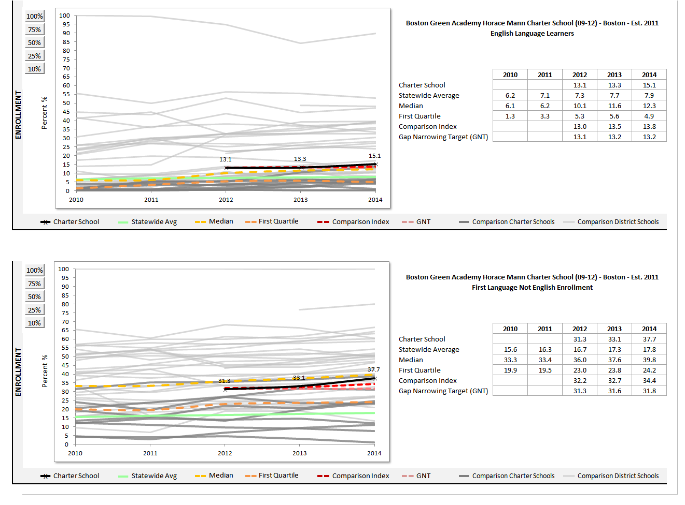

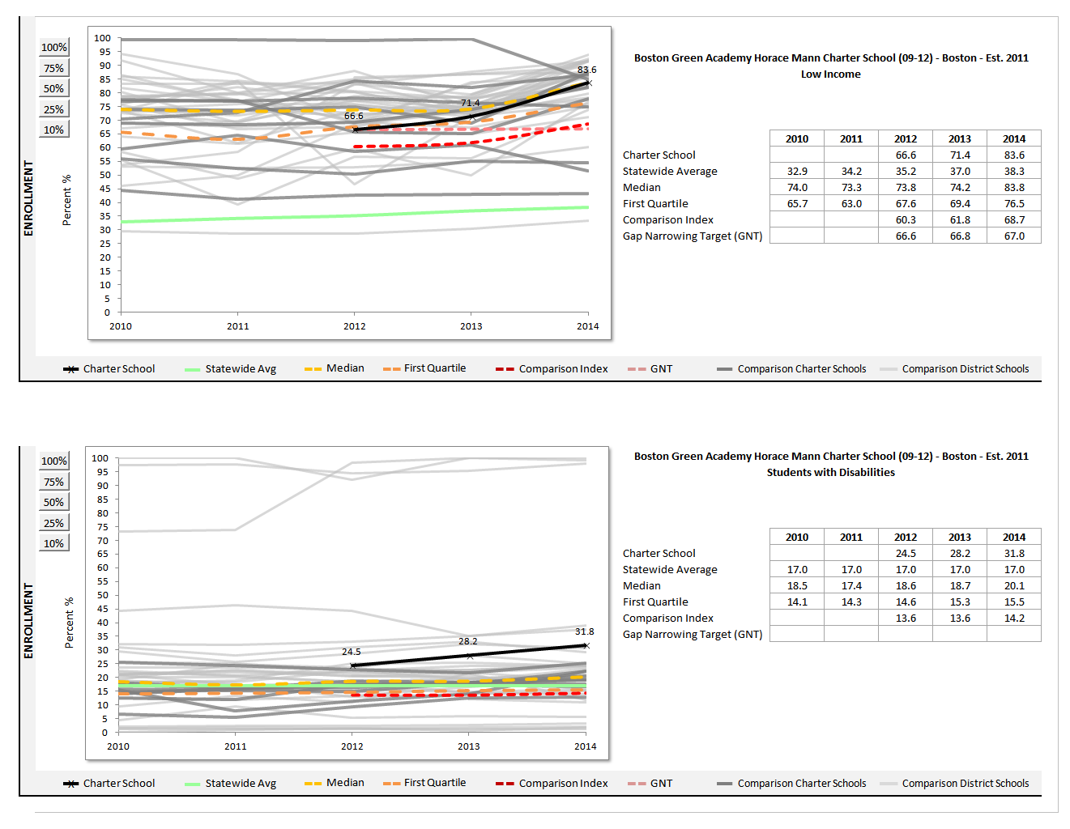

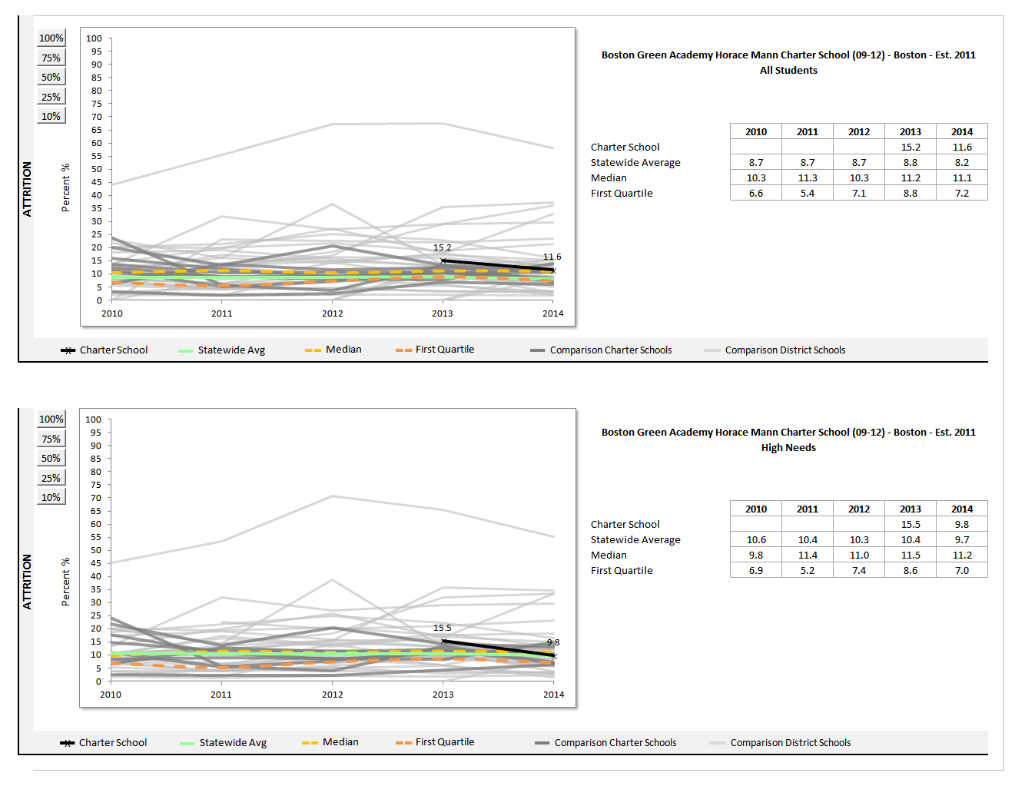

**For assesmment data, please visit: http://profiles.doe.mass.edu/mcas/achievement_level.aspx?linkid=32&orgcode=04110000&orgtypecode=5&

For accountability data, please visit: http://profiles.doe.mass.edu/accountability/report/school.aspx?orgcode=04110305&fycode=2014&report_mode=DETAILThe charter accountability table** (below) provides several sets of data relative to charter school MCAS performance as well as student demographics and indicators. The composite performance index (CPI) and the student growth percentile (SGP) are provided in the aggregate over the term of the charter. The school’s accountability level and cumulative progress and performance index (PPI) are shown if available (this depends on the size and the age of the school). Student enrollment and demographic data are also provided for the available years of the charter term. For detailed definitions of accountability terms, please visit this URL: <http://profiles.doe.mass.edu/accountability/report/aboutdata.aspx#AccountabilityInformation>

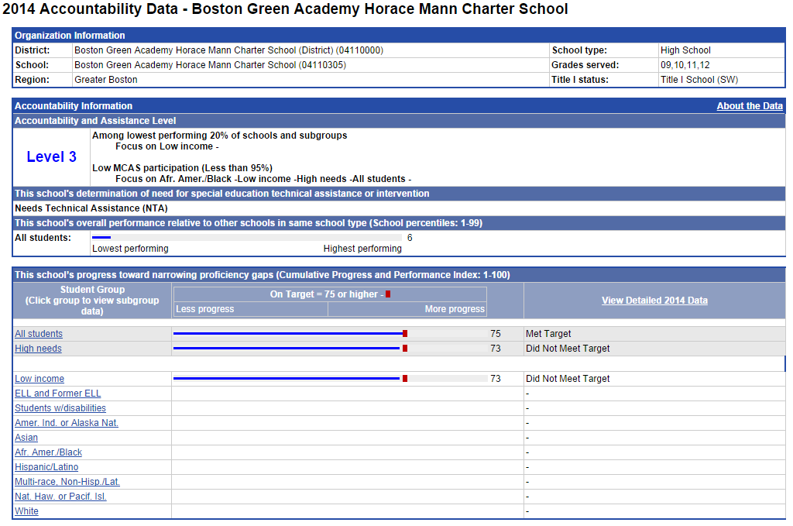

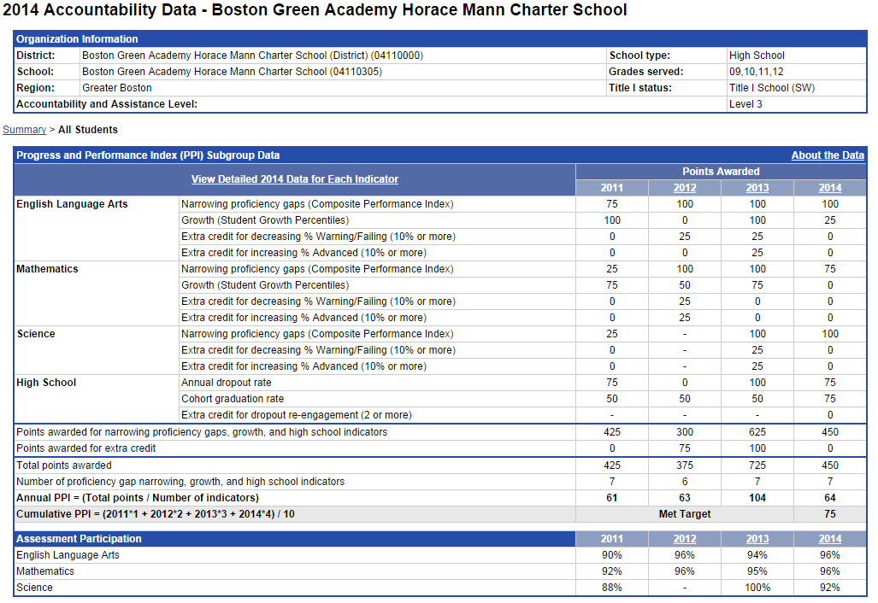

**Appendix D: Financial Dashboard (Criterion 10: Finance)**

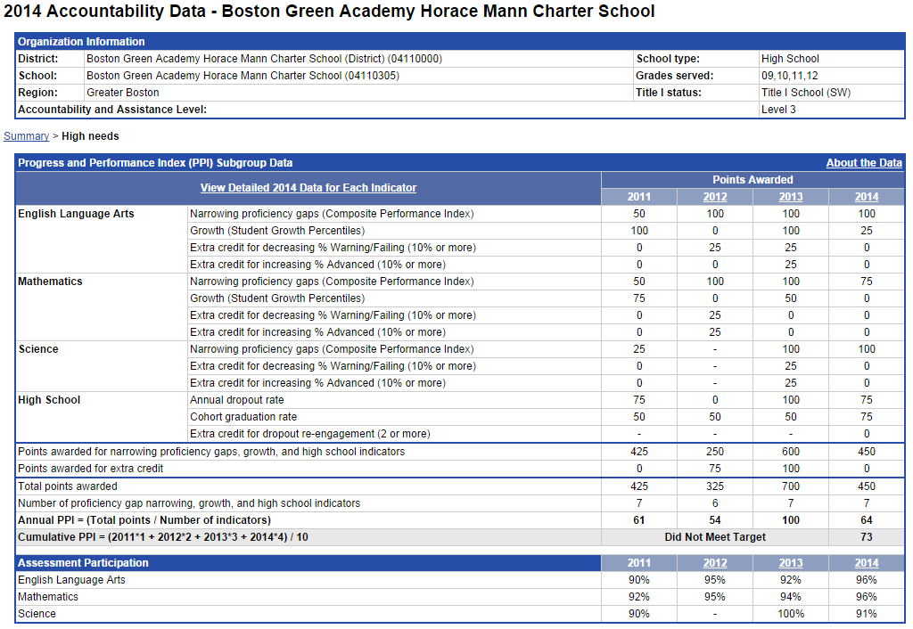

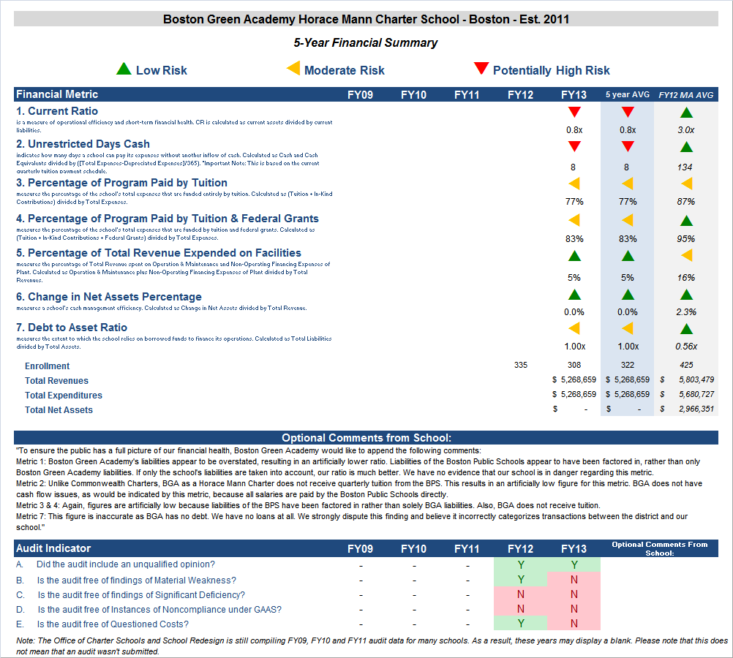



1. 1 The names of each of these schools and additional subgroup detail can be found in the Charter Demographic Analysis and Review Tool (DART), expected to available early in 2014 and upon request. For a charter school that draws more than 20% of its students from a district outside the districts specified in its charter, comparison schools from these districts are also included. This only occurs with two schools located in Cambridge which draw more than 20% of their students from Boston.
2. 2 The midpoint value of all the comparison schools for the percent of students enrolled.
3. 3 The percentage of attrition, or rate at which enrolled students leave the school between the end of one school year and the beginning of the next.
4. 4 A student is *high needs* if he or she is designated as either low income, or ELL, or former ELL, or a student with disabilities. A former ELL student is a student not currently an ELL, but had been at some point in the two previous academic years.

   5 The Gap Narrowing Target (GNT) refers to the halfway point between the school’s baseline rate (which is the rate in the 2010-11 school year, or the first year enrollment data is collected if after 2010-11,) and the current Comparison Index (the “target”)