Massachusetts Department of

Elementary and Secondary Education

75 Pleasant Street, Malden, Massachusetts 02148-4906 Telephone: (781) 338-3000

TTY: N.E.T. Relay 1-800-439-2370

Mitchell D. Chester, Ed.D.
Commissioner

MEMORANDUM

To: | Members of the Board of Elementary and Secondary Education
From: | Mitchell D. Chester, Ed.D., Commissioner
Date: | January 16, 2015
Subject: | Charter Schools – Report on Conditions and Recommendation to Place Martin Luther King, Jr. Charter School of Excellence on Probation

Pursuant to the Charter School Regulations at 603 CMR 1.12(2), I recommend that the Board of Elementary and Secondary Education (Board) place Martin Luther King, Jr. Charter School of Excellence (MLK) on probation. The school has not met the academic conditions that the Board imposed upon its charter; rather than demonstrating significant and sustained academic improvement, scores have declined over the past two years. My recommendation is based upon my continuing concern about the academic performance of this school.

On January 25, 2011, the Board renewed the charter for MLK, placed the school on probation, and directed the school to meet three conditions over the next two years related to program delivery and academic performance. On January 29, 2013, the Board determined that MLK had sufficiently met conditions related to academic growth, establishing a fully documented curriculum, and evaluating and staffing its leadership structure to remove MLK from probation. However, due to continued decline in absolute performance in English language arts over the same time period, the Board imposed further academic conditions to demonstrate significant and sustained academic improvement by December of 2014.

The school has not shown significant and sustained academic improvement by December of 2014, as required by the conditions that the Board imposed on January 29, 2013. The school has been in Level 3 in 2012, 2013, and 2014. Since the conditions were imposed, its school percentile has declined to the 9th percentile as compared to other elementary schools statewide. In 2014, the school did not meet any of its gap-narrowing targets in mathematics or ELA. In addition, qualitative evidence collected by the Department of Elementary and Secondary Education (Department) indicates that MLK is not yet meeting expectations in critical aspects of program delivery such as curriculum and instruction, despite the fact that the school is in its ninth year of operation.

In light of the evidence, I recommend that the school be placed on probation for the remainder of its current charter term, which expires on June 30, 2016. I expect that a school that is approaching a decade of operation demonstrate a strong academic footing. Despite prior probation and conditions, as well as attempts to improve the instructional program, MLK’s academic track record is not acceptable. The school must improve its academic performance by December 2015. This action signals clear concern about the school and whether MLK can fulfill the probationary conditions and offer a successful educational program to the students it serves. In light of MLK’s continued low academic performance, short of clear evidence of academic improvement by the end of this year, MLK faces the prospect that I will recommend non-renewal in February 2016.

Martin Luther King Jr. Charter School of Excellence
Type of Charter  (Commonwealth or Horace Mann) | Commonwealth | Location | Springfield
Regional or Non-Regional? | Non-regional | Districts in Region  (if applicable) | N/A
Year Opened | 2006 | Year(s) Renewed  (if applicable) | 2011
Maximum Enrollment | 360 | Current Enrollment | 362
Grade Span in Charter | K-5 | Current Grade Span | K-5
Students on Waitlist | 247 | Current Age of School | 9 years
Mission Statement
Martin Luther King, Jr. Charter School of Excellence prepares kindergarten through 5th grade students of Springfield for academic success and engaged citizenship through insistence on rigorous, challenging work. The school incorporates Dr. King’s commitment to the highest standards in scholarship, civic participation and the ideal of the beloved community.

Due to the probation and conditions imposed during this charter term, MLK was visited by the Department three times: in 2012, 2013, and 2014. The most recent visit occurred on October 29, 2014; the resulting report is attached to this memorandum. The site visits in 2013 and 2014 served to gather evidence on the school’s progress towards meeting the set of conditions imposed in 2013.

Following is further information on the school’s progress towards meeting the conditions. Other relevant information from the site visits is included at the end of this memorandum.

Review of Progress Made Towards Meeting the Conditions Imposed

This section lists the conditions imposed in 2013 and outlines MLK’s progress towards meeting the conditions.

Condition 1: No later than March 31, 2013, Martin Luther King, Jr. Charter School of Excellence shall submit to the Charter School Office a comprehensive evaluation of the school’s English language arts program conducted by an external consultant.

Status: Met.
On March 26, 2013, MLK submitted an evaluation of its ELA program to the Charter School Office. It was conducted by SchoolWorks, an external consultant.

Condition 2: No later than March 31, 2013, Martin Luther King, Jr. Charter School of Excellence shall submit to, and receive approval from, the Charter School Office for an action plan that specifies the strategies to improve performance in English language arts. The action plan must address implementation of a proven curriculum and instruction program for English language arts. The action plan must include a timetable for the implementation of corrective actions, must set deadlines for the completion of key tasks, and must set clear and specific implementation benchmarks to allow the board of trustees of Martin Luther King, Jr. Charter School of Excellence and the Charter School Office to monitor implementation.

Status: Met.
On April 26, 2013, MLK submitted an action plan to the Charter School Office. The action plan adopted the recommendations made in the external evaluation. It included specific strategies, timetables for actions, deadlines for key tasks, and clear implementation benchmarks. Specifically, the plan called for choosing and adopting an aligned ELA curriculum. MLK selected and began implementing an ELA curriculum, aligned to the Common Core, during the 2013-14 academic year, and is implementing a modified version of this curriculum in the 2014-15 academic year.

Condition 3: Martin Luther King, Jr. Charter School of Excellence must demonstrate that it is an academic success by December of 2014 by providing evidence that the school has met or is making substantial progress toward meeting benchmarks in its approved Accountability Plan and, in particular, has demonstrated significant and sustained academic improvement in English language arts.

Status: Not Met.
In 2012, 2013, and 2014, MLK’s MCAS scores placed the school in Level 3. The school’s percentile, when compared to other elementary schools statewide, has steadily declined over the past three years from the 12th percentile in 2012, to the 11th percentile in 2013, and to the 9th percentile in 2014. Growth scores over the past four years have been variable, but in 2014, Student Growth Percentiles (SGP) for both English language arts and mathematics were below the state medians, 35.5 and 44.0 respectively. In 2014, student performance declined and the school did not meet any of its gap narrowing targets for mathematics or English language arts. English language arts results have steadily declined since 2010, while mathematics scores have shown an overall gain since 2010. See detailed data (Composite Performance Index (CPI) and SGP results) below.

CPI – ELA
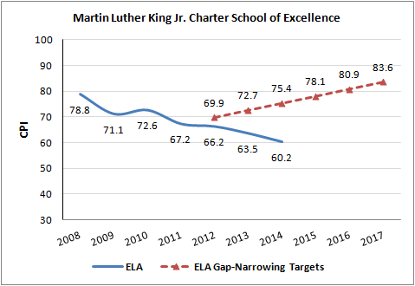

CPI - Math
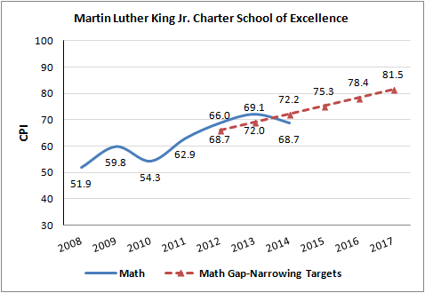

CPI – Science
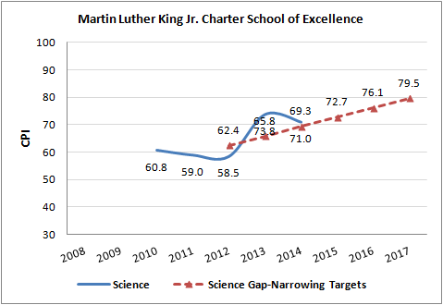

 | MLK Median Student Growth Percentile
Year |  | 2011 | 2012 | 2013 | 2014
English Language Arts |  | 32.0 | 50.5 | 42.0 | 35.5
Mathematics |  | 55.0 | 73.0 | 59.0 | 44.0

Other Information

The purpose of the site visits in 2013 and 2014 was to gather evidence on areas of the Charter School Performance Criteria related to the conditions. As outlined in the attached site visit report, a charter school receives findings and ratings that outline the school’s performance in terms of the Charter School Performance Criteria. Although there were concerning findings and ratings at both of the MLK visits, site visitors did note improvement from 2013 to 2014 and found that some changes to the academic program were in effect by October 2014.

Criterion 6 – Program Delivery
- Instructional expectations in 2013 did not reflect high expectations for students and received a rating of “Falls Far Below.” In response, the school solidified instructional expectations and implemented more structures for professional development during the past year. At the 2014 visit, site visitors observed inconsistent implementation of the new practices, but found that the current expectations were more aligned to the type of work demanded by the Massachusetts Curriculum Frameworks than in previous years. In 2014, the instructional expectations earned a rating of “Partially Meets,” showing improvement.
- Currently, the school’s curriculum is aligned to the 2011 Massachusetts Curriculum Frameworks in terms of sequence and pacing, but curriculum documentation is not complete. This is an improvement from the 2013 site visit, at which site visitors noted that the curriculum was not aligned to the school’s assessment system, was not being implemented as written, and was not sufficiently rigorous.
- Currently, the school has an assessment system in place to monitor student performance. This is an improvement over the 2013 visit, at which site visitors noted that the assessment system was not aligned to curriculum and stakeholders reported that they did not know if students were on target to meet performance goals.

Criterion 8 – Capacity
- The school has not had stability in instructional leadership. The former principal, who began working at MLK in June 2011, resigned in the spring of 2014. Until recently, the executive director has also filled the role of principal. At the 2014 visit, stakeholders had trouble identifying a single instructional leader at the school. At the time of the visit, stakeholders also reported that the school had not conducted any teacher evaluations or observations.
- Subsequent to the visit, on November 21, 2014, the school hired a new principal. The new principal began on December 1, 2014, and he will evaluate teachers and oversee the academic program.

Conditions that Constitute the Terms of Probation

I recommend that the Board place MLK on probation, pursuant to 603 CMR 1.12(2), for the remainder of the school’s charter term. The school’s current charter expires on June 30, 2016.

I also recommend that the Board place the following conditions on the school’s charter as the terms of probation:

- Beginning in February of 2015 and until further notice, MLK must submit to the Department, at charterschools@doe.mass.edu, board meeting agendas, materials, and minutes prior to each board meeting at the same time that these items are sent to the school's board members. Additionally, if board materials do not already include this information, the school must also submit monthly financial statements.
- By March 31, 2015, the school must establish an escrow account in an amount determined by the Department in consultation with the school to pay for any potential closing, legal, and audit expenses associated with closure, should that occur.
- By December 31, 2015, the school must demonstrate clear academic progress through evidence of significant academic improvement in mathematics, English language arts, and science.

Based upon the success—or lack thereof—of MLK in meeting the conditions imposed and in alleviating the causes of its probation, I will recommend further action as appropriate. Please note, meeting these conditions is not a guarantee that probation will not continue or that the school’s charter will be renewed. The Department will continue to monitor developments at the school and conduct site visits. In addition to meeting the terms of its probation, MLK, like all charter schools, also must comply with the terms of its charter. I will report to the Board on the school’s progress in meeting the conditions imposed.

**********************
If you have any questions regarding this recommendation or require additional information, please contact Cliff Chuang, Associate Commissioner (781-338-3222); Jeff Wulfson, Deputy Commissioner (781-338-6500); or me.

Attachment: Motion
Site Visit Reports for MLK, Years Eight and Nine
Request from MLK

