Proposed Academy for the Whole Child Charter School
Executive Summary
This document was prepared by the Academy for the Whole Child Charter School applicant group.
Document was altered to remove footnotes.

Mission
Academy for the Whole Child Charter School sets the foundation for the long-term development of elementary age children in partnership with students, families and communities. By embracing the “whole child” approach, we ensure that each child reaches high levels of academic success, creativity, personal growth and well-being. Through a robust academic and social-emotional curriculum, children learn within a safe, child-centered, and inclusive environment.

Academy for the Whole Child will be a K through 4 regional charter school for 360 children residing in Fitchburg and area communities/school districts: Fitchburg, Leominster, Clinton, Gardner, Athol-Royalston Regional, Orange and Winchendon. Fitchburg is the target location with easy access on and off Route 2 for families coming in from Orange, Athol, Winchendon and Gardner. The planned opening will be August, 2015 beginning with 120 children in grades K, 1 and, followed by grades 3 and 4 in years two and three for a maximum enrollment of 360 children by year five. The total number of available charter school seats at the 9% cap is 1600 students.

We chose the selected communities in the North Central Massachusetts region based on three criteria: the lowest 10% performing school districts; the lowest MCAS achievement ranking; and districts with the highest percentage of free/reduced lunch students. Four of the communities in the proposed region are presently in the lowest 10% of performing school districts in the state: Gardner, Athol-Royalston, Orange and Winchendon. District profile data shows that the average percentage of high needs students of the proposed region is 62% with the greatest percentage of high needs students in Fitchburg at 81.5%, Gardner at 65.7%, Athol-Royalston at 65.1% and Clinton at 57%. Based on the combined average of enrollment data of the proposed districts, A4WC strives to target a population that represents the region showing 60% of children as high needs, 20% special education and 13% English language learners.

There are very limited options for families in the proposed region to send their children to a tuition-free school. This is problematic for families living in one of the four districts that are under-performing. Also parents with a special needs child or struggling learner have expressed concerns that the school in their district does not provide the type of supports or environment to best meet their child’s needs. A4WC whole child approach with smaller class sizes will ensure each child has access to child-center learning supported by qualified and caring adults. A4WC academic goal is for all children to become proficient readers by the end of 3rd grade and by the end of 4th grade be proficient in both ELA and math!

Academy for the Whole Child believes in the “whole child” approach to learning and is collaborating with the ASCD (Association for Supervision and Curriculum Development) and Whole Child Initiative (WCI) to ensure the success of the school. A strong foundation in reading, writing, math, and other core subjects is as important as ever, yet by itself is insufficient for lifelong success. A child who enters school healthy and feels safe is ready to learn. A child who feels supported is more likely to stay in school. And, a child with opportunities in the arts develops a sense of identity and self-esteem. Children who have access to challenging and engaging academic programs are better prepared for further education, work, and civic life. These components must work together, not in isolation. That is the goal of whole child education.

Daniel Pink, author of A Whole New Mind states that traditional schools do not effectively address the changes occurring in our society. The future belongs to a very different kind of person with a very different kind of mind-creators and empathizers, pattern recognizers, and meaning makers. These people- artists, inventors, designers, storytellers, caregivers, consolers, big picture thinkers- will now reap society’s richest rewards and share in its greatest joys”. Children at Academy for the Whole Child will be respected for their individuality, right-brain thinking, cultural differences and innate abilities. Innovation, design thinking, and relevant, child-centered curricula will be the cornerstone of learning at A4WC.

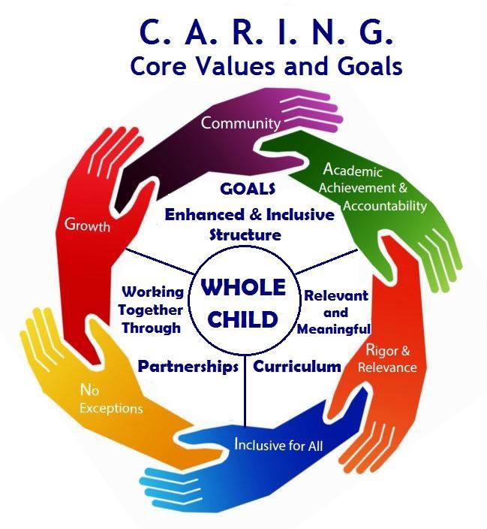
The Founders have developed a framework for Academy for the Whole Child based on the acronym C.A.R.I.N.G., Community, Academic Achievement and Accountability, Rigor and Relevance, Inclusive for All, No Exceptions and Growth. Each of these areas articulate our Core Values and provide the framework for the design elements of the school with the WHOLE CHILD at the center.

While adhering to the Massachusetts Curriculum Frameworks the instructional methodology at the A4WC will focus on educating the whole child in an integrated, child-centered classroom. A4WC believes the point of contact between student and teacher is powerful. “What teachers do in classrooms have twice the impact on student achievement as do school policies regarding curriculum, assessment, staff collegiality and, community involvement.” Curriculum, instruction, and assessment will be research base, data-driven, dependent on analysis of student progress. Program offerings will be English language arts/ELA (creative writing, composition, reading, spelling, vocabulary, and phonics), STEAM (Science, Technology, Engineering, Arts, and Math), World Language, Health and Wellness, and History/Social Sciences. Arts integration will strengthen content learning for diverse learners. “Arts integration is the investigation of curricular content through artistic explorations… and a reflection of both curricula content and the art form itself.”

What is Innovative about Academy for the Whole Child?
Academy for the Whole Child has developed a research-based, comprehensive and innovative program that will be unlike other schools in the proposed area and surrounding communities.

The Key Design Elements are:
  - Whole Child Initiative (WCI). Academy for the Whole will be the first charter school in Massachusetts adopting the Whole Child Initiative. Our mission supports the tenets of WCI that says for all children to learn at their best, they must be healthy, safe, engaged, supported and challenged. A4WCCS will partner with ASCD to bring research-based professional development, teaching resources and the implementation of WCI School Improvement Tool.
  - Mastery of academic fundamentals: A solid foundation at an early age in skills like decoding and computation are critical for higher order and analytical thinking, and future success in school. Through direct instruction of basic skills and knowledge in reading and math, the teacher presents the new skill or knowledge clearly and simply to the students building on previous learning. Children practice the new skills and given immediate feedback. Finally, the students are tested for mastery. Recognizing that children learn differently and at different paces, Academy for the Whole Child will help children through review, remediation, and differentiated instruction where necessary. This process is repeated until mastery.
  - Safety nets for success: A longer school day, after school and summer support programs will provide children and families with additional safety-nets as needed for success. A4WCCS academic day will operate 1.5 hours longer than most traditional school districts within the required school year of 180 days with a student to teacher ratio of no greater than 14 children in grades K, 1 and no greater than 18 children in grades 2, 3, 4 with one teacher and a teaching assistant. Before and after school programs will provide tutoring, homework help, arts and academic enrichment activities. A summer program will be available for children to help reduce the “summer learning loss” and support reading and math through academic enrichment programs.
  - Reggio Emelia Inspired Approach: Reggio Emelia is a highly recognized early childhood approach among professionals and psychologists. The closest school offering this approach is in Andover, MA. Our partnership with Professor Joanne Nichols at Fitchburg State University will assist A4WC with training and program evaluation, with the goal to become a lab site in the region for Reggio Emelia practice.
  - World Language-Spanish: All children will have 30 minutes of Spanish instruction daily and addresses the needs of Hispanic children and families who are trying to master their native language and gives all other children an opportunity to learn a second language. This program has cognitive benefits, increases self-esteem, creativity, and positive attitudes toward diversity. No other school in the area offers this type of program.
- Arts Integration/S.T.E.A.M.: Arts integration traditionally takes place within the arts classroom in most schools or as part of a stand-alone theme based unit. With close collaboration and planning among teachers and arts specialists, A4WC plans to integrate arts daily into academic classroom: ELA, math, social studies and science. 1 hour of concept and skill based learning for master, followed by 1 hour of integrating arts to reinforce concepts and skills. Planning time for collaboration is built into the schedule. Integrating arts is a powerful way to differentiate learning using multi-sensory activities to reinforce concepts and skills for children with special needs and learning styles. S.T.E.A.M. (Science, Technology, Engineering, Arts and Math) is the integration of the arts within the sciences. By adding the arts, the walls between the sciences and math are broken down by unleashing creativity, exploration and relevance to learning.
- Flexible scheduling supports cross grade level activities; combined classes for team teaching; teacher collaboration, data teams; student project presentations/performances; and, team building and community outreach activities. “With large blocks of time to facilitate involvement, students benefit from less fragmentation and more engagement in project-based learning and interdisciplinary activities, promoting skill application, interpersonal relations, and decision-making skills related to concrete, relevant problems (Vars, 1993). Results indicate increased student engagement and achievement and positive social ramifications (Arhar, 1992).
- Daily Arts Instruction: Where other schools are cutting back on arts programs, A4WC is committed to providing every child with 45 min -1 hour daily of instruction in visual arts, music, dance, drama, and media arts.
- Social-Emotional Learning: Academy for the Whole Child understands that the social and emotional needs must be met first for children to learn at their best. A4WC will embed MindUP, an evidence-based curriculum into daily routines and Have a HEART, a teacher created character development program that fosters Honesty, Empathy, Acceptance, Respect and Thoughtfulness.
- The HPHP (high-performing, high-poverty) Readiness Model addresses the challenges of high- poverty settings into design factors that increase the effectiveness of learning and achievement: Readiness to Learn, Readiness to Teach, and Readiness to Act outlines three key elements within each component that help schools overcome the barriers to success. A4WC will adapt the Readiness Model as an on-going process school administrators and staff will follow.
- Parents as Partners: We firmly believe that parent involvement is a shared responsibility between school and parents in the education of their children and that continued parental involvement contributes greatly to student achievement and a positive school environment. Parents will be encouraged to visit the school often, volunteer in the school setting, attend monthly parent meetings, and be involved on sub- committees to develop a student handbook, uniform policy, and other initiatives.
- Community Partnerships and Service Learning: Local agencies, service organizations and churches will assist us in enrollment and recruitment of children; and will help us provide health and wellness services to children, families and staff. We have established collaborations with colleges as a resource for professional development, program resources and evaluation. Through our community partnerships, the business community and family connections, there will be many opportunities for our school and students to participate in rich and meaningful community service learning throughout the year. Children will gain skills necessary for success in school, in the workplace, and in life.

Community Support
During the past year, support for Academy for the Whole Child has been very positive. This is evidenced by more than 1000 individuals who signed a petition supporting A4WCCS, as well as the number of visitors (5500) to the project’s blog. In a public survey distributed in English and Spanish to more than 400 people, 88% said they would support an elementary charter school in Fitchburg. We engaged hundreds of families through our social media campaign on Facebook, and in February 2014, we pre-enrolled 100 children in less than 30 days. Since then, we have re-engaged our supporters and are engaging new supporters with our revised proposal through community out-reach, social media, surveys, and face-to-face meetings. The evidence supports that families in Fitchburg and surrounding communities are looking for an alternative choice to educate their children.

Board Capacity
The proposed Board of Trustees are a driven diverse group of professionals who bring to Academy for the whole child experience in law, real estate, education (primary, secondary, special education, ELL), facilities and municipality management, finance and accounting, technology, grant writing, fundraising, non-profit management, and community partnerships.

To ensure the success of Academy for the Whole Child, founding members and proposed Board of Trustees are consulting with: Donna Snyder, Manager, Whole Child Implementation of ASCD (Association for Supervision and Curriculum Development); Mike Rulon, faculty member of ASCD; Sarah Krongard, Executive Director of MA-ASCD for the Whole Child Initiative, and Lesley University faculty; Dr. Isa Zimmerman, former principal and superintendent and Past President of MA-ASCD; and Kevin Andrews, Former Executive Director of the Neighborhood House Charter School in Dorchester; Joann Nichols, Fitchburg State University professor of Early Childhood Education; and Maria LaFord, Community Health Connections, Caring for Kids program and services in Fitchburg and surrounding communities.

