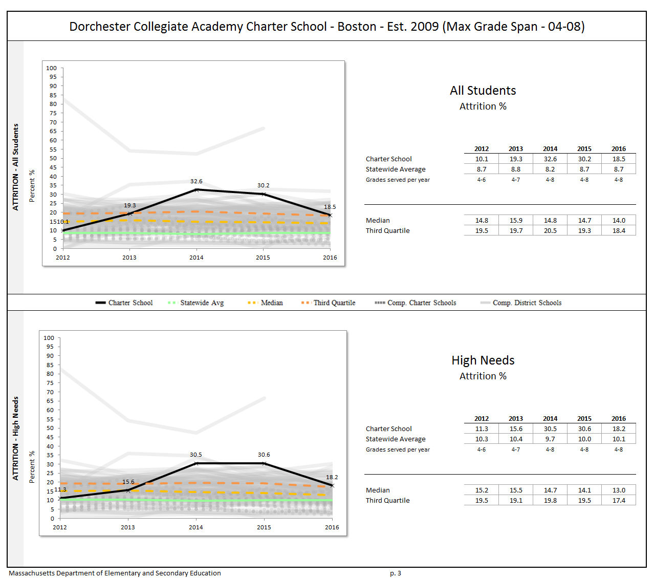
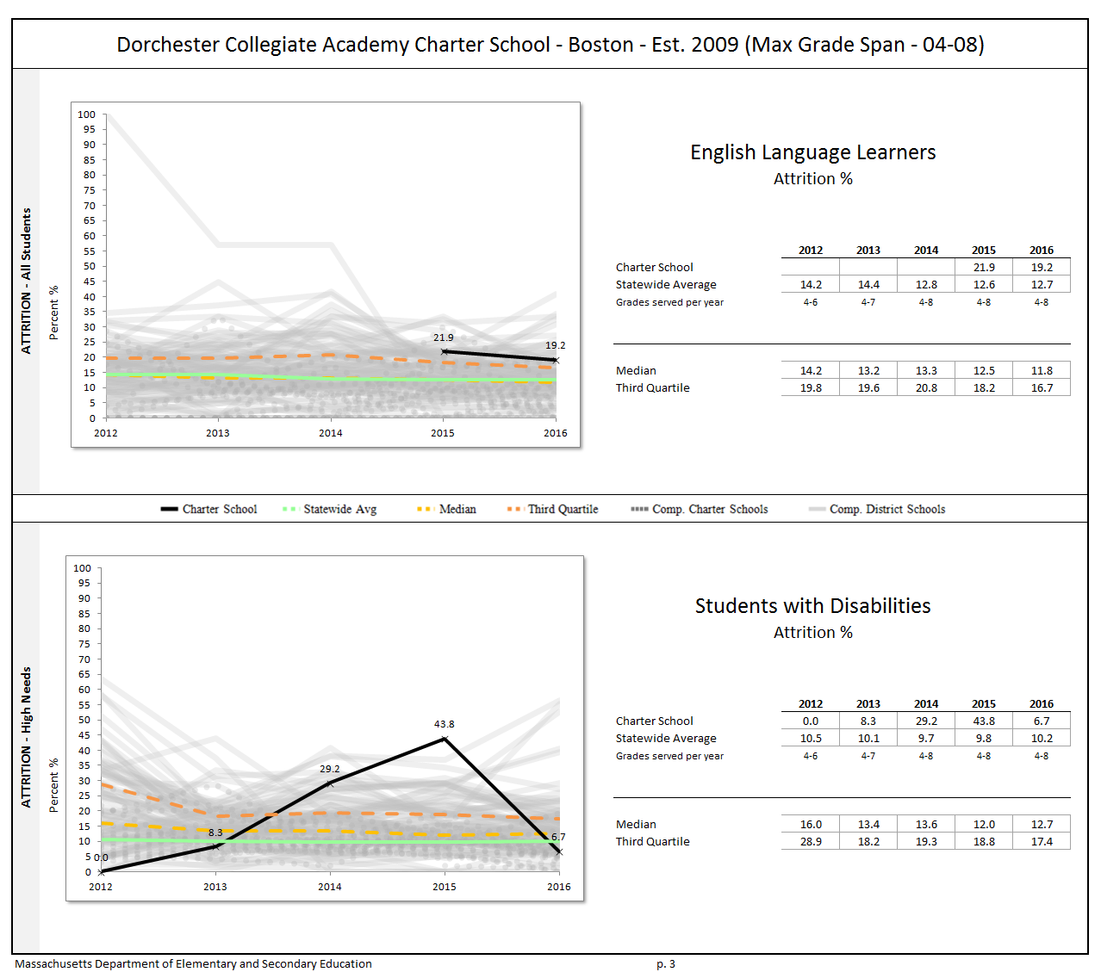

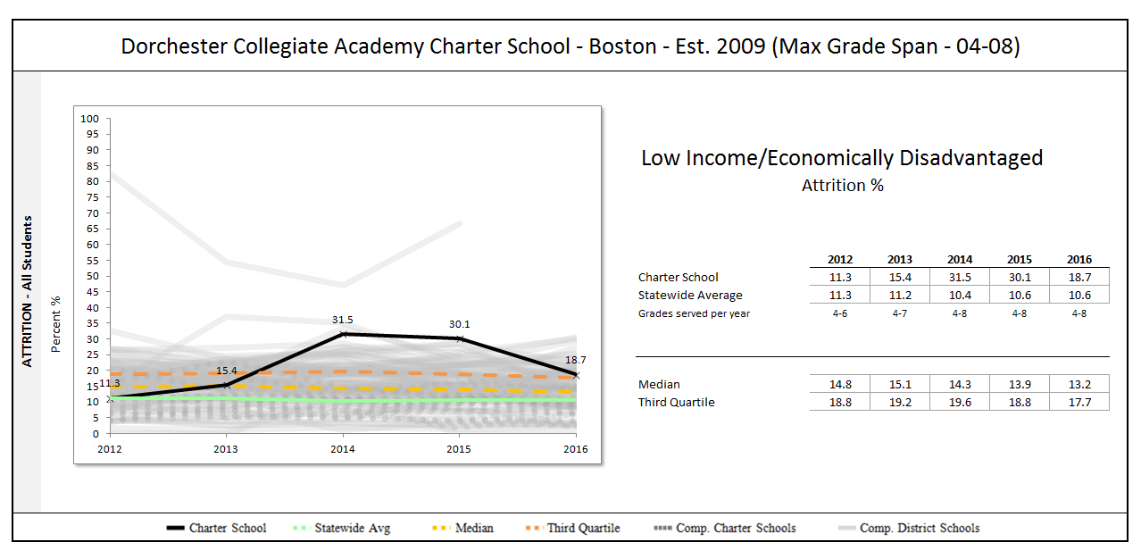

Grade by Grade Attrition for 2013-2014 (students who were enrolled in June 2013 but not in fall 2013):

Student Group | 4 | 5 | 6 | 7 | All
All Students | 25.7 | 27.3 | 53.1 | 25.0 | 32.6
Female | 27.8 | 27.8 | 53.8 | 28.6 | 33.3
Male | 23.5 | 26.7 | 52.6 | 22.2 | 31.9
High needs | 15.0 | 21.4 | 53.6 | 27.6 | 30.5
Low income | 0.0 | 24.0 | 56.0 | 29.6 | 31.5
Students w/disabilities | 28.6 |  |  | 28.6 | 29.2
Afr. Amer./Black | 34.6 | 32.0 | 52.0 | 20.0 | 35.4
Asian
Hispanic/Latino |  | 16.7 |  | 36.4 | 25.0

Grade by Grade Attrition for 2014-2015 (students who were enrolled in June 2014 but not in fall 2014):

Student Group | 4 | 5 | 6 | 7 | All
All Students | 33.3 | 38.9 | 31.4 | 17.9 | 30.2
Female | 26.7 | 44.4 | 31.6 | 18.2 | 29.7
Male | 37.5 | 33.3 | 31.3 | 17.6 | 30.7
High needs | 33.3 | 37.1 | 33.3 | 18.9 | 30.6
ELL | 15.4 | 30.0 |  | 28.6 | 21.9
Low income | 33.3 | 37.1 | 31.3 | 18.9 | 30.1
Students w/disabilities | 80.0 | 28.6 | 28.6 | 25.0 | 43.8
Afr. Amer./Black | 35.5 | 33.3 | 34.6 | 14.8 | 29.5
Asian
Hispanic/Latino | 16.7 | 45.5 | 16.7 | 28.6 | 30.0

Grade by Grade Attrition for 2015-2016 (students who were enrolled in June 2015 but not in fall 2015)
Student Group | 4 | 5 | 6 | 7 | All
All Students | 12.5 | 22.5 | 10.7 | 26.3 | 18.5
Female | 0 | 20 | 10 | 21.1 | 13.3
Male | 20.8 | 24 | 11.1 | 31.6 | 22.1
High needs | 15.2 | 22.6 | 10 | 23.1 | 18.2
Economically Disadvantaged | 18.5 | 27.8 | 0 | 18.2 | 18.7
ELL | 28.6 | 12.5 |  | 33.3 | 19.2
Students w/disabilities | 11.1 |  | 0 | 8.3 | 6.7
Afr. Amer./Black | 15.4 | 20 | 5.3 | 30 | 19
Asian
Hispanic/Latino | 7.7 | 22.2 | 14.3 | 16.7 | 14.3

Additional Information:
Please note that the subgroup data in this attachment are based on Oct. 1 certified SIMS data.

