The information provided in the following tables and graphs provide an overview of the academic performance, student enrollment demographics, student attrition rates, and financial history of the charter school of interest. All data displayed in these graphs is derived from ESE District and School Profiles (http://profiles.doe.mass.edu/).
The charter accountability table provides several sets of data relative to Massachusetts Comprehensive Assessment System test (MCAS) performance for the most recent five years. Performance measures are displayed for all students and the high needs subgroup, including the percent of students scoring proficient or advanced (P/A), and warning or failing (W/F); the composite performance index (CPI); and the student growth percentile (SGP). The school’s accountability level, percentile, English Language Arts (ELA) and mathematics percentiles for all students and targeted subgroups, and the cumulative progress and performance index (PPI) for the aggregate and targeted subgroups are shown, if available (this depends on the size and the age of the school). When applicable, the 4-year and 5-year graduation rates and the annual dropout rate are provided. Detailed definitions of accountability terms can be found at: http://profiles.doe.mass.edu/accountability/report/aboutdata.aspx#AccountabilityInformation.
The longitudinal demographic comparison data presented in the graphs of student enrollment is intended to provide context for the charter school’s recruitment and retention efforts. The set of displayed comparison schools includes the charter school of interest, and all of the public schools in the charter school’s region that serve at least one grade level of students which overlaps with the grade levels served by the charter school. The graphs provide comparison enrollment percentages for four different subgroups of students: low income, students with disabilities, English language learners, and First language not English. Each line on the graph represents the percentage of total school enrollment for a given school or set of schools during the most recent five years. If available, data listed is displayed longitudinally across multiple years in line graph form, with:
- a solid bold black line representing subgroup enrollment in the charter school of interest;
- a solid green line for the statewide average;
- a solid blue line for the comparison district average (current or proposed district, as applicable);
- a dotted orange line for the median enrollment percentage of all comparison schools;
- a dotted dark orange line for the first quartile enrollment percentage of all comparison schools;
- a dotted red line for the comparison index;
- a dotted pink line for the Gap Narrowing Target (GNT); and
- solid gray lines for enrollment percentage in each individual comparison school (darker gray for charter schools, and lighter gray for district schools).
Student enrollment of two comparison districts has been included in the analysis due to Proven Provider requirements.
Student attrition rates are provided for all students and for the high needs subgroup. Please note that district percentages are not included since attrition at the district-level cannot be reasonably compared to attrition at the school-level.
The 5-year financial summary is intended to provide financial context for the charter school’s organizational viability. The definitions of the financial metrics displayed are provided with the summary.
Important Notes:
New statutory provisions related to Criterion 2 were established in 2010. Though comparisons of subgroup enrollment data in a charter school to that of other public schools in a geographic area can provide some information regarding comparability of student populations, it is presented for reference only and primarily to determine trends within the charter school itself and to guide further inquiry. The subgroup composition of a charter school is not required to be a mirror image of the schools in its sending districts and region. The Department urges extreme caution in drawing any conclusions regarding comparability of subgroup populations between districts and schools based on aggregate statistics alone. Students choose to enroll or are assigned to the schools in a geographic region due to a variety of reasons and factors, including: the random lottery admissions requirement for charter schools, district assignment and programmatic placement decisions, parent choice, uneven distribution of families within a geographic region due to housing or wealth distribution patterns, and natural population variation, among many others. In specific caution should be used for special education enrollment data, as new research by Dr. Thomas Hehir (Harvard Graduate School of Education) and Associates (Review of Special Education in the Commonwealth of Massachusetts: A Synthesis Report (August 2014) found that low-income students were identified as eligible for special education services at substantially higher rates than non-low-income students and that across districts with similar demographic characteristics, district behavior differed for special education identification, placement, and performance. Finally, it is also important to note that it may take time for a charter school’s recruitment and retention efforts to be reflected in the aggregate demographic percentages given sibling preference for admission and a limited number of entry grades.
Charter schools are required to receive Department approval for a recruitment and retention plan to be reported on and updated annually. When deciding on charter renewal, the Commissioner and the Board must consider the extent to which the school has followed its recruitment and retention plan by using deliberate, specific strategies towards recruit and retain students in targeted subgroups, whether the school has enhanced its plan as necessary, and the annual attrition of students. As specified in regulation, charter schools were first required to implement recruitment and retention plans in 2011-2012. One of the Department’s key priorities with respect to charter schools is to continue to utilize new tools and processes for robustly assessing this criterion, and to support schools in meeting this criterion.
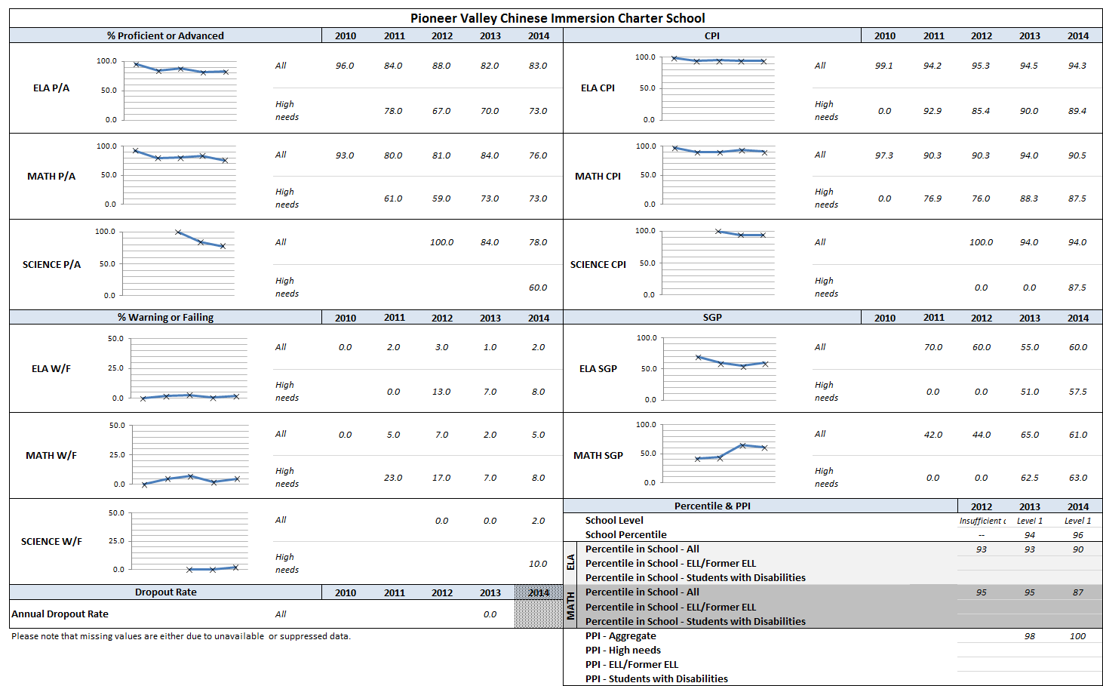
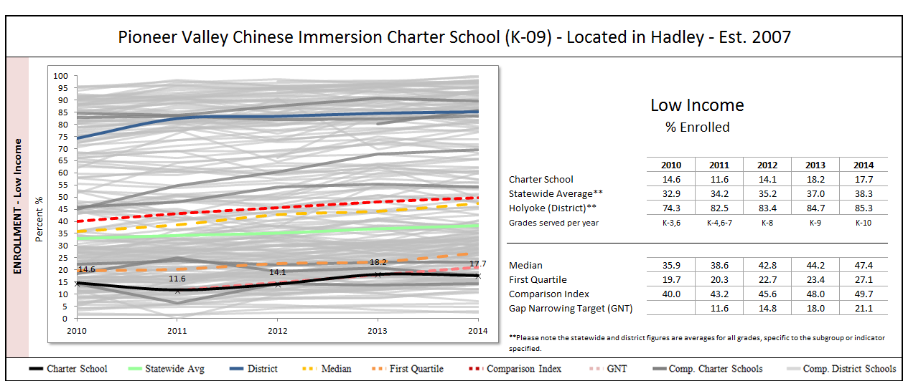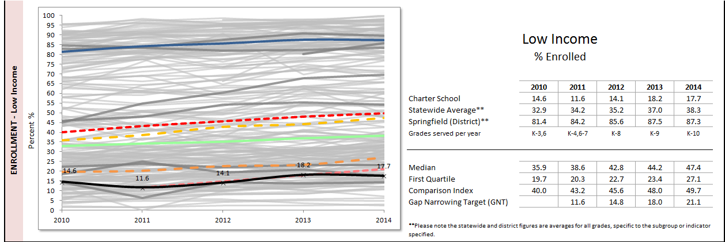
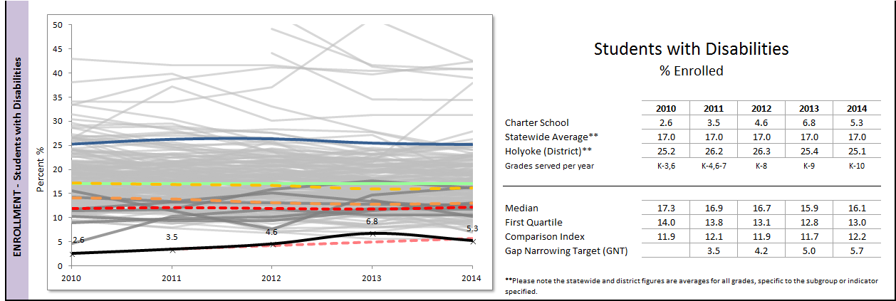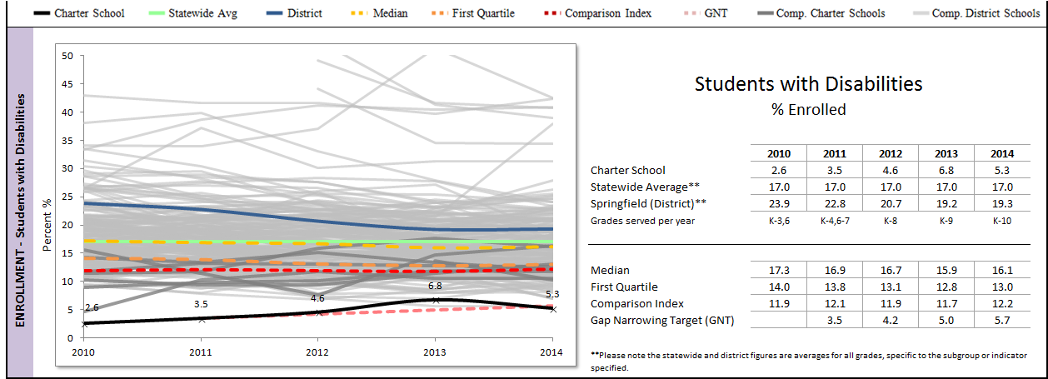
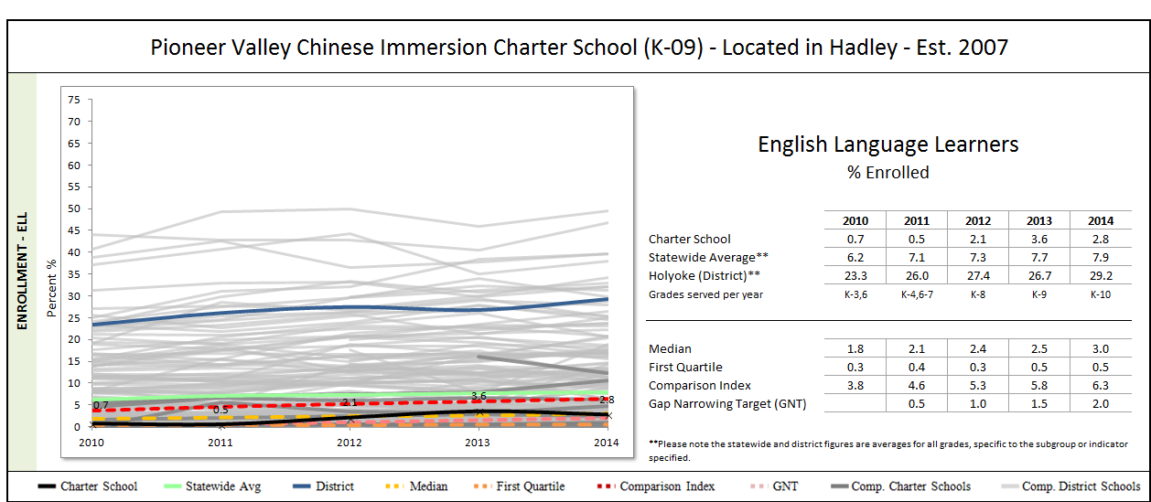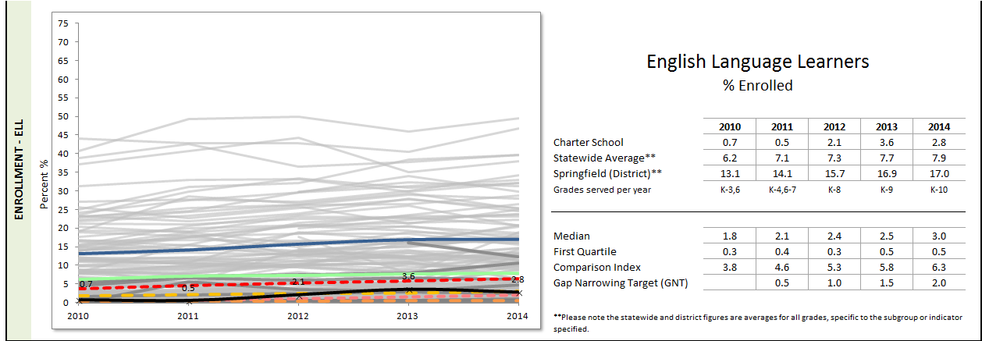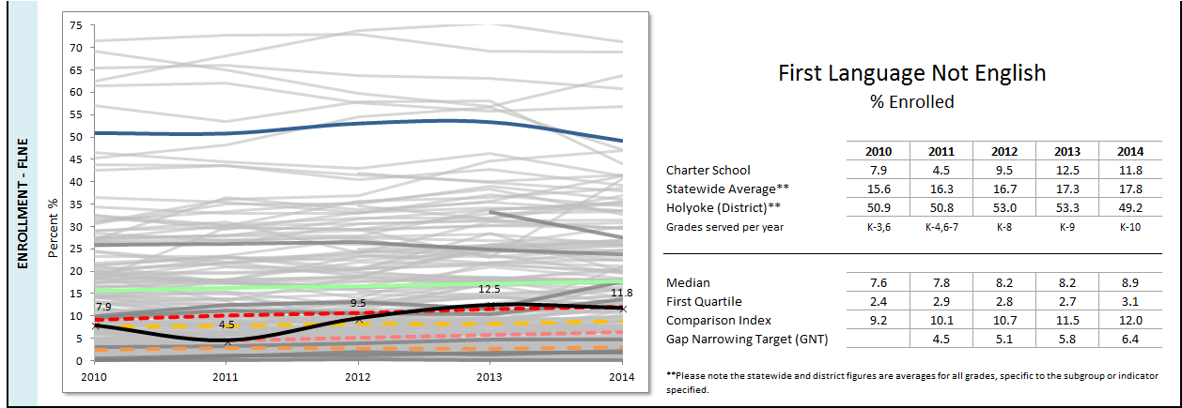
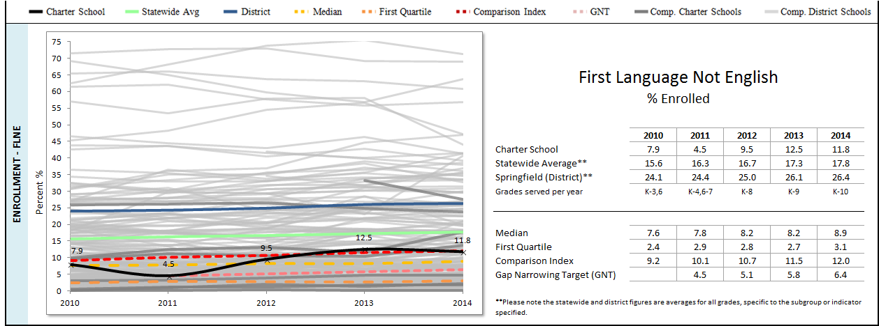
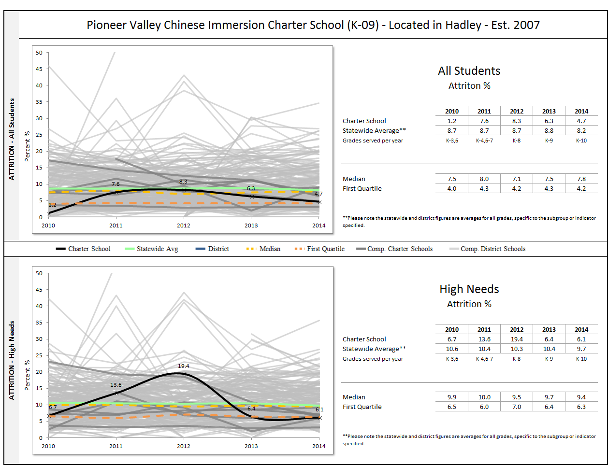

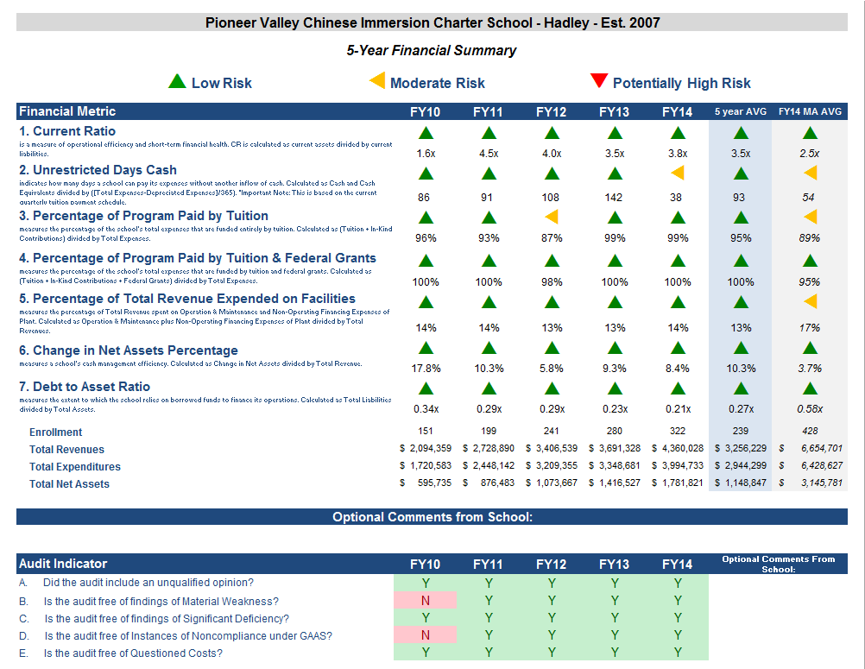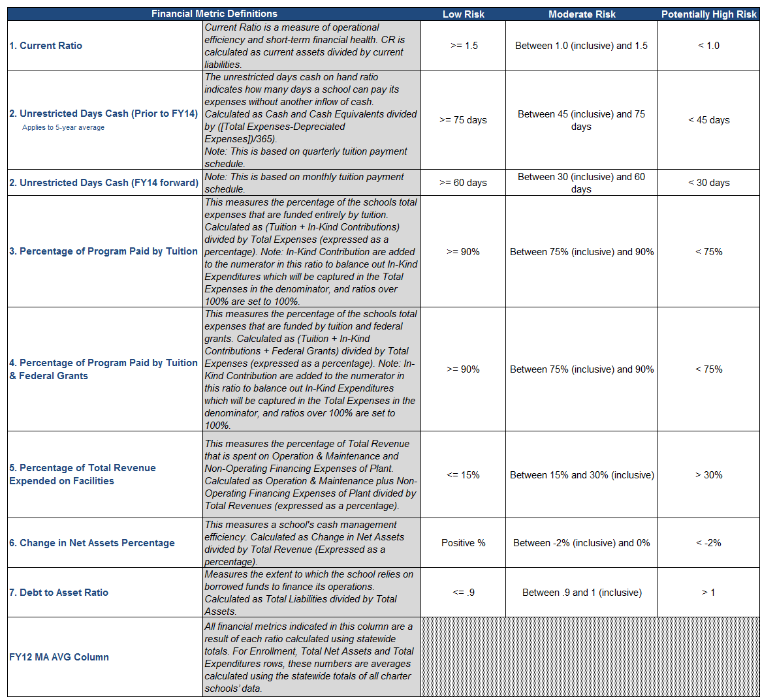

Important Note: The request involves two districts identified as performing in the lowest 10 percent. The relevant data of each district has been included in the Proven Provider analysis.

Proven Provider Context:
Charter school boards of trustees must be granted Proven Provider status when requesting to increase the maximum enrollment of an existing Commonwealth charter school if the sending region includes district(s) that have performed in the lowest 10 percent statewide for two consecutive previous years on the MCAS and where the 9 percent net school spending cap has been, or would be exceeded.

In order to determine if a current board of trustees qualifies for Proven Provider status, the Commissioner will consider affirmative, credible evidence of the existing school's success in each of the three accountability areas: academic program success, organizational viability, and faithfulness to the terms of its charter. Pursuant to 603 CMR 1.04(4)(b), applicants for Proven Provider status must demonstrate success in student academic performance and evidence of overall academic program success, including, but not limited to:
- proficiency levels and growth measures on the MCAS or equivalent assessments for all students and for one or more targeted subgroups as defined in M.G.L. c. 71, § 89(i)(3), which are similar to statewide averages in English Language Arts and mathematics for all students in Massachusetts in comparable grades, over no less than a three-year period for cohorts of students; and
- attendance, retention, attrition, in-school suspension rates, out-of-school suspension rates, and if applicable, graduation and dropout data.

Proven Provider Analysis Graphs:
The graphs of student achievement data provide comparison performance percentages for all students and three different subgroups of students: low income, students with disabilities, and English language learners. Each line on the graph represents the student proficiency levels and growth measure levels on the MCAS English Language Arts and mathematics tests for a given school or set of schools during the most recent five years. The state and district averages in the following graphs do not represent the overall average of the state or relevant district. The Department calculates state and district averages for comparable grades by identifying and averaging the specific grades implemented by the charter school of interest during each relevant year. All data displayed in these graphs is derived from ESE District and School Profiles (http://profiles.doe.mass.edu/). If available, data is displayed longitudinally across multiple years in line graph form, with:
- a solid bold black line representing the charter school of interest;
- a dotted green line for the statewide average for comparable grades;
- a dotted blue line for the comparison district average for comparable grades (current or proposed district, as applicable);
- a dotted orange line for the median performance percentage of all comparison schools;
- a dotted dark orange line for the first quartile performance percentage of all comparison schools; and
- solid gray lines for enrollment percentage in each individual comparison school (darker gray for charter schools, and lighter gray for district schools).
The graphs of student indicator data summarize the in-school suspension rates, out-of-school suspension rates, attendance, retention, and if applicable, 4-year graduation and dropout data for all students during the most recent five years of published data.
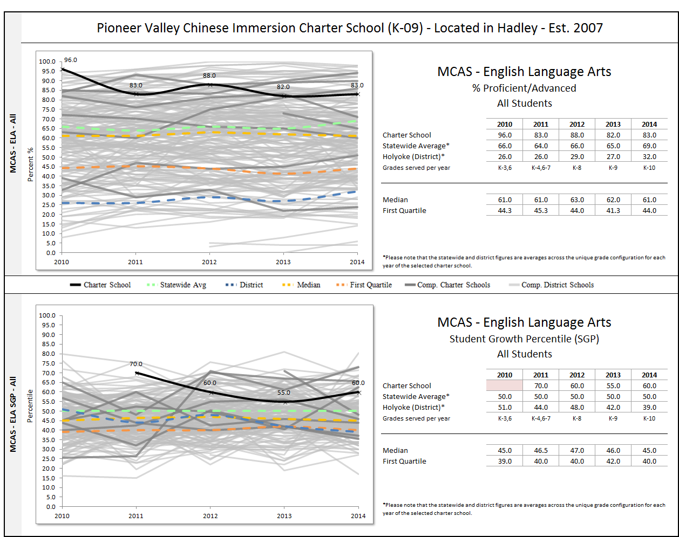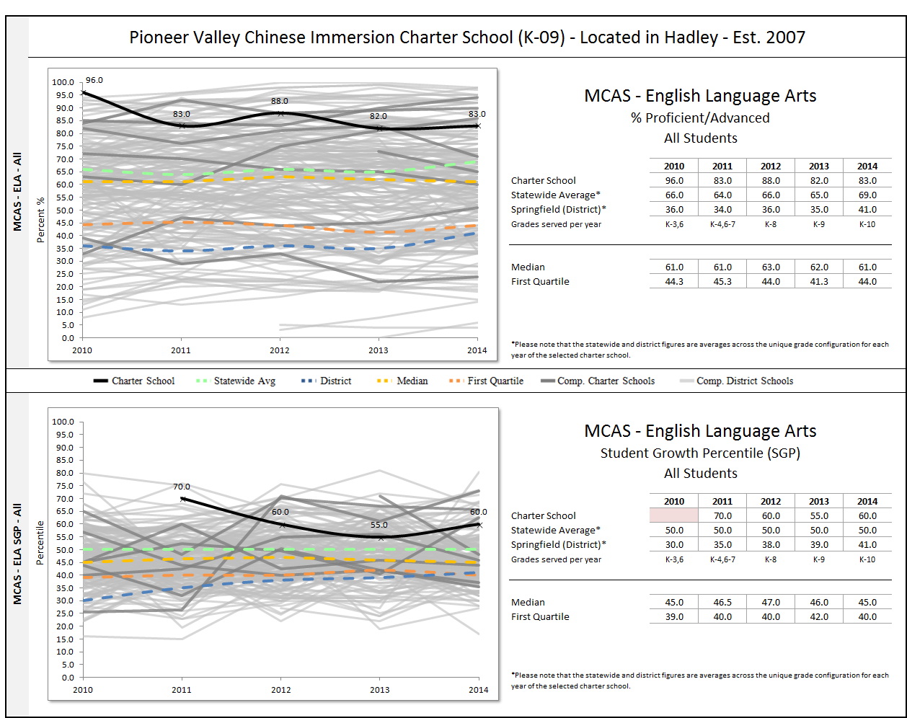
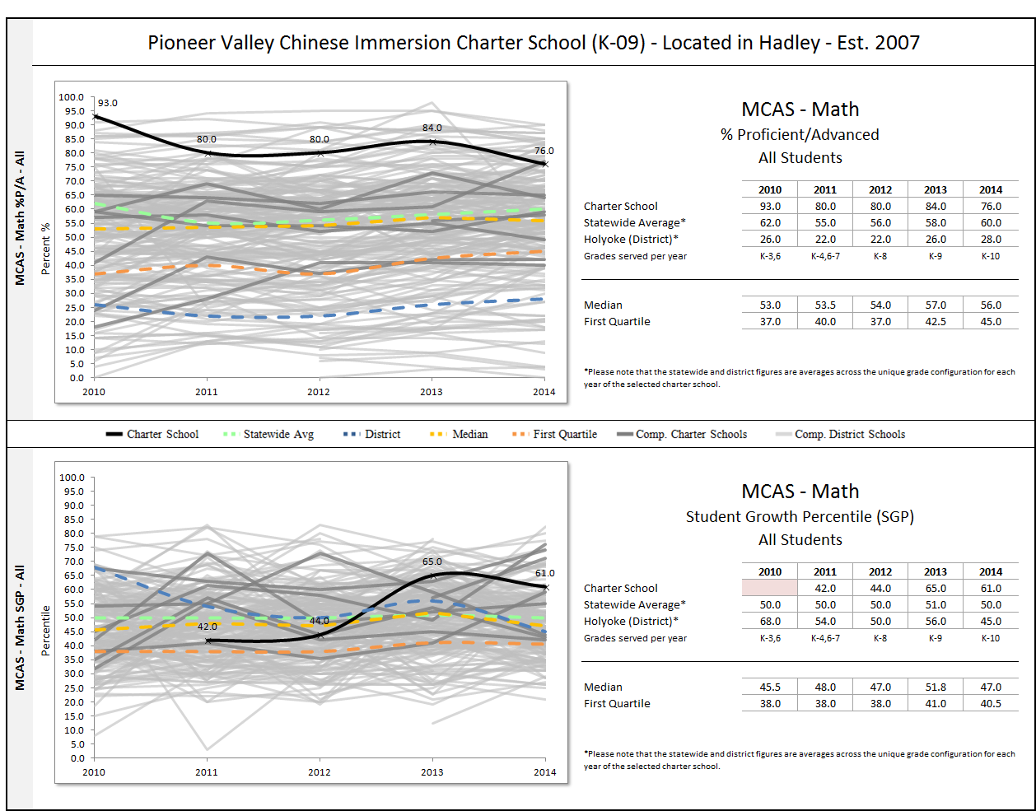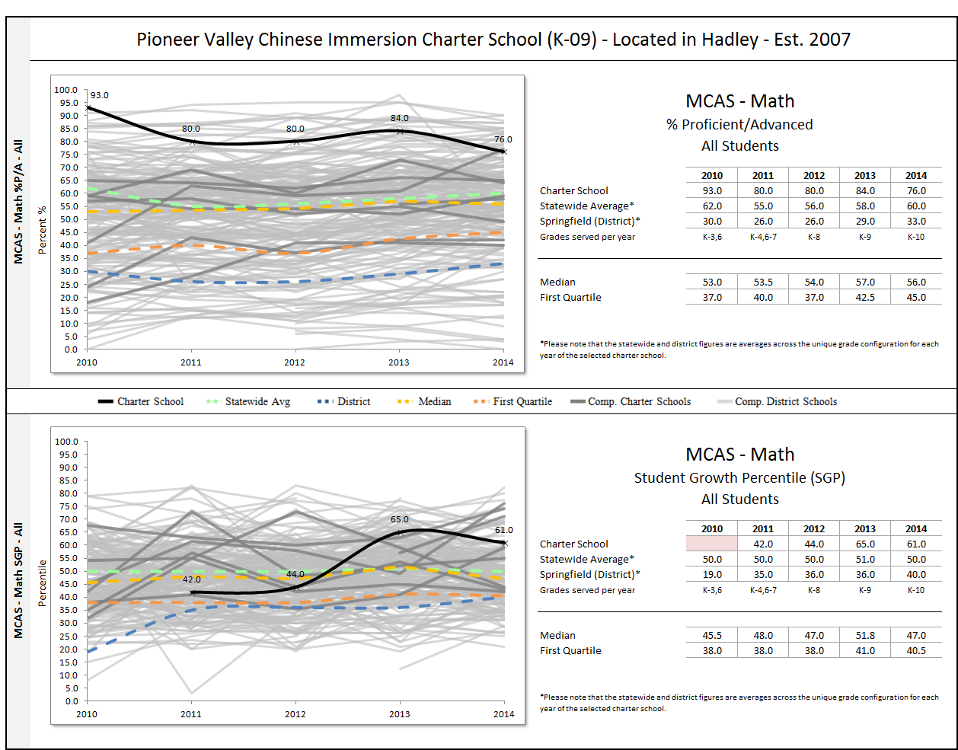
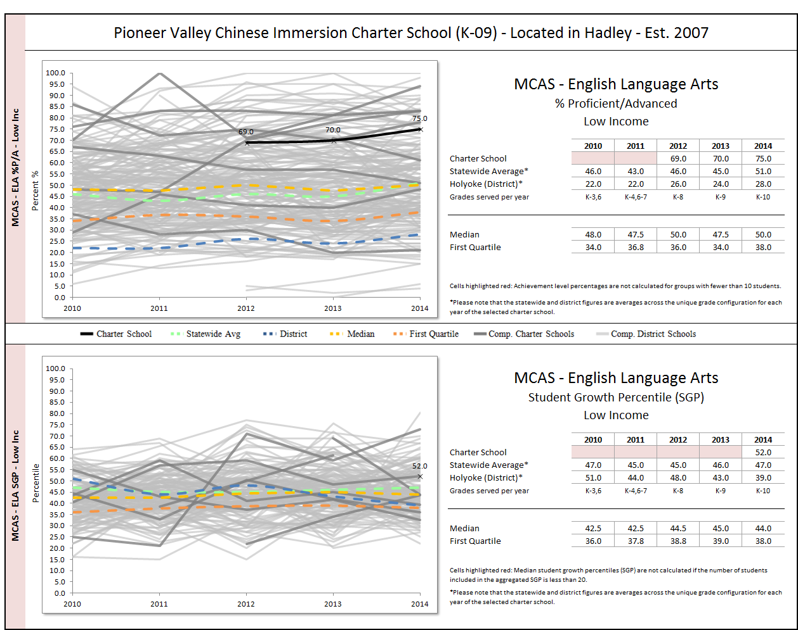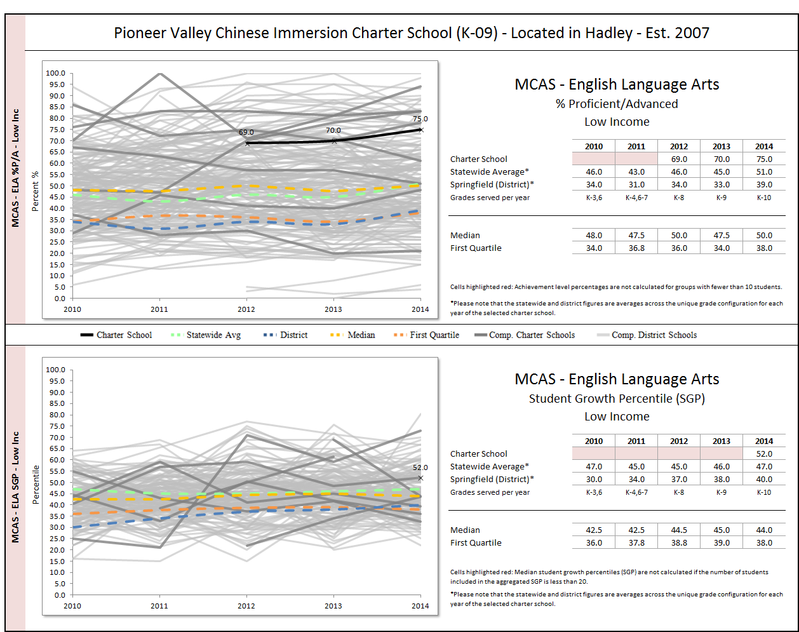
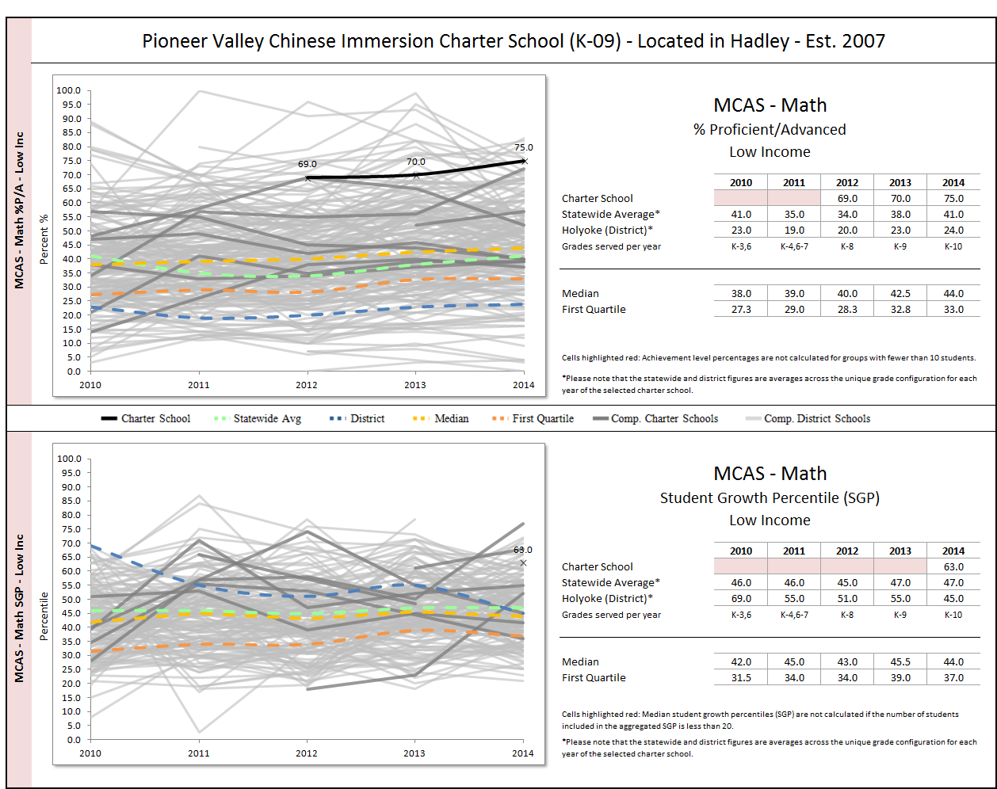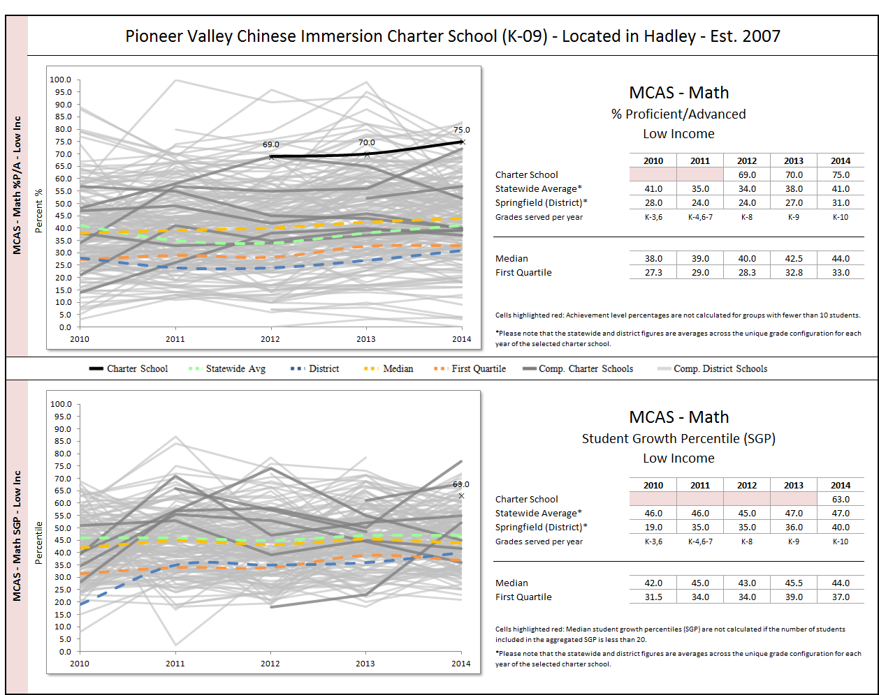
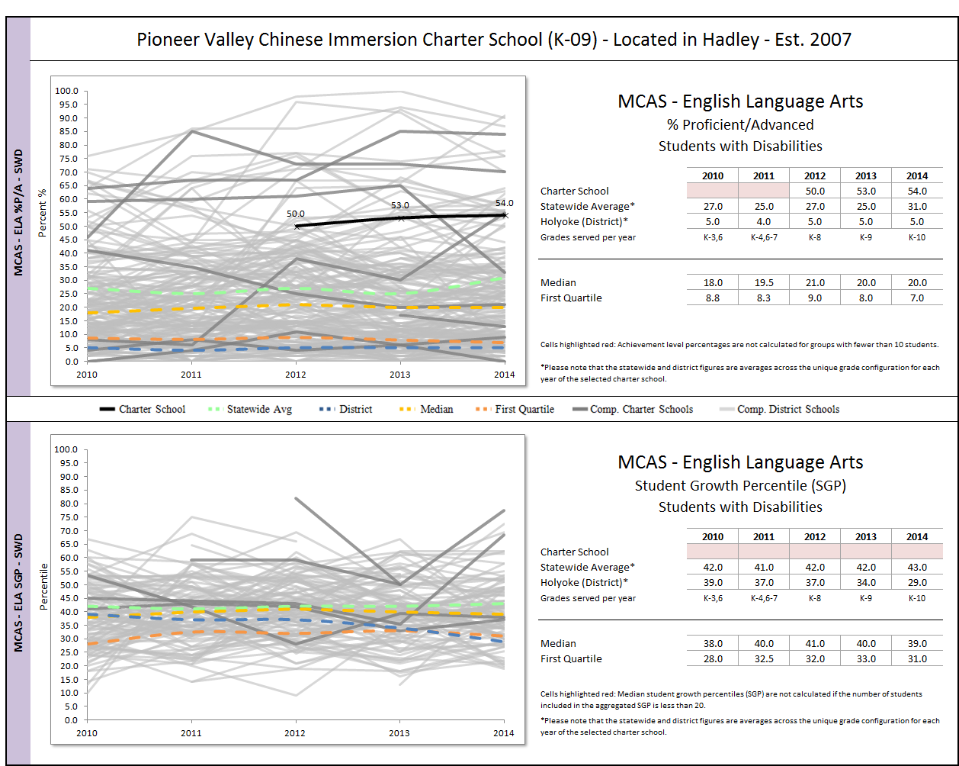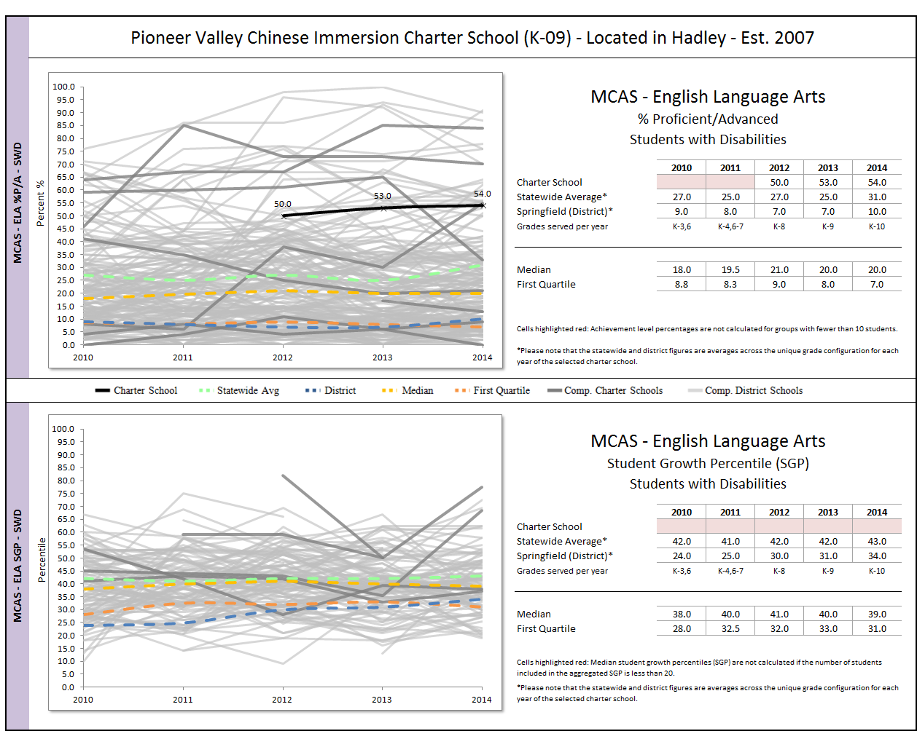
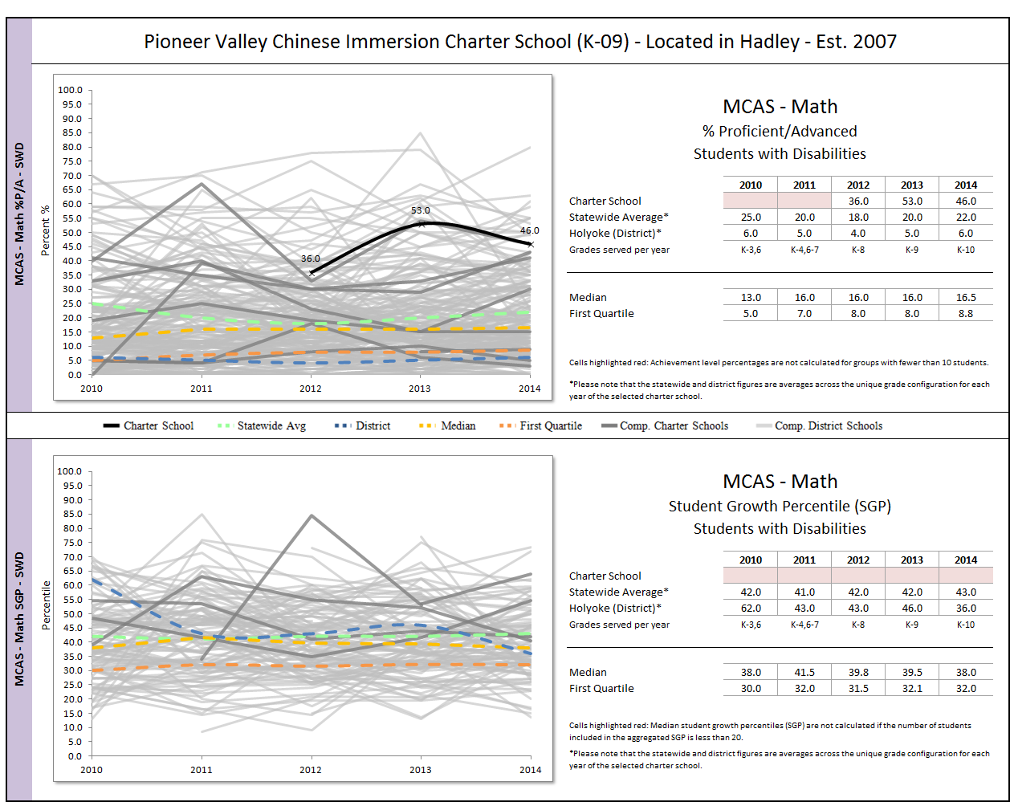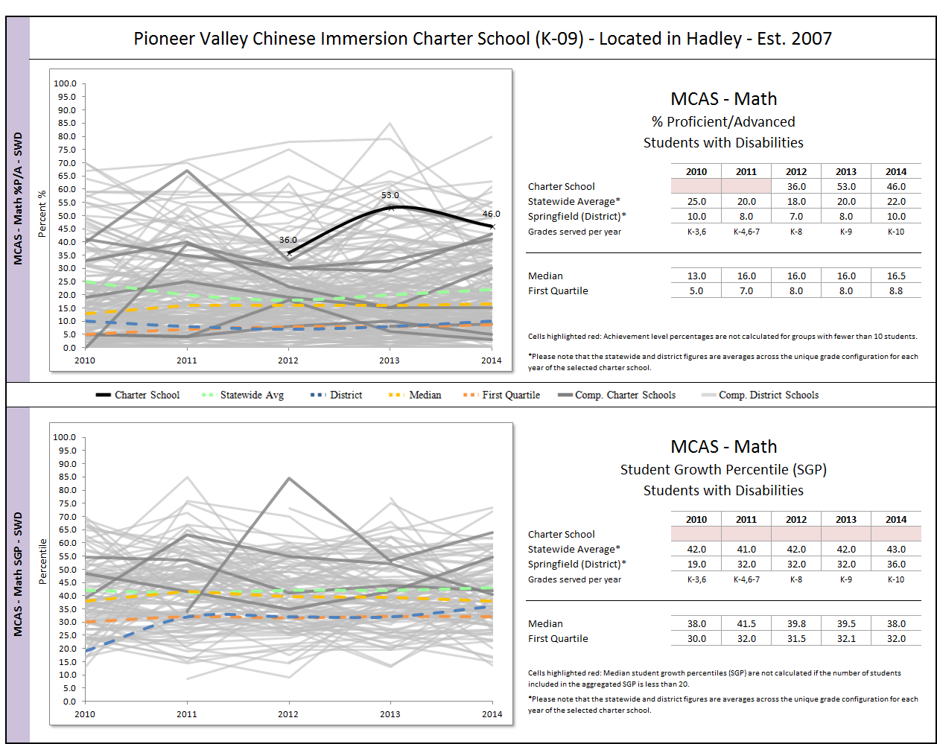
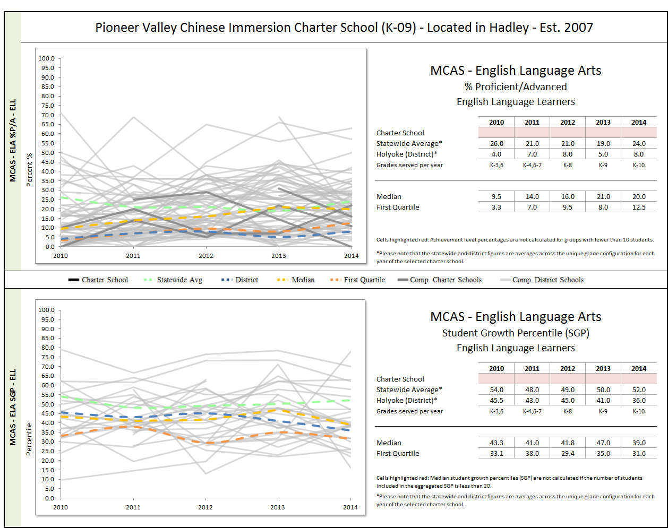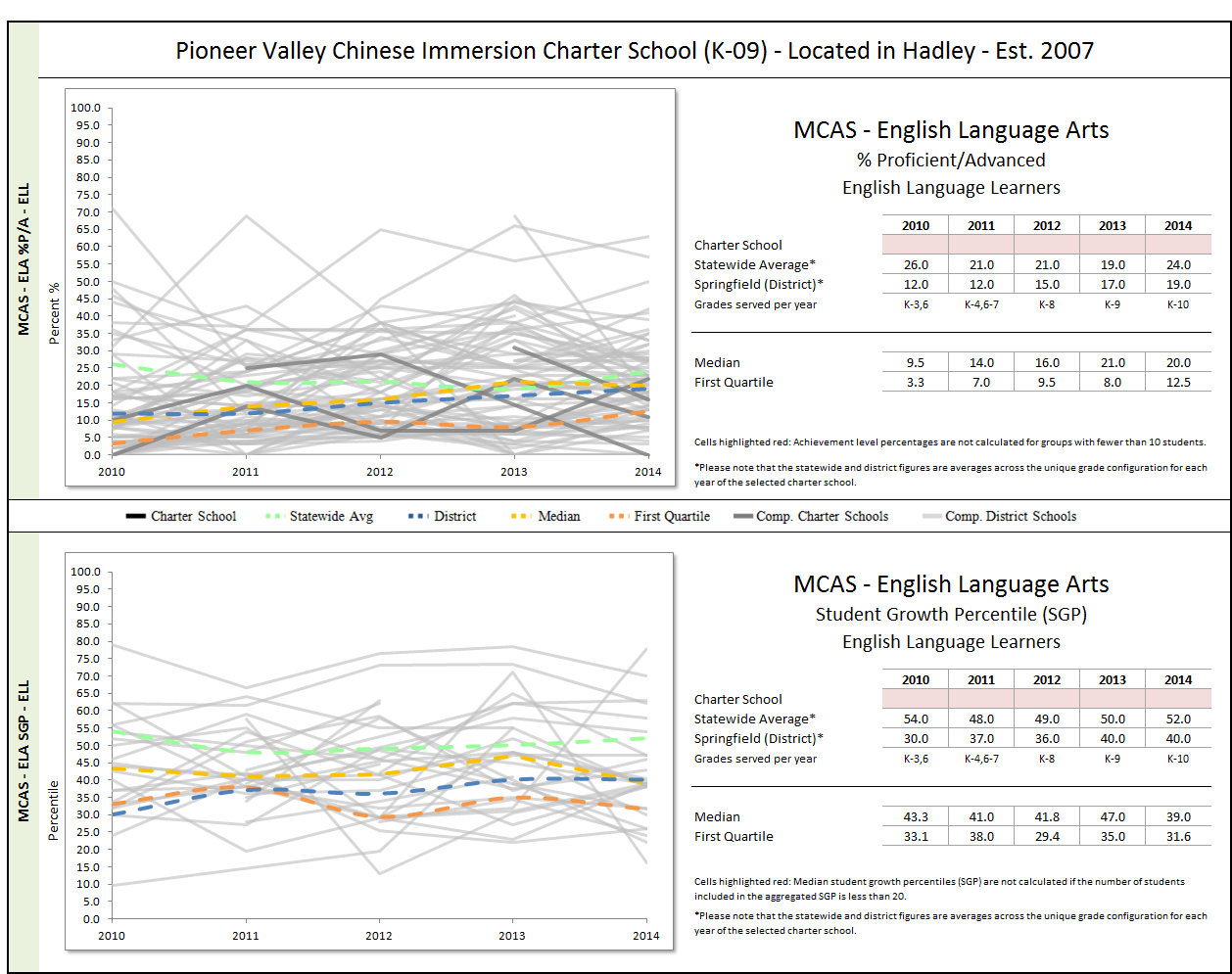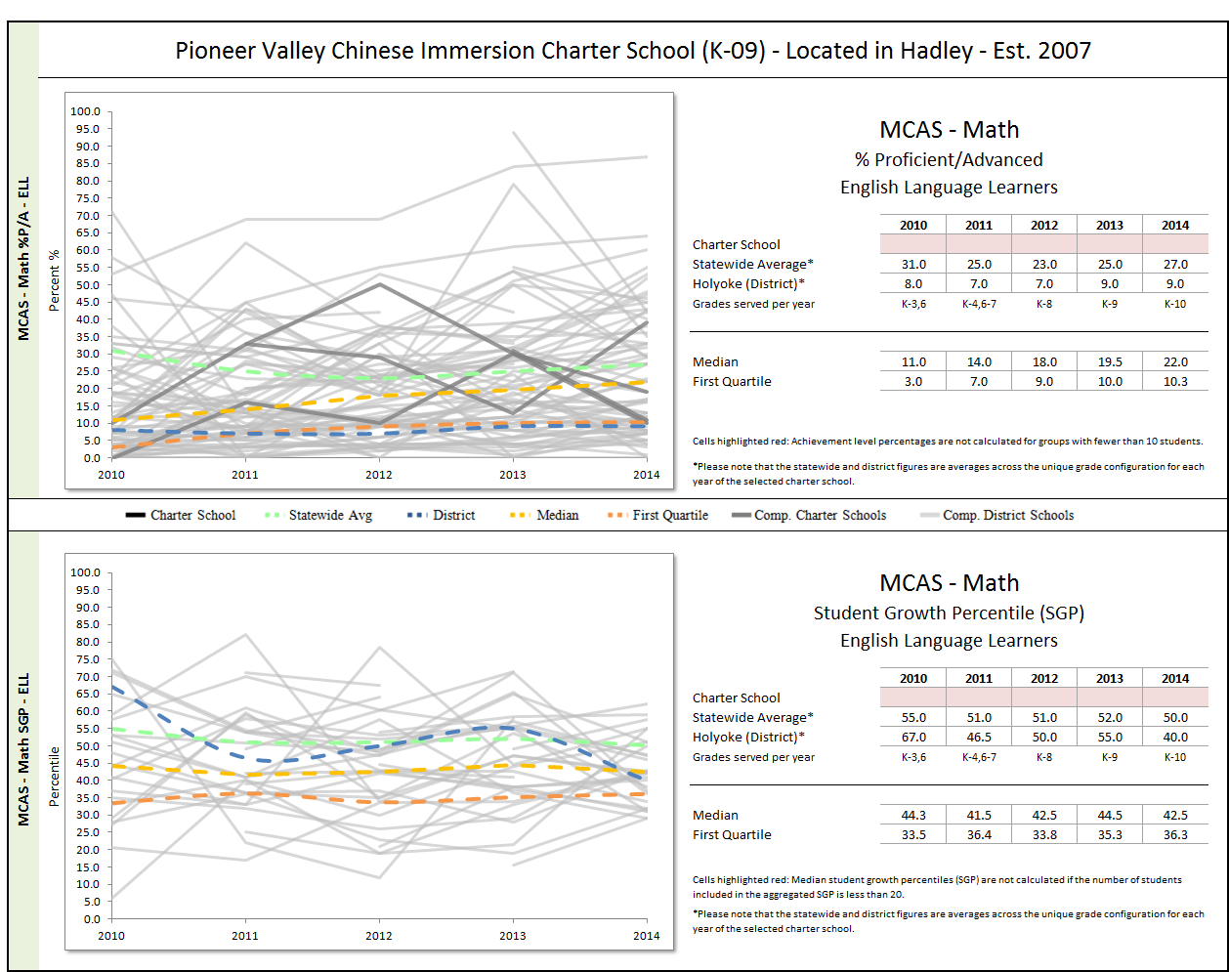
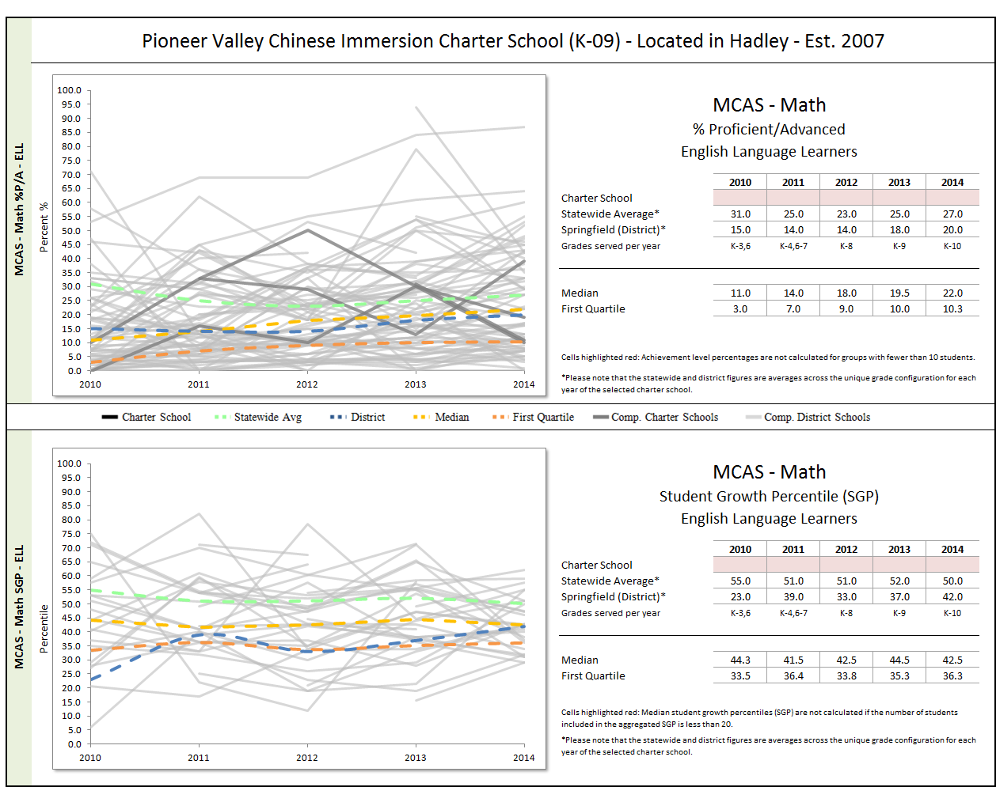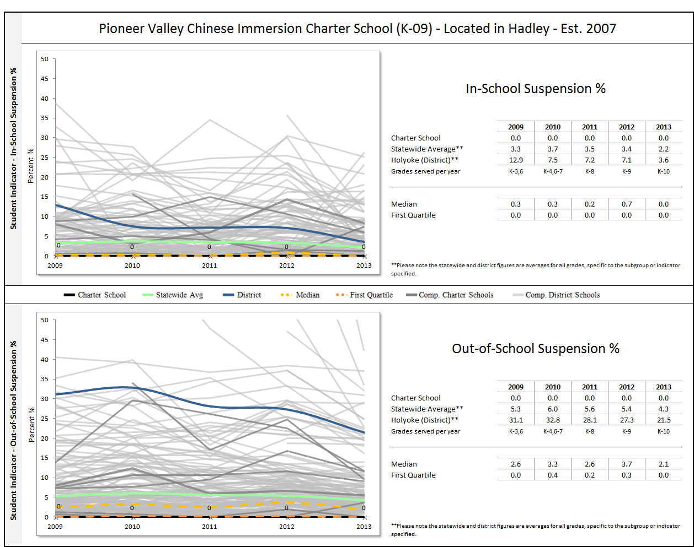
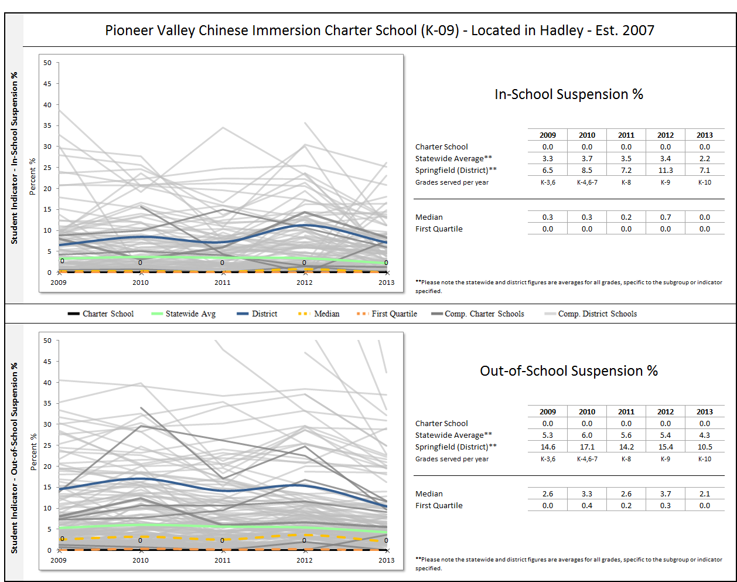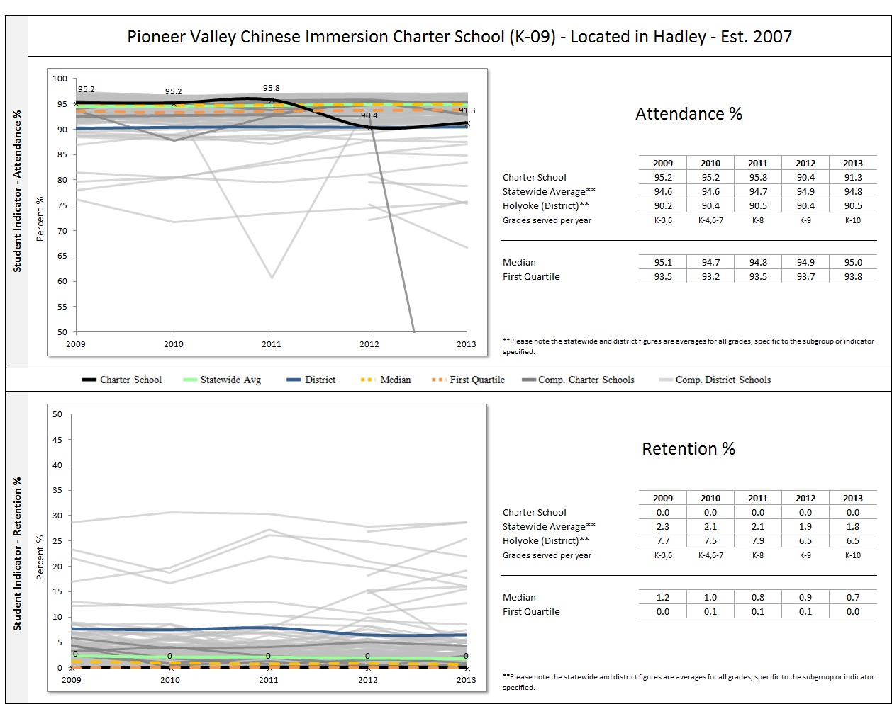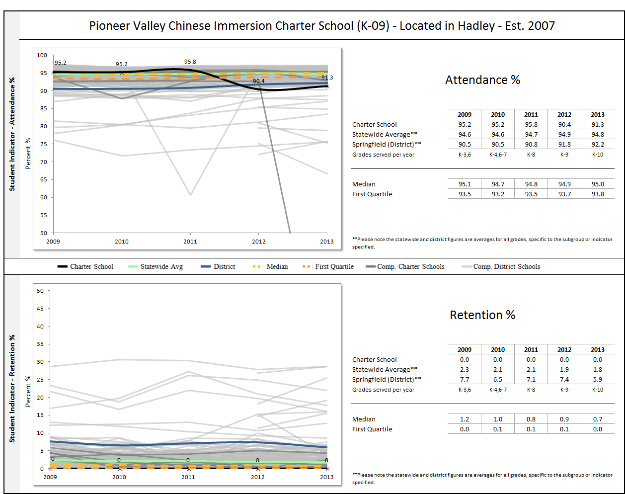

1 The names of each of these schools and additional subgroup detail can be found in the Charter Analysis and Review Tool (CHART), http://www.doe.mass.edu/charter/chart/.
The midpoint value of all comparison schools. This is derived using Microsoft Excel's MEDIAN function.
The first quartile is the middle number between the smallest number and the median of all comparison schools. This is derived using Microsoft Excel's QUARTILE function.
The comparison index provides a comparison figure derived from data of students who reside within the charter school’s sending district(s). The comparison index is a statistically calculated value designed to produce a fairer and more realistic comparison measure that takes into account the charter school’s size and the actual prevalence of student subgroups within only those grade levels in common with the charter school.
The Gap Narrowing Target (GNT) refers to the halfway point between the school’s baseline rate (which is the rate in the 2010-11 school year, or the first year enrollment data is collected if after 2010-11,) and the current Comparison Index (the “target”). The object is to meet this halfway point by the 2016-17 school year (or in a later year if baseline is after 2010-11), giving the school six years to do so. For a school to be on schedule to meet its GNT, an incremental increase must be met annually. To determine this increment, the following equation is used: [(Comparison Index – Baseline) / 2] / 6 years = Annual GNT.
The percentage of attrition, or rate at which enrolled students leave the school between the end of one school year and the beginning of the next.
A student is high needs if he or she is designated as either low income, or ELL, or former ELL, or a student with disabilities. A former ELL student is a student not currently an ELL, but had been at some point in the two previous academic years.
Comparable grades refers to the grades served by the charter school during each year under review.
The midpoint value of all comparison schools. This is derived using Microsoft Excel's MEDIAN function.
The set of displayed comparison schools includes the charter school of interest, and all of the public schools in the charter school’s region that serve at least one grade level of students which overlaps with the grade levels served by the charter school.
The first quartile is the middle number between the smallest number and the median of all comparison schools. This is derived using Microsoft Excel's QUARTILE function.

