Massachusetts Department of

Elementary and Secondary Education

75 Pleasant Street, Malden, Massachusetts 02148-4906 Telephone: (781) 338-3000

TTY: N.E.T. Relay 1-800-439-2370

Mitchell D. Chester, Ed.D.
Commissioner

MEMORANDUM

To: | Members of the Board of Elementary and Secondary Education
From: | Mitchell D. Chester, Ed.D., Commissioner
Date: | December 9, 2016
Subject: | Charter Schools – Report on Probation for Martin Luther King, Jr. Charter School of Excellence

In January 2015, the Board of Elementary and Secondary Education (Board) placed Martin Luther King, Jr. Charter School of Excellence (MLK) on probation and imposed three conditions related to academic improvement and sustainability. At its meeting on February 23, 2016, the Board of Elementary and Secondary Education (Board) voted to renew the charter of MLK and to extend probation with four conditions related to governance and academic achievement. This informational memorandum provides a report on the progress of MLK in meeting these conditions. There is no action or vote associated with this memorandum. I will bring a recommendation to the Board regarding the school’s probation after the school’s fourth condition expires.

MLK has met three of the four conditions imposed; the deadline for the fourth condition is December 31, 2017. Due to the school’s achievement of Level 1 status in 2016, the school did not receive a site visit this fall.

Martin Luther King Jr. Charter School of Excellence
Type of Charter  (Commonwealth or Horace Mann) | Commonwealth | Location | Springfield
Regional or Non-Regional | Non-Regional | Districts in Region  (if applicable) | N/A
Year Opened | 2006 | Year(s) Renewed  (if applicable) | 2011
Maximum Enrollment | 360 | Current Enrollment | 366
Chartered Grade Span | K-5 | Current Grade Span | K-5
Students on Waitlist | 157 | Current Age of School | 11 years
Mission Statement
Martin Luther King, Jr. Charter School of Excellence prepares kindergarten through 5th grade students of Springfield for academic success and engaged citizenship through insistence on rigorous, challenging work. The school incorporates Dr. King’s commitment to the highest standards in scholarship, civic participation and the ideal of the beloved community.

School History

- In 2009, the school was granted a temporary increase in maximum enrollment from 360 to 380, and the maximum authorized enrollment was reduced back to 360 in 2012. During the school’s second charter term the school was persistently overenrolled beyond the maximum allowed by its charter, even during the temporary enrollment increase.

- In January 2011, the Board granted the school a probationary renewal with three conditions related to program delivery, academic performance, and organizational viability.

- In January 2013, the Board determined that MLK had sufficiently met conditions to remove MLK from probation. The school had met conditions related to academic growth, had established a fully documented curriculum, and had evaluated and fully staffed its leadership structure. The Board imposed further academic conditions that required the demonstration of significant and sustained academic improvement by December 2014.

- In January 2015, following a decline in student achievement, the Board again placed the school on probation. The Board established conditions of probation related to governance and sustained academic improvement.

Report on Probation

Below is a summary of the school’s progress toward meeting the four conditions imposed on the school. The fourth condition does not expire until the end of 2017.

Condition 1: Until further notice, Martin Luther King, Jr. Charter School of Excellence must submit to the Department, at charterschools@doe.mass.edu, board meeting agendas, materials, and minutes prior to each board meeting at the same time that these items are sent to the school's board members. Additionally, if board materials do not already include this information, the school must also submit monthly financial statements.

Status: Met/Ongoing
MLK has submitted board packages as directed by the condition. Board packages contain board committee minutes, reports on academic data, financial updates and projections, budget documents, policy documents, and compliance documents.

Condition 2: The school must maintain the established escrow account to pay for any potential closing, legal, and audit expenses associated with closure, should that occur.

Status: Met
As required by conditions established in January 2015, the school opened an escrow account at the Berkshire Bank by March 25, 2015. The account currently holds approximately $17,500 set aside for potential closing costs, should that occur.

Condition 3: By December 31, 2016, the school must demonstrate significant and sustained academic improvement in mathematics, English language arts, and science. Should the school fail to do so, the Commissioner and the Board of Elementary and Secondary Education will consider revoking the school’s charter based on failure to meet this condition, rather than wait to see improvement by December 31, 2017.

Status: Met
Following the school’s academic improvement in 2015, MLK continued to demonstrate academic progress in 2016. Based on 2016 assessment results, the school is now in Level 1 and in the 33rd percentile when compared to other elementary schools statewide.

In 2012, 2013, 2014, and 2015, MLK’s MCAS scores placed the school in Level 3. In 2016, MLK’s PARCC and MCAS scores placed the school in Level 1. The school’s percentile, when compared to other elementary schools statewide, continued to improve in 2016. In 2012, MLK was in the 12th percentile; in 2013, the 11th percentile; and in 2014, the 9th percentile. In 2015, the school was in the 16th percentile. In 2016, the school is in the 33rd percentile.

In 2016, the school has a cumulative Progress and Performance Index (PPI) of 88 for all students and 86 for the high needs subgroup. In 2016, the school met gap narrowing targets for both all students and the high needs subgroup.

PARCC scores are designated by Levels, with Levels 4 and 5 meeting and exceeding expectations respectively. In 2016, 42 percent of MLK students scored in Level 4 and 5 on the ELA PARCC assessment. In mathematics, 60 percent scored in Level 4 and 5. In science and technology/engineering, 40 percent scored Proficient and Advanced on the science and technology/engineering MCAS assessment, below the state average of 47 percent.

The transitional SGP was generated using current PARCC and prior MCAS scores. Student Growth Percentiles (SGP) have varied over the charter term but improved in 2015 and continued to show improvement in 2016 for ELA and mathematics. The school’s SGP for all students in 2016 was 64.0 in ELA (above target growth) and 76.0 in mathematics (above target growth).

Student Growth Percentile
 |  | 2012 | 2013 | 2014 | 2015 | 2016
ELA SGP | All | 50.5 | 42 | 35.5 | 49.5 | 64
 | High needs | 50.5 | 42 | 36 | 41 | 60
Math SGP | All | 73 | 59 | 44 | 64 | 76
 | High needs | 74 | 55.5 | 44.5 | 66 | 73

Composite Performance Index (CPI) scores for the school continued to improve in 2016 for English language arts (ELA) and mathematics, although science and technology/engineering showed a slight decline. The 2016 CPI was 78.6 in English language arts (ELA), 86.6 in mathematics, and 75.9 in science and technology/engineering.

ELA CPI Chart

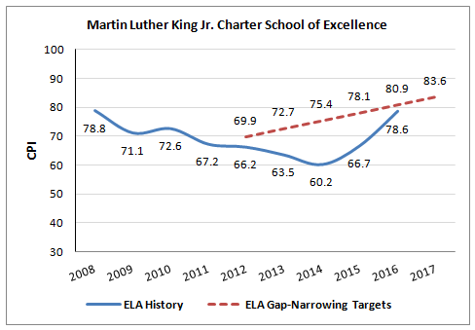
Mathematics CPI Chart
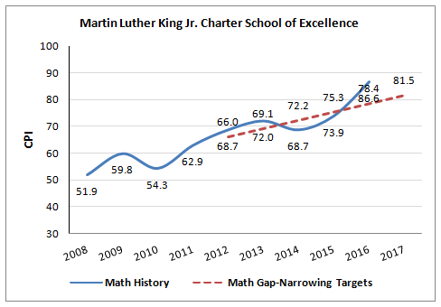

Science CPI Chart
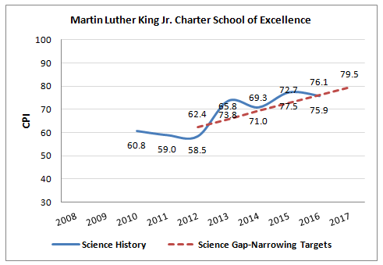

Condition 4: By December 31, 2017, the school must demonstrate continued significant and sustained academic improvement in mathematics, English language arts, and science. Should the school fail to do so, the Commissioner and the Board of Elementary and Secondary Education will consider revoking the school’s charter based on failure to meet this condition.

Status: Not yet applicable

As noted above, MLK has met three of the four conditions imposed, and the deadline for the fourth condition is December 31, 2017. I am pleased with the progress that the school has made so far. Last winter, the Board voted to renew the school’s charter and maintain the probationary status based in part on evidence about substantial changes that MLK’s new instructional leadership put in place. In its tenth year, MLK made substantial changes to its curriculum, instructional practices, professional development, supports for diverse learners, and use of data. Next fall, Department staff will visit the school to gather additional evidence related to school operation. In January 2018, I will provide a full report on the school’s 2016-17 academic results as well as the evidence gathered through our charter school site visit process. At that time, the Board will discuss and vote on the school’s performance related to the probationary conditions.

If you have any questions regarding these amendments or require additional information, please contact Alison Bagg, Director (781-338-3218); Cliff Chuang, Senior Associate Commissioner (781-338-3222); or me.

According to the October 1, 2016, SIMS data, MLK is over-enrolled by 6 students. This is a violation of the school’s charter terms. Charter schools do not receive tuition for over-enrolled students.
Source: As reported in the Massachusetts Charter School Waitlist Initial Report for 2016-2017 from March 15, 2016 (http://www.doe.mass.edu/charter/enrollment/fy2017Waitlist.html)

