Massachusetts Department of

Elementary and Secondary Education

75 Pleasant Street, Malden, Massachusetts 02148-4906 Telephone: (781) 338-3000

TTY: N.E.T. Relay 1-800-439-2370

Jeff Wulfson
Acting Commissioner

MEMORANDUM

To: | Members of the Board of Elementary and Secondary Education
From: | Jeff Wulfson, Acting Commissioner
Date: | November 17, 2017
Subject: | Commonwealth of Massachusetts Virtual Schools – Funding

In his February 12, 2016 memorandum to the Board of Elementary and Secondary Education (Board) regarding renewal of the certificate for Greenfield Commonwealth Virtual School, former Commissioner Chester reflected on virtual schools generally and highlighted challenges these schools face related to governance, enrollment, and funding. Since that time, changes in the virtual school statute, G.L. c. 71, § 94, and actions taken by the boards of trustees of the two Commonwealth Virtual Schools (CMVS) have addressed the issues related to governance and enrollment. The issue related to funding, however, remains and continues to be examined and discussed by the Department of Elementary and Secondary Education (Department) and the Digital Learning Advisory Council (DLAC). This memorandum provides background information for discussion at the Board meeting on November 28, 2017, and my recommendation that the Board vote next month to increase the per pupil tuition rate for each CMVS.

Commonwealth Virtual Schools

A CMVS is a public school operated by a board of trustees whose teachers primarily teach from a remote location using the Internet or other computer-based methods and whose students are not required to be located at the physical premises of the school. Like a charter school, a virtual school is an autonomous, single-school district that operates independently of any existing school district.

The Board grants a certificate to the board of trustees of a virtual school for not less than 3 years and not more than 5 years, as determined by the Board. The school and its board then become a state entity, directly accountable to the Board and the Department. A virtual school may not discriminate in the enrollment of students based on race, color, national origin, creed, sex, gender identity, ethnicity, sexual orientation, mental or physical disability, age, ancestry, athletic performance, special need, English language proficiency, or academic achievement.

The Board has granted two virtual school certificates, one to the Massachusetts Virtual Academy at Greenfield Commonwealth Virtual School (GCVS) and one to the TEC Connections Academy Commonwealth Virtual School (TECCA). Both schools enroll students statewide. As of October 1, 2016, these schools enrolled a total of 1,786 students. Attachments A and B present data about each CMVS.

Governance and Enrollment

With respect to governance, concern has been expressed in the past regarding the capacity of all-volunteer, part-time boards of trustees to effectively oversee statewide schools and to negotiate contracts with education management organizations and hold them accountable for results. Cognizant of the Commissioner’s concerns, GCVS and TECCA have been assertive in negotiating with their education management organizations.

- In September 2016, TECCA amended its contract with Connections Education (“Connections”), a for-profit virtual school provider. The new contract reduced the fees paid by TECCA and transitioned many functions that had been under Connection's oversight to TECCA, including human resources, services for special education and English learners, and professional development. Further, Connections agreed to waive its right to receive repayment of credits issued to the school during its first certificate term.

- In May 2017, GCVS terminated the school’s contract with K12, Inc. (“K12”), a for-profit virtual school provider, effective June 30, 2017. The reasons GCVS gave for the change were concerns about the affordability of K12’s products and services and the opportunity for GCVS to provide more flexible learning options for students through new software and curriculum. The projected cost savings should enable the school to hire additional teachers.

With respect to enrollment, until 2016, the virtual schools law required that not less than 5 percent of the students enrolled in a CMVS reside in the school district(s) that established the school. G.L. c. 71, § 94(c). This put virtual schools, such as GCVS, established in smaller communities at risk if they could not enroll that number of students locally. With the elimination of this requirement, a CMVS may enroll students from across the state. The statute includes a safeguard for school budgets: a school committee may cap enrollment if the number of students residing in the district who are enrolled in virtual schools exceeds one percent of the district’s total enrollment. G.L. c. 71, § 94(t). No district in Massachusetts has yet reached this limit.

Current Per Pupil Tuition Rate

The virtual school statute, at G.L. c. 71, § 94(k), funds a CMVS based upon the funding for school choice under G.L. c. 76, § 12B: the school district of residence of each student enrolled in the CMVS is charged a set tuition, and the Department transfers the funds from the district to the CMVS. Tuition is based on full year enrollment and is prorated if a student is enrolled in the CMVS for only a portion of the school year.

The default tuition rate for a student enrolled in a CVMS is the school choice tuition rate of $5,000. The Board, in consultation with the Operational Services Division (OSD), may approve a rate higher than $5,000 in CMVS certificates provided the rate does not exceed the state average per pupil foundation budget for students of the same classification and grade level. G.L. c. 71, § 94(k); 603 CMR 52.07(1). The state average per pupil foundation budget is $10,774. GCVS and TECCA currently receive a per pupil tuition amount of $6,700, less $75 per pupil retained by the Department for program administration, as permitted by statute ($6,625). For the reasons presented below, I propose increasing the per pupil tuition rate for both schools to $8,265, less $75 per pupil for program administration ($8,190).

Request for Increase to Per Pupil Tuition Rate
Between November 18, 2015, and October 14, 2016, DLAC heard presentations from GCVS and TECCA regarding funding. Both schools were invited to comment on the adequacy of the current rate and explain how they would use a tuition increase to better meet the needs of their students. Both schools indicated that their current tuition rates are not adequate to serve the needs of the students they enroll.

GCVS provided a rationale and requested an adjusted rate between $7,655 and $8,518 per student; TECCA provided a rationale and requested between $9,000 and $12,500 per student.

The schools proposed using additional tuition to meet the needs of their students and to enhance recruitment and retention of educators who possess the specialized knowledge and skill to work with these student populations. Both schools propose hiring additional staff to decrease student load and increase contact time with students. For example, TECCA would hire additional staff to provide individualized services to students; and GCVS would hire additional teachers.

Consideration of Factors Related to Increasing the Per Pupil Tuition Rate

While many variables affect the relative costs of online schools and traditional schooling, both GCVS and TECCA report serving student populations with atypical needs as compared to students enrolled in traditional school districts and charter schools. In granting a certificate to operate a virtual school, the virtual schools statute requires the Board to give preference to proposals that include an educational program or a specialized focus that appropriately addresses students with unique needs. G.L. c. 71, § 94(c). Given the mixed performance of virtual schools in Massachusetts as well as nationally, the Department has encouraged GCVS and TECCA to refine their programs to increase the effectiveness of virtual education (refer to Attachments A and B).

Compared to state averages, students enrolled in virtual schools in Massachusetts are more likely to have had a history of high mobility and lower achievement than students enrolled in brick-and-mortar schools. Virtual school students are more likely to have lower attendance rates and to have been suspended from school or repeated a grade. Students enrolling in virtual schools are significantly more likely to be economically disadvantaged. Finally, the percentage of students with disabilities enrolled in a CMVS is growing faster than the state average.

GCVS and TECCA seek educators who possess the specialized knowledge and skill to teach in the virtual environment and to work with high-need populations. On average, GCVS teachers earn 36 percent less than their counterparts in brick-and-mortar schools and TECCA teachers earn 32 percent less. Both schools propose increasing starting teacher salaries and phasing in salary increases to be more competitive with other districts.

The Board set the current rate of $6,700 based on a review of national studies available in 2012. Our experience since 2012 with the two virtual schools in Massachusetts is that they are held accountable for the same outcomes as brick-and-mortar schools, but for more complex student populations and with fewer resources. This holds true even when the costs attributed to the Commonwealth’s brick-and-mortar schools, such as operations and maintenance, are omitted.

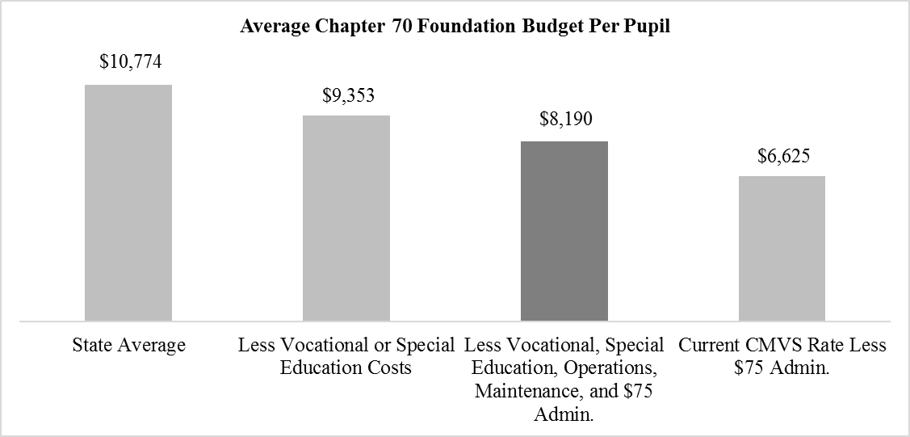

Recommendation

After consideration of each school’s request and the various factors outlined above, I recommend that the Board vote on December 19, 2017 to amend the certificates of the two virtual schools to specify $8,190 in per pupil tuition, effective for FY19, and authorize the Department to adjust this rate annually for inflation. This will enable the virtual schools to provide higher teacher salaries, decrease student load, increase contact time with students and parents/guardians, and help keep pace with the rising costs associated with running any public school. While increased funding does not guarantee improved outcomes, I believe providing these schools with resources to further innovate on the model, coupled with strong oversight, will in time confirm whether full-time virtual schooling can become a viable and effective option for the Commonwealth’s students and families.
As with school choice, sending districts lose funds for each student enrolled in a virtual school; however, for most districts, the impact of a tuition increase will be relatively minimal given the small numbers of students from any one district enrolling in virtual schools.

In addition to the discussions with the DLAC, the Department has begun soliciting feedback from other stakeholders, including the Massachusetts Association of School Superintendents and the Superintendents Advisory Council. Per statute, the Department also consulted with the Operational Services Division about the proposed tuition increase. After additional stakeholder engagement, I anticipate bringing amendments to the certificates for the two virtual schools to the Board for a vote at the December 19, 2017 meeting.

If you have any questions regarding this matter or require additional information, please contact Kenneth Klau, Director, Office of Digital Learning (781-338-3505); Cliff Chuang, Senior Associate Commissioner (781-338-3222); or me.

Attachments:
Attachment A: Data on GCVS
Attachment B: Data on TECCA
Attachment C: Calculation and Disbursement of CMVS Tuition
Attachment D: Student Demographics and Enrollment Trends, 2015-16

http://www.doe.mass.edu/bese/docs/fy2016/2016-02/.
https://malegislature.gov/Laws/GeneralLaws/PartI/TitleXII/Chapter71/Section94.
The virtual schools legislation in 2013 created DLAC to advise the Board and the Commissioner on “matters related to virtual education” including, but not limited to, “recommendations for best practices to encourage online education to complement classroom instruction in district schools and recommendations on the appropriateness of the fee that the department may retain for the administration of the virtual school program.” Chapter 379 of the Acts of 2012, § 7.
The virtual school statute authorizes the Board to grant up to 10 certificates to operate such schools, provided that not more than 2 percent of students statewide attend a CMVS. G.L. c. 71, § 94(c).
If a CMVS desires to change the terms of its certificate, the virtual school's board of trustees must vote on and submit to the Commissioner a request in writing to amend its certificate for the Commissioner's approval. 603 CMR 52.10(2).
Connections provided TECCA with fiscal support to bridge the gap between projected and actual enrollment during the first two years of TECCA’s certificate term.
Chapter 133 of the Acts of 2016, § 49, eliminated the requirement that not less than five percent of the students enrolled in a CMVS reside in the school district(s) that established the school.
For an example of how virtual schools are funded through the school choice mechanism, refer to Attachment C. The tuition for special education students is the cost of providing the special education required by the student. G.L. c. 71, § 94(k).
The per pupil tuition rate of $6,700 was set by the Board on June 25, 2013 when it voted to approve a certificate for GCVS. The Board approved the same rate for TECCA on February 25, 2014.
TECCA presented to the DLAC on November 18, 2015; January 6, 2016; February 25, 2016; September 13, 2016; and October 14, 2016. GCVS made presentations on February 25, 2016, and October 14, 2016.
Virtual schools have larger class sizes and higher student-teacher ratios than the state average. In FY17 GCVS had a student-teacher ratio of 21.5 to 1, and TECCA’s student-teacher ratio was 30.2 to 1. The state average was 13.2 to 1.
G.L. c.71, §94(c), states that the Board shall give preference to proposals that include an educational program or specialized focus that appropriately addresses 1 or more of the following: students with physical or other challenges that make it difficult for them to physically attend a school; students with medical needs requiring a home or hospital setting; students with unusual needs requiring a flexible schedule; students who are over-age for their grade; students who have been expelled; students who have dropped out; students at risk of dropping out; students who are pregnant or have a child; students with social and emotional challenges that make it difficult for them to physically attend a school; students who feel bullied or cannot attend school because the students' safety is at risk; gifted and talented students; students who seek academic work not available in their school; students in rural communities; and students in institutionalized settings. The board shall also consider whether proposed schools will create or enhance the opportunity for students to attend virtual schools in all grades from kindergarten through grade 12.
These data were presented to the Board on February 17, 2017; for details, refer to Attachment D.
The average teacher salary on the GCVS salary scale is $49,062, and the average teacher salary on the TECCA salary scale is $52,139.38. The state average for FY16 was $76,442.
For example, Battaglino, Halderman & Laurans (2012) estimated a $6,400 per pupil cost for a “full virtual model” when the following cost factors are considered: labor, content acquisition, technology and infrastructure, school operations, and student-support services. They noted the cost could vary as much as 20 percent in either direction based on resource allocation across those categories.
A 2016 study of virtual charter schools by the University of Southern Maine (Johnson, A.F., Hopper, F. & Sloan, J.E.) reported that among states that permit the operation of virtual charter schools, the majority fund these schools on a par with brick-and-mortar charter schools and/or non-charter public schools.
Consistent with the state school choice program, the CMVS, as a receiving district, bills the costs of special education services to the students’ district of residence. The CMVS is programmatically responsible for arranging for those services.
$8,265 less $75 per pupil retained by the Department for program administration.
Connections Education, TECCA’s curriculum provider, charges $90 for every $1,000 of per pupil funding. In a February 10, 2017 letter addressed to the Department, the superintendent noted that any tuition increase would go to direct services for students and none would go to Connections.
In FY17, the median district enrolled 5.4 students in a CMVS and sent $36,247 in tuition to a CMVS. A tuition increase to $8,265 in FY17 would have increased total CMVS tuition for the median district by approximately $8,446 to $68,326. Using FY17 figures, increasing per pupil tuition from $6,700 to $8,265 would have increased statewide CMVS tuition from $12.9 million to $15.9 million. In FY17, 14 districts sent more than 20 students to a virtual school, accounting for almost a third of CMVS enrollment.
G.L. c. 71, § 94(k); 603 CMR 52.07(1).

