Massachusetts Department of

Elementary and Secondary Education

75 Pleasant Street, Malden, Massachusetts 02148-4906 Telephone: (781) 338-3000

TTY: N.E.T. Relay 1-800-439-2370

Jeff Wulfson
Acting Commissioner

MEMORANDUM

To: | Members of the Board of Elementary and Secondary Education
From: | Jeff Wulfson, Acting Commissioner
Date: | February 16, 2018
Subject: | Charter Schools – Recommendation to Renew the Charter of Helen Y. Davis Leadership Academy Charter Public School with Probation

This month, the Board of Elementary and Secondary Education (Board) will discuss and vote on the charter renewal application for Helen Y. Davis Leadership Academy Charter Public School (DLA). I recommend that the Board renew the school’s charter and place the school on probation with the conditions described later in this memorandum.

Helen Y. Davis Leadership Academy Charter Public School
Type of Charter  (Commonwealth or Horace Mann) | Commonwealth | Location | Boston
Regional or Non-Regional | Non-Regional | Districts in Region  (if applicable) | N/A
Year Opened | 2003 | Year(s) Renewed  (if applicable) | 2008, 2013
Maximum Enrollment | 216 | Current Enrollment | 214
Chartered Grade Span | 6-8 | Current Grade Span | 6-8
Students on Waitlist | 210 | Current Age of School | 15 years
Mission Statement
Our school develops high-achieving students of good character who use problem solving, communication, and interpersonal skills to inspire others and to catalyze educational, economic, and political advancement within their communities and the broader nation.

Basis of Recommendations Regarding the Renewal of Charters

The charter school regulations state that “[t]he decision by the Board to renew a charter shall be based upon the presentation of affirmative evidence regarding the success of the school’s academic program; the viability of the school as an organization, including the extent to which the school has followed its recruitment and retention plan; and the faithfulness of the school to the terms of its charter.” 603 CMR 1.11(2). Consistent with the regulations, recommendations regarding renewal are based upon the Department of Elementary and Secondary Education’s (Department) evaluation of the school’s performance in these areas as outlined in the Charter School Performance Criteria and Commissioner Chester’s memorandum dated October 7, 2013, regarding Considerations for Charter School Renewal. In its review, the Department has considered the school’s absolute performance at the time of the application for renewal and the progress the school has made during the past four years of its charter. The accountability process for charter schools recognizes that in exchange for increased freedom, a school must demonstrate results within the term of its five-year charter or risk non-renewal or other possible sanctions, including revocation.

The superintendent of Boston Public Schools (BPS) was invited to submit written comment to the Department regarding the renewal of DLA’s charter. The Department did not receive any comment.

Recommendation for Board Action

Based upon the evidence described in the attached Summary of Review and other information summarized below, I recommend that the Board renew the school’s charter and place it on probation with conditions requiring major improvements in governance, financial oversight, and the school’s academic program and performance.

My recommendation to place the school on probation with conditions is based on my concerns about recurring poor governance practices and new evidence revealing a lack of financial oversight and mismanagement of the charter school by the board of trustees. Additionally, throughout the charter term, DLA’s academic performance has declined. Helen Y. Davis Leadership Academy Charter Public School is in its fifteenth year of operation, and I expect a school of this age to be organizationally viable and to deliver a robust program of study with strong academic results.

In July 2017, DLA employees presented concerns to the Department regarding the school’s use and oversight of public funds. Due to the nature of the information shared, the Department referred the matter to the Massachusetts Office of the State Auditor (OSA) and the Massachusetts Office of the Inspector General (OIG). The Department met with representatives from the OSA and the OIG to discuss the concerns. The OSA is presently engaged in a review of DLA that will evaluate governance generally and financial oversight and management specifically. Fieldwork for this review is scheduled through March 2018, and the OSA will issue a report at some point after the fieldwork is complete.

While the OSA’s report will not be finalized in time for a renewal determination, DLA’s fiscal year 2017 audit confirmed some of the concerns presented to the Department in July 2017. The school’s board of trustees did not provide competent stewardship of the school’s finances during the past year. Given the reemergence of poor governance practices coupled with new evidence of troubling decisions made by the school’s board of trustees, placing the school on probation signals my deep concerns about the viability of the school under its current governing board. Evidence relating to my concerns follows.

Mismanagement of the Charter School

As noted in the attached summary of review and data charts, I have concerns regarding financial oversight and management by the board of trustees as well as the school’s poor academic results.

At the conclusion of DLA’s prior charter term (2008-2013), the school’s charter was renewed with a set of three conditions related to governance. The 2013 Summary of Review included evidence related to governance instability and a lack of adequate financial oversight. Board turnover had been high, resulting in a lack of capacity. In 2010-2011, 10 members departed the board and 10 members joined. In 2011-2012, 10 members departed the board and 9 members joined the board. Additionally, twice during the charter term, the school had to issue mid-year layoffs in order to balance the school’s budget. The fiscal year 2012 audit contained two findings of significant deficiency. While board membership has stabilized during the current charter term (2013-2018), I have concerns about the reemergence of a lack of appropriate oversight exercised by the board, further described below.

During the 2013-2014 school year, after the school submitted monthly board minutes, conducted a board self-evaluation, and underwent governance training, the Department conducted a site visit and determined that the school met these conditions. Commissioner Chester released the school from conditions in January 2014.

Governance concerns have resurfaced during the current charter term. The board of trustees has not consistently complied with the Open Meeting Law, has not demonstrated adequate strategic planning, and has not demonstrated competent financial oversight. Most concerning is the failure of the board to exercise its duty of care in connection with retirement of the school’s former executive director with regard to a benefit granted as part of the retirement. This board decision with regard to the benefit is described further below. The school’s former executive director, who was also the school’s founding principal, retired in August 2017 and continues to work for the school as a consultant. Helen Y. Davis Leadership Academy Charter Public School hired an interim executive director before the retirement of the executive director. Later in the summer of 2017, the board hired a different person as acting interim executive director. The second individual to hold the role as acting interim executive director is currently serving as interim executive director.

In July 2017, DLA employees presented concerns to the Department regarding financial decisions made by the school’s board of trustees. The OSA, as noted previously, is currently evaluating the school’s governance, financial oversight, and management. As reported to the Department and documented in DLA’s fiscal audit for fiscal year 2017 (FY17) and board minutes, the board discussed and then voted to “buy back” the retiring executive director’s accumulated sick time in connection with her retirement. It is unclear whether this benefit was provided for in the former executive director’s contracts. The contracts for FY12 through FY14 include the statement that “sick days may not be carried over.” The contract from FYs15-16 is silent on the issue. DLA’s board of trustees included a statement in the school’s FY17 audit stating:“In this audit, it has been made clear that the Academy [DLA] will end the fiscal year 2017 school year with a shortfall of $99,011 due to a one-time payment for unused sick time; which was part of an agreement reached during negotiations with our now retired Executive Director.” The board’s statement also notes that if the board had received better advice from its “consultants,” the sick time pay- out would not have had a “negative impact on the bottom-line.” The audit confirms that DLA had a deficit of approximately $99,011 during FY17.

Declines in Academic Success

I also have concerns about the lack of improvement in student academic results during the charter term. As a grade 6-8 school, DLA has administered both the MCAS and the Next-Generation MCAS to students during this charter term, and assessment performance has declined.

- The school was in Level 1 in 2014 and 2015 and in the 35th and 36th percentiles respectively.
- In 2016, the school was placed in Level 2 for not meeting gap-narrowing goals and for low assessment participation for English Learner (EL) students and former EL students. In 2016, the school was in the 25th percentile.
- The school met its Progress and Performance Index (PPI) targets in 2015, declined in 2016, and improved below target for its Cumulative PPI in 2016.
- In 2017, DLA administered the Next-Generation MCAS in English language arts (ELA) and mathematics in grades 6 through 8 and therefore has no level in 2017.
- In 2017, 34 percent of DLA students in grades 6 through 8 met or exceeded expectations on the Next-Generation MCAS in ELA, below the state average of 49 percent. The school performed above its sending district, Boston Public Schools (BPS), which had an average of 31 percent meeting or exceeding expectations.
- In mathematics, 19 percent of students in grades 6 through 8 met or exceeded expectations on the Next-Generation MCAS, below the state average of 48 percent. The school performed below BPS, where 31 percent of students met or exceeded expectations.
- In 2017, DLA administered the legacy MCAS in science and technology/engineering for grade 8. In science and technology/engineering in grade 8, 6 percent of students earned proficient or advanced on the legacy MCAS, below the state average of 40 percent. The school performed below BPS, where 15 percent of 8th graders scored proficient or advanced.
- As noted in the composite performance index (CPI) charts below, during the current charter term, CPI scores have declined in all subject areas: ELA, mathematics, and science and technology/engineering.

ELA CPI Chart

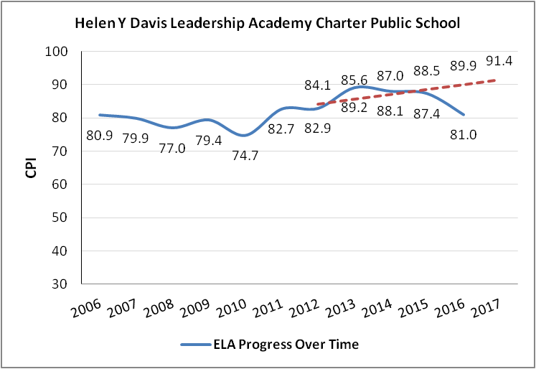

Mathematics CPI Chart

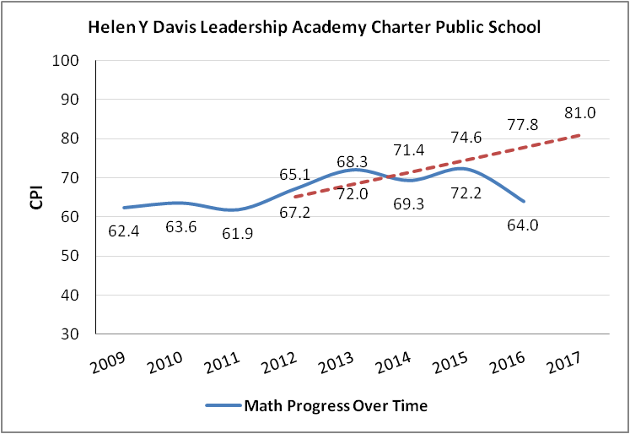

Science CPI Chart

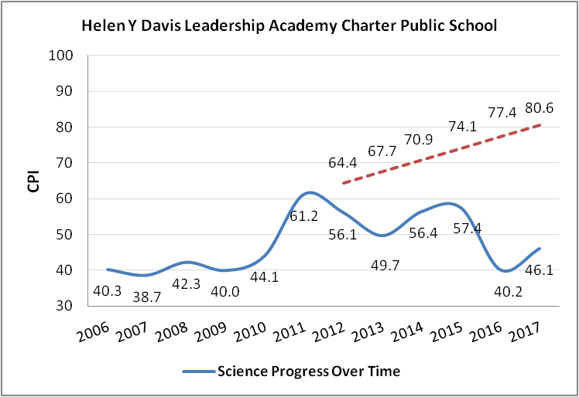

Historical student growth percentile (SGP) data is displayed in the chart that follows. Growth scores have been variable by year and subject area.

DLA Median Student Growth Percentile
Year |  | 2014 | 2015 | 2016 | 2017
ELA SGP | All | 58 | 53.5 | 42 | 61
 | High needs | 58 | 54 | 42 | 61.5
Math SGP | All | 63 | 63 | 47 | 42
 | High needs | 64 | 65.5 | 49 | 44.5

Conditions Imposed with Probation and Charter Renewal

I recommend that the Board vote to place DLA on probation and impose the conditions that follow on the school’s charter. Additional conditions may be imposed after a review of the report from the State Auditor’s Office.

- Until further notice, DLA must submit to the Department of Elementary and Secondary Education (Department), at charterschools@doe.mass.edu or 75 Pleasant St., Malden, MA 02148, board and committee meeting agendas, materials, and minutes prior to each board meeting at the same time that these items are sent to the school’s board members. Additionally, if board materials do not already include this information, the school must also submit monthly financial statements. The documents must reflect adherence to the Open Meeting Law.
- By March 30, 2018, the school must establish an escrow account in an amount determined by the Department in consultation with the school to pay for any potential closing, legal, and audit expenses associated with closure, should that occur.
- By April 18, 2018, all members of the board of trustees must participate in training on the Open Meeting Law offered by the Office of the Attorney General. In addition, all members of the board of trustees must participate in training on state ethics offered by the State Ethics Commission.
- By May 31, 2018, the board of trustees will work with the Department to obtain approval of its bylaws.
- By June 1, 2018, the school must submit to the Department a comprehensive evaluation of its mathematics, English language arts, and science programs. Such comprehensive evaluation must be conducted by an external consultant(s) acceptable to and approved in advance by the Department.
- By June 29, 2018, the school must submit to the Department for approval an action plan to improve academic performance. Such action plan must specify the strategies to improve mathematics, English language arts, and science performance for all student groups. The action plan must set clear and specific implementation benchmarks, with a clear timetable and deadlines for completion of key tasks sufficient to allow the school's board of trustees and the Department to monitor implementation.
- By July 1, 2018, the board of trustees must assess its capacity and expertise, taking into consideration current term limits for existing board members, and add membership that will allow the board to fulfill its governance duties.
- By December 31, 2019, the school must demonstrate that it is an academic success by providing evidence that the school has exhibited significant and sustained academic improvement in mathematics, English language arts, and science.

Should the SAO’s report contain additional evidence concerning the school’s viability, I will share that information with the Board and may recommend additional action with respect to the school’s charter including, but not limited to, possible suspension and revocation of the school’s charter.

In addition to meeting the terms of probation, DLA, like all charter schools, must also comply with the terms of its charter. Failure of DLA to meet the conditions placed on renewal of its charter within the timelines specified may result in immediate suspension and revocation of the school’s charter. I will review and report to the Board on DLA’s success or lack of success in meeting the terms of probation.

If you have any questions regarding this recommendation or require additional information, please contact Alison Bagg, Director (781-338-3218); Cliff Chuang, Senior Associate Commissioner (781-338-3222); or me.

Attachments: DLA Summary of Review

Helen Y. Davis Leadership Academy Charter Public School (DLA) was formerly known as Smith Leadership Academy Charter Public School, but requested, and was granted, a name change amendment that took effect during the 2014-15 school year. The school has operated as Helen Y. Davis Leadership Academy Charter Public School since the summer of 2014.
As reported on March 15, 2017, in the Massachusetts Charter School Waitlist Initial Report for 2017-2018 (FY18).

