Martin Luther King Jr. charter school of Excellence
Year 12 Targeted Site Visit Report

Springfield, MA
March 27, 2018

Massachusetts Department of Elementary and Secondary Education
75 Pleasant Street
Malden, MA 02138
Phone: (781) 338-3227
Fax: (781) 338-3220

This document was prepared by the
Massachusetts Department of Elementary and Secondary Education
Jeffrey C. Riley
Commissioner

The Massachusetts Department of Elementary and Secondary Education, an affirmative action employer, is committed to ensuring that all of its programs and facilities are accessible to all members of the public.
We do not discriminate on the basis of age, color, disability, national origin, race, religion, sex, gender identity, or sexual orientation.
Inquiries regarding the Department’s compliance with Title IX and other civil rights laws may be directed to the
Human Resources Director, 75 Pleasant St., Malden, MA 02148-4906. Phone: 781-338-6105.

© 2018 Massachusetts Department of Elementary and Secondary Education
Permission is hereby granted to copy any or all parts of this document for non-commercial educational purposes. Please credit the “Massachusetts Department of Elementary and Secondary Education.”

This document printed on recycled paper

Massachusetts Department of Elementary and Secondary Education
75 Pleasant Street, Malden, MA 02148-4906
Phone 781-338-3000 TTY: N.E.T. Relay 800-439-2370
www.doe.mass.edu

Table of Contents
Charter School Performance Criteria and Ratings 1
Introduction 2
School Profile 2
School History 2
Demographics 3
Methodology 3
Review of Progress Made Toward Meeting the Conditions Imposed 4
Ratings, Findings, and Evidence 6
Faithfulness to Charter 6
Criterion 1: Mission and Key Design Elements 6
Criterion 2: Access and Equity 8
Criterion 3: Compliance 9
Academic Program Success 9
Criterion 5: Student Performance 9
Criterion 6: Program Delivery 10
Criterion 7: Culture and Family Engagement 17
Organizational Viability 18
Criterion 8: Capacity 18
Criterion 9: Governance 21
Appendix A Criterion 2: Access and Equity 23
Appendix B Criterion 5: Student Performance 29
Appendix C Criterion 10: FinancE 33
Appendix D: Resources 36
Model Curriculum Presentations and Workshop Resources (archived) 38
School’s Response to Y12 Site visit report…………………………………………………………………………..…………………39

Charter School Performance Criteria and Ratings
Massachusetts Charter School Performance Criteria |  |  | Rating
Faithfulness to Charter | Criterion 1: Mission and Key Design Elements  The school is faithful to its mission, implements the key design elements outlined in its charter, and substantially meets its accountability plan goals. |  | ● Partially Meets
 | Criterion 2: Access and Equity  The school ensures access and equity for all students eligible to attend the school. |  | ● Meets
 | Criterion 3: Compliance  The school is in compliance with the terms of its charter and applicable state and federal laws and regulations. |  | N/A 
Academic Program Success | Criterion 5: Student Performance  The school consistently meets state student performance standards as defined by the statewide accountability system. |  | Level: N/A  Percentile: N/A
 | Criterion 6: Program Delivery  The school delivers a high quality academic program that meets the academic needs of all students. | 1. Curriculum | ● Partially Meets
 |  | 2. Instruction | ● Meets
 |  | 3. Assessment and Program Evaluation | ● Meets
 |  | 4. Supports for Diverse Learners | ● Meets
 | Criterion 7: Culture and Family Engagement  The school supports students’ social and emotional health in a safe and respectful learning environment that engages families. | 1. Social, Emotional, and Health Needs | ● Meets
 |  | 2. Family Engagement | N/A
Organizational Viability | Criterion 8: Capacity  The school sustains a well-functioning organizational structure and creates a professional working climate for staff. | 1. School Leadership | ● Meets
 |  | 2. Professional Climate | ● Meets
 | Criterion 9: Governance  Members of the board of trustees act as public agents authorized by the state and provide competent and appropriate governance to ensure the success and sustainability of the school. |  | ● Meets

Rating Key
● Exceeds | The school fully and consistently meets the criterion and is a potential exemplar in this area.
● Meets | The school substantially meets the criterion and/or minor concern(s) are noted.
● Partially Meets | The school meets some aspects of the criterion but not others and/or moderate concern(s) are noted.
● Falls Far Below | The school falls far below the criterion and/or significant concerns are noted.

Introduction

School Profile
Martin Luther King Jr. Charter School of Excellence (MLKCSE)
Type of Charter | Commonwealth | Location | Springfield
Regional or Non-Regional | Non-Regional | Districts in Region | N/A
Year Opened | 2006 | Year(s) Renewed | 2011, 2016
Maximum Enrollment | 360 | Current Enrollment | 363
Chartered Grade Span | K-5 | Current Grade Span | K-5
Students on Waitlist | 186 | Current Age of school | 12 years
Mission Statement:
Martin Luther King, Jr. Charter School of Excellence prepares kindergarten through 5th grade students of Springfield for academic success and engaged citizenship through insistence on rigorous, challenging work. The school incorporates Dr. King’s commitment to the highest standards in scholarship, civic participation, and the ideal of the beloved community.

School History
Martin Luther King Jr. Charter School of Excellence (MLKCSE) opened in 2006 serving students in grades K through 2. Grade three was added in 2007, grade four in 2008, and grade five in 2009. The school opened in its first location at 649 State Street, Springfield, Massachusetts. The school moved to its current location at 285 Dorset Street, Springfield, Massachusetts in 2010 and has operated there for eight years.
Since the school opened, several amendments to the school’s charter have been approved by the Board of Elementary and Secondary Education (BESE) regarding both the school’s schedule and educational philosophy. In 2009, the school was granted a temporary increase for two years in enrollment from 360 to 380; the maximum authorized enrollment was reduced back to 360 in 2012. The school has been persistently over-enrolled throughout the life of the school and is now overenrolled by three students.
In January 2011, BESE granted the school a probationary renewal with three conditions related to program delivery, academic performance, and organizational viability. In January 2013, BESE determined that MLKCSE had “…sufficiently met conditions related to academic growth, establishing a fully documented curriculum, and evaluating and staffing its leadership structure to remove [MLKCSE] from probation.” BESE imposed further academic conditions to demonstrate significant and sustained academic improvement by December 2014.
In January 2015, BESE placed the school on probation again following a continued decline in student achievement and established three conditions of probation related to academic improvement and sustainability. See section, Review of Progress Made Toward Meeting the Conditions Imposed, below for more information.
The school’s executive director has remained the same since the school’s founding, instructional leadership has been inconsistent over the life of the school. Last charter term, the school employed three different individuals as the principal. The school hired a new principal who began work in June 2015 but who left in the Fall of 2017. While the current executive director will finish out his contract in the 2017-2018 school year, the board recently hired a new executive director who will work with the board to replace the principal for the 2018-2019 school year. The school’s current leadership team includes the executive director, director of operations, and director of math curriculum and instruction. The school does not currently employ a principal. See Criterion 8: Key Indicator 8.1: School Leadership for more details about the leadership structure and extent of its impact.

Demographics
See the following link for the school’s most recently available demographic profile:
http://profiles.doe.mass.edu/general/general.aspx?topNavID=1&leftNavId=100&orgcode=04920000&orgtypecode=5
Also see Appendix A: Access and Equity for more information from the Charter Analysis and Review Tool (CHART), which will note when CHART was last updated.

Methodology
The Charter School Performance Criteria (Criteria)[1] define expected performance in the three guiding areas of charter school accountability defined in the current regulations, 603 CMR 1.00: faithfulness to charter; academic program success; and organizational viability. The purpose of the targeted visit is to gather evidence regarding the school’s performance against the conditions placed on the school and the related criteria. The conditions are reviewed in the following section.
This report contains evidence related to a subset of the Criteria: Criterion 1: Mission and Key Design Elements; Criterion 2: Access and Equity; Criterion 5: Student Performance; Key Indicator 6.1: Curriculum; Key Indicator 6.2: Instruction; Key Indicator 6.3: Assessment and Program Evaluation; Key Indicator 6.4: Supports for Diverse Learners; Criterion 7: Key Indicator 7.1 Social, Emotional Support, and Health Needs; Key Indicator 8.1: School Leadership; Key Indicator 8.2: Professional Climate; and Criterion 9: Governance. Ratings that encapsulate a school’s performance in terms of these criteria are found on the first page of this report. Evidence and findings that support the ratings are presented below. Additional evidence related to Criteria 2, 5, and 10 is appended to this report.
The following participants conducted the site visit on March 27, 2018:
- Claire Smithney, Department of Elementary and Secondary Education (DESE), Office of Charter Schools and School Redesign (OCSSR)
- Kara Dunn, SchoolWorks
- Shay Edmond, DESE, OCSSR
- Melissa Gordon, DESE, OCSSR
- Sonia Pope, Holyoke Community Charter School
Before the visit, the site visit team reviewed: the school’s 2016-17 Annual Report; 2016 Summary of Review Report and school response; the school’s Accountability Plan; the 2018 updated Action Plan; student demographics; staff roster; 2014 English learner and special education department self-evaluation; conditions tracker; 2013 District Curriculum Accommodation Plan (DCAP); board materials and minutes; and recent internal and external assessment data.
On site, the team reviewed curricular documents and other information provided by the school. The team conducted 24 classroom observations and interviewed: trustees (4); administrators (3); special education/English as a Second Language (ESL) staff (3); general education teachers (8); special education/ESL teachers (7); families (14); and students (7).

Review of Progress Made Toward Meeting the Conditions Imposed
As noted above, MLKCSE is currently on probation. This section of the report lists the conditions and MLKCSE’s progress toward meeting the conditions. The degree to which the school met the final two conditions will be determined by the Commissioner of Elementary and Secondary Education; that assessment is not included in this report.
Condition 1: Until further notice, Martin Luther King, Jr. Charter School of Excellence must submit to the Department, at charterschools@doe.mass.edu, board meeting agendas, materials, and minutes prior to each board meeting at the same time that these items are sent to the school's board members. Additionally, if board materials do not already include this information, the school must also submit monthly financial statements.
Status: Met/Ongoing
MLKCSE has submitted board packages as directed by the condition. Board packages contain board committee minutes, reports on academic data, financial updates and projections, budget documents, policy documents, and compliance documents.
Condition 2: The school must maintain the established escrow account to pay for any potential closing, legal, and audit expenses associated with closure, should that occur.
Status: Met/Ongoing
As required by conditions established in January 2015, the school opened an escrow account at the Berkshire Bank by March 25, 2015. The account currently holds approximately $17,500 set aside for potential closing costs, should that occur.
Condition 3: By December 31, 2016, the school must demonstrate significant and sustained academic improvement in mathematics, English language arts, and science. Should the school fail to do so, the Commissioner and the Board of Elementary and Secondary Education will consider revoking the school’s charter based on failure to meet this condition, rather than wait to see improvement by December 31, 2017.
Status: Met
In 2012, 2013, 2014, and 2015, MLKCSE’s MCAS scores placed the school in Level 3. The school’s percentile, when compared to other elementary schools statewide, improved in 2015 and 2016. In 2012, MLKCSE was in the 12th percentile; in 2013, the 11th percentile; and in 2014, the 9th percentile. In 2015, the school was in the 16th percentile. In 2016, the school was in the 33rd percentile. In 2016, MLKCSE’s PARCC and MCAS scores placed the school in Level 1.
In 2016, MLKCSE administered the Partnership for the Assessment of Readiness for College and Career (PARCC)/Massachusetts Comprehensive Assessment System (MCAS) assessment in grade five. In 2016, the school had a cumulative Progress and Performance Index (PPI) of 88 for all students and 86 for the high-needs subgroup. In 2016, the school met gap narrowing targets for both all students and the high-needs subgroup. PARCC scores are designated by Levels, with Levels 4 and 5 meeting and exceeding expectations respectively. In 2016, 42 percent of MLKCSE students scored in Level 4 and 5 on the English language arts (ELA) PARCC assessment. In mathematics, 60 percent scored in Level 4 and 5. In science and technology/engineering, 40 percent scored Proficient and Advanced on the science and technology/engineering MCAS assessment, below the state average of 47 percent. The school’s SGP for all students in 2016 was 64.0 in ELA (above target growth) and 76.0 in mathematics (above target growth). See Criterion 5: Student Performance for more information.

Condition 4:
By December 31, 2017, the school must demonstrate continued significant and sustained academic improvement in mathematics, English language arts, and science. Should the school fail to do so, the Commissioner and the Board of Elementary and Secondary Education will consider revoking the school’s charter based on failure to meet this condition.
Status: TBD
In 2017, the Next Generation MCAS was administered statewide for the first time. As such, a majority of schools did not receive Accountability Levels. In 2017, MLKCSE administered the Next Generation MCAS for the first time in ELA and mathematics. The school also administered the legacy MCAS science and technology/engineering assessment for grade 5.

In grades 3 through 5, 33 percent of students met or exceed expectations on the ELA Next Generation MCAS assessment, below the statewide average of 49 percent, but above Springfield Public Schools (SPS), the school’s sending district, at 26 percent. In mathematics in grades 3 through 5, 48 percent of students met or exceeded expectations on the Next Generation MCAS assessment, equal to the statewide average and double SPS at 23 percent. In grade 5, 42 percent of students received proficient or advanced on the science and technology/engineering MCAS, below the statewide average of 46 percent, but above the SPS average of 30 percent.

In 2017, student growth percentiles were 48.5 for ELA and 59.5 in mathematics.

Please see Appendix B: Student Performance for more detail.

Ratings, Findings, and Evidence

Faithfulness to Charter

Criterion 1: Mission and Key Design Elements
The school is faithful to its mission, implements the key design elements outlined in its charter, and substantially meets its accountability plan goals. | ● Partially Meets
Finding: In Year 12, all stakeholders at MLKCSE share a common and consistent understanding of the school’s mission to provide students with rigorous academics, character development, and Dr. King’s beloved community. The school has systems and structures to support its mission and all of its related key design elements; the school continues to work toward fully realizing its mission to provide a rigorous challenging academic program.
All school stakeholders share a common and consistent understanding of the school’s mission as outlined in the charter. MLKCSE’s mission states that the school “…prepares kindergarten through 5th grade students of Springfield for academic success and engaged citizenship through insistence on rigorous, challenging work. The school incorporates Dr. King’s commitment to the highest standards in scholarship, civic participation, and the ideal of the beloved community.” In focus groups, MLKCSE board members, school leaders, and teachers reported elements of the mission, such as academic excellence, civic engagement, and beloved community. Parents and students also described its major components, such as the focus on academic improvement, character development, and the demonstration of Dr. King’s values.
The school operates in a manner faithful to its mission through supportive structures and systems. The MLKCSE board and school leaders explained (and teachers confirmed) that the board and school staff have prioritized student achievement by focusing on data-driven decision making at the program and classroom levels. School leaders and the MLKCSE board reported that the academic excellence committee of the board holds monthly collaborative meetings with school leaders and teachers to review academic progress of cohorts and evaluate data; school leaders and teachers then determine next steps with consultants. The MLKSCSE board also reported that the school has significantly invested in providing support to staff and teachers, including curriculum and instructional development through various consultants’ support. The 2016-2017 Annual Report indicated that the school has budgeted more than $250K on consultants last two years. Teachers and staff added that they engage in monthly content meetings that review and monitor student progress according to standards-based benchmarks and various formative assessments. Additionally, various stakeholders expressed that the school has a focus on improving performance data in alignment with its mission; however, results on statewide assessments do not fully reflect academic success for students, particularly in English Language Arts. . Refer to Criterion 5: Student Performance section below for more information. Also, many stakeholders expressed that the school supports character development and civic engagement through requiring school-wide expectations (e.g., MLK Way, 6 Core Values) and implementing Positive Behavior Interventions and Support (PBIS). Further, school leaders reported (and the 2018 MLKCSE Instructor’s Manual confirmed) that the school maintains a “100% Vision,” an explicit code of conduct, which describes scholar behavior during instruction, scholar expectations for engaging peers, and scholar organization and responsibility.
School stakeholders share a common understanding of the school’s key design element and implement the key design elements in its approved charter. The MLKCSE board and school leaders described the five key design elements as: community service learning; character development; extended instructional time; small classroom size; and rigorous, challenging work with the highest standards in scholarship. Teachers, staff, and parents indicated general understanding of the key design elements. Each of the key design elements and their implementation is discussed below.
Community service learning: School leaders, the MLKCSE board, and teachers explained that the school sponsors one community service event each year; this community service event has a project component for students. The school’s accountability plan indicated that 96 percent of all students scored at least a three (on a four-point scale) in all categories on the community service project rubric. Also, school leaders added that, last fall, the school raised funds for Puerto Rico Hurricane relief and supported Haitian relief efforts. School leaders and teachers indicated that students participate in civic activities such as participating in student council, participating in Springfield community events, and speaking at the Springfield’s celebration of Dr. King’s holiday.
Character development: School leaders and staff reported that the school develops students’ character through the consistent implementation of the MLK way, monthly focus on core values, and the character development room (i.e., reflection area/cool-down room). School leaders added that the staff, the dean of students, and his assistants have worked on, and improved, student culture to the extent that the character development room has not been needed much this year. The site visit team observed core values posted and referred to during lessons. Teachers reported that monthly assemblies feature the core value of the month, celebrating students for their demonstration of the values. Teachers added that students present artistic representation of the core values during assemblies. School leaders and the MLKCSE board explained that character development has resulted in focused, productive, caring, and predictable environments.
Extended instructional time: School leaders reported (and the schedule confirmed) that the school consistently adheres to the 7:30 a.m. - 3:45 p.m. timeframe, with the exception of Tuesday early release for staff professional development. The MLKCSE board also indicated that the school partners with the Martin Luther King Jr. Family Services, Inc., hosting the literacy-based after-school program, Monday through Friday.
Small class size: School leaders and the MLKCSE board reported that the school continues to ensure that each class has less than 18-20students per classrooms; school leaders noted that the maximum capacity of class size is 22 students per classroom. School leaders explained (and teachers confirmed) that the small class size is conducive for small-group instruction, aiding the school in its focus for improving student achievement. Visitors consistently observed small classrooms based on the description provided by the school.
Rigorous challenging work: As mentioned above, the MLKCSE board indicated that they engage school leaders and staff for monthly academic progress meetings, during which they review student data. Also, school leaders explained that they have implement an inclusion model to ensure that all students receive rigorous, challenging work. School leaders indicated (and the site visit team observed) that each Kindergarten, first, and second grade classroom has two teachers to support and challenge all students in a shared co-teaching model. For grades three through five, a third teacher (e.g., special educator, English as a second language [ESL] instructor, and a math and ELA specialist) push into classes, allowing teachers to create and support all small groups. Further, the MLKCSE board, school leaders, and teachers explained that the school has invested in curriculum development (i.e., standards alignment, unit development), teacher coaching, and professional development on rigorous tasks and questioning to ensure that the school is fulfilling this key design element. Further, most parents and students indicated that classes are challenging and provide students with a satisfactory education. Moreover, the majority of classrooms demonstrated sufficient and exemplary evidence of DESE’s high expectations including rigorous, challenging work. Refer to Criterion 6: Key Indicator 6.2 Instruction section below for more information.
Accountability Plan
In its 2016-2017 Annual Report, MLKCSE reported that the school met 6 out of 7 measures of its accountability plan. The school met all of the measures related to the faithfulness to charter (i.e., community service, character development, extended instructional time, class size) and organizational viability (i.e., dissemination). The school met the measure related to one of their academic program success goals (i.e., Achievement Network [ANet] growth goal). However, the school partially met the measure related to other academic program success goal (i.e., Fountas & Pinnell benchmark).
Future site visit teams should examine the extent to which the school prepares kindergarten through 5th grade students of Springfield for academic success in its core subjects, particularly ELA.

Criterion 2: Access and Equity
The school ensures access and equity for all students eligible to attend the school. | ● Meets
Finding: MLKCSE has an approved Recruitment and Retention Plan. MLKCSE has lower attrition rates of all students and all student subgroups than comparison schools. Additionally, the school’s stability rate is higher than the median of comparison schools and has remained above the median for all subgroups. MLKCSE has consistently enrolled populations of all subgroups of students at greater rates than comparison schools.
MLKCSE has received approval from the Department for its Recruitment and Retention plan. Staff reported that they are working to update the student recruitment and retention plan with input from teachers. Staff explained that, at this point, they are improving the plan by identifying criteria for success related to retention.
MLKCSE has lower attrition rates than comparison schools. MLKCSE’s stability rate for all students was above the median of comparison schools in 2016 (89.5 v. 86.5).
MLKCSE has made efforts to enroll a student population that is demographically comparable to comparison schools. MLKCSE has enrolled low-income and students with disabilities at rates consistently above the comparison index. They have enrolled English learners above gap narrowing targets since 2014. See the data in Appendix B for more information about enrollment, attrition, and stability rates.
Finding: MLKCSE eliminates barriers to program access by the availability of translated documents, information about the school’s special education and English as a Second Language (ESL) programming. While MLKCSE’s out-of-school suspension rate has declined over the charter term, it remains above the state average.
MLKCSE translates a variety of documents for families whose first language is not English, including the application for enrollment flyers, and letters from the school. MLKCSE’s website is also translated into multiple languages. The school has drafted policies and procedures related to special education and ESL programming; however, at the time of the visit, the team did not receive the ESL or special education handbook.
In 2016-17, MLKCSE had an in-school suspension rate of 0.3 percent for all students, lower than the state average of 1.7 percent. However, in 2016-17, MLKCSE had an out-of-school suspension rate of 4.6 percent for all students, higher than the statewide average of 2.8 percent for all students. The following subgroups had higher rates of out-of-school: students with disabilities (7.4), male students (6.3), African-American/Black students (5.7), and high needs students (5.1).
See here for more details as well as historical data from 2012-13 to 2016-17: http://profiles.doe.mass.edu/ssdr/default.aspx?orgcode=04920000&orgtypecode=5&=04920000&

Criterion 3: Compliance
The school is in compliance with the terms of its charter and applicable state and federal laws and regulations. | N/A
Finding: The school is out of compliance with state and federal regulations regarding teacher licensure and building inspections.
Per state regulations (603 CMR 1.06 (4)), all teachers beyond their first year of employment must have taken, and passed, the Massachusetts Test for Educator Licensure (MTEL). As of the site visit, one teacher beyond year one of employment have not passed the required MTELs.

Academic Program Success

Criterion 5: Student Performance
The school consistently meets state student performance standards as defined by the statewide accountability system. | Level:N/A Percentile:N/A
Finding: Based on data from 2014 to 2017, MLKCSE has improved its academic performance. In 2017, MLKCSE is meeting state performance standards in math and science, and not fully meeting standards for English language arts (ELA).
2017 Assessment Results (Next Generation MCAS)
In 2017, the Next Generation Massachusetts Comprehensive Assessment System (MCAS) was administered statewide for the first time. As such, a majority of schools did not receive Accountability Levels.
In 2017, in grades 3 through 8, 33 percent of MLKCSE students met or exceeded expectations on the Next Generation MCAS assessment in ELA, below the state average of 49 percent. In mathematics in grades 3 through 8, 48 percent of MLKCSE students met or exceeded expectations on the Next Generation MCAS assessment, equal to the state average of 48 percent.
2017 Assessment Results (Legacy MCAS)
In 2017, MLKCSE administered the legacy MCAS in science and technology/engineering for grades 5. In science and technology/engineering, 42 percent of grade 5 students earned proficient or advanced on the legacy MCAS assessment, slightly below the state average of 46 percent. In 2017, however, the school’s science Composite Performance Index (CPI) was 76.7, which was greater than the state average of 75.3.
2014-2016 Assessment Results (MCAS/PARCC)
Level and Percentile
From 2014 to 2015, the school was identified as Level 3. In 2016, the school progressed to Level 1 for meeting gap-narrowing goals. From 2014 to 2016, the school has performed at the following percentiles: 9 in 2014, 16 in 2015, and 33 in 2016. Refer to Appendix B for detailed student academic performance data in recent years.
Cumulative Progress and Performance Index (PPI)
From 2014 to 2016 the school had a Cumulative Progress and Performance Index (PPI) of 64, 77, and 88 for all students. In 2016, the school met proficiency gap-narrowing targets for ELA, mathematics, and science and technology/engineering. In 2016, the school had a PPI of 86 and met gap narrowing proficiency targets for the high needs subgroup. In 2015, the school had a PPI of 76 for high needs subgroup. In 2014, the school had a PPI of 64 for high needs subgroup.
Composite Performance Index (CPI)
MLKCSE’s composite performance index (CPI) demonstrated improvement from 2014 to 2016 in ELA (from 60.2 to 78.6 CPI); improvement in mathematics (68.7 to 86.6); and improvement in science and technology/engineering (71.0 to 75.9). Since 2014, the school’s CPIs for the high needs subgroup also demonstrated improvement in ELA (58.7 to 77.1); improvement in mathematics (67.0 to 84.9); and improvement in science and technology/engineering (69.8 to 73.3). See Appendix B for CPI trends over time.
Growth
The school’s historical Student Growth Percentile (SGP) data for years 2014 through 2017 for all students and high needs students is displayed in the chart below.

MLKCSE: Median Student Growth Percentile
Year |  | 2014 | 2015 | 2016 | 2017
ELA SGP | All | 35.5 | 49.5 | 64.0 | 48.5
 | High needs | 36.0 | 41.0 | 60.0 | 46.5
Math SGP | All | 44.0 | 64.0 | 76.0 | 59.5
 | High needs | 44.5 | 66.0 | 73.0 | 61.5

Criterion 6: Program Delivery
The school delivers a high quality academic program that meets the academic needs of all students.

Key Indicator 6.1: Curriculum
The school’s documented curriculum is aligned to state curriculum frameworks and expectations; is aligned vertically between grades and horizontally across classrooms at the same grade level; and supports opportunities for all students to master these skills and concepts. The curriculum is regularly reviewed and revised. | ● Partially Meets
Finding: The school’s English language arts and math documented curriculum is aligned to state curriculum frameworks; it is aligned horizontally across classrooms and vertically between grades at the same grade level; and it is regularly reviewed and revised. The school does not have a fully aligned, documented science and English Language Development (ELD) curricula for all grade levels and subject areas. The school is working to ensure that the existing curricula support opportunities for all students, including diverse learners, to master these skills and concepts.
The documented curriculum is aligned to state curriculum frameworks; the school is working to create aligned ELD and science curricula. School leaders reported (and a review of the school’s documented curriculum confirmed) that the school uses a hybrid curriculum for math and ELA. The team noted that the school does not have a documented curriculum for science and social studies, but uses multiple, resources to provide instruction. School leaders explained that the school has developed a math scope and sequence, unit plans, and curriculum maps that integrate content from EnVisions 2.0, EngageNY, Jumpstart Math, and Expressions. Similarly, school leaders explained that the ELA curriculum integrates the various published curriculums (i.e., ELA Pearson curriculum, Mass Model components, and EngageNY), embedding science and social studies content within the ELA as well. Also, the review of the documented curriculum demonstrated alignment to state frameworks for math and ELA. A review of the math unit plans revealed that each unit included topic, standard, domain, specific vocabulary, required assessment, skills block, essential skills and knowledge, materials, additional resources, rigor, intervention-related tasks, special education and ELL suggestions, language objective requirements, and targeted tier vocabulary requirements. Similarly, a review of ELA unit plans revealed that each unit included MA state framework and standards, focus language goals, essential questions, big ideas, overview, questions stems from ANet to cycle through the unit, suggested assessments, specific vocabulary, considerations for diverse learners, texts and materials, and lesson breakdown/pacing. Moreover, school leaders indicated (and visitors confirmed) that some, but not all, of the ELD curriculum is fully aligned to World-class Instructional Design and Assessment (WIDA). Further, school leaders stated that staff are developing the science and ELD curricula.
The school’s curriculum units are aligned horizontally (within grades) and vertically (between grades). School leaders reported (and a review of curricular documents confirmed) that there is horizontal alignment among standards. School leaders reported that pacing calendars assist teachers to ensure that they are aligned horizontally. School leaders explained that each grade is working on the same skills, allowing them to cover all standards, support gaps in understanding, and monitor student and teacher progress. School leaders reported that they identify gaps of student understanding vertically during annual summer revisions. See curriculum revision section below.
The school’s curricula are periodically reviewed, evaluated, and revised. School leaders reported that one teacher per grade reviews the scope and sequence during the summer; a team of teachers works with the coordinator to identify student understanding gaps and fortify those areas for the upcoming year. For instance, school leaders indicated that the ELA team completed an extensive revision of the ELA curriculum last year, incorporating more text-dependent writing based on student gaps in writing. Further, school leaders also explained that they are focusing on incorporating mathematics standards of practices and aligning these practices to Next Generation MCAS expectations.
The school is working to ensure that the curricula support opportunities for all students, including diverse learners, to master these skills and concepts. School leaders and teachers reported that the 2018 Instructors’ Manual has provided guidance to implement student-driven best practices, such as the gradual release model, effective group work, higher-order thinking skills, and differentiation. School leaders and teachers indicated the 2018 Instructors’ Manual is a living document that guides lesson planning and development. Teachers reported (and the 2017 Annual Report confirmed) that the school has focused on building a common understanding of rigorous, standards-aligned tasks and differentiated instruction. Support staff also reported that general education teachers have common planning time with special education teachers, affording teachers the opportunity to plan together, apply certain modifications, and ensure that appropriate differentiated materials and techniques are included in weekly lesson plans.
Future site visit teams should examine the extent to which the school documented curriculum (particularly science and ELD) is aligned to state curriculum frameworks and expectations; is aligned vertically between grades and horizontally across classrooms at the same grade level; and supports opportunities for all students to master these skills and concepts.

Key Indicator 6.2: Instruction
The school staff has a common understanding of high-quality instruction. Instructional practices are aligned to this common understanding. Instructional practices are based on high expectations for all students. Instruction fosters student engagement. Classroom environments are conducive to learning. | ● Meets
Finding: The school demonstrates a common understanding of high-quality instruction. Visitors consistently saw the majority of the described common practices. The majority of the classrooms reflected high expectations for students. Almost all observed classrooms reflected high levels of student engagement and were conducive to learning.
School staff articulated a common language of high-quality instruction and instructional practices were aligned to this common understanding. As mentioned above in Criterion 6: Key Indicator 6.1 Curriculum, school leaders and teachers uniformly stated that the Academic Leadership Team (ALT) has developed the 2018 Instructors’ Manual. Stakeholders reported that it has created a common, consistent language among educators and has created concrete guidance for improved practice. School leaders and teachers reported that this document is also used to anchor professional development and other learning experiences. For instance, teachers recalled that coaches use its language to articulate feedback and explain how to modify instruction during weekly coaching session. School leaders added that the document is used in performance reviews and walkthrough protocols.
Observed instructional practices consistently demonstrated MLKCSE’s expectations for instruction. Before conducting observations of lessons, DESE asked MLKCSE to give descriptions of expected practices aligned to DESE’s criteria for lesson observations. A review of the description indicated the following expected practices: (1) posted and stated content and language objectives; (2) gradual release model (i.e., “I do, we do, you do”); (3) differentiation techniques; and (4) formal and informal assessment to measure student understanding. In 5 out of 24 lessons observed (n=24), instructional practices demonstrated exemplary evidence of the school’s overall model. For these classrooms, all components were observed. For instance, in one classroom, the teachers referred to content and language objectives and reviewed student work, giving students’ feedback based on the objectives. The teacher also used a graphic organizer and other differentiation strategies during the lesson. In 16 out of 24 lessons observed, instructional practices demonstrated sufficient evidence of the school’s overall model. For these classrooms, most of the components were observed. For instance, in one classroom, the teachers used the gradual release model to support student understanding. The teacher required students to answer various higher-order thinking questions throughout the lesson, requiring students to explain their responses. Teachers, in another example, used the gradual release model. Also, the teacher used visual representations to scaffold the concepts for some students. Further, in 3 out of 24 lessons observed, instructional practices demonstrated limited evidence of the school’s overall model.
Instructional practices consistently demonstrated the Department’s high expectations for all students. The Department classroom observation tool includes the following high expectations: (1) teacher communicates and enforces specific standards for student work and effort; (2) the teacher models and reinforces ways that students can master challenging material through effort. In 4 out of 24 lessons observed (n=24), instructional practices demonstrated exemplary evidence of the Department’s model of high expectations. For these classrooms, teachers communicated and enforced specifics for student work and effort and behavior so that most students were able to describe them and take ownership of meeting them; teachers modeled and reinforced ways that students could master challenging material through multiple examples; students demonstrated higher-order thinking; and teachers required students to use academic vocabulary during discourse. For example, in one classroom, teachers held all students accountable for showing their work, making connections to content, and checking and revising their strategy. Teachers, in another example, modeled for students how to discuss their perspective and then required all students to use those accountable talk stems during small group discussions. In 16 out of 24 lessons observed (n=24), instructional practices demonstrated sufficient evidence of the Department’s model of high expectations. For these classrooms, teachers communicated and reinforced specific standards for student work; modeled and reinforced ways that students can master challenging material; and most students demonstrated higher-order thinking. For example, in one classroom, teachers encouraged students to work on their own, and teachers challenged students to demonstrate their thinking. In another example, teachers required students to work independently before offering support, ensuring that each student authentically engaged the content by attempting different strategies and engaging their peers. Further, in 4 out of 24 lessons observed, instructional practices demonstrated limited evidence of the Department’s definition of high expectations (rated as “partially met” or “fell far below”). In these classes, teachers asked low-level questions, such as recall or comprehension questions during whole group discussions or small group interactions. Similarly, learning tasks were low-level, requiring students to identify facts or characters, calculate singular step-problems, or recall events.
Instruction fostered student engagement in a majority of classrooms. In 22 out of 24 lessons observed, teachers used instructional practices that sufficiently or exceedingly motivated and engaged students. In these classrooms, 75-to-100-percent of students were participating and actively engaged in the lesson. Teachers used various techniques to engage students, such as cold-calling, manipulatives, student-choice, learning centers, hand gestures (e.g., thumbs up/thumbs down), and small group assignments. For instance, in one classroom, students engaged in multiple turn-and-talk sessions during a classroom discussion, requiring students to use conversation stems such as, “I disagree because…” In another instance, teachers used multiple techniques such as cold-calling, positive praise, multiple modalities, and purposeful circulation to keep students engaged. In 2 out of 24 lessons observed, teachers demonstrated partial or limited use of student engagement techniques. In these classrooms, less than 74 percent of students were actively engaged in the classrooms.
Classroom environments were conducive to learning in the majority of classrooms. In 22 out of 24 lessons observed, the climate was characterized by expected indicators, such as: respectful relationships, behaviors, tones, and discourse; clear, well-organized routines that maximized learning time; and a physically and emotionally safe environment. In these classrooms, the following trends were observed. Teachers modeled, and students demonstrated, the school’s Core Values (i.e., respect, cooperation, responsibility, learning, social justice, service, perseverance, honesty, the beloved community). Teachers used teachable moments to support students’ character and academic development. The classroom environment was constantly calm and conducive to learning. For instance, in one classroom, teachers and the character development staff de-escalated student behavior or provided additional social-emotional support to students experiencing challenges during the lesson, ensuring that student’s behavior did not disrupt the learning environment. In another instance, students responded to call-and-response routines and adhered to time limits given by timers or teacher count-downs. Students, in another example, demonstrated perseverance and were recognized by teachers for their persistent focus on a challenging problem. In another instance, students collaborated during group work, supported peers during discussions, and shared materials with their peers during the lesson. In 2 out of 24 lessons observed, the climate was characterized by partial or limited evidence of expected indicators. In these classrooms teacher-to-student and student-to-student relationships were not consistently kind, respectful, or warm and teachers did not redirect students who presented challenging behaviors.

Key Indicator 6.3: Assessment and Program Evaluation
The school uses qualitative and quantitative data to improve student outcomes as well as to evaluate the quality and effectiveness of the program in serving all students and modifies the program accordingly. | ● Meets
Finding: The school uses qualitative and quantitative data to improve student outcomes and evaluate the effectiveness of its programs.
The school uses various types of assessments to measure student progress. Teachers reported (and the 2018 Instructors’ Manual and the 2017-2018 assessment inventory confirmed) that all grades assess student understanding through exit tickets (referred to as “quick reviews,” and target tasks). School leaders and teachers explained (and the 2018 Instructors’ Manual confirmed) that kindergarten through fifth grade teachers use the Benchmark Assessment System (BAS) Fountas & Pinnell reading system to monitor students’ literacy progress. School leaders indicated that teachers track math unit assessment results for kindergarten through fifth grades. School leaders and teachers reported (and the 2018 Instructors’ Manual confirmed) that students in grades two through five take the ANet test four times per year to measure and predict their MCAS progress. Staff also noted that the school uses Assessing Comprehension and Communication in English State-to-State assessment (ACCESS) to provide services for ELL students, and MCAS to evaluate students’ mastery of skills.
The school is using data to improve student outcomes and evaluate the quality and effectiveness of structures and programs. Teachers reported that they use the quick reviews and target tasks to arrange Response-to-Intervention (RtI) groups for students. Teachers also indicated that they use the BAS and ANet data to adjust student level-readers and student groupings during classroom interventions and during the intervention block. School leaders explained (and the 2016-2017 Annual Report confirmed) that the after-school program uses MCAS data and interim mock MCAS data to group students during interventions and to target specific skill gaps for each group. Also, school leaders and staff reported that grade-level teams track students by cohort throughout the year, identifying groups of students with gaps, which informs teachers how to adjust their instruction, approach re-teach plans, and assign tiers of support. Additionally, school leaders added that the scope and sequence is intentionally designed to end in late April, allowing grade-level teams to review gaps for focused re-teaching in preparation for MCAS content areas. Support staff indicated (and ELL and special self-assessment document confirmed) that the special education and ELL departments have identified areas of improvement of individual practice and for the department. See section of Criterion 6: Key Indicator 6.4 Supports for Diverse Learners for more information.
Further, MLKCSE board members and school leaders explained (and a review 2017-2018 School Academic Progress Report confirmed) that the MLKCSE board, school leaders, and staff review math, ELA, ANet and MCAS proficiency data. MLKCSE board members indicated that they invested in consultants to support curriculum development and professional development for staff’s increased ability for data-driven instruction and to increase MCAS proficiency data. Further, school leaders emphasized that the data have informed the staff about rigorous grade-level tasks and the scaffolds needed to move students from when they enter to mastering the learning.

Key Indicator 6.4: Supports for Diverse Learners
The school has systems to identify students in need of support, and provides supports, interventions, and resources to meet the academic needs for all students, including but not limited students with disabilities and English learners. | ● Meets
Finding: The school has systems and structures to meet the academic needs for all students, including (but not limited to) students with disabilities and English learners.
There is a consistent understanding of the universal screener systems used to identify students in need of support. School leaders reported that all kindergarten students are given a universal screener during intake. The ELL team is trained on, and provides, the WIDA-ACCESS Placement Test (W-APT)-Kindergarten to these students. Support staff added that any student who indicates a language other than English on the home language survey are given the W-APT. Also, school leaders reported that struggling students are identified by the child study team. See the section below for more information.
The school’s intervention system allows students to move along a continuum of services and change placements according to identified progress or needs. School leaders and teachers reported that teachers refer students to the Child Study Team (CST). School leaders reported that the CST meets twice per week to identify struggling students, create intervention plans for tiered support, and monitors students who need intervention support during weekly meetings. Teachers noted that the CST includes the psychologist, school adjustment counselor, speech pathologist, mentor, dean of students, and school nurse; school leaders reported that the core members include a kindergarten teacher, a special education teacher, and the ELL coordinator. School leaders and teachers explained that the CST reviews multiple sources of data to create intervention plans, make placement decisions, and leverage Tier Two and Three supports. Support staff added that the CST assigns intervention plans for six-week to eight-week periods and follows up with subsequent meetings to monitor the student’s progress.
The school implements tiered supports and various resources to meet the academic needs of the diverse learners. Support staff and teachers reported that the school’s Tier One interventions are robust, including many in-class interventions, such as differentiation techniques, a co-teacher, multiple staff in the classrooms who can work with students in small groups, and a variety of differentiated materials. School leaders noted (and the schedule confirmed) that the school has an intervention period for all students each day for 30 minutes. School leaders added that students are grouped based on exit tickets, target tasks, and current ANet and BAS performance. School leaders added that the Tier Two system is equally as strong. School leaders reported (and support staff and teachers confirmed) that the school employs a number of interventionists who can address a variety of concerns (academic or behavioral) in small settings. School leaders explained that the staffing model (i.e., math and ELA specialists, dean of students, mentors) affords a great amount of flexibility to serve students who are struggling. Teachers indicated that they use BAS and ANet to group students for Tier Two support. Teachers and support staff reported that students have access to Lexia, Envision-online, and NewsELA. Additionally, school leaders stated (and teachers confirmed) that math and ELA specialists, ELL specialists, and a full-time speech pathologist are employed to provide academic support to students. School leaders added (and support staff confirmed) that the dean of students and character development associate push in to provide Tier Three behavioral supports as well. The MLKCSE board members indicated (and school leaders and teachers confirmed) additional supports such as Saturday school for MCAS preparation and the literacy-based after-school tutoring program as additional Tier Two and Three supports for students.
School leaders reported that the special education department includes a special education coordinator, an administrative assistant, a school psychologist, and six special education teachers. School leaders reported that the school contracts with an occupational therapist, a speech and language pathologist, and behavioral health supports to provide additional evaluations and therapeutic supports to students. Also, teachers reported that MLKCSE supports special education students in the general education setting through inclusionary practices. For example, special education teachers can interact with students on a one-to-one basis via private chat or in smaller breakout sessions during lessons. In addition, staff and teachers reported that special education teachers perform such functions as pre-teaching vocabulary, providing students with organizers and templates, providing modifications and accommodations along with core teachers, and working with students on Individualized Education Plans (IEPs). Teachers and staff reported that special education teachers meet with regular education teachers during common planning time each week. Many of these structures were evident during classroom observations. The site visit team observed that many classes included two-to-three adults, all supporting students in various manners.
Support staff reported that ELLs receive support based on ACCESS results. Teachers reported that they provide in-class support and intensive direct English instruction according to the World-Class Instructional Design and Assessment (WIDA) placement test, adjusting to the level and student needs as they progress in the four domains. Support staff indicated that if there is further concern that is not language-acquisition related, teachers will refer the student to the CST. Also, support staff reported (and document review of the school’s curriculum confirmed) that the school does not yet have a fully documented ELD curriculum; staff are currently developing a documented curriculum. School leaders reported (and support staff confirmed) that the ELL teachers use some REACHcurriculum components that complement the core ELA curriculum; they added that ESL teachers develop lesson plans with the Sheltered English Immersion (SEI) focus and very explicit language objectives. Additionally, support staff reported (and student demographic information confirmed) that the school had 75 ELLs who receive direct and monitoring services. School leaders and teachers reported (and the student demographic information document confirmed) that three ESL teachers and an ESL coordinator support the ELL department.
Almost all teachers demonstrate responsibility for all students, including diverse learners in the classrooms. In 22 out of 24 lessons observed, lessons sufficiently met or exceeded expected practices. These practices included: (1) instruction, materials, and assessments are adapted to support/challenge all learners; (2) classroom staff and additional resources support diverse learning needs of students; and (3) SEI practices are evident as applicable. These classrooms were characterized by strategic use of differentiated instruction, including the use of multiple instructional grouping, materials (e.g., manipulative, graphic organizers), and processing of content. For instance, in one classroom, some students used a scaffolded strategy sheet that guided the steps to create a bar graph, while other students used their own strategies for creating the bar graph. In another example, each student used computers to document their strategy and demonstrate their work in completing their math problems. In this classroom, students were able to choose their individual strategy. In another instance, teachers used multiple modalities such as varied visual representations, auditory support, and interpersonal strategies of turn-and-talk to process content. Another example included teachers modeling sentences to help ELs with speaking and writing domains; also, in this classroom, the teacher used realia and gestures to students to recognize sight words. In 2 out of 24 lessons observed, lessons partially fell or fell far below expected practices and did not meet the needs of all learners. In these classrooms, teachers used multiple modalities during lessons, but they were not strategically implemented by teachers. For example, in one classroom, the team observed that a small number of students needed sensory/social-emotional supports, such as wiggle seats or stress balls, but they were not available to students. In another example, students who needed SEI strategies were not addressed by teachers.
The school implements an evaluation system of its special education and EL programs to improve instruction strategies and ensure that the needs of students are met. School leaders reported (and special education and EL self-assessment confirmed) that both programs undergo an annual review of their departments. School leaders reported that each department’s coordinator prepares an annual report, including student data, student progress, modification and updates to the current curriculum, and improvement strategy and action plan for the upcoming year. School leaders noted that both departments share their data analysis to improve their integrated approach to student mastery, working together to evaluate program and monitor their action plans.
See the outcome data in Criterion 5: Student Performance for the performance of the high-needs subgroup.

Criterion 7: Culture and Family Engagement
The school supports students’ social and emotional health in a safe and respectful learning environment that engages families.

Key Indicator 7.1: Social, Emotional, and Health Needs
The school creates a safe and respectful school environment and addresses the physical, social, emotional, and health needs of its students. | ● Meets
Finding: The school creates a safe and respectful school environment and addresses the physical, social, emotional, and health needs of its students.
The school environment is physically and emotionally safe for students. School leaders reported that the school works diligently to ensure that students are both physically and emotionally safe. Visitors noted that guests are required to sign in and are granted access to the school community through a secondary access point, unlocked by the receptionist. Parents confirmed that doors are locked, and guests gain access through a bell system; camera systems also monitor the building. School leaders reported (and the 2018 Instructors’ Manual confirmed) that school leaders and staff actively work on behavior and classroom management to ensure that scholars are physically safe. For instance, school leaders reported that the school subscribes to the “100% Vision” code of conduct that explicitly delineates scholar behavior in various settings. Also, the school leaders reported (and student support staff confirmed) that the dean of students and his department push in to classrooms to ensure that students are supported with emotional well-being throughout the day.
The school has established structures that result in a respectful learning environment. All adults reported (and students confirmed) that the school is respectful, safe, and exemplifies the values of Dr. King. Staff reported (and students and parents confirmed) that the school is guided by the values of respect, cooperation, responsibility, learning, social justice, service, perseverance, honesty, and the beloved community. Visitors noted that these values were posted and referred to during lessons. Teachers and students reported that each value is emphasized and explored each month. A review of 2017 parents survey revealed that 99 percent (n=149, 52 percent response rate) of parents agreed that the school taught and reinforced Dr. King’s values and were satisfied. Additionally, all stakeholders referred to, and were able to explain, the school-wide expectations, including the “MLK Way,” STAR, 100% Vision. Further, parents noted that the school demonstrates a sense of community – for example, staff know all students by name, adults are present during arrival and dismissal to engage with families and students, and staff are focused on student achievement and positive outcomes.
The school has demonstrated a significant reduction in suspension this year. School leaders reported that student suspensions have decreased this year with nine occurrences this year (last year 41 suspensions occurred). A review of school suspension data revealed that five in-school suspensions and four out-of-school suspensions occurred this year. See Criterion 2: Access and Equity for information regarding the school’s suspension and expulsion rates.
The school has formalized procedures to identify and support students at risk and in crisis. The staff coordinates with community services as needed. Stakeholders reported that the school uses the student support team (SST), CST, and external agencies to support students who are at risk and in crisis. School leaders reported (and teachers confirmed) that the school has hired character development associates and mentors, along with the dean of students, to support Tier Three needs. School leaders also reported that the school hosts social work interns to support students with Tier Three needs. Staff and teachers indicated that the SST includes the dean of students, school adjustment counselor/social worker, nurse, and character development associate. The team supports the CST in providing interventions to struggling students. See Criterion 6: Key Indicator 6.4 Supports for Diverse Learners for additional details. Further, support staff noted that the dean of students and school adjustment counselor/social worker coordinate with external agencies to provided additional support to students who have intense, crisis-related needs.

Organizational Viability

Criterion 8: Capacity
The school sustains a well-functioning organizational structure and creates a professional working climate for all staff.

Key Indicator 8.1: School Leadership
The school has an effective school leadership team that implements a clearly defined mission and set of goals. The school defines and delineates clear roles and responsibilities among leaders, staff, management, and board members. The school has clear and well-understood systems for decision-making and communication processes among all members of the school community. | ● Meets
Finding: The school is developing its school leadership team to implement its mission and to define clear roles and responsibilities and to develop a shared decision-making model.
The school has developed a school leadership team that aims to obtain staff commitment to improving student learning and is working to implement a clearly-defined mission and set of goals. School leaders indicated (and teachers confirmed) that school leaders implemented a shared leadership model consisting of the administrative team and academic leadership team (ALT). As mentioned in the Criterion 6: Key Indicator 6.1 Curriculum and Criterion 6: Key Indicator 6.2 Instruction sections, school leaders reported that, this year, the ALT has focused on the school’s goal of rigorous tasks, differentiation, and content-specific high-leverage techniques. School leaders, teachers, and the ALT reported that the ALT supports the teaching staff by providing instructional guidance and professional learning opportunities (e.g., improving the teaching and learning cycle, instructional rounds) to ensure better student outcomes. Teachers expressed their appreciation for the continuity and stability of the current senior leadership team and its effect on the staff and families. Further, school leaders reported that the executive director presented the mission, vision, core values, school goals, and improvement strategy for the school and reviews these guiding principles throughout the year.
The school defines and delineates clear roles and responsibilities among leaders, staff, management, and MLKCSE board members to reflect a culture of shared accountability. Staff reported (and a review of the 2016-2017 Annual Report confirmed) that the school has a clear organizational chart with clear reporting structures and well-defined teams in the school. A review of the 2018 Instructors’ Manual indicated that four distinct teams operate the school: the administrative team (i.e., executive director and director of operations); the academic leadership team (i.e., executive director, director of curriculum and assessment, director of teaching, special education coordinator, ELA coordinator, ELL coordinator); grade-level teams (i.e., grade-level teachers, ELL teacher, special education teacher, math and literacy specialists); and student support team (i.e., dean of students, school adjustment counselor, nurse, mentor, and character development associate). School leaders reported that the administrative team makes decisions in regards to all aspects of administration of the school (e.g. operation, finance, and human resources), except for instruction and curricular decisions; they noted that the academic leaders address academic programming issues (e.g., instruction, curriculum, assessment and professional development.) Also, school leaders and teachers reported that the previous principal left in June 2017, indicating that the executive director is fulfilling both roles during the SY1718. Additionally, the 2018 Instructors’ Manual delineated the roles and responsibilities for each staff type, including core and specials teachers, special education teachers, ELA and special education coordinators, math and ELA specialists, directors, and the executive director. Further, school leaders and MLKCSE board members indicated that while both the executive director and the MLKCSE board are responsible for the implementation of the mission and student achievement, each stakeholder has clear and distinct roles to carry out the mission. School leaders and MLKCSE board members explained that the board has high-level oversight of fiduciary, budget, and sustainability, policy, evaluation of the executive director, bylaws development, and overall academic progress. MLKCSE board members and school leaders added that school leaders have the direct responsibility to implement the school mission and academic programming.
School staff have shared decision making and communication processes among all members of the school community. School leaders reported (and the 2018 Instructor’s Manual confirmed) that the school makes decisions based on their values and mission. For instance, in the 2018 Instructors’ Manual states, “…we engage in making classroom and whole-school change decisions, we must consider the following Principles for Decision-Making: Is this aligned to this year’s strategy? How do we know? Where does this fall on the effort/impact graph?” Additionally, all stakeholders expressed an openness to collaborate among colleagues and administration. Teachers reported that the staff and teachers have decision-making ability that often contributes to the school’s progress. Staff and teachers added that teachers and staff have autonomy in their instruction and teacher teams. Staff explained that when the school is considering a decision, the question is posed to the staff during a weekly staff meeting; grade-level teams discuss and send their input to the director assigned to their team. Then, the academic leadership team discusses and advises the executive director in his final decision. Further, the school’s communication process functions inversely: the executive director sends the communication to directors, then directors communicate it to grade-level teams. School leaders and teachers also indicated that school leaders leverage weekly faculty meetings and emails for most communications.

Key Indicator 8.2: Professional Climate
The school staff frequently collaborate and engage in professional development to improve implementation of the curriculum and instructional practice. A system is in place for monitoring instructional practice for consistency, which includes a formal process of teacher evaluation. | ● Meets
Finding: The school has consistent structures for collaboration, professional development, and supervision.
The school has consistent structures for regular, frequent collaboration and professional development to improve implementation of the curriculum and instructional practice. School leaders and teachers reported (and a review of professional development calendar confirmed) that teachers collaborate during a weekly professional development session on Tuesday afternoons from 2:30-4:00 p.m. Teachers and staff reported (and a review of the 2017-2018 professional development calendar confirmed) that professional development has a regular, persistent focus on instructional improvement. For instance, topics this year have included: using differentiated instruction; data-driven instruction; SEI strategies; developing, implementing and maximizing content and language objectives; using text-dependent questions; and classroom management. The 2017-2018 professional development calendar also indicated various content-specific topics, such as scaffolding text complexity in language in vocabulary, and leveraging standards of mathematical practice in classrooms. School leaders reported (and teachers confirmed) that general education and special education teachers meet weekly to review curriculum, plan for the following week, and refine the plan to include appropriate accommodations and modifications to address students’ diverse learning needs. School leaders indicated (and teachers confirmed) that collaboration between ESL staff and general education teachers occurs weekly during common planning time on Mondays. Teachers reported (and the 2018 Instructor’s Manual confirmed) that grade-level teams meet on Thursdays to develop ELA and math lesson components (e.g., exit tickets, exemplars), to anticipate student misconceptions of standard-based content. In subsequent meetings, grade-level teams analyze student progress on exit tickets and target tasks and create re-teach action plans. Further, school leaders, support staff, and teachers positively described professional development and collaborative meetings as effective, informative, supportive, and beneficial.
The school implements a consistent observation and feedback cycle to monitor instructional practice for consistency and a formal process for teacher evaluation. School leaders and teachers reported (and the 2018 Instructors’ Manual confirmed) that teachers meet individually with coaches (i.e., director of curriculum and assessment, ELL coordinator, ELA coordinator, and math coordinator) weekly to review lesson plan implementation during classroom observation. School leaders and teachers explained that they have a post-observation meeting with their coach consistently each week. School leaders and coaches indicated that they give feedback that is consistent with student needs and teachers’ individual growth plans. Teachers added that the part-time director of teaching observes, evaluates, and provides additional coaching, as well, to instructional staff. As mentioned in Criterion 8: Key Indicator 8.1 School Leadership, stakeholders explained the director of teaching has been empowered to be the instructional leader in the absence of the principal, in addition to monitoring and supporting teacher development. Teachers also indicated that feedback from the director of teaching and coaches have been constructive and specific to their improvement needs. When asked, teachers gave examples of specific feedback in terms of “glows” and “grows.” For instance, a teacher shared a “grow” that a coach recently shared, working on the gradual release, ensuring that the teacher not blur the mini-lesson and student peer-peer exchanges. Additionally, school leaders, support staff, and teachers explained that the executive director and the director of teaching implement the educator evaluation process with fidelity. School leaders reported (and teachers confirmed) that the school uses the MA Educator Evaluation system to monitor practice and evaluate teachers. School leaders and teachers adequately described the components of the system, including creating an educator plan, creating professional and student learning goals, and conducting announced and unannounced observation visits.

Criterion 9: Governance
Members of the board of trustees act as public agents authorized by the state and provide competent and appropriate governance to ensure the success and sustainability of the school. | ● Meets
Finding: The MLKCSE board of trustees provides appropriate governance to ensure the success and sustainability of the school.
MLKCSE board members sustain their membership and a regular, consistent meeting schedule. MLKCSE board members reported that it has 14 official members in adherence to its bylaws. The board of MLKCSE reported that the board chair maintains the bylaws with the support of the founding executive director. The MLKCSE board added that they need to review the bylaws and invest in more professional development for the board related to the bylaws. The MLKCSE board indicated that the board chair also works with school leadership to ensure attendance of board members and relevant members of the school community.
MLKCSE board members indicated they have regularly scheduled monthly meetings, noting that the committees meet more often as needed. For instance, the search committee meets weekly during this transition season, whereas, the finance and governance committees meet quarterly. When asked about fulfilling quorum requirements, MLKCSE board members explained that the board is working to assess the commitment level of current members and recruit new qualified, committed members to ensure full participation from board members. Also, MLKCSE board members indicated that they have five committees that meet monthly as well: Academic Excellence, Human Resources, Search Committee, Finance, and Governance. During the focus group, board members reported that they communicate well with each other and cooperate effectively.
MLKCSE board members are active and engaged in fulfilling their legal responsibilities and obligations to the school. MLKCSE board members explained that meetings are open to the public; they noted that they work diligently to post the agenda and notification 48-hours prior to the meeting and do not allow new items to be discussed if not previously posted. MLKCSE board members added that meetings are hosted at the school. MLKCSE board members reported (and MLKCSE board meeting minutes confirmed) that meeting minutes record public monthly meetings and a portion meeting is allotted for public comments in accordance with open meeting law. A review of MLKCSE board meeting minutes routinely include: (1) date, time, place; (2) members present or absent; (3) decisions made and actions taken, including a record of all votes; (4) a summary of the discussions on each subject; and (5) a list of documents/exhibits used at the meeting. A review of committee minutes indicated that minutes are recorded in similar fashion as full board meetings.
The MLKCSE board, while remaining a governing authority, demonstrates appropriate oversight of the charter school’s leaders, financial health, progress toward meeting academic goals, and alignment with the mission. MLKCSE board members and school leaders reported that the MLKCSE board maintains an annual evaluation process of the executive director. MLKCSE board members explained that the executive director’s evaluation includes a self-assessment of progress toward objectives, reflection with the board about progress, and then, the board votes on the evaluation. The MLKCSE board does not evaluate other school staff. MLKCSE board and school leaders indicated that the executive director evaluates the principals and other school personnel. Also, MLKCSE board members added (and MLKCSE board meeting minutes confirmed) that the MLKCSE board discussed the financial health during each meeting, including current financial standing, tuition reimbursement, funding, and salary structure. Additionally, MLKCSE board members and school leaders reported (and a review of MLKCSE board minutes confirmed) that the board reviews students’ progress toward math and ELA performance goals, policy (i.e., enrollment, legal), results of satisfaction data, and financial health updates during each meeting. MLKCSE board members stated that they wanted to see improvement of the school’s academic achievement and teacher capacity. MLKCSE board members and school leaders noted key moves to improve the student achievement, such as hiring the full-time director of teaching to fortify instructional leadership, improving their coaching structure, and emphasizing increased data analysis for school leaders and grade-level teams. MLKCSE board members added that they regularly review the school’s progress on the action plan, asking hard questions of executive director and directors, and deeply discussing the progress of coaches to improve teacher capacity. For instance, MLKCSE board members stated that they review the list of weekly professional development, progress of comparative student performance with district public schools, evaluate the effectiveness of the school practices and determine the need for changes for optimal results. Further, MLKCSE board members and school leaders reported that the role of the MLKCSE board is to provide oversight and governance instead of daily management of the school. School leaders expressed their appreciation for the MLKCSE board’s willingness to support and empower the executive director to innovate and solve the school’s current challenges.
The MLKCSE board is developing its strategic and continuous improvement plan by setting, and regularly monitoring, progress relative to priorities and goals that are aligned with the school’s mission, vision, and educational philosophy. MLKCSE board members reported four main priorities for the future: (1) hiring executive director (which they have now accomplished) and principal; (2) obtaining good standing with DESE-discontinuing current probationary conditions; (3) maintaining Level 1 accountability status; (4) ensuring financial sustainability; (5) recruitment and development of new board members for optimal engagement; and (6) maintaining an exceptional, diverse staff. Additionally, MLKCSE board members explained that their recruitment and on-boarding process includes a gap identification process that assesses the board’s needs in terms of structural improvement (i.e., more educational-oriented board members, governance committee members, and parent and student membership) and network expansion (e.g., connecting with more funding sources). Further, MLKCSE board members explained that they are content with the current model of board and school leadership succession. For instance, the new executive director will meet numerous times with the current executive director, school leadership, the Academic Excellence Committee as part of the onboarding process. They also have plans for the new executive director to visit the school for a few days in May 2018 to work and visit with stakeholders prior to assuming his/her role at the school on June 11, 2018.

Appendix A
Criterion 2: Access and Equity
All data displayed in these graphs are derived from ESE District and School Profiles (http://profiles.doe.mass.edu/).
The longitudinal demographic comparison data presented in the graphs of student enrollment is intended to provide context for the charter school’s recruitment and retention efforts. The set of displayed comparison schools includes the charter school of interest, and all of the public schools in the charter school’s region that serve at least one grade level of students which overlaps with the grade levels served by the charter school. The graphs provide comparison enrollment percentages for four different subgroups of students: low income /economically disadvantaged,* students with disabilities, English language learners, and first language not English. Each line on the graph represents the percentage of total school enrollment for a given school or set of schools during the most recent five years. If available, data listed is displayed longitudinally across multiple years in line graph form, with:
- a solid bold black line representing subgroup enrollment in the charter school of interest;
- a solid green line for the statewide average;
- a solid blue line for the comparison district average;
- a dotted orange line for the median enrollment percentage of all comparison schools;
- a dotted dark orange line for the first quartile enrollment percentage of all comparison schools;
- a dotted red line for the comparison index;
- a dotted pink line for the Gap Narrowing Target (GNT); and
- solid gray lines for enrollment percentage in each individual comparison school (darker gray for charter schools, and lighter gray for district schools).
Student attrition rates are provided for all students and for the high needs subgroup. Please note that district percentages are not included since attrition at the district-level cannot be reasonably compared to attrition at the school-level. In addition, stability rates are provided for all students and for the high needs subgroup.
Note: New statutory provisions related to Criterion 2 were established in 2010, and as specified in regulation, charter schools were first required to implement recruitment and retention plans in 2011-2012. Charter schools are required to receive Department approval for a recruitment and retention plan to be reported on and updated annually. When deciding on charter renewal, the Commissioner and the board must consider the extent to which the school has followed its recruitment and retention plan by using deliberate, specific strategies to recruit and retain students in targeted subgroups, whether the school has enhanced its plan as necessary, and the annual attrition of students.
Though comparisons of subgroup enrollment data in a charter school to that of other public schools in a geographic area as provided in Appendix B can provide some information regarding comparability of student populations, it is presented for reference only and primarily to determine trends within the charter school itself and to guide further inquiry. The subgroup composition of a charter school is not required to be a mirror image of the schools in its sending districts and region. The Department urges caution in drawing any conclusions regarding comparability of subgroup populations between schools and districts based on aggregate statistics alone. Enrollment of students in traditional public schools differs significantly from enrollment of students in charter schools. In particular, charter schools are required by law to use a lottery process when admitting students; traditional public schools must accept all students that live within the municipality or region that they serve. Specific caution should be used for special education enrollment data, as research by Dr. Thomas Hehir (Harvard Graduate School of Education) and Associates (Review of Special Education in the Commonwealth of Massachusetts: A Synthesis Report (August 2014) found that low-income students were identified as eligible for special education services at substantially higher rates than non-low-income students. Further, across districts with similar demographic characteristics, district behavior differed for special education identification, placement, and performance. Finally, it is important to note that student demographics for a charter school, particularly in the aggregate, will not immediately reflect recruitment and retention efforts; charter school must give preference in enrollment to siblings of currently attending students and are permitted to limit the grades in which students may enter the school.

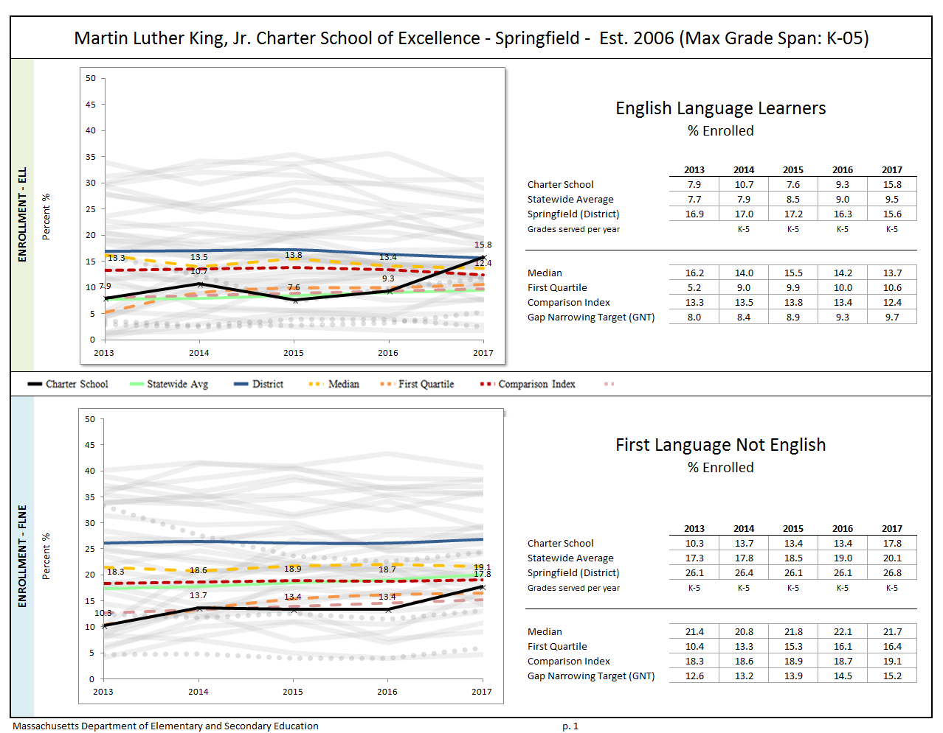
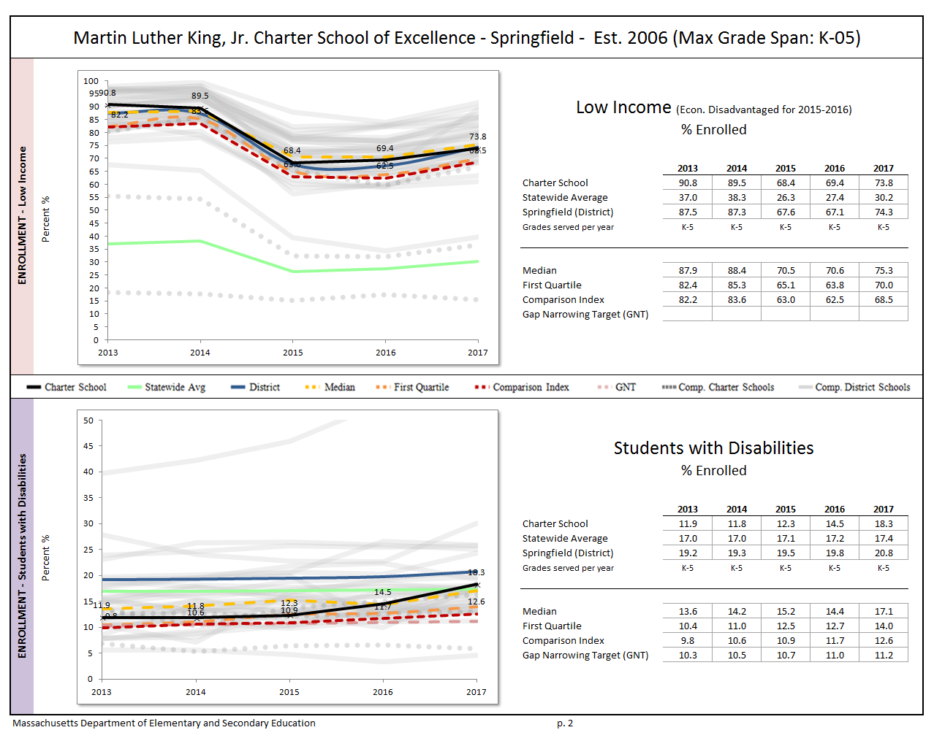
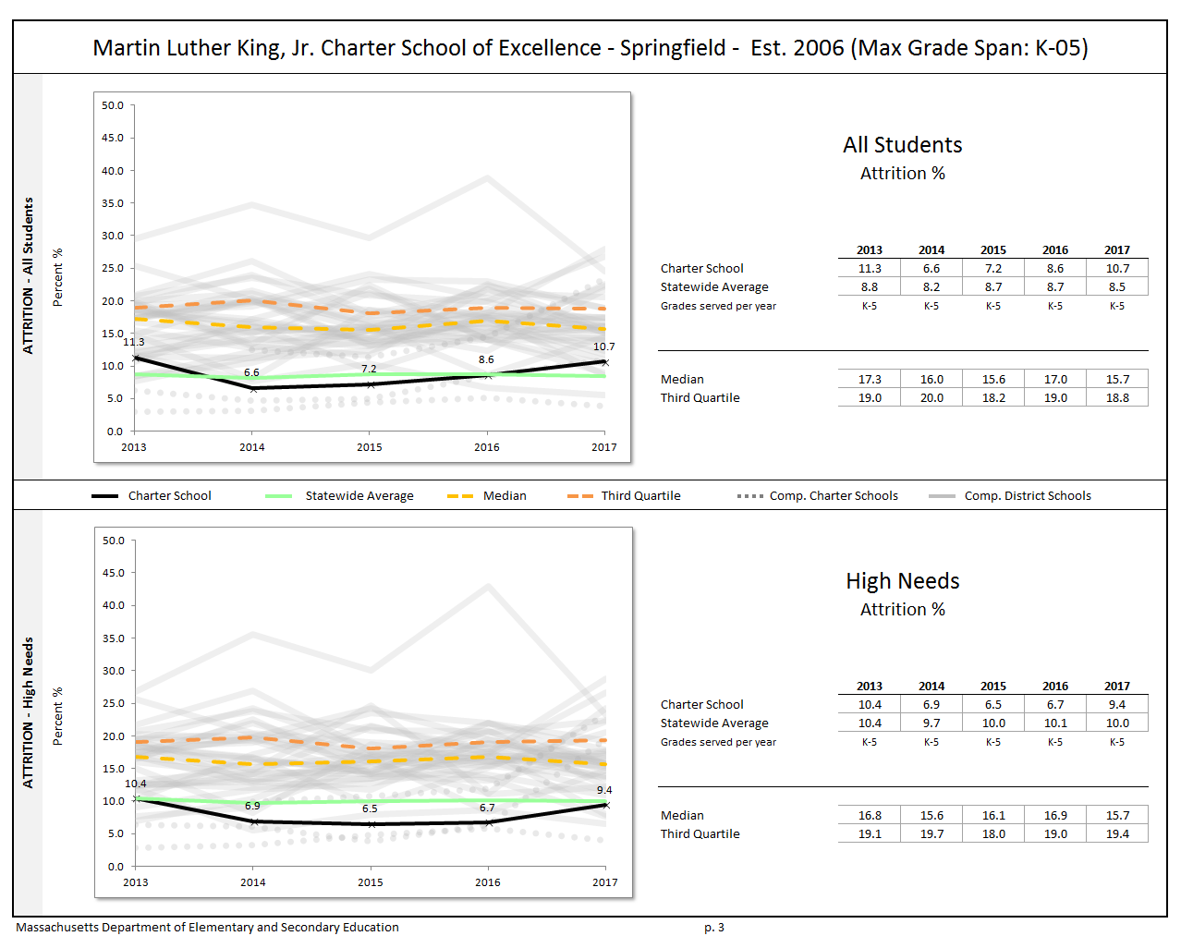
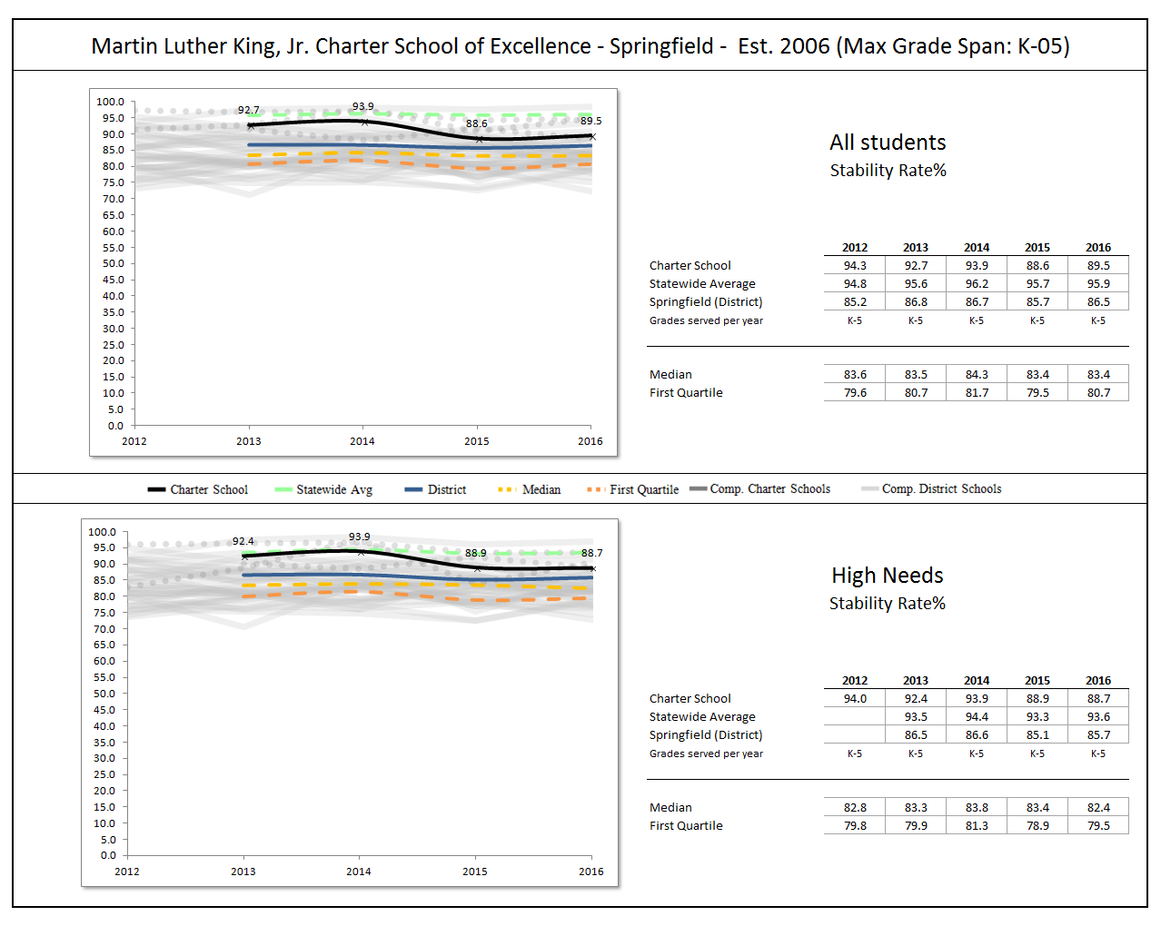

Appendix B
Criterion 5: Student Performance
The charter accountability table (below) provides several sets of data relative to charter school performance on statewide assessments as well as student indicators. The percent of students scoring proficient or advanced (P/A), the composite performance index (CPI), the percent of students scoring warning or failing (W/F), and the student growth percentile (SGP) are all displayed in the aggregate over the term of the charter. For schools participating in PARCC in 2015 and 2016, the percent of students who met or exceeded expectations (Level 4 and 5) and those who did not meet expectations (Level 1) are displayed. Because these are not exact equivalents to MCAS proficient/advanced or warning/failing, these figures are not included in the graph. A Transitional Composite Performance Index (Trans. CPI) and Transitional Student Growth Percentile (Trans. SGP) generated using current PARCC and prior MCAS scores are displayed as equivalents to MCAS CPI and SGP. These figures are included in the graphs. The school’s accountability level, percentile, English Language Arts (ELA) and math percentiles for the aggregate and targeted subgroups, and cumulative progress and performance index (PPI) for the aggregate and targeted subgroups are shown if available (this depends on the size and the age of the school). When applicable, the 4-year and 5-year graduation rates as well as the annual dropout rate are also provided for the available years of the charter term. For detailed definitions of accountability terms, please visit this URL: http://profiles.doe.mass.edu/accountability/report/aboutdata.aspx#AccountabilityInformation.

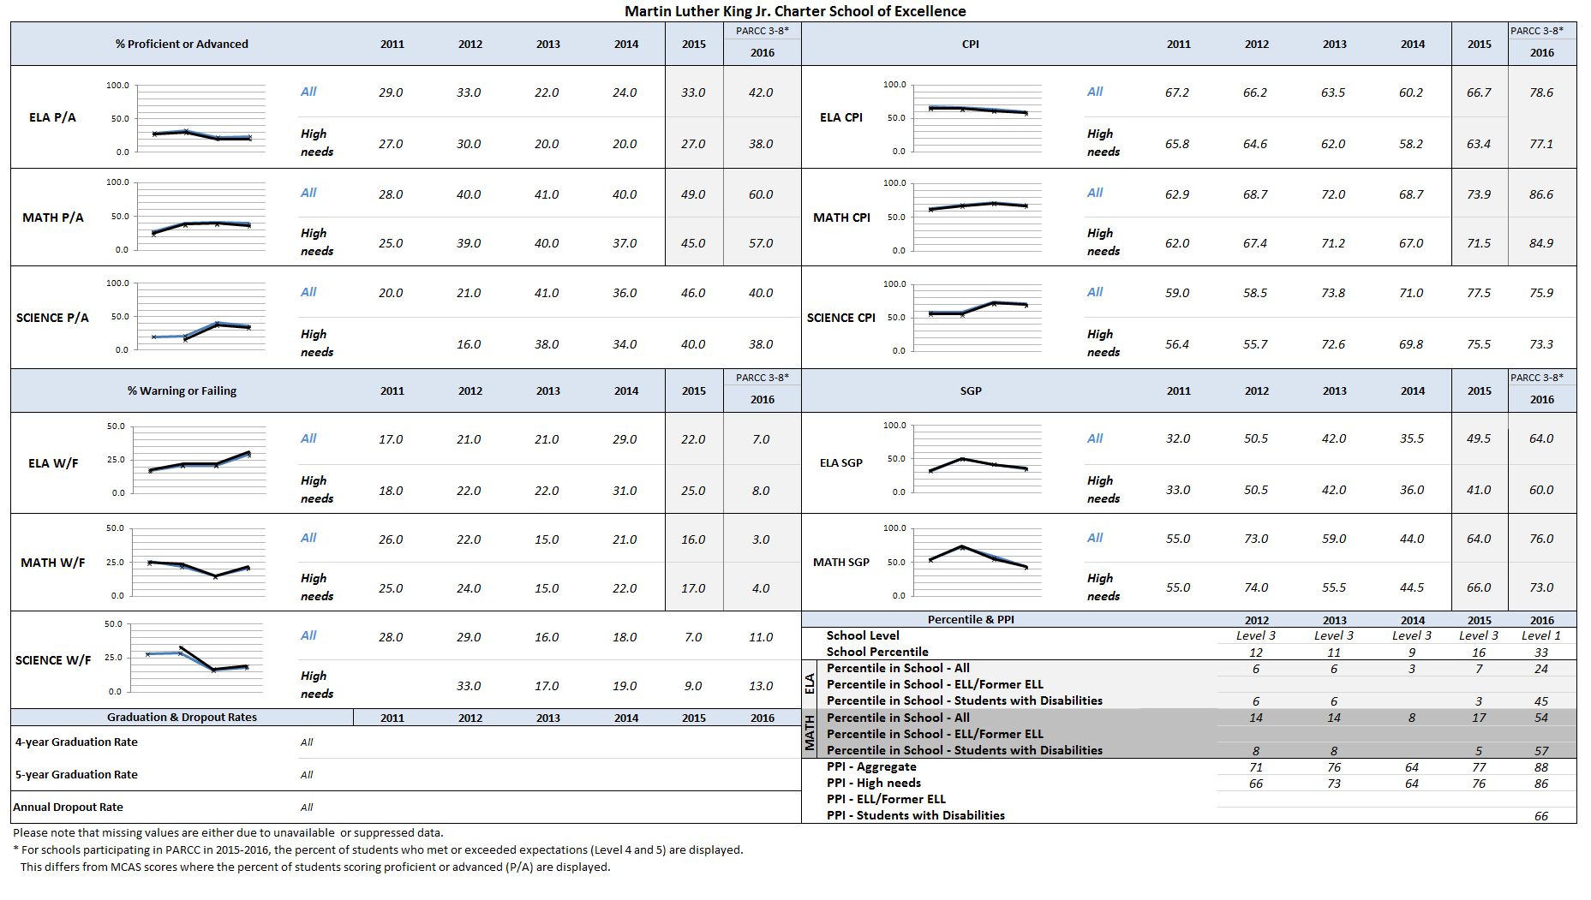

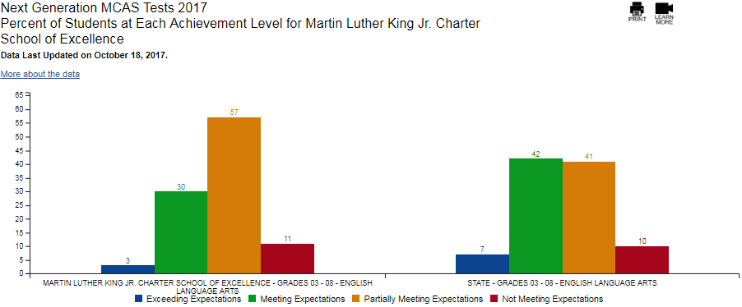

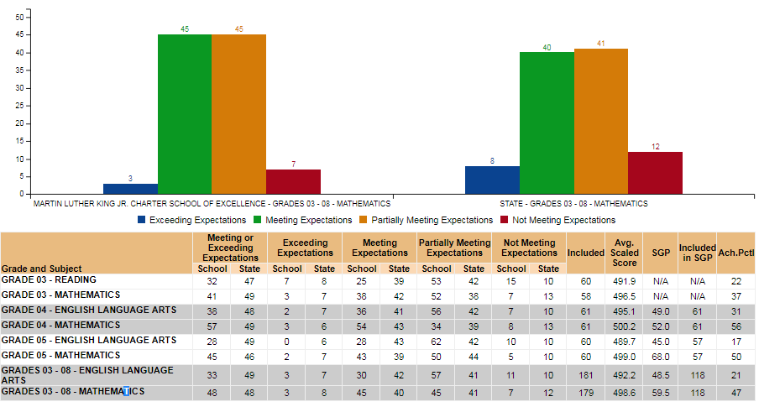

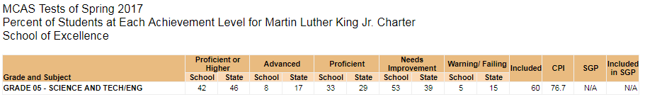

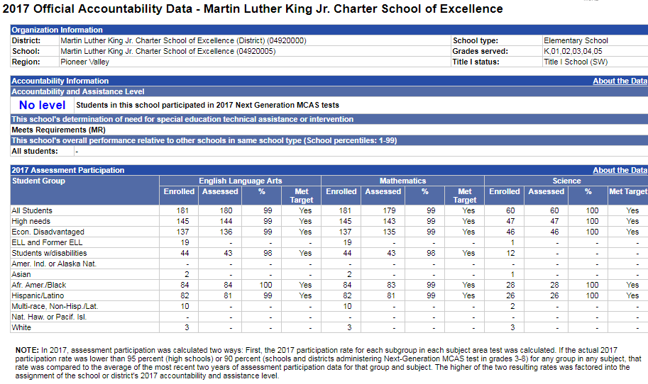

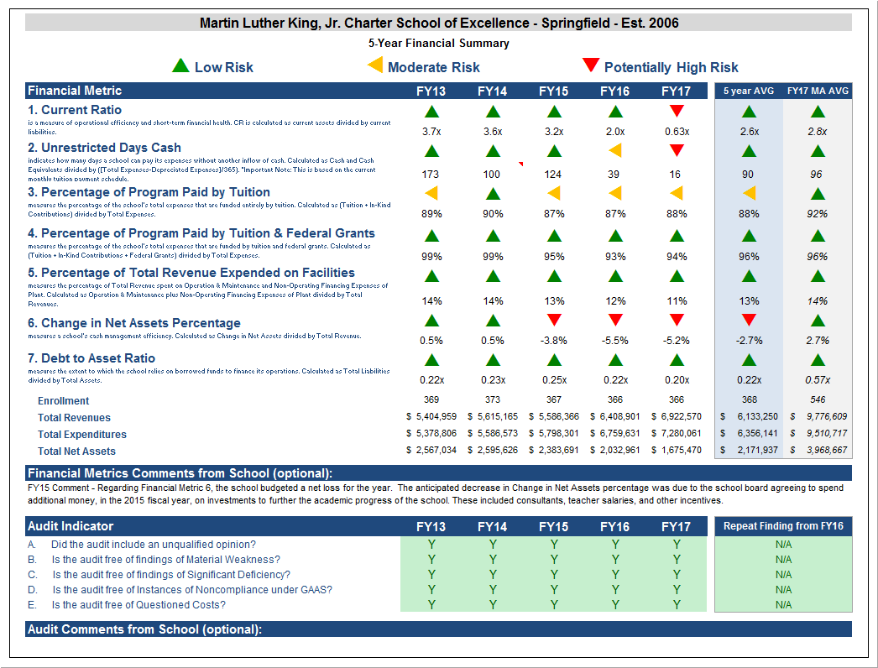
Appendix C
Criterion 10: FinancE

Financial Metric Definitions |  | Low Risk | Moderate Risk | Potentially High Risk
1. Current Ratio | Current Ratio is a measure of operational efficiency and short-term financial health. CR is calculated as current assets divided by current liabilities. | >= 1.5 | Between 1.0 (inclusive) and 1.5 | < 1.0
2. Unrestricted Days Cash (Prior to FY14)  Applies to 5-year average | The unrestricted days cash on hand ratio indicates how many days a school can pay its expenses without another inflow of cash. Calculated as Cash and Cash Equivalents divided by ([Total Expenses-Depreciated Expenses])/365).  Note: This is based on quarterly tuition payment schedule. | >= 75 days | Between 45 (inclusive) and 75 days | < 45 days
2. Unrestricted Days Cash (FY14 forward) | 4th quarterly tuition payments to Commonwealth charter schools in FY14 were made after June 30, 2014, which resulted in lower-than-typical cash at fiscal year-end, affecting the risk levels for the current ratio and unrestricted days cash indicators for FY14 on a one-time basis. Payments for FY15 and after are made on a monthly basis, and parameters for risk have been adjusted accordingly. | >= 60 days | Between 30 (inclusive) and 60 days | < 30 days
3. Percentage of Program Paid by Tuition | This measures the percentage of the school’s total expenses that are funded entirely by tuition. Calculated as (Tuition + In-Kind Contributions) divided by Total Expenses (expressed as a percentage). Note: In-Kind Contribution are added to the numerator in this ratio to balance out In-Kind Expenditures which will be captured in the Total Expenses in the denominator, and ratios over 100% are set to 100%. | >= 90% | Between 75% (inclusive) and 90% | < 75%
4. Percentage of Program Paid by Tuition & Federal Grants | This measures the percentage of the school’s total expenses that are funded by tuition and federal grants. Calculated as (Tuition + In-Kind Contributions + Federal Grants) divided by Total Expenses (expressed as a percentage). Note: In-Kind Contribution are added to the numerator in this ratio to balance out In-Kind Expenditures which will be captured in the Total Expenses in the denominator, and ratios over 100% are set to 100%. | >= 90% | Between 75% (inclusive) and 90% | < 75%
5. Percentage of Total Revenue Expended on Facilities | This measures the percentage of Total Revenue that is spent on Operation & Maintenance and Non-Operating Financing Expenses of Plant. Calculated as Operation & Maintenance plus Non-Operating Financing Expenses of Plant divided by Total Revenues (expressed as a percentage). | <= 15% | Between 15% and 30% (inclusive) | > 30%
6. Change in Net Assets Percentage | This measures a school's cash management efficiency. Calculated as Change in Net Assets divided by Total Revenue (Expressed as a percentage). | Positive % | Between -2% (inclusive) and 0% | < -2%
7. Debt to Asset Ratio | Measures the extent to which the school relies on borrowed funds to finance its operations. Calculated as Total Liabilities divided by Total Assets. | <= .9 | Between .9 and 1 (inclusive) | > 1
FY16 MA AVG Column | All financial metrics indicated in this column are a result of each ratio calculated using statewide totals. For Enrollment, Total Net Assets and Total Expenditures rows, these numbers are averages calculated using the statewide totals of all charter schools’ data.

Appendix D: Resources
Massachusetts charter schools have autonomy in many areas, including their mission, curriculum, design elements, teaching methods, budgeting, and hiring. The following is a list of resources from the Department or other organizations grouped by the Charter School Performance Criteria. These resources are not meant to be prescriptive, nor is there an expectation that charter schools implement any of the following suggestions. These resources are intended to provide information that may be helpful to effectively serve students.
The Department has also compiled strong or promising practices that have demonstrated potential to be effective around creating conditions for dissemination, sharing resources and information, and sustaining partnerships.
Schools can utilize the Office of Charter Schools and School Redesign website to reference many accountability documents on how the Department provides accountability to charter schools. Information and resources found on the website include:
- Charter School Performance Criteria; including considerations for alternative charter schools
- Charter School Site Visit Protocol
- Guide to Charter School Accountability
- Charter renewal documents and guidance
- Guidance documents on writing Accountability Plans

Curriculum
Title | Description | Link
Massachusetts Curriculum Frameworks (MCF) | Current curriculum framework, which include:  - English Language Arts (ELA)  - Math  - Science, Technology/Engineering  - Social Studies  - WIDA English Language Development Standards | http://www.doe.mass.edu/frameworks/
ESE’s Model Curriculum Units | These model curriculum units provide exemplars that can be useful as the district develops its systematic approach to curriculum and/or continues to develop curriculum | http://www.doe.mass.edu/ele/instruction/mcu/
Creating Curriculum Units at the Local Level | A guidance document that can serve as a resource for professional study groups, as a reference for anyone wanting to engage in curriculum development, or simply as a way to gain a better understanding of the process used to develop Massachusetts’ Model Curriculum Units. | http://www.doe.mass.edu/instruction/impd/
Creating Model Curriculum Units | A series of videos that captures the collaboration and deep thinking by curriculum design teams over the course of a full year as they worked to develop Massachusetts’ Model Curriculum Units. The series includes videos about developing essential questions, establishing goals, creating embedded performance assessments, designing lesson plans, selecting high-quality materials, and evaluating the curriculum unit. | http://www.youtube.com/playlist?list=PLTuqmiQ9ssquWrLjKc9h5h2cSpDVZqe6t
Model Curriculum Units | A video series that shows examples of the implementation of Massachusetts’ Model Curriculum Units. | http://www.youtube.com/playlist?list=PLTuqmiQ9ssqvx_Yjra4nBfqQPwc4auUBu
The Model Curriculum Unit and Lesson Plan Template | This template includes Understanding by Design elements. It could be useful for districts’ and schools’ curriculum development and revision. | http://www.doe.mass.edu/instruction/impd/
Model Curriculum Presentations and Workshop Resources (archived) | These resources provide more information about the model curriculum units. | http://www.doe.mass.edu/instruction/curate/resources.html
ESE’s Quality Review Rubrics | These rubrics can support the analysis and improvement of the district’s existing curriculum units. | http://www.doe.mass.edu/instruction/curate/resources.html
Curriculum Mapping: Raising the Rigor of Teaching and Learning | A presentation that provides definitions of curriculum mapping, examples of model maps, and descriptions of curriculum mapping processes. | http://www.doe.mass.edu/instruction/curate/resources.html
Sample curriculum maps | These sample curriculum maps were designed to assist schools and districts with making sense of students' learning experiences over time, ensuring a viable and guaranteed curriculum, establishing learning targets, and aligning curriculum to ensure a consistent implementation of the MA Frameworks. | http://www.doe.mass.edu/instruction/curate/resources.html

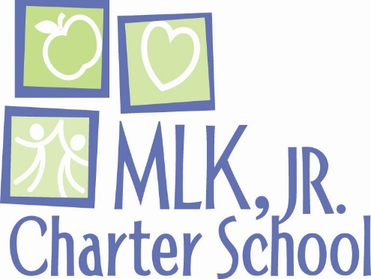

MLK’s RESPONSE TO YEAR 12 TARGETED SITE VISIT REPORT

MLK Charter School finds Department of Elementary & Secondary Education site visits very helpful. We appreciate the effort and thought that DESE puts into site visits.

This response supplements the information in the Year 12 Targeted Site Visit Report. WE identify two of MLK’s student performance accomplishments not mentioned in the site visit report. The response also presents additional context in regard to ELA performance and documentation of the science and ELD curriculum.

Two number 1 performances that we are proud of:

- 2016 – MLKCSE was the number 1 elementary school in Massachusetts for math growth for black/African American students
- 2017 – MLKCSE was the number 1 5th grade in Massachusetts for math growth for Hispanic/Latino students

MLKCSE’s hybrid science and English Language Development curricula are not fully documented. However, MLKCSE students are learning the curricula despite the curricula not being fully documented.

Science: The site visit report finds and provides supporting documentation that MLKCSE student performance meets state standards in science.

Moreover, MLKCSE students in black/African, economically disadvantaged, and high needs subgroups significantly outperform their peers across the state.

2017 5th Grade Science MCAS
 | MLK CHARTER SCHOOL | STATE
Black/African American advanced & proficient | 40% | 24%
Black/African American warning | 11% | 28%
Economically disadvantaged adv. & proficient | 40% | 27%
Economically disadvantaged warning | 7% | 27%
High needs advanced & proficient | 38% | 27%
High needs warning | 6% | 26%

English language learners: Based on 2018 ACCESS results, 90% of MLKCSE ELLs improved their scores from the prior school year.

Moreover, MLKCSE is in the process of diligently developing the ELD curriculum. On December 31, 2016, the MLKCSE ESL department coordinator completed the DESE-sponsored Next Generation ESL Project: Model Curriculum Units Facilitator Training (ESL MCU FacT) which prepares educators to effectively and collaboratively design Next Generation ESL curriculum units within the context of the Massachusetts Definition of the Focus of ESL Instruction. The MLKCSE coordinator returned to begin planning the further development of a fully aligned ESL curriculum.

In June and July of 2017, the ELL coordinator and members of the ESL department collaborated with the ELA coordinator to prepare K-5 revisions to the ELA curriculum. Next, the ESL department began creating a hybrid K-5 ESL Supplemental Guide aligned to the ELA curriculum using the DESE Collaboration Tool introduced in the ESL MCU FacT.

By 2017, the ELA and math curriculum included preliminary components for differentiation, scaffolding, tiered vocabulary and language objectives. ESL students utilized the ELA and math embedded grade-level assessments. During 2016-2018, ESL students in grades 3-5 demonstrated the ability to access curriculum materials with appropriate classroom SEI instructional supports. MLKCSE scholars demonstrate continued, sustained academic improvement in mathematics and English language arts. The following chart compares MLKCSE and State 2017 MCAS performance for Ever ELLs.

2017 MCAS Ever ELL | MLK ELA SS | MLK ELA SGP | MLK Math SS | MLK Math SGP | State ELA SS | State ELA SGP | State Math SS | State Math SGP
 | 486.1 | 49.5 | 497.9 | 64 | 489.1 | 50 | 490.6 | 48

Additionally, MLKCSE utilized the core ESL textbook series, Reach, for grades K, 1 and 4. Students have had the use of chrome books to access LEXIA and Pearson Realize digital ELA and math platforms that provide visual and auditory support along with universal access to computer tools and headsets.

Preliminary Fountas & Pinnell benchmark assessments (BAS) confirm that at all grade levels in 2017-2018 MLKCSE scholars made typical or greater growth in reading.

- Typical growth in Grade K is 4 levels. Median student growth was 5 levels.
- Typical growth in Grade 1 is 6 levels. Median student growth was 6 levels.
- Typical growth in Grade 2 is 3 levels. Median student growth was 4 levels.
- Typical growth in Grade 3 is 3 levels. Median student growth was 3 levels.
- Typical growth in Grade 4 is 3 levels. Median student growth was 3 levels.
- Typical growth in Grade 5 is 3 levels. Median student growth was 3 levels.

In grades K and 2, MLKCSE exceeded typical grade level student growth. MLKCSE equaled typical growth in grades 1, 3, 4, and 5.

Alan M. Katz
Executive Director
June 12, 2018

According to the October 1, 2017, SIMS data, MLKCSE is over-enrolled by 3 students, in violation of the school’s charter terms. Charter schools do not receive tuition for over-enrolled students.
[1] The Charter School Performance Criteria v. 3.2 is found at: http://www.doe.mass.edu/charter/acct.html?section=criteria
Data for 2015-2016 not available per the website.
Once the statewide accountability system is established pursuant to Every Student Succeeds Act (ESSA), the Department will articulate the use of ratings and academic data in reports and in charter accountability decisions.
1 The names of each of these schools and additional subgroup detail can be found in the Charter Analysis and Review Tool (CHART), http://www.doe.mass.edu/charter/chart/.
The midpoint value of all comparison schools. This is derived using Microsoft Excel's MEDIAN function.
The first quartile is the middle number between the smallest number and the median of all comparison schools. This is derived using Microsoft Excel's QUARTILE function.
The comparison index provides a comparison figure derived from data of students who reside within the charter school’s sending district(s). The comparison index is a statistically calculated value designed to produce a fairer and more realistic comparison measure that takes into account the charter school’s size and the actual prevalence of student subgroups within only those grade levels in common with the charter school.
The Gap Narrowing Target (GNT) refers to the halfway point between the school’s baseline rate (which is the rate in the 2010-11 school year, or the first-year enrollment data is collected if after 2010-11,) and the current Comparison Index (the “target”). The object is to meet this halfway point by the 2016-17 school year (or in a later year if baseline is after 2010-11), giving the school six years to do so. For a school to be on schedule to meet its GNT, an incremental increase must be met annually. To determine this increment, the following equation is used: [(Comparison Index – Baseline) / 2] / 6 years = Annual GNT.
The percentage of attrition, or rate at which enrolled students leave the school between the end of one school year and the beginning of the next.
A student is high needs if he or she is designated as either low income, or ELL, or former ELL, or a student with disabilities. A former ELL student is a student not currently an ELL but had been at some point in the two previous academic years. 8the Stability Rate measures how many students remain in a district or school throughout the school year. * 2014-2015 is the first year for which the category “Economically Disadvantaged” is being reported, replacing the “Low-income,” “Free Lunch” and “Reduced Lunch” categories used in 2013-2014 and earlier. It is important for users of this data to understand that enrollment percentages and achievement data for "economically disadvantaged" students cannot be directly compared to "Low-income" data in prior years. Please see http://www.doe.mass.edu/infoservices/data/ed.html for important information about the new “Economically Disadvantaged” category.

