States with Full-Time Virtual Schools

According to the report Keeping Pace with K-12 Online Learning, 24 states plus Washington, D.C. had full-time virtual schools in 2009 serving approximately 175,000 students. States with the greatest numbers of full-time, online students include Arizona, Ohio, Minnesota, Colorado, Washington, California, and Pennsylvania.

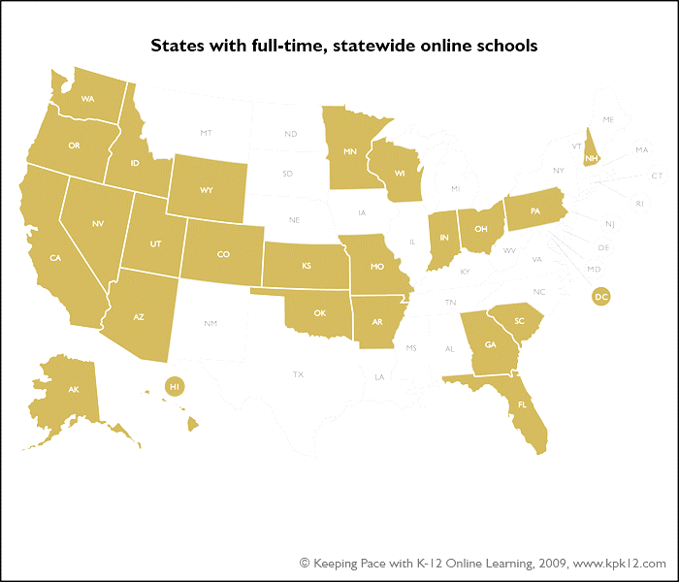

The following table lists the states that have full-time virtual schools and provides information on the operating entity, funding, fiscal and/or enrollment limitations, and student enrollment for each of them.

State | Operating Entity | Funding | Fiscal/  Enrollment Cap | Enrollment | Notes
Alaska | Two charter schools | State aid follows the student to the online school | Not reported by Keeping Pace | 350 full-time students in one of the online schools, no data for the other
Arizona | 14 charter schools and districts | State aid follows the student to the online school. 95% for full-time, 85% for part-time | In 2009, Arizona removed restrictions on new programs | 23,000 (total of part-time and full-time)
Arkansas | Charter schools | $5,905 per student | Capped at 500 students | 500
California | Charter schools and districts | State aid follows the student to the online school | Pupil-teacher ratio less than or equal to 25:1 OR less than or equal to the pupil-teacher ratio in the largest unified school district in the county (or counties in which the school operates) | Not reported by Keeping Pace | Online charter schools are required to spend 80% or more of total revenues on instruction
Colorado | Charter school and districts | State aid follows the student to the online school | Not reported by Keeping Pace | 11,641 (part-time and full-time) | Eighteen full-time multi-districts, nine single district, and two supplemental
Florida | Districts | State aid follows the student to the online school. | No cap | 154,125 full-time and part-time – almost all supplemental, not full-time | Legislation in 2008 and 2009 requires all school districts to offer full-time online programs for grades K-12  .
Georgia | State and districts | The Georgia Virtual School (K-8) is funded from a state appropriation, about $1.75 million in 2008-09. State aid follows the student to online schools operated by districts | Not reported by Keeping Pace | 9,793 (part-time and full-time)
Hawaii | Charter school | State aid follows the student to the online school | Not reported by Keeping Pace | 2,500 (part-time and full-time)
Idaho | Charter schools and districts | State aid follows the student | Not reported by Keeping Pace | 9,646 (full-time and part-time) | One state virtual school, four virtual charter schools, a fifth opening fall 2009, and a state distance education academy.
Indiana | Charter schools | State aid follows the student to the online school | Up to 500 student enrollment in 2011. | 200
Kansas | Charter schools and districts | State aid follows the student to the online school | Only students who reside in Kansas are eligible for FTE funding, with some exceptions for out-of-state students | 5,399 (full-time and part-time) | Forty-five district programs and charter schools enroll students statewide
Minnesota | Charter schools and districts | State aid follows the student to the online school | Minnesota has extensive policies and tracking of their online programs | 28,332 (full-time and part-time) | Twenty-five charter  schools, multidistrict  programs, and consortia of  schools are approved  by the Minnesota  Department of  Education
Nevada | Charter schools and districts | State aid follows the student to the online school | Not reported by Keeping Pace | Not reported by Keeping Pace | Students must get permission from their own school district before taking part in another school district’s online program when the online program is not a charter school
New Hampshire | Charter | State aid follows the student.  Funding per full-time student in 2008-09 was $3,830, increasing to $5,450 per full-time student in 2009-10. | Not reported by Keeping Pace | 2,000 part-time students | New Hampshire has a statewide virtual charter school.
Ohio | Community schools (similar to charter schools) | State aid follows the student to the online school | As of August 2009, the moratorium on new eCommunity  Schools remained in effect. | 27,037 (full-time and part-time) | As of August 2009, Ohio has twenty-eight eCommunity (charter) schools.
Oklahoma | Districts | State aid follows the student to the online school | Students in an online program must be “regularly enrolled” in the school district - there are exceptions. | Over 800 | Two statewide full-time online schools managed by school districts and online providers
Oregon | State, charter schools and districts | State aid follows the student to the online school. | There is a two-year limitation on the growth of existing virtual schools. They are restricted to their student enrollment on May 1, 2009. Schools  are allowed to enroll students above the cap if 50% of the students  in the school are resident in the district in which the school is chartered. | About 6,000
Pennsylvania | Charter schools and districts | State aid follows the student to the online school.  The state provides a reimbursement to the sending district of approximately 30% to cover the district’s fixed costs. | Not reported by Keeping Pace | Not reported by Keeping Pace | Eleven online charter schools and additional district programs
South Carolina | Charter schools | State aid follows the student to the online school | Not reported by Keeping Pace | 10,298 (includes part-time and full-time) | In 2008, there were three authorized online charters. In 2009, there were five operating charter schools.
Utah | State and charter schools | The UT Electronic High School is state funded. Utah also has virtual charter schools. State aid follows the student to the online school. | Not reported by Keeping the Pace | 7,216 (includes part-time and full-time)
Washington | Districts | Beginning with the 2011-12 school year, districts will receive funding for students in online courses or programs only if the course/program meets criteria set up by the state | Not reported by Keeping Pace | 14,000 (full-time and part-time) | Many district programs, often operated by national providers, serving students statewide; no charter school law; extensive state rules governing online learning
Wisconsin | Charter schools and districts | State aid follows the student to the online school | Beginning in the 2009 school year, the total number of students attending virtual charter schools may not exceed 5,250. | 3,635 | One state virtual school; the state also has numerous district  programs and online charter schools.
Wyoming | Charter schools and districts | It is up to the districts to agree in advance on how funding is to be applied. | Not reported by Keeping Pace | Not reported by Keeping Pace | Wyoming Switchboard Network (WSN) approves charter and district virtual schools

