

Martin Luther King Jr. Charter School of Excellence

Summary of Review

January 2011

Summary of Review – January 2011

Martin Luther King Jr. Charter School of Excellence
285 Dorset Street
Springfield, MA 01108

I. Sources of Evidence for this Document 1
II. Summary of Review Findings 1
III. School Profile 5
Mission Statement 5
Major Amendments 5
Demographics 5
IV. Areas of Accountability 7
A. Faithfulness to Charter 7
B. Academic Program 9
C. Organizational Viability 21
V. MCAS Performance 27
VI. Comparative Statistical Analysis of MCAS Results 30
VII. Adequate Yearly Progress Data 32
VIII. Accountability Plan Objectives and Measures 33

I. Sources of Evidence for this Document

The charter school regulations state that “[t]he decision by the Board [of Elementary and Secondary Education] to renew a charter shall be based upon the presentation of affirmative evidence regarding the success of the school’s academic program; the viability of the school as an organization; and the faithfulness of the school to the terms of its charter” 603 CMR 1.12(3). Consistent with the regulations, recommendations regarding renewal are based upon the Department of Elementary and Secondary Education’s (Department) evaluation of the school’s performance in these areas. In its review, the Department has considered both the school’s absolute performance at the time of the application for renewal and the progress the school has made during the first four years of its charter. Performance is evaluated against both the Massachusetts Charter School Common School Performance Criteria and the school’s accountability plan. The evaluation of the school has included a review of the following sources of evidence, all of which are available from the Charter School Office:

- the application for renewal submitted by the school,
- the school’s annual reports for the term of the charter,
- site visit reports generated by the Charter School Office in the second, third, and fourth years of the school’s charter,
- independent financial audits,
- Coordinated Program Review reports,
- the year five Renewal Inspection Report and Federal Programs Renewal Inspection Report, and
- other documentation, including amendments to the school’s charter.

The following sections present a summary from all of these sources regarding the school’s progress and success in raising student achievement, establishing a viable organization, and fulfilling the terms of its charter.

II. Summary of Review Findings

Listed below are the findings contained in the review of the school’s performance in the three areas of accountability. Further evidence to support each finding can be found in the body of the report.

A. Faithfulness to Charter Findings

Stakeholders describe important elements of the school’s mission as striving for academic excellence and developing a beloved community in which students develop social skills.

The school has made progress in establishing a program that aligns with the character development and community aspects of its mission.

During its first four years, MLK was not operating in a manner fully consistent with its mission of preparing students for academic success. During the current school year, MLK has made significant changes in order to realign the academic program and school culture to its mission.

The instructional leadership is in transition. While there is an interim plan in place, the leadership structure contains a vacancy.

B. Academic Program Findings

Student MCAS performance has been variable in English language arts (ELA) and low in mathematics. A majority of students are not reaching proficiency on either test.

Throughout the term of the charter, MLK performed at a statistically significantly higher level then the sending district in the aggregate in English language arts (ELA), but not in mathematics. In terms of subgroups, the sending district performed at a statistically significantly higher level in mathematics.

MLK did not make AYP in 2010 in ELA or mathematics. The school has a status of “Improvement Year 2—Subgroups” for ELA.

Over the term of the current charter, students have not demonstrated consistent improvement on internal assessments.

MLK primarily uses commercially created curriculum in all content areas.

Additional curriculum materials are not well documented. The school is in the process of developing and re-aligning curriculum with the Massachusetts curriculum frameworks (MCF).

A qualified administrator oversees a special education program in which staffing and services have been significantly expanded to better meet the needs of students.

The special education program has structures and staffing in place to identify assess and serve students who require special education services.

The school has established a program which supports diverse learners and students who struggle academically to enable them to participate in and benefit from the educational goals and mission of the charter school.

Potential English language learner (ELL) students are effectively identified and assessed. English language development instruction is provided and some sheltered English immersion is available.

Over the past four years MLK has collected assessment data, but this has not led to effective program adjustments. The school is implementing a new system of regular student achievement review based on the new benchmark assessments.

Over the past five years, MLK’s classroom and school environment has shown marked improvement. The school has implemented a new behavioral management system, the MLK Way.

The renewal inspection team found that MLK maintains an orderly environment in which all staff members consistently reinforce the school’s standards for conduct.

The majority of instructional practice is effectively delivered.

The school’s constructivist pedagogical approach has been better implemented at the school this year, however, this remains a work in progress.

Over the term of the charter, MLK has increased the number of supports for teachers and created additional opportunities for professional development.

Due to the recent departure of a school administrator, formal evaluations have not yet begun this year.

The school has created a highly communicative, collaborative professional environment.

C. Organizational Viability Findings

During its first charter term, MLK received unqualified audit opinions with no material findings each year. The school has developed a sound budgeting process and the board of trustees reviews financial data on a regular basis.

MLK’s board of trustees is engaged in appropriate oversight of the school’s program. Over the past two years, board work has focused on examining academic achievement.

The board of trustees annually assesses the performance of the school’s executive director.

Currently, four individuals serve in leadership roles who communicate frequently, but informally.

Parent surveys and focus group comments demonstrate strong levels of satisfaction with the school’s mission, educational program, and amount of communication with families.

The school’s new facility provides a safe and welcoming learning environment.

The purchase of the new facility in 2009 provides a stable facility for the future of the school.

The school is in compliance with the requirements of the Coordinated Program Review (CPR).

A majority of the teaching staff are highly qualified.

MLK has not yet disseminated any best practices. The school is working to develop best practices worthy of dissemination in the future.

D. Accountability Plan Objectives and Measures

MLK has met a majority of measures in its accountability plan related to faithfulness to charter.

MLK has not met a majority of measures in its accountability plan related to academic achievement.

MLK met all of its measures in its accountability plan pertaining to organizational viability.

III. School Profile

Martin Luther King Jr. Charter School of Excellence (MLK)
Type of Charter | Commonwealth | Location | Springfield
Regional/Non-Regional | Non-Regional | Districts in Region | NA
Year Opened | 2006 | Year Renewed | NA
Maximum Enrollment | 380 | Current Enrollment | 407
Students on Waitlist | 69 | Grades Served | K-5

Mission Statement
“Martin Luther King, Jr. Charter School of Excellence prepares kindergarten through 5th grade students of Springfield for academic success and engaged citizenship through insistence on rigorous, challenging work. The school incorporates Dr. King’s commitment to the highest standards in scholarship, civic participation and the ideal of the beloved community.”

Major Amendments
MLK has received the following major amendment during the charter term:
- On November 17, 2009, The Board of Elementary and Secondary Education approved a temporary charter amendment to increase the school’s maximum enrollment from 360 to 380, a total increase of 20 students, for school years 2010 and 2011. This temporary enrollment increase is meant to accommodate school’s current fourth grade class, which was overenrolled during the school’s first year (as a kindergarten class) and remains overenrolled. When the overenrolled cohort of students graduates, in 2012, MLK’s maximum enrollment will return to 360, and each grade level will serve approximately 60 students.

Demographics
The following table compares demographic data of the charter school to the Springfield Public School District from which its draws most of its students, and to the state. The comparison includes 33 schools in the district with grade levels that overlap with the charter school.
- Comparison Minimum refers to the school(s) among the 33 schools with the lowest percentage of students in a given category.
- Comparison Median refers to the school(s) among the 33 schools with the middle percentage of students in a given category.
- Comparison Maximum refers to the school(s) among the 33 schools with the highest percentage of students in a given category.
- The Comparison Total represents the percentage of the total number of students in a given category in all 33 schools combined.

 | Race/Ethnicity (%) | African American | Asian | Hispanic | White | Native American | Native Hawaiian, Pacific Islander | Multi-Race, Non-Hispanic
 | Martin Luther King Jr. Charter School of Excellence | 56.6% | 0.0% | 36.4% | 2.1% | 1.3% | 0.0% | 3.5%
(33 Schools) | Comparison Minimum | 10.9% | 0.0% | 30.2% | 2.9% | 0.0% | 0.0% | 0.5%
(33 Schools) | Comparison Median | 19.4% | 1.6% | 54.2% | 15.8% | 0.0% | 0.0% | 4.6%
(33 Schools) | Comparison Maximum | 34.5% | 9.3% | 84.9% | 33.8% | 0.6% | 0.3% | 10.6%
(33 Schools) | Comparison Total | 21.2% | 2.1% | 56.2% | 15.7% | 0.0% | 0.0% | 4.7%
 | State | 8.2% | 5.3% | 14.8% | 69.1% | 0.3% | 0.1% | 2.2%

 | Other Demographics (%) | Males | Females | First Language Not English | Limited English Proficient | Special Education | Low-Income
 | Martin Luther King Jr. Charter School of Excellence | 52.9% | 47.1% | 9.6% | 5.3% | 9.0% | 84.6%
(33 Schools) | Comparison Minimum | 46.6% | 27.2% | 6.2% | 0.7% | 11.3% | 64.8%
(33 Schools) | Comparison Median | 52.7% | 47.3% | 18.5% | 12.9% | 18.2% | 85.2%
(33 Schools) | Comparison Maximum | 72.8% | 53.4% | 43.8% | 31.3% | 66.8% | 95.7%
(33 Schools) | Comparison Total | 53.4% | 46.6% | 21.4% | 14.0% | 22.7% | 82.9%
 | State | 51.3% | 48.7% | 15.6% | 6.2% | 17.0% | 32.9%

IV. Areas of Accountability

A. Faithfulness to Charter

ESE Charter School Performance Criteria: Consistency of school operations with the school’s charter and approved charter amendments
The school operates in a manner consistent with the mission, vision, educational philosophy and governance and leadership structure outlined in the school’s charter and approved charter amendments.

Finding: Stakeholders describe important elements of the school’s mission as striving for academic excellence and developing a beloved community in which students develop social skills.
MLK’s stakeholders have consistently emphasized character development, academic excellence, and the building of a beloved community as envisioned by Dr. Martin Luther King, Jr. as important aspects of the school’s charter. School leaders, teachers, students, board members, and parents all noted that the school seeks to have students work collaboratively and cooperatively as part of a school community and to also give back to their larger community through service learning.

Finding: The school has made progress in establishing a program that aligns with the character development and community aspects of its mission.
Over the past five years, MLK has clarified its academic program in order to better align with the social and emotional development aspects of its mission. For example, community service has become better integrated into the school’s practices. According to the school’s accountability plan, all students are expected to participate in a community service learning activity once a year. In the school’s second year, students did not complete community service activities. During the third year visit, the school began to conduct school-wide service projects, but students interviewed by the site visit team were unable to discuss or recall such efforts. During the renewal inspection, students were able to discuss specific projects and activities in which they contributed to a greater cause. Teachers also connect such experiences to the grade level’s curriculum.

Similarly, the school has improved on its delivery of its character development program. In the school’s third year, site visitors learned that the school’s “Dr. King curriculum” was not developed; nor did site visitors observe lessons or readings that emphasized the values of Dr. King as the school had promised. The renewal inspection team found that there are formal and informal structures in the school to teach a character curriculum based on the life and work of Dr. King. The main vehicle for delivering this character development curriculum is during morning meetings held in each home room. There is a daily “morning routine” scheduled into the outset of each day from 8:00-8:30 in which students arrive at the school and engage in an activity which reflects a monthly theme of the curriculum – respect, cooperation, responsibility, learning, social justice, service, perseverance, honesty and beloved community. During the renewal inspection team’s visit in October, the monthly theme was cooperation. The team observed that morning meeting was used as a time to explicitly discuss the concept of cooperation or practice the skill of cooperation, and they also observed teachers referring to cooperation during regular classroom instruction. The nine Dr. King values/themes are posted on the walls of every classroom.

Additionally, during the current year, school leaders have sought to establish a more orderly school and classroom environment in order to foster character development, improve social skills and help students progress academically. In the fall of 2010, a new system, called the MLK Way, was implemented with the aim of reducing behavioral issues and improving the focus on student learning. The MLK Way is a system created to establish school-wide behavioral and academic expectations for students and enforce their use by all school personnel. The system is multi-faceted, including school-wide procedures for behavior management routines and procedures and specific verbal and non-verbal communication between students and teachers for everything from requesting to use the bathroom, to showing readiness for the next activity, to keeping focus on the person speaking. Additionally, the MLK Way outlines consistent processes at the grade and classroom level for creation of classroom rules, ending and beginning the day routines.

Finding: During its first four years, MLK was not operating in a manner fully consistent with its mission of preparing students for academic success. During the current school year, MLK has made significant changes in order to realign the academic program and school culture to its mission.
During the school’s second, third, and fourth years, site visitors found uneven adherence to the school’s educational philosophy, instructional practices, and disciplinary system. Additionally, student academic performance on the Massachusetts Comprehensive Assessment System (MCAS) tests and the internally tracked Developmental Reading Assessment (DRA) had not demonstrated consistent improvement. During school visits, site visitors found that in some classes student behavior disrupted instruction and interfered with learning. School administrators have acknowledged concerns about MLK’s academic program and school culture and made changes. In MLK’s third year, the school hired curriculum and instruction consultants, added supplemental academic support programs, and hired additional staff to improve behavior management and school culture. In the school’s fourth year, the school’s executive director outlined a clear vision and list of priorities in order to alter the school’s trajectory. MLK sent teachers to visit high performing charter schools, hired math coaches, further developed academic supports for students, provided teachers with more guidance and support, and reorganized the duties of school administrators.

The renewal inspection team found that MLK’s academic program is currently under significant review and re-alignment with the mission of achieving high academic standards. Many of the efforts undertaken by the school in the prior two years have been continued. Teachers have been provided with professional development trainings, the school adopted a new benchmark assessment system, and two ELA specialists were hired. Additionally, major changes are underway this year that include changes in course offerings, adjustments to personnel (discussed further below), and curricular review, revision, and re-alignment. In order to increase the time spent on teaching math and literacy, the board discussed and approved the elimination of Spanish from course offerings. Changes made to curriculum content, organization and pacing have been driven by a response to MCAS data and the school’s implementation of a new internal benchmark assessment, Achievement Network (ANet).

The adoption of the MLK Way as the behavior management system has created a shift in the school’s culture. Many stakeholders reported a clear shift in the focus and feel of the school community. They also noted that the school’s relocation, in the summer of 2010, to a newly renovated facility has helped the school deliver a safe, orderly academic program. Teachers and school administrators noted that the entire school community is now focused on improving behavior so that improvements in teaching and learning could follow.

Finding: The instructional leadership is in transition. While there is an interim plan in place, the leadership structure contains a vacancy.
As described earlier, the executive director began a review of the academic program during the 2009-10 school year, leading to changes in roles and responsibilities of key school administrators. In January 2010, the executive director assumed responsibility for the overall educational program of MLK and reduced the director of education’s responsibilities to solely focus on supervision of curriculum and instruction. Another administrative position, academic coordinator, was also created last year. This year, the academic coordinator assumed full responsibility for the MLK Way and the new benchmark assessment program. Two months into the current school year, the director of education resigned. At the time of the renewal inspection visit other school administrators were adjusting their schedules and responsibilities to help supervise curriculum and instruction, but lesson plan approval, teacher evaluation, progress reports, and report cards were not yet assigned to a staff member. Given the unexpected timing of the resignation, the executive director – with input from other school administrators and the board – was still considering how to manage the vacancy.

ESE Charter School Performance Criteria: Accountability plan objectives and measures
The school meets, or shows progress towards meeting the faithfulness to charter objectives and measures set forth in its accountability plan.

Finding: MLK has met a majority of measures in its accountability plan related to faithfulness to charter.
A charter school creates an accountability plan to set objectives in each of the three areas of charter school accountability for the charter term and to show growth over time. MLK has reported against an accountability plan that was revised in March 2009. The accountability plan includes three objectives and six measures related to faithfulness to charter. MLK met four and did not meet two measures. A summary of the school’s success in meeting the objectives and measures contained in its accountability plan can be found in Section VIII of this report.

B. Academic Program

ESE Charter School Performance Criteria: MCAS performance
Students at the school demonstrate Proficiency, or progress toward meeting proficiency targets on state standards, as measured by the Massachusetts Comprehensive Accountability System (MCAS) exams in all subject areas and at all grade levels tested for accountability purposes.

Finding: Student MCAS performance has been variable in English language arts (ELA) and low in mathematics. A majority of students are not reaching proficiency on either test.
During this charter term, MLK students annually completed the MCAS grade three reading assessment, the grades four and five English language arts (ELA) assessments, the grades three through five mathematics assessments, and the grade five science and technology assessment. The following analyses present MCAS performance data on the tests in reading, ELA and mathematics utilized by the Department for No Child Left Behind (NCLB) accountability purposes. This data also includes the Student Growth Percentile (SGP) which measures how much a student's MCAS performance has improved from one year to the next relative to his or her academic peers: other students statewide with a similar MCAS test score history. Section V summarizes other MCAS performance by grade level and provides data for tests that do not count towards AYP determinations in 2010.

 | Key: N = # of students tested; CPI = Composite Performance Index
 |  | Warning/Failing % |  | Needs Improvement % |  | Proficient % |  | Advanced/Above Prof. %

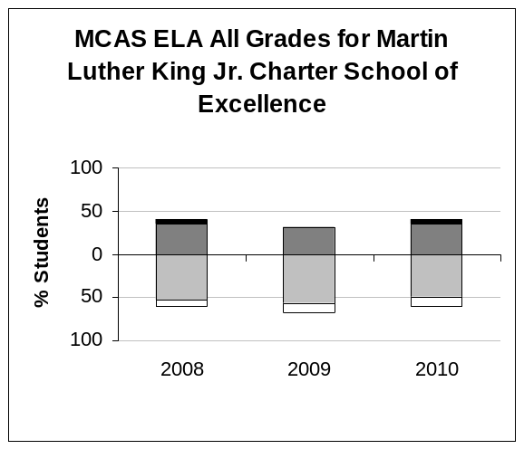 | 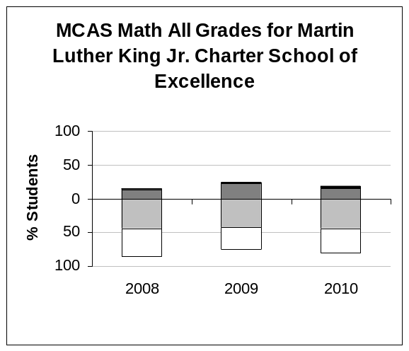
  ELA All Grades | 2008 | 2009 | 2010
  % Advanced | 5 | 1 | 4
  % Proficient | 35 | 31 | 36
  % Needs Improvement | 53 | 56 | 49
  % Warning/Failing | 8 | 11 | 12
  N | 40 | 96 | 169
  CPI | 78.8 | 71.1 | 72.6
  SGP |  | 48.0 | 44.0
  N for SGP |  | 34 | 89
  Math All Grades | 2008 | 2009 | 2010
  % Advanced | 3 | 3 | 4
  % Proficient | 13 | 22 | 15
  % Needs Improvement | 44 | 42 | 45
  % Warning/Failing | 41 | 32 | 36
  N | 39 | 99 | 168
  CPI | 51.9 | 59.8 | 54.3
  SGP |  | 27.0 | 32.0
  N for SGP |  | 37 | 92

Finding: Throughout the term of the charter, MLK performed at a statistically significantly higher level then the sending district in the aggregate in English language arts (ELA), but not in mathematics. In terms of subgroups, the sending district performed at a statistically significantly higher level in mathematics.

District comparisons
The CPI of MLK has been compared to that of the Springfield Public Schools (Springfield) because MLK is in NCLB Improvement Year Two status for subgroups in ELA.

Statistical analyses, two-tailed t tests for the equality of means, were performed to determine if any differences in performance between MLK and Springfield students were statistically significant at a 95 percent confidence level. Comparisons were made only if there were at least 40 students tested in a given grade or subgroup.

- Seven grade-to-grade and aggregate comparisons were conducted ELA and six grade-to-grade and aggregate comparisons were conducted in mathematics.
  - ELA: MLK performed at a statistically significant higher level than Springfield in two instances. Springfield did not perform at a statistically significant higher level than MLK. There were no statistically significant differences in performance in the other five comparisons.
  - Mathematics: MLK did not perform at a statistically significant higher level than Springfield. Springfield performed at a statistically significant higher level than MLK four times. There were no statistically significant differences in performance in the other two comparisons.
  - Section VI of this document provides detailed information.

- Eight subgroup grade-to-grade and aggregate comparisons were conducted in both ELA and mathematics.
  - ELA: There were no statistically significant differences in performance in the eight comparisons.
  - Mathematics: MLK did not perform at a statistically significant higher level than Springfield. Springfield performed at a statistically significant higher level than MLK in five instances. There were no statistically significant differences in performance in the remaining three comparisons.
  - Section VI of this document provides detailed information.

ESE Charter School Performance Criteria: Adequate Yearly Progress
The school makes Adequate Yearly Progress (AYP) in the aggregate and for all statistically significant sub-groups. The school is not identified for accountability purposes (not designated as in Needs Improvement, Corrective Action, or Restructuring).

Finding: MLK did not make AYP in 2010 in ELA or mathematics. The school has a status of “Improvement Year 2—Subgroups” for ELA.
- In 2010, MLK did not make AYP for ELA in subgroups. The school did not make AYP for mathematics in the aggregate or for subgroups.
- The school currently has a status of “Improvement Year 2 – Subgroups” for ELA.
- MLK has a performance rating of “Moderate” for ELA and “Very Low” for mathematics.
- In 2010, the school has an improvement rating of “No Change” for ELA and “Declined” for mathematics.
- The AYP summary in Section VII includes full details.

Adequate Yearly Progress History |  |  |  |  |  |  |  |  |  | NCLB Accountability Status
 |  | 2003 | 2004 | 2005 | 2006 | 2007 | 2008 | 2009 | 2010 | NCLB Accountability Status
ELA | Aggregate | - | - | - | - | - | No | No | Yes | Improvement Year 2 - Subgroups
ELA | All Subgroups | - | - | - | - | - | - | No | No | Improvement Year 2 - Subgroups
MATH | Aggregate | - | - | - | - | - | No | Yes | No | No Status
MATH | All Subgroups | - | - | - | - | - | - | Yes | No | No Status

Meeting state targets  MLK’s performance on ELA exams between 2008 and 2010 was below state CPI performance targets each year.  Meeting school improvement targets  MLK did not meet its own improvement targets in ELA in 2009 or 2010. | 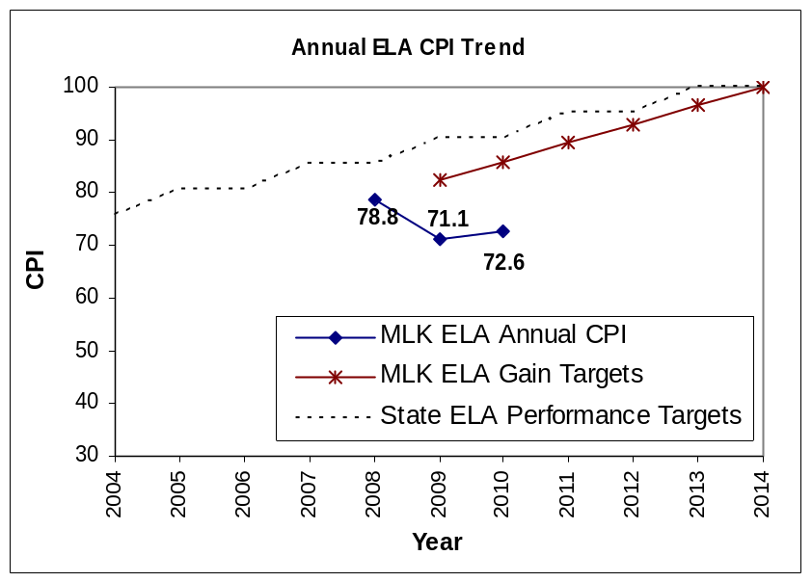

Meeting state targets  MLK’s performance on math exams between 2008 and 2010 was below state CPI performance targets each year.  Meeting school improvement targets  MLK met its own improvement target in math in 2009, but not in 2010. | 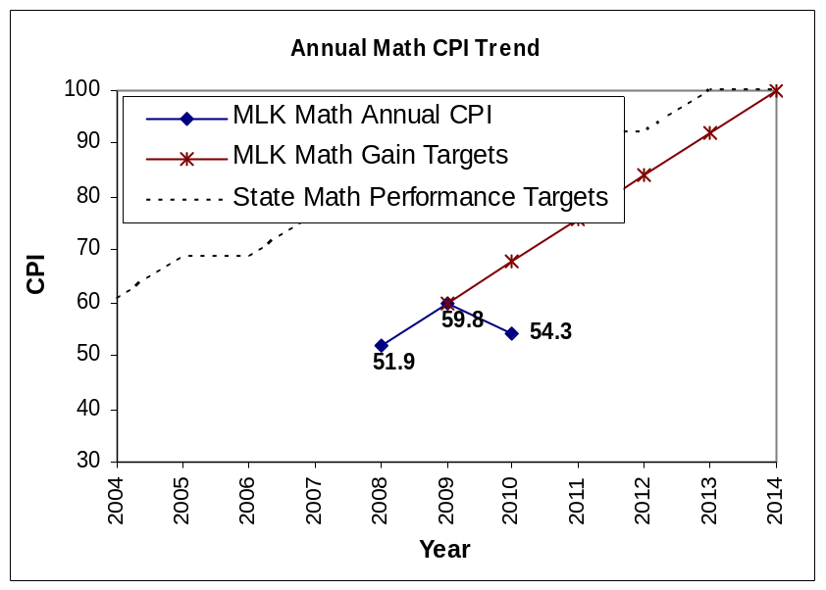

ESE Charter School Performance Criteria: Internal measures of student achievement
Student performance is strong and demonstrates improvement on internally-developed assessments of academic achievement.

Finding: Over the term of the current charter, students have not demonstrated consistent improvement on internal assessments.
During the charter term, MLK administered the Developmental Reading Assessment (DRA), the Phonological Awareness Literacy Screening (PALS), and the Northwest Educational Assessment (NWEA) to students. The DRA has been administered to kindergarten students once a year and all grades above kindergarten twice a year since the school’s opening in 2006. Over time, there has been a general decline in achievement between first and second testing sessions, with the exception of the 2008-09 school year, in which only first grade declined. Results from the 2009-10 DRA returned to the pattern of mixed (mostly negative) results with three out of five grades declining between the first and second testing sessions.

While growth in PALS showed improvement in 2007-08 and 2008-09, school leaders discontinued the use of PALS in first through third grade in 2010 and, therefore, data are not included in this analysis. MLK began testing students with the NWEA during the 2009-10 school year and has not yet reported on student performance. Please refer to the chart below to see testing results.

 | DRA |  |  |  |  |  |  |  | PALS
Academic Year | Test | % meeting benchmark |  |  |  |  |  |  | Test | % meeting benchmark
 |  | K | 1 | 2 | 3 | 4 | 5 |  |  | K | 1 | 2 | 3
2006-2007 | Winter 2007 |  | 52 | 58
2006-2007 | Spring 2007 | 63 | 43 | 59
2006-2007 | Year's Avg. | 63 | 48 | 59
2007-2008 | Fall 2007 |  | 81 | 58 | 54 |  |  |  | Fall 2007 | 78 | 71 | 78 | 87
2007-2008 | Winter 2008 | 81 | 36 | 49 | 52 |  |  |  | Spring 2008 | 84 | 86 | 90 | 93
2007-2008 | Year's Avg. | 81 | 59 | 54 | 53 |  |  |  | Year's Avg. | 81 | 79 | 84 | 90
2008-2009 | Fall 2008 |  | 82 | 62 | 59 | 35 |  |  | Fall 2008 | 61 | 91 | 79 | 88
2008-2009 | Winter 2009 | 93 | 38 | 63 | 60 | 64 |  |  | Spring 2009 | 87 | 81 | 91 | 90
2008-2009 | Year's Avg. | 93 | 60 | 63 | 60 | 50 |  |  | Year's Avg. | 74 | 86 | 85 | 89
2009-2010 | Fall 2009 |  | 80 | 84 | 70 | 65 | 24 |  | Fall 2009 | 69
2009-2010 | Spring 2010 |  | 72 | 74 | 64 | 88 | 49 |  | Spring 2010
2009-2010 | Year's Avg. |  | 76 | 79 | 67 | 77 | 37 |  | Year's Avg. | 69

ESE Charter School Performance Criteria: Curriculum
The school’s curriculum is documented, articulates the skills and concepts that all students must know and be able to do to meet state standards, is aligned horizontally and vertically, and supports opportunities for all students to master these skills and concepts.

Finding: MLK primarily uses commercially created curriculum in all content areas.
MLK uses Houghton Mifflin reading series for ELA and TERC investigations in Number, Data, and Space for mathematics. The Science and Technology for Children program is used for science. The Social Studies Alive! textbook is used to teach social studies. Teachers have reported to site visitors that they supplement these materials to meet the needs of students whose skills are below grade level.

Finding: Additional curriculum materials are not well documented. The school is in the process of developing and re-aligning curriculum with the Massachusetts curriculum frameworks (MCF).
The renewal inspection team found that a variety of tools are used to document curriculum: curriculum maps, report card check offs, pacing guides, and alignment tables. However, the degree to which each content area documented the above elements varied, and some subject areas did not include all elements. Weekly lesson plans are created by classroom teachers and consistently included summary, vocabulary, Do Now, activities, homework, and assessment. A review of lesson plans showed that MCF are sometimes referenced on weekly lesson plans, but most plans did not include them.

The school is in the very early stages of revising curriculum content, organization, and pacing. This revision process is being driven largely by responses to MCAS data and in order to prepare for the implementation of the Achievement Network (ANet) benchmark testing system. ANet is a company which provides regular, MCAS aligned math and ELA assessments to schools, analyzes the assessments, and provides teacher training on use of the data to inform instruction. MLK teachers and administrators are making adjustments to the curriculum to match ANet’s testing schedule. The renewal inspection team examined documents that showed initial alignment of ELA MCF standards with Houghton Mifflin objectives (the school’s ELA curriculum) and ANet objectives. Mathematics pacing guides for each grade level included plans for units to cover in a specified number of sessions and days, and a common classroom start day, as guided by the ANet timeline for testing. Other subject areas (science/social studies) are in the early stages of creating similar curriculum maps and pacing guides.

ESE Charter School Performance Criteria: Diverse learners
The school provides services for all students, including English language learners and those with disabilities and/or special education needs, as required by law. The school establishes and implements an accommodation plan that addresses the needs of diverse learners.

Finding: A qualified administrator oversees a special education program in which staffing and services have been significantly expanded to better meet the needs of students.
MLK presently enrolls 41 students who receive special education, or approximately 10 percent of the overall school population. Forty students receive their services in a full inclusion setting, with a single student listed as “partially included.” The special education program has a single dedicated classroom space.

The special education program is overseen by a part-time licensed special education administrator who is contracted through a health services agency. The administrator is onsite at least one day per week, conducts bi-monthly meetings with the special education department staff, and conducts regular observations of special educators implementing service delivery in the classrooms for purposes of feedback and supervision.

MLK’s expansion of staffing and services for special education students was the result of an internal evaluation of service delivery and effectiveness which included administrators, special education service delivery providers and general education staff. The school’s special education staff has approximately doubled since last year, now consisting of five special education teachers and one 0.8 FTE speech and language pathologist. One special education teacher is assigned to each grade level in grades two through four, with kindergarten and first grade sharing one teacher, and grades four and five sharing another. Special education staff provide inclusion support in the general education classroom and pull-out instruction as described on each student’s IEP. Staff and administrators reported that all services were delivered as described in student IEPs, and that conclusion was supported by classroom observations conducted by the federal programs renewal inspection team.

Finding: The special education program has structures and staffing in place to identify assess and serve students who require special education services.
At the start of the school year both special and general education staff receive training on special education requirements and the contents of individual student’ IEPs. Interviews with the general and special education staff indicated that special education teacher participation in grade level team meetings is an effective means of communication for staff, allowing the special educator to do advance planning for upcoming lessons, although some indicted that additional time would be beneficial. Student assessments are performed either in-house or particularly in the area of psychological and functional behavioral assessments, by staff contracted by the school.

Finding: The school has established a program which supports diverse learners and students who struggle academically to enable them to participate in and benefit from the educational goals and mission of the charter school.
Of the school’s 19 classrooms, 13 have teaching partners and six have co-teachers. MLK co-teachers are seeking to become full-time professionals in the field. Saturday instruction occurs four times annually and is targeted to MCAS test preparation at nominal cost. Summer school is available to all students in the school, but is targeted to students with low benchmark scores on MCAS. The summer program operates for four weeks in the month of July from 8:30 a.m. until noon during which time instruction is provided in mathematics and ELA as well as art and physical education. Breakfast is provided each day during the summer program, which is attended by approximately 50 students.

Finding: Potential English language learner (ELL) students are effectively identified and assessed. English language development instruction is provided and some sheltered English immersion is available.
All students newly enrolled at MLK are issued a home language survey, and 50 students underwent screening and language assessments at the start of the current school year as a result of which MLK has identified 30 students as ELL, or 7.5 percent of the overall population. Of the students identified as ELL, assessment results indicated that one student was functioning at Level 1, two students were at Level 2, ten students assessed to be at Level 3 and 14 students were assessed at Level 4. Twenty students whose first language was not English were determined to be English proficient as a result of initial identification assessments. No students have been transitioned by the school from limited English proficient to formerly limited English proficient. The native language of non-native English speaking students is almost exclusively Spanish.

Fifteen instructional staff have received training in Category I (second language teaching and learning), three in Category II (sheltering content instruction), two in Category III (assessment of speaking and listening) and two have been trained in Category IV (teaching reading and writing to ELL students). Additional staff training needs to occur in order for the school to be able to offer a full program of sheltered English immersion to all students who require that service.

The instructional staff reported that the ELL teacher collaborates with the general education teachers to coordinate the instruction in the language development class with the material being presented in the regular education classroom.

ESE Charter School Performance Criteria: Program evaluation and planning
The school regularly and systematically reviews the quality and effectiveness of the academic program and modified the program accordingly. Teachers and school leaders use qualitative and quantitative evidence to inform, guide, and improve instructional planning and practice.

Finding: Over the past four years MLK has collected assessment data, but this has not led to effective program adjustments. The school is implementing a new system of regular student achievement review based on the new benchmark assessments.
The school has tracked data pertaining to the measures in its accountability plan, including DRA, PALS, and MCAS data. In past years, school stakeholders reported that teachers were still learning how to use data to inform instruction. Indeed, collection of these data has not resulted in improved achievement. The renewal inspection team determined that the school has not developed clear systems for data analysis or program assessment based on the analysis. The only programmatic change based on data cited by school stakeholders was the addition of math and literacy coaches. Last year, the school’s low MCAS results became an impetus for changes currently happening at the school. Board members made MCAS a regular agenda item for board meetings starting in January 2010.

As mentioned above, the school is partnering with the Achievement Network (ANet) in an effort to develop a standards-based, data driven instructional system as described in the school’s charter. The ANet system provides nine assessments annually in grades three through five of which five are mathematics assessments, and four assessments are in English language arts. Mathematics and literacy specialists, using their own resources for grades kindergarten through two, will conduct a similar process. The academic coordinator is also responsible for the implementation of the ANet system. The results of the assessments will be reviewed and analyzed five times annually and will result in the development of student specific re-teaching plans to address identified weaknesses. The renewal inspection team determined that the school has already created structures to enable a better and more systematic use of data: there is a schedule of ANet assessment administrations as well as follow-up meetings for disaggregating results and collaborative planning for re-teaching throughout the year.

ESE Charter School Performance Criteria: Classroom and school environment
The classroom and school environment is orderly, supports the goal of student understanding and mastery of skills, and is consistent with the school’s mission.

Finding: Over the past five years, MLK’s classroom and school environment has shown marked improvement. The school has implemented a new behavioral management system, the MLK Way.
During the second, third, and fourth years, administrators, parents and teachers reported that managing student behavior issues was one the school’s most pressing concerns. Fourth year site visitors observed disruptive behavior that interfered with instruction in a third of classrooms. Additionally, in the forth year, implementation of the school’s disciplinary system was not seen by site visitors. In the fall of 2010, the renewal inspection team found an orderly classroom and school environment that has resulted from a new behavior management and school culture initiative, the MLK Way.

As described previously, the MLK Way is a system created to establish school-wide behavioral and academic expectations for students and enforce their use by all school personnel. The academic coordinator developed the core of this initiative over the summer of 2010, integrating lessons learned from schools visits to high performing charter schools and the MLK’s mission and vision. All staff participated in one week of professional development on the new strategies before school began. The academic coordinator has responsibility for following up with observations and further maintenance of the initiative.

School stakeholders all reported that the MLK Way has vastly altered the classroom and school environment for the better. Teacher observations during the new school year have focused solely on effective use of the MLK Way. Every teacher has been observed at least once and received feedback on their use of the MLK Way system. According to the executive director, more than 75 percent of classrooms were doing very well with the new system; additional supports have been offered to struggling teachers. Parents, school leaders, teachers, and students all remarked that rules were being enforced much more strictly and consistently than in the past. Parents and students noted that positive feedback, in addition to corrective actions, was being delivered to students.

Finding: The renewal inspection team found that MLK maintains an orderly environment in which all staff members consistently reinforce the school’s standards for conduct.
Every classroom observed by the renewal inspection team exhibited elements of the school’s new cultural initiative, the MLK Way. Three particular strategies were observed on a regular basis and noted by many members of the school community in interviews: the role model criteria, STAR, and the 100 percent technique.

The role model criteria create positive reinforcement for good behavior through tangible rewards. Students are assessed daily, based on their compliance with a published list of five behaviors such as: completing reading logs, class work, and homework; participating/cooperating respectfully all day; and arriving on time in uniform, walking in an MLK line, and dismissing safely. Students are given daily feedback on their role model status through the use of a chart found in every classroom. After earning a number of daily stars, students become role models and earn a certificate and privileges that are consciously public.

STAR stands for: Sit up in learning position, Track the speaker, Ask and answer questions, and Raise a quiet hand to speak. When school faculty and staff ask students to, “Get into STAR position,” students are expected to sit down with backs straight and eyes forward, hands in front of them and fingers intertwined. Signs listing the details of STAR were also posted in every classroom throughout the building. Teachers and other staff were observed regularly asking students to get into STAR. Students, when requested, were able to demonstrate STAR and could explain its purpose.

“100 percent” is a phrase borrowed from the book, Teach Like a Champion, by Doug Lemov. MLK teacher learned this technique during professional development visits to other charter schools. Regardless of the behavioral strategy or request, teachers are encouraged to expect and enforce 100 percent compliance by students. Many teachers across grade levels were heard saying, “I want 100 percent,” and repeating exercises with students until they got it. This was especially evident when teachers asked students to get into STAR.

Various attention-getting strategies and a public color system for conduct were also documented in many classroom observations. Though called upon less regularly, these were also seen to be effective in the establishment of an orderly environment. In the former, teachers rang bells, sang call-and-response songs, or clapped to refocus groups of students in non-punitive ways. In most cases, students responded quickly to such devices. When they did not, teachers, in almost every instance, repeated the exercise until they had full attention from 100 percent of the students.

Having multiple adults on staff for student support, and as supports in classrooms, also bolstered the enforcement of school norms and the creation of an orderly environment. There is a large student support team, consisting of a character development specialist, student support advocate, beloved community advocate, and school social worker. The school also employs at least two adults in every classroom. Class sizes ranged from 17 to 23, with a median of 20. These teachers are either a lead teacher with a teaching partner (typically a paraprofessional who may ultimately become a full teacher) or two co-teachers – full teachers who team-teach. Teaching partners were observed to focus primarily on maintenance of school norms and correction of behaviors. Regardless of role or title, adults throughout the school were observed reinforcing the school’s standard of conduct in a consistent fashion, thus leading to an orderly environment.

ESE Charter School Performance Criteria: Instruction
School-wide instructional practice is aligned with the school design, instructional expectations, and the curriculum. Instruction is effectively delivered and conveys clear expectations to students. The use of classroom time maximized meaningful student learning. Students are actively engaged in learning.

Finding: The majority of instructional practice is effectively delivered.
In past years, site visitors found that often, student behavior interfered with effective delivery of instruction. The renewal inspection team observed that a majority of classes were well-structured, clearly delivered, and used class time effectively. Consistent use of the school-wide behavior policy and techniques showed a strong impact on the instructional climate. Three areas, in particular, were consistently observed across grade levels and subject areas: strong class structure, clear delivery of instruction, and effective use of class time. In a smaller but significant percentage of classes, these elements were conspicuously absent. However, very few of the classes observed effectively employed strategies for inspiring higher-order thinking.

Structure: A majority of classes observed by the renewal inspection team had a clear structure with elements common to most classes. They began with an opening exercise or task, transitioned to full group instruction, then moved into individual, small group, or work in pairs. Students were observed transitioning smoothly from one activity to the next, reinforced with cues and use of school-wide behavioral norms previously described.

Delivery: The renewal inspection team observed that teachers clearly delivered instruction consistently or partially in most of classes visited. There were a few classes in which there was no evidence of clear delivery. In most cases, teacher instructions were clear and purposeful. Teachers used visual models and examples to clarify expectations and model examples of the work they wanted students to do. In many cases, students were observed to effectively understand directions and moved smoothly into working on the activities presented.

Use of class time: Class time was used effectively in a majority of classes. The clear routines previously described clearly aided in the utilization of class time for instruction in a majority of classrooms observed. A total of four classes exhibited a lack of effective management of time. Teachers were seen using consistent attention-grabbing techniques, such as asking students to get into STAR, ringing a bell, or singing a call-and-response song prior to delivering instructions or as a means of refocusing students on the task in front of them. Behavioral issues were managed with minimal distraction. Lesson plans were followed effectively with smooth transitions from one activity to another.

In approximately a fifth of classrooms observed by the renewal inspection team, instruction lacked structure and effective use of class time. Students were not engaged, or failed to understand what teachers were asking them to do. In these classes, students often did not understand the vocabulary used by the teacher; tasks were either too remedial or too advanced. Nor were there effective checks for understanding. Despite having at least two adults in every classroom, there did not appear to be clear roles for the second adult in many of these rooms.

Higher-order thinking was consistently absent in over half of classes. In many of these cases, teachers presented lessons or activities that appeared to be aimed at higher-order thinking, but fell short of their goal. Students were observed to be confused by the task or unable to produce the higher-order thinking requested, often because of a lack of appropriate scaffolding, unclear instruction, or misalignment with students’ level of development.

Finding: The school’s constructivist pedagogical approach has been better implemented at the school this year, however, this remains a work in progress.
In its charter application MLK describes constructivism as the school’s preferred instruction practice. As defined in the school’s application, constructivism is based on the principle that:
Students construct meaning by building on existing background knowledge, discussing key concepts, and engaging in a variety of experiences and activities that connect what they already know with new ideas. It emphasizes hands-on learning, problem solving, group work, and varied modes of instructional delivery.
In the school’s second year, site visitors did not see evidence of this method. In the third and fourth year, the constructivist approach was noted to be a goal for the school, but not yet fully implemented. The renewal inspection team found that elements of constructivism were present in more than half of classrooms observed. However, the team also found that stakeholders expressed different definitions and ideas about implementation of this instructional practice.

Interviews with teachers determined that there has been no professional development on constructivism, but that many saw it as a central element in their approach to teaching. Classroom instructional strategies observed by the renewal inspection team that reflected a constructivist approach included: group activities in which roles were assigned; independent work requiring construction of models or solving problems; or activities that asked students to use their own life experience or opinions as the basis for learning.

Interviews with school leaders and teachers, as well as reviews of observation tools and sample observations, confirmed that constructivism is not currently a focus of teacher evaluation. Furthermore, interviews with board members, school leaders and teachers brought out differences in opinion about the emphasis on constructivism in the school’s future. According to some leaders and board members, the use of constructivist techniques and curricular materials could come under review if academic achievement does not show improvement.

ESE Charter School Performance Criteria: Professional Climate
Teachers are provided with feedback, guidance, professional development, and opportunities for collaboration that lead to improved instructional practice and student achievement. The school establishes a professional climate resulting in a purposeful learning environment and reasonable rates of retention for school administrators, teachers, and staff.

Finding: Over the term of the charter, MLK has increased the number of supports for teachers and created additional opportunities for professional development.
Over the charter term, MLK has hired math and literacy coaches to work with teachers, hired additional teaching partners, developed improvement plans for struggling teachers, increased the number of informal observations, offered additional professional development sessions, and created more time for teacher collaboration. The renewal inspection team found that efforts to provide teachers with support and additional development have increased further this year. In the past, professional development has been created and delivered in house. These sessions were largely informal and based on teacher interest, rather than a structured approach to school improvement. In the past nine months, MLK has sought external partners and resources to provide professional development. As mentioned above, the school has recently sent teachers and administrators to visit high performing charter schools, has partnered with Uncommon Schools for teacher trainings, and sent teachers to a math curriculum training. Additionally, the school has begun regularly scheduled training and data analysis sessions with ANet.

Finding: Due to the recent departure of a school administrator, formal evaluations have not yet begun this year.
The director of education, who was responsible for evaluating teacher performance resigned two months into the school year. As of the renewal site visit, there had been no formal evaluation of instruction and it was unclear who would have responsibility for evaluation in the future. Detailed evaluations were conducted in the prior school year. Teachers were evaluated on classroom teaching, performance of routine and administrative duties, communication, and ongoing learning for professional growth and development. However, there were no formal evaluations conducted for teaching partners prior to the behavior management observations begun this fall. As previously mentioned, observations assessing faculty implementation of the MLK Way have been the focus of the current school year.

Finding: The school has created a highly communicative, collaborative professional environment.
A wide variety of forums exist for various members of the school community to share their perceptions and have input into school decisions. School leaders conduct an all-staff check-in with faculty and staff twice a week for 15 minutes. Grade-level meetings occur three times per week for longer periods, allowing teachers, co-teachers, and teaching partners to collaborate on classroom practices and curriculum. There is also a monthly full staff meeting.

School leaders and teachers reported that an annual debriefing occurs each June, resulting in topics to be dealt with in working sessions. A review of the list of topics provided for working sessions over the past four years shows a wide range covering curriculum, school culture, special events, pedagogy, faithfulness to charter, and parent communication. School leaders stated that some of these working sessions lead to the formation of committees to work on special projects.

The executive director communicates with the entire school through a weekly update. These page-length memos outline important issues and events in the school community, praise for specific teachers and groups, the executive director’s vision for the school, and general encouragement. They also provide a detailed history of the school’s development. Updates are addressed to the school staff and sent out at the beginning of each week.

ESE Charter School Performance Criteria: Accountability plan objectives and measures
The school meets, or shows progress towards meeting the academic achievement objectives and measures set forth in its accountability plan.

Finding: MLK has not met a majority of measures in its accountability plan related to academic achievement.
MLK’s accountability plan includes three objectives and six measures related to academic achievement. The school partially met one and did not meet four measures. One measure is not yet assessable. A summary of the school’s success in meeting the objectives and measures contained in its accountability plan can be found in Section VIII of this report.

C. Organizational Viability

ESE Charter School Performance Criteria: Financial management
The school demonstrates financial solvency, stability, internal controls, and oversight.

Finding: During its first charter term, MLK received unqualified audit opinions with no material findings each year. The school has developed a sound budgeting process and the board of trustees reviews financial data on a regular basis.
In FY07 through FY10, MLK has received unqualified annual independent audits with no internal control issues cited or management letters. The school has maintained revenues in excess of expenditures. In FY08 through FY10 the school has recorded a positive change in net assets; in 2010 the school had a surplus of approximately $790,000. As of June 30, 2010, MLK had accumulated net assets of nearly $2.5 million, of which 100 percent was unrestricted. The school had a line of credit through the end of 2009, but did not renew the line of credit when they switched banks with the facility purchase in June 2009.

The school’s budgeting process is well understood by all school stakeholders. The executive director and school accountant draft the budget using conservative estimates of revenue, building the budget on 90 to 95 percent of enrollment. The budget is then shared with the board treasurer, who is a CPA, and then the full board votes on the budget in June of each year.

The school’s accountant prepares monthly income and balance sheet statements for the board. The executive director looks at a draft of such statements; the accountant prepares a memo to the board describing highlights and trends in cash surplus over time. The board reported that they review financials quarterly and receive monthly updates.

There is a related non profit organization, the Friends of Martin Luther King Jr. Charter School of Excellence, Inc. (Friends of MLK). The organization fund-raises to supplement revenues and is the owner of the school’s new facility. Future minimum annual lease payments from the school to Friends of MLK will be $391,716 through June of 2014, at which time the payments will be adjusted based on the debt agreement with the bank.

ESE Charter School Performance Criteria: Board governance
The members of the board understand their responsibilities and are engaged in oversight of the school’s academic progress and financial condition.

Finding: MLK’s board of trustees is engaged in appropriate oversight of the school’s program. Over the past two years, board work has focused on examining academic achievement.
MLK is governed by a board of trustees that consists of 19 members who represent a wide range of skills and experience, including several former teachers and school administrators, several financial professionals, legal experts, and experts in state government. There are four standing committees: executive, finance, human resources, and governance. In addition, there are three ad hoc committees: academic excellence, funds development, and building. Committees do not meet on a regular basis, but schedule meetings when deemed appropriate, ahead of discussions at the full board meeting. The board has established an annual calendar for review of specific policies and specific votes, such as the approval of the audit, review of school handbooks, and evaluation of the executive director. While a majority of board meetings achieve a quorum, there are three board members who attended only three out of 22 meetings during the past two years; there is no policy regarding attendance.

The board has engaged in appropriate oversight of the school’s operation and academic program. The board has completed an annual evaluation of the executive director each year. Individual board members reported high levels of communication with the executive director. Additionally board members have been involved with securing the school’s new facility; they engaged in visits to potential building sites, meetings with banks, and development of fundraising ideas for the capital campaign. Individual board members have also visited other schools to learn more about creating effective school culture and improving academic performance.

Citing concerns about the school’s performance, the executive director assumed responsibility for the academic program in December 2009, effectively demoting the director of education. From that point on, the board of trustees requested that academic achievement and MCAS be discussed at every meeting. In subsequent 2010 meetings, the executive director and academic excellence committee reported on plans for improving MCAS achievement. Board minutes show that board members fully engaging in the school’s efforts to turnaround academic achievement in an advisory and oversight capacity.

ESE Charter School Performance Criteria: School leadership
The board of trustees regularly and systematically assesses the performance of (the) school leader(s) against clearly defined goals and makes effective and timely use of the evaluations. School leaders administer the school in a manner that ensures academic success, organizational viability, and faithfulness to charter.

Finding: The board of trustees annually assesses the performance of the school’s executive director.
The board’s governance committee asks the executive director to complete a self-reflection; he does so in both January and June. In the summer of each year, the governance committee writes its evaluation and discusses it with the full board. Evaluations report on the categories of student achievement, personnel, financial management, and operations. These evaluations also include reflections on site visit reports conducted by the Department and reference stakeholder satisfaction data. Student achievement data are referenced but not specifically cited. For the past two school years, the board commended the academic leadership of the school, but added that they wanted the executive director to address use of the pedagogical approach outlined in the charter and to prioritize areas of concern outlined in Department site visit reports.

ESE Charter School Performance Criteria: Organizational planning
The school has clear and well-understood systems for decision-making and communication. These systems result in a common sense of purpose for all school constituents. The school has realistic plans for program improvement based on evaluation and analysis of data.

Finding: Currently, four individuals serve in leadership roles who communicate frequently, but informally.
The executive director founded the school and holds ultimate responsibility for the school. He was recently given another four-year contract by the board of trustees. In addition to the executive director, there are three other individuals who serve in a significant leadership capacity at MLK. A daily operations supervisor has been in the position for more than four years and supervises non-educational staff. A program development coordinator, who coordinates field trips, substitutes and other non-operational systems, has been in his current position for one year. The academic coordinator is a recently-created position, currently filled by an employee who has been with the school in various roles for the past three years. Together, these four individuals make up the current leadership of the school. Another position – supervisor of curriculum and instruction (formerly the director of education) – was recently vacated and remains unfilled.

Communication between these leaders is reported to be frequent, but informal. There are no clear job descriptions – a conscious choice on the part of the executive director, but something that is discussed among leadership with differing opinions. One example of shifting job responsibilities: when the director of education was asked to reduce non-instructional duties, the daily operations supervisor took over responsibility for the coordination of substitutes for the building; this task is now held by the program development coordinator.

ESE Charter School Performance Criteria: Family satisfaction
The school demonstrates that families and students are satisfied with the school’s program.

Finding: Parent surveys and focus group comments demonstrate strong levels of satisfaction with the school’s mission, educational program, and amount of communication with families.
During each site visit over the term of the charter, parents stated satisfaction with the school’s mission, and program. Additionally, nearly 100 percent of parents responding to the school’s annual survey reported satisfaction with the school’s program three years in a row. Close to 50 percent of parents completed the survey each year. During the renewal inspection visit, parents reported having communication with teachers and/or other school personnel either through telephone calls, weekly progress reports, email, or face-to-face conversations. In addition, the maintenance of a relatively large number of teachers per classroom allows for increased attention to communication with parents and guardians.

ESE Charter School Performance Criteria: School safety
The school establishes and maintains a physically safe environment for students and staff. The school establishes an environment that is free from harassment and discrimination, and effectively addresses the social, emotional, and health needs of its students.

Finding: The school’s new facility provides a safe and welcoming learning environment.
In the summer of 2010, MLK renovated and moved in to a large, one-story structure that now holds the entire academic program in one building. In contrast to the past school site, stakeholders consistently expressed great satisfaction with the current space. The inside of the building is freshly painted, with many windows and natural light in all classes. Rooms are well-provisioned and organized, including SmartBoards in all third through fifth grade classrooms. There are also sinks in each room and bathrooms in kindergarten rooms. The temperature is regulated; every student in the upper grades has an individual locker. Students in lower grades have cubbies in their classes. There are multiple specialty rooms and offices for break-out activities with small groups and individual students. A full cafeteria adjoins a large indoor physical education room, with a sliding door allowing for large group meetings. A teacher room is centrally located to classrooms. Outdoor space is also more extensive, including an outdoor recreation area, nature trail and ample space for recess and organized games. It is a secure facility with locked doors and security cameras. Adults were on sight and observed actively supervising students in and out of doors at all times.

In contrast, the school’s former facility was far from ideal. There was a busy street separating the school’s two main buildings, bathrooms were run-down, classrooms were cramped, and there was no outside space for younger students to play during recess.

Beyond the physical plant, the school provides a variety of additional services through school employees or outside contract. Among those most relevant to maintain a safe facility are a full-time nurse, a contracted occupational therapist, mental health providers, and a speech and language therapist. Numerous part-time staff also supervise students during lunch and recess; a variety of interns from local colleges assist in classes and monitor other school activities.

ESE Charter School Performance Criteria: School facilities
The school provides facilities that meet applicable state and federal requirements, are suited to its programs, and are sufficient to serve diverse student needs.

Finding: The purchase of the new facility in 2009 provides a stable facility for the future of the school.
On June 15, 2009, the school purchased its current 67,000 square foot facility, which sits on 9.3 acres of land in a residential neighborhood of Springfield. The school entered into a $5,900,000 Mortgage and Security Agreement between the Massachusetts Development Finance Agency and Berkshire Bank, with a 30-year mortgage at a current interest rate of 4.39 percent, which is set for five years and then adjusts.

Prior to the school’s purchase, the facility served as a headquarters to GoodWill Industries. The facility is currently built out to effectively serve 420 students in approximately 46,000 square feet, with an additional 21,000 square feet reserved for future development. It currently includes 18 classrooms (each with external windows), a media center, a computer lab, a nurse’s suite, an art room, a music room, a large multi-purpose room that opens into the cafeteria, a staff work room and lounge, and a variety of offices and rooms for small-group work. The nine acres of land surrounding the facility have been upgraded to include a playing field, basketball court, and nature trail. The school moved to its current location in June of 2010.

ESE Charter School Performance Criteria: Compliance
The school is in compliance with the requirements of the Coordinated Program Review (CPR). Employees of the school meet all applicable state and federal qualifications and standards.

Finding: The school is in compliance with the requirements of the Coordinated Program Review (CPR).
The last full Coordinated Program Review (CPR) activity at MLK was conducted in January 2008 covering the areas of special education, civil rights and English language learner education. The final report resulting from the CPR activity was published in October 2008. In response to the findings contained in the report, the school submitted a Corrective Action Plan (CAP) which was reviewed and approved by the Department. Subsequent to approval of the CAP plan, the school has demonstrated its progress in addressing the areas of non-compliance identified in the report through the submission of progress reports at intervals scheduled by the Department. By reviewing the progress report submissions, the Department determined in October 2009 that all issues identified in the CPR report had been fully addressed by the school. The next compliance review activity for this school is a mid-cycle review which is scheduled for FY11.

Finding: A majority of the teaching staff are highly qualified.
During the 2009-10 school year, approximately 86 percent of teachers were highly qualified.

ESE Charter School Performance Criteria: Dissemination
The school has collaborated with its sending district(s) on the sharing of innovative practices, or provided models for replication and best practices.

Finding: MLK has not yet disseminated any best practices. The school is working to develop best practices worthy of dissemination in the future.
As stated in the application and reported to the renewal inspection team, the school is working on developing its own model before considering ways to share best practices. Their primary focus is on learning from other successful models and integrating those lessons into the culture and values of MLK. Innovations, such as the MLK Way, may be candidates for dissemination in the future, but the school requires additional time to fully implement and assess the results of these experiments. The school provided several ideas for future dissemination in its renewal application, including: hiring teachers who are relatively new to the profession as teaching partners, and allowing them to grow into positions as co-teachers and lead teachers; providing college scholarships for some students through the Dr. King Scholars Program; and, pursuing the ideal of the beloved community.

ESE Charter School Performance Criteria: Accountability plan objectives and measures
The school meets, or shows progress towards meeting the organizational viability objectives and measures set forth in its accountability plan.

Finding: MLK met all of its measures in its accountability plan pertaining to organizational viability.
MLK’s accountability plan includes three objectives and seven measures related to organizational viability. The school met all measures. A summary of the school’s success in meeting the objectives and measures contained in its accountability plan can be found in Section VIII of this report

V. MCAS Performance

English language arts

 | Key: N = # of students tested; CPI = Composite Performance Index
 |  | Warning/Failing % |  | Needs Improvement % |  | Proficient % |  | Advanced/Above Prof. %

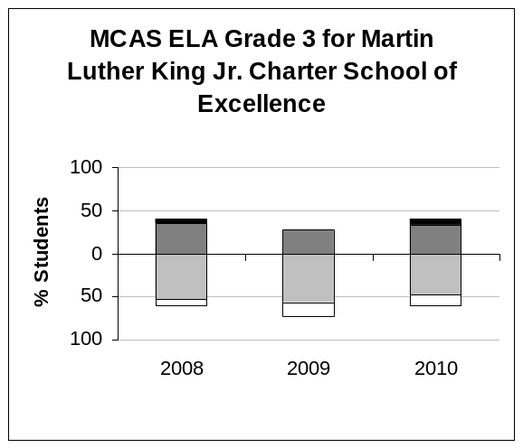 | 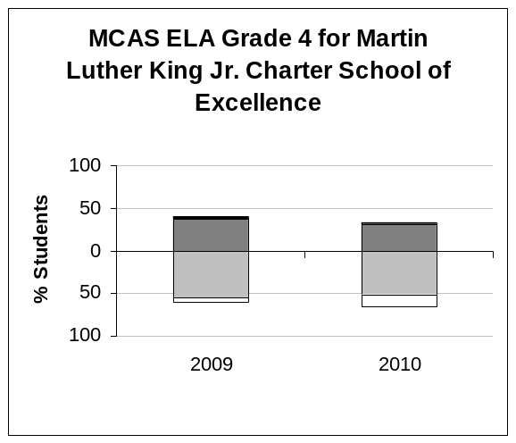
  ELA Grade 3 | 2008 | 2009 | 2010
  % Advanced | 5 | 0 | 7
  % Proficient | 35 | 28 | 33
  % Needs Improvement | 53 | 57 | 47
  % Warning/Failing | 8 | 16 | 14
  N | 40 | 58 | 73
  CPI | 78.8 | 69.0 | 74.0
  ELA Grade 4 | 2009 | 2010
  % Advanced | 3 | 2
  % Proficient | 37 | 32
  % Needs Improvement | 55 | 51
  % Warning/Failing | 5 | 15
  N | 38 | 59
  CPI | 74.3 | 67.4
  SGP | 48.0 | 51.5
  N for SGP | 34 | 58
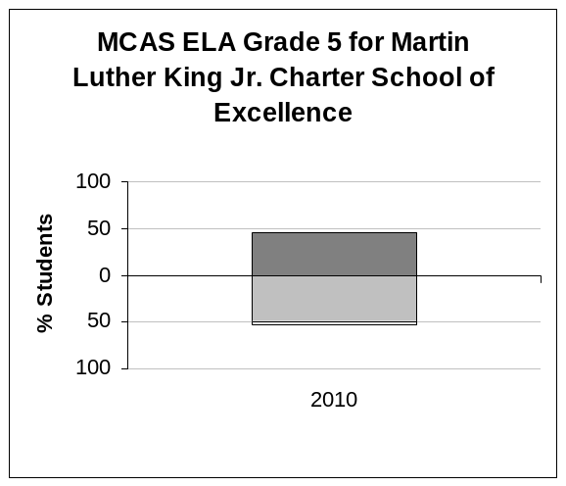
  ELA Grade 5 | 2010
  % Advanced | 0
  % Proficient | 46
  % Needs Improvement | 49
  % Warning/Failing | 5
  N | 37
  CPI | 78.4
  SGP | 41.0
  N for SGP | 31

Mathematics

 | Key: N = # of students tested; CPI = Composite Performance Index
 |  | Warning/Failing % |  | Needs Improvement % |  | Proficient % |  | Advanced/Above Prof. %

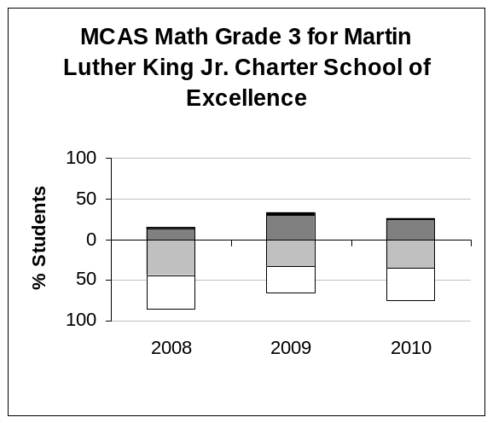 | 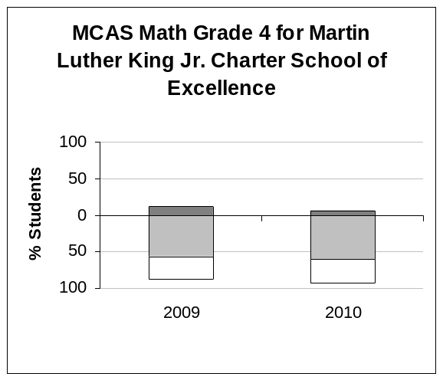
  Math Grade 3 | 2008 | 2009 | 2010
  % Advanced | 3 | 5 | 3
  % Proficient | 13 | 29 | 24
  % Needs Improvement | 44 | 33 | 36
  % Warning/Failing | 41 | 33 | 38
  N | 39 | 58 | 72
  CPI | 51.9 | 64.7 | 56.6
  Math Grade 4 | 2009 | 2010
  % Advanced | 0 | 0
  % Proficient | 12 | 7
  % Needs Improvement | 56 | 61
  % Warning/Failing | 32 | 32
  N | 41 | 59
  CPI | 53.0 | 51.3
  SGP | 27.0 | 23.0
  N for SGP | 37 | 57
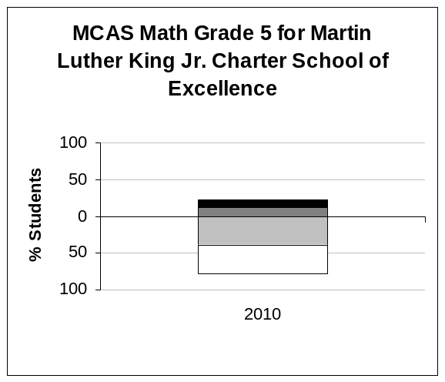
  Math Grade 5 | 2010
  % Advanced | 11
  % Proficient | 11
  % Needs Improvement | 38
  % Warning/Failing | 41
  N | 37
  CPI | 54.7
  SGP | 47.0
  N for SGP | 35

MLK Median Student Growth Percentiles (SGP)
Year | 2008 | 2009 | 2010
English Language Arts | - | 48.0 | 44.0
Mathematics | - | 27.0 | 32.0

Science

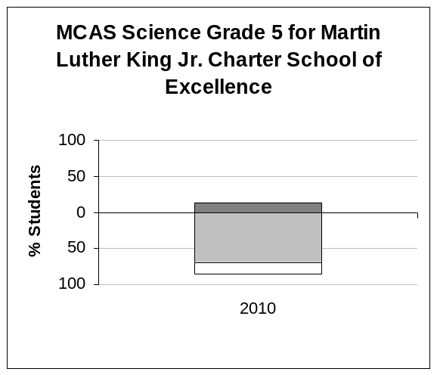
Science Grade 5 | 2010
% Advanced | 0
% Proficient | 14
% Needs Improvement | 70
% Warning/Failing | 16
N | 37
CPI | 60.8

VI. Comparative Statistical Analysis of MCAS Results

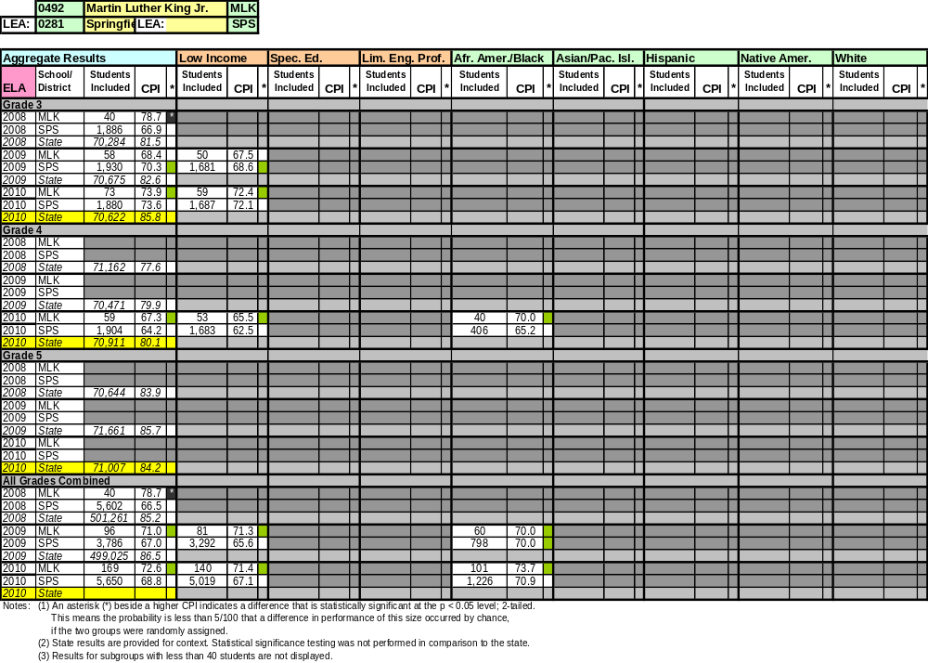

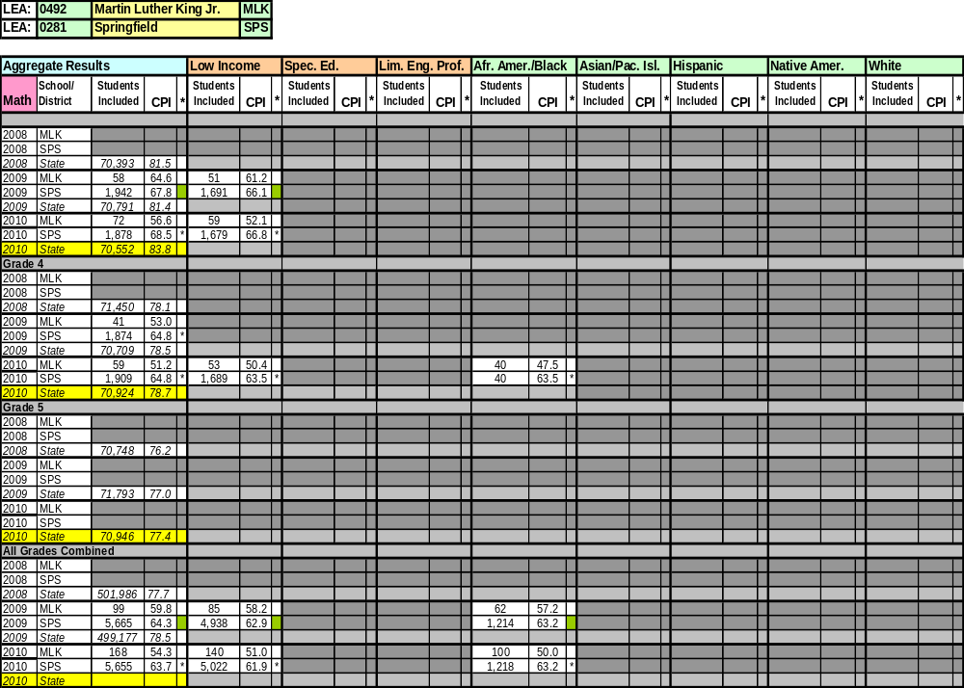

VII. Adequate Yearly Progress Data

Performance and improvement ratings for Massachusetts public schools are based on aggregate student performance on MCAS tests. Performance is measured using the Composite Performance Index (CPI), a measure of the distribution of student performance relative to attaining proficiency. Ratings are used to track schools’ progress toward meeting the goal of all students achieving proficiency in English language arts and mathematics by 2014. MLK’s most recent AYP Data is presented below.

 | NCLB Accountability Status | Performance Rating | Improvement Rating
ENGLISH LANGUAGE ARTS | Improvement Year 2 - Subgroups | Moderate | No Change
MATHEMATICS | No Status | Very Low | Declined

English Language Arts
Student Group | (A) Participation |  |  |  | (B) Performance |  |  | (C) Improvement |  |  |  | (D) Attendance |  |  | AYP 2010
Student Group | Enrolled | Assessed | % | Met Target (95%) | N | 2010 CPI | Met Target (90.2) | 2009 CPI Baseline | Gain Target | On Target Range | Met Target | % | Change | Met Target | AYP 2010
Aggregate | 169 | 169 | 100 | Yes | 169 | 72.6 | No | 71.1 | 5.8 | 74.4-79.4 | Yes/SH | 94.3 | -0.3 | Yes | Yes
Lim. English Prof. | 9 | - | - | - | - | - | - | - | - | - | - | - | - | - | -
Special Education | 19 | 19 | - | - | 19 | - | - | - | - | - | - | - | - | - | -
Low Income | 140 | 140 | 100 | Yes | 140 | 71.4 | No | 71.3 | 5.7 | 74.5-79.5 | No | 94.0 | -0.3 | Yes | No
Afr. Amer./Black | 101 | 101 | 100 | Yes | 101 | 73.8 | No | 70.0 | 6.0 | 73.5-78.5 | Yes | 94.3 | -0.4 | Yes | Yes
Asian or Pacif. Isl. |  | - | - | - | - | - | - | - | - | - | - | - | - | - | -
Hispanic | 55 | 55 | 100 | Yes | 55 | 69.5 | No | 69.2 | 6.2 | 70.9-79.9 | Yes/SH | 94.4 | 0.0 | Yes | Yes
Native American | 2 | - | - | - | - | - | - | - | - | - | - | - | - | - | -
White | 4 | - | - | - | - | - | - | - | - | - | - | - | - | - | -
Mathematics
Student Group | (A) Participation |  |  |  | (B) Performance |  |  | (C) Improvement |  |  |  | (D) Attendance |  |  | AYP 2010
Student Group | Enrolled | Assessed | % | Met Target (95%) | N | 2010 CPI | Met Target (84.3) | 2009 CPI Baseline | Gain Target | On Target Range | Met Target | % | Change | Met Target | AYP 2010
Aggregate | 169 | 168 | 99 | Yes | 168 | 54.3 | No | 59.8 | 8.0 | 65.3-70.3 | No | 94.3 | -0.3 | Yes | No
Lim. English Prof. | 9 | - | - | - | - | - | - | - | - | - | - | - | - | - | -
Special Education | 19 | 19 | - | - | 19 | - | - | - | - | - | - | - | - | - | -
Low Income | 140 | 140 | 100 | Yes | 140 | 51.1 | No | 58.2 | 8.4 | 64.1-69.1 | No | 94.0 | -0.3 | Yes | No
Afr. Amer./Black | 101 | 100 | 99 | Yes | 100 | 50.0 | No | 57.3 | 8.5 | 63.3-68.3 | No | 94.3 | -0.4 | Yes | No
Asian or Pacif. Isl. |  | - | - | - | - | - | - | - | - | - | - | - | - | - | -
Hispanic | 55 | 55 | 100 | Yes | 55 | 58.6 | No | 59.7 | 8.1 | 63.3-72.3 | No | 94.4 | 0.0 | Yes | No
Native American | 2 | - | - | - | - | - | - | - | - | - | - | - | - | - | -
White | 4 | - | - | - | - | - | - | - | - | - | - | - | - | - | -

Adequate Yearly Progress History |  |  |  |  |  |  |  |  |  | NCLB Accountability Status
 |  | 2003 | 2004 | 2005 | 2006 | 2007 | 2008 | 2009 | 2010 | NCLB Accountability Status
ELA | Aggregate | - | - | - | - | - | No | No | Yes | Improvement Year 2 - Subgroups
ELA | All Subgroups | - | - | - | - | - | - | No | No | Improvement Year 2 - Subgroups
MATH | Aggregate | - | - | - | - | - | No | Yes | No | No Status
MATH | All Subgroups | - | - | - | - | - | - | Yes | No | No Status

VIII. Accountability Plan Objectives and Measures

A. Faithfulness to Charter | 2009-10 Performance | Notes
Objective: Parent involvement consistent with parent/guardian contract.
Measure: 2/3 of parents/guardians who conference with the school to address disruptive student behavior will partner with us to improve behavior. | Not Met | - 2008-09, approximately two-thirds of the parents/guardians who attended a conference about behavior issues partnered with the school.  - 2009-10, less than two-thirds (58%) of parents/guardians partnered with the school.
Measure: Parent/guardian confirmation of reading at home with 80% of students four times per week. | Not Met | - 2008-09, the school did not meet the goal.  - 2009-10, less than 59% of students were reading at home with parents. Data gathered by the school each month shows a span of 41% to 59% of students read at home each month.  - A renewed effort has been made to increase parent involvement in this area. The school reported that 65% of students met the weekly goal for September 2010 – six percentage points higher than the most successful month last year, but still 15% lower than the target.
Objective: Building a beloved community.
Measure: MLK will retain 90% of non-graduating students each year, excluding students who move out of the area or require a specialized placement. | Met | - From the 2008-09 school year to the 2009-10 school year, MLK retained 92.6% of the student body.  - From the 2009-10 school year, to the current school year, MLK retained 93.1% of the school body.
Measure: No more than 10% of faculty members leave annually because they are dissatisfied. | Met | - For the first four years of the school’s charter, less than 10% of the staff resigned from the school.
Objective: Community service learning.
Measure: All students participate in at least one community service learning activity each year. | Met | - The school has improved its abilities to provide students with community service learning opportunities over the course of the charter term.  - In 2009-10, all grades participated in community service learning. All grades participated in fund-raising efforts to support the victims of the tragedy in Haiti. In addition, students participated in recycling projects and apple harvesting for local food banks.
Measure: All teachers report in their post-community-service, teacher reflection forms that the community service learning specifically supports at least one area of core academic achievement. | Met | - The school reported in its application that all teachers agreed that community service learning supports academic achievement.  - The renewal inspection team found that teacher reflection forms are a commonly understood and regularly implemented practice.
B. Academic Program | 2009-10 Performance
Objective: As excellent scholars, all students will (1) read and write proficiently and (2) accurately apply mathematical principles.
Measure: Students will improve academic achievement over time against an objective standard. MLK Charter School will meet the Composite Performance Index (CPI) targets for achieving AYP. MLK Charter School will make AYP annually (aggregate and for significant sub-groups). | Not Met | - MLK did not make AYP in 2008 for either subject.  - In 2009 the school made AYP for mathematics, but not ELA.  - In 2010, the school made AYP in the aggregate for ELA, but not subgroups. MLK did not make AYP in mathematics.  - Although the school made its CPI target in the aggregate for ELA, it did not make its CPI targets in ELA subgroups or in the aggregate or subgroups for mathematics. Its performance rating for ELA in 2010 is “moderate,” and improvement rating is “no change.” Its performance rating for mathematics in 2010 is “very low,” and its improvement rating is “declined.”
Objective: Students will demonstrate academic achievement relative to similar students (by sub-group):
Measure: 3rd grade reading /math MCAS:  top 40/60% of Springfield schools (2008)  top 35/55% of Springfield schools (2009)  top 30/50% of Springfield schools (2010)  top 25/45% of Springfield schools (2011) | Not Met | - The school met this measure in 2008 for ELA.  - The school did not meet this measure for math in any year 2008-2010.
Measure: 4th grade ELA/ math MCAS:  top 35/55% of Springfield schools (2009)  top 30/50% of Springfield schools (2010)  top 25/45% of Springfield schools (2011) | Not Met | - The school met this measure for ELA in 2009.  - The school did not meet this measure for math in 2009 or 2010.
Measure: 5th grade ELA /math MCAS:  top 30/50% of Springfield schools (2010)  top 25/40% of Springfield schools (2011) | Not Met | - The school met this measure for ELA in 2010.  - The school did not meet this measure for math in 2010.
Objective: Students will demonstrate progress over the course of the school year:
Measure: The percentage of students in each grade meeting the benchmark on PALS and DRA will increase over the course of each academic year and in comparison to that cohort’s performance one year earlier. | Partially Met | - Over time, there has been a general decline in achievement between first and second testing sessions of the DRA, with the exception of the 2008-09 school year, in which only grade 1 declined. Results from the 2009-10 DRA returned to the pattern of mixed (mostly negative) results with three out of five grades declining between the first and second testing sessions.  - Student performance on PALS showed improvement. Four out of five grades scored slightly higher on their fall 2009 test than they had on their fall 2008 test.  - While growth in PALS was consistent in 2007-08 and 2008-09, school leaders discontinued the use of PALS in grades 1-3 in 2010 and, therefore, data are not included in this analysis.
Measure: The percentage of students in grades 3-5 meeting the benchmark on the Northwest Educational Assessment math will increase in comparison to that cohort's performance one year earlier. | Not Applicable | - The school began to administer the NWEA in 2009-10; therefore, there is no cohort for comparison.
C. Organizational Viability | 2009-10 Performance
Objective: Ongoing active governance by the board of trustees:
Measure: The board will meet at least 10 times yearly and review issues identified in the board calendar including approval of the budget, evaluation of the executive director, the accountability plan, MCAS results, legal issues, and insurance coverage. | Met | - During the past two years, the board created annual calendars that provided a schedule for review of policies throughout the year.  - The meeting minutes of the committees, as well as full Board meetings, show annual attention to approval of the budget, evaluation of the executive director, attention to accountability plan measures, MCAS results, legal issues and insurance coverage.
Measure: MLK Charter School has a long-term facility by the 2009-2010 school year. | Met | - The Friends of Martin Luther King, Jr. Charter School of Excellence, Inc. signed a purchase and sale agreement in June 15, 2009 for a new facility at 285 Dorset Street. Construction was completed over the course of the 2009-10 school year; the school moved into the new building in the early summer of 2010.
Measure: Funds development adequately supports facility purchase, construction, and renovation. | Met | - The school was able to secure adequate funding to purchase and renovate its facility.
Objective: Unwavering fiscal responsibility:
Measure: The audit for each fiscal year will confirm an operating surplus or 2:1 ratio of current assets to liabilities on the combined balance sheets of the school and the Friends of Martin Luther King, Jr. Charter School of Excellence, Inc. | Met | - In FY10 the ratio for the school was 6:1, with current assets of $1,689,284 and liabilities of $276,921.  - In FY09, the ratio for the school was 5.1:1, with current assets of $1,227,928 and liabilities of $239,998.
Measure: The audit for each fiscal year will have no material findings. | Met | - In all years, MLK had no material findings in audits.
Objective: Responsiveness to the families it serves:
Measure: School will have enrollment of 99% of charter capacity each year. | Met | - As of October 1, 2010, the school enrolls 407 students. Charter capacity for 2010-11 is 380 students.  - For the 2009-10 school year, the school’s average membership was 361 students; their charter enrollment capacity was 360 students.
Measure: 90% of parents/guardians responding to an annual survey will express overall satisfaction with MLK Charter School. | Met | - The parent survey distributed in February 2010 yielded 148 responses, for a 55% response rate among families (271 families at that point in time).  - Parents reported 97%-99% satisfaction rates for each question of the survey.

As reported by the school at the time of the renewal inspection visit.
As reported by the school at the time of the renewal inspection visit.

