Massachusetts Department of

Elementary and Secondary Education

75 Pleasant Street, Malden, Massachusetts 02148-4906 Telephone: (781) 338-3000

TTY: N.E.T. Relay 1-800-439-2370

Mitchell D. Chester, Ed.D.
Commissioner

MEMORANDUM

To: | Members of the Board of Elementary and Secondary Education
From: | Mitchell D. Chester, Ed.D., Commissioner
Date: | March 9, 2012
Subject: | Lowell Community Charter Public School – Report on Conditions and School’s Request to Modify Conditions

Lowell Community Charter Public School (LCCPS) opened in 2000 and was first renewed in 2005. In February 2010, the Board of Elementary and Secondary Education (Board) granted LCCPS a probationary renewal with conditions requiring the school to meet academic targets, to implement a school-wide corrective action plan, and to reduce the school’s maximum enrollment from 900 to 610 and grade span from K-8 to K-4. This renewal followed an earlier recommendation, in January 2010, to not renew the school’s charter. In March 2011, LCCPS submitted a request to amend the probationary conditions to (1) allow an extra year to reach the planned enrollment level of 610, and (2) allow the school to remain at grades K-6. In April 2011, the Board granted the school’s request.

This memorandum serves as a report on the school’s progress in relation to the renewal conditions. Additionally, the school has requested a further amendment to the enrollment condition. The school has requested that it be allowed to return to a K-8 configuration and to eventually reach a maximum enrollment of 700 students by the 2017-18 school year. I am not recommending that the school’s request be granted at this time. While I am heartened to see progress in the school’s academic performance, it is premature at this point to grant the school an expansion of grades served and number of seats. Given its probationary renewal, the school must establish a sustained record of academic growth and success with its current population of students before the Department can grant an expansion.

Mission

The school’s mission statement reads: “The purpose of the Lowell Community Charter Public School is to prepare a cross section of Lowell children for success as students, citizens, and workers by providing them with a comprehensive curriculum in a supportive, challenging, multicultural learning environment. The school’s highest priority is the promotion of academic achievement for all students in each of the areas addressed by the Massachusetts curriculum frameworks, including: English, reading and language arts, writing, mathematics, science, health and fitness, world languages, art, and music, as well as character and ethics. The Lowell Community Charter Public School will place special emphasis on the contributions that immigrants have made to American life and to Lowell’s development over the years, and on the culture, language, and history of the Southeast Asian and Latino peoples who comprise a substantial portion of Lowell’s present day population. The school will actively promote the joy of discovery and creativity in the learning process, and will integrate the use of technology into aspects of instruction. The opportunity for learning will be enhanced through a longer school day and an extended year. Student achievement will be demonstrated in measurable terms to parents, students, and the community at large.”

Report on Conditions

The following conditions were imposed by the Board in April 2011:

Condition 1: No later than September 2012, the school shall reduce its maximum enrollment to 610 students.

Status: In progress
In March 2010, LCCPS submitted a plan to reduce the school’s maximum enrollment and grades served. The school followed the plan for the 2010-11 school year, serving 791 students in grades K-6. In April 2011, the Board granted LCCPS’s request to be given until September 2012 to reduce its enrollment to 610. At the time of the December 2011 site visit, LCCPS was serving 677 students in grades K-6. The school has planned for an enrollment of 610 students for the 2012-13 school year as illustrated by budget projections created by the school.

Condition 2: By December of 2011, Lowell Community Charter Public School shall demonstrate that it is an academic success by:

  - meeting academic growth targets in English language arts and mathematics, as established by the Department of Elementary and Secondary Education, or
  - achieving Adequate Yearly Progress in the aggregate and for all statistically significant subgroups in English language arts and mathematics in 2010 and 2011, and
  - by meeting the goals and objectives established the school’s Accountability Plan.

Status: Met
In 2011, LCCPS made AYP in the aggregate for both mathematics and ELA, but not for all subgroups in either subject area. The school currently has a status of Restructuring Year 2 for subgroups in both subject areas. Over the past two years, however, LCCPS’s growth targets have met the Department’s standards for typical growth. In 2011, LCCPS’s median student growth percentile (SGP) for ELA was 49.0 which is within in the typical range. The school’s median SGP for mathematics was 64.0 in 2011, which is considered in the high range for growth. While LCCPS students have displayed typical to high growth in 2011, overall proficiency rates in both ELA and mathematics remain below 50 percent. Please see the data tables below. Finally, during the 2010-11 school year, LCCPS met a majority (eight out of ten) of the academic measures established in its accountability plan.

ELA All Grades 2008 2009 2010 2011  % Advanced 2 4 4 2  % Proficient 30 29 34 40  % Needs Improvement 41 47 45 40  % Warning/Failing 26 21 18 17  N 446 463 485 363  CPI 64.5 66.6 70.6 72.1  SGP 39.0 37.0 53.0 49.0  N for SGP 328 339 346 223 | Math All Grades 2008 2009 2010 2011  % Advanced 9 8 7 10  % Proficient 20 18 23 33  % Needs Improvement 35 37 40 41  % Warning/Failing 36 37 30 17  N 448 463 484 362  CPI 58.9 57.1 60.6 72.7  SGP 47.0 38.0 50.5 64.0  N for SGP 328 340 344 223
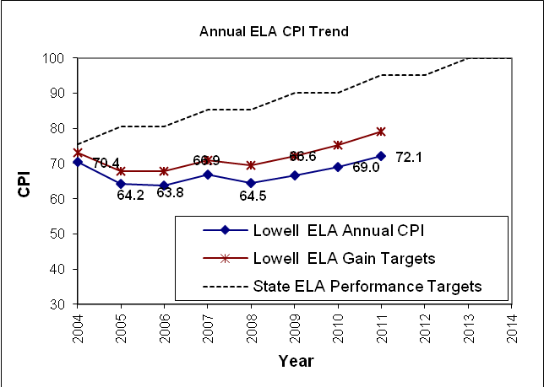 | 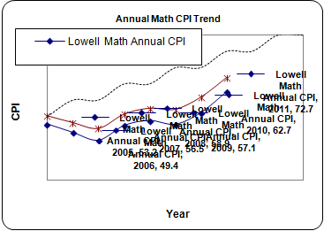

Adequate Yearly Progress History |  |  |  |  |  |  |  |  |  | NCLB Accountability Status
 |  | 2004 | 2005 | 2006 | 2007 | 2008 | 2009 | 2010 | 2011
ELA | Aggregate | Yes | Yes | No | Yes | No | No | No | Yes | Restructuring Year 2 - Subgroups
 | All Subgroups | Yes | No | No | No | No | No | No | No
MATH | Aggregate | Yes | Yes | No | Yes | No | No | No | Yes | Restructuring Year 2 - Subgroups
 | All Subgroups | - | No | No | Yes | No | No | No | No

Site Visit Summary

In December 2011, a team from the Department’s Charter School Office conducted a Year Twelve Site Visit in order to assess the school’s progress in terms of its conditions and as a normal part of the charter school accountability cycle. A copy of the Year Twelve Site Visit Report is attached to this memo and the team’s findings are summarized below in the three areas of accountability: faithfulness to charter, academic success, and organizational viability.

Faithfulness to Charter
- During the summer of 2011, the school terminated its relationship with its former Educational Management Organization. As required by the school’s probationary conditions, LCCPS’s board of trustees is in the process of contracting with a new external partner, the Center for Collaborative Education, to provide assistance in the school’s improvement efforts.
- The school’s recent focus has emphasized the academic achievement aspects of the mission.
Academic Success
- In general, site visitors noted that instructional practice was rich and varied. Site visitors observed a majority of classes that transitioned between multiple groupings, collaborative and student centered activities, and a variety of activities and methods that created a productive and enjoyable learning environment.
- Site visitors noted that most classrooms had posted objectives and clearly articulated agendas, making learning explicit to visitor and student alike.
- In a majority of classrooms, instruction was found to be clear, reinforced, and effective. Lesson plans with varied groupings and activities kept students engaged.
- The school continues to refine and modify its documented curriculum.
- This year, the school has begun using new curriculum: Pearson’s Envision Math, Fundations phonics program, and a new writing program using two commercial curriculums.
- A large majority of classrooms were orderly and supported student learning. Site visitors observed elements of the Responsive Classroom management method. These were effectively employed by teachers.
- The entire school, including classrooms and common spaces, was found to be clean, bright, and orderly, providing a rich environment for student learning.
- Processes for formal teacher evaluation are being revised. All teachers report receiving ample informal feedback and guidance this year.
- LCCPS teachers and administrators report that the school has maintained and improved the systems and structures for the collection, analysis, and use of data that were put in place last year. Site visitors determined that the use of data to drive instruction, make adjustment to curriculum, and provide supports to students is an essential aspect of the school’s culture.
Organizational Viability
- The board of trustees continues to develop its capacity. It has recently added four new members. All other board members joined the board after August 2010.
- The school has established systems and structures to review the effectiveness of the academic program as driven by academic data.
- The board of trustees provides oversight and leadership in key areas of the school.
- Community members reported high levels of satisfaction with the school.
- School community members all expressed concern about the school’s ability to weather a further reduction of enrollment as required by the current conditions. All stakeholders noted that the reduction would cause financial and academic hardship for the school.

Request to Amend the Conditions

In January 2012, LCCPS’s board of trustees submitted a request to amend or remove the enrollment conditions that were placed upon the school. LCCPS has requested to add grade seven during the 2012-13 school year, and grade eight during the 2013-14 school year. Additionally, the school has requested a change to its maximum enrollment from 610 to 700 students by 2017-18. In order to accommodate an “enrollment bubble” in the school’s current grades three and four, LCCPS requested a temporary maximum enrollment of 750 students for the 2012-13 and 2013-14 school years, after which it will begin the process of evening out classes to reach its target maximum enrollment of 700 students.

Recommendation

While the school has made strides in improving academic performance and establishing systems and structures to operate a viable organization, LCCPS has yet to demonstrate a sustained track record of academic success and strong organizational competence. For this reason, I am not prepared to recommend an additional expansion of grade levels served and a further increase in its maximum enrollment.

***************************

If you have any questions or require additional information, please contact Barry Barnett, Acting Director of Charter Schools, Innovation, and Redesign, at 781-338-3225; or Jeff Wulfson, Deputy Commissioner, at 781-338-6500; or me.

Enclosures: Amendment request letter from LCCPS
Year Twelve Site Visit Report for LCCPS

