Match Charter Public School 2008-2009 through 2011-2012: Percent of Students Scoring Proficient/Advanced - All Students
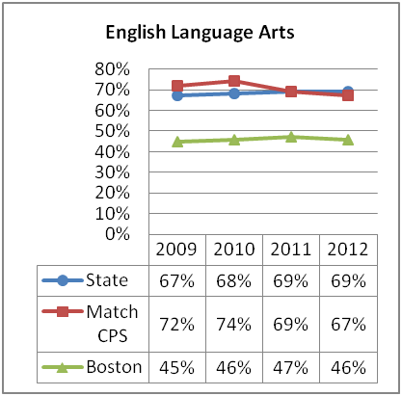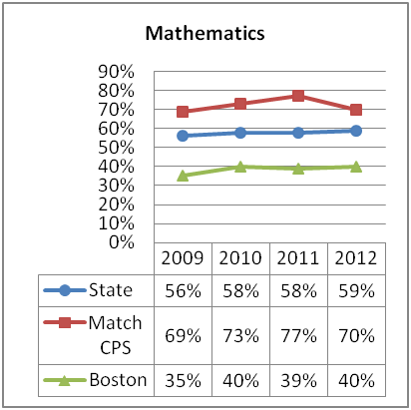

Match Charter Public School 2008-2009 through 2011-2012: Median Student Growth Percentile - All Students
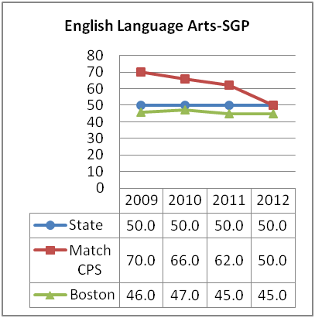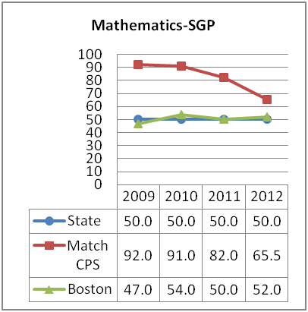
Match Charter Public School 2008-2009 through 2011-2012: Percent of Students Scoring Proficient/Advanced - High Needs
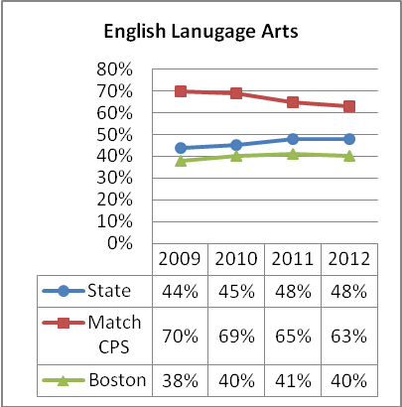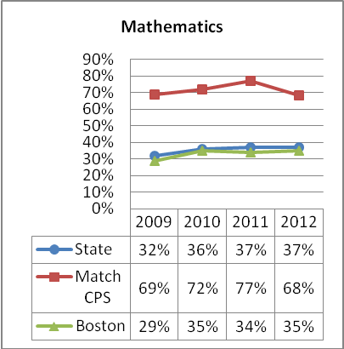

Match Charter Public School 2008-2009 through 2011-2012: Median Student Growth Percentile - High Needs
